**Comsats University Islamabad**

**Assignment 1**

|  |  |  |  |
| --- | --- | --- | --- |
| **Program** | BCS 5A | **Semester** | SP20 |
| **Subject** | Artificial Intelligence | **Subject Code** | CSC 462 |
| **Section** | A | **Instructor** | Dr. Sohaib Ali |

**Question: CLO-2**

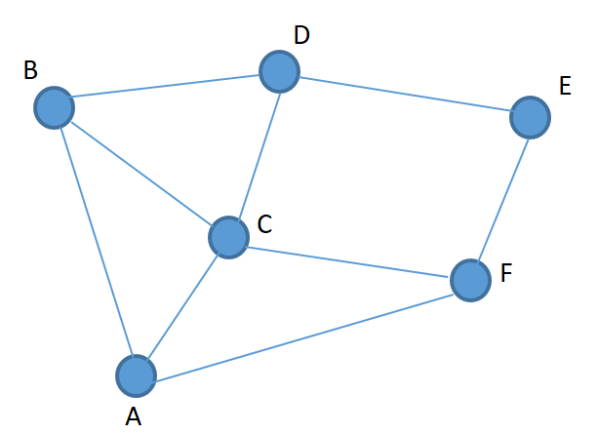Write a python code of a searching algorithm that finds all possible distinct paths from node A to node E in the following graph. Please note that you should not visit a single node multiple times in a single path.

**Hint:** Use a recursive implementation of depth first search