VIVEKANAND EDUCATION SOCIETY'S
INSTITUTE OF TECHNOLOGY
DEPARTMENT OF COMPUTER ENGINEERING

MICRO PROJECT REPORT
Aegis CrisisNav: Multimodal Geospatial GraphRAG for Crisis Response

Project / Course Detail | Value
Project title | Aegis CrisisNav: Multimodal Geospatial Crisis Response & Infrastructure GraphRAG
SDG alignment | SDG 3: Good Health and Well-Being; SDG 11: Sustainable Cities and Communities
Course / subject name | To be completed by student
Course code / semester / academic year | To be completed by student
Faculty in-charge / project mentor | To be completed by student
Project group number | To be completed by student
Submission date | 05 November 2026

Project Team Details
Student name | Roll no. | Class / division | Institute email
To be completed | To be completed | Computer Engineering | To be completed

Academic Year: To be completed by student

Table of Contents
- 1. Abstract
- 2. Introduction
- 3. Problem Definition, Objectives and Scope
- 4. Background / Literature Review
- 5. Proposed Solution and System Design
- 6. Methodology and Implementation
- 7. Testing, Evaluation and Results
- 8. Sustainability and SDG Alignment
- 9. Feasibility, Limitations and Risk Considerations
- 10. Conclusion and Future Scope
- 11. References
- 12. Appendices
Page numbers should be updated in Word after editing student-specific fields.

1. Abstract
Aegis CrisisNav is a prototype crisis-response mission-control platform for emergency routing in the Chembur region of Mumbai. It combines a geospatial infrastructure graph, incident-report retrieval, reconnaissance imagery, vehicle-specific hazard constraints, explainable route selection, and a Streamlit dashboard. The system loads a NetworkX directed graph from JSON, retrieves relevant disaster reports using deterministic or optional Gemini embeddings, synchronizes flood and structural-damage conditions onto road edges, and computes hazard-penalized routes using Dijkstra’s algorithm. It also produces K-shortest contingency corridors, selects reachable facilities using capacity information, and exposes route provenance through hazard elimination logs, segment-level reasoning, counterfactual comparisons, evidence citations, and bottleneck detection. The project includes deterministic fallbacks so the core workflow operates without an API key. Verification of the repository pipeline passed all five test stages: graph loading, report retrieval, agent routing, explainability, and benchmark evaluation. The observed benchmark summary was mean NDCG@3 = 0.763, MRR = 1.000, mean Precision@3 = 0.556, mean Faithfulness = 0.850, and mean LLM-judge score = 8.95/10. The prototype supports SDG 3 and SDG 11 indirectly by improving emergency coordination and resilient urban routing, while remaining limited by simulated data and the absence of live sensor, traffic, and hospital integrations.

2. Introduction

2.1 Background and Motivation
Disaster response requires decisions that combine geography, infrastructure condition, vehicle capability, medical capacity, and rapidly changing hazard information. A shortest-distance route can be unsafe when a road is flooded or a bridge is structurally damaged. Graph-based routing provides a natural representation of roads and facilities, while retrieval-augmented reasoning can connect dispatch reports and images to the affected graph entities.

2.2 Problem Context
Conventional navigation systems generally optimize travel time and do not expose the evidence behind emergency route changes. Dispatchers need a single interface that identifies safe corridors, explains rejected roads, compares alternatives, and accounts for hospital or shelter capacity. This project addresses that gap through a local, explainable GraphRAG prototype.

2.3 Intended Users / Stakeholders
- Emergency dispatchers and incident commanders
- Ambulance, rescue-truck, and supply-convoy operators
- Hospitals, shelters, and logistics coordinators
- Students and researchers studying GraphRAG, geospatial AI, and explainable routing

3. Problem Definition, Objectives and Scope

3.1 Problem Statement
Design and implement a prototype that recommends safe, hazard-aware emergency routes and facilities from natural-language crisis directives, while showing the graph, evidence, constraints, alternatives, and reasoning behind each recommendation.

3.2 Objectives
- Develop a directed geospatial infrastructure graph for roads, bridges, hospitals, shelters, and depots.
- Retrieve relevant incident reports and reconnaissance images for a crisis query.
- Update graph edge conditions using flood depth, structural damage, and status telemetry.
- Calculate vehicle-aware routes using explicit hazard-penalized edge weights.
- Generate alternate corridors and explain why they are less suitable.
- Evaluate retrieval and response quality with IR, faithfulness, relevance, and judge metrics.

3.3 Scope and Deliverables
Included: local JSON graph and incident data, deterministic multimodal retrieval, optional Gemini integration, Streamlit dashboard, Folium map, Pyvis graph, explainability module, benchmark suite, and Neo4j Cypher export. Excluded: live emergency deployment, real-time traffic feeds, authenticated hospital APIs, production sensor ingestion, and safety certification.

3.4 Assumptions and Constraints
The Chembur network and incident reports are simulation data. The prototype assumes valid node names and structured incident fields. Gemini is optional. No private personal data or credentials are included. Results should not be used as an operational emergency system without validated live data, fail-safe procedures, and human supervision.

4. Background / Literature Review
Source / technology | Approach or key finding | Strength / limitation | Relevance
NetworkX documentation | Graph representation and shortest-path algorithms | Transparent and easy to prototype; in-memory only | Provides Dijkstra and K-shortest path operations
Folium / Leaflet documentation | Interactive web maps using geographic coordinates and tile layers | Fast visualization; depends on map tiles | Displays routes, facilities, hazards, and markers
Pyvis / vis-network | Interactive force-directed graph visualization | Good topology exploration; layout is visual rather than analytic | Shows infrastructure graph and highlighted corridor
Google Gemini API documentation | Embedding and generative language services | Optional external dependency and API-key requirement | Adds semantic retrieval and readable synthesis
GraphRAG concept | Retrieval plus graph context for grounded generation | Improves context linkage; quality depends on data grounding | Connects reports/images to affected graph entities

4.1 Identified Gap and Project Contribution
The project contribution is an integrated educational prototype that combines explicit graph routing, multimodal incident retrieval, vehicle thresholds, facility capacity, and human-readable provenance in one dashboard. Its main value is practical integration and inspectability rather than a new routing algorithm.

5. Proposed Solution and System Design

5.1 Proposed Solution
A user enters a crisis directive or selects a preset. The agent decomposes the request, resolves landmarks, retrieves incidents and images, updates affected edges, computes a primary and alternate route, selects a facility when needed, and synthesizes a dispatch order. The UI presents the map, telemetry, route segments, evidence, reasoning trace, graph topology, and evaluation results.

5.2 System Architecture / Conceptual Design
Figure 1 presents the implemented processing flow. The route decision is deterministic: the optional LLM formats or summarizes verified facts; it is not the primary path optimizer.
Stage | Input | Processing | Output
User interface | Natural-language directive, vehicle, image | Streamlit form and scenario presets | Crisis query state
Query decomposition | Query text | Regex, aliases, fuzzy matching | Origin, destination, facility intent
Evidence retrieval | Query and local indexes | Cosine similarity over text/image vectors | Reports, images, affected IDs
Graph synchronization | Incident fields | Update edge status, flood, damage, traversability | Current hazard graph
Routing | Graph and vehicle profile | Dijkstra and K-shortest paths | Primary and contingency routes
Explainability | Routes, incidents, graph | Provenance, eliminations, comparisons, bottlenecks | Reasoning dossier
Synthesis | Verified route facts | Optional Gemini or deterministic template | Dispatch order
Figure 1: Implemented GraphRAG crisis-response workflow

5.3 Module Description
Module / component | Responsibility | Input | Output
app.py | Streamlit mission-control interface | Agent state, graph, reports, images | Dashboard views and controls
graph_store.py | Graph loading, dynamic updates, route calculation | Network JSON, hazard fields | Routes, alternatives, Cypher, Pyvis HTML
multimodal_retriever.py | Text/image indexing and retrieval | Reports, images, query | Ranked evidence and graph context
agent_workflow.py | End-to-end orchestration | Directive, vehicle, optional image | Agent state and dispatch order
explainability.py | Decision provenance and counterfactuals | Routes and incidents | Reasoning steps and citations
evaluation.py | IR and response evaluation | Benchmark queries and agent | Metrics and scorecards

5.4 Data / Inputs / Dataset
Inputs are local JSON and PNG assets. sample_osm_network.json contains 16 nodes and a directed representation of 44 edges. disaster_reports.json contains six timestamped incident or clearance reports with affected nodes/edges, severity, flood depth, damage severity, source, action, and image references. damage_images contains synthetic tactical imagery and downloaded/static reconnaissance assets. The data is intended for demonstration and does not represent a live or authoritative emergency feed.

5.5 Algorithm / Design Decisions
For an edge (u,v), the effective cost is base travel time multiplied by a transparent penalty factor: 1 + 8×damage + 4×hazard risk + flood penalty, where flood penalty = (flood depth in cm / 10)×1.5 when water is present. Edges exceeding vehicle water tolerance, with damage >= 0.85, or marked non-traversable receive infinite cost. NetworkX Dijkstra minimizes total cost. NetworkX shortest_simple_paths provides up to three valid alternatives.

6. Methodology and Implementation

6.1 Workflow / Development Method
- Inspect the crisis-response problem and define node, edge, incident, and facility fields.
- Implement graph loading and hazard-aware route calculations.
- Implement text/image retrieval with deterministic fallback embeddings.
- Implement agent orchestration and natural-language landmark resolution.
- Implement explainability views, map/graph UI, and benchmark evaluation.
- Run repository tests and capture browser-based demonstration evidence.

6.2 Technologies, Tools and Resources
Category | Technology / tool | Purpose / justification
Language / framework | Python 3.10+; Streamlit | Application logic and interactive dashboard
Graph processing | NetworkX >= 3.0 | Directed graph, Dijkstra, K-shortest paths
Maps | Folium, Streamlit-Folium, OpenStreetMap | Interactive geospatial route visualization
Graph visualization | Pyvis | Force-directed knowledge graph display
AI services | Google Gemini API; google-generativeai | Optional embeddings and language synthesis
Numerical / data | NumPy, Pandas, scikit-learn | Vectors, similarity, tables, evaluation support
Images | Pillow | Image loading, feature extraction, synthetic image generation
Configuration | python-dotenv | Optional environment configuration
Export | Neo4j Cypher generator | Portable graph-database export; Neo4j is not runtime storage
Testing | Python test_pipeline.py; browser demonstration | Functional and UI verification

6.3 Implementation Details
CrisisSpatialGraph loads nodes and edges from JSON and adds reverse edges for two-way streets. MultimodalRetriever indexes incident text and image metadata in Python lists, not Qdrant or another vector database. Text uses Gemini embeddings when configured and a deterministic MD5 token projection otherwise. Images use RGB moments, edge energy, quadrant features, and filename semantics. CrisisResponseAgent executes decomposition, hazard assessment, spatial traversal, and dispatch synthesis. ReasoningChainVisualizer builds the route trace and evidence dossier. Evaluation computes NDCG, MRR, Precision, Recall, faithfulness, answer relevance, and a rubric-based composite score.

6.4 User Interface / Prototype / Output

Figure 2: Tactical Mission & Map view captured from the running Streamlit application.
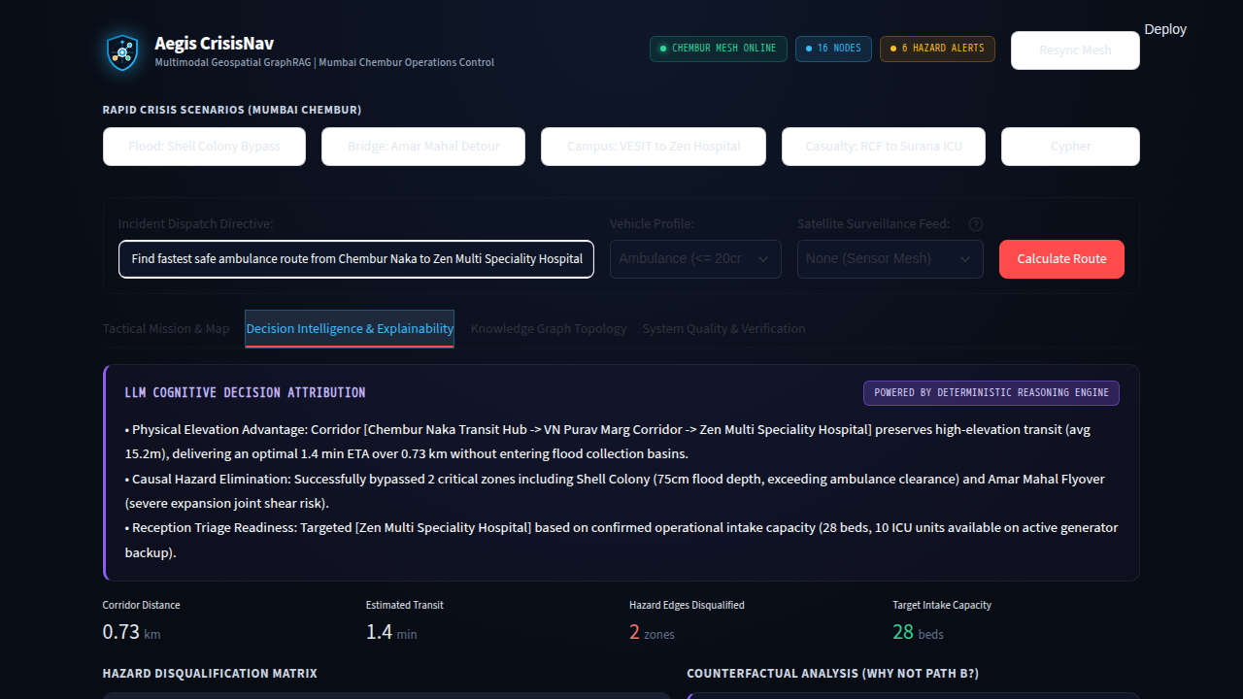
Figure 3: Decision Intelligence & Explainability view captured from the running application.
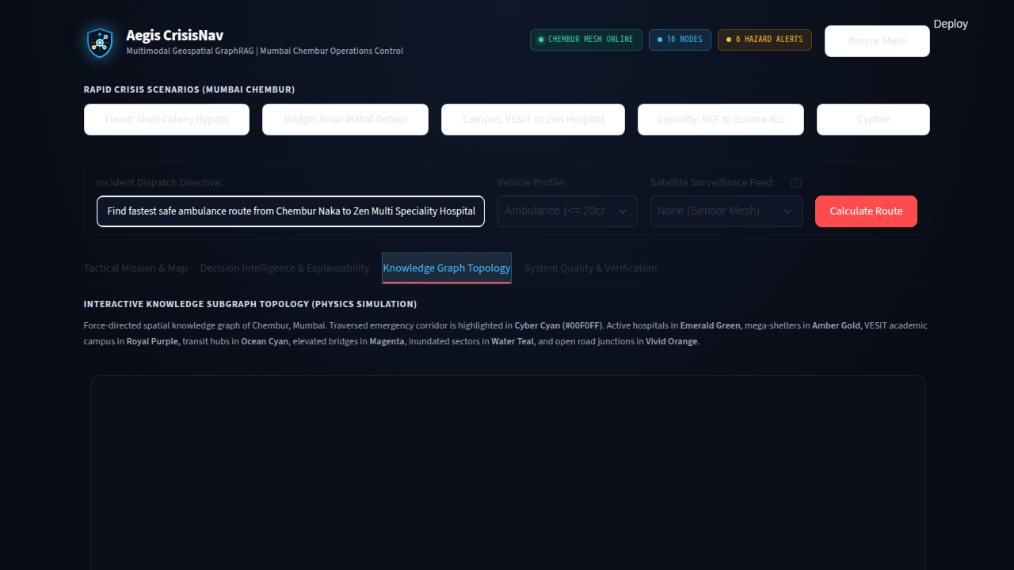
Figure 4: Knowledge Graph Topology view captured from the running application.
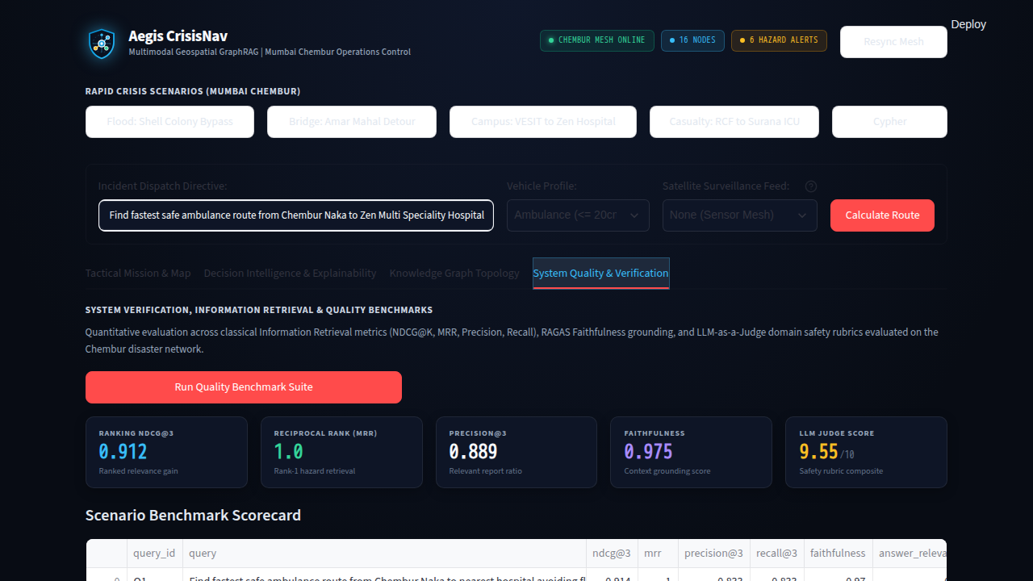
Figure 5: System Quality & Verification view captured from the running application.

6.5 Team Contribution
Team member | Assigned responsibility | Work completed / evidence
To be completed by student | To be completed | Repository implementation and demonstration evidence should be assigned by the team.

7. Testing, Evaluation and Results

7.1 Test Plan and Test Cases
Test ID | Test input / scenario | Expected result | Observed result | Status
TC-01 | Load sample network | Nodes and edges load | 16 nodes and 44 edges loaded | PASS
TC-02 | Retrieve Shell Colony flood report | Relevant incident returned | Report retrieval completed; top result returned | PASS
TC-03 | Ambulance route Chembur Naka to nearest hospital | Safe route avoids 75 cm flood | 3-node route, 0.73 km, 1.4 min | PASS
TC-04 | Explain selected route | Reasoning steps and eliminations generated | 3 reasoning steps and 1 eliminated hazard edge | PASS
TC-05 | Run benchmark suite | Metrics and judge score produced | All benchmark cases completed | PASS

7.2 Evaluation Metrics
Metric | Measurement method / formula | Observed value | Interpretation
Mean NDCG@3 | Ranked relevance against graded ground truth | 0.763 | Relevant reports generally appear near the top
MRR | 1 / rank of first relevant result, averaged | 1.000 | A relevant report was first for the benchmark queries
Mean Precision@3 | Relevant retrieved items / 3 | 0.556 | Moderate top-three retrieval precision
Mean Recall@3 | Relevant retrieved items / all relevant items | Not displayed in test summary | Implemented by benchmark suite; inspect detailed results for per-case values
Mean Faithfulness | Grounding checks against reports and route nodes | 0.850 | Generated responses remain structurally grounded
Mean answer relevance | Lexical operational overlap with query | Implemented | Measures response-query alignment
LLM-judge composite | Weighted safety, feasibility, triage, grounding rubric | 8.95 / 10 | Strong simulated response quality under deterministic fallback

7.3 Results and Discussion
The repository verification script completed successfully. The route for the default ambulance scenario was N_CHEMBUR_NAKA → N_INT_VN_PURAV → N_HOSP_ZEN, covering 0.73 km with an estimated 1.4-minute effective travel time. The explanation identified one impassable hazard zone and produced route-level reasoning. Retrieval and benchmark metrics demonstrate that the prototype pipeline is functioning on its sample dataset; they should not be interpreted as field accuracy because the dataset is small and simulated.

7.4 Validation / Demonstration Evidence
Validation evidence consists of the successful test_pipeline.py execution and Figures 2–5, which were captured from the local Streamlit application at http://127.0.0.1:8501 during report preparation. The screenshots are browser captures of the implemented dashboard, not generated illustrations. The repository is AadiSingh0805/KGIRS-MicroProject.

8. Sustainability and SDG Alignment

8.1 Sustainability Assessment
Dimension | Project-specific assessment / evidence
Environmental | The prototype is software-only and reduces paper-based dispatch artifacts. Local deterministic processing can avoid unnecessary API calls, but browser rendering, image processing, and optional LLM calls still consume energy.
Social | The dashboard supports safer routing and facility visibility. Human dispatch oversight is required because simulated or stale data could create unsafe recommendations. Accessibility and multilingual support are future needs.
Economic | It uses open-source libraries, local JSON, and optional APIs, making the prototype inexpensive. Production operation would require validated data feeds, hosting, support, and monitoring.

8.2 UN Sustainable Development Goals
SDG | Linked feature | Expected / observed contribution | Evidence / indicator
SDG 3: Good Health and Well-Being | Hospital routing, ICU/capacity display, casualty triage scenario | Supports faster and more informed emergency coordination | Route ETA, hospital capacity fields, casualty preset
SDG 11: Sustainable Cities and Communities | Hazard-aware urban routing and infrastructure bottleneck analysis | Supports resilient transport and emergency access planning | Flood/bridge avoidance, alternative corridors, graph topology

8.3 Sustainability Measures and Trade-offs
The system uses lightweight deterministic fallbacks and in-memory indexing for the prototype. This improves portability and avoids mandatory cloud usage, but it sacrifices the scale and indexing capabilities of a production vector database. A production version should cache embeddings, resize images, limit repeated model calls, and retain only necessary incident data.

8.4 Sustainability Indicator / Follow-up
Proposed future indicators include energy per benchmark run, average response latency, API calls per query, data freshness, route task-completion rate, and dispatcher usability score. These were not measured in this micro project.

9. Feasibility, Limitations and Risk Considerations

9.1 Feasibility
Technical feasibility is demonstrated by the runnable Python/Streamlit prototype and passing pipeline tests. Resource feasibility is high for academic use because the sample data is local and Gemini is optional. Operational feasibility is limited because live sensor, traffic, hospital, authentication, and audit integrations are absent. The academic prototype cost is approximately ₹0 for open-source software and local execution; optional Gemini or hosting would add usage-based costs.
Item / resource | Estimated cost (₹) | Basis / notes
Hardware / hosting / cloud | 0 for local demo | Uses existing computer; production hosting excluded
Software / API / dataset | 0 without Gemini | Open-source dependencies and local sample data; Gemini optional
Other resources | 0 | Academic prototype
Total estimated cost | 0 for prototype | Production cost not estimated

9.2 Limitations
- Simulated and small dataset; no live traffic, weather, sensor, or hospital feeds.
- Retrieval uses in-memory lists and custom vectors; Qdrant is not used.
- Neo4j is an export target, not the runtime database.
- LangGraph is described conceptually but is not a dependency in the implementation.
- Image matching is feature-based rather than a trained multimodal model.
- Benchmark metrics are limited to three predefined scenarios.
- The system should not be used for real emergency dispatch without validation and human authorization.

9.3 Risks, Ethics, Privacy and Security
Incorrect or stale hazard data could produce unsafe routes, so every deployment needs data validation, timestamps, human approval, and fail-safe behavior. LLM output must remain grounded in verified route facts and should not be treated as an autonomous command. The project contains no personal medical records or credentials. API keys must remain in environment variables and never be committed. Future versions should add access control, audit logs, model monitoring, bias testing, and explicit emergency-use disclaimers.

10. Conclusion and Future Scope

10.1 Summary
Aegis CrisisNav implements an integrated GraphRAG-style crisis-response prototype. It combines NetworkX hazard-aware routing, local incident retrieval, optional Gemini assistance, explainability, maps, graph visualization, facility capacity, and evaluation in a single Streamlit application. The repository tests passed, and the dashboard was demonstrated through browser screenshots. The project meets its prototype objectives while clearly remaining a simulated decision-support system rather than a production emergency platform.

10.2 Future Scope
- Connect validated live feeds for weather, traffic, road closures, sensors, and hospital capacity.
- Replace in-memory retrieval with Qdrant, FAISS, or another production vector index when scale requires it.
- Add Neo4j runtime support, temporal graph updates, and audit history.
- Use current Gemini SDKs or local models with structured output validation.
- Add role-based access, multilingual dispatch, accessibility improvements, and offline operation.
- Evaluate with larger datasets, human dispatcher studies, latency, energy, and reliability measurements.

11. References
- [1] AadiSingh0805, “KGIRS-MicroProject,” GitHub repository, 2026. https://github.com/AadiSingh0805/KGIRS-MicroProject
- [2] NetworkX Developers, “NetworkX Documentation,” 2026. https://networkx.org/documentation/stable/
- [3] Streamlit, “Streamlit Documentation,” 2026. https://docs.streamlit.io/
- [4] Folium, “Folium Documentation,” 2026. https://python-visualization.github.io/folium/
- [5] Pyvis, “Pyvis Documentation,” 2026. https://pyvis.readthedocs.io/
- [6] Google, “Gemini API Documentation,” 2026. https://ai.google.dev/gemini-api/docs
- [7] OpenStreetMap Foundation, “OpenStreetMap,” 2026. https://www.openstreetmap.org/
- [8] United Nations, “Sustainable Development Goals,” 2026. https://sdgs.un.org/goals

12. Appendices

Appendix A: Additional Screenshots / Outputs
Figures 2–5 contain browser-captured dashboard evidence. The test output recorded: 16 nodes, 44 edges; route 0.73 km and 1.4 min; mean NDCG@3 0.763; MRR 1.000; mean Precision@3 0.556; mean Faithfulness 0.850; judge score 8.95/10.

Appendix B: Selected Pseudocode
1. Parse query and resolve origin/destination.
2. Retrieve top-k incident reports and images.
3. For each affected edge, update status, flood depth, damage, and traversability.
4. Compute edge cost using base time and hazard penalties.
5. Run Dijkstra for the primary route and shortest_simple_paths for alternatives.
6. Generate provenance, eliminated-edge, counterfactual, and bottleneck explanations.
7. Synthesize a grounded dispatch order with Gemini or deterministic fallback.

Appendix C: Repository / Demonstration Information
Repository: https://github.com/AadiSingh0805/KGIRS-MicroProject. Demonstration command: streamlit run app.py. Verification command: python test_pipeline.py. No API keys, passwords, or private data are included in this report.

