NavCert Offline: Classical Image Processing for Robust On-Device Digitization of Maritime Certificates
Aadidev Raizada
Mukesh Patel School of Technology Management and Engineering
SVKM's NMIMS, Mumbai, India
aadidevraizada26@gmail.com

Abstract—Seafarers' certificates are checked in ports and on board, often without a network connection. NavCert Offline is an Android application that digitizes them entirely on the phone. A classical OpenCV front end finds the page with Canny edges, morphological closing and polygon approximation, rectifies it with a four-point homography, screens capture quality with brightness and Laplacian-variance tests, and enhances it with CLAHE, median filtering and unsharp masking or adaptive thresholding. On-device OCR and a rule, MiniLM and MobileBERT cascade then extract five certificate fields. We measure the image processing on 200 paired synthetic camera captures under eight degradations with known ground truth. Rectification lowers the mean character error rate (CER) from 9.6% to 4.2% and raises five-field exact match from 69.1% to 88.4%; the paired CER reduction is 5.4 points (95% CI 3.9–7.1). Contrast enhancement gives no average gain with the evaluation OCR engine, helps under low light and blur, and hurts under overexposure. Under cast shadows, adaptive thresholding keeps CER below 0.5% where global and Otsu thresholds reach 34–40%. Text survives 8×8 DCT coding at 0.29 bit/pixel with 0.35% CER, while three-step and 2-D logarithmic block matching find the true motion vector on only 30–33% of textured text blocks. An in-app Pipeline Lab shows every operation on the user's own scan.
Index Terms—document image processing, perspective rectification, CLAHE, adaptive thresholding, mobile OCR, block matching, maritime certificates
I. Introduction
Merchant shipping runs on certified people. The STCW Convention sets the certification every seafarer must prove, and its 2010 Manila amendments target fraudulent certificates of competency [1]. The 2026 BIMCO/ICS report estimates 2,565,580 STCW-certified seafarers serving 85,148 ships [2]; India supplies 311,936 of them, 12.16% of the total [3]. Each certificate is read again and again by employers, manning agents and port state control officers, and the checks matter: an IMO study around 2000 recorded 12,635 detected forgery cases, with 82% of survey respondents reporting forged certificates of competency [4], and Asia-Pacific port state control recorded 877 crew-certificate deficiencies in 2022 and 1,304 in 2024 [5]. Electronic certificates help, but IMO guidance assumes that the verifying party has an Internet connection [6], which a ship at sea or a remote berth cannot promise.
A hand-held phone photo is a poor input for OCR: the page is a projected trapezium on a cluttered table, unevenly lit, blurred, noisy and JPEG-compressed. This paper asks how much of that gap classical image and video processing can close on the device, and measures the answer. Its contributions are:
1) a fully offline Android pipeline that detects, rectifies, checks and enhances a certificate photo, reads it and extracts five fields (certificate name, issue date, port of issue, issuing authority, expiry date);
2) a paired, seeded benchmark of 200 synthetic captures that isolates what rectification, enhancement and binarization contribute, with studies of quality checks, shadow thresholding, DCT coding and block matching;
3) Pipeline Lab, an in-app tool that runs eleven syllabus-level operations, from point processing to block matching, on the user's own scan.
II. Related Work
Capture and rectification. OCRdroid guided phone capture but recognized text on a server [7]; the ICDAR 2015 SmartDoc competition benchmarked page detection and OCR on smartphone photos [8]. Classical rectification fits a homography to four page corners [9], found with Canny edges [10], border following [11] and Douglas–Peucker simplification [12]. Learned dewarpers such as DocUNet [13] and DocTr [14] also flatten curled pages but need training data and far more compute.
Enhancement and binarization. Histogram equalization is the standard global contrast tool [15]; CLAHE equalizes tiles and clips their histograms to limit noise gain [16]. Otsu's method picks one global threshold [17]; Sauvola's method [18] adapts it locally for unevenly lit documents. Laplacian variance is a common focus measure [19].
Mobile OCR and document models. Modern line recognizers decode with CTC [20]. The PP-OCR family targets small devices [21], down to a 5M-parameter PP-OCRv5 [22] and PP-OCRv6 tiers of 1.5M–34.5M parameters [23], with a detector based on differentiable binarization [24]. ML Kit bundles an offline Latin recognizer [25]. Layout-aware models [26], [27] and OCR-free models such as Donut [28] are stronger on forms but larger. For extraction, BERT-style question answering [29] has compact variants in MobileBERT [30] and MiniLM [31]; integer quantization [32] and ONNX Runtime Mobile [33] make them practical on phones. Unlike prior capture systems, this work keeps every stage on the device and reports a paired measurement of each classical stage.
III. System Overview
Fig. 1 shows the implemented system. The user photographs a certificate through the system camera or imports one from the gallery; a crop editor allows manual correction. DocumentScanner prepares the image (Section IV), and ML Kit Text Recognition v2 returns blocks, lines and boxes. In printed and automatic modes the text is laid out, corrected and passed to the field extractor; in handwriting mode PP-OCRv5 re-reads each line (Section VI). Documents, JPEG previews (quality 88), folders and notes stay in app-private files, and the manifest removes the INTERNET and ACCESS_NETWORK_STATE permissions that the ML Kit dependency would add. The app is written in Kotlin with Jetpack Compose, targets API 36 (minimum 24) and uses OpenCV 4.13.0 [34], ML Kit text recognition 16.0.1, ONNX Runtime Android 1.24.1 and TensorFlow Lite Task Text 0.4.4. Fig. 2 previews the image processing stages detailed in Section IV.

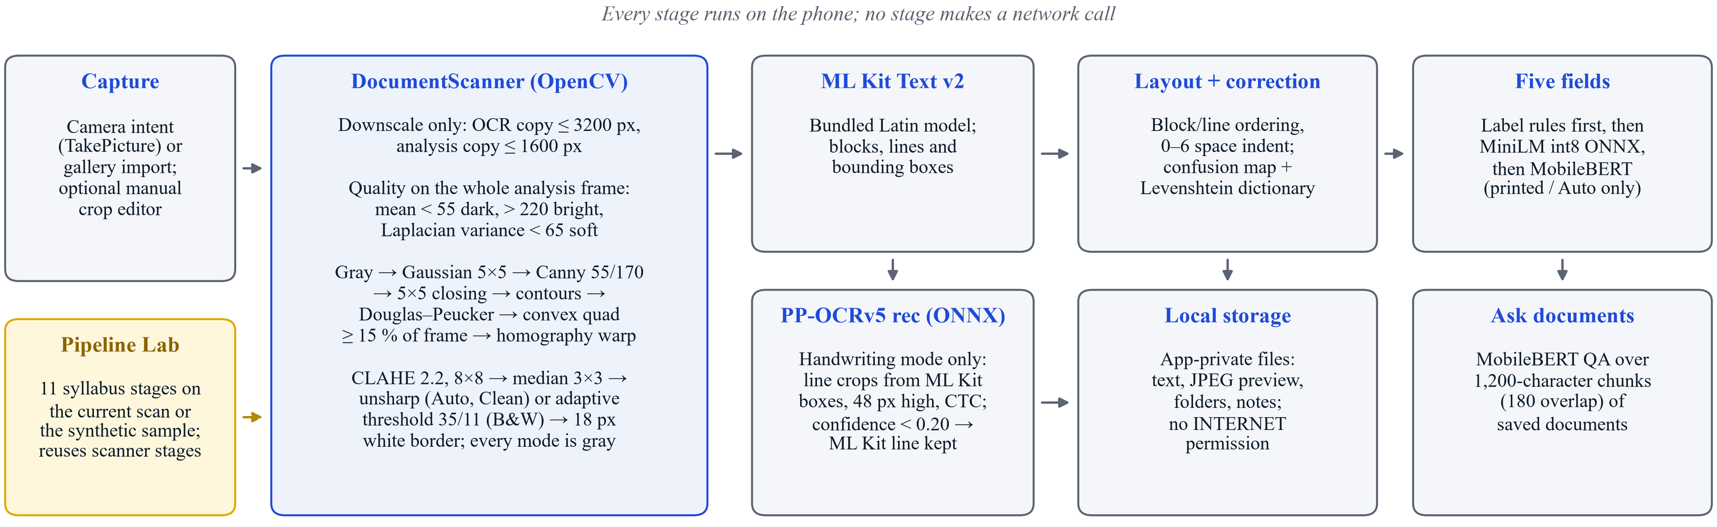
Fig. 1. Implemented architecture. The OpenCV stage serves both recognition paths; correction and field extraction run only in printed and automatic modes; Pipeline Lab reuses the scanner's stage functions.
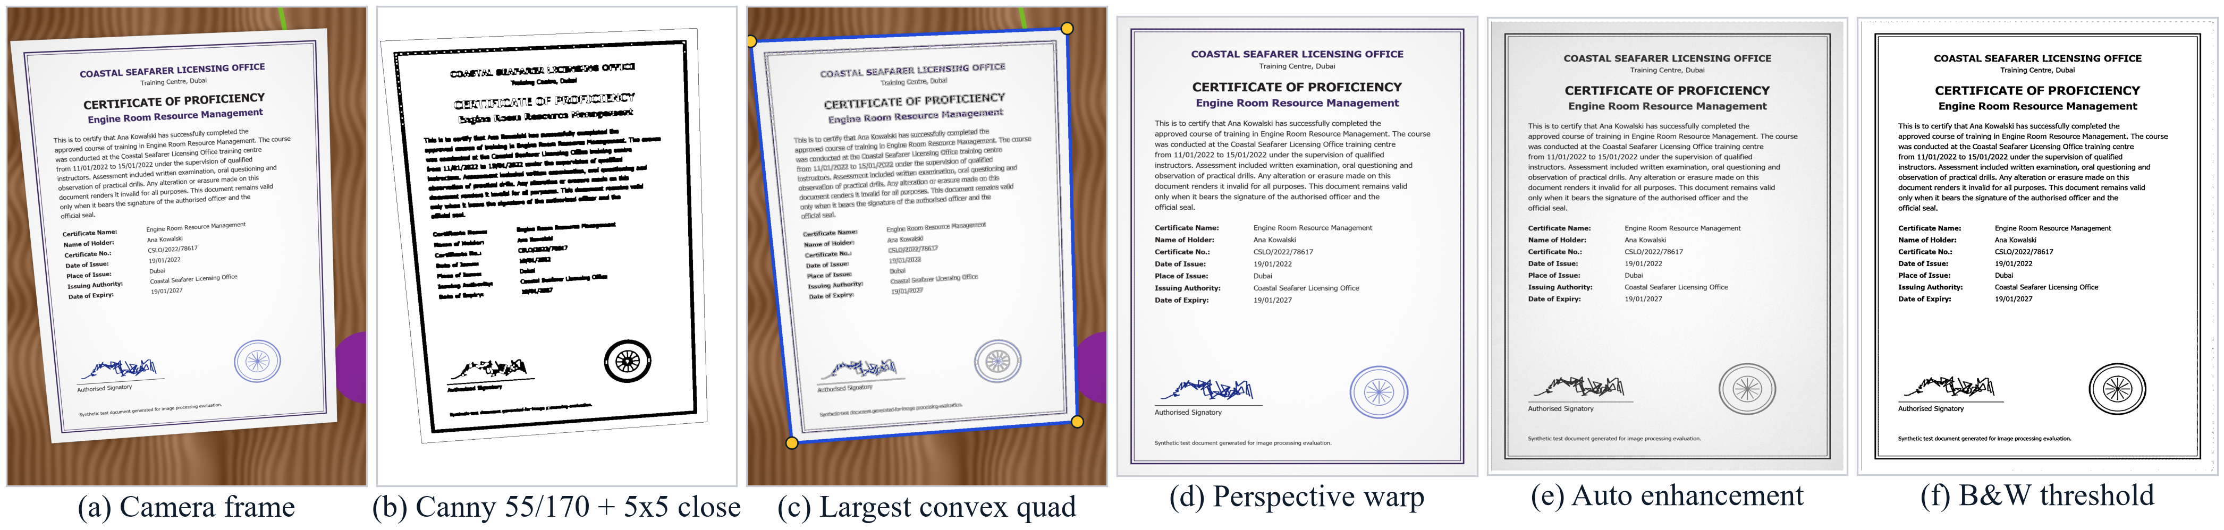
Fig. 2. Stages on a synthetic tilted capture: (a) camera frame; (b) closed Canny edges; (c) contours (gray) and the selected convex quadrilateral; (d) rectification; (e) Auto enhancement; (f) B&W adaptive threshold. The double border inside the page is a deliberate distractor quadrilateral.

IV. Image Processing Pipeline
Table I lists every stage with the constants in DocumentScanner.kt.
A. Resolution and Page Detection
The app only downsamples: one copy for OCR is capped at 3200 px on its longer side and one for analysis at 1600 px; smaller photos keep their size. All stages work on luminance [15],
$Y=0.299R+0.587G+0.114B.$ (1)
TABLE I
Image processing stages and constants
Stage | Operation | Constants
Resize | Bilinear, downscale only | OCR ≤ 3200, analysis ≤ 1600 px
Quality | Mean gray; var(∇²f) | < 55 dark; > 220 bright; < 65 soft
Smooth | Gaussian blur | 5×5, σ ≈ 1.1
Edges | Canny | T_{L} = 55, T_{H} = 170
Close | Morphological closing | 5×5 rectangle
Polygon | Douglas–Peucker | 20 largest; ε = 2% of perimeter
Page | Largest convex 4-gon | ≥ 15% of frame
Warp | Homography, bicubic | Replicated border
Contrast | CLAHE | Clip 2.2; 8×8 tiles
Denoise | Median | 3×3
Sharpen | Unsharp mask | σ/a 1.05/1.32 Auto; 1.35/1.50 Clean
Binarize | Adaptive (B&W mode) | Block 35, C = 11
Pad | Constant border | 18 px white

The analysis image is smoothed with a 5×5 Gaussian kernel,
$G_{σ}\left(x,y\right)=\frac{1}{2πσ^{2}}e^{−\frac{x^{2}+y^{2}}{2σ^{2}}},$ (2)
with σ = 0.3((k − 1)/2 − 1) + 0.8 ≈ 1.1 for k = 5. Canny's detector [10] computes the Sobel gradient
$M=\sqrt{{G_{x}}^{2}+{G_{y}}^{2}}, θ=atan2\left(G_{y},G_{x}\right),$ (3)
keeps only local maxima of M along θ, and links edges by hysteresis: a pixel with M > T_{H} = 170 starts an edge that may continue through pixels with M > T_{L} = 55, so strong page borders seed edges and the low threshold carries them through shadow. A 5×5 closing [35],
$A•B=\left(A⊕B\right)⊖B,$ (4)
bridges breaks in the edge map without growing the outline. Contours are traced [11], the 20 largest are simplified by Douglas–Peucker [12] at 2% of their perimeter, and the largest convex quadrilateral covering at least 15% of the frame is the page. Its corners are ordered by the extremes of x + y and y − x and scaled to the OCR copy; if no candidate qualifies, the whole frame is used.
B. Perspective Rectification
A plane and its image are related by a homography with eight degrees of freedom [9]:
$u=\frac{h_{11}x+h_{12}y+h_{13}}{h_{31}x+h_{32}y+1}, v=\frac{h_{21}x+h_{22}y+h_{23}}{h_{31}x+h_{32}y+1}.$ (5)
Each corner gives two linear equations, so four corners with no three collinear fix H (the direct linear transform). The target is as wide as the longer of the top and bottom edges and as tall as the longer side edge, so the aspect ratio is approximate; resampling is bicubic with replicated borders.
C. Capture Quality Checks
Two features are computed on the whole 1600 px analysis frame before rectification, so the background counts toward both: the mean gray level and the Laplacian variance [19]
$S=\frac{1}{N}\sum_{x,y}{{\left(∇²f\left(x,y\right)−μ\right)}^{2}},$ (6)
with the 4-neighbor Laplacian ∇²f and its mean μ. The checks run in order and the first failure is shown: mean < 55 "Too dark", mean > 220 "Too bright", S < 65 "Soft image". The thresholds are hand-set heuristics.
D. Enhancement
Every mode first converts the page to gray. CLAHE [16] equalizes each of 8×8 tiles through its cumulative histogram,
$T_{k}\left(r\right)=\left(L−1\right)\sum_{j=0}^{r}{p_{k}\left(j\right)},$ (7)
after clipping the tile histogram at 2.2 times its mean bin height and redistributing the excess, which caps the slope of T_{k} and so the noise gain. Each pixel blends the four nearest tile mappings,
$g\left(r\right)=\sum_{i,j}{w_{ij}T_{ij}\left(r\right)},$ (8)
with i, j ∈ {0, 1}, bilinear weights w₀₀ = (1 − a)(1 − b), w₁₀ = a(1 − b), w₀₁ = (1 − a)b, w₁₁ = ab from the pixel's offsets a, b ∈ [0, 1] between tile centers, so no seams appear. Fig. 3 shows the effect under a shadow: global equalization darkens the shadow further, while CLAHE keeps both halves legible. A 3×3 median, g = median{f(s,t) : (s,t) ∈ S_{xy}}, then removes speckle without blurring strokes. Auto and Clean modes sharpen by unsharp masking,
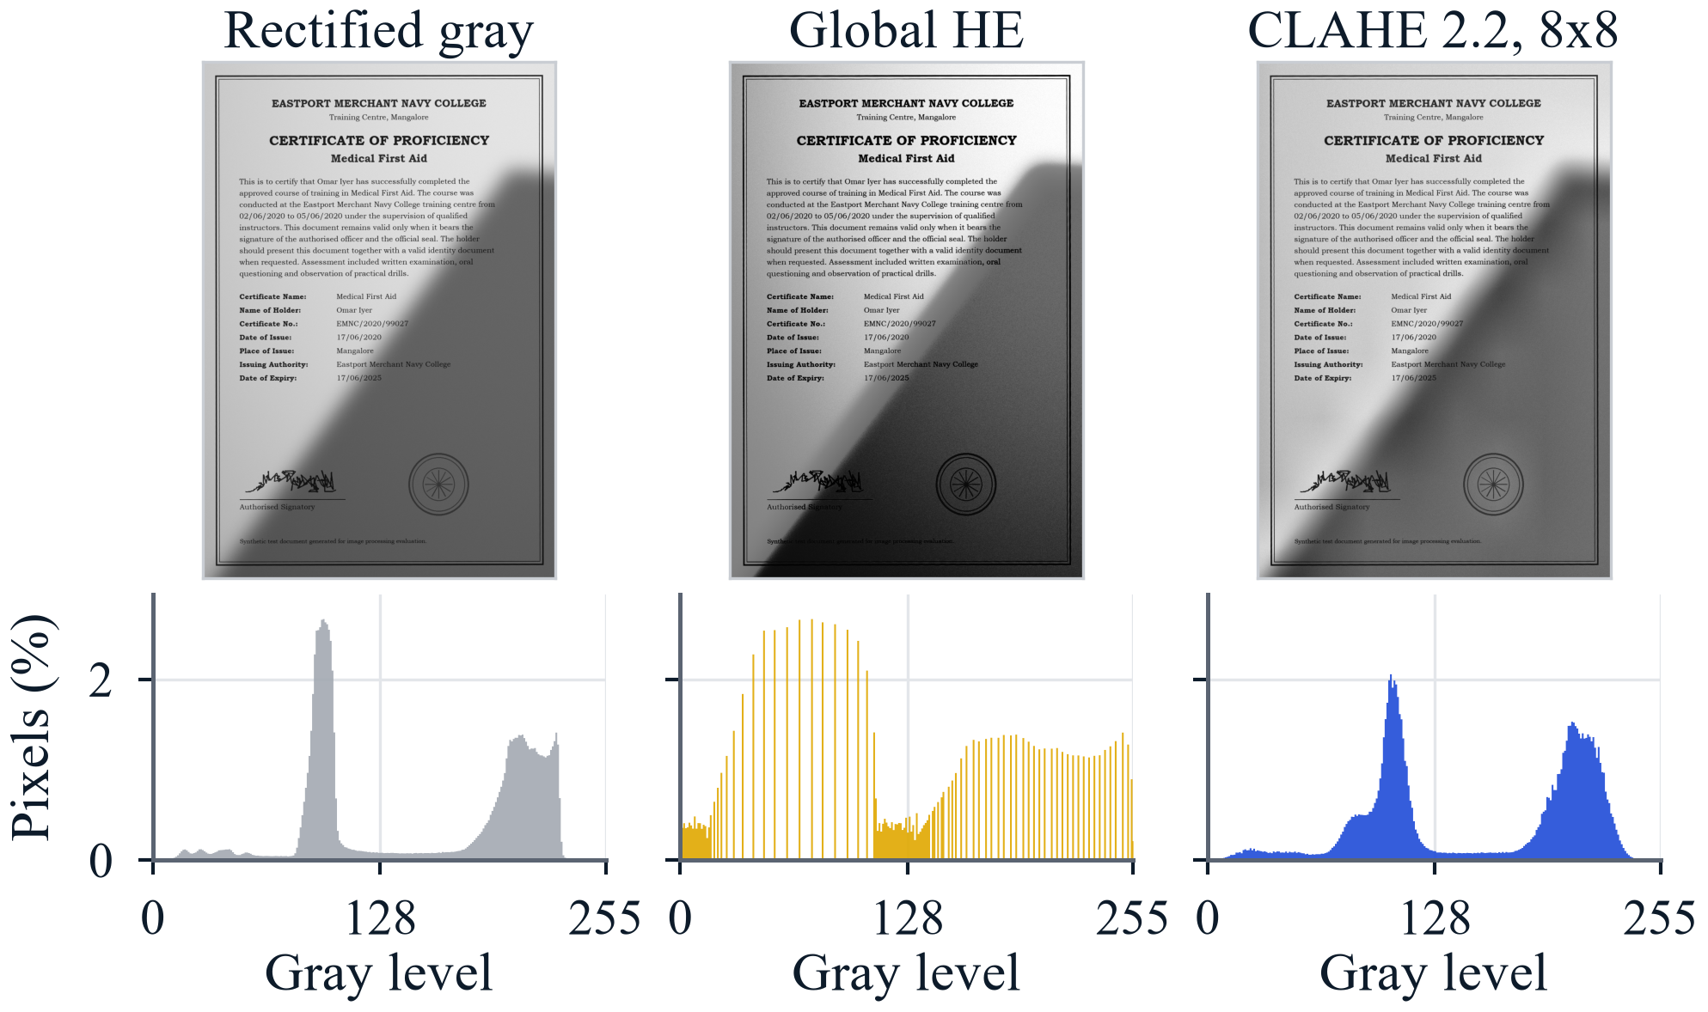
Fig. 3. A shadowed page: rectified gray, global histogram equalization and CLAHE (clip 2.2, 8×8 tiles), with gray-level histograms.
$g=af+\left(1−a\right)f_{σ}=f+k\left(f−f_{σ}\right),$ (9)
with f_{σ} a Gaussian blur and k = a − 1: σ = 1.05, k = 0.32 (Auto) or σ = 1.35, k = 0.50 (Clean). B&W mode instead binarizes against a local threshold,
$T\left(x,y\right)=\sum_{s,t}{w\left(s,t\right)f\left(x+s,y+t\right)}−C,$ (10)
with w a normalized 35×35 Gaussian window and C = 11; a pixel becomes white if f > T. For comparison, Otsu's method [17] picks the global t that maximizes
${σ_{B}}^{2}\left(t\right)=ω_{0}\left(t\right)ω_{1}\left(t\right){\left[μ_{0}\left(t\right)−μ_{1}\left(t\right)\right]}^{2},$ (11)
with class probabilities ω₀, ω₁ and means μ₀, μ₁. Every mode ends with an 18 px white border, so OCR always receives a gray or binary page with a margin.
E. Transform Coding and Motion
Stored previews are JPEG files, that is, 8×8 block DCT coding [36] with
$F\left(u,v\right)=\frac{C\left(u\right)C\left(v\right)}{4}\sum_{x=0}^{7}{\sum_{y=0}^{7}{f\left(x,y\right)c_{xu}c_{yv}}},$ (12)
where c_{xu} = cos[(2x + 1)uπ/16], C(0) = 1/√2 and C(u) = 1 otherwise [37]; quantization rounds F/Q for a quality-scaled table Q, and PSNR = 10 log₁₀(255²/MSE). Block matching estimates a block's displacement d = (u, v), |u|, |v| ≤ p, between a current frame c and a reference r by minimizing [38], [39]
$D\left(d\right)=\frac{1}{N^{2}}\sum_{p∈B}{\left|c\left(p\right)−r\left(p+d\right)\right|},$ (13)
over the pixels p of the N×N block B. Exhaustive search (ES) tests all (2p + 1)² = 225 offsets for p = 7; three-step search (TSS) [39] tests 9 points at step 4 and 8 more at steps 2 and 1, 25 in all; 2-D logarithmic search [38] moves a five-point cross and halves the step when the center wins. Both fast searches assume the cost falls monotonically toward the minimum. The app captures single stills, so motion estimation appears only in Pipeline Lab and the benchmark.
V. Pipeline Lab
Pipeline Lab runs eleven stages on the current scan or a bundled synthetic certificate and shows the intermediate images, histograms and measurements (Fig. 4): (1) spatial and gray-level resolution and PNG/JPEG sizes; (2) negative, contrast stretch, log, gamma and intensity slicing; (3) histograms, global equalization and CLAHE; (4) mean, Gaussian and median filtering of salt-and-pepper noise with PSNR, sharpening, the DFT spectrum and a Gaussian low-pass; (5) 8×8 DCT coding with a quality slider; (6) Sobel, Prewitt, Laplacian, LoG and Canny edges; (7) dilation, erosion, opening, closing and boundary extraction; (8) fixed, Otsu and adaptive thresholds with 4- and 8-connected components; (9) RGB, HSV and YUV channels with hue slicing of ink and stamp; (10) page geometry with Euclidean, city-block and chessboard distances; and (11) block matching.
Point operations, histograms, Otsu, labelling, binary morphology, the DCT and the three searches are unit-tested Kotlin written from first principles; the other stages call OpenCV and the production DocumentScanner functions, so the Lab shows exactly what the scanner does. In stage 11, frame t is synthesized from frame t − 1 by a 4 px / −3 px shift, a 0.4° rotation and noise; ES, TSS and 2-D log search run on 16×16 blocks with p = 7, blank blocks are ignored, and a dominant vector longer than 1.5 px is reported as camera motion. This steady-capture decision is a Lab demonstration, not part of the capture screen.
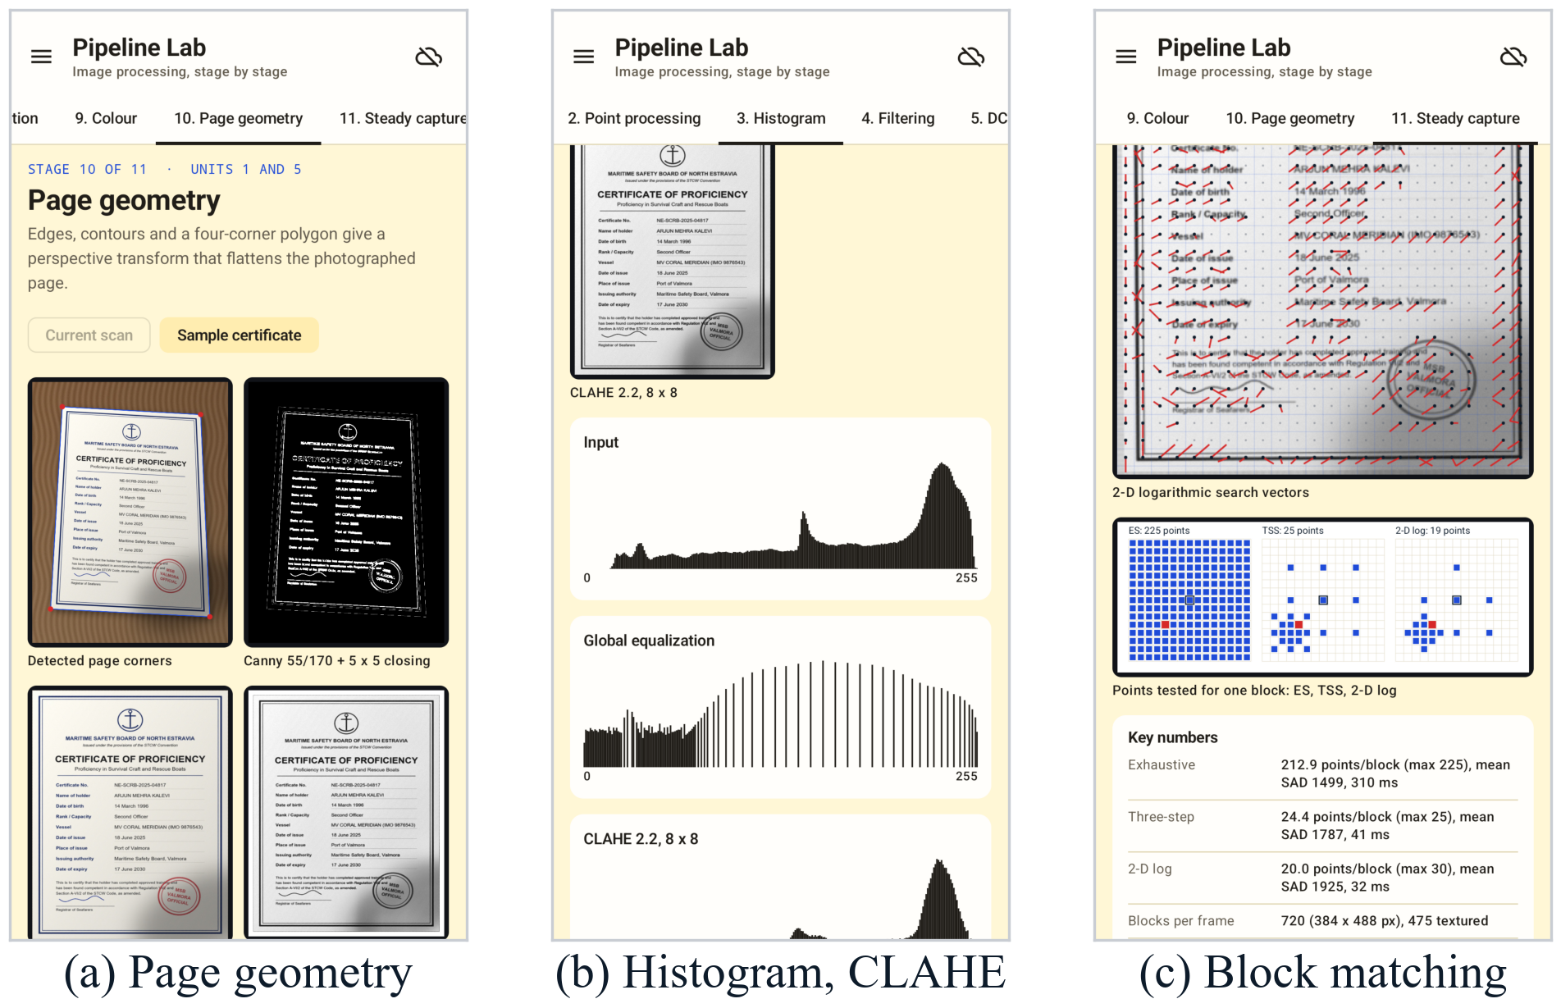
Fig. 4. Pipeline Lab on the synthetic sample: (a) corners, closed Canny edges, warp and enhancement; (b) input, equalized and CLAHE histograms; (c) points tested by ES, TSS and 2-D log search for one block, with the cost of each method.
VI. Recognition, Layout and Field Extraction
ML Kit Text Recognition v2 reads printed text with its bundled Latin model [25]. A formatter orders blocks and lines top to bottom and left to right and indents lines by zero to six spaces. In handwriting mode, each ML Kit line box is cropped from the enhanced page with margins of 4% (horizontal) and 22% (vertical), resized to a height of 48 px with a width that is a multiple of 8 (16–2048 px), scaled to [−1, 1] and read by the 7.96 MB PP-OCRv5 English recognizer [22] in ONNX Runtime [33] with greedy CTC decoding [20]; below a confidence of 0.20 the ML Kit line is kept. This path returns text only: correction and field extraction are skipped.
In printed and automatic modes, a conservative corrector maps digit–letter confusions and replaces a word only when a dictionary word is within Levenshtein distance 1 (2 for seven or more letters) [40] and clearly closer than the runner-up; short, all-capital and digit-bearing words are protected. Field extraction is a cascade. Label rules ("Issued at place on date", labelled dates, port lines, header organizations) run first. Missing fields go to a MiniLM question-answering model fine-tuned on certificate text and exported to int8 ONNX (32.3 MiB, 384-token windows, stride 96); if it cannot run, the 100.46 MB MobileBERT model [30] answers. A model is queried only when matching evidence (for example expiry wording) is present, answers must be 2–160 characters, and dates must match a date pattern. MobileBERT also answers free questions over saved documents using 1,200-character chunks with 180-character overlap.
Fig. 5 shows the main screens on an Android emulator (Pixel profile) with a synthetic certificate. The preview reports the quality verdict and whether page borders were found, and offers the Auto, Clean and B&W enhancement modes. An earlier build was also installed and run on an OPPO CPH2665 phone with Android 15.
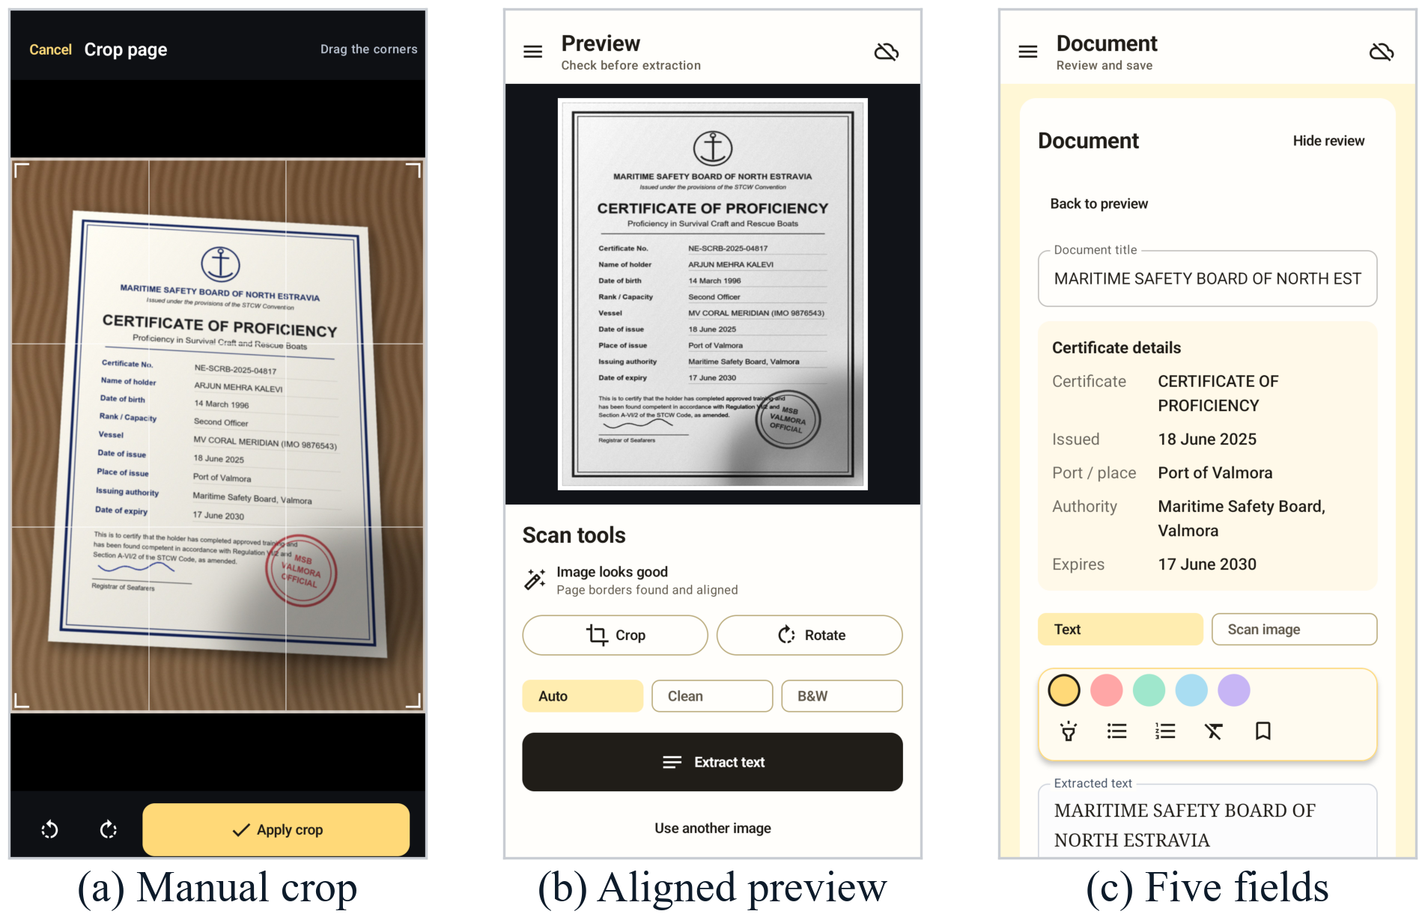
Fig. 5. App screens with a synthetic certificate: (a) manual crop of a tilted photo; (b) aligned preview with quality verdict and enhancement modes; (c) extracted certificate details.
The adaptation corpus had 108 PDFs and 351 pages (295 unique), split by document into 206/56/33 pages. A 4.37M-parameter tiny BERT reached only 23.5% test exact match, so MiniLM, starting from a SQuAD 2.0 checkpoint [31], [41], was fine-tuned on 169 weak rows from an expanded set of archives (Table II). Its scores are text-only pilot results on a six-document, 26-field gold set checked by hand; they exclude capture and OCR errors.
TABLE II
Certificate-field QA models (text input, exact match)
Model | Weak val. | Gold (26) | Size
Tiny BERT (4.37M) | 35.3%¹ | 4 (15.4%) | 17.5 MB
MiniLM, fp32 | 35/49 (71.4%) | 15 (57.7%) | 126.9 MiB
MiniLM, int8 (app) | 33/49 (67.3%) | 15 (57.7%) | 32.3 MiB
¹Own validation split. Gold by field (MiniLM fp32): name 2/6, issue date 3/6, port 4/4, authority 2/4, expiry 4/6. The int8 model changed three individual gold predictions.
VII. Experimental Setup
Real certificates are private, so the benchmark renders synthetic ones whose text, fields and corners are known; no real certificate appears in this paper. Forty A4 pages (1240×1754 px, seeds 1000–1039) use one of 12 fonts, a title, a body paragraph, seven labelled fields in three date formats, a decorative double border, a colored seal and a signature. Each page is warped into an 1800×2400 frame on a wood, laminate or fabric background with clutter, drop shadow and vignetting, with 3% corner jitter, noise σ = 2 and JPEG quality 92. One degradation is then applied at three severities: tilt (jitter 0.06/0.10/0.14), cast shadow (0.65/0.45/0.30), low light (gain 0.40/0.25/0.15), overexposure (gain 1.45/1.80/2.20), Gaussian blur (σ = 1.2/2.0/3.0 px), motion blur (7/13/19 px), noise (σ = 10/20/32) or JPEG (quality 25/12/6). With a clean condition this gives 25 conditions × 8 captures, n = 200.
A line-by-line Python port of DocumentScanner.kt yields four variants per capture: raw photo, rectified, rectified + Auto, and rectified + B&W. OCR is PaddleOCR 3.7.0 with PP-OCRv6 small detection and recognition [23] in ONNX Runtime 1.30.0 on the CPU, with orientation and unwarping disabled. After lower-casing and collapsing whitespace,
$CER=\frac{S+D+I}{N},$ (14)
the Levenshtein distance over the reference length; WER is the same over words, and both count reading-order errors, whereas word recall ignores order. Field exact match takes the first line containing a field label and compares the rest of it with the true value (5 fields, 1,000 slots). Page IoU uses the convex intersection of detected and true quads. The overall paired interval is the benchmark's bootstrap; per-degradation intervals are percentile bootstraps over captures (10,000 resamples, seed 152) computed from the per-capture results. Timings are desktop medians on an AMD Ryzen 9 8945H.
VIII. Results
A. Rectification and Enhancement
TABLE III
OCR on the same 200 captures (PP-OCRv6 small)
Variant | Mean CER | Median CER | WER | Word recall | Field EM
Raw photo | 9.6% | 0.49% | 14.1% | 92.9% | 69.1%
Rectified | 4.2% | 0.10% | 8.7% | 92.4% | 88.4%
+ Auto (gray) | 4.2% | 0.10% | 7.4% | 93.6% | 88.4%
+ B&W adaptive | 7.6% | 0.58% | 14.6% | 86.7% | 74.0%

Rectification more than halves the mean CER and raises field exact match from 691 to 884 of 1,000 slots (Table III). Against the raw photo, the Auto page lowers CER by 5.4 points (95% CI 3.9–7.1), better on 112 captures, worse on 40 and tied on 48. The gain is geometric: rectified and enhanced pages have the same CER and field score, and word recall barely moves (92.9% to 93.6%). Every field improves with rectification (of 200): certificate name 136→177, issue date 145→180, port 152→180, authority 117→170, expiry 141→177. B&W is worse than gray on average.
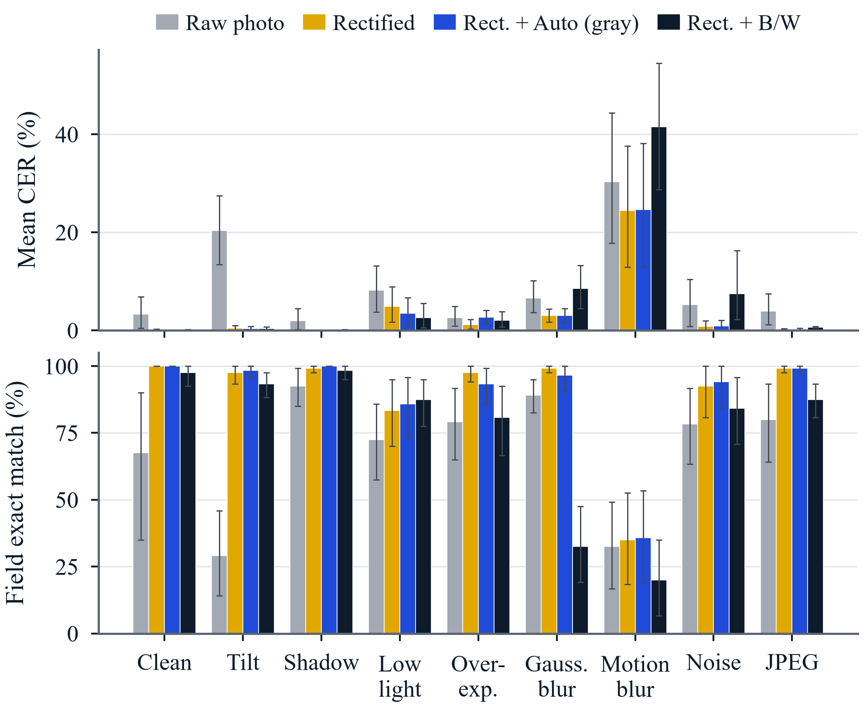
Fig. 6. Mean CER (top) and five-field exact match (bottom) by degradation. Error bars: 95% percentile-bootstrap intervals over captures.
B. Effect by Degradation
TABLE IV
Results by degradation (%), n = 24 per row (clean 8)
Degradation | Quad / IoU≥0.9 | CER raw | CER rect. | CER gray | ΔCER raw−gray (95% CI) | EM raw | EM gray
Clean | 100/100 | 3.3 | 0.1 | 0.0 | 3.2 (0.4, 6.8) | 67.5 | 100.0
Tilt | 100/100 | 20.3 | 0.5 | 0.4 | 20.0 (13.1, 27.1) | 29.2 | 98.3
Shadow | 100/100 | 1.9 | 0.0 | 0.0 | 1.9 (0.2, 4.4) | 92.5 | 100.0
Low light | 33/29 | 8.2 | 4.9 | 3.5 | 4.7 (1.5, 9.0) | 72.5 | 85.8
Overexp. | 100/46 | 2.5 | 1.1 | 2.7 | -0.1 (-2.1, 2.4) | 79.2 | 93.3
Gauss. blur | 100/96 | 6.6 | 3.0 | 3.0 | 3.6 (0.6, 7.3) | 89.2 | 96.7
Motion blur | 100/46 | 30.3 | 24.4 | 24.6 | 5.7 (2.7, 9.1) | 32.5 | 35.8
Noise | 100/100 | 5.2 | 0.8 | 0.9 | 4.4 (-0.2, 9.8) | 78.3 | 94.2
JPEG | 100/100 | 3.9 | 0.3 | 0.3 | 3.7 (0.9, 7.2) | 80.0 | 99.2
Quad: page quadrilateral found. ΔCER: paired reduction from raw photo to Auto gray. EM: five-field exact match.
Fig. 6 and Table IV break the result down. Tilt dominates: raw CER of 20.3% falls to 0.4% after rectification although raw word recall is already 99.4%, so the words are read but the reading order is scrambled. Enhancement matters where detection fails or text is soft. Under low light a quad is found on only 33% of captures; at the strongest level, where raw and rectified are the same image, CER falls from 11.1% to 7.2% with Auto and to 3.8% with B&W. Under Gaussian blur, word recall rises from 90.8% to 96.3%. Under overexposure enhancement hurts (rectified 1.1%, Auto 2.7%), plausibly because CLAHE and sharpening amplify the clipped background. Motion blur is the hardest case (24.4% after rectification), and binarization worsens it to 41.5% by breaking smeared strokes.
C. Page Detection and Quality Checks
A quadrilateral was found on 184 of 200 captures and matched the true page with IoU ≥ 0.9 on 156; when found, mean IoU was 0.976 and median corner error 1.3 px in the 1800×2400 frame. Misses concentrate in low light; IoU drops under overexposure and motion blur.
TABLE V
Quality verdict vs applied degradation (n = 200)
Expected \ app label | Good | Dark | Bright | Soft
Good (n = 104) | 104 | 0 | 0 | 0
Too dark (n = 24) | 8 | 16 | 0 | 0
Too bright (n = 24) | 5 | 0 | 19 | 0
Soft image (n = 48) | 37 | 0 | 0 | 11

The quality checks raised no false alarm and gave the expected label on 150 of 200 captures (Table V). The dark flag fired on every medium and strong low-light capture; the eight misses were mild ones with mean gray 65. The blur flag caught all eight strong Gaussian-blur captures but only 1 of 24 motion-blurred ones: motion blur keeps strong second derivatives across the stroke direction, so the whole-frame Laplacian variance, background texture included, stays above 65.
D. Thresholding Under Shadow
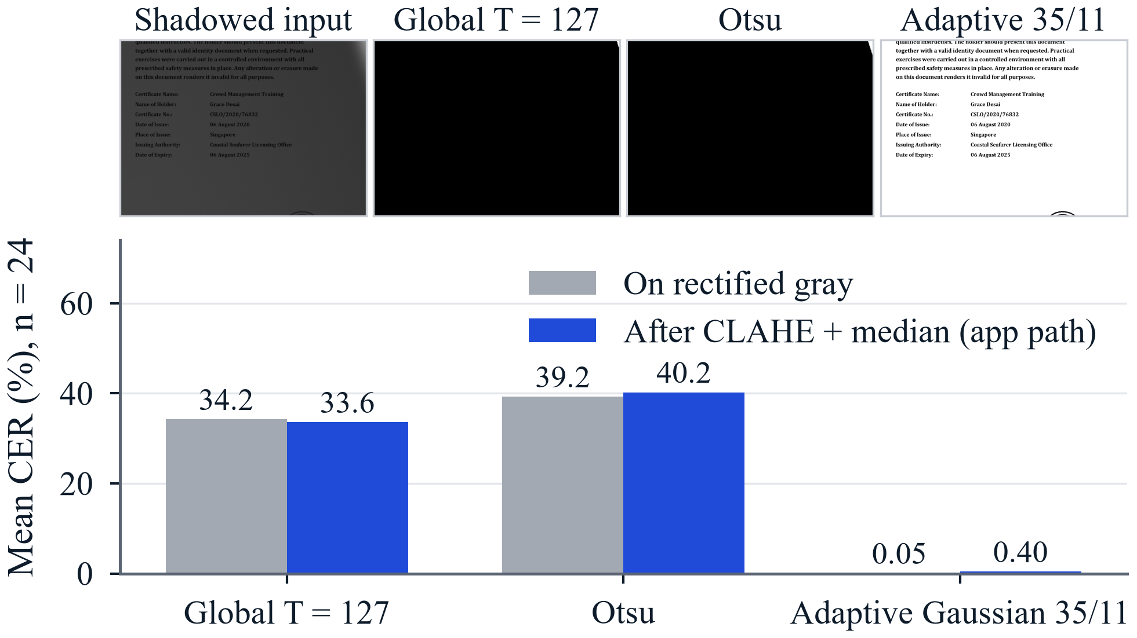
Fig. 7. Global, Otsu and adaptive thresholds on a strongly shadowed page (top) and mean CER over the 24 shadow captures (bottom).
TABLE VI
Binarization of 24 shadowed pages (true corners)
Method | CER gray | Ink F1 | CER app path | Ink F1
Global T = 127 | 34.2% | 0.41 | 33.6% | 0.30
Otsu | 39.2% | 0.25 | 40.2% | 0.22
Adaptive 35/11 | 0.05% | 0.91 | 0.40% | 0.87
No threshold | 0.03% | – | – | –
App path: after CLAHE and 3×3 median. Ink F1: pixel F1 against the rendered ink mask.
Rectifying the 24 shadow captures with their true corners isolates binarization (Fig. 7, Table VI). Only the adaptive threshold survives, with CER 0.05%, close to the 0.03% of the gray page. Otsu fails even under the mildest shadow (26.1% CER), and the fixed threshold works at mild severity (0.04%) but not at medium or strong (39.7% and 62.9%). CLAHE and the median do not rescue either global method.
E. DCT Compression
TABLE VII
8×8 DCT coding of six clean pages
Quality factor | 90 | 75 | 50 | 30 | 20 | 10 | 5 | 2
PSNR (dB) | 46.0 | 39.0 | 34.9 | 32.3 | 30.3 | 27.7 | 25.4 | 23.6
Nonzero coeff. (%) | 12.7 | 10.1 | 8.1 | 6.8 | 6.0 | 4.7 | 3.8 | 3.1
JPEG bit/pixel | 0.99 | 0.72 | 0.56 | 0.45 | 0.38 | 0.29 | 0.23 | 0.19
OCR CER (%) | 0.11 | 0.41 | 0.33 | 0.28 | 0.34 | 0.35 | 0.48 | 1.21
Uncompressed CER 0.02%. Keeping only the top-left k×k coefficients gives CER 0.12%, 0.30%, 0.75%, 4.1% and 98.9% for k = 6, 4, 3, 2, 1 (PSNR 30.3 to 16.6 dB).
Text is robust to transform coding (Table VII). At quality 10 only 4.7% of coefficients are nonzero and a real JPEG needs 0.29 bit/pixel, yet CER stays at 0.35% while PSNR falls to 27.7 dB. CER is not monotonic at high quality (0.41% at 75, 0.33% at 50), so differences below about half a point are noise. Zonal coding fails only below 3×3 coefficients, when strokes merge into block averages. The app's quality-88 previews therefore cost little in legibility.
F. Block-Matching Motion Estimation
TABLE VIII
Block matching on 10 text frame pairs (9,990 blocks)
Frames, method | Points/block | Exact MV | MV error (px) | Mean MAD
Sharp, ES | 225 | 99.9% | 0.00 | 1.60
Sharp, TSS | 25 | 29.6% | 5.05 | 6.59
Sharp, 2-D log | 20.7 (≤ 31) | 32.8% | 5.10 | 6.82
Low-pass, ES | 225 | 92.9% | 0.10 | 0.22
Low-pass, TSS | 25 | 49.1% | 3.22 | 0.82
Low-pass, 2-D log | 21.5 (≤ 31) | 58.7% | 2.96 | 0.72
Exact MV and MV error over textured blocks (std. dev. > 10): 5,221 sharp, 5,097 low-pass. Low-pass: Gaussian σ = 2 on both frames.
Ten pairs of 480×640 frames were made by shifting a synthetic capture by a random integer vector in [−7, 7]² and adding noise (σ = 2), so every true vector is known. ES recovers it on 99.9% of textured blocks (Table VIII). TSS and 2-D log search test 9–11 times fewer points but are exact on only 29.6% and 32.8% of blocks, with mean errors above 5 px. Fig. 8 shows why: on text the cost surface has many local minima, and the first coarse step commits to the wrong one. Low-pass filtering both frames raises the fast searches to 49.1% and 58.7%, at a small cost to ES (92.9%).
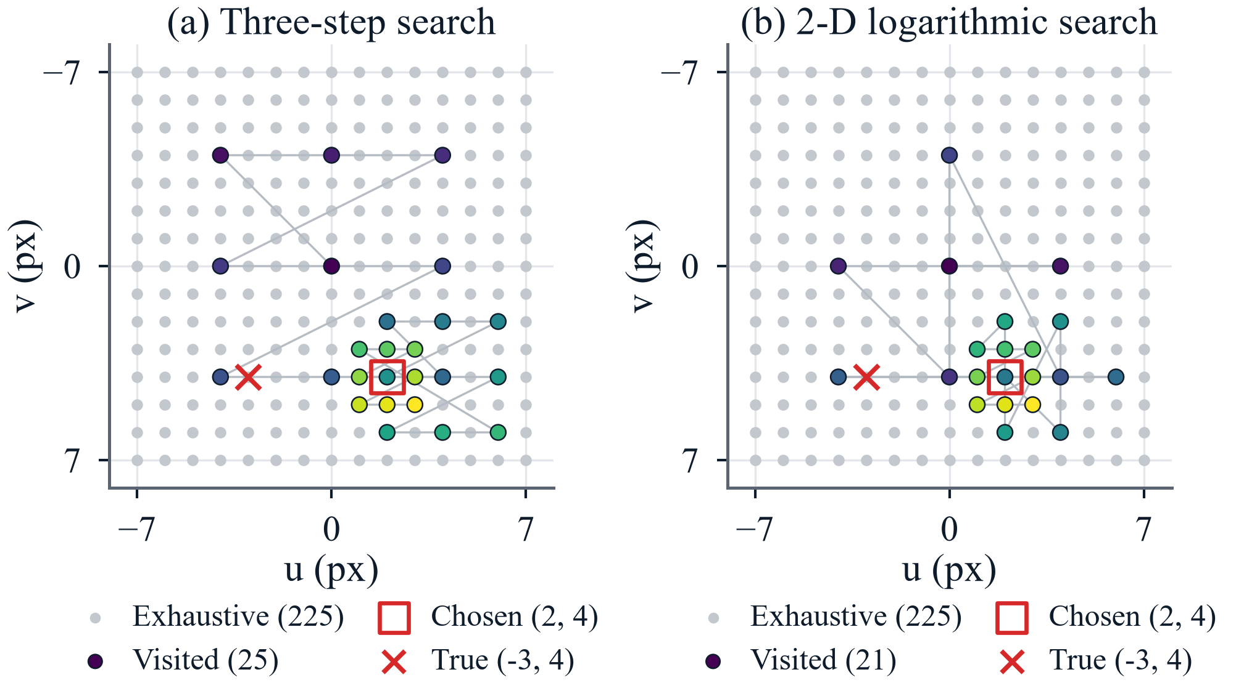
Fig. 8. Points visited by (a) TSS and (b) 2-D log search for one text block; both settle at the local minimum (2, 4), while the true vector is (−3, 4).
G. Processing Time
Median desktop times per 1800×2400 capture (12 captures × 5 repeats) were 1.3 ms (resize), 14.6 ms (quality check), 6.3 ms (detection), 8.8 ms (warp) and 6.2 ms or 19.1 ms (Auto or B&W enhancement), against 1063 ms for one PP-OCRv6 call: the classical Auto path costs about 37 ms, roughly 3.5% of OCR. Phone latency was not measured.
IX. Discussion
Why rectification dominates. Learned line detectors tolerate skew, so on a tilted page nearly every word is still read; what breaks is the line structure: slanted lines interleave, and a label no longer shares a line with its value. The homography restores horizontal lines and with them the label–value structure that label-based extraction needs, which is why CER and field match move together while word recall stays flat.
When enhancement helps and hurts. A learned recognizer already normalizes contrast, so CLAHE and sharpening add little on well-exposed pages. They help where the signal is weak (dark or Gaussian-blurred captures, especially when no page is found) and hurt on clipped input, where CLAHE stretches residual texture and the unsharp mask overshoots. The measured brightness and sharpness could pick the mode.
Why Otsu fails under shadow. A cast shadow splits the paper into two background modes, so the variance-maximizing threshold separates lit from shadowed paper instead of ink from paper; a local threshold follows the illumination.
Why fast block matching fails on text. Text is a quasi-periodic texture: a shift of one character or line pitch gives a near-equal match, so the cost surface is not unimodal and a coarse step lands in the wrong basin. Smoothing widens the true basin. For a steady-capture trigger, exhaustive search on a small, smoothed preview frame is the safer choice.
Implications for the app. Rectification should stay mandatory and Auto gray the default; B&W suits uneven light but not blur or noise. The quality check should run on the detected page and needs a directional blur measure. In a companion synthetic experiment, a learned depth-3 decision tree on the same two features reached 92.7% accuracy against 78.1% for the hand-set thresholds, which supports calibrating them on real phone captures.
X. Limitations and Future Work
The benchmark is synthetic: clean one-column pages with known fonts and a simple camera model. Real captures add lens distortion, curl, glare, handwriting, tables and stamps over text, so the absolute numbers are optimistic; the paired differences are the result. The benchmark OCR is PP-OCRv6 on a desktop while the app uses ML Kit, so the study must be repeated on the phone with latency and memory. Samples are small (24 captures per degradation, 26 gold fields), and the benchmark's field rule is simpler than the app's cascade.
Contour detection fails on borderless and low-contrast pages; corner ordering by x + y and y − x can collide for a page rotated near 45°; the Canny and quality thresholds need per-device calibration. The companion evaluation also exposed two post-correction defects, a digit guard that kept the confusion map from firing and a dictionary without maritime words; both are now fixed and locked by regression tests. Future work will build a vessel-disjoint set of real photographed certificates with verified text, fields and corners; try learned detection and dewarping [13], [14], [24] where contours fail; compare PP-OCRv6 with ML Kit on the phone; add an expiry-after-issue consistency check; and test layout-aware [27] and OCR-free [28] extractors within the mobile budget.
XI. Conclusion
NavCert Offline captures, rectifies, enhances, reads and parses a certificate entirely on a phone. On 200 paired synthetic captures, its classical front end lowers mean CER from 9.6% to 4.2% and lifts five-field exact match from 69.1% to 88.4%, almost all of it from geometric rectification. Adaptive thresholding is the right binarizer under shadow, DCT coding at preview quality costs almost nothing in legibility, and fast block matching is unreliable on text unless frames are smoothed first. Pipeline Lab makes each operation visible on the user's own scan. The next step is the same paired measurement on real certificates photographed with the phone.
References
[1] International Maritime Organization, "International Convention on Standards of Training, Certification and Watchkeeping for Seafarers (STCW)," IMO web page, accessed Oct. 2026. [Online]. Available: https://www.imo.org/en/ourwork/humanelement/pages/stcw-convention.aspx
[2] BIMCO and International Chamber of Shipping, "Seafarer Workforce Report 2026: Executive summary," Jun. 2026. [Online]. Available: https://www.bimco.org/media/mxhbsjxb/seafarer-workforce-report-2026-executive-summary.pdf
[3] Marine Insight, "India overtakes China to become world's 2nd largest supplier of seafarers," Aug. 3, 2026. [Online]. Available: https://www.marineinsight.com/india-overtakes-china-to-become-worlds-2nd-largest-supplier-of-seafarers/
[4] IMO Sub-Committee on Standards of Training and Watchkeeping, "Unlawful practices associated with certificates of competency," Secretariat, doc. STW 32/6 (mirror hosted by NTOU). [Online]. Available: https://dstm.ntou.edu.tw/var/file/71/1071/img/558/STW32-6-UnlawfulPracticesAssociatedWithCertificatesOfCompetency(Secretariat).pdf
[5] Tokyo MOU Secretariat, Annual Report on Port State Control in the Asia-Pacific Region 2024, 2025. [Online]. Available: https://www.tokyo-mou.org/wp/wp-content/uploads/ANN24-1.pdf
[6] International Maritime Organization, "Guidelines on the use of electronic certificates of seafarers," MSC.1/Circ.1665, Jun. 28, 2023. [Online]. Available: https://admin.soefartsstyrelsen.dk/Media/638684798012087625/MSC.1-Circ.1665 - Guidelines On The Use Of Electronic Certificates Of Seafarers.PDF
[7] M. Zhang, A. Joshi, R. Kadmawala, K. Dantu, S. Poduri, and G. S. Sukhatme, "OCRdroid: A framework to digitize text using mobile phones," in Mobile Computing, Applications, and Services, Lecture Notes of the ICST, 2010, pp. 273-292. doi: 10.1007/978-3-642-12607-9_18.
[8] J.-C. Burie et al., "ICDAR2015 competition on smartphone document capture and OCR (SmartDoc)," in Proc. 13th Int. Conf. Document Analysis and Recognition, 2015, pp. 1161-1165. doi: 10.1109/ICDAR.2015.7333943.
[9] R. Hartley and A. Zisserman, Multiple View Geometry in Computer Vision, 2nd ed. Cambridge, U.K.: Cambridge Univ. Press, 2004. doi: 10.1017/CBO9780511811685.
[10] J. Canny, "A computational approach to edge detection," IEEE Trans. Pattern Anal. Mach. Intell., vol. PAMI-8, pp. 679-698, 1986. doi: 10.1109/TPAMI.1986.4767851.
[11] S. Suzuki and K. Abe, "Topological structural analysis of digitized binary images by border following," Comput. Vis., Graph., Image Process., vol. 30, pp. 32-46, 1985. doi: 10.1016/0734-189X(85)90016-7.
[12] D. H. Douglas and T. K. Peucker, "Algorithms for the reduction of the number of points required to represent a digitized line or its caricature," Cartographica, vol. 10, pp. 112-122, 1973. doi: 10.3138/FM57-6770-U75U-7727.
[13] K. Ma et al., "DocUNet: Document image unwarping via a stacked U-Net," in Proc. IEEE/CVF CVPR, 2018, pp. 4700-4709. doi: 10.1109/CVPR.2018.00494.
[14] H. Feng, Y. Wang, W. Zhou et al., "DocTr: Document image transformer for geometric unwarping and illumination correction," in Proc. 29th ACM Int. Conf. Multimedia, 2021, pp. 273-281. doi: 10.1145/3474085.3475388.
[15] R. C. Gonzalez and R. E. Woods, Digital Image Processing, 4th ed. New York, NY, USA: Pearson, 2018 (ISBN 978-0-13-335672-4).
[16] K. Zuiderveld, "Contrast limited adaptive histogram equalization," in Graphics Gems IV, P. S. Heckbert, Ed. San Diego, CA, USA: Academic Press, 1994, pp. 474-485.
[17] N. Otsu, "A threshold selection method from gray-level histograms," IEEE Trans. Syst., Man, Cybern., vol. SMC-9, pp. 62-66, 1979. doi: 10.1109/TSMC.1979.4310076.
[18] J. Sauvola and M. Pietikainen, "Adaptive document image binarization," Pattern Recognit., vol. 33, pp. 225-236, 2000. doi: 10.1016/S0031-3203(99)00055-2.
[19] J. L. Pech-Pacheco et al., "Diatom autofocusing in brightfield microscopy: A comparative study," in Proc. 15th Int. Conf. Pattern Recognition (ICPR), vol. 3, 2000, pp. 314-317. doi: 10.1109/ICPR.2000.903548.
[20] A. Graves et al., "Connectionist temporal classification: Labelling unsegmented sequence data with recurrent neural networks," in Proc. 23rd Int. Conf. Machine Learning (ICML), 2006, pp. 369-376. doi: 10.1145/1143844.1143891.
[21] Y. Du et al., "PP-OCR: A practical ultra lightweight OCR system," arXiv:2009.09941, 2020.
[22] C. Cui et al., "PP-OCRv5: A specialized 5M-parameter model rivaling billion-parameter vision-language models on OCR tasks," arXiv:2603.24373, Mar. 2026.
[23] PaddlePaddle Team, "PP-OCRv6 release," Hugging Face Blog, Jun. 22, 2026. [Online]. Available: https://huggingface.co/blog/PaddlePaddle/pp-ocrv6
[24] M. Liao, Z. Wan, C. Yao, K. Chen, and X. Bai, "Real-time scene text detection with differentiable binarization," in Proc. AAAI Conf. Artificial Intelligence, vol. 34, no. 7, 2020, pp. 11474-11481. doi: 10.1609/aaai.v34i07.6812.
[25] Google, "Text recognition v2," ML Kit for Android, accessed Oct. 2026. [Online]. Available: https://developers.google.com/ml-kit/vision/text-recognition/v2/android
[26] Y. Xu et al., "LayoutLM: Pre-training of text and layout for document image understanding," in Proc. 26th ACM SIGKDD Int. Conf. Knowledge Discovery and Data Mining, 2020, pp. 1192-1200. doi: 10.1145/3394486.3403172.
[27] Y. Huang, T. Lv, L. Cui, Y. Lu, and F. Wei, "LayoutLMv3: Pre-training for document AI with unified text and image masking," in Proc. 30th ACM Int. Conf. Multimedia, 2022, pp. 4083-4091. doi: 10.1145/3503161.3548112.
[28] G. Kim et al., "OCR-free document understanding transformer," in Computer Vision - ECCV 2022, LNCS, vol. 13688, 2022, pp. 498-517. doi: 10.1007/978-3-031-19815-1_29.
[29] J. Devlin, M.-W. Chang, K. Lee, and K. Toutanova, "BERT: Pre-training of deep bidirectional transformers for language understanding," in Proc. NAACL-HLT, 2019, pp. 4171-4186. doi: 10.18653/v1/N19-1423.
[30] Z. Sun et al., "MobileBERT: A compact task-agnostic BERT for resource-limited devices," in Proc. 58th Annu. Meeting Assoc. Computational Linguistics, 2020, pp. 2158-2170. doi: 10.18653/v1/2020.acl-main.195.
[31] W. Wang et al., "MiniLM: Deep self-attention distillation for task-agnostic compression of pre-trained transformers," arXiv:2002.10957, 2020.
[32] B. Jacob et al., "Quantization and training of neural networks for efficient integer-arithmetic-only inference," in Proc. IEEE/CVF CVPR, 2018, pp. 2704-2713. doi: 10.1109/CVPR.2018.00286.
[33] Microsoft, "ONNX Runtime Mobile," ONNX Runtime documentation, accessed Oct. 2026. [Online]. Available: https://onnxruntime.ai/docs/tutorials/mobile/
[34] G. Bradski, "The OpenCV library," Dr. Dobb's Journal of Software Tools, Nov. 2000. [Online]. Available: https://forum.opencv.org/t/opencv-article-in-dr-dobbs-journal/8962
[35] R. M. Haralick, S. R. Sternberg, and X. Zhuang, "Image analysis using mathematical morphology," IEEE Trans. Pattern Anal. Mach. Intell., vol. PAMI-9, pp. 532-550, 1987. doi: 10.1109/TPAMI.1987.4767941.
[36] G. K. Wallace, "The JPEG still picture compression standard," IEEE Trans. Consum. Electron., vol. 38, pp. xviii-xxxiv, 1992. doi: 10.1109/30.125072.
[37] N. Ahmed, T. Natarajan, and K. R. Rao, "Discrete cosine transform," IEEE Trans. Comput., vol. C-23, pp. 90-93, 1974. doi: 10.1109/T-C.1974.223784.
[38] J. R. Jain and A. K. Jain, "Displacement measurement and its application in interframe image coding," IEEE Trans. Commun., vol. COM-29, pp. 1799-1808, 1981. doi: 10.1109/TCOM.1981.1094950.
[39] R. Li, B. Zeng, and M. L. Liou, "A new three-step search algorithm for block motion estimation," IEEE Trans. Circuits Syst. Video Technol., vol. 4, pp. 438-442, 1994. doi: 10.1109/76.313138.
[40] V. I. Levenshtein, "Binary codes capable of correcting deletions, insertions, and reversals," Soviet Physics Doklady, vol. 10, no. 8, pp. 707-710, 1966 (translation of Dokl. Akad. Nauk SSSR, vol. 163, no. 4, pp. 845-848, 1965). [Online]. Available: https://mathnet.ru/eng/dan31411
[41] deepset, "deepset/minilm-uncased-squad2," Hugging Face model card, accessed Oct. 2026. [Online]. Available: https://huggingface.co/deepset/minilm-uncased-squad2

