PHASE 3: SOLUTION ARCHITECTURE & TECHNICAL DESIGN
Agentic Data-Analyst Agent for PostgreSQL
SAD • HLD • LLD • ADRs • Tool/API Specs • DB Design • Security Design • Infra Design • NFRs

Document 1: Solution Architecture Document (SAD)

3.1 Purpose and Requirements Traceability
This SAD defines the architecture that satisfies the Business Requirements Document and Requirements Traceability Matrix produced in Phase 1, within the feasibility findings and plan from Phase 2. Every major component below is traced to the requirement(s) it exists to satisfy.
Architecture Component | Satisfies Requirement(s)
Agent Orchestrator (plan/execute/reflect loop) | BR-3 (multi-step investigation)
Schema Introspector tool | BR-2 (connect to target DB), supports BR-3
SQL Executor + Guardrails | BR-2, BR-6 (never writes to DB)
Stats Engine (sandboxed) | BR-3, BR-5 (narrative + supporting data)
Verifier | BR-4 (self-verification before final answer)
Output Formatter | BR-5 (plain-language narrative + visual)
Clarification logic in Orchestrator | BR-7 (ask when uncertain rather than guess)
Eval Harness (offline) | BR-8 (measurable accuracy/faithfulness)
Self-hosted deployment (Docker) | BR-9 (no credential transmission to a third party)
Nebius AI Builder LLM Client | BR-10 (operate within Nebius program resources)

3.2 Architecture Principles
- Self-hosted by default — no component transmits or stores the user's database credentials outside their own environment.
- Read-only at every layer — the database role, the query validator, and the design intent all independently enforce that the agent cannot write to the target database (defense in depth).
- Verification before presentation — no answer reaches the user without at least one independent check.
- Bounded by design — every loop has an iteration cap; every query has a row limit and timeout. The agent fails toward “I'm not sure”, never toward an unbounded retry or a silent wrong answer.
- Modular tools — each tool (schema, SQL, stats, verify) is independently callable and testable, so failures are isolated and diagnosable.

3.3 High-Level Architecture
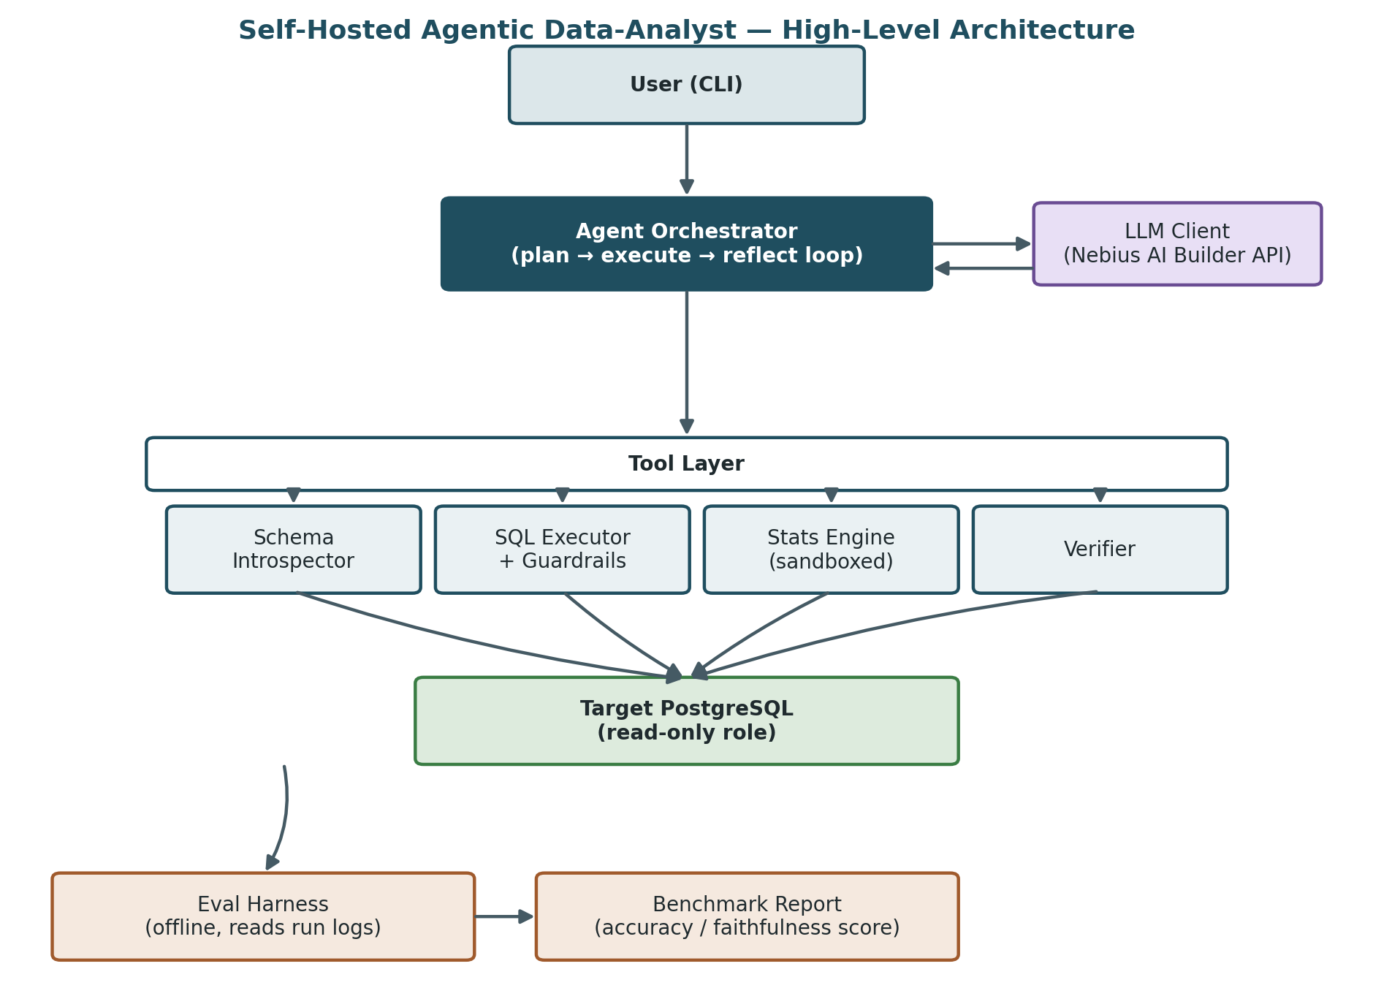
The user interacts with a local CLI application. The Agent Orchestrator drives the investigation, calling the Nebius-hosted LLM to plan and interpret results, and calling tools in the Tool Layer to actually touch the database. All tool-layer access to the target database goes through a read-only connection role. The Eval Harness runs offline against recorded run logs to produce a benchmark score — it is not part of the live user-facing path.

3.4 Data Flow (Narrative)
- 1. User submits a natural-language question via the CLI.
- 2. Orchestrator calls the Schema Introspector (once per session, cached) to ground itself in the actual table/column structure.
- 3. Orchestrator asks the LLM to plan the next step given the question, schema, and any evidence gathered so far.
- 4. Orchestrator executes the chosen tool (SQL Executor or Stats Engine) and observes the result.
- 5. Orchestrator reflects: is there enough evidence to answer, or is another step needed? (bounded by an iteration cap)
- 6. Once evidence is sufficient, the Verifier issues an independent, differently-phrased query to check the conclusion.
- 7. If verification is consistent, the Output Formatter produces a narrative answer with supporting data. If not, the agent either re-investigates (within the cap) or flags uncertainty and asks the user a clarifying question.
- 8. Every step (plan, tool call, result, verification outcome) is written to a run log, which the offline Eval Harness later scores against the benchmark rubric.

Document 2: High-Level Design (HLD)

Component Responsibilities
Component | Responsibility
CLI / App entry point | Accepts the user's question and DB connection string; displays the final narrative answer and supporting output
Agent Orchestrator | Owns the plan/execute/reflect/verify loop; calls the LLM for reasoning; enforces the iteration cap
LLM Client | Thin wrapper around the Nebius AI Builder API; handles retries and call/token logging
Schema Introspector | Reads table, column, and type metadata from the target database (read-only)
SQL Executor | Runs agent-generated SQL against the read-only connection, enforcing row limits and timeouts
Stats Engine | Runs a restricted, allow-listed set of pandas/statistical operations on query results returned in-memory
Verifier | Issues one independent follow-up query/check per conclusion and compares outcomes
Output Formatter | Converts the agent's findings into plain-language narrative plus a simple chart/table
Run Logger | Records every step of a session to a structured log file for later evaluation
Eval Harness | Offline tool that replays or scores logged sessions against the benchmark rubric from the RTM (BR-8)

Technology Stack
Layer | Choice | Rationale
Language | Python 3.11+ | Best-supported ecosystem for both LLM tooling and data/stats work (pandas)
DB driver | psycopg (v3) | Mature, actively maintained PostgreSQL driver with good read-only/transaction control
Data handling | pandas | Standard for the sandboxed statistics tool's allow-listed operations
LLM access | Nebius AI Builder API (OpenAI-compatible chat/completions interface) | Program resource already available; avoids a second vendor integration
CLI framework | Typer (or argparse for a minimal footprint) | Fast to build a clean self-hosted CLI
Packaging | Docker / docker-compose | Portable, self-hosted distribution without a hosted backend
Config/secrets | .env file, not committed to version control | Keeps DB credentials local to the user's own environment (BR-9)

Deployment View
Single Docker container running the CLI/agent application, with an optional second container providing a demo PostgreSQL instance for development and evaluation. See Document 8 (Infrastructure Design) for full detail.

Document 3: Low-Level Design (LLD)

Agent Investigation Loop
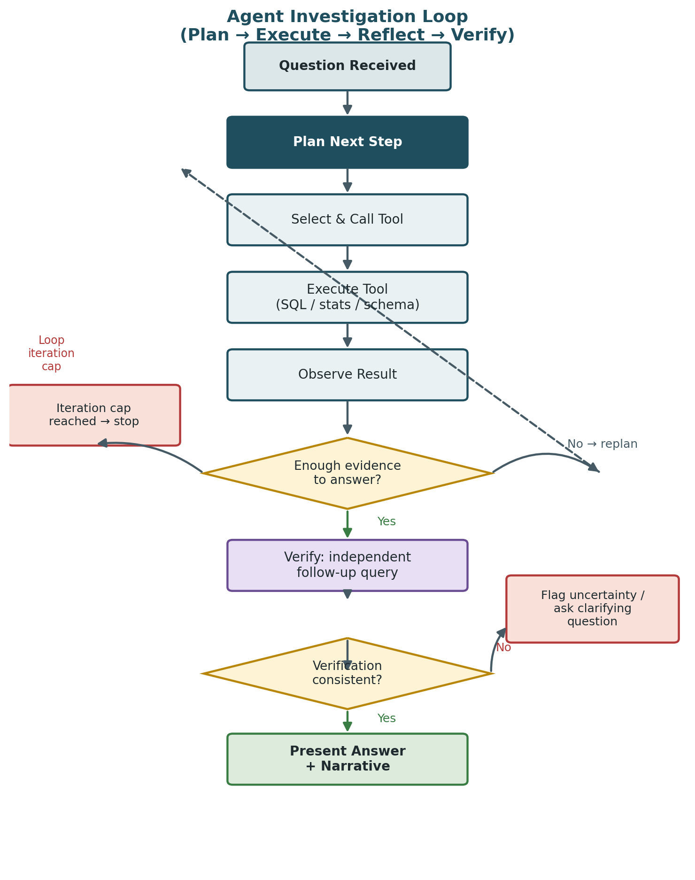

Loop Pseudocode
state = InvestigationState(question, schema, evidence=[], iterations=0)

while state.iterations < MAX_ITERATIONS:
plan = llm.plan_next_step(state)
if plan.action == "ANSWER_READY":
break
result = tools[plan.tool_name].execute(plan.tool_args)
state.evidence.append(result)
state.iterations += 1
run_logger.record(state, plan, result)

if state.iterations >= MAX_ITERATIONS and not plan.action == "ANSWER_READY":
return uncertain_response("Could not reach a confident answer in time")

verification = verifier.check(state.draft_answer, state.evidence)
if verification.consistent:
return output_formatter.render(state.draft_answer, state.evidence)
else:
return clarify_or_reinvestigate(state, verification)

Tool Interface Contract
All tools implement a common interface so the Orchestrator can call any of them uniformly: a name, a JSON-schema-style parameter definition (used both for validation and for the LLM's function-calling interface), and a bounded, structured return value. See Document 5 for the full specification of each tool.

Error Handling & Timeouts
- Every SQL and stats tool call has an explicit timeout (default 10s); a timeout is treated as a failed step, logged, and counted against the iteration cap — not retried indefinitely.
- LLM API errors trigger a small number of retries with backoff before the session fails gracefully with an explicit error message, never a silent hang.
- Any tool exception is caught at the Orchestrator level and surfaced to the loop as a failed observation, so a single bad query cannot crash the session.

Iteration & Cost Controls
- MAX_ITERATIONS default: 8 plan/execute cycles per question.
- Per-session LLM call count and token usage are logged for later cost analysis (see NFRs).
- The Verifier issues exactly one additional check per draft answer, not an open-ended re-verification loop.

Document 4: Architecture Decision Records (ADRs)

ADR-001: Restrict v1 to PostgreSQL only
Status: Accepted
Context: Supporting multiple SQL dialects (MySQL, Snowflake, BigQuery) multiplies introspection, query-generation, and testing surface area within a 2–3 week solo timeline.
Decision: Support PostgreSQL exclusively for v1.
Alternatives considered: Dialect-agnostic abstraction layer from day one (rejected: adds complexity before there's a second dialect to abstract over); SQLite for simplicity (rejected: less representative of real business database environments).
Consequences: Faster delivery and a cleaner story for the portfolio artifact; adding a second dialect later requires isolating the SQL-generation and introspection logic behind an interface, which is deferred, not precluded.

ADR-002: Self-hosted deployment, not a hosted multi-tenant SaaS
Status: Accepted
Context: Accepting and storing other people's database credentials centrally creates a real security and liability program that is out of proportion to a solo portfolio project.
Decision: Ship as a self-hosted CLI/Docker application that the user runs against their own environment; no credentials are ever transmitted to or stored by a central service.
Alternatives considered: Hosted SaaS with centralized credential storage (rejected: liability and scope far exceed project timeline); browser-based tool with credentials held client-side only (rejected: adds a frontend/backend split not needed for the goal).
Consequences: Removes an entire category of security engineering from v1 scope (see Security Design); trades off convenience — the user must run the tool themselves.

ADR-003: Custom plan/execute/reflect loop, not a heavy agent framework
Status: Accepted
Context: Agent frameworks (LangChain, LlamaIndex agents, etc.) provide useful abstractions but add debugging opacity and dependency weight; the loop itself is simple enough to own directly, and full control aids both the POC spike and the eval harness's ability to inspect every step.
Decision: Implement a minimal custom loop (see LLD) with direct function-calling against the Nebius API.
Alternatives considered: Adopt a full agent framework (rejected for v1: opacity and indirection when debugging the higher-risk verification behavior); use raw prompt-chaining with no explicit state object (rejected: harder to log and evaluate).
Consequences: More initial code to write, but a fully inspectable, log-friendly loop that the Eval Harness and the POC can reason about directly.

ADR-004: Allow-listed operations for the sandboxed stats tool
Status: Accepted
Context: The stats tool needs to run agent-directed data operations (aggregation, trend/outlier checks) without exposing arbitrary code execution as an attack surface, even in a self-hosted personal tool.
Decision: Expose a fixed set of named pandas/statistics operations (e.g., groupby-aggregate, rolling mean, z-score outlier check) that the agent selects and parameterizes, rather than agent-generated free-form Python passed to `exec`/`eval`.
Alternatives considered: Full sandboxed subprocess/container executing arbitrary agent-written Python (rejected for v1: materially higher engineering cost for a personal tool's threat model); no stats tool at all, SQL only (rejected: limits the investigative depth that differentiates this project).
Consequences: Slightly less flexible than free-form code execution, but removes an entire class of code-injection risk and is faster to build and test.

ADR-005: Verification via an independent follow-up query, not model self-critique alone
Status: Accepted
Context: Asking the same model to simply 'double check its own answer' in text is prone to confirming its own mistake (rubber-stamping). An independent, differently-phrased query against the actual data provides real evidence rather than re-stated confidence.
Decision: The Verifier issues a second, independently-formulated query designed to reach the same conclusion via a different path, and flags inconsistency if the two disagree.
Alternatives considered: Pure textual self-critique with no new query (rejected: doesn't catch data-grounded errors); a second, larger LLM as an independent judge (rejected for v1: added cost/complexity beyond the timeline; noted as a future enhancement).
Consequences: Meaningfully increases confidence in BR-4/BR-8 compliance at the cost of at least one extra tool call and LLM round-trip per question.

Document 5: Tool / API Specifications
The system exposes no public network API in v1 (self-hosted, single-user CLI). “API” here refers to the internal tool contracts the Agent Orchestrator calls, defined as function-calling schemas presented to the LLM and enforced in code.
Tool | Parameters | Returns | Guardrails
introspect_schema() | none (reads full accessible schema once per session) | Table/column/type metadata, foreign-key hints where present | Read-only role; cached per session to limit repeated calls
run_sql(query: str) | query — a single SELECT statement | Rows (capped), row count, execution time | Rejects any non-SELECT statement; enforces row limit (default 500) and timeout (default 10s)
run_stats(operation: str, params: object, data_ref: str) | operation — one of an allow-listed set (aggregate, rolling_mean, outlier_zscore, correlation, segment); params — operation-specific args; data_ref — reference to a prior query result | Computed result (table or summary statistic) | Operation must be in the allow-list; runs against already-fetched in-memory data only, never a new raw DB connection
verify(claim: str, evidence_ref: str) | claim — the draft conclusion; evidence_ref — the supporting query result(s) | consistent: bool, detail: str, new_query_used: str | Always issues exactly one new, independently-phrased query; never re-runs the original query verbatim
format_output(answer: str, evidence: list) | answer — verified conclusion; evidence — supporting data points | Narrative text + a simple chart/table payload | No DB or LLM access; pure presentation step

Document 6: Database Design

Target Database (User-Provided)
The database being analyzed is external and user-owned; this project does not design its schema. The system's only requirements of it are: PostgreSQL, and a connection made available through a role restricted to read-only access. Schema is discovered dynamically at runtime via the Schema Introspector (Document 5).

Sample / Demo Dataset (for development and evaluation)
A small representative schema is needed to build and evaluate the agent during Phases 4–5. Proposed sample schema (retail/sales domain, consistent with the owner's existing forecasting-project data where reuse is possible):
Table | Key Columns | Notes
customers | customer_id (PK), region, signup_date, segment | Small dimension table to support segmentation questions
products | product_id (PK), category, unit_price | Dimension table
orders | order_id (PK), customer_id (FK), order_date, channel | One row per order
order_items | order_item_id (PK), order_id (FK), product_id (FK), quantity, line_total | Fact table; most investigative questions join through here

Internal / Application State
No internal database is required for v1. Session run logs (for the Eval Harness) are written as structured JSON/CSV files rather than a database, since there is a single user and no concurrent-access requirement — this avoids adding a persistence layer that the requirements don't call for.

Document 7: Security Design
Threats considered below are scoped to this project's actual v1 shape (self-hosted, single user, Postgres-only, read-only). Threats specific to a hosted multi-tenant version are intentionally out of scope, per the Initial Scope Statement.
Threat | Risk | Mitigation
Credential exposure | DB connection string or Nebius API key leaked via logs, version control, or shared files | Loaded from a local .env file excluded via .gitignore; never written to run logs; never transmitted to any service other than the target DB and the Nebius API the user already trusts
Destructive or unintended writes to the target DB | Agent-generated SQL contains an UPDATE/DELETE/DDL statement | Enforced in three independent layers: (1) DB role has no write privileges, (2) SQL Executor rejects any non-SELECT statement before execution, (3) connection opened in read-only transaction mode
Prompt injection via data content | A crafted value stored in the target database (e.g., a product description) attempts to hijack the agent's instructions when read into context | Tool outputs are treated strictly as data, never as instructions; the agent's available actions are limited to the fixed tool set regardless of data content, so an injected instruction has no executable path
Unsafe code execution in the stats tool | Arbitrary code execution if the stats tool accepted free-form agent-generated code | Addressed by ADR-004: allow-listed operations only, no exec/eval of agent-supplied code
Runaway resource consumption | An unbounded loop or unbounded query result consumes excessive time, tokens, or memory | Iteration cap (Document 3), per-query row limits and timeouts (Document 5)
Data exposure to a third-party LLM API | Rows or schema details from the target database are sent to the Nebius-hosted model as part of normal operation | Inherent to using a hosted model; mitigated by clearly documenting this to the user and recommending sample/non-sensitive data for v1 demonstrations; a fully local model is noted as a future option, out of scope for v1

Traceability to Requirements
This design satisfies BR-6 (never writes to the database, enforced at three independent layers) and BR-9 (self-hosted, no third-party credential storage), and documents the residual, accepted risk of sending data to a hosted LLM as an explicit trade-off rather than an oversight.

Document 8: Infrastructure Design

Deployment Model
- A single Docker Compose file defines the application container and, for development/evaluation only, an optional local PostgreSQL container seeded with the sample dataset.
- In real usage, the user points the application container at their own existing PostgreSQL instance instead of the bundled sample container.

Configuration
- All configuration (DB connection string, Nebius API key, iteration cap, row limits) is supplied via environment variables or a local .env file, never hard-coded.
- .env is excluded from version control via .gitignore; a .env.example documents required variables without real values.

Network
- Outbound only: the application calls the Nebius AI Builder API and the user-specified PostgreSQL host. No inbound network exposure is required — this is a local/CLI tool, not a hosted service.

Storage
- A single mounted volume for run logs (used by the Eval Harness); no other persistent storage is required for v1.

Startup
docker compose up # starts the app (and the demo Postgres container, if used)

Document 9: Non-Functional Requirements (NFRs)
Category | Requirement | Target
Performance | End-to-end latency for a typical multi-step question | ≤ 60 seconds under normal Nebius API latency
Reliability | Agent must fail toward an explicit uncertain/clarifying response, never crash or hang silently | 100% of forced-timeout and forced-error test cases return a graceful response
Cost / resource bound | LLM calls and tool calls per question are capped | ≤ 8 plan/execute iterations, 1 verification call per question
Portability | Runs identically on any machine with Docker installed | Single `docker compose up` command with no manual setup steps beyond .env configuration
Observability | Every step of every session is traceable after the fact | 100% of sessions produce a complete run log covering plan, tool calls, results, and verification outcome
Maintainability | Each tool is independently testable in isolation from the full agent loop | Each tool in Document 5 has at least one standalone unit test
Security | Database write protection does not depend solely on prompting the model | Write protection enforced at the DB role and query-validator layers, verified by an explicit attempted-write test (per BR-6)

Readiness to Implement
Check | Status
Design meets requirements (RTM traceability) | Confirmed — see Document 1, Section 3.1
Architecture is feasible within timeline | Confirmed in Phase 2 Feasibility Study; highest-risk items (loop, verification) are scoped for early validation via the POC
Security risks considered | Confirmed — see Document 7; write-protection and credential handling addressed at multiple layers
Major design decisions documented | Confirmed — five ADRs recorded in Document 4
Ready to begin implementation | Yes — proceed to Phase 4 (Build), starting with the Week 1 schedule (Architecture design → Schema Introspector → SQL Executor → Nebius integration → POC spike)

