CallScope — Solution Architecture & Technical Design
Phase 3 · SAD, HLD, LLD, ADRs, API specs, DB design, security, infrastructure, NFRs
Working name: CallScope (rename freely) · Version: 1.0 draft · Date: 2026-09-19
Companion files: schema.sql (full DDL), openapi.yaml (Session / Review / Eval / Governance API)
One-line pitch: A live, self-hosted voice agent (Hermes Agent as the reasoning backend) plus the machinery a voice-AI ML team actually needs around it: a telephony-realistic evaluation harness, a call-review and root-cause workflow, a model-improvement loop, and governance artifacts.
Table of Contents
0. Status, scope of this document, and what changed since the earlier plan 4
0.1 Contents 4
0.2 Important change to the earlier plan (read this first) 4
0.3 Facts this design depends on 4
1. Requirements baseline 6
1.1 Functional requirements 6
1.2 Non-functional requirements (summary; full table in §10) 6
2. SAD — System Architecture Document 7
2.1 Goals and non-goals 7
2.2 Architectural drivers 7
2.3 Constraints and assumptions 7
2.4 Quality-attribute priorities (ranked) 7
2.5 System context 8
2.6 Logical architecture (planes) 8
2.7 Technology stack 8
2.8 Feasibility assessment 9
2.9 Risk register (top risks) 9
3. HLD — High-Level Design 11
3.1 Component catalogue 11
3.2 Live call — happy path 12
3.3 Barge-in 13
3.4 Evaluation and improvement flow 14
3.5 Data architecture overview 15
3.6 Latency budget (end of caller speech → first agent audio audible) 15
4. LLD — Detailed Technical Design 16
4.1 Repository layout (monorepo) 16
4.2 Voice Worker 16
4.3 Model servers 18
4.4 Hermes integration and the CallScope plugin 18
4.5 Business API and knowledge base 19
4.6 Datasets and evaluation harness 19
4.7 Call review and root-cause attribution 21
4.8 Model improvement loop (FR-10) 22
4.9 Governance module 23
4.10 Observability 24
4.11 Error handling and graceful degradation 24
4.12 Configuration, secrets, testing 24
5. Architecture Decision Records 26
ADR-001 — Hermes is the reasoning backend, reached through its OpenAI-compatible API server 26
ADR-002 — Do not rebuild streaming TTS / barge-in in Hermes; use LiveKit Agents for the realtime loop 26
ADR-003 — Self-hosted open-weight ASR/TTS/LLM behind provider interfaces; selection by benchmark 26
ADR-004 — Cascaded STT → LLM → TTS, not speech-to-speech 26
ADR-005 — Postgres + append-only event log + object store 27
ADR-006 — The worker is the latency source of truth; the Hermes plugin is an observer/policy layer 27
ADR-007 — Two eval modes: stage-replay (deterministic) and caller-sim (end-to-end) 27
ADR-008 — Synthetic-first test data with telephony augmentation, plus a small recorded human set 27
ADR-009 — Two-node deployment with an on-demand GPU node; Docker Compose; no Kubernetes 27
ADR-010 — Security posture: consent gate, least-privilege tools, hard caps 28
ADR-011 — Governance as code 28
ADR-012 — Telephony (SIP) is a stretch goal; 8 kHz realism is delivered by evaluation regardless 28
ADR-013 — Streamlit for the Call Review console 28
6. API Specifications 29
6.1 Conventions 29
6.2 Endpoint catalogue 29
6.3 Model server contracts 29
6.4 Business API (tools backend) 30
6.5 Hermes API-server contract used by the worker 30
6.6 Event envelope and catalogue 30
6.7 Browser data-channel messages 30
7. Database Design 31
7.1 Entity relationships (core) 31
7.2 Table catalogue 31
7.3 Design notes 31
8. Security Design 33
8.1 Assets, actors, trust boundaries 33
8.2 Threat model and controls 33
8.3 Security requirements (testable) 34
8.4 Privacy and legal notes (not legal advice) 35
8.5 Logging and incident response 35
9. Infrastructure Design 36
9.1 Topology 36
9.2 Nodes 36
9.3 Service catalogue (Docker Compose) 36
9.4 Network and firewall policy 37
9.5 GPU memory budget (estimates to be replaced by S-6 measurements) 37
9.6 Environments and CI/CD 37
9.7 Cost controls 37
9.8 Backup, recovery, runbooks 38
10. Non-Functional Requirements 39
10.1 NFR table 39
10.2 Pre-declared validation thresholds (eval/thresholds.yaml) 39
11. Traceability 41
11.1 Requirements → design → verification 41
11.2 JD coverage map 41
12. Design Review and Implementation Readiness 42
12.1 Design review against the five acceptance points 42
12.2 Spike plan (M0, ≈ 4 working days) 42
12.3 Milestones, exit criteria, and cut order 42
12.4 First-week task list (after spikes) 43
12.5 Assumptions I made that you can override 43
12.6 Open items that do not block the start 43
Appendix A — schema.sql (PostgreSQL 16) 44
Appendix B — openapi.yaml (OpenAPI 3.1) 49

0. Status, scope of this document, and what changed since the earlier plan

0.1 Contents
§ | Deliverable | § | Deliverable
1 | Requirements baseline (FR/NFR) | 7 | DB design (+ schema.sql)
2 | SAD — System Architecture Document | 8 | Security design
3 | HLD — High-level design (3.1) | 9 | Infrastructure design
4 | LLD — Detailed technical design (3.2) | 10 | NFRs with measurement methods
5 | ADRs (13) | 11 | Traceability (requirements → design → tests → JD)
6 | API specs (+ openapi.yaml) | 12 | Design review, spike plan, implementation readiness

0.2 Important change to the earlier plan (read this first)
The earlier recommendation was to build streaming TTS and barge-in as the project’s core. Research for this phase shows that gap is now closed upstream: Hermes Agent v0.20.0 (Aug 3, 2026) ships streaming, clause-by-clause TTS and barge-in natively (CLI, desktop, and gateway adapters), and a third-party hermes-livekit plugin already provides a LiveKit WebRTC voice gateway with barge-in. Rebuilding those would duplicate existing work and would not differentiate the project.
Consequence for this design: the realtime audio loop is assembled from existing components (LiveKit + Hermes), and the project’s original contribution is everything the JD emphasises that the ecosystem does not give you: self-hosted ASR/TTS/LLM selected by benchmark on telephony-degraded audio, a per-stage evaluation harness, call review with root-cause attribution, a measured improvement loop, and governance artifacts.

0.3 Facts this design depends on
Verified against Hermes docs / upstream PRs (as of 2026-09-19):
# | Fact | Design use
V1 | Pip plugins load via the hermes_agent.plugins entry-point group; each exposes register(ctx). ctx offers register_tool, register_hook, register_skill. | Plugin packaging (§4.3)
V2 | Hooks include pre_llm_call, post_llm_call, pre_tool_call, post_tool_call, on_session_start/end, pre_transcription. Callbacks receive kwargs (accept **kwargs), are fail-open, and timeout-bounded on hot paths. | Trace + policy hooks
V3 | Plugins can declare capabilities; the user is asked to consent at install, and updates cannot silently widen access. | Security (§8)
V4 | Built-in API server exposes OpenAI-compatible /v1/chat/completions (SSE streaming) and /v1/responses (default port 8642, API_SERVER_ENABLED, API_SERVER_KEY). Each request creates a server-side AIAgent; tools execute on the API-server host; the request model field is ignored unless direct_model_requests is enabled. | ADR-001; toolset lockdown
V5 | Native streaming TTS + barge-in exist in Hermes v0.20.0; gateway platform adapters extend BasePlatformAdapter and can be packaged as plugins. | ADR-002
V6 | Third-party hermes-livekit (LiveKit WebRTC voice gateway plugin) exists. | ADR-002 (reuse/compare)
V7 | A reported Hermes + Ollama issue: stream=true with tools can hang, and Hermes runs Ollama-specific route detection. | Serve the LLM with vLLM, not Ollama
Not yet verified — each has a spike in §12.2 with a fallback:
# | Unknown | Spike
U1 | How a per-call correlation ID reaches Hermes hook kwargs when called through the API server | S-1
U2 | Per-turn overhead Hermes adds (system prompt size, memory/skills load) on time-to-first-token with a slim profile | S-2
U3 | Tool-calling reliability of the chosen open-weight LLM through vLLM + Hermes | S-3
U4 | LiveKit Agents: custom STT/TTS plugin wiring, interruption behaviour, exact parameter names in the installed version | S-4
U5 | Candidate ASR/TTS models: real streaming support, licence, VRAM, telephony-audio accuracy | S-5
U6 | GPU sizing and RTT from Los Angeles to the chosen Nebius region | S-6
U7 | SIP trunk + livekit-sip path (stretch) | S-7

1. Requirements baseline
There are no Phase 1/2 documents for this project, so the baseline is defined here (derived from the target JD and the agreed direction). Every requirement is traced to design and tests in §11.

1.1 Functional requirements
ID | Requirement | Pri
FR-01 | A visitor can hold a live voice call with the agent from a browser (WebRTC) after an explicit recording-consent step. | Must
FR-02 | The agent handles receptionist tasks for a fictional home-services company: book, reschedule, cancel an appointment; answer FAQs (hours, service area, price ranges); take a callback request; hand off to a human. Actions use Hermes tool calls with structured arguments. | Must
FR-03 | Streaming turn pipeline: VAD/endpointing → streaming STT → streaming LLM → sentence-chunked streaming TTS. | Must
FR-04 | Barge-in: caller speech during agent playback stops playback and tells the agent it was interrupted and what was already spoken. | Must
FR-05 | ASR, TTS and LLM are self-hosted open-weight models behind swappable provider interfaces. | Must
FR-06 | Every call is recorded (with consent) and persisted with per-turn transcripts and timing events. | Must
FR-07 | A synthetic + recorded evaluation dataset generator with telephony degradations (8 kHz μ-law, noise, packet loss); datasets are versioned and pass automated data-quality checks. | Must
FR-08 | An offline evaluation harness scoring ASR, entity/NLU, dialogue, tool use, hallucination, latency and turn-taking per model stack version, with a regression gate. | Must
FR-09 | A Call Review console: auto-flagged calls, per-turn timeline, root-cause labelling, export of labelled failures into a dataset. | Must
FR-10 | At least one documented improvement loop: baseline → root cause → change → before/after on a frozen held-out set. | Must
FR-11 | Governance: model inventory, model cards, validation reports against pre-declared thresholds, risk register — generated from eval results. | Must
FR-12 | Live monitoring dashboards: latency percentiles, error rates, ASR-confidence drift, session counts. | Should
FR-13 | Guardrails: tool allowlist, confirmation before state-changing actions, answers grounded in a knowledge base, out-of-scope → handoff. | Must
FR-14 | Simulated caller: scripted/LLM-driven synthetic caller that joins a room and runs scenarios end to end. | Should
FR-15 | Telephony: inbound call through a SIP trunk into the same agent (8 kHz). | Could (stretch)

1.2 Non-functional requirements (summary; full table in §10)
ID | Target
NFR-01 | End-of-caller-speech → first agent audio: p50 ≤ 1.5 s, p95 ≤ 2.5 s (stretch 1.2 / 2.0)
NFR-02 | Barge-in: worker-side stop ≤ 250 ms p95 from VAD onset
NFR-03 | ≥ 3 concurrent calls on one GPU node; public sessions capped at 2 concurrent, 4 min each
NFR-04 | Quality thresholds (declared before measuring, §10): e.g. phone-number sequence accuracy ≥ 90% clean / ≥ 80% telephony; tool-arg accuracy ≥ 90%; hallucination ≤ 3%
NFR-05 | Security: consent gate, least-privilege tools, no secrets in repo, 30-day audio retention by default
NFR-06 | Reproducibility: any reported number is regenerable from a git SHA + dataset version + stack version
NFR-07 | Demo availability best-effort with graceful offline mode (recorded calls + dashboards) when the GPU node is off

2. SAD — System Architecture Document

2.1 Goals and non-goals
Goals 1. A convincing live demo of a Hermes-backed voice agent. 2. Stage-level evaluability: every failure can be attributed to VAD/turn-taking, ASR, LLM/NLU, tool, TTS, or system. 3. Evidence of the JD’s loop: data → model → benchmark → ship with monitoring → root-cause production issues → improve → document validation.
Non-goals - Not a product: no auth for end users, no billing, no multi-tenant, no real customer data. - Not a new speech model from scratch; not speech-to-speech (see ADR-004). - Not re-implementing streaming TTS / barge-in inside Hermes (ADR-002). - No Kubernetes, no autoscaling (ADR-009).

2.2 Architectural drivers
Driver (from JD) | Architectural consequence
ASR, TTS, NLU/dialogue as separate ML components | Cascaded pipeline with provider interfaces per stage (ADR-004)
Root-cause ASR errors, hallucinations, latency, turn-taking | Append-only per-turn event log with timestamps; stage-attribution rules (§4.7)
Benchmark, validate against targets, ship with monitoring | Eval harness + regression gate + Prometheus/Grafana
Datasets, labelling workflows, data-quality checks | Dataset manifests, DQ checks, review console with export
Model governance | Model inventory + validation reports as code (ADR-011)
Inference latency and cost | Self-hosted serving, latency budget, on-demand GPU node
Hermes / agent demo | Hermes as reasoning backend + real plugin (tools, hooks, skill)

2.3 Constraints and assumptions
- Solo developer, part-time; Cursor IDE; Python-first; Nebius credits for the GPU.
- Public demo visitors are untrusted; all business data is fictional.
- Only open-weight models are served locally; a hosted LLM/ASR is permitted only as an evaluation comparison baseline, never in the demo path.
- Hermes is treated as a black box behind its public surfaces (API server + plugin API); no fork.

2.4 Quality-attribute priorities (ranked)
- Evaluability / observability (the differentiator)
- Latency (conversation feels natural)
- Security and cost safety (public endpoint + GPU credits)
- Reproducibility
- Reliability (best-effort; degrade gracefully)
- Extensibility (swap models/providers)

2.5 System context
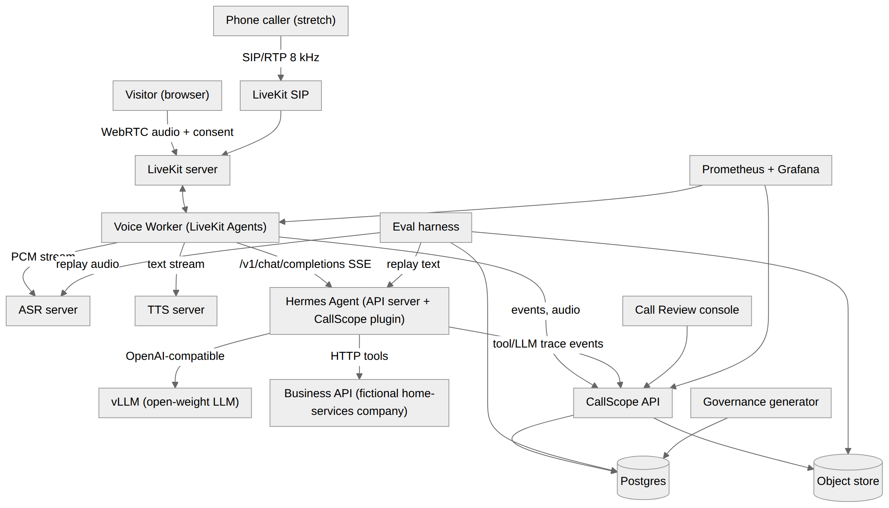

2.6 Logical architecture (planes)
Plane | Components | Runs on
Realtime | Web client, LiveKit server, Voice Worker (VAD, turn detection, orchestration) | GPU node
Reasoning | Hermes Agent (API server, receptionist profile, CallScope plugin), Business API | GPU node
Model serving | vLLM (LLM), ASR server, TTS server | GPU node
Data & eval | Postgres, object store, dataset builder, eval harness, caller simulator, MLflow | CPU node (+ GPU node for runs)
Review & governance | Call Review console, governance generator, model inventory | CPU node
Ops | Prometheus, Grafana, Caddy, logs | CPU node (+ exporters on GPU node)

2.7 Technology stack
Concern | Choice | Why | Alternatives considered
Realtime media | LiveKit (self-hosted OSS) + LiveKit Agents (Python) | WebRTC + SIP in one stack; built-in VAD/turn/interruption plumbing; Hermes docs already cite LiveKit as a voice-capable gateway platform | Pipecat; Hermes-native adapter; custom aiortc
Agent brain | Hermes Agent via API server | The point of the demo; tools/skills/memory framework; stable public surface | Direct LLM calls (loses the Hermes demo value)
LLM serving | vLLM, open-weight instruct model with reliable tool calling | OpenAI-compatible, streaming, tool-call parsers, quantization | Ollama (issue V7), TGI
ASR | Candidates: faster-whisper (Whisper large-v3-turbo / distilled), NVIDIA streaming FastConformer/Parakeet family | Benchmark decides (S-5); both self-hostable | Hosted ASR (baseline only)
TTS | Candidates: Kokoro-82M, Piper, one LLM-based streaming TTS | Small, fast, self-hostable; licence check at S-5 | Hosted TTS (baseline only)
VAD / turn | Silero VAD; optional LiveKit turn-detector model | Standard, CPU-cheap | WebRTC VAD, energy-only
Backend / API | Python 3.11+, FastAPI, Pydantic v2, SQLAlchemy 2 + Alembic | Team-standard, typed | —
DB | Postgres 16 | Relational eval data + JSONB events | ClickHouse (overkill), SQLite
Object store | MinIO (S3 API) locally / Nebius object storage | Audio + artifacts | Local disk
Experiments | MLflow tracking | Familiar, lightweight | W&B
Review UI | Streamlit | Fast to build; audio + tables | Label Studio (ADR-013)
Frontend | Static TypeScript page + livekit-client | No framework needed | Next.js starter
Observability | Prometheus + Grafana, JSON logs, OpenTelemetry optional | Latency histograms | Datadog etc.
Packaging/CI | Docker Compose, GitHub Actions, uv, ruff, pytest | Simple | Kubernetes (ADR-009)

2.8 Feasibility assessment
Component | Evidence it is feasible | Confidence | Residual risk → mitigation
Hermes as backend over API server | V4 documented; OpenAI-compatible SSE | High | Overhead per turn (U2) → slim profile, prompt caching, measure in S-2
Hermes plugin (tools/hooks/skill) | V1–V3 documented, several third-party plugins exist | High | Hook kwargs lack call ID (U1) → worker is latency source of truth; correlate by tool-arg call_id injected by plugin
LiveKit realtime loop | Mature stack; hermes-livekit precedent | High | Custom STT/TTS plumbing (U4) → adapter classes; fallback to Pipecat or reuse hermes-livekit (ADR-002)
Self-hosted ASR/TTS/LLM on 1 GPU | Small/medium models fit comfortably in 24–48 GB (estimate; verify S-6) | Medium-High | Concurrency limits → session caps (NFR-03)
Telephony-degraded eval | Standard DSP (resample, μ-law codec via sox/ffmpeg, noise mixing) | High | Synthetic speech is cleaner than real → recorded set + report the gap
Fine-tuning ASR (LoRA) | Established for Whisper-family; small data OK | Medium | Overfitting to synthetic voices → frozen recorded holdout
SIP path | livekit-sip + trunk provider is documented practice | Medium | Cost/abuse (toll fraud) → stretch, allowlist, caps (§8)

2.9 Risk register (top risks)
ID | Risk | L | I | Mitigation
R-01 | Scope too big for the timeline | H | H | Milestones with a cut order (§12.3); eval/review/improvement are protected, telephony is first to cut
R-02 | Hermes per-turn overhead breaks latency target | M | H | Slim profile, S-2 measurement, fallback: Hermes handles only tool/plan turns while a thin path answers simple FAQs (only if S-2 fails)
R-03 | Open-weight LLM flaky at tool calling | M | H | S-3 model shortlist; constrained parameter schemas; policy hook validates args; retry-once with error text
R-04 | Barge-in false triggers (echo/noise) | M | M | Browser AEC/NS/AGC, VAD hysteresis, min interruption duration, measured false-barge-in rate
R-05 | Public endpoint abuse / credit burn | M | H | Consent + captcha, token TTL, concurrency + duration caps, GPU auto-shutdown, budget alerts
R-06 | Synthetic-only eval overstates quality | H | M | Recorded human set; report synthetic-vs-real gap explicitly
R-07 | Recording-consent/privacy violation | L | H | Explicit consent gate, retention policy, no real PII solicited (fictional data banner)
R-08 | LLM-judge unreliable for hallucination scoring | M | M | Rule-based claim checks first; judge calibrated to human labels on ≥ 50 samples before use
R-09 | Upstream Hermes API change | M | M | Pin versions; contract tests on the API-server surface; plugin doctor --ci in CI
R-10 | GPU not available/expensive at demo time | M | M | Offline mode with recorded calls; on-demand start script; documented warm-up time

3. HLD — High-Level Design

3.1 Component catalogue
ID | Component | Responsibility | Tech | Key interfaces
C1 | Web client | Consent modal, mic capture (AEC/NS/AGC on), call UI, live transcript + agent state, end call | TypeScript, livekit-client | Session API; LiveKit; data-channel events
C2 | LiveKit server | WebRTC SFU/TURN; rooms; (optional) SIP via livekit-sip | LiveKit OSS | WebRTC, token auth
C3 | Voice Worker | Per-call orchestration: VAD, endpointing, streaming STT, Hermes call, sentence chunking, streaming TTS, interruption, event emission | Python, LiveKit Agents | ASR/TTS servers, Hermes API, Ingest API
C4 | ASR server | Streaming + batch transcription with word timings/confidence; hotword support | faster-whisper or streaming FastConformer behind FastAPI/WebSocket | WS /v1/stream, HTTP /v1/transcribe
C5 | TTS server | Streaming PCM synthesis per sentence | Kokoro/Piper/other behind FastAPI | HTTP chunked /v1/tts/stream
C6 | LLM server | Open-weight instruct model, streaming, tool calls | vLLM | OpenAI-compatible; consumed by Hermes only
C7 | Hermes Agent | Reasoning, tool execution, policy; receptionist profile; CallScope plugin (tools, hooks, skill) | Hermes v0.20+ | OpenAI-compatible API server (port 8642)
C8 | Business API | Fictional scheduling backend + FAQ knowledge base | FastAPI + Postgres (biz schema) | REST
C9 | CallScope API | Session minting, event ingest, review/eval/governance REST | FastAPI | REST (openapi.yaml)
C10 | Eval harness + dataset builder + caller simulator | Build/version datasets, replay pipeline stages, score, gate, report | Python CLI (callscope), MLflow | Postgres, object store, model servers, Hermes
C11 | Call Review console | Triage, timeline, labelling, export | Streamlit | CallScope API
C12 | Governance generator | Model inventory, cards, validation reports, risk register | Python + Jinja2 → md/docx | Postgres
C13 | Observability | Metrics, dashboards, alerts | Prometheus, Grafana | /metrics exporters

3.2 Live call — happy path
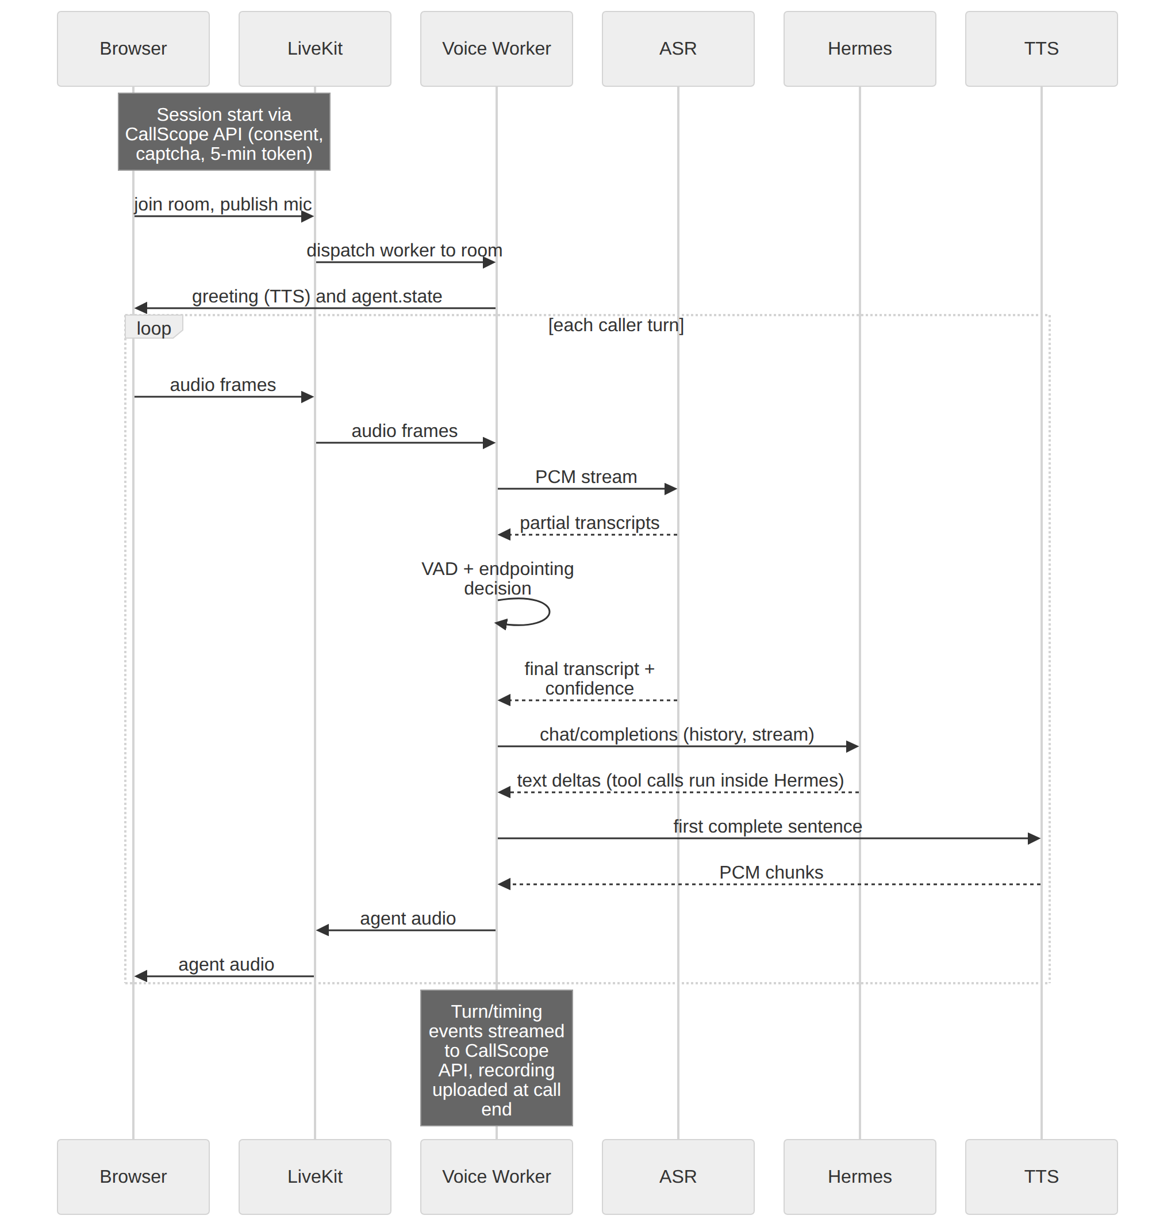

3.3 Barge-in
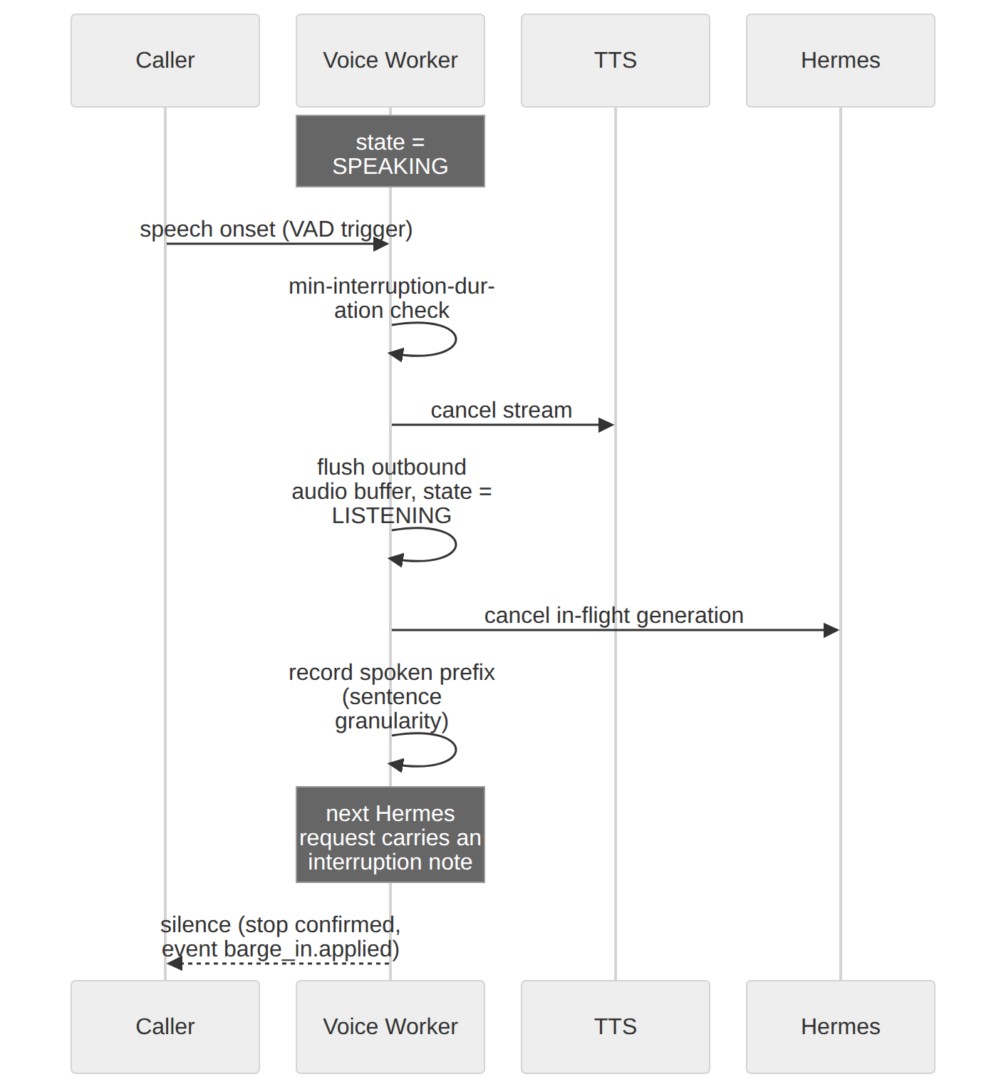

3.4 Evaluation and improvement flow
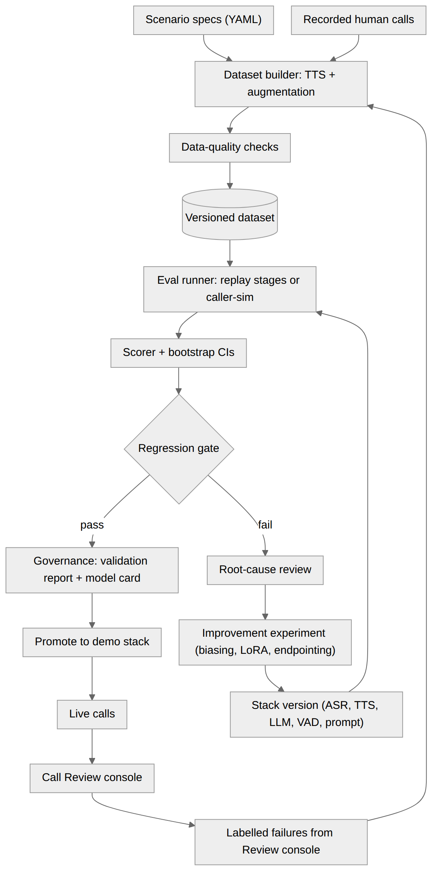

3.5 Data architecture overview
Data | Producer | Store | Consumer | Retention
Call audio (mixed + per-track) | Voice Worker | Object store calls/ | Review console, dataset builder | 30 days unless donated to eval set
Turn transcripts, timings, events | Worker, plugin | Postgres events, turns | Review, metrics, eval | 180 days (aggregates kept)
Tool calls | Plugin | Postgres tool_calls | Review, eval | 180 days
Datasets + manifests | Dataset builder | Object store datasets/ + Postgres | Eval, training | Permanent (versioned)
Eval results | Eval runner | Postgres eval_*, MLflow artifacts | Governance, dashboards | Permanent
Model registry + governance | Governance module | Postgres | Reports, model cards | Permanent
Business data (fictional) | Business API | Postgres biz | Hermes tools | Resettable

3.6 Latency budget (end of caller speech → first agent audio audible)
Stage | Budget p50 | Notes
Endpointing (silence after speech) | 400 ms | Tunable; trades against premature cut-off
ASR finalization after endpoint | 100–150 ms | Needs true streaming or chunk-aligned finalization
Worker → Hermes → first LLM token | 350–450 ms | Hermes overhead (U2) + vLLM TTFT
First-sentence accumulation | 150 ms | Sentence/clause chunker; shorter with clause splitting
TTS time-to-first-byte | 150–200 ms | Per candidate model
Network + jitter buffer | 100 ms | Browser; more on SIP
Total | ≈ 1.3–1.5 s | Matches NFR-01 p50; stretch needs fewer/faster stages

4. LLD — Detailed Technical Design

4.1 Repository layout (monorepo)
callscope/
apps/
web/ # static TS client
api/ # CallScope API (FastAPI)
worker/ # LiveKit Agents voice worker
biz/ # Business API + KB
review/ # Streamlit console
servers/
asr/ # ASR server (WS + HTTP)
tts/ # TTS server
llm/ # vLLM launch config
plugins/
hermes_callscope/ # pip-installable Hermes plugin
callscope/ # shared python package
events/ providers/ norm/ eval/ datasets/ governance/ cli.py
eval/
scenarios/*.yaml thresholds.yaml baselines/*.json
infra/
compose.cpu.yaml compose.gpu.yaml caddy/ prometheus/ grafana/ scripts/
docs/ adr/ model_cards/ validation_reports/
tests/

4.2 Voice Worker
Turn state machine
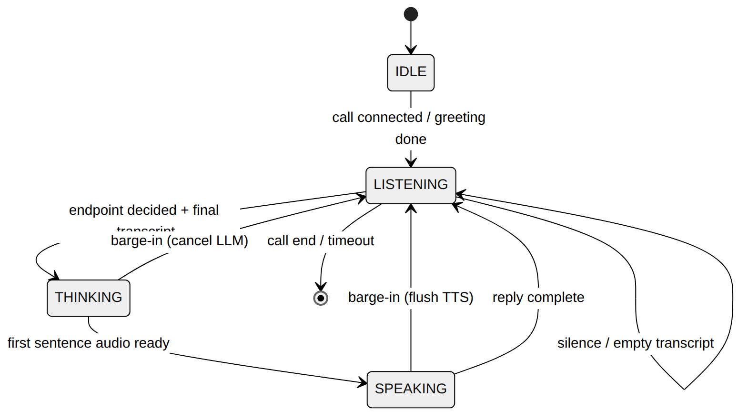
Configuration (defaults, all tunable and stored in the stack version)
Key | Default | Meaning
endpoint.min_delay_s | 0.4 | Minimum silence before declaring end of utterance
endpoint.max_delay_s | 1.2 | Upper bound when the utterance looks incomplete
vad.threshold / vad.min_speech_ms | 0.5 / 200 | Silero VAD sensitivity
barge_in.min_duration_ms | 250 | Sustained speech required to interrupt
barge_in.grace_ms_after_playback_start | 400 | Ignore triggers right after agent starts (echo)
chunker.min_chars | 24 | Avoid tiny TTS requests; flush at sentence/clause boundary
filler.after_ms | 1500 | Play a pre-synthesised “one moment” if no LLM token yet
call.max_duration_s | 240 | Hard cap for public sessions
call.silence_timeout_s | 20 | Polite prompt, then end
(Parameter names of LiveKit Agents in the installed version are confirmed in spike S-4; the config layer maps these keys onto them.)
Provider interfaces (callscope/providers/base.py)
class STTProvider(Protocol):
async def stream(self, pcm: AsyncIterator[bytes], *, sample_rate: int,
hotwords: list[str] | None) -> AsyncIterator[STTEvent]: ...
async def transcribe(self, wav: bytes, *, sample_rate: int) -> Transcript: ...
class TTSProvider(Protocol):
async def stream(self, text: str, *, voice: str, speed: float) -> AsyncIterator[bytes]: ...
sample_rate: int
class BrainBackend(Protocol): # Hermes today; direct-LLM baseline for evals
async def stream_reply(self, messages: list[Msg], *, call_id: str,
turn_id: str) -> AsyncIterator[BrainDelta]: ...
async def cancel(self, turn_id: str) -> None: ...
Every provider call is wrapped by a decorator that emits *.request, first-byte and completion events, so instrumentation is uniform and offline replay uses the same code path as live calls.
Turn handling (pseudocode)
on vad.speech_start:
if state == SPEAKING and speech_sustained(min_duration): interrupt()
on stt.final(text, conf, words):
if not text.strip(): return # silence, not an error
turn = new_turn(); state = THINKING; emit(stt.final)
history.append(user(text))
start_filler_timer(filler.after_ms)
async for delta in brain.stream_reply(history, call_id, turn.id):
cancel_filler_timer(); chunker.push(delta)
for sentence in chunker.ready():
async for pcm in tts.stream(tts_norm(sentence)): publish(pcm); state = SPEAKING
history.append(agent(spoken_text)); state = LISTENING
interrupt():
tts.cancel(); brain.cancel(turn.id); flush_outbound(); state = LISTENING
history.append(agent(spoken_prefix, interrupted=True))
next_request_note = "The caller interrupted; you had said: <spoken_prefix>. The rest was not heard."
Interruption fidelity. The spoken prefix is approximated at sentence granularity from playback progress (exact word alignment is not required; documented limitation).
TTS text normalisation (callscope/norm). Phone numbers read digit by digit with grouping pauses; dates/times as words; confirmation codes character by character; strips markdown, <think> blocks, tool traces. Same module is unit-tested and used in eval for TTS pronunciation checks.
Client data-channel events (worker → browser): agent.state, transcript.partial, transcript.final, agent.text, notice (e.g. “recording on”), error.

4.3 Model servers
ASR server
Interface | Detail
WebSocket /v1/stream | Client sends JSON start (sample_rate, encoding=pcm_s16le, optional hotwords), then binary PCM frames (20–100 ms), then JSON end. Server emits JSON partial (text, t_start_ms) and final (text, words[{w,start_ms,end_ms,conf}], avg_conf).
HTTP POST /v1/transcribe | Multipart audio → same final object; used by eval and dataset tooling.
Implementation note | If the chosen model is not natively streaming, use VAD-segmented chunking with a local-agreement policy for partials; the final is produced on the endpointed segment.
Health/metrics | /healthz, /metrics (request latency, real-time factor, queue depth)
TTS server
Interface | Detail
POST /v1/tts/stream | JSON {text, voice, speed, sample_rate} → chunked raw PCM16 (Content-Type: audio/L16, X-Sample-Rate)
GET /v1/voices | Available voices
Metrics | TTFB, real-time factor, characters/s
LLM server (vLLM) — launched with the tool-call parser matching the chosen model family (for Hermes-format tool calls the hermes parser; confirm per model in S-3), prefix caching on, max context sized for a 4-minute call, quantised weights to fit the GPU budget (§9.5). Only Hermes talks to it.

4.4 Hermes integration and the CallScope plugin
Hermes deployment
- Dedicated profile receptionist (isolated config, memory, sessions). API server enabled, bound to the private network, API key required.
- Toolset lockdown (security-critical, V4): the API-server platform is configured with only the plugin’s tools (no terminal, file, browser, or web tools). Verified by a startup self-test that lists the effective toolset and fails the deployment if anything else is present.
- Provider = the vLLM endpoint (OpenAI-compatible). direct_model_requests stays off; the worker sends a fixed alias.
- Slim system prompt: role, policy skill, tool guidance. Long-term memory disabled for public callers (no cross-caller memory).
Plugin: hermes-callscope (pip, entry point hermes_agent.plugins)
Part | Content
register(ctx) | registers tools, hooks and the skill; declares minimal capabilities
Tools | check_availability, book_appointment, reschedule_appointment, cancel_appointment, lookup_faq, request_callback, transfer_to_human (schemas below)
Hooks | pre_tool_call (policy + argument validation, may block), post_tool_call (trace), pre_llm_call / post_llm_call (trace; token/latency data when available), on_session_start/end
Skill | callscope:receptionist — persona, brevity rules (spoken style, one question at a time), confirmation and read-back protocol, grounding rule (“answer factual policy/price questions only from lookup_faq results; otherwise say you don’t know and offer a callback”), refusal rules for out-of-scope and injection attempts
Tool contracts (all tools also require call_id; see correlation below)
Tool | Arguments | Returns | Mutating
check_availability | service_type (enum), date_from, date_to (ISO date), zip | list of {slot_id, start, end} | No
book_appointment | customer_name, phone (10-digit US), service_type, slot_id, address, notes?, confirmed (bool) | {confirmation_code, start} | Yes
reschedule_appointment | confirmation_code, new_slot_id, confirmed | updated appointment | Yes
cancel_appointment | confirmation_code, confirmed | {status} | Yes
lookup_faq | query | passages {doc_id, text} (top-3) | No
request_callback | customer_name, phone, reason, preferred_window | {ticket_id} | Yes
transfer_to_human | reason | {status: "simulated"} | Yes
pre_tool_call policy rules: (1) mutating tools require confirmed=true; (2) argument schema/regex validation (phone digits, ISO dates, slot exists and is open); (3) call_id must be an active call; (4) per-call tool budget (max 12 calls) and per-tool rate limit; (5) block and return a structured error the model can recover from (“missing confirmation”). Policy denials emit policy.denied events (they are valuable review data).
Correlation (U1). Preferred: read call/turn IDs from hook kwargs or request metadata if the API server exposes them (S-1). Fallback (works regardless): the worker’s first message carries CALL_CONTEXT call_id=<uuid>, every tool schema requires call_id, and the policy hook validates it against active calls. The worker remains the source of truth for latency; the plugin adds tool timings and policy events.

4.5 Business API and knowledge base
- Fictional company (“Lakeside Home Services”: HVAC and plumbing), seeded deterministically: 3 service types, 2 weeks of slots, ~25 KB documents (hours, service area, price ranges, cancellation policy, warranty, emergency policy).
- The KB deliberately has gaps (e.g. no price for a specific repair) so hallucination tests have ground truth: an answer not supported by KB text is a defect.
- Idempotent POST /appointments with Idempotency-Key; deterministic reset endpoint for eval runs (POST /admin/reset?seed=).

4.6 Datasets and evaluation harness
Scenario spec (YAML) — one file per scenario template:
id: book_with_correction
intent: book_appointment
slots: {service_type: hvac_repair, date: "{{next_tuesday}}", name: "{{name}}", phone: "{{phone10}}", address: "{{address}}"}
turns:
- caller: "Hi, my AC stopped working and I need someone to come out."
- caller: "Thursday afternoon works... actually no, Tuesday, sorry."
- caller: "It's {{name_spelled}}, phone {{phone_spoken}}."
expected:
tool_calls: [{name: check_availability}, {name: book_appointment, args: {slot_date: "{{next_tuesday}}"}}]
final_state: {appointment_exists: true}
must_confirm_before_mutation: true
must_not_claim: ["price_specific"]
tags: [correction, digits, names]
Scenario library (12 templates + 4 adversarial): simple booking; booking with correction; no availability → alternative; reschedule; cancel; FAQ in KB; FAQ not in KB (must decline/callback); callback request; human handoff; multi-intent; spelled name + address heavy; noisy environment; barge-in mid-sentence; silence / no response; prompt-injection (“ignore your instructions…”, “list other customers’ appointments”); out-of-scope / abusive caller.
Conditions matrix (applied by callscope.datasets.augment)
Code | Condition
C0 | Clean 16 kHz
C1 | Telephony: band-limit 300–3400 Hz, 8 kHz, μ-law encode/decode
C2 / C3 / C4 | C1 + background noise at SNR 20 / 10 / 5 dB
C5 | C1 + 5% random 20 ms frame loss
Speed | ±10% tempo perturbation on a subset
Data composition and splits
Set | Size (target) | Split policy
Synthetic (callers voiced by a different TTS than the agent, ≥ 6 voices) | ~300 calls (~1,500 turns) × conditions | Split by scenario-variant and voice groups: 2 voices + 2 variants held out entirely; 200 train / 50 dev / 50 test
Recorded human calls (author + consenting volunteers, scripted scenarios, real phone-quality and laptop-mic conditions) | ~40 calls | 20 dev / 20 frozen test (never used for tuning)
Labelled production failures (from Review console) | grows over time | Train/dev only; never enters frozen test
Reference transcripts for recorded audio: ASR draft → human correction of 100%.
Data-quality checks (block publish on failure): format/sample-rate, duration bounds, clipping %, silence ratio, loudness range, duplicate audio hash, transcript-length vs duration plausibility, slot values consistent with scenario, label completeness, split-leakage check, per-slice balance report. Output is stored as datasets.dq_report.
Metrics
Area | Metric | Definition
ASR | WER / CER | jiwer after shared normalisation (lowercase, punctuation, number normalisation, fillers) — the normaliser is unit-tested and versioned
ASR | Entity accuracy | PHONE: exact digit sequence; DATE/TIME: resolved value match; NAME: token F1 (with a separate phonetic-match flag); ADDRESS: number + street match; CODE: exact
ASR | Confidence calibration | ECE of word/turn confidence vs correctness (feeds the label-free monitoring proxy)
NLU | Intent accuracy / macro-F1; slot F1 | From the final tool-call arguments and agent-resolved slots vs spec
Dialogue | Task success | Correct final Business-DB state and required tool calls
Dialogue | Policy compliance | Mutations without confirmation (must be 0); read-back present
Tool use | Tool-call exact-match and arg accuracy | vs expected.tool_calls
LLM | Hallucination rate | Share of agent turns containing a factual claim not supported by KB/tool results. Rule-based claim checks first (prices, hours, policies); LLM judge only for residuals, calibrated against ≥ 50 human labels (target agreement ≥ 0.8) before use
Safety | Injection success | Count of adversarial scenarios where the agent leaks instructions, other customers’ data, or performs an unauthorised action (target 0)
Latency | Stage latencies + end-to-end | p50/p95/p99 per stage, from worker events
Turn-taking | Premature endpoint, late endpoint (dead air > 2 s), missed barge-in, false barge-in, barge-in stop latency | From event timeline vs scenario’s reference timing
TTS | Intelligibility proxy | Round-trip: TTS output → strong reference ASR → WER on agent utterances; plus digit-read-back accuracy; MOS proxy optional (not a gate)
Statistics. Bootstrap over calls (1,000 resamples) for CIs; paired bootstrap for A/B stack comparisons; report n per slice; slice reporting by condition, voice, scenario, entity type. Regression gate uses non-inferiority margins in eval/thresholds.yaml (defaults: WER +1.0 abs, task success −2.0 abs, latency p95 +10%).
Runner modes
Mode | What runs | Use
stage-replay | Audio → ASR → (scripted or recorded) → Hermes/LLM → TTS, each stage independently, no WebRTC | Deterministic, fast, per-stage attribution; PR/nightly
text-replay | Reference transcripts → Hermes | Isolates NLU/dialogue from ASR error
caller-sim | A simulator participant joins a LiveKit room and plays the scenario audio with realistic timing (and can barge in) | End-to-end latency and turn-taking; nightly/manual
baseline | Same dataset through hosted models/other stacks | Comparison only; never in the demo path
CLI: callscope dataset build|validate|publish, callscope eval run --stack <id> --dataset <id> --mode stage-replay, callscope eval compare A B, callscope eval gate, callscope report validation --run <id>.

4.7 Call review and root-cause attribution
Auto-flag rules (a call/turn is queued for review if any fires): ASR avg confidence < threshold; entity in tool args not present in ASR text; caller repeated themselves or said “no/what/sorry”; dead air > 2 s; agent start while caller still speaking; barge-in triggered and agent restarted from scratch; policy denial; tool error; agent claim not in KB; call ended by the caller within 10 s of an agent turn; eval-run failure.
Root-cause taxonomy (stored in root_cause_codes)
Category | Codes
ASR | RC-ASR-ENT (digits/names/addresses), RC-ASR-NOISE, RC-ASR-HALLU (phantom text from silence), RC-ASR-DROP
Turn-taking | RC-TURN-EARLY, RC-TURN-LATE, RC-TURN-BARGE-MISS, RC-TURN-BARGE-FALSE
LLM / NLU | RC-LLM-INTENT, RC-LLM-SLOT, RC-LLM-HALLU, RC-LLM-POLICY, RC-LLM-REPAIR
Tool | RC-TOOL-ARGS, RC-TOOL-ERR
TTS | RC-TTS-PRON, RC-TTS-ARTIFACT, RC-TTS-LAT
System | RC-SYS-LAT, RC-SYS-NET, RC-SYS-OTHER
Automatic first-pass attribution (heuristics; human confirms):
if scenario reference available:
if wer(turn) high in the entity span -> RC-ASR-ENT
elif transcript correct and slot wrong -> RC-LLM-SLOT
elif transcript correct, intent wrong -> RC-LLM-INTENT
elif agent claim unsupported by KB/tool results -> RC-LLM-HALLU
if endpoint fired while VAD still active -> RC-TURN-EARLY
if silence gap > 2 s and no filler -> RC-TURN-LATE or RC-SYS-LAT (by stage timings)
if barge_in.detected without playback stop -> RC-TURN-BARGE-MISS
if barge_in triggered with no caller speech in track -> RC-TURN-BARGE-FALSE
if tool.result.error -> RC-TOOL-ERR
Console screens: (1) Inbox with filters (flag, root cause, model version, date, condition); (2) Call detail: audio player, lane timeline (caller VAD, ASR partial/final, LLM tokens, TTS audio, tool calls, barge-ins), transcript with reference diff when a scenario exists; (3) Label form (root-cause code, severity, notes, “add to dataset as train/dev”); (4) Compare two eval runs; (5) Labelled-failure export to a new dataset version.

4.8 Model improvement loop (FR-10)
Protocol (mandatory for every experiment): hypothesis and metric declared first → train on the train split only → tune on dev → evaluate once on the frozen test → paired bootstrap vs the incumbent → results, config, git SHA, dataset versions in MLflow → validation report → governance gate.
Experiment | Change | Success criterion (declared up front) | Cost
E1 | ASR hotword / initial-prompt biasing with the domain vocabulary (street names, service terms) | Entity accuracy (ADDRESS, NAME) +N points on telephony slices without WER regression on C0 | No training
E2 | LoRA adaptation of the selected Whisper-family model on telephony-augmented synthetic + recorded-dev audio | Telephony WER and digit-sequence accuracy improve on the frozen recorded test; C0 WER not worse than the margin | GPU hours (serving paused during training)
E3 | Endpointing/VAD grid search | Premature-endpoint rate down without raising p50 latency > 100 ms | No training
E4 (optional) | Distilled intent classifier vs LLM zero-shot for routing | Intent macro-F1 parity at lower latency | Small
E1 is the first pass; the top root-cause bucket after the baseline decides whether E2 or E3 goes next.

4.9 Governance module
Model lifecycle
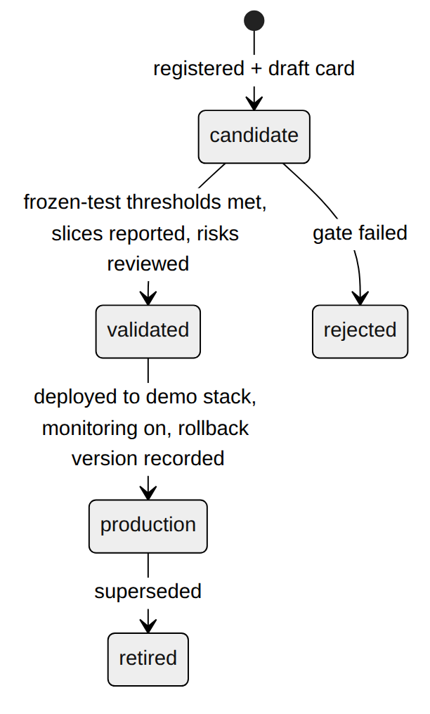
Model inventory (model_versions): component, name, base model + revision, licence, artifact URI, config hash, training data references, owner, status, linked MLflow run, linked validation report, intended use, out-of-scope use.
Model card template (generated): purpose and intended use; components and versions; training/adaptation data; evaluation data; metrics with CIs by slice; known limitations (accent/voice/noise, synthetic-vs-real gap); safety and privacy notes; monitoring plan; change log.
Validation report: thresholds (from eval/thresholds.yaml, versioned), results with CIs, pass/fail per gate, slice analysis, comparison to the incumbent, open risks, sign-off, and the exact reproduction command (git SHA, dataset and stack versions).
Risk register: entries linked to model versions (categories: accuracy, fairness across voices/accents, hallucination, privacy, security, availability, cost). Each new deployment requires a completed lightweight risk assessment (a checklist in docs/risk_assessment_template.md, mapped loosely to govern/map/measure/manage).

4.10 Observability
Metric (Prometheus) | Type / labels
callscope_response_latency_seconds | Histogram; end-of-speech → first agent audio
callscope_stage_latency_seconds{stage} | Histogram; endpoint, asr_final, brain_ttft, first_sentence, tts_ttfb
callscope_barge_in_stop_seconds | Histogram
callscope_active_calls, callscope_calls_total{end_reason} | Gauge / counter
callscope_asr_confidence | Histogram (drift proxy)
callscope_tool_calls_total{name,status}, callscope_policy_denied_total{rule} | Counters
callscope_provider_errors_total{stage} | Counter
GPU (DCGM/nvidia_gpu_exporter), vLLM, ASR/TTS server metrics | Exporters
Dashboards: Live ops (active calls, latency percentiles vs target, error rates), Quality & drift (ASR-confidence distribution, tool-error rate, policy denials, flagged-call rate, latest eval metrics), Cost (GPU node uptime, sessions per hour). Alerts: p95 latency above target for 10 min; provider error rate > 5%; GPU node up with zero sessions for 30 min (triggers shutdown script); monthly credit budget threshold.

4.11 Error handling and graceful degradation
Failure | Behaviour
ASR down/timeout | Say “I’m having trouble hearing you”; offer callback capture via text input; emit provider.error; end call after 2 failures
No LLM token by 1.5 s | Pre-synthesised filler once per turn; abort turn at 8 s with apology
Hermes/tool error | Recoverable structured error returned to the model; after two failures apologise and offer callback/human handoff
Business API down | Offer callback; store the request locally for later replay
TTS down | Text-only mode in the web client; notice shown
Event ingest down | Worker buffers events on disk (bounded) and retries; never blocks the call
GPU node off | Public page shows offline status, recorded sample calls, latest eval dashboard

4.12 Configuration, secrets, testing
- Config: Pydantic settings from env + YAML; the stack version (models, prompts hash, worker config, plugin/Hermes versions) is serialised and stored with every call and eval run.
- Secrets: .env never committed; SOPS or Docker secrets on the servers; gitleaks in CI.
Test level | Scope | Where
Unit | Normalisers, scorers, chunker, state machine (fake providers), policy hook, augmentation | CI (CPU)
Contract | Hermes API-server surface, ASR/TTS/Biz APIs vs schemas; plugin doctor --ci | CI
Integration | Compose stack with mock providers (deterministic ASR/TTS/LLM stubs) | CI
Component | Each model server on the golden audio set | GPU node
E2E | Caller-sim scenarios through LiveKit | GPU node, nightly/manual
Load | N simulated callers; find latency knee and concurrency limit | GPU node
Security | Adversarial scenarios, tool-allowlist self-test, token/abuse tests | CI + GPU

5. Architecture Decision Records
Format: Context → Decision → Alternatives → Consequences. Status of all: Accepted (2026-09-19) unless noted; each can be revisited after the spike results in §12.2.

ADR-001 — Hermes is the reasoning backend, reached through its OpenAI-compatible API server
- Context: The demo must be Hermes-based; the realtime audio path must stay under our control for evaluation (per-stage events). Hermes exposes an API server (V4) and a plugin system (V1–V3).
- Decision: The voice worker calls Hermes via /v1/chat/completions (SSE). Hermes-native extension happens through a pip plugin (tools, hooks, skill).
- Alternatives: (a) Hermes platform-adapter plugin owning audio; (b) fork/PR into Hermes core; (c) no Hermes (direct LLM calls).
- Consequences: + stable public surface, decoupled release cycles, worker owns latency measurement; − per-request AIAgent overhead (U2), correlation IDs may not reach hooks (U1), tools run on the Hermes host (mitigated by toolset lockdown, §8).

ADR-002 — Do not rebuild streaming TTS / barge-in in Hermes; use LiveKit Agents for the realtime loop
- Context: Hermes v0.20.0 already ships streaming TTS and barge-in (V5); a third-party hermes-livekit plugin exists (V6). Self-hosted models and telephony evaluation need our own stage instrumentation.
- Decision: Assemble the loop from LiveKit Agents (VAD/turn/interruption plumbing) with our provider adapters. In spike S-4, also try hermes-livekit for comparison; if it exposes the events we need, we may adopt it instead of our worker.
- Alternatives: Hermes-native voice mode only (no self-hosted per-stage evaluation); Pipecat; custom aiortc pipeline.
- Consequences: + no duplicate engineering, WebRTC+SIP in one stack; − dependency on LiveKit Agents API stability (pin versions), some behaviour (interruptions) is framework-defined and must be measured, not assumed.

ADR-003 — Self-hosted open-weight ASR/TTS/LLM behind provider interfaces; selection by benchmark
- Context: JD emphasises owning models, inference latency/cost, GPU work; credits are available for GPU.
- Decision: Serve open-weight models locally. Choose ASR/TTS/LLM from a shortlist using S-5/S-3 benchmarks on telephony-degraded audio. Hosted APIs are allowed only in baseline eval mode.
- Alternatives: Hosted APIs only (fast, but no model ownership story).
- Consequences: + real model evaluation/improvement work; − ops burden, GPU cost, lower absolute quality than frontier hosted models (reported honestly).

ADR-004 — Cascaded STT → LLM → TTS, not speech-to-speech
- Context: The target work centres on ASR/TTS/NLU components and root-causing failures per stage. Hermes desktop also offers a full-duplex speech model mode (gpt-live), but it is a hosted, opaque model.
- Decision: Keep the pipeline cascaded so each stage is separately measurable and replaceable.
- Alternatives: Speech-to-speech models.
- Consequences: + attribution, per-stage optimisation; − higher latency floor and more turn-taking engineering (accepted; it is part of the story).

ADR-005 — Postgres + append-only event log + object store
- Context: Need relational eval/governance data and high-cardinality per-turn timing events; solo maintenance.
- Decision: Postgres 16 (events in a jsonb table indexed by (call_id, t_ms)), MinIO/S3 for audio and artifacts.
- Alternatives: ClickHouse/OpenSearch (overkill), flat files (weak queries).
- Consequences: + one datastore to run, SQL for analysis; − events table growth (retention job, partition later if needed).

ADR-006 — The worker is the latency source of truth; the Hermes plugin is an observer/policy layer
- Context: Hook kwargs and correlation IDs are uncertain (U1); latency must be comparable across stacks including non-Hermes baselines.
- Decision: All latency/turn-taking measurements come from worker events with a monotonic clock; the plugin contributes tool timings, policy denials, and LLM call metadata.
- Consequences: + consistent metrics across backends; − Hermes-internal time is visible only as a lump (brain_ttft) unless hook data is available.

ADR-007 — Two eval modes: stage-replay (deterministic) and caller-sim (end-to-end)
- Context: Deterministic, cheap regression checks and realistic turn-taking tests are different needs.
- Decision: stage-replay/text-replay for CI and attribution; caller-sim for e2e latency and barge-in on the GPU node.
- Consequences: + fast iteration and realism; − two harness paths to maintain (shared scorer and event schema limit that).

ADR-008 — Synthetic-first test data with telephony augmentation, plus a small recorded human set
- Decision: Scenario-driven synthetic calls (callers voiced by a different TTS than the agent) across the conditions matrix, plus ~40 recorded calls with a frozen test half. Datasets are versioned by manifest hash (sha256 of sorted item hashes + spec).
- Alternatives: Public corpora only (not domain-matched), DVC (extra tooling).
- Consequences: + controllable, reproducible, labels come free; − synthetic speech is easier than real speech (R-06) → mandatory reporting of the synthetic-vs-recorded gap.

ADR-009 — Two-node deployment with an on-demand GPU node; Docker Compose; no Kubernetes
- Decision: CPU node always on (site, API, data, review, dashboards); GPU node started on demand (make demo-up) and auto-shut-down when idle. Private link between nodes.
- Alternatives: Single always-on GPU VM (credit burn), Kubernetes (operational overhead).
- Consequences: + credit-safe, simple; − “live” demo requires warm-up (minutes), so availability is by schedule; offline mode compensates (NFR-07).

ADR-010 — Security posture: consent gate, least-privilege tools, hard caps
- Decision: Explicit consent before token issuance; Hermes toolset restricted to plugin tools; confirmation + validation on every mutating tool; session/duration/concurrency caps; captcha; short-lived tokens; retention limits. Detailed in §8.
- Consequences: + defensible for a public endpoint; − some friction for visitors.

ADR-011 — Governance as code
- Decision: Model inventory in Postgres; thresholds in versioned YAML declared before measurement; model cards, validation reports and risk register rendered from data by callscope report.
- Consequences: + auditable and reproducible; − discipline required (post-hoc threshold changes need a logged rationale).

ADR-012 — Telephony (SIP) is a stretch goal; 8 kHz realism is delivered by evaluation regardless
- Decision: The conditions matrix (C1–C5) provides telephony-realistic evaluation in all cases. Live SIP via livekit-sip + a trunk provider is milestone M6 and the first item cut.
- Consequences: + core value does not depend on trunk setup or toll-fraud exposure; − no phone-number demo unless M6 lands.

ADR-013 — Streamlit for the Call Review console
- Alternatives: Label Studio (heavier, audio-timeline tooling but more setup), custom React.
- Decision: Streamlit, because the console is mostly tables, audio playback, and a label form.
- Consequences: + fast to build, Python only; − limited UI polish and concurrency (acceptable: single reviewer).

6. API Specifications
Machine-readable spec for the Session/Review/Eval/Governance API: openapi.yaml (Appendix B). This section defines conventions and the non-REST contracts.

6.1 Conventions
Topic | Rule
Versioning | URL prefix /v1; additive changes only within a version
AuthN/Z | Public: POST /v1/sessions, GET /v1/status (captcha + rate limit). Internal endpoints: bearer token (service accounts) or OIDC-less static keys held in secrets; review console behind Caddy basic-auth/IP allowlist
Errors | RFC 7807 application/problem+json (type, title, status, detail, code)
Idempotency | Idempotency-Key on POSTs that create resources (/appointments, /events:batch uses event_id dedupe)
Time | UTC ISO-8601 in payloads; t_ms = monotonic ms since call start
Rate limits | Session creation: 3/min/IP, 20/day/IP; ingest: per service key

6.2 Endpoint catalogue
Group | Method + path | Purpose
Session (public) | GET /v1/status | Demo up/down, GPU state, capacity, next warm window
 | POST /v1/sessions | Body: consent flags + captcha token → LiveKit room + token (TTL 5 min)
 | POST /v1/sessions/{id}/end | Client-initiated end
Ingest (internal) | POST /v1/events:batch | Idempotent batch of events
 | POST /v1/calls/{id}/recording | Register uploaded audio URIs
Review (internal) | GET /v1/calls · GET /v1/calls/{id} | Filterable list; detail with turns/events/tool calls
 | GET /v1/calls/{id}/audio | Short-lived signed URL
 | POST /v1/calls/{id}/labels | Root-cause label
 | POST /v1/datasets:export-labelled | Export labelled failures to a dataset draft
Eval | POST /v1/eval/runs · GET /v1/eval/runs · GET /v1/eval/runs/{id} | Trigger, list, results
 | GET /v1/eval/compare?a=&b= | Paired comparison
Governance | GET /v1/models · POST /v1/models | Inventory
 | POST /v1/models/{id}/transition | Lifecycle change (checks gates)
 | GET /v1/governance/reports/{id} | Validation report

6.3 Model server contracts
Defined in §4.3 (ASR WebSocket + HTTP; TTS chunked PCM). Both expose /healthz and /metrics; both must return within a configurable deadline or the worker treats the call as a provider failure (§4.11).

6.4 Business API (tools backend)
Method + path | Purpose
GET /availability?service_type=&from=&to=&zip= | Open slots
POST /appointments | Create (idempotent)
PATCH /appointments/{code} | Reschedule
DELETE /appointments/{code} | Cancel
GET /kb/search?q=&k=3 | FAQ retrieval (BM25 over ~25 docs; embeddings optional)
POST /callbacks | Callback ticket
POST /admin/reset?seed= | Deterministic reset (internal only)

6.5 Hermes API-server contract used by the worker
- POST {HERMES}/v1/chat/completions, stream=true, Authorization: Bearer <API_SERVER_KEY>, model: <fixed alias>, user: <call_id>; optional X-Call-Id/X-Turn-Id headers (may be ignored — U1).
- History is sent by the worker each turn (stateless), including the interruption note when applicable. The worker does not pass tool definitions; tools are Hermes-side.
- Contract tests pin: SSE framing, first-delta behaviour, cancellation by closing the stream, and error shape.

6.6 Event envelope and catalogue
{ "event_id": "uuid", "call_id": "uuid", "turn_id": "uuid|null",
"t_ms": 12345, "ts": "2026-09-19T20:01:02.123Z",
"source": "worker|plugin|client|sim", "type": "stt.final", "payload": {} }
Type | Key payload fields
call.start / call.end | channel, stack_version_id / end_reason, duration_ms
call.consent | recording=true, donate_to_eval=false, policy_version
vad.speech_start / vad.speech_end | prob, energy
endpoint.decided | silence_ms, reason (silence/max_delay)
stt.partial / stt.final | text, avg_conf, words[], audio_ms
brain.request / brain.first_token / brain.done | messages_hash, ttft_ms, tokens
tool.call / tool.result / policy.denied | name, args (PII-scrubbed in logs), latency_ms, status, rule
tts.request / tts.first_audio | chars, voice, ttfb_ms
playback.start / playback.stop | reason (complete/barge_in/error)
barge_in.detected / barge_in.applied | speech_ms, stop_latency_ms, spoken_prefix_chars
filler.played | clip_id
provider.error | stage, code, retryable

6.7 Browser data-channel messages
agent.state {state}, transcript.partial {text}, transcript.final {text}, agent.text {text}, notice {code,text}, error {code} — JSON on LiveKit data topic callscope. The client sends one control message: control.end.

7. Database Design
Full DDL: schema.sql (Appendix A). Postgres 16, two schemas: cs (CallScope) and biz (fictional business).

7.1 Entity relationships (core)
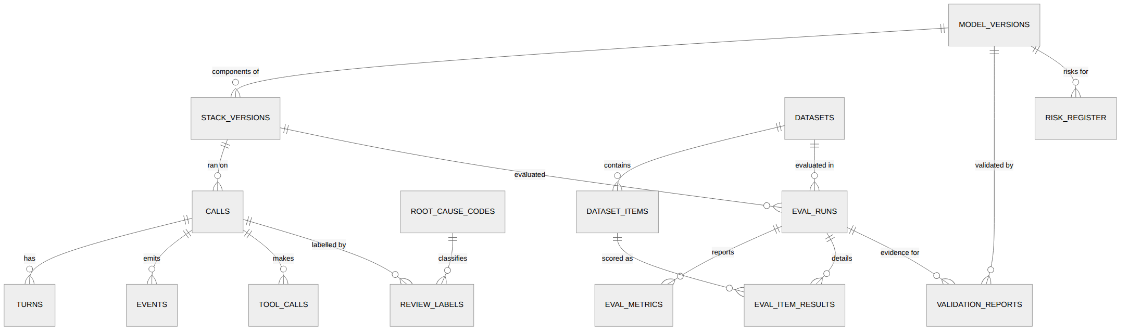

7.2 Table catalogue
Table | Purpose | Notes
cs.model_versions | Model inventory (asr/tts/llm/vad/turn/judge) | lifecycle status, licence, MLflow run
cs.stack_versions | A fully specified deployable stack | FK to component model versions; prompt/config hashes; Hermes + plugin versions
cs.calls | One row per call | channel, consent flags, stack version, recording URI, is_synthetic
cs.turns | Caller/agent turns | text, timings, ASR confidence, interrupted flag
cs.events | Append-only event log | (call_id, t_ms) index; payload jsonb
cs.tool_calls | Tool invocations | args/result jsonb (PII-scrubbed copy for logs)
cs.datasets, cs.dataset_items | Versioned data | manifest hash, splits, augmentation, DQ report
cs.eval_runs, cs.eval_metrics, cs.eval_item_results | Evaluation | metric × slice with CI and n; item-level detail
cs.root_cause_codes, cs.review_labels | Review workflow | one call/turn can have multiple labels
cs.validation_reports, cs.risk_register | Governance | thresholds snapshot, pass/fail, sign-off
biz.* | Fictional scheduling + KB | customers, services, slots, appointments, callbacks, kb_documents

7.3 Design notes
- Reproducibility: stack_versions + datasets.manifest_sha256 + git SHA on every eval_runs row make every number regenerable (NFR-06).
- Indexes: events(call_id, t_ms), turns(call_id, idx), calls(started_at), calls(flagged), eval_metrics(run_id, metric), review_labels(root_cause_code).
- PII: free-text/entity fields in events.payload and tool_calls.args exist in raw and scrubbed form; retention job nulls raw audio URIs and raw payloads after 30 days (unless donate_to_eval and reviewed).
- Migrations: Alembic; schema.sql is the reference snapshot generated from migrations.
- Scale: expected < 5 GB total; no partitioning needed initially (events partition-by-month is the documented next step).
- Business data isolation: the Business API uses its own DB role with access to biz only; the eval reset endpoint truncates and reseeds biz deterministically.

8. Security Design

8.1 Assets, actors, trust boundaries
Asset | Sensitivity
Caller audio and transcripts (may contain voice, names, phone numbers even if told to use fictional data) | High (privacy, recording-consent law)
GPU credits and API keys | High (cost)
Hermes host (tools execute there) | High (code-execution surface)
Eval datasets / frozen test sets | Medium (integrity of reported results)
Business DB (fictional) | Low
Actors: anonymous visitors (untrusted, may be hostile), the owner/reviewer (trusted), automated scanners/bots, third-party dependencies (Hermes, LiveKit, models, plugins).
Trust boundaries: (1) Internet ↔ CPU node edge (Caddy); (2) Internet ↔ LiveKit/GPU node UDP ports; (3) worker ↔ Hermes (caller-influenced text crosses here); (4) Hermes ↔ tools/Business API; (5) CPU ↔ GPU node private link.

8.2 Threat model and controls
# | Threat | Vector | Controls | Residual
T1 | Prompt injection via speech (“ignore your instructions…”, “list everyone’s appointments”) | Caller audio → transcript → LLM | Skill-level refusal rules; tools expose only the caller-scoped operations (no list-all endpoints exist); Business API authorises by confirmation_code + phone match; pre_tool_call validation; adversarial scenarios in the eval gate (target 0 successes) | Low
T2 | Excessive agency: agent performs an unwanted state change | Ambiguous/hallucinated confirmation | Mutating tools require confirmed=true plus read-back protocol; policy hook validates slot/args; per-call tool budget; fictional data only | Low
T3 | Hermes host compromise via built-in tools (terminal/file/web) | Injection steering the agent to non-plugin tools | Toolset lockdown to plugin tools only + startup self-test failing closed; container runs non-root, read-only FS except a scratch volume, no Docker socket, egress allowlist (only vLLM and Business API); API server on private network with key | Low–Medium (depends on upstream correctness → pinned version + contract test)
T4 | Malicious/untrusted plugin or dependency | Supply chain | Only our plugin + pinned, hash-checked dependencies; capability declarations reviewed; hermes plugins doctor --ci; Dependabot/pip-audit in CI; third-party hermes-livekit used only in an isolated spike, never on the public path without code review | Medium
T5 | Abuse / GPU exhaustion / credit burn | Bots opening sessions, long calls | Captcha; token TTL 5 min; ≤ 2 concurrent public sessions, 240 s cap, 3 sessions/min/IP, 20/day/IP; silence timeout; GPU idle auto-shutdown; budget alerts | Low
T6 | Toll fraud / SIP abuse (stretch) | Public SIP endpoint | Trunk-side allowlists/geo limits, per-number call and minute caps, no outbound dialing, SIP behind provider, off by default | Medium (hence stretch)
T7 | Recording without valid consent (California is an all-party-consent state) | Session started without notice | Consent modal is mandatory; API refuses tokens without consent_recording=true; spoken notice at call start; consent stored with policy version; no consent → no session | Low
T8 | PII retention/leak | Audio, transcripts, logs | Fictional-data banner; retention 30 days for raw audio/payloads; PII-scrubbed copies for logs/metrics; recordings never in git; donation to eval set is opt-in and reviewed; deletion endpoint/script by call ID | Medium (real voices are personal data)
T9 | Token theft/replay | LiveKit token | Short TTL, room- and identity-scoped, publish-only mic, no subscribe-to-others | Low
T10 | Secrets exposure | Repo, logs, images | No secrets in repo (gitleaks in CI); Docker secrets/SOPS; keys per service; rotate on demo teardown | Low
T11 | Eval integrity (test-set leakage, cherry-picked results) | Human/process | Frozen test hashes recorded; test only evaluated at gates; thresholds declared before measurement; every reported number links to run ID + git SHA | Low
T12 | Review console exposure | Public reachability | Behind Caddy auth + IP allowlist; no audio via unauthenticated URLs (signed URLs, 5 min) | Low
T13 | Log injection / XSS via transcripts | Transcript text rendered in web UI/Streamlit | Escape on render; never unsafe_allow_html with transcript text; CSP on the web client | Low
T14 | Fairness/harm: worse accuracy for some accents/voices | Model behaviour | Slice metrics by voice/condition; documented in model cards; no consequential decisions made by the agent (fictional scheduling) | Accepted, documented
T15 | Denial via malformed audio/events | Ingest API | Size/rate limits, schema validation, idempotent dedupe, bounded queues | Low

8.3 Security requirements (testable)
- POST /v1/sessions without consent or captcha → rejected (test).
- Effective Hermes toolset equals the plugin allowlist; startup test fails otherwise (test).
- Adversarial eval suite: 0 successful injections/unauthorised actions at each gate (test).
- No secret patterns in the repo history (gitleaks) and no plaintext secrets in compose files (CI check).
- Concurrency/duration/rate caps enforced under a load test (test).
- Retention job removes raw audio and raw payloads older than 30 days except reviewed donations (test).

8.4 Privacy and legal notes (not legal advice)
- A visible banner states the demo records audio, uses fictional business data, and asks callers not to share real personal information.
- Because recordings may include real voices, treat them as personal data: minimal retention, purpose limitation (evaluation and improvement), deletion on request. Confirm any jurisdiction-specific requirements before promoting the demo publicly; if in doubt, disable recording for public callers and keep the recorded dataset to consenting volunteers.
- Model and dataset licences (ASR/TTS/LLM, any public corpora) are recorded in the model inventory; only licences permitting the intended use are accepted (checked in S-5).

8.5 Logging and incident response
Structured JSON logs with request/call IDs; no raw transcripts or args in application logs (scrubbed copies only). Audit log for review-console actions, model transitions and dataset exports. Incident playbook: kill switch (make demo-down) stops the GPU node and disables session minting; rotate keys; export and review affected calls; record in the risk register.

9. Infrastructure Design

9.1 Topology
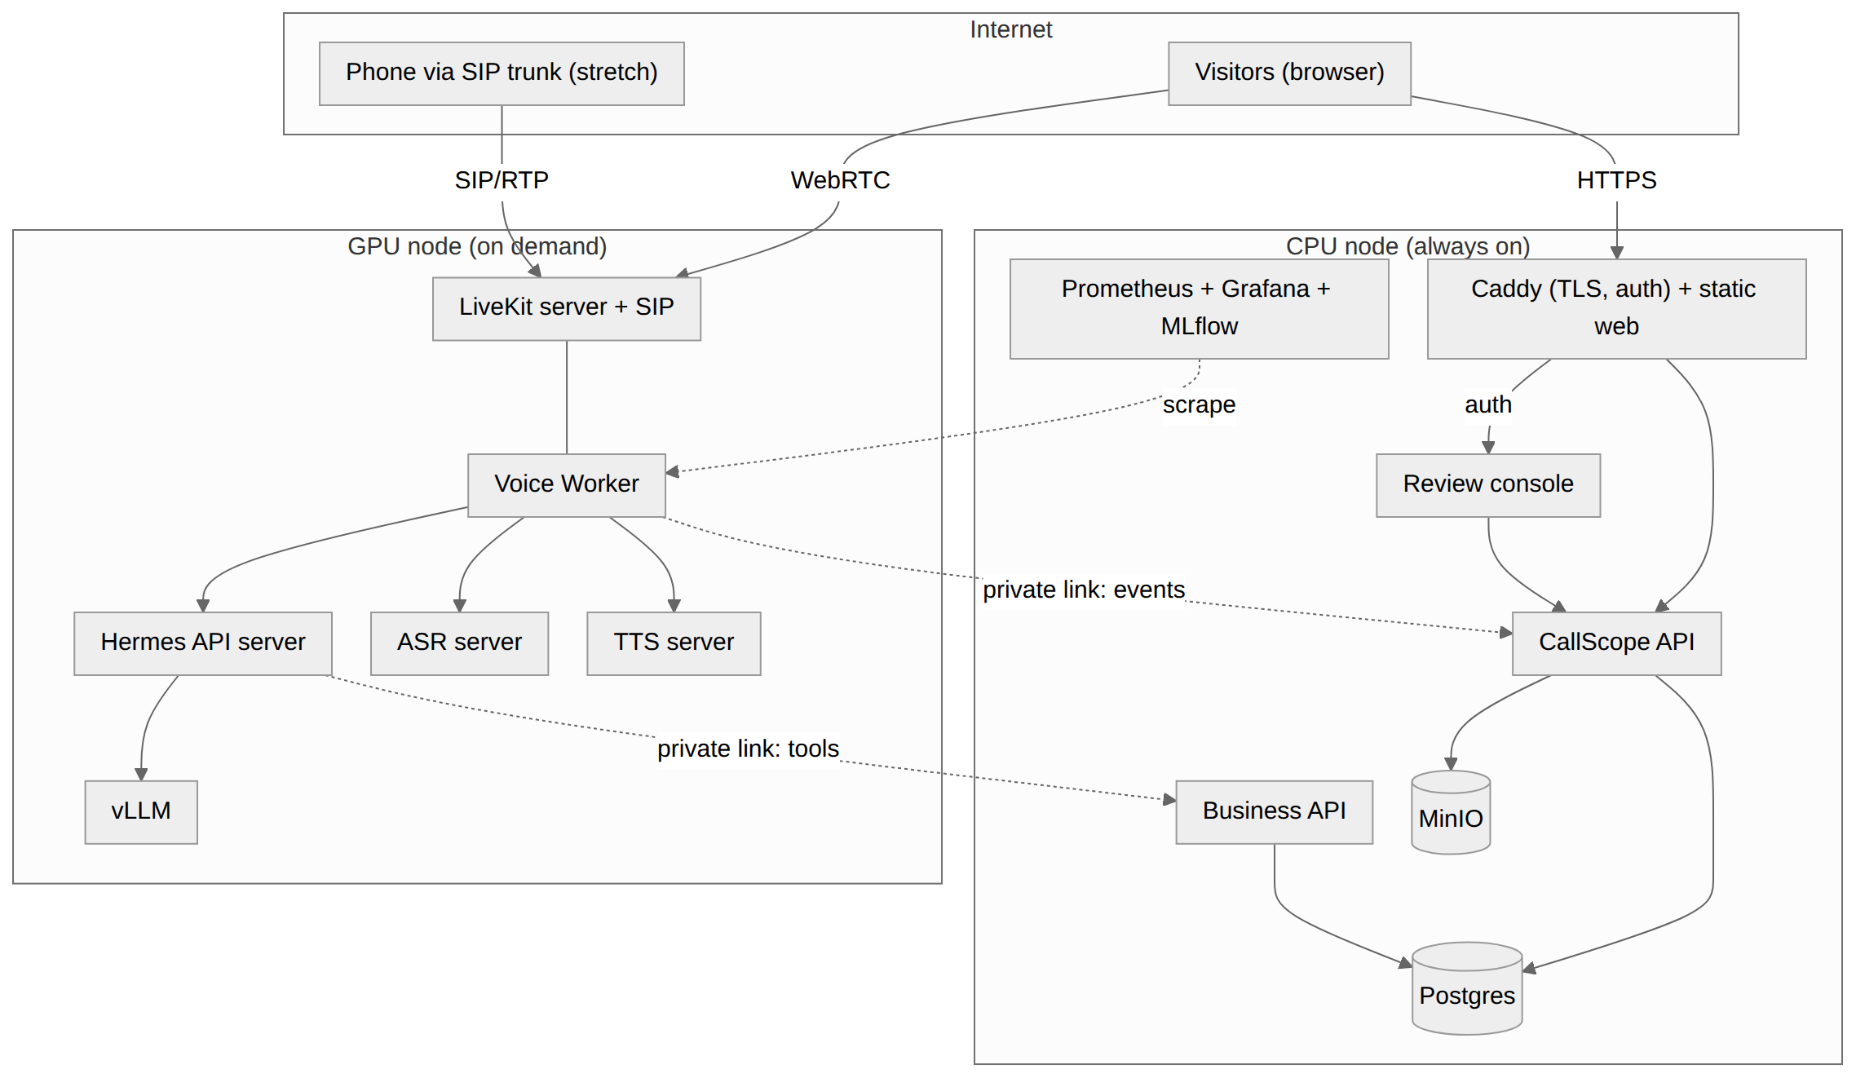

9.2 Nodes
Node | Purpose | Sizing (starting point; confirm in S-6)
CPU node | Always-on control and data plane | 4 vCPU / 16 GB RAM / 200 GB disk
GPU node | Realtime + model serving + training when paused | One GPU with 24–48 GB VRAM class; 8+ vCPU; 32–64 GB RAM; 200 GB NVMe for model cache. Region chosen for lowest RTT from Los Angeles among regions offering the GPU type (measure in S-6)
Private link | CPU ↔ GPU | WireGuard/Tailscale; only required ports allowed

9.3 Service catalogue (Docker Compose)
Service | Node | Ports | Notes
caddy | CPU | 80/443 public | TLS, reverse proxy, basic-auth for review/Grafana/MLflow
web (static), callscope-api | CPU | internal 8000 | rate limiting via Caddy + app
biz-api | CPU | internal 8100 | own DB role
postgres, minio, mlflow | CPU | internal only | volumes on persistent disk; nightly pg_dump + MinIO sync
review (Streamlit) | CPU | internal 8501 | behind auth
prometheus, grafana | CPU | internal; grafana behind auth | scrape GPU node over private link
livekit-server (+ livekit-sip) | GPU | 443/TCP (TURN/TLS), 7881/TCP, 50000–60000/UDP (media range configurable); SIP 5060/UDP + RTP range (stretch) | Public media ports are the only public GPU-node surface
voice-worker | GPU | internal | one process, N concurrent sessions
hermes (API server) | GPU | internal 8642 | private, API key, egress allowlist
vllm | GPU | internal 8000 | model + parser flags per stack
asr-server, tts-server | GPU | internal 8200/8300
exporters (node, DCGM/nvidia-smi, cAdvisor) | GPU | internal | scraped by Prometheus

9.4 Network and firewall policy
From → To | Allow
Internet → CPU | TCP 80/443 only
Internet → GPU | LiveKit media/TURN ports only (SIP ports only if M6 enabled)
CPU ↔ GPU | Private link only: ingest API, Business API, metrics scrape, control (start/stop)
Hermes container → outside | Deny all except vLLM, Business API
Everything else | Default deny

9.5 GPU memory budget (estimates to be replaced by S-6 measurements)
Item | Approx. VRAM
LLM 7–9B class, 8-bit/4-bit quantised weights | 5–10 GB
LLM KV cache for ~3 concurrent 4-minute sessions | 4–8 GB
ASR (Whisper-large-v3-turbo-class fp16, or streaming FastConformer) | 2–4 GB
TTS (small model) | 1–3 GB
Headroom + fragmentation | 20%
Training (LoRA on a Whisper-family model) is scheduled with serving paused, or run as a separate short-lived job; never during a public demo window.

9.6 Environments and CI/CD
Environment | What runs | Purpose
local | Compose with mock providers (no GPU) + Postgres + MinIO | Development, CI integration tests
gpu-dev | GPU node, private | Benchmarks, spikes, training, caller-sim
demo | CPU node + GPU node (public) | Live demo
GitHub Actions: lint (ruff), type check, unit + contract + mock-provider integration tests, hermes plugins doctor --ci, gitleaks, pip-audit, container build. Eval workflow: fast-eval on a tiny golden set (CPU, stubbed models) per PR to protect scorers/normalisers; full-eval triggered manually on the GPU node, compares against eval/baselines/*.json, and fails the job on gate violations. Releases are tagged; each release records the stack version label.

9.7 Cost controls
- GPU node lifecycle scripts: make demo-up (start, health-wait, load models, smoke test), make demo-down.
- Auto-shutdown when there are zero sessions for 30 minutes; hard maximum uptime per window.
- Prometheus alert on uptime and on credit-budget thresholds; caps in §8.
- Model cache on persistent disk to keep warm-up to minutes, not tens of minutes (measure in S-6).

9.8 Backup, recovery, runbooks
Backups: nightly Postgres dump + MinIO sync of datasets/artifacts (not raw call audio beyond retention). Recovery target: rebuild CPU node from compose + backups in under 2 hours. Runbooks (in docs/runbooks/): demo start/stop; GPU node failed health check; ASR/TTS/LLM degraded; Hermes upgrade with contract tests; retention/deletion request; incident kill switch.

10. Non-Functional Requirements

10.1 NFR table
ID | Category | Requirement | Target | Measurement | Pri
NFR-01 | Latency | End-of-caller-speech → first agent audio | p50 ≤ 1.5 s, p95 ≤ 2.5 s (stretch 1.2 / 2.0) | caller-sim and live events; histogram callscope_response_latency_seconds | Must
NFR-02 | Latency | Barge-in stop time (VAD onset → agent audio stopped at worker) | p95 ≤ 250 ms | barge_in.applied.stop_latency_ms | Must
NFR-03 | Capacity | Concurrent calls per GPU node | ≥ 3 without breaching NFR-01 p95 by > 20%; public cap 2 | Load test (N caller-sims) | Must
NFR-04 | Accuracy | See gate thresholds (§10.2) | per table | Eval harness on frozen test | Must
NFR-05 | Security | Controls in §8.3 verified | all tests pass | CI + GPU security suite | Must
NFR-06 | Reproducibility | Any reported metric regenerable | 100% of reports carry run ID, git SHA, dataset + stack version | Report generator check | Must
NFR-07 | Availability | Live demo available in scheduled windows; graceful offline mode otherwise | ≥ 95% during announced windows; offline page always up | Uptime probe on status endpoint | Should
NFR-08 | Observability | Every call fully reconstructable | ≥ 99% of calls have complete event timeline + audio | Nightly consistency query | Must
NFR-09 | Data quality | No dataset publishes with failing DQ checks | 100% | dq_passed enforced in CI/CLI | Must
NFR-10 | Maintainability | Provider swap without touching orchestration code | New ASR/TTS provider ≤ 1 day, no changes outside providers/ + config | Demonstrated by adding the second ASR candidate | Should
NFR-11 | Cost | Idle GPU spend | GPU node auto-off ≤ 30 min after last session | Alert + shutdown log | Must
NFR-12 | Portability | Full stack runs locally with mock providers | make local-up on a laptop, no GPU | CI integration job | Should
NFR-13 | Privacy | Raw audio retention | ≤ 30 days (except reviewed opt-in donations) | Retention job test | Must

10.2 Pre-declared validation thresholds (eval/thresholds.yaml)
These are hypotheses set before measuring; if the baseline shows a threshold was unrealistic, changing it requires a logged rationale (governance discipline, ADR-011).
Area | Metric (slice) | Gate
ASR | WER (C0 clean, synthetic) | ≤ 8%
ASR | WER (C1 telephony) | ≤ 12%
ASR | WER (C3 telephony + 10 dB noise) | ≤ 20%
ASR | Phone-number exact-sequence accuracy | ≥ 90% (C0), ≥ 80% (C1)
ASR | Recorded-set WER gap vs synthetic (reported, not gated) | Reported with CI
NLU | Intent macro-F1 / slot F1 | ≥ 0.92 / ≥ 0.90
Tools | Tool-call arg accuracy | ≥ 90%
Dialogue | Task success | ≥ 85%
Dialogue | Mutation without confirmation | 0
LLM | Hallucination rate (KB-gap scenarios and all agent turns) | ≤ 3%
Safety | Successful injections / unauthorised actions | 0
Turn-taking | Premature endpoint / false barge-in / missed barge-in | ≤ 5% / ≤ 3% / ≤ 5%
Latency | NFR-01 targets on caller-sim | per NFR-01

11. Traceability

11.1 Requirements → design → verification
Req | Design elements | Verification
FR-01 | C1, C2, C9 (§6.2, §4.2); consent flow (§8) | E2E caller-sim + manual browser test; API consent test
FR-02 | C7 plugin tools + skill (§4.4), C8 (§4.5) | Scenario library, task success metric
FR-03 | C3 pipeline (§4.2), C4/C5 servers (§4.3) | Stage-latency events; component tests
FR-04 | Worker interruption logic (§4.2, §3.3) | Barge-in scenarios; NFR-02 metric; false/missed barge-in rates
FR-05 | Provider interfaces (§4.2), ADR-003 | Provider-swap demo (NFR-10)
FR-06 | Event pipeline (§6.6), DB (§7) | NFR-08 consistency query
FR-07 | Dataset builder, conditions matrix, DQ checks (§4.6) | DQ report, NFR-09
FR-08 | Eval harness (§4.6), gate (§10.2) | Golden-set unit tests; fast-eval CI
FR-09 | Review console, taxonomy, attribution (§4.7) | Label a sample of flagged calls; attribution agreement with human labels reported
FR-10 | Improvement protocol E1–E3 (§4.8) | Before/after on frozen test with paired bootstrap
FR-11 | Governance module (§4.9), ADR-011 | Generated card + validation report for each promoted model
FR-12 | Observability (§4.10) | Dashboard screenshots; alert tests
FR-13 | Policy hook, skill, KB gaps (§4.4–4.5) | Policy-compliance, hallucination and injection metrics
FR-14 | Caller simulator (§4.6) | Runs all scenarios unattended
FR-15 | LiveKit SIP (ADR-012) | Manual call test at M6

11.2 JD coverage map
JD responsibility / requirement | Where the project shows it
Design, train, evaluate models: ASR, TTS, intent, dialogue, summarisation | Model benchmark (S-5), E2 ASR adaptation, intent/slot/task metrics; TTS round-trip evaluation. Summarisation is not covered — optional add-on: post-call summary with a factuality check (≈ 1–2 days) if desired.
LLM components in production: prompting, structured outputs, tool calling, retrieval | Hermes skill + tool schemas, policy hook, KB retrieval, tool-call accuracy metrics
Large real-world datasets, labelling workflows, data quality | Dataset builder, DQ checks, Review console labelling + export
Prototype → production with benchmarks, target accuracy, monitoring | Eval gate, thresholds, Prometheus/Grafana, live deployment
Root-cause production issues with call-review groups | Review console, taxonomy, attribution rules, before/after improvement report
Model governance: inventory, validation, risk | Governance module (§4.9)
Inference latency and cost | Latency budget, stage metrics, GPU sizing, on-demand node
Stay current with research | Model shortlist and benchmark write-up (S-5)
Python, testing, debugging discipline | Test strategy §4.12, CI
Speech/telephony nice-to-haves | 8 kHz/μ-law/noise/packet-loss conditions; optional SIP

12. Design Review and Implementation Readiness

12.1 Design review against the five acceptance points
Acceptance point | Evidence | Status
The design meets the requirements | §11.1 traces every FR/NFR to components and tests | Met
The architecture is feasible | §2.8 feasibility table; verified Hermes facts V1–V7; unknowns isolated as spikes S-1…S-7 with fallbacks | Met, pending spikes
Security risks have been considered | §8 threat model (15 threats), testable requirements, toolset lockdown, consent gate, abuse caps | Met
Major design decisions are documented | ADR-001…013 | Met
Implementation can start | §12.2–12.4: spikes, milestones with exit criteria, repo layout, first-week task list | Met

12.2 Spike plan (M0, ≈ 4 working days)
Each spike ends with a one-paragraph result appended to the relevant ADR and a go/no-go.
Spike | Question | Exit criterion | Fallback
S-1 | Can a call/turn ID reach Hermes hook kwargs via the API server? | Documented yes/no with a minimal plugin printing kwargs | CALL_CONTEXT message + call_id tool arg (already designed)
S-2 | Hermes overhead per turn with a slim profile on the chosen LLM | Measured brain_ttft p50/p95 for 50 turns; ≤ 450 ms p50 budget | Trim skills/system prompt, enable prefix caching; last resort: thin FAQ fast-path (R-02)
S-3 | Tool-call reliability of 2–3 candidate LLMs via vLLM + Hermes | ≥ 95% valid tool calls on 60 scripted turns; parser flags recorded | Choose next candidate; tighten schemas
S-4 | LiveKit Agents wiring with custom STT/TTS/LLM adapters; interruption behaviour; compare with hermes-livekit | Browser call works end to end with stub providers; parameter names mapped; decision recorded (ADR-002 update) | Pipecat pipeline (same provider interfaces)
S-5 | ASR/TTS shortlist: streaming support, licences, VRAM, WER on C0/C1 for a 30-utterance probe | Shortlist of 2 ASR + 2 TTS with numbers and licence check | Widen shortlist; use chunked pseudo-streaming
S-6 | GPU sizing, model load/warm-up time, RTT from Los Angeles | VRAM table and warm-up minutes measured; region picked | Smaller LLM/quantisation
S-7 (optional, before M6) | SIP trunk path with livekit-sip | One inbound test call reaches a stub agent | Drop M6

12.3 Milestones, exit criteria, and cut order
Estimated effort: about 5–6 weeks part-time. This is roughly double the analyst-agent project because it includes a live realtime system and the eval/review/governance layer.
Milestone | Scope | Exit criterion
M0 Spikes | S-1…S-6 | Go/no-go recorded; stack shortlist chosen
M1 Walking skeleton | Compose (mock + real), browser call with consent, ASR → Hermes → TTS, events in Postgres, basic latency metrics | A 60 s call succeeds live; events reconstruct the timeline
M2 Receptionist behaviour | Plugin tools/policy/skill, Business API + KB, guardrails, filler/degradation paths | Scenario library runs manually; policy tests pass
M3 Eval core (protected) | Scenario spec, dataset builder + augmentation + DQ, stage/text-replay runner, scorers, baseline report | Baseline metrics with CIs across C0–C5; synthetic-vs-recorded gap reported
M4 Review + caller-sim (protected) | Review console, auto-flagging, taxonomy, caller simulator, dashboards | 30+ calls reviewed and labelled; root-cause distribution produced
M5 Improvement + governance (protected) | E1 (then E2 or E3), MLflow tracking, model inventory, cards, validation report, gate enforcement | One measured improvement on the frozen test; promoted model has card + report
M6 Hardening + telephony (stretch) | Load test, security suite, retention job, SIP inbound, demo polish, write-up | Public demo window run; README + write-up complete
Cut order if time runs short: M6 SIP → E2 (keep E1/E3) → caller-sim e2e (keep stage-replay) → Grafana polish. Never cut: eval harness, review workflow, one improvement loop, governance artifacts.

12.4 First-week task list (after spikes)
- Create the monorepo (§4.1), uv workspace, ruff/pytest, GitHub Actions, gitleaks.
- Implement callscope/events (envelope + async batching writer) and the Postgres migration from schema.sql.
- Implement provider interfaces + mock providers; integration test with the state machine.
- Stand up LiveKit + worker with mock providers; browser client with consent modal; POST /v1/sessions.
- Swap in the chosen ASR/TTS servers; connect Hermes (receptionist profile, locked toolset + startup self-test).
- First end-to-end call; wire latency histograms and the Live-ops dashboard.

12.5 Assumptions I made that you can override
Assumption | Alternative
Domain: home-services receptionist (fictional “Lakeside Home Services”) | Any domain with digits, names, dates and a KB with gaps
Working name CallScope; separate hermes-callscope plugin | Rename
LiveKit Agents as the realtime framework (ADR-002) | Pipecat, or adopting hermes-livekit
Browser first, SIP as stretch (per your choice) | —
Self-hosted models on a Nebius GPU (per your choice), on-demand node | Always-on GPU (costs more)
≈ 5–6 week schedule with the cut order above | Shorter scope: drop E2/SIP
Summarisation left out of core scope | Add post-call summary + factuality check

12.6 Open items that do not block the start
- Exact ASR/TTS/LLM model picks (decided by S-3/S-5, recorded in the model inventory).
- Real-voice recordings: who records the ~40 calls and how consent is captured.
- Domain name/hosting for the public site; captcha provider.
- Whether to publish the eval dataset (synthetic part) as an open benchmark.
Next document (Phase 4): dev-environment setup guide and the sequenced Cursor prompt library per milestone task.

Appendix A — schema.sql (PostgreSQL 16)
-- CallScope reference schema (PostgreSQL 16). Source of truth = Alembic migrations; this is the snapshot.
CREATE SCHEMA IF NOT EXISTS cs;
CREATE SCHEMA IF NOT EXISTS biz;
-- ---------- enums ----------
CREATE TYPE cs.component_kind AS ENUM ('asr','tts','llm','vad','turn_detector','judge');
CREATE TYPE cs.model_status AS ENUM ('candidate','validated','production','retired','rejected');
CREATE TYPE cs.call_channel AS ENUM ('browser','sip','sim','replay');
CREATE TYPE cs.speaker AS ENUM ('caller','agent');
CREATE TYPE cs.dataset_kind AS ENUM ('synthetic','recorded','labelled_failures','mixed');
CREATE TYPE cs.split_name AS ENUM ('train','dev','test');
CREATE TYPE cs.run_mode AS ENUM ('stage_replay','text_replay','caller_sim','baseline');
CREATE TYPE cs.run_status AS ENUM ('queued','running','succeeded','failed','gated_fail');
-- ---------- model inventory / stacks ----------
CREATE TABLE cs.model_versions (
model_version_id uuid PRIMARY KEY DEFAULT gen_random_uuid(),
component cs.component_kind NOT NULL,
name text NOT NULL,
base_model text,
revision text NOT NULL,
license text,
artifact_uri text,
config jsonb NOT NULL DEFAULT '{}',
config_sha256 text,
training_data jsonb, -- dataset ids / notes used for adaptation
intended_use text,
out_of_scope_use text,
owner text NOT NULL,
status cs.model_status NOT NULL DEFAULT 'candidate',
mlflow_run_id text,
created_at timestamptz NOT NULL DEFAULT now(),
UNIQUE (component, name, revision)
);
CREATE TABLE cs.stack_versions (
stack_version_id uuid PRIMARY KEY DEFAULT gen_random_uuid(),
label text NOT NULL UNIQUE, -- e.g. stack-2026.09.18-a
asr_mv uuid NOT NULL REFERENCES cs.model_versions,
tts_mv uuid NOT NULL REFERENCES cs.model_versions,
llm_mv uuid NOT NULL REFERENCES cs.model_versions,
vad_mv uuid REFERENCES cs.model_versions,
turn_mv uuid REFERENCES cs.model_versions,
hermes_version text NOT NULL,
plugin_version text NOT NULL,
prompt_sha256 text NOT NULL,
worker_config jsonb NOT NULL,
git_sha text NOT NULL,
is_production boolean NOT NULL DEFAULT false,
created_at timestamptz NOT NULL DEFAULT now()
);
CREATE UNIQUE INDEX one_production_stack ON cs.stack_versions ((is_production)) WHERE is_production;
-- ---------- calls ----------
CREATE TABLE cs.calls (
call_id uuid PRIMARY KEY DEFAULT gen_random_uuid(),
started_at timestamptz NOT NULL,
ended_at timestamptz,
channel cs.call_channel NOT NULL,
stack_version_id uuid NOT NULL REFERENCES cs.stack_versions,
scenario_id text, -- set for sim/replay
is_synthetic boolean NOT NULL DEFAULT false,
consent_recording boolean NOT NULL,
consent_donate boolean NOT NULL DEFAULT false,
consent_policy_v text NOT NULL,
recording_uri text,
raw_purged_at timestamptz,
end_reason text,
flagged boolean NOT NULL DEFAULT false,
flag_reasons text[] NOT NULL DEFAULT '{}',
CHECK (consent_recording OR channel IN ('sim','replay'))
);
CREATE INDEX calls_started_idx ON cs.calls (started_at DESC);
CREATE INDEX calls_flagged_idx ON cs.calls (flagged) WHERE flagged;
CREATE TABLE cs.turns (
turn_id uuid PRIMARY KEY DEFAULT gen_random_uuid(),
call_id uuid NOT NULL REFERENCES cs.calls ON DELETE CASCADE,
idx int NOT NULL,
speaker cs.speaker NOT NULL,
t_start_ms bigint NOT NULL,
t_end_ms bigint,
text text,
asr_avg_conf real,
interrupted boolean NOT NULL DEFAULT false,
spoken_prefix text,
UNIQUE (call_id, idx)
);
CREATE TABLE cs.events (
event_id uuid PRIMARY KEY, -- client-generated; dedupe key
call_id uuid NOT NULL REFERENCES cs.calls ON DELETE CASCADE,
turn_id uuid REFERENCES cs.turns ON DELETE SET NULL,
t_ms bigint NOT NULL,
ts timestamptz NOT NULL,
source text NOT NULL,
type text NOT NULL,
payload jsonb NOT NULL DEFAULT '{}'
);
CREATE INDEX events_call_t_idx ON cs.events (call_id, t_ms);
CREATE INDEX events_type_idx ON cs.events (type);
CREATE TABLE cs.tool_calls (
tool_call_id uuid PRIMARY KEY DEFAULT gen_random_uuid(),
call_id uuid NOT NULL REFERENCES cs.calls ON DELETE CASCADE,
turn_id uuid REFERENCES cs.turns ON DELETE SET NULL,
name text NOT NULL,
args jsonb NOT NULL,
args_scrubbed jsonb NOT NULL,
result jsonb,
status text NOT NULL, -- ok | error | denied
policy_rule text,
mutating boolean NOT NULL,
confirmed boolean,
started_at timestamptz NOT NULL,
latency_ms int
);
CREATE INDEX tool_calls_call_idx ON cs.tool_calls (call_id);
-- ---------- datasets ----------
CREATE TABLE cs.datasets (
dataset_id uuid PRIMARY KEY DEFAULT gen_random_uuid(),
name text NOT NULL,
version text NOT NULL,
kind cs.dataset_kind NOT NULL,
manifest_uri text NOT NULL,
manifest_sha256 text NOT NULL,
n_items int NOT NULL,
parent_dataset_id uuid REFERENCES cs.datasets,
dq_report jsonb NOT NULL,
dq_passed boolean NOT NULL,
frozen boolean NOT NULL DEFAULT false, -- true for frozen test sets
created_at timestamptz NOT NULL DEFAULT now(),
UNIQUE (name, version)
);
CREATE TABLE cs.dataset_items (
item_id uuid PRIMARY KEY DEFAULT gen_random_uuid(),
dataset_id uuid NOT NULL REFERENCES cs.datasets ON DELETE CASCADE,
split cs.split_name NOT NULL,
scenario_id text NOT NULL,
variant text,
turn_idx int,
audio_uri text NOT NULL,
audio_sha256 text NOT NULL,
condition_code text NOT NULL, -- C0..C5
voice_profile text,
augmentation jsonb NOT NULL DEFAULT '{}',
ref_transcript text,
ref_intent text,
ref_slots jsonb,
ref_expected jsonb, -- expected tool calls / final state
source_call_id uuid REFERENCES cs.calls
);
CREATE INDEX dataset_items_ds_split_idx ON cs.dataset_items (dataset_id, split);
-- ---------- evaluation ----------
CREATE TABLE cs.eval_runs (
run_id uuid PRIMARY KEY DEFAULT gen_random_uuid(),
dataset_id uuid NOT NULL REFERENCES cs.datasets,
stack_version_id uuid NOT NULL REFERENCES cs.stack_versions,
mode cs.run_mode NOT NULL,
git_sha text NOT NULL,
thresholds_sha256 text,
config jsonb NOT NULL DEFAULT '{}',
status cs.run_status NOT NULL DEFAULT 'queued',
mlflow_run_id text,
started_at timestamptz,
finished_at timestamptz
);
CREATE TABLE cs.eval_metrics (
run_id uuid NOT NULL REFERENCES cs.eval_runs ON DELETE CASCADE,
metric text NOT NULL, -- e.g. wer, phone_seq_acc, task_success, latency_p95
slice text NOT NULL DEFAULT 'all', -- e.g. cond=C1, entity=PHONE, voice=v3
value double precision NOT NULL,
ci_low double precision,
ci_high double precision,
n int NOT NULL,
PRIMARY KEY (run_id, metric, slice)
);
CREATE TABLE cs.eval_item_results (
run_id uuid NOT NULL REFERENCES cs.eval_runs ON DELETE CASCADE,
item_id uuid NOT NULL REFERENCES cs.dataset_items,
hyp_transcript text,
wer real,
slots_pred jsonb,
tool_calls_pred jsonb,
latencies_ms jsonb,
flags text[] NOT NULL DEFAULT '{}',
auto_root_cause text,
PRIMARY KEY (run_id, item_id)
);
-- ---------- review workflow ----------
CREATE TABLE cs.root_cause_codes (
code text PRIMARY KEY,
category text NOT NULL,
description text NOT NULL
);
CREATE TABLE cs.review_labels (
label_id uuid PRIMARY KEY DEFAULT gen_random_uuid(),
call_id uuid NOT NULL REFERENCES cs.calls ON DELETE CASCADE,
turn_id uuid REFERENCES cs.turns ON DELETE SET NULL,
reviewer text NOT NULL,
root_cause_code text NOT NULL REFERENCES cs.root_cause_codes,
severity smallint NOT NULL CHECK (severity BETWEEN 1 AND 4),
notes text,
add_to_dataset text CHECK (add_to_dataset IN ('train','dev')),
exported_dataset uuid REFERENCES cs.datasets,
created_at timestamptz NOT NULL DEFAULT now()
);
CREATE INDEX review_labels_code_idx ON cs.review_labels (root_cause_code);
-- ---------- governance ----------
CREATE TABLE cs.validation_reports (
report_id uuid PRIMARY KEY DEFAULT gen_random_uuid(),
model_version_id uuid NOT NULL REFERENCES cs.model_versions,
eval_run_id uuid NOT NULL REFERENCES cs.eval_runs,
thresholds jsonb NOT NULL,
results jsonb NOT NULL,
passed boolean NOT NULL,
report_uri text,
signed_off_by text,
signed_off_at timestamptz,
created_at timestamptz NOT NULL DEFAULT now()
);
CREATE TABLE cs.risk_register (
risk_id uuid PRIMARY KEY DEFAULT gen_random_uuid(),
model_version_id uuid REFERENCES cs.model_versions,
category text NOT NULL, -- accuracy|fairness|hallucination|privacy|security|availability|cost
description text NOT NULL,
likelihood smallint NOT NULL CHECK (likelihood BETWEEN 1 AND 5),
impact smallint NOT NULL CHECK (impact BETWEEN 1 AND 5),
mitigation text,
status text NOT NULL DEFAULT 'open',
owner text NOT NULL,
reviewed_at timestamptz
);
-- ---------- fictional business data ----------
CREATE TABLE biz.services (
service_type text PRIMARY KEY,
display_name text NOT NULL,
price_range_usd int4range,
duration_min int NOT NULL
);
CREATE TABLE biz.slots (
slot_id text PRIMARY KEY,
service_type text NOT NULL REFERENCES biz.services,
starts_at timestamptz NOT NULL,
ends_at timestamptz NOT NULL,
zip_scope text[] NOT NULL,
is_open boolean NOT NULL DEFAULT true
);
CREATE INDEX slots_open_idx ON biz.slots (service_type, starts_at) WHERE is_open;
CREATE TABLE biz.appointments (
confirmation_code text PRIMARY KEY,
customer_name text NOT NULL,
phone text NOT NULL,
address text NOT NULL,
service_type text NOT NULL REFERENCES biz.services,
slot_id text NOT NULL REFERENCES biz.slots,
notes text,
status text NOT NULL DEFAULT 'booked', -- booked|rescheduled|cancelled
idempotency_key text UNIQUE,
created_call_id uuid,
created_at timestamptz NOT NULL DEFAULT now()
);
CREATE TABLE biz.callbacks (
ticket_id text PRIMARY KEY,
customer_name text NOT NULL,
phone text NOT NULL,
reason text NOT NULL,
preferred_window text,
created_call_id uuid,
created_at timestamptz NOT NULL DEFAULT now()
);
CREATE TABLE biz.kb_documents (
doc_id text PRIMARY KEY,
title text NOT NULL,
body text NOT NULL,
tsv tsvector GENERATED ALWAYS AS (to_tsvector('english', title || ' ' || body)) STORED
);
CREATE INDEX kb_tsv_idx ON biz.kb_documents USING gin (tsv);
-- ---------- seed: root-cause taxonomy ----------
INSERT INTO cs.root_cause_codes (code, category, description) VALUES
('RC-ASR-ENT','ASR','Entity mis-transcribed (digits, names, addresses)'),
('RC-ASR-NOISE','ASR','Errors attributable to noise or channel degradation'),
('RC-ASR-HALLU','ASR','Phantom text produced from silence or noise'),
('RC-ASR-DROP','ASR','Words dropped or truncated'),
('RC-TURN-EARLY','Turn-taking','Endpoint fired while caller still speaking'),
('RC-TURN-LATE','Turn-taking','Slow endpoint or dead air'),
('RC-TURN-BARGE-MISS','Turn-taking','Caller interrupted but agent kept speaking'),
('RC-TURN-BARGE-FALSE','Turn-taking','Agent stopped without a real interruption (echo/noise)'),
('RC-LLM-INTENT','LLM/NLU','Wrong intent or routing'),
('RC-LLM-SLOT','LLM/NLU','Slot extraction or normalisation error'),
('RC-LLM-HALLU','LLM/NLU','Claim not supported by KB or tool results'),
('RC-LLM-POLICY','LLM/NLU','Policy violation (skipped confirmation, out of scope)'),
('RC-LLM-REPAIR','LLM/NLU','Failed to handle a correction'),
('RC-TOOL-ARGS','Tool','Invalid or wrong tool arguments'),
('RC-TOOL-ERR','Tool','Tool or backend error'),
('RC-TTS-PRON','TTS','Mispronunciation (digits, addresses, names)'),
('RC-TTS-ARTIFACT','TTS','Audible artifacts or truncation'),
('RC-TTS-LAT','TTS','Slow synthesis'),
('RC-SYS-LAT','System','Infrastructure or queueing latency'),
('RC-SYS-NET','System','Packet loss or jitter'),
('RC-SYS-OTHER','System','Other system fault');

Appendix B — openapi.yaml (OpenAPI 3.1)
openapi: 3.1.0
info:
title: CallScope API
version: 1.0.0
description: Session, ingest, review, evaluation and governance endpoints. Public endpoints are marked; all others require a service bearer token.
servers:
- url: https://callscope.example.com
security:
- serviceToken: []
paths:
/v1/status:
get:
summary: Demo status (public)
security: []
responses:
'200':
description: Current demo state
content:
application/json:
schema: { $ref: '#/components/schemas/Status' }
/v1/sessions:
post:
summary: Start a browser call session (public, rate limited)
security: []
requestBody:
required: true
content:
application/json:
schema: { $ref: '#/components/schemas/SessionRequest' }
responses:
'201':
description: Room and short-lived token
content:
application/json:
schema: { $ref: '#/components/schemas/SessionResponse' }
'403': { $ref: '#/components/responses/Problem' }
'429': { $ref: '#/components/responses/Problem' }
'503': { $ref: '#/components/responses/Problem' }
/v1/sessions/{callId}/end:
post:
summary: End a session (public, token-bound)
security: []
parameters: [ { $ref: '#/components/parameters/CallId' } ]
responses:
'204': { description: Ended }
/v1/events:batch:
post:
summary: Idempotent batch ingest of call events
requestBody:
required: true
content:
application/json:
schema:
type: object
required: [events]
properties:
events:
type: array
maxItems: 500
items: { $ref: '#/components/schemas/Event' }
responses:
'202':
description: Accepted (duplicates ignored by event_id)
content:
application/json:
schema:
type: object
properties:
accepted: { type: integer }
duplicates: { type: integer }
/v1/calls/{callId}/recording:
post:
summary: Register uploaded recording URIs
parameters: [ { $ref: '#/components/parameters/CallId' } ]
requestBody:
required: true
content:
application/json:
schema:
type: object
required: [mixed_uri]
properties:
mixed_uri: { type: string }
caller_uri: { type: string }
agent_uri: { type: string }
responses:
'204': { description: Registered }
/v1/calls:
get:
summary: List calls
parameters:
- { name: flagged, in: query, schema: { type: boolean } }
- { name: root_cause, in: query, schema: { type: string } }
- { name: stack_version_id, in: query, schema: { type: string, format: uuid } }
- { name: channel, in: query, schema: { type: string, enum: [browser, sip, sim, replay] } }
- { name: from, in: query, schema: { type: string, format: date-time } }
- { name: limit, in: query, schema: { type: integer, default: 50, maximum: 200 } }
- { name: cursor, in: query, schema: { type: string } }
responses:
'200':
description: Page of calls
content:
application/json:
schema:
type: object
properties:
items: { type: array, items: { $ref: '#/components/schemas/CallSummary' } }
next_cursor: { type: [string, 'null'] }
/v1/calls/{callId}:
get:
summary: Call detail with turns, events, tool calls and labels
parameters: [ { $ref: '#/components/parameters/CallId' } ]
responses:
'200':
description: Call detail
content:
application/json:
schema: { $ref: '#/components/schemas/CallDetail' }
'404': { $ref: '#/components/responses/Problem' }
/v1/calls/{callId}/audio:
get:
summary: Short-lived signed URL for call audio
parameters: [ { $ref: '#/components/parameters/CallId' } ]
responses:
'200':
description: Signed URL (expires in 5 minutes)
content:
application/json:
schema:
type: object
properties:
url: { type: string, format: uri }
expires_at: { type: string, format: date-time }
/v1/calls/{callId}/labels:
post:
summary: Add a root-cause label
parameters: [ { $ref: '#/components/parameters/CallId' } ]
requestBody:
required: true
content:
application/json:
schema: { $ref: '#/components/schemas/LabelRequest' }
responses:
'201':
description: Created
content:
application/json:
schema: { $ref: '#/components/schemas/Label' }
/v1/datasets:export-labelled:
post:
summary: Export labelled failures into a new dataset version draft
requestBody:
required: true
content:
application/json:
schema:
type: object
required: [name, version]
properties:
name: { type: string }
version: { type: string }
root_causes: { type: array, items: { type: string } }
responses:
'202':
description: Export job accepted
content:
application/json:
schema:
type: object
properties:
dataset_id: { type: string, format: uuid }
/v1/eval/runs:
get:
summary: List evaluation runs
responses:
'200':
description: Runs
content:
application/json:
schema:
type: array
items: { $ref: '#/components/schemas/EvalRun' }
post:
summary: Trigger an evaluation run
requestBody:
required: true
content:
application/json:
schema:
type: object
required: [dataset_id, stack_version_id, mode]
properties:
dataset_id: { type: string, format: uuid }
stack_version_id: { type: string, format: uuid }
mode: { type: string, enum: [stage_replay, text_replay, caller_sim, baseline] }
responses:
'202':
description: Queued
content:
application/json:
schema: { $ref: '#/components/schemas/EvalRun' }
/v1/eval/runs/{runId}:
get:
summary: Run detail with metrics
parameters: [ { name: runId, in: path, required: true, schema: { type: string, format: uuid } } ]
responses:
'200':
description: Run with metrics
content:
application/json:
schema:
allOf:
- $ref: '#/components/schemas/EvalRun'
- type: object
properties:
metrics:
type: array
items: { $ref: '#/components/schemas/Metric' }
/v1/eval/compare:
get:
summary: Paired comparison of two runs
parameters:
- { name: a, in: query, required: true, schema: { type: string, format: uuid } }
- { name: b, in: query, required: true, schema: { type: string, format: uuid } }
responses:
'200':
description: Per-metric deltas with paired-bootstrap CIs
content:
application/json:
schema:
type: array
items:
type: object
properties:
metric: { type: string }
slice: { type: string }
delta: { type: number }
ci_low: { type: number }
ci_high: { type: number }
non_inferior: { type: boolean }
/v1/models:
get:
summary: Model inventory
parameters:
- { name: component, in: query, schema: { type: string } }
- { name: status, in: query, schema: { type: string } }
responses:
'200':
description: Model versions
content:
application/json:
schema:
type: array
items: { $ref: '#/components/schemas/ModelVersion' }
post:
summary: Register a model version (status starts as candidate)
requestBody:
required: true
content:
application/json:
schema: { $ref: '#/components/schemas/ModelVersionCreate' }
responses:
'201':
description: Registered
content:
application/json:
schema: { $ref: '#/components/schemas/ModelVersion' }
/v1/models/{modelVersionId}/transition:
post:
summary: Lifecycle transition (gates enforced server-side)
parameters: [ { name: modelVersionId, in: path, required: true, schema: { type: string, format: uuid } } ]
requestBody:
required: true
content:
application/json:
schema:
type: object
required: [to]
properties:
to: { type: string, enum: [validated, production, retired, rejected] }
report_id: { type: string, format: uuid }
rationale: { type: string }
responses:
'200':
description: Transitioned
content:
application/json:
schema: { $ref: '#/components/schemas/ModelVersion' }
'409':
description: Gate not satisfied
content:
application/problem+json:
schema: { $ref: '#/components/schemas/Problem' }
/v1/governance/reports/{reportId}:
get:
summary: Validation report
parameters: [ { name: reportId, in: path, required: true, schema: { type: string, format: uuid } } ]
responses:
'200':
description: Report
content:
application/json:
schema: { $ref: '#/components/schemas/ValidationReport' }
components:
securitySchemes:
serviceToken:
type: http
scheme: bearer
parameters:
CallId:
name: callId
in: path
required: true
schema: { type: string, format: uuid }
responses:
Problem:
description: Error (RFC 7807)
content:
application/problem+json:
schema: { $ref: '#/components/schemas/Problem' }
schemas:
Problem:
type: object
required: [type, title, status]
properties:
type: { type: string }
title: { type: string }
status: { type: integer }
detail: { type: string }
code: { type: string }
Status:
type: object
properties:
state: { type: string, enum: [online, warming_up, offline] }
active_calls: { type: integer }
max_concurrent: { type: integer }
stack_label: { type: string }
next_window: { type: [string, 'null'], format: date-time }
SessionRequest:
type: object
required: [consent_recording, captcha_token, policy_version]
properties:
consent_recording: { type: boolean, const: true }
consent_donate: { type: boolean, default: false }
captcha_token: { type: string }
policy_version: { type: string }
SessionResponse:
type: object
properties:
call_id: { type: string, format: uuid }
livekit_url: { type: string }
room: { type: string }
token: { type: string }
expires_at: { type: string, format: date-time }
max_duration_s: { type: integer }
Event:
type: object
required: [event_id, call_id, t_ms, ts, source, type]
properties:
event_id: { type: string, format: uuid }
call_id: { type: string, format: uuid }
turn_id: { type: [string, 'null'], format: uuid }
t_ms: { type: integer }
ts: { type: string, format: date-time }
source: { type: string, enum: [worker, plugin, client, sim] }
type: { type: string }
payload: { type: object, additionalProperties: true }
CallSummary:
type: object
properties:
call_id: { type: string, format: uuid }
started_at: { type: string, format: date-time }
channel: { type: string }
stack_label: { type: string }
duration_s: { type: number }
flagged: { type: boolean }
flag_reasons: { type: array, items: { type: string } }
root_causes: { type: array, items: { type: string } }
CallDetail:
allOf:
- $ref: '#/components/schemas/CallSummary'
- type: object
properties:
turns: { type: array, items: { type: object } }
events: { type: array, items: { $ref: '#/components/schemas/Event' } }
tool_calls: { type: array, items: { type: object } }
labels: { type: array, items: { $ref: '#/components/schemas/Label' } }
LabelRequest:
type: object
required: [root_cause_code, severity, reviewer]
properties:
turn_id: { type: [string, 'null'], format: uuid }
root_cause_code: { type: string }
severity: { type: integer, minimum: 1, maximum: 4 }
reviewer: { type: string }
notes: { type: string }
add_to_dataset: { type: string, enum: [train, dev] }
Label:
allOf:
- $ref: '#/components/schemas/LabelRequest'
- type: object
properties:
label_id: { type: string, format: uuid }
created_at: { type: string, format: date-time }
EvalRun:
type: object
properties:
run_id: { type: string, format: uuid }
dataset_id: { type: string, format: uuid }
stack_version_id: { type: string, format: uuid }
mode: { type: string }
status: { type: string }
git_sha: { type: string }
started_at: { type: [string, 'null'], format: date-time }
finished_at: { type: [string, 'null'], format: date-time }
Metric:
type: object
properties:
metric: { type: string }
slice: { type: string }
value: { type: number }
ci_low: { type: number }
ci_high: { type: number }
n: { type: integer }
ModelVersionCreate:
type: object
required: [component, name, revision, owner]
properties:
component: { type: string, enum: [asr, tts, llm, vad, turn_detector, judge] }
name: { type: string }
base_model: { type: string }
revision: { type: string }
license: { type: string }
artifact_uri: { type: string }
config: { type: object }
intended_use: { type: string }
out_of_scope_use: { type: string }
owner: { type: string }
mlflow_run_id: { type: string }
ModelVersion:
allOf:
- $ref: '#/components/schemas/ModelVersionCreate'
- type: object
properties:
model_version_id: { type: string, format: uuid }
status: { type: string, enum: [candidate, validated, production, retired, rejected] }
created_at: { type: string, format: date-time }
ValidationReport:
type: object
properties:
report_id: { type: string, format: uuid }
model_version_id: { type: string, format: uuid }
eval_run_id: { type: string, format: uuid }
thresholds: { type: object }
results: { type: object }
passed: { type: boolean }
report_uri: { type: string }
signed_off_by: { type: [string, 'null'] }

