CERTIFICATE

This is to certify that Aditya, a student of Computer Applications, has successfully completed the mini project titled “Graph Traversal Visualizer using Breadth-First Search (BFS)” during the academic session 2025–2026. This project has been carried out as a part of the technical training program requirement. The project demonstrates the student’s ability to understand and implement algorithmic concepts in a practical and visual manner. It focuses on the visualization of Breadth-First Search traversal on a grid-based system. The student has successfully designed and developed the project using Python programming language and Pygame library. The project reflects strong knowledge of data structures, especially queue, and graph traversal techniques. The work presented in this project is original and has not been submitted elsewhere for any other academic purpose. It highlights the student’s analytical thinking, problem-solving skills, and programming ability.
We wish the student success in future academic and professional endeavors.

Project Guide: Mr.Akshay Awasthi
Assistant professor
University institute of computing
Chandigarh University

ACKNOWLEDGEMENT

This project presents a detailed visual implementation of the Breadth-First Search (BFS) algorithm, which is one of the fundamental techniques used for graph traversal. The primary aim of this project is to provide an interactive and intuitive platform for understanding how BFS works in real-time.
In traditional education systems, algorithms are often taught theoretically, which makes it difficult for students to visualize their actual execution. This project addresses that limitation by offering a graphical interface that demonstrates the step-by-step traversal process.
The system allows users to select a starting node and observe how BFS explores neighboring nodes level-by-level. Each node is represented visually, and different colors are used to indicate various states such as visited and unvisited nodes.
The BFS algorithm utilizes a queue data structure, ensuring that nodes are processed in a First In First Out (FIFO) manner. This guarantees systematic exploration and helps in finding the shortest path in unweighted graphs.
The project is implemented using Python programming language and Pygame library, which provides the necessary tools for graphical visualization and user interaction.
Overall, this project enhances conceptual understanding of algorithms and demonstrates how visualization can simplify complex computational processes.

Aditya Parmar
MCA (AI & ML)
Chandigarh University,

ABSTARCT

This project presents a detailed visual implementation of the Breadth-First Search (BFS) algorithm, which is one of the fundamental techniques used for graph traversal. The primary aim of this project is to provide an interactive and intuitive platform for understanding how BFS works in real-time.
In traditional education systems, algorithms are often taught theoretically, which makes it difficult for students to visualize their actual execution. This project addresses that limitation by offering a graphical interface that demonstrates the step-by-step traversal process.
The system allows users to select a starting node and observe how BFS explores neighboring nodes level-by-level. Each node is represented visually, and different colors are used to indicate various states such as visited and unvisited nodes.
The BFS algorithm utilizes a queue data structure, ensuring that nodes are processed in a First In First Out (FIFO) manner. This guarantees systematic exploration and helps in finding the shortest path in unweighted graphs.
The project is implemented using Python programming language and Pygame library, which provides the necessary tools for graphical visualization and user interaction.
Overall, this project enhances conceptual understanding of algorithms and demonstrates how visualization can simplify complex computational processes.

INTRODUCTION

Graph traversal algorithms are an essential part of computer science and play a significant role in solving various real-world problems such as network routing, pathfinding, and artificial intelligence.
Among these algorithms, Breadth-First Search (BFS) is one of the most widely used techniques due to its simplicity and efficiency. BFS explores nodes in a level-wise manner, starting from a source node and visiting all its immediate neighbors before moving to the next level.
The algorithm uses a queue data structure, which follows the First In First Out (FIFO) principle. This ensures that nodes are explored in the correct order, making BFS suitable for finding the shortest path in unweighted graphs.
The main objective of this project is to develop a visualization tool that demonstrates how BFS operates step-by-step. Visualization plays a crucial role in improving the understanding of algorithm behavior.
The system represents the graph in the form of a grid, where each cell acts as a node. Users can interact with the grid and initiate the traversal process.
The project is developed using Python and Pygame, which provide an efficient and interactive graphical environment.
This project bridges the gap between theoretical knowledge and practical implementation, allowing users to gain a deeper understanding of BFS.
It also helps in developing logical thinking and problem-solving skills, which are essential in computer science.
The visualization makes it easier to observe how nodes are visited and how the algorithm progresses.
Thus, this project serves as an effective educational tool for learning graph traversal techniques.

TOOLS & TECHNOLOGY USED

The development of the BFS Visualizer project involves the integration of multiple tools and technologies to ensure efficient performance, smooth visualization, and user interaction.
Python is used as the primary programming language due to its simplicity, readability, and strong support for algorithm development. It allows easy implementation of data structures and logic.
Pygame is used as the graphical library to create an interactive interface. It helps in rendering the grid, handling user inputs, and animating the traversal process.
The project makes use of data structures, particularly the queue, which is essential for implementing the BFS algorithm. The queue ensures that nodes are processed in the correct order.
Graph theory concepts are applied where each cell in the grid represents a node, and connections between adjacent cells represent edges.
Visual Studio Code (VS Code) is used as the development environment for writing, debugging, and executing the code efficiently.
The project is executed on operating systems such as Windows or Linux, which provide compatibility with Python and Pygame.
Event handling mechanisms are used to capture user inputs such as mouse clicks and keyboard actions.
These technologies collectively help in building a robust, interactive, and educational visualization system.
The combination of programming, visualization, and algorithmic logic makes this project both practical and informative.

SOURCE CODE
import tkinter as tk
from collections import deque
import time
ROWS, COLS = 20, 20
CELL_SIZE = 30
class BFSVisualizer:
def __init__(self, root):
self.root = root
self.root.title("BFS Shortest Path Visualizer")
# Title
tk.Label(root, text="BFS Shortest Path Visualizer",
font=("Arial", 16, "bold")).pack()

# Instructions
tk.Label(root, text="Click/Drag to draw walls | Click 'Start BFS' to find shortest path",
font=("Arial", 10)).pack()

# Canvas
self.canvas = tk.Canvas(root, width=COLS*CELL_SIZE, height=ROWS*CELL_SIZE)
self.canvas.pack()

# Grid Setup
self.grid = [[0]*COLS for _ in range(ROWS)]
self.start = (0, 0)
self.end = (ROWS-1, COLS-1)

# Mouse Controls
self.canvas.bind("<Button-1>", self.toggle_wall)
self.canvas.bind("<B1-Motion>", self.drag_wall)

# Buttons
frame = tk.Frame(root)
frame.pack()

tk.Button(frame, text="Start BFS", command=self.run_bfs, width=12).grid(row=0, column=0)
tk.Button(frame, text="Clear Grid", command=self.reset_grid, width=12).grid(row=0, column=1)

# Legend
tk.Label(root,
text="Green=Start Red=End Black=Wall Blue=Visited Yellow=Shortest Path",
font=("Arial", 10)).pack()

self.draw_grid()

# Draw Grid
def draw_grid(self):
self.canvas.delete("all")
for i in range(ROWS):
for j in range(COLS):
color = "white"

if self.grid[i][j] == 1:
color = "black"

if (i, j) == self.start:
color = "green"
elif (i, j) == self.end:
color = "red"

self.canvas.create_rectangle(
j*CELL_SIZE, i*CELL_SIZE,
(j+1)*CELL_SIZE, (i+1)*CELL_SIZE,
fill=color, outline="gray"
)

# Click to toggle wall
def toggle_wall(self, event):
col = event.x // CELL_SIZE
row = event.y // CELL_SIZE

if (row, col) != self.start and (row, col) != self.end:
self.grid[row][col] = 1 - self.grid[row][col]

self.draw_grid()

# Drag to draw walls
def drag_wall(self, event):
col = event.x // CELL_SIZE
row = event.y // CELL_SIZE

if 0 <= row < ROWS and 0 <= col < COLS:
if (row, col) != self.start and (row, col) != self.end:
self.grid[row][col] = 1

self.draw_grid()

# Reset grid
def reset_grid(self):
self.grid = [[0]*COLS for _ in range(ROWS)]
self.draw_grid()

# BFS Visualization
def run_bfs(self):
queue = deque([self.start])
visited = {self.start: None}

while queue:
x, y = queue.popleft()

if (x, y) == self.end:
self.show_path(visited)
return

for dx, dy in [(-1,0),(1,0),(0,-1),(0,1)]:
nx, ny = x+dx, y+dy

if 0 <= nx < ROWS and 0 <= ny < COLS:
if self.grid[nx][ny] == 0 and (nx, ny) not in visited:
queue.append((nx, ny))
visited[(nx, ny)] = (x, y)

if (nx, ny) != self.end:
self.canvas.create_rectangle(
ny*CELL_SIZE, nx*CELL_SIZE,
(ny+1)*CELL_SIZE, (nx+1)*CELL_SIZE,
fill="lightblue"
)

self.root.update()
time.sleep(0.02)

# Show shortest path
def show_path(self, visited):
node = self.end

while node is not None:
x, y = node

if node != self.start and node != self.end:
self.canvas.create_rectangle(
y*CELL_SIZE, x*CELL_SIZE,
(y+1)*CELL_SIZE, (x+1)*CELL_SIZE,
fill="yellow"
)

node = visited[node]

self.root.update()
time.sleep(0.04)

# redraw start & end
x, y = self.start
self.canvas.create_rectangle(
y*CELL_SIZE, x*CELL_SIZE,
(y+1)*CELL_SIZE, (x+1)*CELL_SIZE,
fill="green"
)

x, y = self.end
self.canvas.create_rectangle(
y*CELL_SIZE, x*CELL_SIZE,
(y+1)*CELL_SIZE, (x+1)*CELL_SIZE,
fill="red"
)

# ▶ Run Application
root = tk.Tk()
app = BFSVisualizer(root)
root.mainloop()

OUTPUT WINDOW

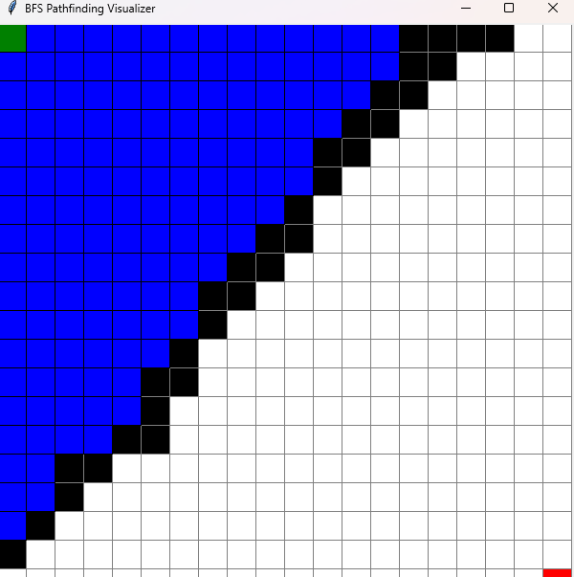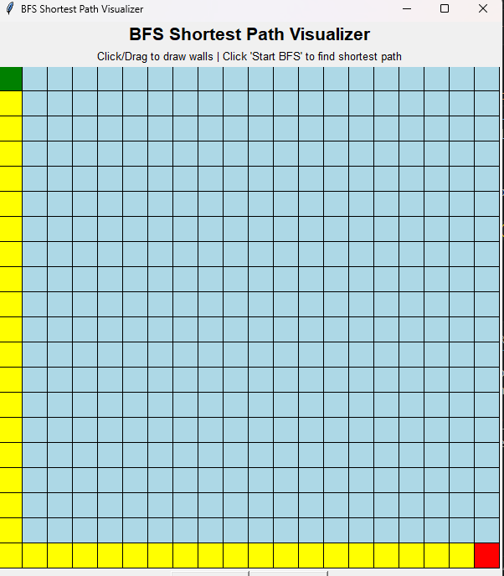

CONCLUION

The BFS Visualizer project successfully demonstrates how graph traversal algorithms can be effectively understood through visualization techniques. It provides an interactive environment where users can observe the step-by-step execution of the Breadth-First Search algorithm.
The project simplifies complex algorithmic concepts by presenting them in a visual and user-friendly manner. It highlights the importance of data structures such as queues in implementing traversal algorithms.
The use of Python and Pygame ensures that the system is efficient, flexible, and easy to use. The graphical interface enhances user engagement and makes learning more intuitive.
Through this project, users can clearly understand how nodes are explored level-by-level and how BFS guarantees the shortest path in unweighted graphs.
The project also improves problem-solving skills and logical thinking, which are essential for computer science students.
It serves as a strong foundation for learning advanced algorithms and data structures.
Future enhancements can include features such as shortest path visualization, obstacle handling, and advanced user controls.
Overall, the project achieves its objective of providing a clear and practical understanding of BFS traversal.

GITHUB SCREEN-SHOT AND LINK

FUTURE ENHANCEMENT

The current BFS Visualizer project provides a basic and effective visualization of graph traversal. However, it can be further improved by adding advanced features to enhance its functionality and usability.
One of the major enhancements can be the addition of shortest path visualization between a start and end node, which will make the project more practical and useful.
Another improvement can be the implementation of obstacles or walls in the grid, allowing users to simulate real-world scenarios such as maze solving.
The project can also include a feature to adjust the speed of visualization, enabling users to control how fast or slow the algorithm runs.
Adding multiple algorithms such as Depth-First Search (DFS), Dijkstra’s Algorithm, and A* Search can make the system more comprehensive and educational.
The user interface can be further improved by adding buttons, legends, and labels to make the application more user-friendly.
The project can also be converted into a web-based application using technologies like HTML, CSS, and JavaScript for better accessibility.
Another enhancement could be adding sound effects or animations to improve user engagement.
Data saving and loading features can also be included to store user-created graphs.
With these improvements, the project can evolve into a complete algorithm visualization tool useful for both students and professionals.

REFRENCES

The development of this project required the use of various learning resources, documentation, and online materials to understand the concepts of graph traversal and visualization.

The development of this project required the use of various learning resources, documentation, and online materials to understand the concepts of graph traversal and visualization.
- Python Official Documentation – https://docs.python.org
This was used to understand the fundamentals of Python programming and built-in data structures.
- Pygame Documentation – https://www.pygame.org/docs
It provided detailed guidance on creating graphical interfaces, handling events, and rendering animations.
- GeeksforGeeks – https://www.geeksforgeeks.org
This platform was helpful for understanding the Breadth-First Search algorithm, its implementation, and real-world applications.
- W3Schools – https://www.w3schools.com
Used for basic Python concepts and syntax reference during development.
- Stack Overflow – https://stackoverflow.com
Helped in resolving coding errors, debugging issues, and understanding best practices.
- Data Structures and Algorithms Books
Various academic books were referred to understand graph theory, BFS traversal, and queue operations in depth.
- YouTube Tutorials and Online Courses
These resources helped in understanding visualization techniques and improving implementation skills.
All these references played an important role in successfully completing the project and enhancing conceptual clarity.

