Global Launch Analysis
Launches 2002 to 2026 | Generated 19 September 2026

Key findings
- 3,000 completed launches between 2002 and 2026, with an overall success rate of 94.6%.
- Busiest year: 2025 with 341 launches.
- Most active provider: SpaceX (24% of all launches).
- Most launched rocket: Falcon 9 (689 launches).
- Among rockets with at least 20 launches, Atlas V 401 has the highest success rate (100.0%) and Rokot/Briz-KM the lowest (89.3%).

Launches over time
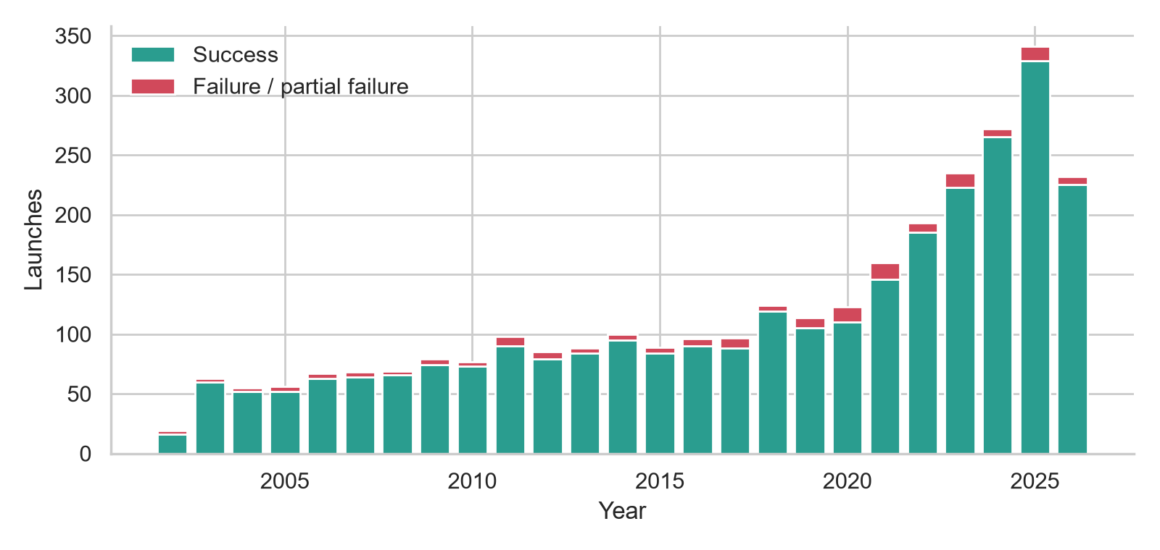
Figure 1. Launches per year, split by outcome.

Reliability
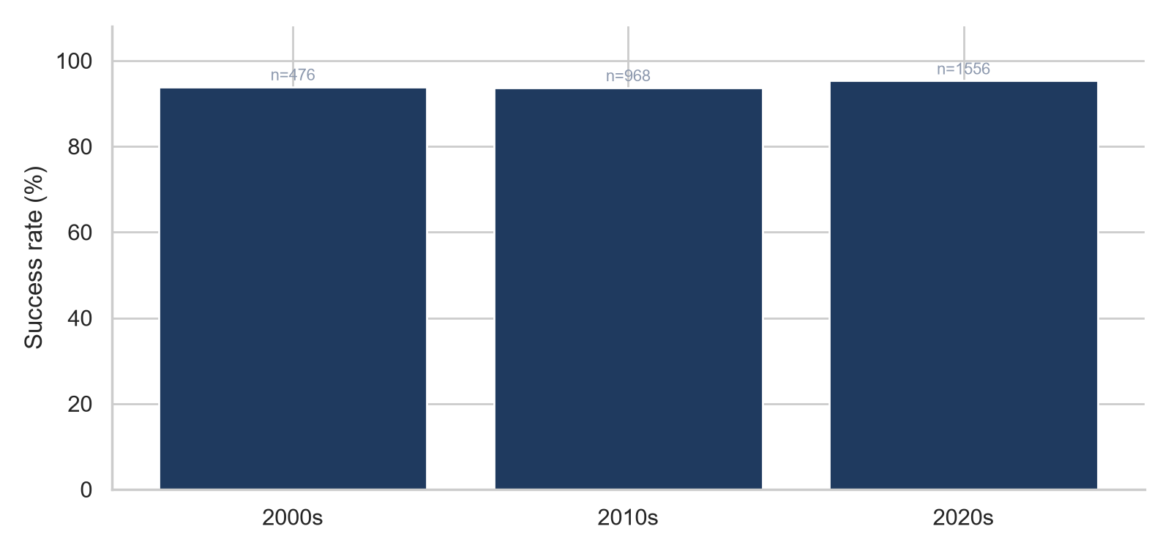
Figure 2. Success rate by decade (n = launches in that decade).

Reliability by rocket
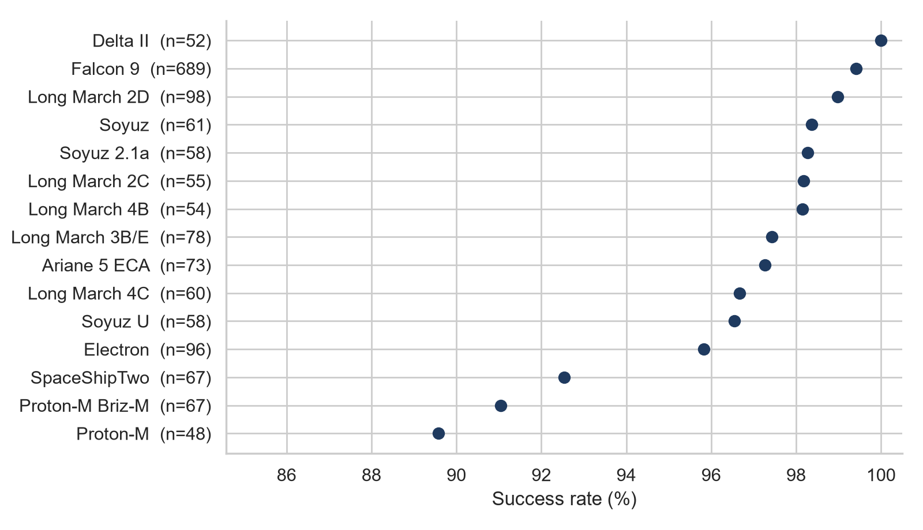
Figure 3. Success rate of the most-launched rockets (at least 20 launches).
Rocket | Launches | Successes | Success rate
Falcon 9 | 689 | 685 | 99.4%
Long March 2D | 98 | 97 | 99.0%
Electron | 96 | 92 | 95.8%
Long March 3B/E | 78 | 76 | 97.4%
Ariane 5 ECA | 73 | 71 | 97.3%
SpaceShipTwo | 67 | 62 | 92.5%
Proton-M Briz-M | 67 | 61 | 91.0%
Soyuz | 61 | 60 | 98.4%
Long March 4C | 60 | 58 | 96.7%
Soyuz 2.1a | 58 | 57 | 98.3%
Soyuz U | 58 | 56 | 96.6%
Long March 2C | 55 | 54 | 98.2%
Long March 4B | 54 | 53 | 98.1%
Delta II | 52 | 52 | 100.0%
Proton-M | 48 | 43 | 89.6%

Providers and orbits
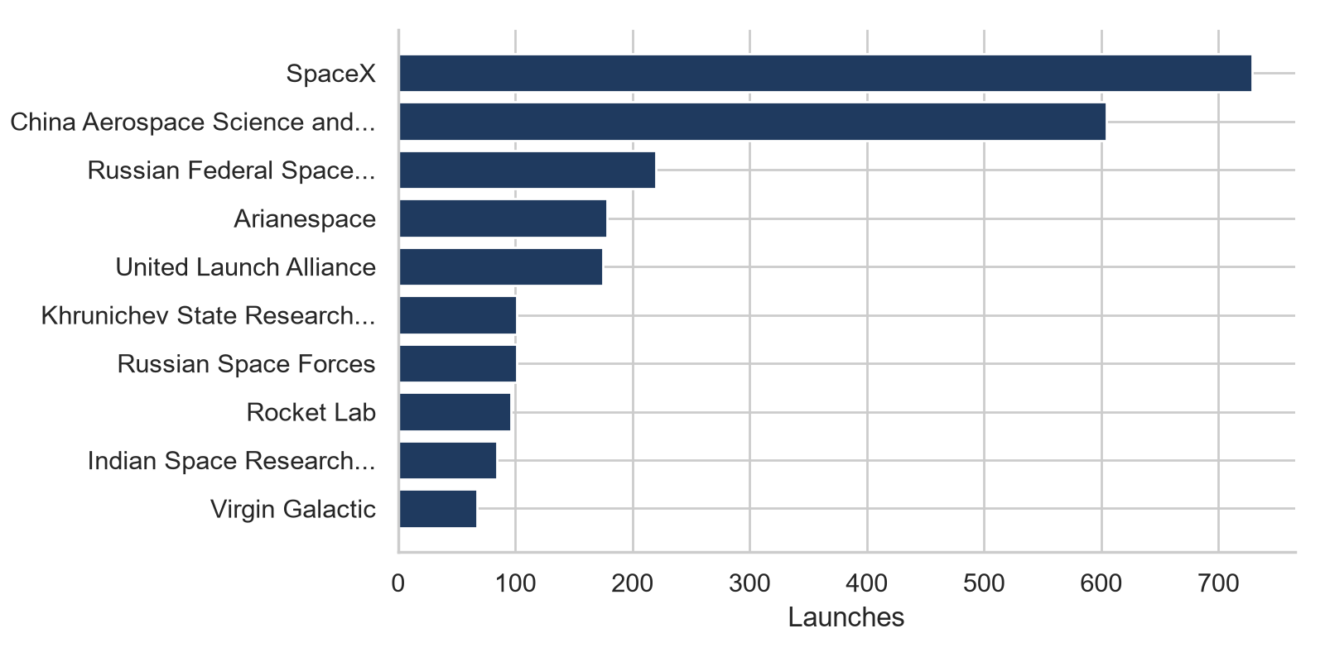
Figure 4. Top 10 providers by launch count.
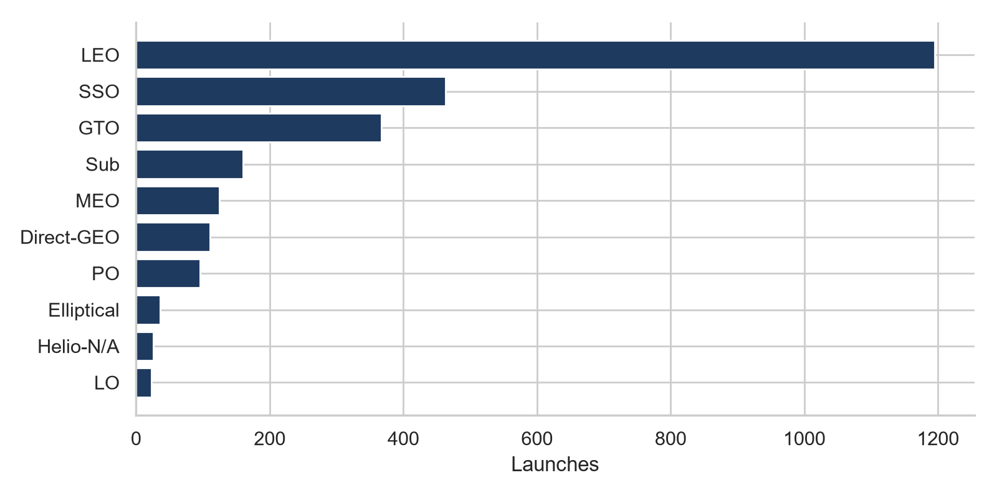
Figure 5. Top 10 target orbits (launches with unknown orbit excluded).

About the data
- Source: Launch Library 2 by The Space Devs, pulled with fetch_data.py.
- Only launches with a recorded outcome are included; scheduled or unknown launches are dropped.
- A launch counts as a success only if its status is Launch Successful. Partial failures count as failures.
- Rocket, provider, and orbit names are shown as they appear in the source data.

