JAVA
________________________________________________________________________
Q. what is JAVA?
__________________________________________________________________________
Java is pure object oriented language
Types of object oriented programming?
___________________________________________________________________________________
There are two types of Object Oriented Programming
______________________________________________________________________
1. Semi Object oriented programming or Partial Object Oriented programming
_________________________________________________________________________________
Semi object oriented programming means not necessary to use object oriented concept compulsory in code means we can use some feature of procedure oriented for develop application called as semi object oriented.
C++ is semi object oriented language means using C++ we can achieve OOP concept as well as you can use all C feature in C++ i.e. can use Procedure oriented approach in C++ so we can it is called as semi object oriented language.

2. Pure Object Oriented Programming
____________________________________________________________________________________
Pure Object Oriented means we cannot develop any application without using OOP feature called as pure object oriented language
like as java , c# are the pure object oriented means we cannot run any program of java or c# without class and class is feature of OOP , we cannot create any program java or c# without inheritance so inheritance is feature of OOP so we can say it is object oriented programming.

Q. What is diff between C++ and JAVA?
___________________________________________________________________________________

C++ | JAVA
Semi object oriented | Pure object oriented
C++ can use structure and union | JAVA not use structure
C++ use delete operator | JAVA not use delete operator use garbage collection
C++ support external use of pointer | JAVA use internal pointer but programmer not need to declare it manually
C++ support operator overloading | JAVA not support to operator overloading
C++ Support friend function | Java not support to friend function
C++ achieve abstraction using pure virtual function | Java achieve abstraction using abstract keyword
C++ not support to final keyword use const keyword for constant declaration | JAVA use final keyword for declare constant, avoid function overriding and avoid inheritance
C++ use template | Java use generics
C++ provide data structure library using standard template library | Java provide data structure implementation using collection framework
C++ use inline function and macros | Java not support inline function and macros
You can use call value with object in C++ | But in java we must be work with call by reference with object.
C++ support multiple inheritance using classes | JAVA implement multiple inheritance using interface
C++ support scope operator access global variable in local block | Java not support to global variable in java static work like as global
C++ allows us can define function outside of class | Java not allow define function outside of class must be define within class
C++ not support this() constructor | Java support to this() constructor
C++ use base class constructor concept for pass parameter to parent constructor from child class | Java use super() constructor concept for pass parameter to parent constructor from child class.

How to Create Application using java
__________________________________________________________________________
If we want to create application using java we have some important steps.
1. Installed JDK
_____________________________________________________________________
Q. what is JDK?
_________________________________________________________________
JDK stands for Java Development Kit
JDK: JDK is software cluster or it is group of software which contain some supporting software’s those help us to create and execute java application as well as provide environment to us to create and execute java application it contain compiler, JVM etc
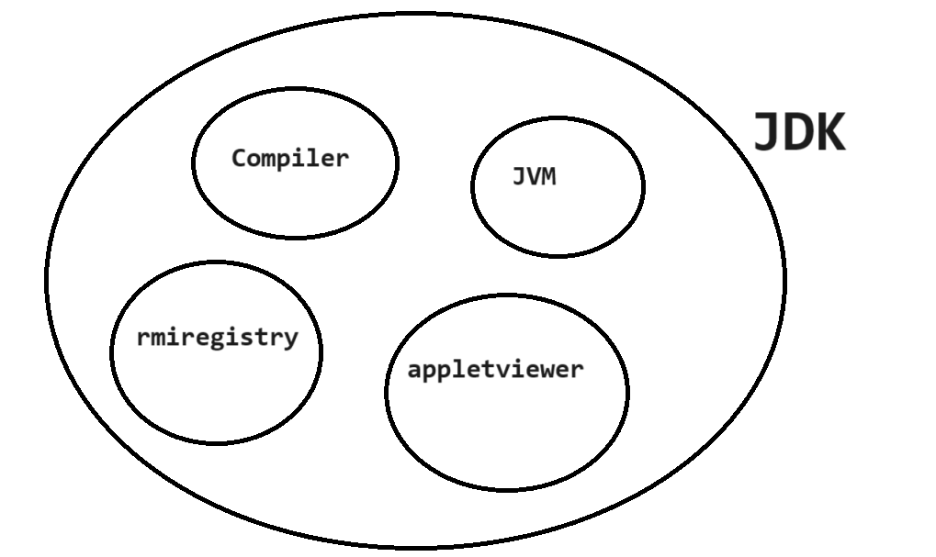

Q. what is compiler?
____________________________________________________________
Compiler is application or software which is used for convert your source code to byte code in java.



Q. What is byte code?
______________________________________________________________________________
byte code is intermediate code or it is machine understandable code means byte code is responsible to generate machine code with the JVM means byte code can accept by JVM and put in RAM and generate machine code from that and execute it and generate output.

Q. Why java develop by code?
_________________________________________________________________________
The benefit of byte code is it is platform independent code.
Q. what is platform?
__________________________________________________________________________
Here we can say platform is operating system and byte code is plat form independent means it is operating system independent means byte code can execute on any operating system so java is platform independent language
Means if you generate byte code on windows operating system it will execute on Linux , unix etc
Following diagram shows platform independency
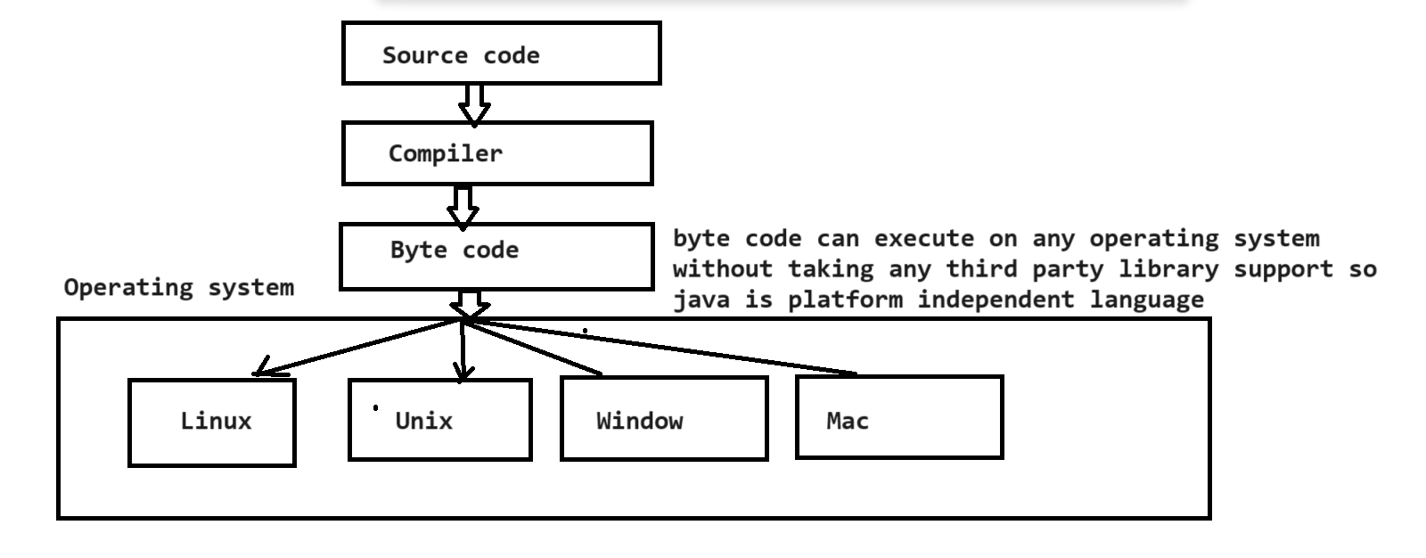

Q. what is JVM?
__________________________________________________________________________
JVM stands Java Virtual Machine we can say it is application which is responsible for accept byte code generated by compiler and put byte code in ram verify byte code and then convert in machine code and process on it and generate output
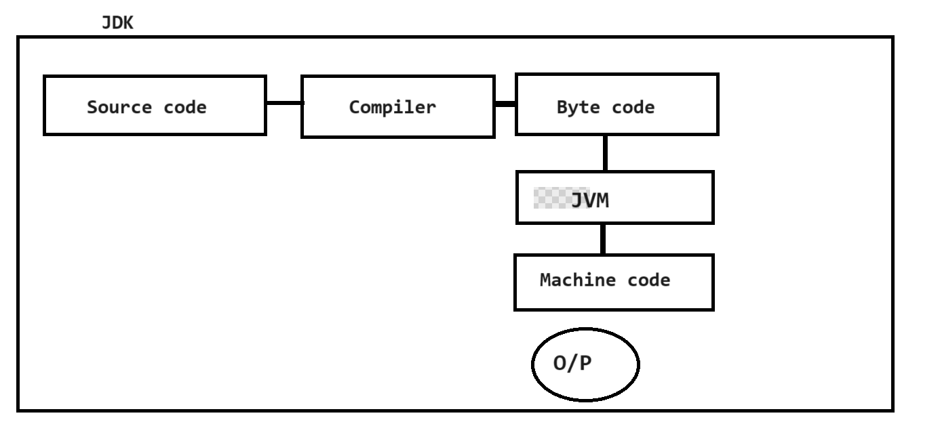

2. Create Sample Application
____________________________________________________________________________
If we want to create any program in java then must be use minimum single class
public class FirstJuly
{ public static void main(String x[])
{ System.out.println("good morning");
}
}
public class FirstJuly
_____________________________________________________________________________
public is access specifier

Q. what is access specifier?
____________________________________________________________________________
access specifier are the some keywords which is responsible apply restrictions on class and its member.

There are four types of access specifier in JAVA
______________________________________________________________________________
public : it allow us access member outside of class within same package as well as outside of class outside of package using its object.
private: private means member cannot access outside of class
protected: protected means member can access only child class of same package as well as outside of package.
default: default means member can access outside of class using its object but within package.
class : class is keyword for class declaration and FirstJuly is class name and user can give any name to his class.

public static void main(String x[]): it is main function of java same like as main function in C or C++ and String x[] is command line argument in main function.

System.out.println("good morning"): it is output statement of java same like as printf() in c

Meaning of System.out.println(): System is class out is static reference PrintStream class and System and PrintStream maintain HAS-A relationship between them and println() is overloaded method for display output on output screen.

once we create application of java we can save program
Note: you can write code of java using notepad,eclipse etc

3. Save Application : if we want to save java program then save in bin folder where JDK installed and give classname and filename same with .java extension as per our example you have to give file name FirstJuly.java

4. Compile Application
Q. what is compilation?
__________________________________________________________________________
Compilation is process where we convert your source code to in to byte code.

How to compile java program
____________________________________________________________________
if we want to compile java program then use the following steps.
a. open command prompt
search --- command prompt and press enter
b. go where java file save
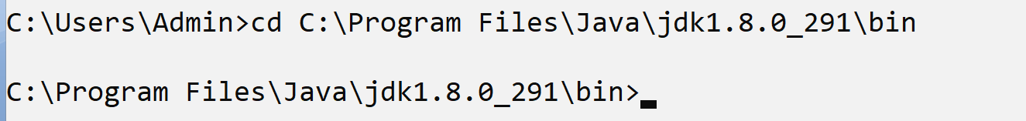
c. Type command javac filename.java
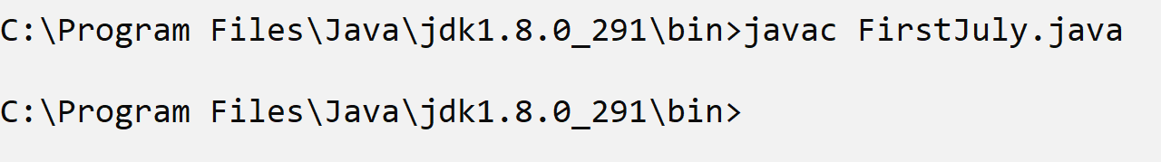
Note: when we compile any file in java then java compiler create new file automatically with extension of .class and in this file contain your byte code.

5. Run Application: if we want to run java code you have to type command after compilation we cannot run java program without compile

java filename.
Example : java FirstJuly
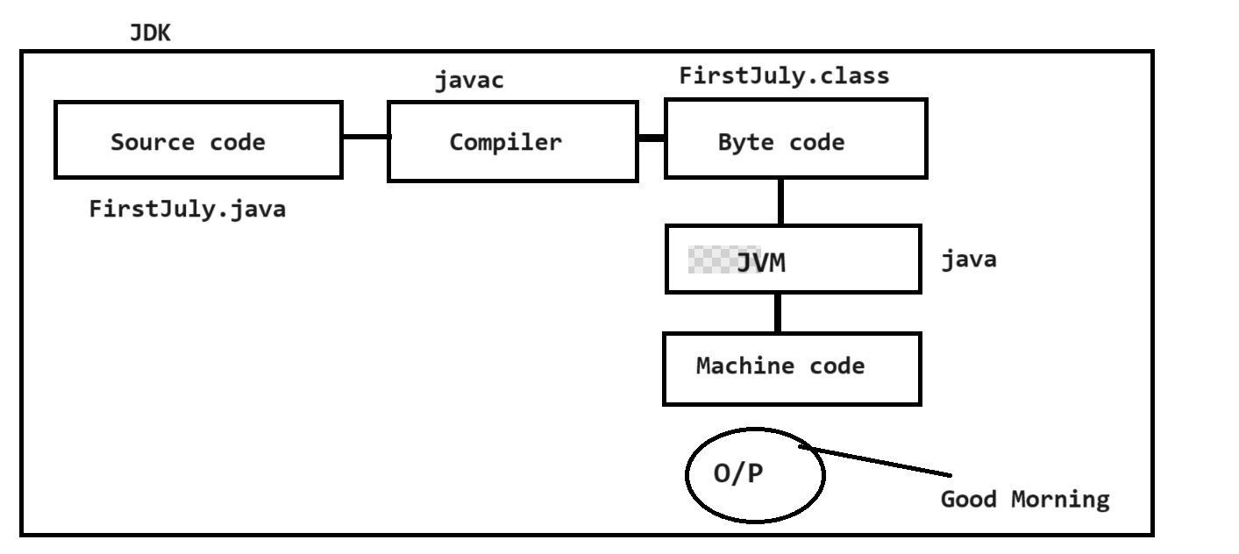

Command line arguments
____________________________________________________________________
Command line argument is parameter present in main function of string type called as command
line arguments.
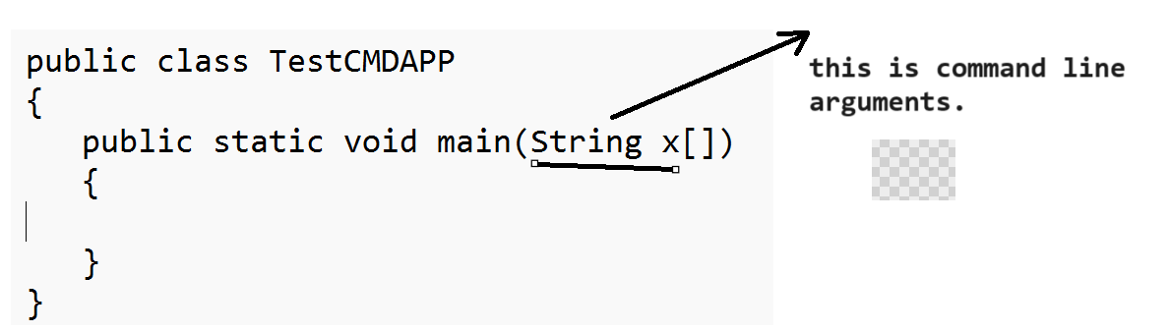

Q. what is purpose of command line arguments?
________________________________________________________________
The main goal of command line argument is accept input from keyboard at run time where we
execute your program basically command line argument is infinite string array means we can accept n number of input through the command line argument but the first input of command line is at position of zero.

Now we want to create program accept two input values and calculate its addition.
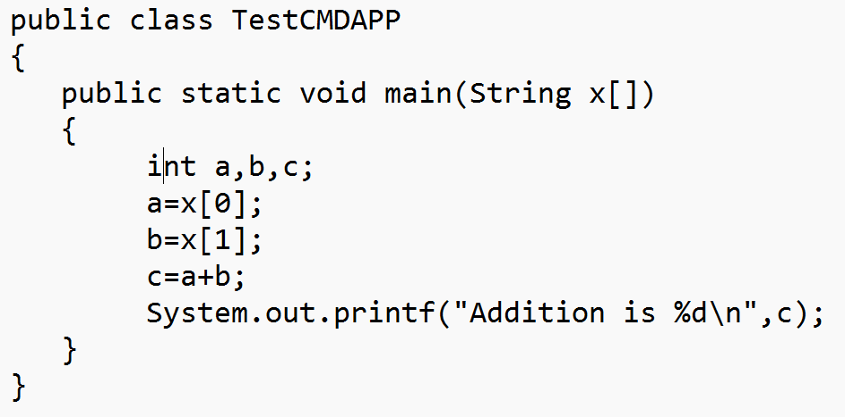
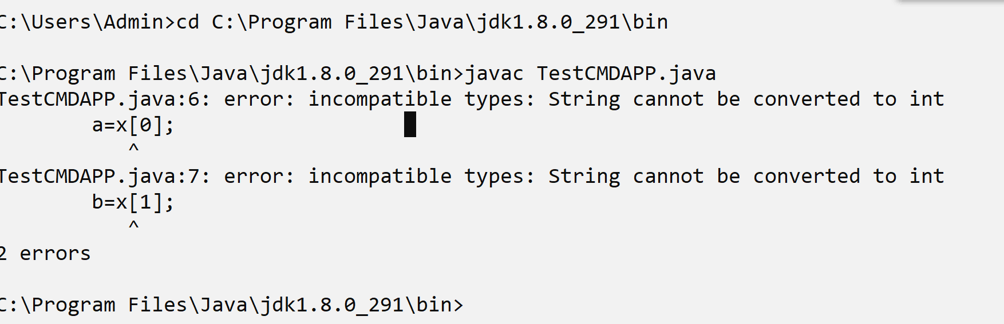
If we think about above code we get two compile time errors incompitable types because we have resource for accept input of type string and we required to input of type integer and we try to store string value in integer so we cannot store directly string value to integer value so compiler will generate compile time error.

How to solve this type of error in JAVA?
__________________________________________________________________________________
If we want to solve this type of error in java we have to use type casting technique means we required to convert string value to integer value as per our example.

How to convert String value to integer value in JAVA?
____________________________________________________________________________________
if we want to convert string value to integer value in java we have to use following syntax

int value = Integer.parseInt(String): Here Integer is class and parseInt() is function of Integer class which is used for convert your string value to integer value in JAVA.
How to convert string to float
______________________________________________________________________________
float variable=Float.parseFloat(String): this is used for convert string value to float value.
How to convert String to double
_____________________________________________________________________________
double value=Double.parseDouble(String): convert string value to double value
etc

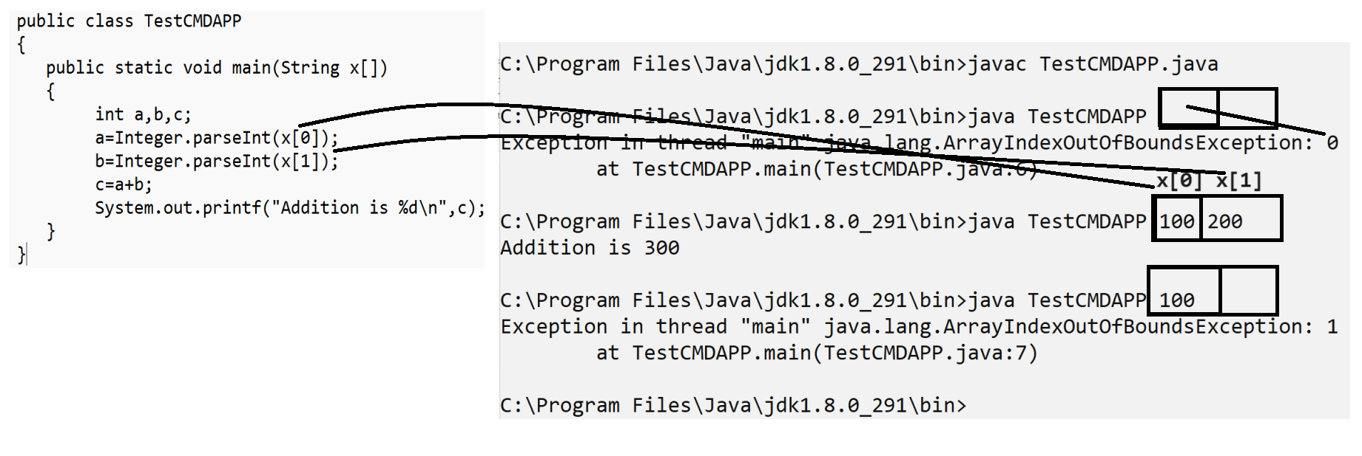
Note: if we use command line for input then we must be pass input on same like where you execute or run you java program if give less input than your size then index of the input thrown as error

Example: WAP to input radius of circle and calculate its area using command line argument
public class CircleAreaApp
{
public static void main(String x[])
{
float radius,area,PI=3.14f;
radius=Float.parseFloat(x[0]);
area=radius*radius*PI;
System.out.printf("Area of circle is %f\n",area);
}
}

Example: WAP to input two values from keyboard consider first as base and second as index and calculate its power.
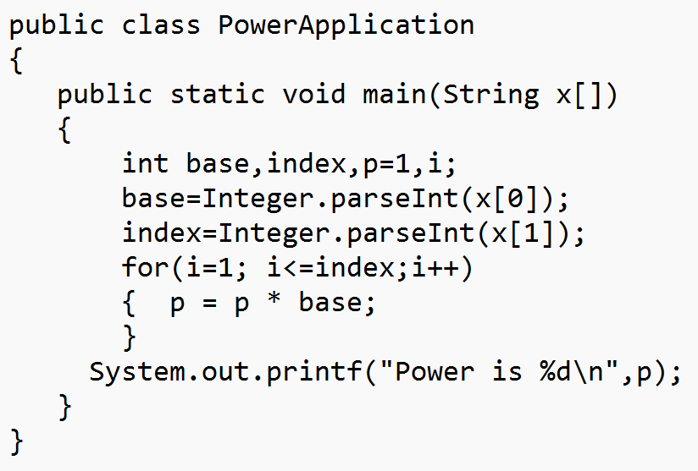
If you use command line argument then we must be accept input on same line we cannot accept input on new line so if we want to accept input on new line then we have to use Scanner class.

Steps to work with Scanner class
_______________________________________________________________________________
1. Add java.util package in application
___________________________________________________________________________
Q. what is package?
________________________________________________________
Package is a collection of classes and interfaces in java it is like as header file in c language.
but header file is collection of functions and package is collection of classes and interfacesbecause java is pure object oriented language

Q. How to import or Add package in application?
_______________________________________________________________________
If we want to add package in application we have to use import keyword.
Syntax: import packagename.*: this statement indicate we can import member from package in application
or
import packagename.classname: this statement indicate we can import specific member from package in application.
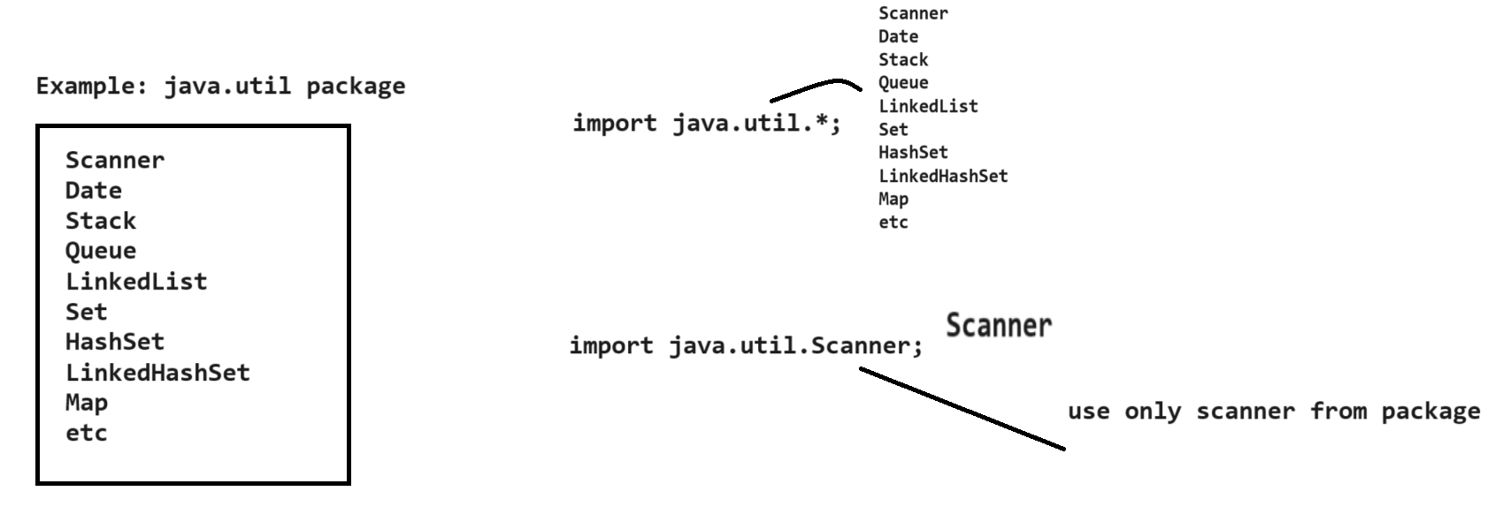

2. Create Object of Scanner class.
if we want to use any class we must be create its object means we must be create object of Scanner class
Syntax:
Scanner ref = new Scanner(System.in);

Example: Scanner xyz = new Scanner(System.in);

3. Use its method to work with Scanner
Scanner class provides some inbuilt method to us for accept input from keyboard.

int nextInt(): this function is used for accept input of type integer
float nextFloat(): this function is used for accept input of type float
double nextDouble(): this function is used for accept input of type double
long nextLong(): this function is used for accept input of type long
String nextLine(): this function is used for accept input of type string
etc

Example: We want to input two values and calculate its addition.
import java.util.*;//step1
public class AddScanApp
{ public static void main(String x[])
{ Scanner xyz = new Scanner(System.in);//step2
int a,b,c;
System.out.println("enter two values");
a=xyz.nextInt();//step3
b=xyz.nextInt();//step3;
c=a+b;
System.out.printf("Addition is %d\n",c);
}
}
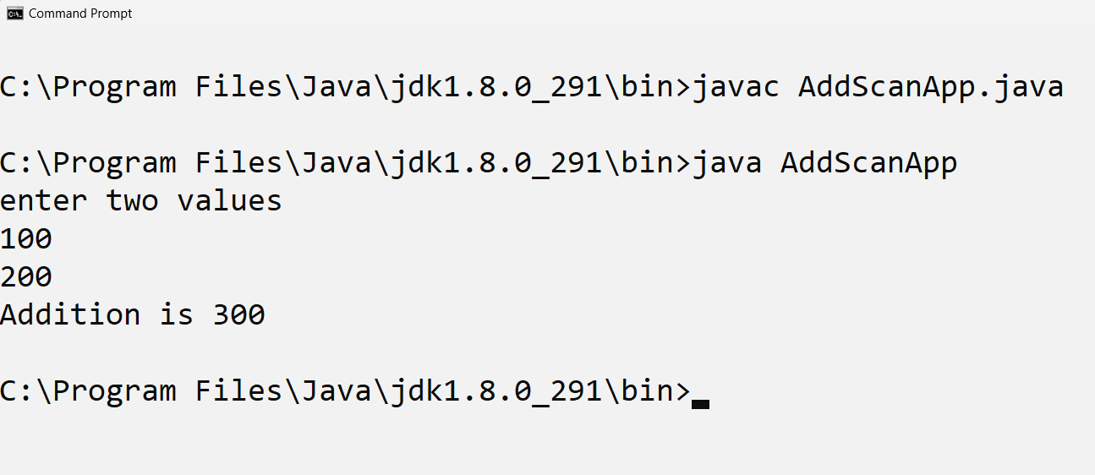
Example: WAP to input name id and marks of student and display it
marks type should be float.

import java.util.*; //step1
public class StudScanApp
{ public static void main(String x[])
{ Scanner xyz = new Scanner(System.in);//step2
System.out.println("Enter name");
String name=xyz.nextLine();
int id=xyz.nextInt();
float per=xyz.nextFloat();
System.out.printf("Name is %s\n",name);
System.out.printf("Id is %d\n",id);
System.out.printf("Percentage is %f\n",per);

}
}

Q1. Why java is platform independent language?
________________________________________________________________________________
Java develop the byte code after program compilation and byte code can execute on any operating system without taking any third party software support so java is platform independent language.

Example: support consider we compile java program on windows operating system so we can execute .class file means byte code on linux ,mac etc means we can say you can run java program on any operating system so java is platform independent language.
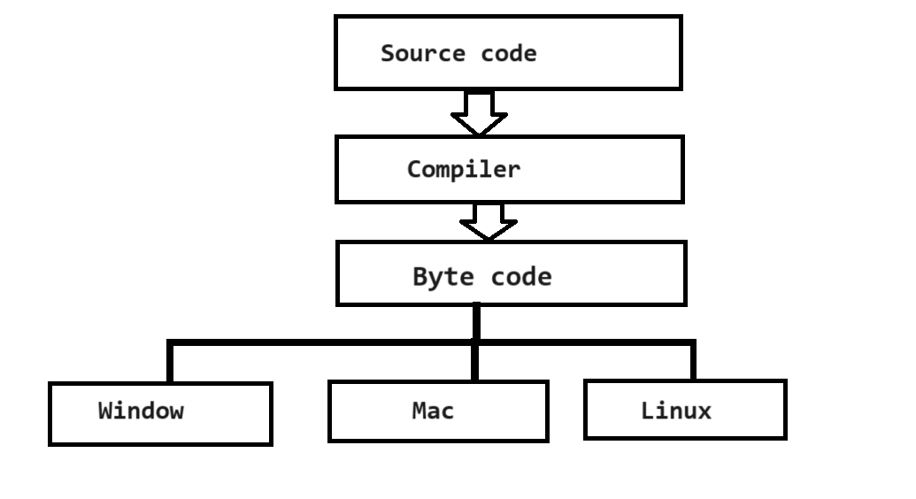
Q2. Explain Feature of java?
Pure object oriented: we cannot create java program without OOP features like as class ,inheritance etc.
Platform independent: we can execute java program on any operating system without taking any third party tool support so it is platform independent.
Robust and secure: robust means java handle the run time program termination means manage exception at run time as well as manage memory like as garbage collection at run time etc so it is robust and secure means java provide the some security API to us which help us to apply security on java application so it is secure like as spring security etc.

Multithreaded : Java provide support to multithreading means using java we can achieve multi threaded application which help us to improve perform of application as well as it help us to manage servers, gaming API , multi threaded application help us to share resources etc.

Interpreted: java use the compiler as well as interpreter under JVM which help us to interpreted byte code at run time and convert in machine code for execution purpose.

Huge API Library : java provide huge inbuilt classes to us for build application like as java provide collection framework which help us to implement data structure , java provide spring security PAI to us which help us to provide security to application etc.

Q3. What is byte code and why java develops byte code explain with example?
Byte code is machine understandable code means byte code helps us to generate machine code means we can say byte code work as intermediate between source code and machine code and JVM read byte code and generate machine code

Q4. Explain JDK, JRE and JVM?
_______________________________________________________________________________
JDK (JDK stands for Java Development Kit): JDK is collection of tools or application which help us to provide environment to us to create and execute java application means using JDK you can create java code ,compile it and run it means in JDK contain compiler as well as JVM
means compiler help us to convert source code to byte code and JVM help us to convert byte code to machine code means JDK normally refer in development environment where developer can write code ,compile and run it and check output

JRE (Java runtime Environment): JRE is physical existence of JVM means JRE contain only JVM which is used for execute java program or run java program means using JRE we cannot compile java program just you can run java program using JRE. so normally JRE used in Test environment or production environment where tester can execute code and check and production means where project get deploy by production team.

JVM: JVM stands for java virtual machine it is logical existence of JRE means JVM help us to read byte code verify byte code and execute it means using JVM we can run java program but JVM is logically present in JRE.

Q5. Is JVM platform dependent or independent?
_____________________________________________________________________________
JVM is platform dependent because role of JVM is convert byte code to machine code and every operating system has different machine code generation technique so Oracle develop the JDK setup separate for every operating system and it contain common compiler in every setup but different JVM as per operating system means every operating system has different JVM so we can say JVM is platform dependent tool.

Q6.Why main method is static in java?
__________________________________________________________________________
because java main function present in class and we run java program using class which contain main method and main method call by JVM and if method present in class then need to create object but when we create object then constructor get executed means if main method not static then JVM need to create object of class and if user define parameterized constructor in class where main method is exist then at the time object creation JVM need to pass parameter but JVM cannot pass parameter to user constructor so avoiding this possibility JVM want to call main method without object so it is static because static member can call without object.

Q7. Can we overload the main method?
______________________________________________________________________________
yes we can overload the main method because if we have main method with different data type except string so it is overloaded by JVM execute program using main method which contain string array as single parameter
Example:
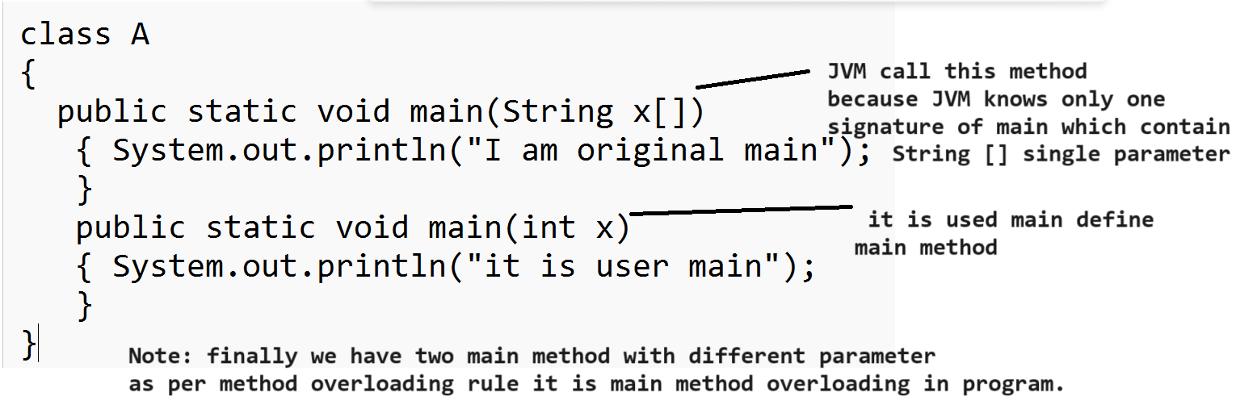

Q8. What happen if we pass different parameter in main except String?
____________________________________________________________________________________
If we pass different parameter in main except string then program get compile but not run because
Because when we compile program then compiler think main method may be overloaded but when we run program then JVM knows only one method which contain string array as argument and if JVM not found this parameter in main method then generate error at run time
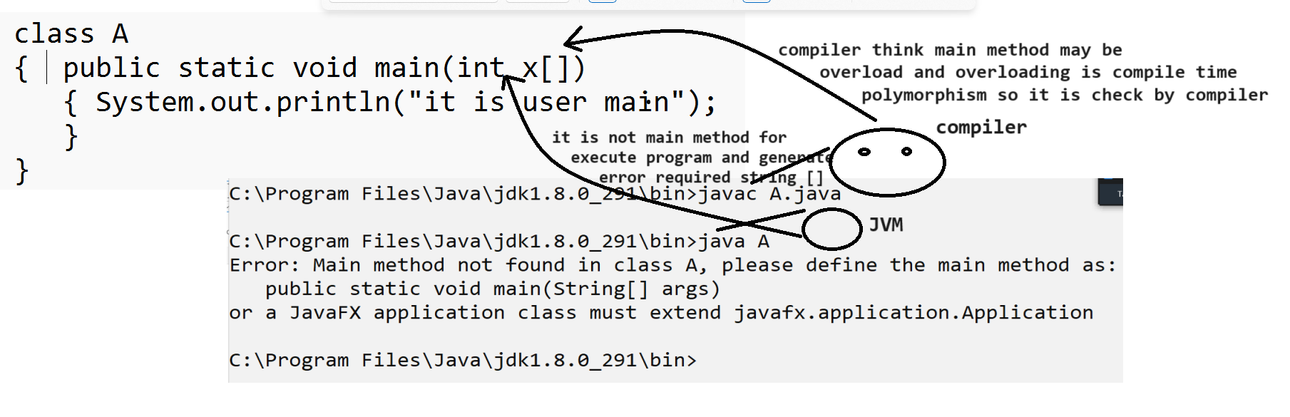
Q9. Explain JVM Architecture?
Q10. Why java is pure object oriented language?
Q11. What is command line argument and why use it?

