Bapuji Educational Association (Regd.)
Bapuji Institute of Engineering and Technology
Department of Computer Science and Engineering

Question Bank 2

Sl.No | Question | BL | Marks
1. | Develop the Bottom-up heap construction algorithm. Apply heapsort to arrange the list of numbers 2, 9, 7,6, 5, 8 in ascending order using array representation. | L3 | 10 M
2. | Define AVL Trees. Explain its four rotation types | L2 | 10 M
3. | Define heap. Explain the properties of heap along with its representation. | L2 | 10 M
4. | Design Horspools algorithm for string matching. Apply Horspools algorithm to find the pattern BARBER in the text: JIM_SAW_ME_IN_A_BARBERSHOP | L3 | 10 M
5 | Define AVL tree with an example. Give Worst case efficiency of operations on AVL tree. Construct AVL tree of the list of keys: 5,6,8,3,2,4,7 indicating each step of key insertion and rotation | L3 | 10 M
6 | Define Heap. Explain the bottom-up heap construction algorithm. Apply heap sort to sort the list of numbers 2,9,7,6,5,8 in ascending order using array representation | L3 | 10 M
7. | Define 2-3 tree. Give the worst case efficiency of operations on 2-3 tree. Build 2-3 tree for the list of keys 9,5,8,3,2,7 by indicating each step of key insertion and node splits. | L3 | 10 M
8. | Design Horspool algorithm for string matching. Apply this algorithm to find the pattern BARBer in the text:  JIM_SAW_ME_IN_A_BARBERSHOP | L3 | 10 M
9. | Apply Dijkstra’s algorithm to find the single source shortest path for a given graph by considering ‘s’ as source vertex.Illustrate each step.  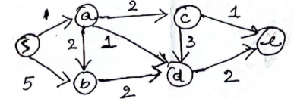 | L3 | 10 M
10 | Define transitive closure. Write Warshall’s algorithm to compute transitive closure. Illustrate using the following directed graph.  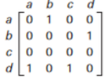 | L3 | 10 M
11 | Define Spanning tree? Construct Kruskal algorithm and apply the same to compute the minimum cost spanning tree for the following undirected graph.  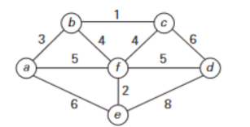 | L3 | 10 M
12 | Construct the Huffman Tree and resulting code for the following  Character A B C D _  Probability 0.4 0.1 0.2 0.15 0.15  i) Encode the text: ABACABAD  ii)Decode the text: 100010111001010 | L3 | 10 M
13 | Using Branch and Bound technique Solve the below instance of knapsack problem.  Item Weight Value.  Item Weight Value  1 2 12  2 1 10  3 3 20  4 2 5  The Knapsack Capacity W is 5 | L3 | 10 M
14 | Define Backtracking. Illustrate N queen’s problem using backtracking to solve the 4-Queens problem. | L2 | 10M
15 | Differentiate between Branch and Bound technique and Backtracking. Apply backtracking to solve the following instance of subset-sum problem S = {3, 5, 6, 7} and d=15. Construct a state space tree. | L3 | 10M
16 | Explain the following with examples  i) P Problem  ii) NP Problem  iii) NP - Complete Problem | L2 | 10M
17 | Explain greedy approximation algorithm to solve discrete knapsack problem | L2 | 10M

