**1. Hilbert Matrix**

1. **Why is it justified to use the LU or QR factorizations as opposed of calculating**

**an inverse matrix?**

It is justified to use the LU or QR factorizations as opposed of calculating an inverse matrix since calculating the inverse matrix is more time consuming than the method of solving LU or QR factorizations. The range of the problem entails that we only solve for b, which LU/QR does without as much calculations as finding the inverse of the matrix. Essentially, we are not trying to find every single x value possible for every single b value, we’re trying to find a single x value for a single b value, which LU/QR factorization is slightly more efficient at.

**II. What is the benefit of using LU or QR-factorization in this way? (Your answer should consider the benefit in terms of conditioning error)**

The benefit of using LU or QR-factorization in this way is that it saves processing time and power by dividing the elimination step from the manipulations of the right hand side, which can potentially take a long unit of time. Also, LU/QR provides an efficient alternative to compute the matrix inverse.

Error plots of n x error(*10-17):

|  |  |  |
| --- | --- | --- |
| LU | QR-Householders | QR-Givens |

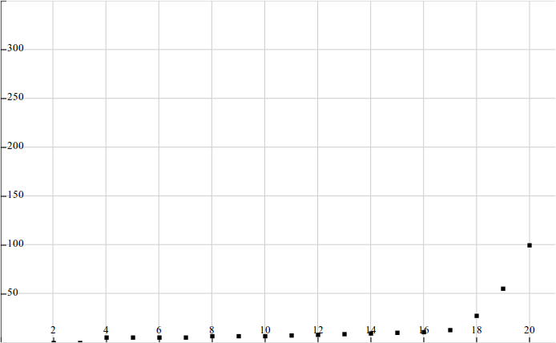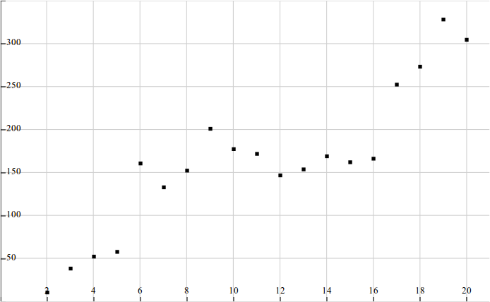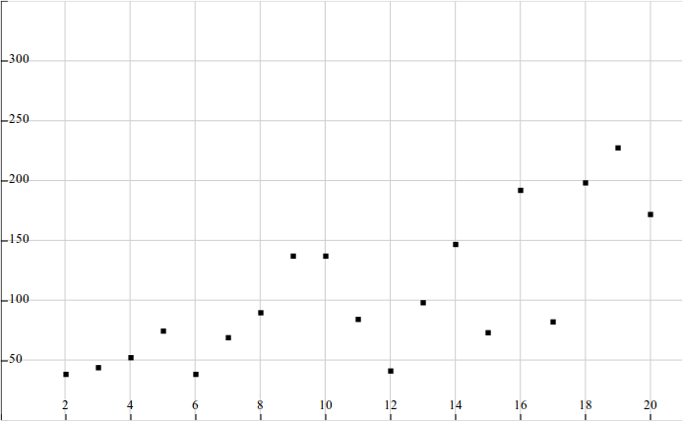

**2. Convolution Codes**

**Insert Aadil’s description here

**3. Urban Population Dynamics**

**1. Interpret the data in the matrix, and discuss the social factors that influence those**

**numbers.**

Given a certain age bracket, each value in the first row represents the reproduction rate of each age group for the female gender. The first value in the first row and first column, 0, is such due to the social tendency of young children aged 0-9 to not have children. The next 4 values represent the reproduction rates for the respective age groups 10-19, 20-29, 30-39, 40-49. The following 4 values are 0, because after the age of 50, human beings tend to stop reproducing and/or die.

The values on the diagonal represent the survival rate of each age group—in percentage—to the next age group. For example, the value in the second row, first column, is 0.7, which reads “70 percent of the 0-9 year old age group make it to the 10-19 years age group”. The social factors that yield this result is due to the fact that children are very vulnerable to environmental factors such as diseases, and are more likely to die.

**2. What will the population distribution be in 2010? 2020? 2030? 2040? 2050? Calculate**

**also the total population in those years, and by what fraction the total population**

**changed each year.**

[Obtain from Jon’s program output]

**3. Use the power method to calculate the largest eigenvalue of the Leslie matrix A. The**

**iteration of the power method should stop when you get 8 digits of accuracy. What**

**does this tell you? Will the population go to zero, become stable, or be unstable**

**in the long run? Discuss carefully and provide the mathematical arguments for your**

**conclusion. You might want to investigate the convergence of ||Ak||.**

**(a) Largest Eigenvalue**

The largest eigenvalue: 1.28ish. Run Jon’s and see what value you get.

**(b) What does the largest eigenvalue tell you? Will the population go to zero, become stable, or be unstable in the long run?**

The largest eigenvalue shows us that the population that the Leslie matrix represents will increase exponentially be a factor of the largest eigenvalue, which in our case is [insert largest eigenvalue here].

**(c) Will the population go to zero, become stable, or be unstable in the long run? You might want to investigate the convergence of ||Ak||.**

The population will become unstable, because the population will become so large, due to exponential growth, that the world will become overpopulated since the population will increase by a factor of [insert largest eigenvalue here].

**4. Suppose we are able to decrease the birth rate of the second age group by half in**

**2020. What are the predictions for 2030, 2040 and 2050? Calculate again the largest**

**eigenvalue of A (to 8 digits of accuracy) with your program and discuss its meaning**

**regarding the population in the long run.**