**DAY NO: 1**

**ASSIGNMENT ON**

**MACHINE LEARNING AND DEEP LEARNING**

**ALGORITHM**

**PRESENTED BY ST AIML :**

**AADIL RAYEEN [42]**

**UNDER THE GUIDANCE OF**

**MRS. PRANJALI SANKHE,**

**ASSISTANT PROFESSOR**

**AIML-DEPT**

MACHINE LEARNING

RANDOM FOREST ALGORITHM

Random Forest is a popular machine learning algorithm that belongs to the supervised learning technique. It can be used for both Classification and Regression problems in ML. It is based on the concept of **ensemble learning,** *which is a process of*combining multiple classifiers to solve a complex problem and improve the model's performance.

**The greater number of trees in the forest leads to higher accuracy and prevents the problem of overfitting.**

The below diagram explains the working of the Random Forest algorithm:

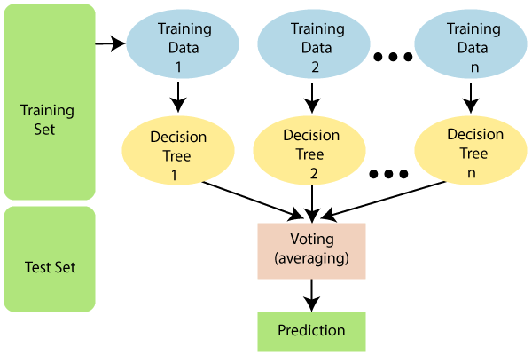

The working of the algorithm can be better understood by the below example:

**Example:** Suppose there is a dataset that contains multiple fruit images. So, this dataset is given to the Random forest classifier. The dataset is divided into subsets and given to each decision tree. During the training phase, each decision tree produces a prediction result, and when a new data point occurs, then based on the majority of results, the Random Forest classifier predicts the final decision. Consider the below image:

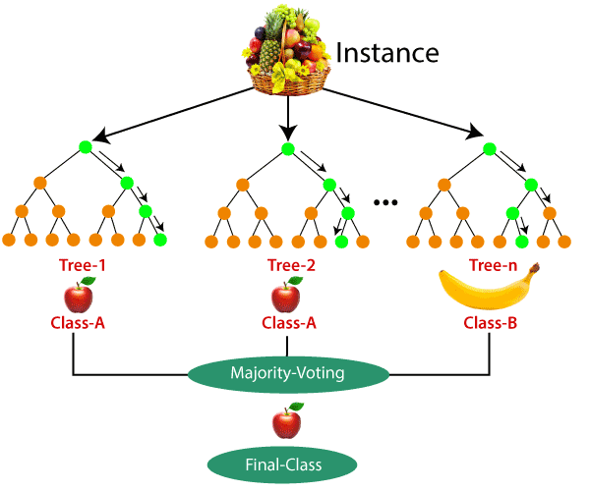

**Application:**

There are mainly four sectors where Random forest mostly used:

1. **Banking:** Banking sector mostly uses this algorithm for the identification of loan risk.
2. **Medicine:** With the help of this algorithm, disease trends and risks of the disease can be identified.
3. **Land Use:** We can identify the areas of similar land use by this algorithm.
4. **Marketing:** Marketing trends can be identified using this algorithm.

**Advantages:**

* Random Forest is capable of performing both Classification and Regression tasks.
* It is capable of handling large datasets with high dimensionality.
* It enhances the accuracy of the model and prevents the overfitting issue.

DEEP LEARNING

MULTI-LAYER PERCERPTRON ALGORITHM

What is Perceptron Model in Machine Learning ?

Perceptron is Machine Learning algorithm for supervised learning of various binary classification tasks. Further, **Perceptron is also understood as an Artificial Neuron or neural network unit that helps to detect certain input data computations in business intelligence**.

Basic Component of Perceptron

Mr. Frank Rosenblatt invented the perceptron model as a binary classifier which contains three main components. These are as follows:

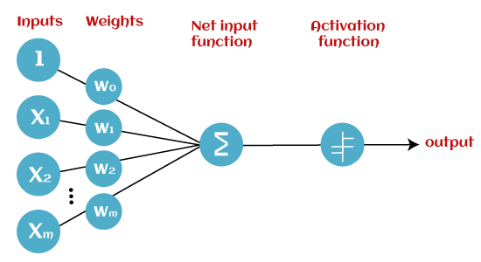

* **Input Nodes or Input Layer:**

This is the primary component of Perceptron which accepts the initial data into the system for further processing. Each input node contains a real numerical value.

* **Wight and Bias:**

Weight parameter represents the strength of the connection between units. This is another most important parameter of Perceptron components. Weight is directly proportional to the strength of the associated input neuron in deciding the output. Further, Bias can be considered as the line of intercept in a linear equation.

* **Activation Function:**

These are the final and important components that help to determine whether the neuron will fire or not. Activation Function can be considered primarily as a step function.

Multi-Layer perceptron defines the most complex architecture of artificial neural networks. It is substantially formed from multiple layers of the perceptron. TensorFlow is a very popular deep learning framework released by, and this notebook will guide to build a neural network with this library. If we want to understand what is a Multi-layer perceptron, we have to develop a multi-layer perceptron from scratch using Numpy.

The pictorial representation of multi-layer perceptron learning is as shown below-

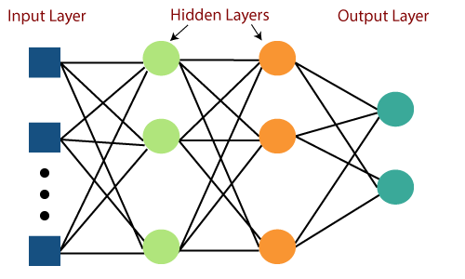

MLP networks are used for supervised learning format. A typical learning algorithm for MLP networks is also called **back propagation's algorithm**.

A multilayer perceptron (MLP) is a feed forward artificial neural network that generates a set of outputs from a set of inputs. An MLP is characterized by several layers of input nodes connected as a directed graph between the input nodes connected as a directed graph between the input and output layers. MLP uses backpropagation for training the network. MLP is a deep learning method.