**DAY NO: 2**

**ASSIGNMENT ON**

**MACHINE LEARNING AND DEEP LEARNING**

**MODEL WITH CODE**

**PRESENTED BY ST AIML :**

**AADIL RAYEEN [42]**

**PRIYANSHU SAH [43]**

**HARSH SHARMA [46]**

**PRASHANT SHARMA [48]**

**UNDER THE GUIDANCE OF**

**MS. PRANITI PATIL,**

**ASSISTANT PROFESSOR**

**AIML-DEPT**

**Deep Learning Model and Algorithm**

**Multilayer Perceptron (MLP) Algorithm**

* In Deep Learning, the main aim is to mimic the human brain.
* How to mimic?
* To mimic with the help of neurones forming neural network as like human brain.
* Deep learning requires huge amount of data (BIG DATA)

|  |  |  |  |
| --- | --- | --- | --- |
| **Study Time** | **Playing Time** | **Sleeping Time** | **Result** |
| 4 hr | 6 hr | 7 hr | 0 |
| 2 hr | 5 hr | 8 hr | 0 |
| 7 hr | 3 hr | 6 hr | 1 |
| 5 hr | 2 hr | 7 hr | 1 |

* The above table is a binary classification problem.
* Our aim is to predict whether the student will pass or fail.
* How to predict?

## **Perceptron :**

* Here inputs are the independent features.
* Weights are the computer assumed based numbers taken as randomly.
* Now summation added with bias -> x1w1+x2w2+x3w3+….xnwn (depending on the number of features).
* What is bias?
* Bias is a constant number in the equation assumed randomly like intercept (c) in the linear regression.
* Summation and activation happens in the hidden layer.
* Number of hidden layers dependent on the number of inputs given.
* Training of the data happens in the hidden layer.
* What actually happens in the hidden layer?
* As soon as the inputs comes to the hidden layer, the summation of the product of inputs and weights get assigned.

Value of the weights decide what level it should activated to pass the signal to the neurone.

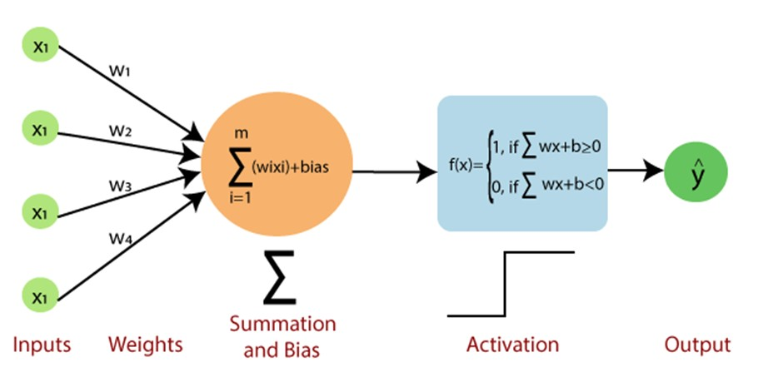

## **Activation Function :**

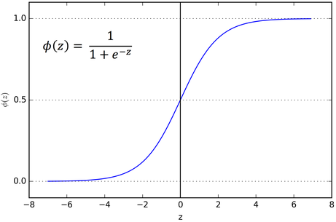

## **Sigmoid Function**

* Sigmoid Activation Function is used for binary classification.
* The output of the sigmoid function is either 0 or 1.
* Sigmoid function can give the value between 0 to 1, if it >= 0.5 it is taken as 1 and if it is < 0.5 it is taken as 0.
* If it is not equal to the desired output, backward propagation happens.
* What is backward propagation?
* Backward propagation is the process of going back in the algorithm and changing the value of the weights.
* The aim of the backward propagation is to update the value of the weights.
* And then forward propagation happens to get the desired output.
* Backward propagation and forward propagation happens until we get the accurate output.
* Error of the output = Actual output - Predicted output
* Error of the output should be closer to 0.
* 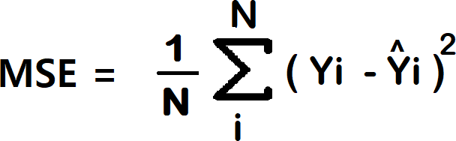How to handle the errors?

## Loss function

* While happening backward propagation, optimisers are used to update the weights.
* Gradient Descent is a kind of Optimiser in deep learning.

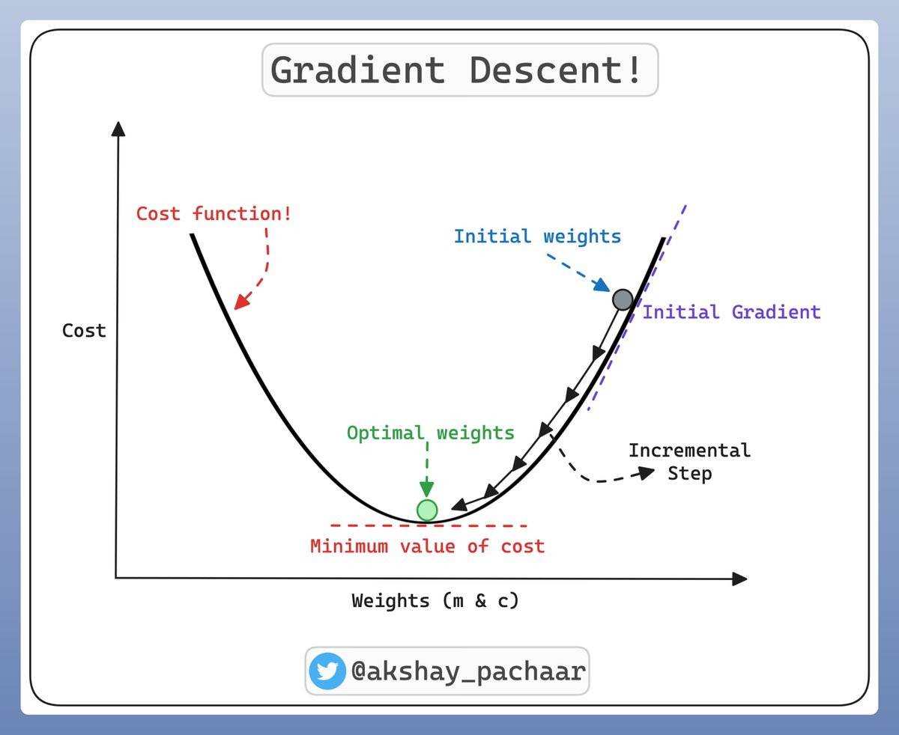

MACHINE LEARNING

RANDOM FOREST ALGORITHM

Random Forest is a popular machine learning algorithm that belongs to the supervised learning technique. It can be used for both Classification and Regression problems in ML. It is based on the concept of **ensemble learning,** *which is a process of*combining multiple classifiers to solve a complex problem and improve the model's performance.

**The greater number of trees in the forest leads to higher accuracy and prevents the problem of overfitting.**

The below diagram explains the working of the Random Forest algorithm:

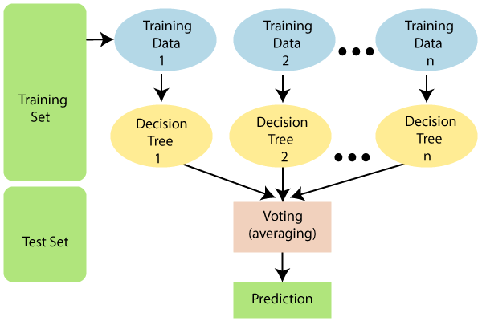

The working of the algorithm can be better understood by the below example:

**Example:** Suppose there is a dataset that contains multiple fruit images. So, this dataset is given to the Random forest classifier. The dataset is divided into subsets and given to each decision tree. During the training phase, each decision tree produces a prediction result, and when a new data point occurs, then based on the majority of results, the Random Forest classifier predicts the final decision. Consider the below image:

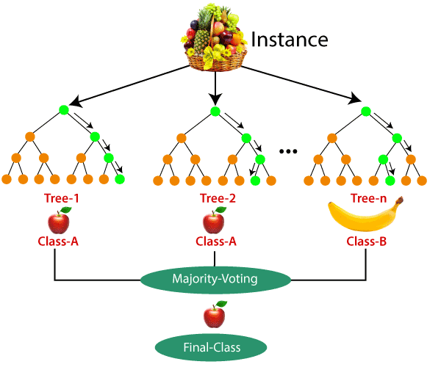

**Application:**

There are mainly four sectors where Random forest mostly used:

1. **Banking:** Banking sector mostly uses this algorithm for the identification of loan risk.
2. **Medicine:** With the help of this algorithm, disease trends and risks of the disease can be identified.
3. **Land Use:** We can identify the areas of similar land use by this algorithm.
4. **Marketing:** Marketing trends can be identified using this algorithm.

**Advantages:**

* Random Forest is capable of performing both Classification and Regression tasks.
* It is capable of handling large datasets with high dimensionality.
* It enhances the accuracy of the model and prevents the overfitting issue.

