School Teaching Assistant Application

(iTeach)

Aadil Mohammed

Student ID: 180034848

**Abstract**

This report outlines the design and creation of a school teaching web application targeted towards primary schools, enabling administrators to manage classes, students, parents, and teachers. Additionally, teachers can create reflections to summarize student progress and can be shared with parents.

This report contains an introduction outlining the reasons behind the implementation of such a system. Includes project background research with analysing existing software’s available, project specification (i.e., technologies used and why), project planning and timetable, project design which consists of UI wireframes and design diagrams, implementation and lastly testing and evaluation to assess the overall work undertaken during this project.

Contents

1 Introduction 3

2 Background Research 4

2.1 Existing Software’s 4

2.1.1 Target Tracker 4

2.1.1.1 Knowledge Elicitation – Teacher Feedback 4

2.1.2 DreamClass 4

References 7

# 1 Introduction

# 2 Background Research

With the current situation of Covid-19 taking place and schools closing due to the lockdown, it has had a significant impact on student learning. For example, a study conducted by (Sharp et al., 2020) pinpoints that 98% of teachers have reported that students are behind in their studies compared to where the students should be at the end of their curriculum learning. Moreover, addressing the importance of online school platforms, such as finding ways for teachers to continue teaching pupils, further research from (dfedigital.blog.gov.uk, n.d.) indicates how digital education platforms have effectively helped students continue their learning. One of the main benefits includes teachers sharing valuable resources with parents to support their children at home.

Regarding how parents have impacted student learning, a resource from (Waterford 2018) found that teachers who influence parental engagement ought to see changes in their classroom. For example, better class motivation, increase in grades, positive attitude towards learning and most importantly, parents having to be aware of their children's education. Thus, the inspiration or concept of addressing parental engagement in iTeach can help parents stay on track and further aid pupil learning.

A school teaching web application can enable teachers to work and monitor a student’s progress online. A feature to support this in my application is for allowing teachers to create reflections. Reflections impose of general notes made about the student, additional resources such as pdf files, images and assigning assessments. Parents can view their child’s reflection to understand what they are learning and engage with their child to ensure they are well on track. This also includes referring to resources such as homework tasks or other activities uploaded by the teacher. In addition, teachers can view their classes where they can view students and the year group of that class. For example, three main key stages are covered in primary schools, which include KS1 (Key Stage 1), KS2 and KS3. Based on the class and year group taught, teachers can effectively create assessments inside reflections for those students, making it more straightforward and accurate regarding teachers being able to reflect on recent activities carried out or specific achievements for those students in the particular year group.

## 2.1 Existing Software’s

This section refers to existing software’s that are already apparent, which has provided me with the inspiration of creating my software that is both similar and unique to these current systems. A thorough analysis of Target Tracker and DreamClass will be conducted and compared to iTeach, my implementation of a school web application.

## 2.1.1 Target Tracker

Target Tracker is a complete school assessment system. It is mainly used as a mobile app where it features creating assessments and focuses on parental engagement. Similarly, my software focuses on the same aspect but is optimized as a web application as opposed to a mobile app.

The unique differences between my implementation of iTeach is how information is recorded via reflections. The reason for this is because, all information is situated in one place (i.e., assessments are assigned within reflections that can be viewed in one-place alongside other information such as notes and resources) thus ensures simplicity when parents view information. With Target Tracker, assessments that are created for students are recorded separately and shared with parents.

Moreover, in relation towards school management, iTeach enables administrators to create classes, teachers, students, parents and can assign roles to specific users, in which administrator’s are able to monitor and control information.

Target tracker is used to provide information by the end of half term to inform parents how well the students are doing. With iTeach, use of reflections can allow teachers to monitor student progress quite frequently and showcase to parents what their children have been recently doing, in which can encapsulate information based on weekly activities/work carried out.

## 2.1.2 DreamClass

DreamClass is another school and classroom management solution that is hosted on the cloud. More specifically, it offers tools directed towards managing students, classes, and teachers with additional operations such as covering finances. In comparison to iTeach, although a similar concept might exist in managing courses, teachers, students, and parents’, operations are instead performed differently. Furthermore, the idea of creating reflections does not exist in DreamClass and does not focus on aspects regarding parental engagement, which is a unique feature within iTeach. Overall, DreamClass is a management system, whereas iTeach also highlights teacher and parent functionalities to monitor student progress.

In researching DreamClass, screenshots are taken from (SoftwareAdvice, n.d.). The figures below demonstrate the difference in UI design and functionalities between DreamClass and iTeach.

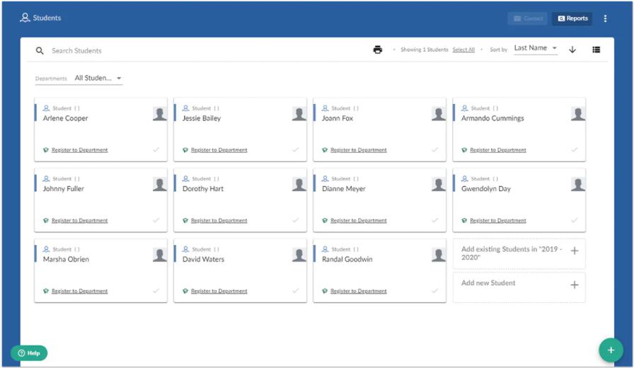

*Fig 1 (SoftwareAdvice, n.d.) shows all the students that have been registered in the application.*

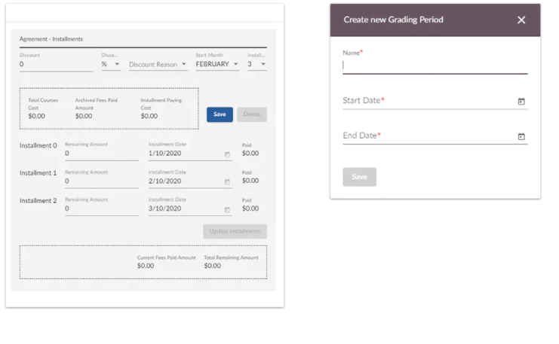

*Fig 2 shows an overview of the finance and grading form (SoftwareAdvice, n.d.)*

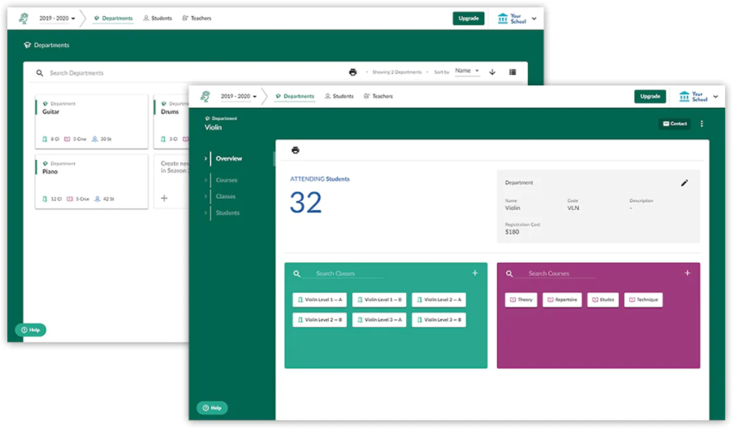

*Fig 3 shows the main dashboard with an overview of students, classes, courses, and finance (SoftwareAdvice, n.d.)*

## 2.1.3 SchoolBox

# 3 Project Planning and Timetable

## 3.1 Project Management Methodology

In this section of the report the discussion as to how the project had been managed in-line with the methodology chosen will be covered. Scrum methodology has been applied throughout the course of the projects lifetime, starting with

refers to the various artefacts and documentation that was produced to elicit user requirements, design a suitable system, implement the system and testing that took place to ensure the validity of the features implemented.

## 3.2 Requirements Analysis

## 3.3 Functional Requirements

## 3.4 Non-Functional Requirements

## 3.5 Timetable

# 4 Technology Choices

# 5 The Interim Design

# 6 Project Design

## 6.1 UI Wireframes

## 6.2 Activity Diagrams

## 6.3 Database Schema

# 7 Implementation

## 7.1 Basic Implementation (Must-Have Features)

## 7.2 Extra Features (Could-Have Features)

## 7.3 Commenting Code

# 8 Testing and Evaluation

# 8.1 Test Plan

# References

Sharp, C., Nelson, J., Lucas, M., Julius, J., Mccrone, T. and Sims, D. (2020). *Schools’ responses to Covid-19 The challenges facing schools and pupils in September 2020*. [online] . Available at: <https://www.nfer.ac.uk/media/4119/schools_responses_to_covid_19_the_challenges_facing_schools_and_pupils_in_september_2020.pdf>.

[Accessed 20 07 2021]

‌ SoftwareAdvice. (n.d.). *DreamClass*. [online] Available at: https://www.softwareadvice.co.uk/software/116976/dreamclass [Accessed 20 Jul. 2021].

‌dfedigital.blog.gov.uk. (n.d.). *Digital education platforms and how they’re helping schools - DfE Digital and Technology*. [online] Available at: https://dfedigital.blog.gov.uk/2021/02/12/digital-education-platforms/ [Accessed 20 Jul. 2021].

‌

Waterford (2018). *How Parent Involvement Leads to Student Success | Waterford.org*. [online] Waterford.org. Available at: <https://www.waterford.org/education/how-parent-involvment-leads-to-student-success/> [Accessed 20 Jul. 2021].

‌

<https://www.softwareadvice.co.uk/software/82608/schoolbox>

<https://www.mybib.com/tools/harvard-referencing-generator>

# [Scrum Methodology Phases which Help in Agile SDLC Process: 5 Key Steps (xbsoftware.com)](https://xbsoftware.com/blog/software-development-life-cycle-sdlc-scrum-step-step/)