Table 1 — Dataset split and leakage/split audit
Item | Train | Val | Test | Overlap conclusion
Samples | 21,473 | 4,601 | 4,602 | —
ID overlap | 0 | 0 | 0 | No direct ID leakage
File-path overlap | 0 | 0 | 0 | No duplicate file leakage
Session overlap | 0 | 0 | 0 | No session leakage

Table 2 — Clean performance comparison against baselines
Model | Params | Size MB | Test Acc | Test Macro-F1 | Test Weighted-F1
CNN | 110,949 | 0.435 | 90.31 | 86.25 | 90.05
LSTM | 164,565 | 0.633 | 97.54 | 96.39 | 97.54
BiLSTM | 187,061 | 0.719 | 97.31 | 96.09 | 97.31
CNN-LSTM | 215,269 | 0.830 | 91.50 | 88.26 | 91.35
Transformer Encoder | 132,869 | 0.519 | 91.46 | 87.76 | 91.34
Temporal ViT | 131,077 | 0.513 | 89.46 | 85.30 | 89.26
PatchTST-lite | 22,085 | 0.097 | 68.38 | 60.41 | 67.24
A4 Dual-Average | 349,573 | 1.381 | 92.92 | 90.31 | 92.91
A5 Cross-Attention | 366,597 | 1.450 | 92.24 | 89.01 | 92.20
A7 Full Dual | 374,918 | 1.484 | 92.22 | 89.34 | 92.18
DRFT-LSTM | 303,211 | 1.177 | 96.94 | 95.64 | 96.93

Table 3 — Robustness comparison under CSI degradation

Condition | LSTM WF1 | BiLSTM WF1 | A5 WF1 | DRFT-LSTM WF1 | Best
Clean | 97.54 | 97.31 | 92.20 | 96.93 | LSTM
Gaussian noise 0.20 | 96.56 | 96.36 | 90.79 | 95.79 | LSTM
Random SC mask 30% | 57.11 | 56.69 | 62.98 | 80.68 | DRFT
Random SC mask 50% | 46.55 | 45.09 | 51.83 | 64.67 | DRFT
Contiguous SC mask 30% | 48.57 | 47.53 | 56.35 | 67.42 | DRFT
Temporal mask 30% | 82.16 | 80.85 | 55.25 | 84.51 | DRFT
Crop-resize 75% | 96.46 | 96.69 | 88.12 | 95.09 | BiLSTM
Combined mild | 65.01 | 64.76 | 55.50 | 80.40 | DRFT
Combined harsh | 49.26 | 48.16 | 44.17 | 63.08 | DRFT

Table 4 — Robustness drop from clean

Model | Clean WF1 | Random SC 30 Drop | Random SC 50 Drop | Contig SC 30 Drop | Temporal 30 Drop | Combined Harsh Drop
LSTM | 97.54 | 40.44 | 50.99 | 48.97 | 15.38 | 48.28
BiLSTM | 97.31 | 40.61 | 52.22 | 49.77 | 16.45 | 49.15
A5 | 92.20 | 29.22 | 40.37 | 35.86 | 36.95 | 48.04
DRFT-LSTM | 96.93 | 16.25 | 32.26 | 29.51 | 12.42 | 33.85

Table 5 — Edge efficiency comparison

Model | Params | Size MB | CUDA ms/sample | CPU ms/sample | Peak memory MB
CNN | 110,949 | 0.435 | 0.696 | 1.63 | 23.32
LSTM | 164,565 | 0.633 | 2.23 | 6.83 | 41.78
BiLSTM | 187,061 | 0.719 | 3.54 | 11.08 | 57.94
A4 Dual-Average | 349,573 | 1.381 | 4.08 | 6.76 | 24.36
A5 Cross-Attention | 366,597 | 1.450 | 4.40 | 7.10 | 24.63
DRFT-LSTM | 303,211 | 1.177 | 3.54 | 17.98 | 43.93

Table 6 — Ablation of your earlier EdgeViT variants

Variant | Fusion idea | Params | Test Acc | Test Macro-F1 | Test Weighted-F1
A3 Dual-Concat | Concatenation | 362,373 | 92.37 | 89.29 | 92.36
A4 Dual-Average | Parameter-free average | 349,573 | 92.92 | 90.31 | 92.91
A5 Cross-Attention | Cross-attention fusion | 366,597 | 92.24 | 89.01 | 92.20
A6 Gate-only | Adaptive gate | 357,894 | 91.50 | 88.38 | 91.46
A7 Full Dual | Gate + cross-attention | 374,918 | 92.22 | 89.34 | 92.18

Table — DRFT-LSTM component ablation: clean performance and edge profile
Variant | Architectural meaning | Params | Size MB | CUDA ms | CPU ms | Test Acc | Macro-F1 | Weighted-F1
D1 Fine-only | Fine temporal LSTM branch only | 173,974 | 0.670 | 2.06 | 8.10 | 96.44 | 94.94 | 96.42
D2 Coarse-only | Downsampled coarse temporal LSTM branch only | 53,334 | 0.209 | 0.82 | 1.87 | 95.74 | 93.86 | 95.71
D3 Dual-concat | Fine + coarse branches with concat fusion | 236,231 | 0.912 | 2.70 | 9.77 | 96.28 | 94.67 | 96.28
DRFT-LSTM | Fine + coarse + frequency branch with gated fusion | 303,211 | 1.177 | 3.54 | 17.98 | 96.94 | 95.64 | 96.93

Table — DRFT-LSTM ablation robustness under CSI degradation

Condition | D1 Fine-only WF1 | D2 Coarse-only WF1 | D3 Dual-concat WF1 | DRFT-LSTM WF1 | Best
Clean | 96.42 | 95.71 | 96.28 | 96.93 | DRFT
Gaussian noise 0.20 | 95.81 | 95.61 | 94.65 | 95.79 | D1 ≈ DRFT
Random SC mask 10% | 89.04 | 84.10 | 90.42 | 92.17 | DRFT
Random SC mask 30% | 75.18 | 68.03 | 77.63 | 80.68 | DRFT
Random SC mask 50% | 61.49 | 55.43 | 64.09 | 64.67 | DRFT
Contiguous SC mask 10% | 87.10 | 81.66 | 88.79 | 90.15 | DRFT
Contiguous SC mask 30% | 67.56 | 61.77 | 71.11 | 67.42 | D3
Temporal mask 10% | 93.24 | 92.02 | 93.63 | 90.65 | D3
Temporal mask 30% | 91.59 | 88.18 | 92.15 | 84.51 | D3
Time shift 50 | 96.39 | 95.58 | 96.55 | 96.90 | DRFT
Crop-resize 75% | 94.48 | 95.01 | 94.20 | 95.09 | DRFT
Combined harsh | 67.12 | 58.65 | 67.05 | 63.08 | D1

Novelty statement:
CSI-based human activity recognition is promising for privacy-preserving edge-IoT sensing, but real-world CSI streams are vulnerable to subcarrier loss, temporal corruption, and channel degradation. Standard LSTM and BiLSTM models achieve high clean accuracy but degrade sharply under such impaired observations. To address this limitation, we propose DRFT-LSTM, a dual-resolution frequency-temporal LSTM model that combines fine-grained temporal dynamics, coarse temporal context, and subcarrier-aware frequency encoding through adaptive gated fusion. The model maintains competitive clean performance while substantially improving robustness under CSI degradation, making it suitable for practical edge-IoT activity-recognition deployments.

Temporary Framework diagram:
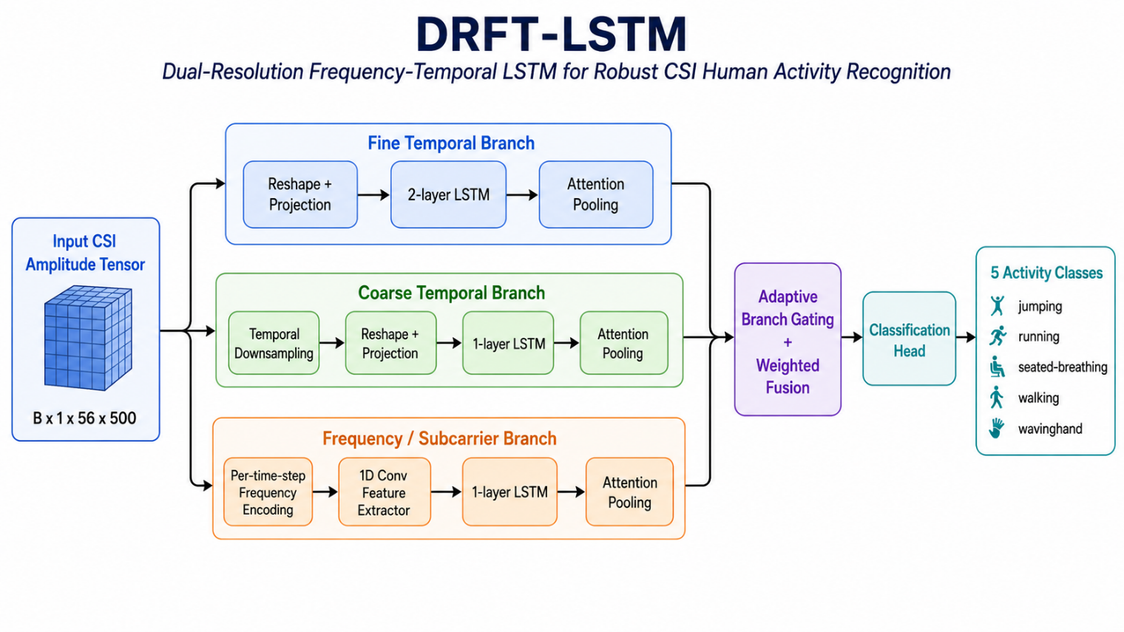

New baseline results:
Clean performance / efficiency table
Model | Params | Model Size MB | CUDA Latency ms | CPU Latency ms | Peak Mem MB | Clean Acc | Clean Macro-F1 | Clean Weighted-F1
Attention-BiLSTM | 339,446 | 1.301 | 4.04 | 9.17 | 47.95 | 98.04 | 97.29 | 98.04
CNN-GRU-Attention | 421,430 | 1.616 | 1.03 | 22.04 | 36.00 | 95.91 | 94.15 | 95.89
Robustness table: weighted-F1
Model | Clean | Gaussian Noise 0.20 | Random SC Mask 30% | Random SC Mask 50% | Contiguous SC Mask 30% | Temporal Mask 30% | Crop-Resize 75% | Combined Harsh
Attention-BiLSTM | 98.04 | 97.29 | 62.87 | 50.73 | 51.81 | 91.54 | 96.96 | 54.18
CNN-GRU-Attention | 95.89 | 95.73 | 64.10 | 50.07 | 58.70 | 92.26 | 93.55 | 53.97
Robustness-drop table: weighted-F1 drop from clean
Model | Clean WF1 | Random SC Mask 30% Drop | Random SC Mask 50% Drop | Contiguous SC Mask 30% Drop | Temporal Mask 30% Drop | Crop-Resize 75% Drop | Combined Harsh Drop
Attention-BiLSTM | 98.04 | 35.17 | 47.31 | 46.23 | 6.50 | 1.08 | 43.86
CNN-GRU-Attention | 95.89 | 31.79 | 45.83 | 37.19 | 3.63 | 2.35 | 41.93

