CollabLearn Project Journal
A descriptive journal of the codebase and product surface
Prepared from repository review on March 11, 2026

Table of Contents
- Preface and Journal Method
- Repository Map and Architecture
- Frontend Application and Routing
- Design Language and UI System
- Skills Marketplace and Profiles
- Booking and Session Lifecycle
- AI Learning Engine and Roadmaps
- Community and Social Posts
- Messaging and Real-Time Features
- Modules and Courses
- Admin Console and Governance
- Backend Infrastructure and Middleware
- Client Route Journal
- Data Model Catalog
- Model Field Notes
- API Catalog
- API Area Journal
- Operational Scripts and Environment
- Testing and Known Gaps
- Closing Reflection
Note: update fields in Word to insert page numbers if needed.

Preface and Journal Method
In this entry I focused on Preface and Journal Method. This journal is written as a descriptive walkthrough of the CollabLearn codebase rather than a marketing brief. Every claim is tied to a file, route, or model that exists in the repository. The notes were assembled by reading the README, the React router, and the Express entry point. I then traced each endpoint to its controller and data model to see how features are assembled.
My next pass centered on Preface and Journal Method. The document reflects the repository state on March 11, 2026. Flow charts are included to show how data moves between the client, API, and database. Where the UI suggests a feature but the API is the real source of truth, the journal clarifies the boundary. The overall goal is to help future teammates understand both the structure and the intent of the system.

Repository Map and Architecture
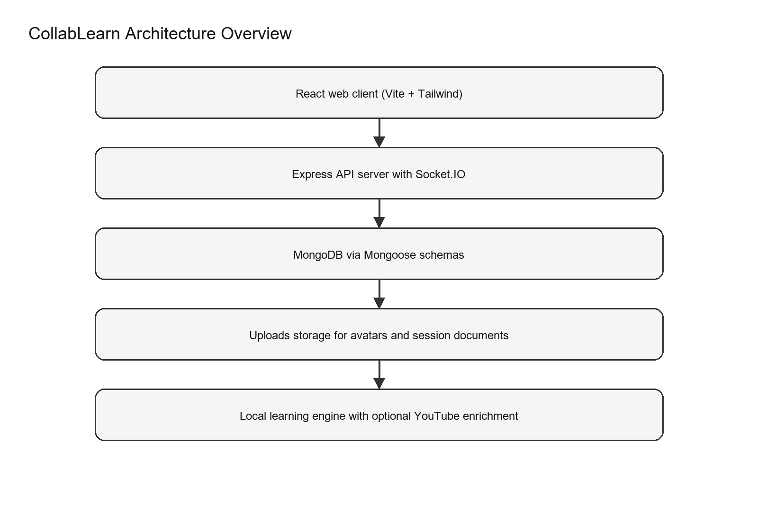
Figure 1. High level architecture of the web client, API, database, and supporting services.
In this entry I focused on Repository Map and Architecture. The repository is organized into client and server directories, which separates the React UI from the Node API. Additional folders such as flutter_app, android, and ios exist, but the README states the web app is the active product surface. Root scripts like start.bat and run_everything.bat provide Windows friendly shortcuts for running the stack. The server bootstraps Express, sets up Socket.IO, and listens on port 5001 by default.
My next pass centered on Repository Map and Architecture. MongoDB connectivity is managed through Mongoose, and the connection status is logged for visibility. Uploads are stored under server/uploads with dedicated subfolders for avatars and session documents. CORS origins default to common Vite ports, and can be overridden with an environment variable. Compression, JSON body parsing, and URL encoded parsing are enabled at the API layer.
I continued by reviewing Repository Map and Architecture. The architecture favors a single deployable service rather than multiple microservices. The AI learning engine is implemented locally in the API layer, which keeps the app functional without external AI keys. The client connects to the API through a configurable API_URL constant, defaulting to localhost. This structure supports a straightforward local development workflow and a clear production path.

Frontend Application and Routing
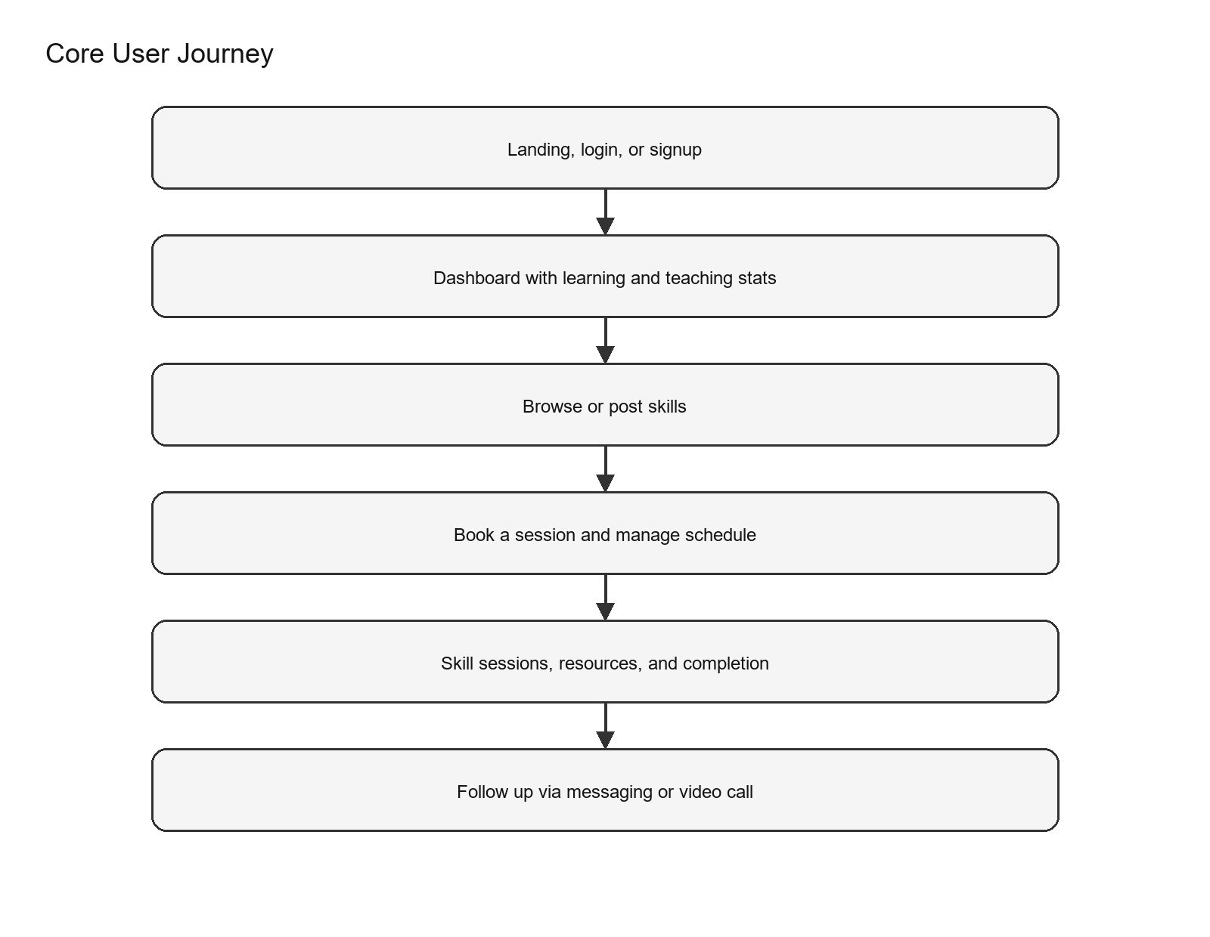
Figure 2. A simplified end to end user journey across the main client routes.
In this entry I focused on Frontend Application and Routing. App.jsx lazy loads most routes to keep initial load times small. Suspense uses a RouteLoader component to keep transitions smooth while bundles load. ScrollToTop resets the scroll position between route changes to prevent stale offsets. ThemeProvider wraps the app, allowing global theme context.
My next pass centered on Frontend Application and Routing. A toaster is configured with dark styling to keep notifications consistent with the UI. Google OAuth is optional and only enabled when a client ID is configured. ProtectedRoute checks for a token in localStorage and redirects unauthenticated users to /login. Role gating in ProtectedRoute keeps admin routes limited to users with admin role.
I continued by reviewing Frontend Application and Routing. Routes cover dashboards, marketplace pages, community, messaging, AI learning, modules, courses, and admin tools. The video call route accepts optional room IDs, suggesting room based conferencing. Payment and premium routes exist in the client, likely as stubs or future integrations. A not found route is provided for any unknown path.

Design Language and UI System
In this entry I focused on Design Language and UI System. The base stylesheet imports Space Grotesk and IBM Plex Mono, giving the UI a distinctive voice. The body uses a dark theme with layered radial gradients for depth. Utility classes implement a glassmorphism system with panels, cards, chips, and tabs. Hover and shimmer effects add motion without heavy animations.
My next pass centered on Design Language and UI System. Forms use glass inputs with focus glow for better accessibility cues. Buttons use gradient fills and subtle lift to emphasize primary actions. The design system appears consistent across pages like AI learning and messages. Overall styling signals a modern, technical brand.

Skills Marketplace and Profiles
In this entry I focused on Skills Marketplace and Profiles. The Skill model supports both offering and seeking modes, allowing one user to teach and learn. Offering details include level, description, price, session count, rating, and duration. Seeking details include progress and preferred schedule slots. Categories span a broad list from programming to lifestyle to reflect a general marketplace.
My next pass centered on Skills Marketplace and Profiles. Skills are not automatically public; posting to the marketplace sets isPosted to true. Skill search can filter by query, category, and level for offering skills. User data is populated for search results so the marketplace can show instructor identity. RecommendationService scores skills based on match, category affinity, instructor quality, and timing.
I continued by reviewing Skills Marketplace and Profiles. Recommendations are diversified by category to avoid a single topic dominating the list. User profiles expose skillsOffering and skillsSeeking through virtual population. Availability is stored separately and can be fetched for scheduling. Avatar URLs are normalized so the UI can show uploaded or external images consistently.

Booking and Session Lifecycle
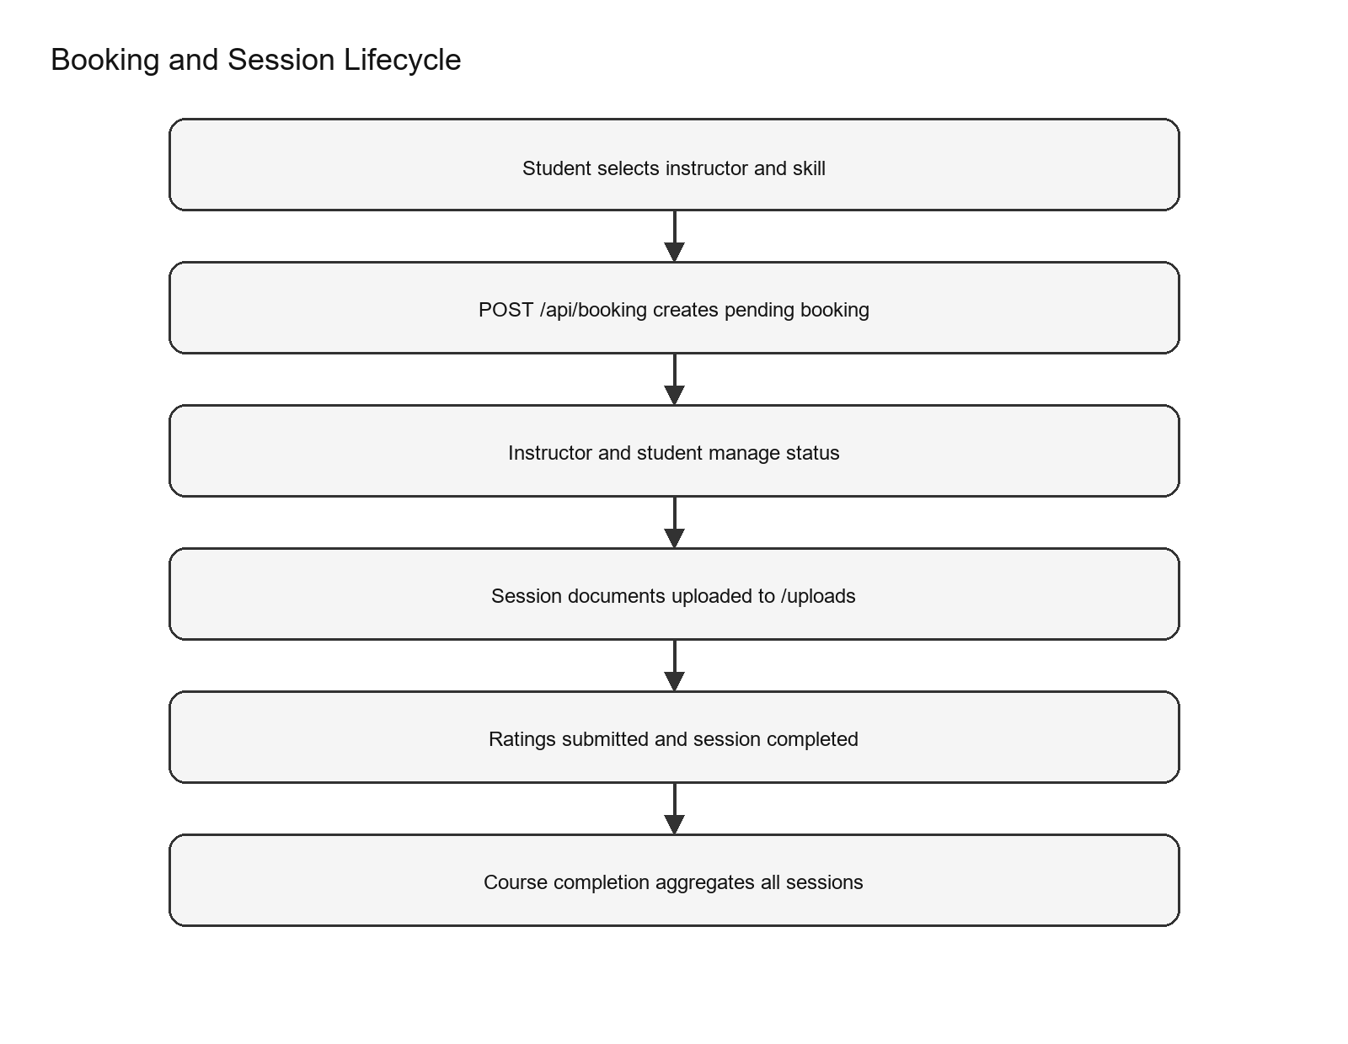
Figure 3. The booking and session lifecycle including documents and completion.
In this entry I focused on Booking and Session Lifecycle. Bookings link instructor, student, skill, date, and duration into a single record. Status values include pending, confirmed, cancelled, ongoing, and completed. Session documents are stored with metadata and uploaded through multer. Ratings are captured for both instructor and student roles.
My next pass centered on Booking and Session Lifecycle. Course completion aggregates session ratings across a skill. The booking router supports creation, listing by role, status updates, and session detail fetches. Upload and delete routes store files under uploads/session-documents. Session counts track multi session courses.
I continued by reviewing Booking and Session Lifecycle. SkillSessions on the client retrieves sessions for a skill and shows role specific UI. The client supports uploading shared resources and marking a course complete.

AI Learning Engine and Roadmaps
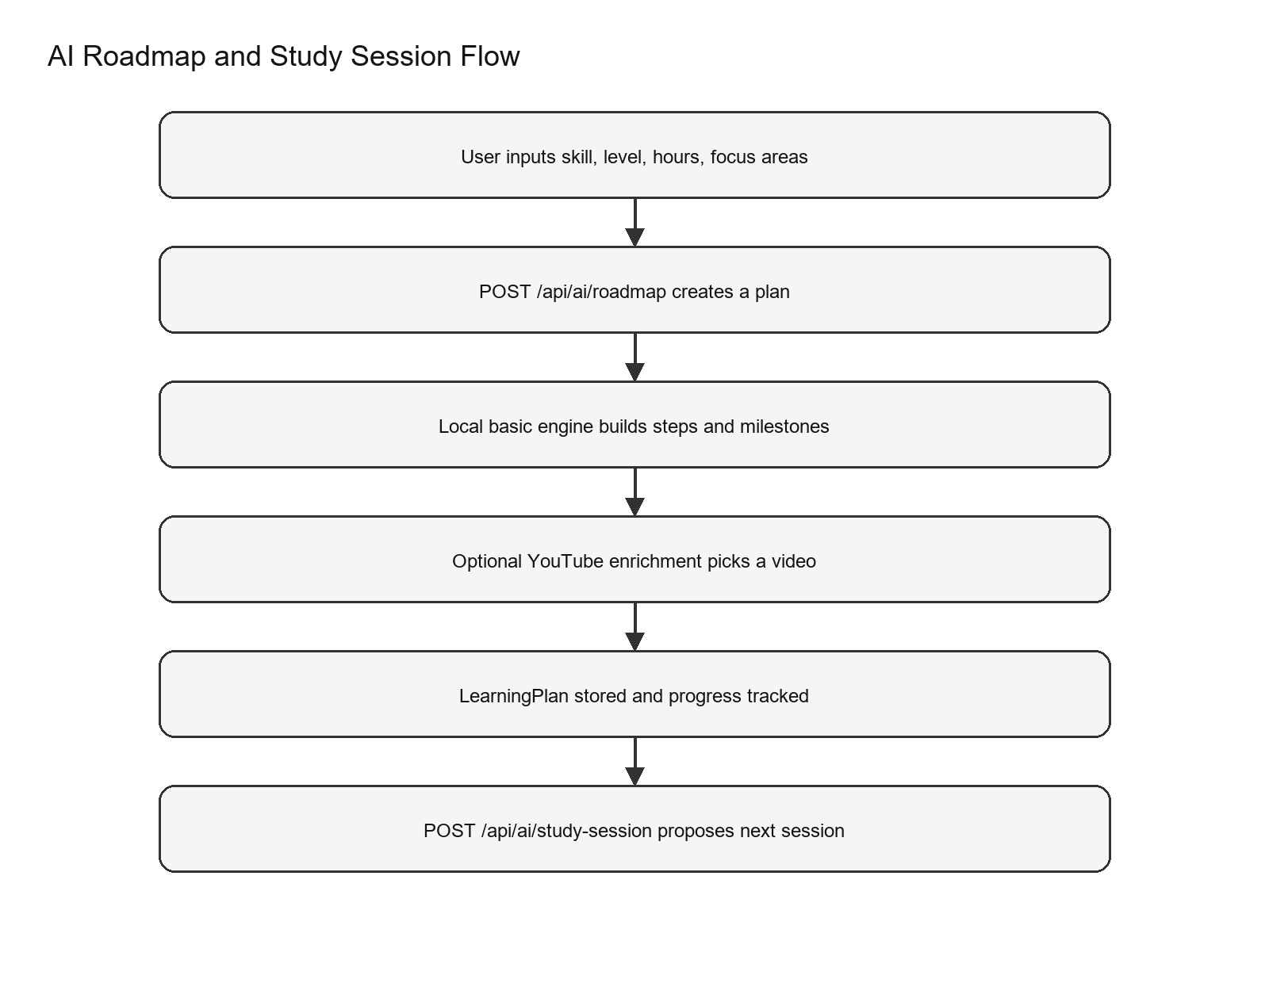
Figure 4. The AI roadmap and study session data path from input to stored plan.
In this entry I focused on AI Learning Engine and Roadmaps. The AI controller reports a local basic engine as its provider. Roadmap generation accepts skill, level, weekly hours, target weeks, and focus areas. LearningPlan stores summary, steps, milestones, resources, habits, and checkpoints. Custom training data exists for javascript and python with default phases and resources.
My next pass centered on AI Learning Engine and Roadmaps. Fallback phases and habits are used when no custom data exists. YouTube enrichment is optional and uses cached search results when keys are configured. Study sessions are generated with tasks, reflection questions, and pitfalls. Plans can be saved and progress percentages are calculated from completed steps.
I continued by reviewing AI Learning Engine and Roadmaps. AI Learning page shows saved plans and syncs progress to the server. The page also exports a plan to markdown for offline use. A learning engine status check is available through the UI. AiChatbot provides quick prompts and can return inline roadmaps.

Community and Social Posts
In this entry I focused on Community and Social Posts. Posts store author identity, title, excerpt, tags, and engagement stats. Comments are embedded with author and timestamp for a lightweight thread model. Post listing supports pagination and ordering by timestamp. Top contributors are computed with aggregation and filtered to remove anonymous entries.
My next pass centered on Community and Social Posts. Likes toggle user IDs in the likedBy list and update like counts. Comments increment stats counts for engagement tracking. Admin routes allow post deletion for moderation. The community routes map cleanly to the CommunityPage and PostPage views.

Messaging and Real-Time Features
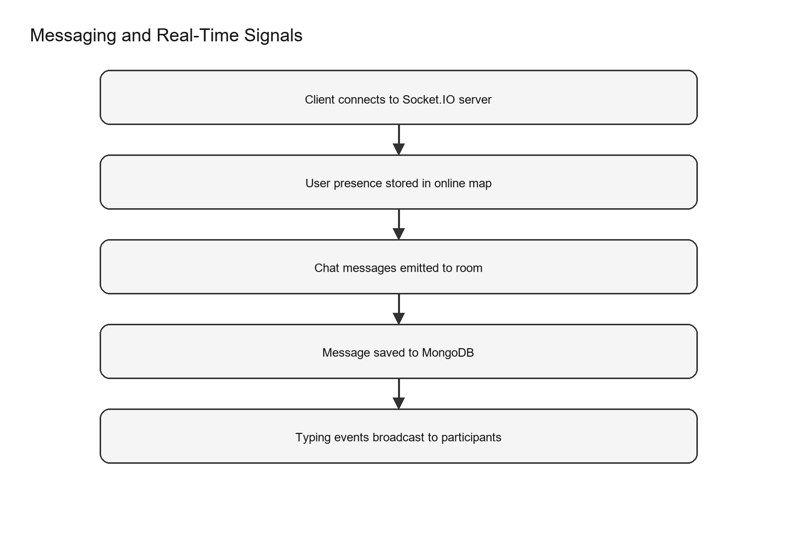
Figure 5. Real time message flow from client to server and back.
In this entry I focused on Messaging and Real-Time Features. Socket.IO runs on the same server instance and shares CORS configuration. Online users are tracked in a Map and broadcast on connect or disconnect. Chat rooms are joined by a deterministic chatId derived from user IDs. Messages are persisted via the Message model before being emitted.
My next pass centered on Messaging and Real-Time Features. Typing and stop typing events are broadcast to peers. The Messages page orders contacts by recent activity and online status. The UI shows typing indicators and formats timestamps for recent messages. Contact ordering is stored in localStorage for stability across refreshes.

Modules and Courses
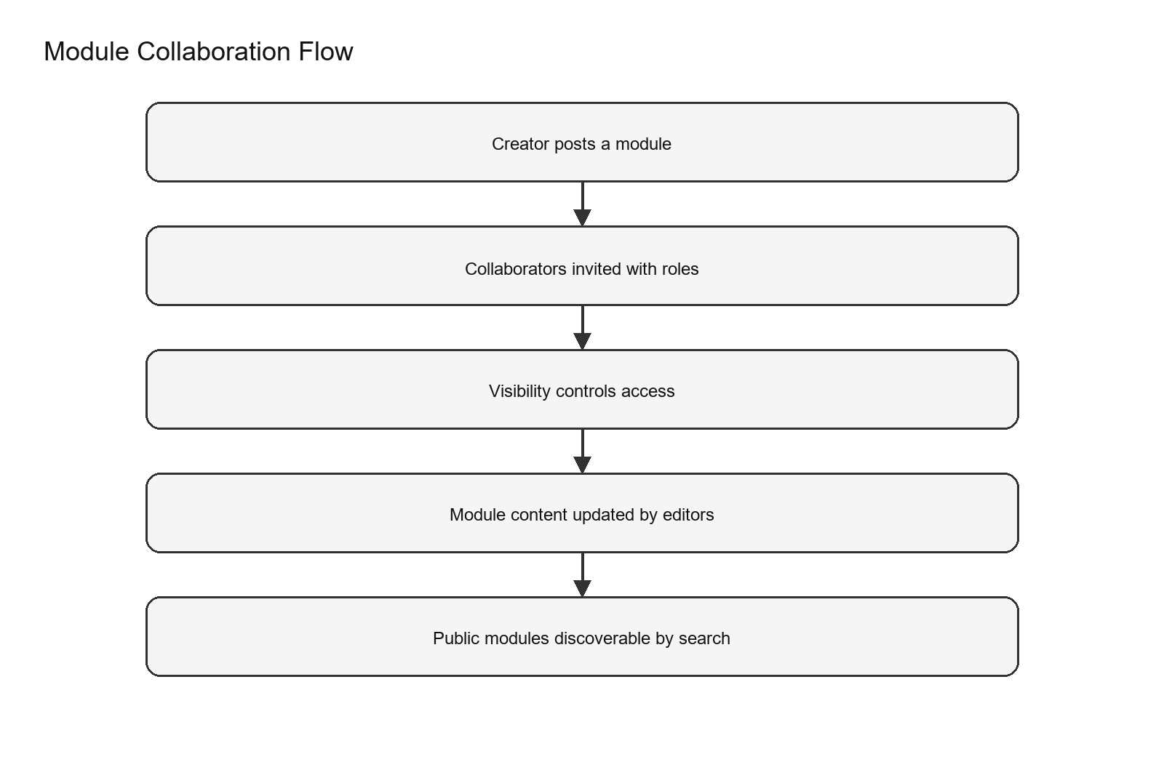
Figure 6. Module creation and collaboration flow.
In this entry I focused on Modules and Courses. Modules are collaborative documents with owner, collaborators, and visibility rules. Collaborators have editor or viewer roles, which affects edit permissions. Modules can be public, private, or link based, enabling controlled sharing. Content is stored as a flexible string, allowing HTML or rich text deltas.
My next pass centered on Modules and Courses. Text indexes are configured for module search. Courses are simple video based entries with title, instructor, and category. A seed endpoint loads example courses for demo content. Client routes include Courses and CoursePlayer for consumption.

Admin Console and Governance
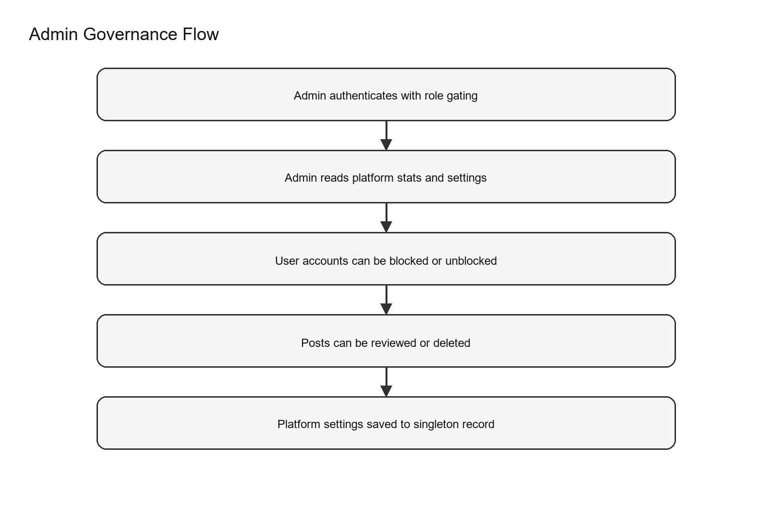
Figure 7. Admin flow from authentication to settings and moderation.
In this entry I focused on Admin Console and Governance. Admin routes require both authentication and admin role checks. Settings are stored as a singleton record with key main_settings. Settings include maintenance mode and minimum password length. Admin stats count users, bookings, posts, and instructors.
My next pass centered on Admin Console and Governance. Super admin emails are defined in config and cannot be blocked. Admins can block and unblock user accounts. Subscription status can be toggled for a user. Post moderation is available through admin routes.
I continued by reviewing Admin Console and Governance. Admin dashboard routes mirror server capabilities. Analytics includes monthly registration aggregation.

Backend Infrastructure and Middleware
In this entry I focused on Backend Infrastructure and Middleware. The API asserts JWT_SECRET is set and not a placeholder. Authentication middleware decodes tokens and attaches user metadata. Optional auth allows modules to be read when logged in or public. RequireAdmin blocks non admin users from admin endpoints.
My next pass centered on Backend Infrastructure and Middleware. CORS origins are parsed from env or default to common dev ports. Uploads are served statically from /uploads. Avatar uploads sanitize filenames and restrict to image types. Session documents allow common document and image types up to 10MB.
I continued by reviewing Backend Infrastructure and Middleware. The server exposes a health endpoint with database status. Messages and users have direct endpoints for the messaging UI.

Operational Scripts and Environment
In this entry I focused on Operational Scripts and Environment. Root npm scripts install and run client and server together. Concurrently runs both dev servers for local work. Root batch files provide quick start, debug, and diagnostic utilities. Server .env example defines JWT_SECRET and MONGODB_URI.
My next pass centered on Operational Scripts and Environment. Client .env example defines VITE_API_URL and VITE_GOOGLE_CLIENT_ID. Super admin allow list is configurable via SUPER_ADMIN_EMAILS.

Testing and Known Gaps
In this entry I focused on Testing and Known Gaps. Test scripts exist in package.json for both server and client. A dedicated tests directory is not obvious at the root level. Some admin stats fields are placeholders, such as newRequests. Student dashboard includes mock values for streak and rating.
My next pass centered on Testing and Known Gaps. Post reports count is referenced but not stored in the Post schema. These gaps can be addressed without major architecture changes.

Closing Reflection
In this entry I focused on Closing Reflection. The system is cohesive, with marketplace, AI planning, booking, and messaging aligned. The local AI engine keeps the product functional without external dependencies. The data model is modular and supports incremental feature growth. The design system gives the UI a premium, consistent feel.
My next pass centered on Closing Reflection. Future work can focus on test coverage and operational hardening. This journal should help onboard new contributors quickly.

Client Route Journal
In this entry I focused on Client route coverage. The route / renders CollabLearnLanding. Public landing and primary entry point for new visitors. The route /login renders LoginPage. Login form that returns a token stored in localStorage. The route /signup renders SignupPage. Registration form and account creation flow.
My next pass centered on Client route coverage. The route /dashboard renders Dashboard. Member overview with stats and upcoming sessions. The route /browse-skills renders BrowseSkills. Marketplace browsing and skill discovery. The route /skill-recommendations renders SkillRecommendations. Personalized recommendations view.
I continued by reviewing Client route coverage. The route /calendar renders CalendarPage. Schedule view for sessions and time management. The route /community renders CommunityPage. Community feed for posts and engagement. The route /messages renders MessagesPage. Direct chat and real time messaging.
Another slice of the journal covers Client route coverage. The route /book-session renders BookingSessionPage. Session booking form and instructor selection. The route /skill-sessions renders SkillSessions. Session management view with resources and completion. The route /ai-learning renders AiLearningPage. Roadmap generation, progress tracking, and study sessions.
In this entry I focused on Client route coverage. The route /modules renders ModuleDashboard. Module listing and search. The route /modules/create renders ModuleEditor. Module creation and collaboration setup. The route /modules/:id renders ModuleEditor. Module editing and updates.
My next pass centered on Client route coverage. The route /courses renders Courses. Course catalog view. The route /courses/:id/learn renders CoursePlayer. Course playback experience. The route /profile renders ProfilePage. Account profile and skills management.
I continued by reviewing Client route coverage. The route /settings renders SettingsPage. Account preferences and configuration. The route /video-call renders VideoCall. Video call entry point. The route /video-call/:roomID renders VideoCall. Room based video calling.
Another slice of the journal covers Client route coverage. The route /admin renders AdminDashboard. Admin overview with metrics. The route /admin/manage-users renders ManageUsers. User management and access control. The route /admin/manage-posts renders ManagePosts. Moderation of community posts.
In this entry I focused on Client route coverage. The route /admin/analytics renders AnalyticsDashboard. Admin reporting and metrics. The route /admin/settings renders AdminSettings. Platform settings and maintenance flags. The route /get-premium renders GetPremium. Premium upgrade entry point.
My next pass centered on Client route coverage. The route /payment renders GooglePayExample. Payment example flow for experimentation. The route /teach renders Teach. Teaching onboarding and guidance. The route * renders NotFoundPage. Fallback for unmatched routes.

Data Model Catalog
The data model is intentionally modular. Users, skills, bookings, learning plans, and content each have their own schema. This makes it easier to evolve parts of the system without forcing one oversized document structure.
Model | Purpose | Key fields
User | Core account profile used across the system. | name, email, password, avatar, bio, rating.average, rating.count, totalSessions, badges, isPremium, isActive, timestamps
Skill | Marketplace skill entry for offering or seeking modes. | name, offering.level, offering.description, offering.sessions, offering.rating, offering.price, offering.duration, seeking.progress, seeking.currentInstructor, preferredSchedule, isOffering, isSeeking, category, subCategory, tags, isPosted, priority
Booking | Scheduled session between instructor and student. | instructor, student, skill, date, duration, notes, status, sessionDocuments, sessionCount, sessionRating, courseCompleted, courseRating, completedAt
LearningPlan | AI generated learning roadmap and progress tracking. | user, skill, learnerLevel, weeklyHours, targetWeeks, focusAreas, plan.summary, plan.steps, plan.milestones, plan.resources, plan.habits, plan.checkpoints, completedStepIndexes, progressPercentage, source
Module | Collaborative learning artifact or lesson module. | title, description, owner, collaborators, content, visibility, tags, quizzes, timestamps
Course | Video based course catalog item. | title, instructor, description, category, thumbnailUrl, videoUrl, difficulty, duration, createdAt
Post | Community post with engagement metrics. | author, avatar, title, excerpt, tags, stats.comments, stats.views, stats.likes, timestamp, likedBy, comments, userId
Message | Chat message stored for realtime conversations. | chatId, senderId, text, time
Availability | Weekly availability blocks for a user. | userId, day, startTime, endTime, isAvailable, timezone, notes
Admin | Administrator account record. | email, password, role, isActive, timestamps
Setting | Singleton settings record for platform configuration. | key, siteName, maintenanceMode, minPasswordLength, geminiApiKey, timestamps

Model Field Notes
The User model supports core account profile used across the system. It includes fields such as name, email, password, avatar, bio, rating.average, rating.count, totalSessions, badges, isPremium, isActive, timestamps. These fields create the minimum structure needed for the client UI and API responses.
The Skill model supports marketplace skill entry for offering or seeking modes. It includes fields such as name, offering.level, offering.description, offering.sessions, offering.rating, offering.price, offering.duration, seeking.progress, seeking.currentInstructor, preferredSchedule, isOffering, isSeeking, category, subCategory, tags, isPosted, priority. These fields create the minimum structure needed for the client UI and API responses.
The Booking model supports scheduled session between instructor and student. It includes fields such as instructor, student, skill, date, duration, notes, status, sessionDocuments, sessionCount, sessionRating, courseCompleted, courseRating, completedAt. These fields create the minimum structure needed for the client UI and API responses.
The LearningPlan model supports ai generated learning roadmap and progress tracking. It includes fields such as user, skill, learnerLevel, weeklyHours, targetWeeks, focusAreas, plan.summary, plan.steps, plan.milestones, plan.resources, plan.habits, plan.checkpoints, completedStepIndexes, progressPercentage, source. These fields create the minimum structure needed for the client UI and API responses.
The Module model supports collaborative learning artifact or lesson module. It includes fields such as title, description, owner, collaborators, content, visibility, tags, quizzes, timestamps. These fields create the minimum structure needed for the client UI and API responses.
The Course model supports video based course catalog item. It includes fields such as title, instructor, description, category, thumbnailUrl, videoUrl, difficulty, duration, createdAt. These fields create the minimum structure needed for the client UI and API responses.
The Post model supports community post with engagement metrics. It includes fields such as author, avatar, title, excerpt, tags, stats.comments, stats.views, stats.likes, timestamp, likedBy, comments, userId. These fields create the minimum structure needed for the client UI and API responses.
The Message model supports chat message stored for realtime conversations. It includes fields such as chatId, senderId, text, time. These fields create the minimum structure needed for the client UI and API responses.
The Availability model supports weekly availability blocks for a user. It includes fields such as userId, day, startTime, endTime, isAvailable, timezone, notes. These fields create the minimum structure needed for the client UI and API responses.
The Admin model supports administrator account record. It includes fields such as email, password, role, isActive, timestamps. These fields create the minimum structure needed for the client UI and API responses.
The Setting model supports singleton settings record for platform configuration. It includes fields such as key, siteName, maintenanceMode, minPasswordLength, geminiApiKey, timestamps. These fields create the minimum structure needed for the client UI and API responses.

API Catalog
The API is organized by feature area and lives under /api. Each route file maps to a controller with clear naming conventions. Authentication is required for most personalized data, while some endpoints remain public for browsing and discovery.
Area | Method | Endpoint | Purpose
Auth | POST | /api/auth/register | Create a new user account.
Auth | POST | /api/auth/login | Login and receive JWT token.
Auth | POST | /api/auth/google | Google OAuth login.
Auth | GET | /api/auth/user/:userId | Public profile lookup.
Auth | GET | /api/auth/me | Current user profile.
Auth | PUT | /api/auth/profile | Update user profile.
Auth | POST | /api/auth/avatar | Upload avatar image.
Auth | DELETE | /api/auth/delete | Delete account and related data.
Dashboard | GET | /api/dashboard/test | Dashboard route test.
Dashboard | GET | /api/dashboard/stats | User dashboard summary.
Dashboard | GET | /api/dashboard/student/:studentId | Instructor view of student stats.
Skills | POST | /api/skills/post | Post skill to marketplace.
Skills | POST | /api/skills/offering | Add skill offering.
Skills | PUT | /api/skills/offering/:skillId | Update skill offering.
Skills | DELETE | /api/skills/offering/:skillId | Delete skill offering.
Skills | POST | /api/skills/seeking | Add skill seeking.
Skills | PUT | /api/skills/seeking/:skillId | Update skill seeking.
Skills | DELETE | /api/skills/seeking/:skillId | Delete skill seeking.
Skills | GET | /api/skills/my-skills | Fetch user skills.
Skills | GET | /api/skills/search | Search skills.
Skills | GET | /api/skills/categories | Skill categories.
Skills | GET | /api/skills/names | Skill name list.
Skills | GET | /api/skills/recommendations | Personalized recommendations.
Booking | POST | /api/booking | Create booking.
Booking | GET | /api/booking/student/:id | Student bookings.
Booking | GET | /api/booking/instructor/:id | Instructor bookings.
Booking | PATCH | /api/booking/:id | Update booking status.
Booking | GET | /api/booking/session/:id | Session details.
Booking | POST | /api/booking/:id/upload-document | Upload session document.
Booking | DELETE | /api/booking/:id/delete-document/:docId | Delete session document.
Booking | POST | /api/booking/:id/complete | Submit rating and complete session.
Booking | POST | /api/booking/:id/complete-session | Complete session with rating.
Booking | POST | /api/booking/complete-course | Complete course and rate.
Booking | PATCH | /api/booking/:id/session-count | Update session count.
Courses | GET | /api/courses | List courses.
Courses | GET | /api/courses/:id | Get course details.
Courses | POST | /api/courses/seed | Seed example courses.
Community | GET | /api/posts | List posts with pagination.
Community | GET | /api/posts/top-contributors | Top contributors.
Community | GET | /api/posts/:id | Get single post.
Community | POST | /api/posts | Create a post.
Community | DELETE | /api/posts/:id | Delete a post.
Community | POST | /api/posts/:id/like | Like or unlike a post.
Community | POST | /api/posts/:id/comment | Add a comment.
AI | GET | /api/ai/studio-status | Learning engine status.
AI | POST | /api/ai/studio-test | Verify learning engine.
AI | POST | /api/ai/chat | Mentor chat response.
AI | POST | /api/ai/study-session | Generate study session plan.
AI | POST | /api/ai/roadmap | Generate roadmap.
AI | GET | /api/ai/plans | List saved learning plans.
AI | GET | /api/ai/plans/:planId | Get learning plan.
AI | PATCH | /api/ai/plans/:planId/progress | Update plan progress.
Modules | GET | /api/modules | List modules (public or user access).
Modules | POST | /api/modules | Create module.
Modules | GET | /api/modules/:id | Get module details.
Modules | PUT | /api/modules/:id | Update module.
Modules | DELETE | /api/modules/:id | Delete module.
Admin | GET | /api/admin/settings | Read settings.
Admin | PUT | /api/admin/settings | Update settings.
Admin | GET | /api/admin/stats | Admin stats.
Admin | GET | /api/admin/users | List users.
Admin | PUT | /api/admin/users/:userId/block | Block user.
Admin | PUT | /api/admin/users/:userId/unblock | Unblock user.
Admin | PUT | /api/admin/users/:userId/subscription | Update subscription.
Admin | GET | /api/admin/posts | List posts for moderation.
Admin | DELETE | /api/admin/posts/:postId | Delete post as admin.

API Area Journal
In this entry I focused on API area summary. The Auth API covers 8 endpoints. Examples include POST /api/auth/register, POST /api/auth/login, POST /api/auth/google. The overall intent is to support auth workflows from the client. The Dashboard API covers 3 endpoints. Examples include GET /api/dashboard/test, GET /api/dashboard/stats, GET /api/dashboard/student/:studentId. The overall intent is to support dashboard workflows from the client.
My next pass centered on API area summary. The Skills API covers 12 endpoints. Examples include POST /api/skills/post, POST /api/skills/offering, PUT /api/skills/offering/:skillId. The overall intent is to support skills workflows from the client. The Booking API covers 11 endpoints. Examples include POST /api/booking, GET /api/booking/student/:id, GET /api/booking/instructor/:id. The overall intent is to support booking workflows from the client.
I continued by reviewing API area summary. The Courses API covers 3 endpoints. Examples include GET /api/courses, GET /api/courses/:id, POST /api/courses/seed. The overall intent is to support courses workflows from the client. The Community API covers 7 endpoints. Examples include GET /api/posts, GET /api/posts/top-contributors, GET /api/posts/:id. The overall intent is to support community workflows from the client.
Another slice of the journal covers API area summary. The AI API covers 8 endpoints. Examples include GET /api/ai/studio-status, POST /api/ai/studio-test, POST /api/ai/chat. The overall intent is to support ai workflows from the client. The Modules API covers 5 endpoints. Examples include GET /api/modules, POST /api/modules, GET /api/modules/:id. The overall intent is to support modules workflows from the client.
In this entry I focused on API area summary. The Admin API covers 9 endpoints. Examples include GET /api/admin/settings, PUT /api/admin/settings, GET /api/admin/stats. The overall intent is to support admin workflows from the client.
This journal is written as a descriptive walkthrough of the CollabLearn codebase rather than a marketing brief. This detail reinforces how the product is structured and how a developer can locate the source of truth. It also hints at the expected user experience and the operational behavior of the platform. When combined with related routes and models, the note forms part of a traceable end to end flow.
Every claim is tied to a file, route, or model that exists in the repository. This detail reinforces how the product is structured and how a developer can locate the source of truth. It also hints at the expected user experience and the operational behavior of the platform. When combined with related routes and models, the note forms part of a traceable end to end flow.
The notes were assembled by reading the README, the React router, and the Express entry point. This detail reinforces how the product is structured and how a developer can locate the source of truth. It also hints at the expected user experience and the operational behavior of the platform. When combined with related routes and models, the note forms part of a traceable end to end flow.
I then traced each endpoint to its controller and data model to see how features are assembled. This detail reinforces how the product is structured and how a developer can locate the source of truth. It also hints at the expected user experience and the operational behavior of the platform. When combined with related routes and models, the note forms part of a traceable end to end flow.
The document reflects the repository state on March 11, 2026. This detail reinforces how the product is structured and how a developer can locate the source of truth. It also hints at the expected user experience and the operational behavior of the platform. When combined with related routes and models, the note forms part of a traceable end to end flow.
Flow charts are included to show how data moves between the client, API, and database. This detail reinforces how the product is structured and how a developer can locate the source of truth. It also hints at the expected user experience and the operational behavior of the platform. When combined with related routes and models, the note forms part of a traceable end to end flow.
Where the UI suggests a feature but the API is the real source of truth, the journal clarifies the boundary. This detail reinforces how the product is structured and how a developer can locate the source of truth. It also hints at the expected user experience and the operational behavior of the platform. When combined with related routes and models, the note forms part of a traceable end to end flow.
The overall goal is to help future teammates understand both the structure and the intent of the system. This detail reinforces how the product is structured and how a developer can locate the source of truth. It also hints at the expected user experience and the operational behavior of the platform. When combined with related routes and models, the note forms part of a traceable end to end flow.
The repository is organized into client and server directories, which separates the React UI from the Node API. This detail reinforces how the product is structured and how a developer can locate the source of truth. It also hints at the expected user experience and the operational behavior of the platform. When combined with related routes and models, the note forms part of a traceable end to end flow.
Additional folders such as flutter_app, android, and ios exist, but the README states the web app is the active product surface. This detail reinforces how the product is structured and how a developer can locate the source of truth. It also hints at the expected user experience and the operational behavior of the platform. When combined with related routes and models, the note forms part of a traceable end to end flow.
Root scripts like start.bat and run_everything.bat provide Windows friendly shortcuts for running the stack. This detail reinforces how the product is structured and how a developer can locate the source of truth. It also hints at the expected user experience and the operational behavior of the platform. When combined with related routes and models, the note forms part of a traceable end to end flow.
The server bootstraps Express, sets up Socket.IO, and listens on port 5001 by default. This detail reinforces how the product is structured and how a developer can locate the source of truth. It also hints at the expected user experience and the operational behavior of the platform. When combined with related routes and models, the note forms part of a traceable end to end flow.
MongoDB connectivity is managed through Mongoose, and the connection status is logged for visibility. This detail reinforces how the product is structured and how a developer can locate the source of truth. It also hints at the expected user experience and the operational behavior of the platform. When combined with related routes and models, the note forms part of a traceable end to end flow.
Uploads are stored under server/uploads with dedicated subfolders for avatars and session documents. This detail reinforces how the product is structured and how a developer can locate the source of truth. It also hints at the expected user experience and the operational behavior of the platform. When combined with related routes and models, the note forms part of a traceable end to end flow.
CORS origins default to common Vite ports, and can be overridden with an environment variable. This detail reinforces how the product is structured and how a developer can locate the source of truth. It also hints at the expected user experience and the operational behavior of the platform. When combined with related routes and models, the note forms part of a traceable end to end flow.
Compression, JSON body parsing, and URL encoded parsing are enabled at the API layer. This detail reinforces how the product is structured and how a developer can locate the source of truth. It also hints at the expected user experience and the operational behavior of the platform. When combined with related routes and models, the note forms part of a traceable end to end flow.
The architecture favors a single deployable service rather than multiple microservices. This detail reinforces how the product is structured and how a developer can locate the source of truth. It also hints at the expected user experience and the operational behavior of the platform. When combined with related routes and models, the note forms part of a traceable end to end flow.
The AI learning engine is implemented locally in the API layer, which keeps the app functional without external AI keys. This detail reinforces how the product is structured and how a developer can locate the source of truth. It also hints at the expected user experience and the operational behavior of the platform. When combined with related routes and models, the note forms part of a traceable end to end flow.
The client connects to the API through a configurable API_URL constant, defaulting to localhost. This detail reinforces how the product is structured and how a developer can locate the source of truth. It also hints at the expected user experience and the operational behavior of the platform. When combined with related routes and models, the note forms part of a traceable end to end flow.
This structure supports a straightforward local development workflow and a clear production path. This detail reinforces how the product is structured and how a developer can locate the source of truth. It also hints at the expected user experience and the operational behavior of the platform. When combined with related routes and models, the note forms part of a traceable end to end flow.
App.jsx lazy loads most routes to keep initial load times small. This detail reinforces how the product is structured and how a developer can locate the source of truth. It also hints at the expected user experience and the operational behavior of the platform. When combined with related routes and models, the note forms part of a traceable end to end flow.
Suspense uses a RouteLoader component to keep transitions smooth while bundles load. This detail reinforces how the product is structured and how a developer can locate the source of truth. It also hints at the expected user experience and the operational behavior of the platform. When combined with related routes and models, the note forms part of a traceable end to end flow.
ScrollToTop resets the scroll position between route changes to prevent stale offsets. This detail reinforces how the product is structured and how a developer can locate the source of truth. It also hints at the expected user experience and the operational behavior of the platform. When combined with related routes and models, the note forms part of a traceable end to end flow.
ThemeProvider wraps the app, allowing global theme context. This detail reinforces how the product is structured and how a developer can locate the source of truth. It also hints at the expected user experience and the operational behavior of the platform. When combined with related routes and models, the note forms part of a traceable end to end flow.
A toaster is configured with dark styling to keep notifications consistent with the UI. This detail reinforces how the product is structured and how a developer can locate the source of truth. It also hints at the expected user experience and the operational behavior of the platform. When combined with related routes and models, the note forms part of a traceable end to end flow.
Google OAuth is optional and only enabled when a client ID is configured. This detail reinforces how the product is structured and how a developer can locate the source of truth. It also hints at the expected user experience and the operational behavior of the platform. When combined with related routes and models, the note forms part of a traceable end to end flow.
ProtectedRoute checks for a token in localStorage and redirects unauthenticated users to /login. This detail reinforces how the product is structured and how a developer can locate the source of truth. It also hints at the expected user experience and the operational behavior of the platform. When combined with related routes and models, the note forms part of a traceable end to end flow.
Role gating in ProtectedRoute keeps admin routes limited to users with admin role. This detail reinforces how the product is structured and how a developer can locate the source of truth. It also hints at the expected user experience and the operational behavior of the platform. When combined with related routes and models, the note forms part of a traceable end to end flow.
Routes cover dashboards, marketplace pages, community, messaging, AI learning, modules, courses, and admin tools. This detail reinforces how the product is structured and how a developer can locate the source of truth. It also hints at the expected user experience and the operational behavior of the platform. When combined with related routes and models, the note forms part of a traceable end to end flow.
The video call route accepts optional room IDs, suggesting room based conferencing. This detail reinforces how the product is structured and how a developer can locate the source of truth. It also hints at the expected user experience and the operational behavior of the platform. When combined with related routes and models, the note forms part of a traceable end to end flow.
Payment and premium routes exist in the client, likely as stubs or future integrations. This detail reinforces how the product is structured and how a developer can locate the source of truth. It also hints at the expected user experience and the operational behavior of the platform. When combined with related routes and models, the note forms part of a traceable end to end flow.
A not found route is provided for any unknown path. This detail reinforces how the product is structured and how a developer can locate the source of truth. It also hints at the expected user experience and the operational behavior of the platform. When combined with related routes and models, the note forms part of a traceable end to end flow.
The base stylesheet imports Space Grotesk and IBM Plex Mono, giving the UI a distinctive voice. This detail reinforces how the product is structured and how a developer can locate the source of truth. It also hints at the expected user experience and the operational behavior of the platform. When combined with related routes and models, the note forms part of a traceable end to end flow.
The body uses a dark theme with layered radial gradients for depth. This detail reinforces how the product is structured and how a developer can locate the source of truth. It also hints at the expected user experience and the operational behavior of the platform. When combined with related routes and models, the note forms part of a traceable end to end flow.
Utility classes implement a glassmorphism system with panels, cards, chips, and tabs. This detail reinforces how the product is structured and how a developer can locate the source of truth. It also hints at the expected user experience and the operational behavior of the platform. When combined with related routes and models, the note forms part of a traceable end to end flow.
Hover and shimmer effects add motion without heavy animations. This detail reinforces how the product is structured and how a developer can locate the source of truth. It also hints at the expected user experience and the operational behavior of the platform. When combined with related routes and models, the note forms part of a traceable end to end flow.
Forms use glass inputs with focus glow for better accessibility cues. This detail reinforces how the product is structured and how a developer can locate the source of truth. It also hints at the expected user experience and the operational behavior of the platform. When combined with related routes and models, the note forms part of a traceable end to end flow.
Buttons use gradient fills and subtle lift to emphasize primary actions. This detail reinforces how the product is structured and how a developer can locate the source of truth. It also hints at the expected user experience and the operational behavior of the platform. When combined with related routes and models, the note forms part of a traceable end to end flow.
The design system appears consistent across pages like AI learning and messages. This detail reinforces how the product is structured and how a developer can locate the source of truth. It also hints at the expected user experience and the operational behavior of the platform. When combined with related routes and models, the note forms part of a traceable end to end flow.
Overall styling signals a modern, technical brand. This detail reinforces how the product is structured and how a developer can locate the source of truth. It also hints at the expected user experience and the operational behavior of the platform. When combined with related routes and models, the note forms part of a traceable end to end flow.
The Skill model supports both offering and seeking modes, allowing one user to teach and learn. This detail reinforces how the product is structured and how a developer can locate the source of truth. It also hints at the expected user experience and the operational behavior of the platform. When combined with related routes and models, the note forms part of a traceable end to end flow.
Offering details include level, description, price, session count, rating, and duration. This detail reinforces how the product is structured and how a developer can locate the source of truth. It also hints at the expected user experience and the operational behavior of the platform. When combined with related routes and models, the note forms part of a traceable end to end flow.
Seeking details include progress and preferred schedule slots. This detail reinforces how the product is structured and how a developer can locate the source of truth. It also hints at the expected user experience and the operational behavior of the platform. When combined with related routes and models, the note forms part of a traceable end to end flow.
Categories span a broad list from programming to lifestyle to reflect a general marketplace. This detail reinforces how the product is structured and how a developer can locate the source of truth. It also hints at the expected user experience and the operational behavior of the platform. When combined with related routes and models, the note forms part of a traceable end to end flow.
Skills are not automatically public; posting to the marketplace sets isPosted to true. This detail reinforces how the product is structured and how a developer can locate the source of truth. It also hints at the expected user experience and the operational behavior of the platform. When combined with related routes and models, the note forms part of a traceable end to end flow.
Skill search can filter by query, category, and level for offering skills. This detail reinforces how the product is structured and how a developer can locate the source of truth. It also hints at the expected user experience and the operational behavior of the platform. When combined with related routes and models, the note forms part of a traceable end to end flow.
User data is populated for search results so the marketplace can show instructor identity. This detail reinforces how the product is structured and how a developer can locate the source of truth. It also hints at the expected user experience and the operational behavior of the platform. When combined with related routes and models, the note forms part of a traceable end to end flow.
RecommendationService scores skills based on match, category affinity, instructor quality, and timing. This detail reinforces how the product is structured and how a developer can locate the source of truth. It also hints at the expected user experience and the operational behavior of the platform. When combined with related routes and models, the note forms part of a traceable end to end flow.
Recommendations are diversified by category to avoid a single topic dominating the list. This detail reinforces how the product is structured and how a developer can locate the source of truth. It also hints at the expected user experience and the operational behavior of the platform. When combined with related routes and models, the note forms part of a traceable end to end flow.
User profiles expose skillsOffering and skillsSeeking through virtual population. This detail reinforces how the product is structured and how a developer can locate the source of truth. It also hints at the expected user experience and the operational behavior of the platform. When combined with related routes and models, the note forms part of a traceable end to end flow.
Availability is stored separately and can be fetched for scheduling. This detail reinforces how the product is structured and how a developer can locate the source of truth. It also hints at the expected user experience and the operational behavior of the platform. When combined with related routes and models, the note forms part of a traceable end to end flow.
Avatar URLs are normalized so the UI can show uploaded or external images consistently. This detail reinforces how the product is structured and how a developer can locate the source of truth. It also hints at the expected user experience and the operational behavior of the platform. When combined with related routes and models, the note forms part of a traceable end to end flow.
Bookings link instructor, student, skill, date, and duration into a single record. This detail reinforces how the product is structured and how a developer can locate the source of truth. It also hints at the expected user experience and the operational behavior of the platform. When combined with related routes and models, the note forms part of a traceable end to end flow.
Status values include pending, confirmed, cancelled, ongoing, and completed. This detail reinforces how the product is structured and how a developer can locate the source of truth. It also hints at the expected user experience and the operational behavior of the platform. When combined with related routes and models, the note forms part of a traceable end to end flow.
Session documents are stored with metadata and uploaded through multer. This detail reinforces how the product is structured and how a developer can locate the source of truth. It also hints at the expected user experience and the operational behavior of the platform. When combined with related routes and models, the note forms part of a traceable end to end flow.
Ratings are captured for both instructor and student roles. This detail reinforces how the product is structured and how a developer can locate the source of truth. It also hints at the expected user experience and the operational behavior of the platform. When combined with related routes and models, the note forms part of a traceable end to end flow.
Course completion aggregates session ratings across a skill. This detail reinforces how the product is structured and how a developer can locate the source of truth. It also hints at the expected user experience and the operational behavior of the platform. When combined with related routes and models, the note forms part of a traceable end to end flow.
The booking router supports creation, listing by role, status updates, and session detail fetches. This detail reinforces how the product is structured and how a developer can locate the source of truth. It also hints at the expected user experience and the operational behavior of the platform. When combined with related routes and models, the note forms part of a traceable end to end flow.
Upload and delete routes store files under uploads/session-documents. This detail reinforces how the product is structured and how a developer can locate the source of truth. It also hints at the expected user experience and the operational behavior of the platform. When combined with related routes and models, the note forms part of a traceable end to end flow.
Session counts track multi session courses. This detail reinforces how the product is structured and how a developer can locate the source of truth. It also hints at the expected user experience and the operational behavior of the platform. When combined with related routes and models, the note forms part of a traceable end to end flow.
SkillSessions on the client retrieves sessions for a skill and shows role specific UI. This detail reinforces how the product is structured and how a developer can locate the source of truth. It also hints at the expected user experience and the operational behavior of the platform. When combined with related routes and models, the note forms part of a traceable end to end flow.
The client supports uploading shared resources and marking a course complete. This detail reinforces how the product is structured and how a developer can locate the source of truth. It also hints at the expected user experience and the operational behavior of the platform. When combined with related routes and models, the note forms part of a traceable end to end flow.
The AI controller reports a local basic engine as its provider. This detail reinforces how the product is structured and how a developer can locate the source of truth. It also hints at the expected user experience and the operational behavior of the platform. When combined with related routes and models, the note forms part of a traceable end to end flow.
Roadmap generation accepts skill, level, weekly hours, target weeks, and focus areas. This detail reinforces how the product is structured and how a developer can locate the source of truth. It also hints at the expected user experience and the operational behavior of the platform. When combined with related routes and models, the note forms part of a traceable end to end flow.
LearningPlan stores summary, steps, milestones, resources, habits, and checkpoints. This detail reinforces how the product is structured and how a developer can locate the source of truth. It also hints at the expected user experience and the operational behavior of the platform. When combined with related routes and models, the note forms part of a traceable end to end flow.
Custom training data exists for javascript and python with default phases and resources. This detail reinforces how the product is structured and how a developer can locate the source of truth. It also hints at the expected user experience and the operational behavior of the platform. When combined with related routes and models, the note forms part of a traceable end to end flow.
Fallback phases and habits are used when no custom data exists. This detail reinforces how the product is structured and how a developer can locate the source of truth. It also hints at the expected user experience and the operational behavior of the platform. When combined with related routes and models, the note forms part of a traceable end to end flow.
YouTube enrichment is optional and uses cached search results when keys are configured. This detail reinforces how the product is structured and how a developer can locate the source of truth. It also hints at the expected user experience and the operational behavior of the platform. When combined with related routes and models, the note forms part of a traceable end to end flow.
Study sessions are generated with tasks, reflection questions, and pitfalls. This detail reinforces how the product is structured and how a developer can locate the source of truth. It also hints at the expected user experience and the operational behavior of the platform. When combined with related routes and models, the note forms part of a traceable end to end flow.
Plans can be saved and progress percentages are calculated from completed steps. This detail reinforces how the product is structured and how a developer can locate the source of truth. It also hints at the expected user experience and the operational behavior of the platform. When combined with related routes and models, the note forms part of a traceable end to end flow.
AI Learning page shows saved plans and syncs progress to the server. This detail reinforces how the product is structured and how a developer can locate the source of truth. It also hints at the expected user experience and the operational behavior of the platform. When combined with related routes and models, the note forms part of a traceable end to end flow.
The page also exports a plan to markdown for offline use. This detail reinforces how the product is structured and how a developer can locate the source of truth. It also hints at the expected user experience and the operational behavior of the platform. When combined with related routes and models, the note forms part of a traceable end to end flow.
A learning engine status check is available through the UI. This detail reinforces how the product is structured and how a developer can locate the source of truth. It also hints at the expected user experience and the operational behavior of the platform. When combined with related routes and models, the note forms part of a traceable end to end flow.
AiChatbot provides quick prompts and can return inline roadmaps. This detail reinforces how the product is structured and how a developer can locate the source of truth. It also hints at the expected user experience and the operational behavior of the platform. When combined with related routes and models, the note forms part of a traceable end to end flow.
Posts store author identity, title, excerpt, tags, and engagement stats. This detail reinforces how the product is structured and how a developer can locate the source of truth. It also hints at the expected user experience and the operational behavior of the platform. When combined with related routes and models, the note forms part of a traceable end to end flow.
Comments are embedded with author and timestamp for a lightweight thread model. This detail reinforces how the product is structured and how a developer can locate the source of truth. It also hints at the expected user experience and the operational behavior of the platform. When combined with related routes and models, the note forms part of a traceable end to end flow.
Post listing supports pagination and ordering by timestamp. This detail reinforces how the product is structured and how a developer can locate the source of truth. It also hints at the expected user experience and the operational behavior of the platform. When combined with related routes and models, the note forms part of a traceable end to end flow.
Top contributors are computed with aggregation and filtered to remove anonymous entries. This detail reinforces how the product is structured and how a developer can locate the source of truth. It also hints at the expected user experience and the operational behavior of the platform. When combined with related routes and models, the note forms part of a traceable end to end flow.
Likes toggle user IDs in the likedBy list and update like counts. This detail reinforces how the product is structured and how a developer can locate the source of truth. It also hints at the expected user experience and the operational behavior of the platform. When combined with related routes and models, the note forms part of a traceable end to end flow.
Comments increment stats counts for engagement tracking. This detail reinforces how the product is structured and how a developer can locate the source of truth. It also hints at the expected user experience and the operational behavior of the platform. When combined with related routes and models, the note forms part of a traceable end to end flow.
Admin routes allow post deletion for moderation. This detail reinforces how the product is structured and how a developer can locate the source of truth. It also hints at the expected user experience and the operational behavior of the platform. When combined with related routes and models, the note forms part of a traceable end to end flow.
The community routes map cleanly to the CommunityPage and PostPage views. This detail reinforces how the product is structured and how a developer can locate the source of truth. It also hints at the expected user experience and the operational behavior of the platform. When combined with related routes and models, the note forms part of a traceable end to end flow.
Socket.IO runs on the same server instance and shares CORS configuration. This detail reinforces how the product is structured and how a developer can locate the source of truth. It also hints at the expected user experience and the operational behavior of the platform. When combined with related routes and models, the note forms part of a traceable end to end flow.
Online users are tracked in a Map and broadcast on connect or disconnect. This detail reinforces how the product is structured and how a developer can locate the source of truth. It also hints at the expected user experience and the operational behavior of the platform. When combined with related routes and models, the note forms part of a traceable end to end flow.
Chat rooms are joined by a deterministic chatId derived from user IDs. This detail reinforces how the product is structured and how a developer can locate the source of truth. It also hints at the expected user experience and the operational behavior of the platform. When combined with related routes and models, the note forms part of a traceable end to end flow.
Messages are persisted via the Message model before being emitted. This detail reinforces how the product is structured and how a developer can locate the source of truth. It also hints at the expected user experience and the operational behavior of the platform. When combined with related routes and models, the note forms part of a traceable end to end flow.
Typing and stop typing events are broadcast to peers. This detail reinforces how the product is structured and how a developer can locate the source of truth. It also hints at the expected user experience and the operational behavior of the platform. When combined with related routes and models, the note forms part of a traceable end to end flow.
The Messages page orders contacts by recent activity and online status. This detail reinforces how the product is structured and how a developer can locate the source of truth. It also hints at the expected user experience and the operational behavior of the platform. When combined with related routes and models, the note forms part of a traceable end to end flow.
The UI shows typing indicators and formats timestamps for recent messages. This detail reinforces how the product is structured and how a developer can locate the source of truth. It also hints at the expected user experience and the operational behavior of the platform. When combined with related routes and models, the note forms part of a traceable end to end flow.
Contact ordering is stored in localStorage for stability across refreshes. This detail reinforces how the product is structured and how a developer can locate the source of truth. It also hints at the expected user experience and the operational behavior of the platform. When combined with related routes and models, the note forms part of a traceable end to end flow.
Modules are collaborative documents with owner, collaborators, and visibility rules. This detail reinforces how the product is structured and how a developer can locate the source of truth. It also hints at the expected user experience and the operational behavior of the platform. When combined with related routes and models, the note forms part of a traceable end to end flow.
Collaborators have editor or viewer roles, which affects edit permissions. This detail reinforces how the product is structured and how a developer can locate the source of truth. It also hints at the expected user experience and the operational behavior of the platform. When combined with related routes and models, the note forms part of a traceable end to end flow.
Modules can be public, private, or link based, enabling controlled sharing. This detail reinforces how the product is structured and how a developer can locate the source of truth. It also hints at the expected user experience and the operational behavior of the platform. When combined with related routes and models, the note forms part of a traceable end to end flow.
Content is stored as a flexible string, allowing HTML or rich text deltas. This detail reinforces how the product is structured and how a developer can locate the source of truth. It also hints at the expected user experience and the operational behavior of the platform. When combined with related routes and models, the note forms part of a traceable end to end flow.
Text indexes are configured for module search. This detail reinforces how the product is structured and how a developer can locate the source of truth. It also hints at the expected user experience and the operational behavior of the platform. When combined with related routes and models, the note forms part of a traceable end to end flow.
Courses are simple video based entries with title, instructor, and category. This detail reinforces how the product is structured and how a developer can locate the source of truth. It also hints at the expected user experience and the operational behavior of the platform. When combined with related routes and models, the note forms part of a traceable end to end flow.
A seed endpoint loads example courses for demo content. This detail reinforces how the product is structured and how a developer can locate the source of truth. It also hints at the expected user experience and the operational behavior of the platform. When combined with related routes and models, the note forms part of a traceable end to end flow.
Client routes include Courses and CoursePlayer for consumption. This detail reinforces how the product is structured and how a developer can locate the source of truth. It also hints at the expected user experience and the operational behavior of the platform. When combined with related routes and models, the note forms part of a traceable end to end flow.
Admin routes require both authentication and admin role checks. This detail reinforces how the product is structured and how a developer can locate the source of truth. It also hints at the expected user experience and the operational behavior of the platform. When combined with related routes and models, the note forms part of a traceable end to end flow.
Settings are stored as a singleton record with key main_settings. This detail reinforces how the product is structured and how a developer can locate the source of truth. It also hints at the expected user experience and the operational behavior of the platform. When combined with related routes and models, the note forms part of a traceable end to end flow.
Settings include maintenance mode and minimum password length. This detail reinforces how the product is structured and how a developer can locate the source of truth. It also hints at the expected user experience and the operational behavior of the platform. When combined with related routes and models, the note forms part of a traceable end to end flow.
Admin stats count users, bookings, posts, and instructors. This detail reinforces how the product is structured and how a developer can locate the source of truth. It also hints at the expected user experience and the operational behavior of the platform. When combined with related routes and models, the note forms part of a traceable end to end flow.
Super admin emails are defined in config and cannot be blocked. This detail reinforces how the product is structured and how a developer can locate the source of truth. It also hints at the expected user experience and the operational behavior of the platform. When combined with related routes and models, the note forms part of a traceable end to end flow.
Admins can block and unblock user accounts. This detail reinforces how the product is structured and how a developer can locate the source of truth. It also hints at the expected user experience and the operational behavior of the platform. When combined with related routes and models, the note forms part of a traceable end to end flow.
Subscription status can be toggled for a user. This detail reinforces how the product is structured and how a developer can locate the source of truth. It also hints at the expected user experience and the operational behavior of the platform. When combined with related routes and models, the note forms part of a traceable end to end flow.
Post moderation is available through admin routes. This detail reinforces how the product is structured and how a developer can locate the source of truth. It also hints at the expected user experience and the operational behavior of the platform. When combined with related routes and models, the note forms part of a traceable end to end flow.
Admin dashboard routes mirror server capabilities. This detail reinforces how the product is structured and how a developer can locate the source of truth. It also hints at the expected user experience and the operational behavior of the platform. When combined with related routes and models, the note forms part of a traceable end to end flow.
Analytics includes monthly registration aggregation. This detail reinforces how the product is structured and how a developer can locate the source of truth. It also hints at the expected user experience and the operational behavior of the platform. When combined with related routes and models, the note forms part of a traceable end to end flow.
The API asserts JWT_SECRET is set and not a placeholder. This detail reinforces how the product is structured and how a developer can locate the source of truth. It also hints at the expected user experience and the operational behavior of the platform. When combined with related routes and models, the note forms part of a traceable end to end flow.
Authentication middleware decodes tokens and attaches user metadata. This detail reinforces how the product is structured and how a developer can locate the source of truth. It also hints at the expected user experience and the operational behavior of the platform. When combined with related routes and models, the note forms part of a traceable end to end flow.
Optional auth allows modules to be read when logged in or public. This detail reinforces how the product is structured and how a developer can locate the source of truth. It also hints at the expected user experience and the operational behavior of the platform. When combined with related routes and models, the note forms part of a traceable end to end flow.
RequireAdmin blocks non admin users from admin endpoints. This detail reinforces how the product is structured and how a developer can locate the source of truth. It also hints at the expected user experience and the operational behavior of the platform. When combined with related routes and models, the note forms part of a traceable end to end flow.

