InCIS 2027 Paper Title
Indicate Submission Type: Completed Research Paper, Short Paper
<<<Author details and abstracts SHOULD NOT be included in the paper; they shall be added separately during the submission process in the review system.>>>

Introduction
Authors are requested to follow the formatting guidelines described in this document when preparing submissions for InCIS 2027. The most practical approach is to substitute the sample content in this template with the actual content of your manuscript while retaining all style settings. Pre-configured styles such as Normal, Heading, Bullet, References, Title, Author, and Affiliation are included in the template to minimize formatting effort and promote consistency across submissions.

Page Size and Spacing
The printable area on each page (excluding headers and footers) must be confined to a rectangle of 16.5 x 22.8 cm (6.5 x 9 in.), centered on a US letter page and beginning 1.27 cm (0.5 in.) from the top of the page. The manuscript must be formatted for US letter size only (in MS Word, verify this under File --> Page Setup). Right margins must be justified, not ragged. All margins must be set to 1 inch (2.5 cm) on all sides. Authors using this template on macOS should verify that Word has not altered these dimensions. Authors must verify that their manuscript conforms to the following requirements:
- Line spacing must be set to single (exactly 1.0).
- Margins must be 1 inch (2.54 cm) on all sides.
- Do not alter character or word spacing.
- Do not insert double spaces between sentences; word processors no longer require this practice.
- Do not modify any styles defined in this template.
- Ensure all body text is justified, not “ragged” (i.e., left-aligned only).
Submissions that do not conform to these requirements may be desk-rejected.

Length
Completed research papers and short papers are subject to maximum page limits. Specific requirements for each submission category are provided in the Submission Guidelines document available on the conference website. Submissions that exceed the applicable page limit will be rejected without review.

Title
The manuscript title must be typeset using the “Title” style defined in this template, which is set in 18-point Georgia bold. Authors should apply standard title case throughout, as in the example “Exploring Digital Resilience in Financial Ecosystems” rather than “exploring digital resilience in financial ecosystems.” All proper nouns must be capitalized. Articles (the, a, an), coordinating conjunctions (and, but, or, for, nor, so, yet), and prepositions (on, at, to, from, by, in, of, etc.) should be written in lowercase unless they appear as the first word of the title.

Normal or Body Text
Body text must use the “Normal” style, which is set to Georgia 10-point (or a comparable proportional serif font approximating Times New Roman 10-point, if Georgia is unavailable). Sans-serif and monospaced fonts, such as Arial and Courier, should be reserved for special-purpose text, such as source code (SpecialStyle). All references to Georgia font in this document should be read as “Georgia or equivalent.”

Sections
Section headings must use the “Heading 1” style, configured as Georgia 13-point bold, left-aligned. Sections should not be numbered.

Subsections
Subsection headings must use the “Heading 2” style, configured as Georgia 11-point bold italic with initial letters capitalized. Minor words such as “the,” “of,” “a,” and “an” should not be capitalized unless they appear as the first word of the heading.

Sub-subsections
Sub-subsection headings must use the “Heading 3” style, configured as Georgia 10-point bold with initial letters capitalized. Authors should not introduce additional heading levels beyond this third tier.

Figures, Tables & Captions
Figures and tables should be positioned as close as possible to the text in which they are first referenced.
Captions must use the “Caption” style, configured as Georgia 10-point bold. Each caption must be numbered sequentially (e.g., “Table 1” or “Figure 2”), centered, and placed below the figure or table. The words “Figure” and “Table” should always be spelled out in full (not abbreviated as “Fig.”). As the proceedings will be available in electronic form, color figures are permissible.

Inserting Images
MS Word occasionally produces inflated PDF file sizes when images have been resized or cropped within the application. To mitigate this, authors should resize and optimize images to the intended print resolution (typically 300 dpi) using a dedicated image editor before inserting them via Insert | Picture | From File.
Figure 1 illustrates a proposed research model; the approach of using a bordered table cell to anchor a figure works reliably in Word. When pasting a figure from another application such as PowerPoint, authors should use Paste Special and select “Picture” to prevent layout drift. The figure must be set to “In line with text” (accessible via the Layout tab on double-clicking the image) to maintain consistent positioning.

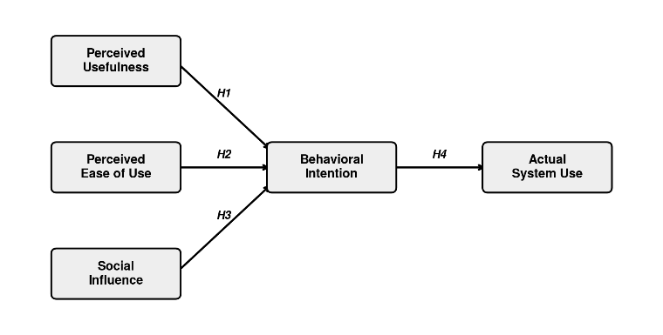
Figure 1. Technology Acceptance Model: Antecedents of Behavioral Intention and System Use

Table Style
A table may be inserted directly into the manuscript using standard Word table tools. Authors are encouraged to adjust vertical cell spacing for readability. In Word, this can be done via Format | Paragraph, under the Line and Page Breaks tab. As illustrated in Table 1, cells typically appear more balanced when equal spacing is applied above and below the text.

 | Method A | Method B
Group I | 142 | 108
Group II | 76 | 119
Group III | 93 | 88
Table 1. Sample Experimental Results by Group

Language, Style, and Content
Authors may use any standard dialect of English (British, Indian, American, Canadian, etc.) provided usage is internally consistent throughout the manuscript. Hyphenation is at the author’s discretion. To serve international readership effectively, the following conventions should be observed:
- Adopt clear and direct prose.
- Avoid unnecessarily complex or lengthy sentence constructions.
- Define or briefly explain all domain-specific terms that may be unfamiliar to a general IS readership.
- Spell out all acronyms upon first use, followed by the abbreviation in parentheses, e.g., “enterprise resource planning (ERP).”
- Contextualize local or regional references that may not be universally recognized.
- Use gender-neutral language throughout. Avoid gender-specific pronouns (he, she) and gendered occupational terms (chairman, manpower). Preferred alternatives include they, s/he, chair, workforce, and person-years.

Conclusion
Manuscripts submitted to InCIS 2027 should be written for a broad academic audience and presented to a professional standard. These guidelines are intended to assist authors in meeting that standard and, equally, to reduce the formatting workload on the conference organizers. Rigorous adherence to the prescribed format is essential to ensure a consistent and high-quality set of proceedings. The organizing committee looks forward to receiving well-prepared submissions.

Acknowledgments (optional)
To preserve the integrity of the double-blind review process, acknowledgments must not be included in the initial submission. If the paper is accepted, acknowledgments may be added to the camera-ready version.

References and Citations
All references must follow the MIS Quarterly formatting requirements (https://misq.umn.edu/formatting-your-manuscript). Complete bibliographic information is required in each entry, including volume, issue, month of publication, publisher, city, editors, all author surnames and initials, and page numbers where applicable. Authors using EndNote should confirm that the style file corresponds to the current MIS Quarterly format; earlier versions of the software may reference an outdated style. The updated EndNote style file is accessible at the link below.
References must be drawn exclusively from published sources that are accessible to the public. Proprietary or unpublished materials may not be cited.
The reference list must be arranged in alphabetical order by the first author’s surname.

References
<<<Please ensure that all references are present, complete, and accurate as per the examples below.>>>
Alavi, S., Weiss, M., Backmann, J., Vomberg, A., & Desernot, C. (2025). The Effect of Management Information Systems on Employee Performance: The Role of Transparency. Information Systems Research, 37(1), 44–62.
Lekwijit, S., Terwiesch, C., Asch, D. A., & Volpp, K. G. (2024). Evaluating the Efficacy of Connected Healthcare: An Empirical Examination of Patient Engagement Approaches and Their Impact on Readmission. Management Science, 70(6), 3417–3446.
Sachdeva, A., & Kim, A. (2024). Taking the Chat out of Chatbot? Collecting User Reviews with Chatbots and Web Forms. Journal of Management Information Systems, 41(1), 146–177.
Tarafdar, M., Stich, J.-F., Maier, C., & Laumer, S. (2024). Techno-Eustress Creators: Conceptualization and Empirical Validation. Information Systems Journal, 34(6), 2097–2131.
Wang, Z., Guo, H., & Liu, D. (2024). Economics of Analytics Services on a Marketplace Platform. MIS Quarterly, 48(2), 775–823.

