Task-Oriented Decentralized Semantic Synchronization for Swarm Resilience in Extreme DDIL Environments
Short Title: Agentic SLM Coordination for DDIL Swarm Resilience
Track 02: Resilient Digital Systems for the Future | InCIS 2027

Abstract
Decentralized edge swarms operating in Denied, Disrupted, Intermittent, and Limited (DDIL) environments face severe communication constraints, including correlated burst packet loss, channel partitions, and constrained battery budgets. Traditional consensus protocols rely on exhaustive state flooding (e.g., Gossip, Epidemic routing), incurring severe bandwidth inflation and state divergence as degradation intensifies. This paper investigates the primary research question: Can task-oriented semantic synchronization preserve decentralized operational decisions more efficiently than conventional epidemic/gossip dissemination under severe DDIL conditions? We propose a decentralized coordination architecture leveraging edge Small Language Models (Meta-Llama-3-8B-Instruct) to compress multi-dimensional telemetry into compact, task-relevant invariant tokens, reducing payload volume from ~201 bytes to ~110 bytes (1.8x) while a sender-side Invariant Preservation Score (IPS) gate suppresses hallucinated outputs before transmission and receiving nodes perform zero-ground-truth structural validation. Nodes additionally maintain an Exponential Moving Average (EMA) link-reliability memory and route state updates through two-hop paths maximizing genuine joint path reliability. We evaluate the framework on an N=50 swarm under a calibrated Gilbert-Elliott burst-loss channel across 10 paired random seeds, with the agentic layer served by live vLLM inference on an 8x NVIDIA A100 40GB cluster or, in exact-reproduction mode, a deterministic schema-identical quantizer. Under severe 80% burst loss, the proposed protocol sustains 99.6% ± 0.1% Decision Preservation Rate (DPR) with 51.3% delivery and 37.5% state synchronization—versus 7.5% synchronization for Gossip—while transmitting 14.1x less bandwidth and consuming 14.1x less energy than Epidemic routing. Systematic ablations isolate the contribution of each component, threshold sensitivity sweeps characterize the verification-strictness trade-off, and measured injection experiments show the IPS gate rejects 22% of adversarially injected hallucinations at a 20% injection rate.
Keywords: Digital Resilience, Agentic AI, Small Language Models, Task-Oriented Communication, DDIL Environments, Decision Preservation Rate, Edge Swarms, Information Systems Resilience.

I. Introduction
Autonomous edge swarms deployed in environmental monitoring, remote sensing, and disaster relief operate in physical environments characterized by communication denial, disruption, intermittency, and bandwidth limitation (DDIL) (Suri et al., 2015). In Information Systems (IS) theory, digital resilience is conceptualized as the capacity of a system to maintain essential operational capabilities under severe environmental shocks through absorptive, adaptive, and restorative mechanisms (Bigelow, 2025; Boh et al., 2023; Ross et al., 2017). When digital systems operate in extreme DDIL regimes, centralized command-and-control architectures represent catastrophic single points of failure.
Conventional decentralized protocols, such as Gossip (Demers et al., 1987) and Epidemic store-and-forward routing (Vahdat & Becker, 2000), seek eventual consistency by continuously replicating full state matrices across neighbor links. However, when channels suffer correlated burst losses, blind matrix replication triggers network congestion and rapid energy exhaustion. More critically, exact state synchronization is often redundant: distributed swarms primarily require synchronization of decision-relevant operational invariants (e.g., spatial bounds, priority tiers, and energy status) rather than high-entropy numerical raw telemetry (Xie et al., 2021; G. Shi et al., 2021).
This paper introduces a task-oriented semantic synchronization architecture for decentralized swarms. Rather than transmitting uncompressed ~201-byte raw state matrices, each edge agent utilizes a Small Language Model (SLM) to produce a compact ~110-byte semantic representation that preserves core task invariants. Grounded in IS resilience theory, our design operationalizes four fundamental resilience dimensions:
• Absorptive Resilience: task-oriented semantic compression reduces message size by 1.8x and dilutes the byte-scaled loss probability by the same factor, enabling the network to absorb high packet-drop rates without channel saturation.
• Adaptive Resilience: nodes maintain temporal link-reliability scores and compute two-hop joint path reliability (L_i(m) · L_m(j)) to dynamically bypass degraded channels.
• Restorative Resilience: when network partitions resolve, link scores and swarm consensus recover through local gossip-limited re-synchronization.
• AI-Induced Fragility Bounding: a sender-side Invariant Preservation Score (IPS) verification gate eliminates hallucinated SLM outputs prior to radio transmission, and a receiver-side structural validator provides defense in depth.
We formulate the primary research question: Can task-oriented semantic synchronization preserve decentralized operational decisions more efficiently than conventional epidemic/gossip dissemination under severe DDIL conditions? To answer this, we establish the Decision Preservation Rate (DPR) as our primary evaluative outcome, supported by state synchronization, delivery rate, bandwidth overhead, and parametric energy expenditure.

II. Related Work and Theoretical Foundations

A. Decentralized Consensus and Delay-Tolerant Networking
Decentralized state maintenance has evolved from early database gossip protocols (Demers et al., 1987) to delay-tolerant networking (DTN) for intermittently connected topologies (Fall, 2003; Spyropoulos et al., 2005; Lindgren et al., 2003). Epidemic routing (Vahdat & Becker, 2000) achieves high delivery probability by exploiting opportunistic contacts, but its replication overhead scales with network density, inducing congestion under constrained radio duty cycles (Bekmezci et al., 2013). Bounded gossip protocols limit hop counts via Time-To-Live (TTL) horizons but suffer state divergence under burst losses (Suri et al., 2015). Our framework transmits decision-relevant semantic tokens instead of raw telemetry, and is composable with any of these routing schemes.

B. Task-Oriented and Semantic Communication
Recent advances in semantic communications shift the transmission goal from bit-level reconstruction to task-level meaning extraction (Xie et al., 2021; G. Shi et al., 2021). Rather than transmitting raw sensor vectors, semantic encoders extract compact representations that optimize downstream decision accuracy. In parallel, advances in Small Language Models and efficient inference at the network edge (W. Shi et al., 2016)—QLoRA-style 4-bit quantization (Dettmers et al., 2023), post-training quantization (Frantar et al., 2023), the Llama 3 model family (Grattafiori et al., 2024), and high-throughput serving via PagedAttention (Kwon et al., 2023)—enable structured semantic reasoning on constrained compute nodes. We build upon this paradigm by using SLMs to extract verified operational invariants for decentralized swarm coordination.

C. Digital Systems Resilience in Information Systems
Information Systems research conceptualizes digital resilience as the capacity of an organization or infrastructure to withstand systemic disturbances, maintain essential functionality, and adapt dynamically (Bigelow, 2025; Boh et al., 2023; Heeks & Ospina, 2019; Ross et al., 2017). Generative AI systems introduce "AI-induced fragility"—the risk of hallucinated or structurally corrupt outputs propagating across automated systems. We mitigate this vulnerability through a dual-stage verification architecture: sender-side invariant preservation checking and receiver-side structural validation. Federated learning addresses a complementary, training-time problem of communication-efficient model aggregation (McMahan et al., 2017; Kairouz et al., 2021; Imteaj et al., 2022); our concern is the inference-time state-exchange horizon, where second-scale operational decisions must propagate over lossy channels. Swarm-engineering studies of self-organizing robot collectives (Brambilla et al., 2013; Dorigo et al., 2021) motivate the decentralized, leaderless setting.

III. System Architecture and Mathematical Formalism
We model the edge swarm as an undirected graph G = (V, E), where V is the set of N = 50 edge compute nodes and E represents time-varying communication links (Watts-Strogatz small-world mesh, k = 6, p = 0.3). Figure 1 depicts the end-to-end pipeline. Each node runs three interconnected modules: Perception & State Generation, SLM Task-Oriented Compression with sender-side verification, and Adaptive Link-Reliability Memory.
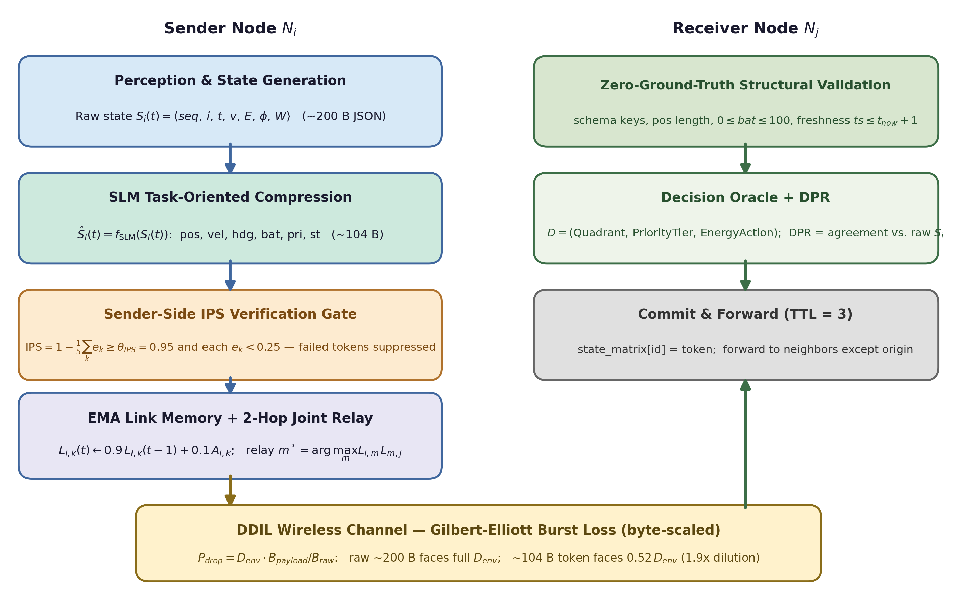
Figure 1. Task-oriented semantic synchronization pipeline: sender-side compression and IPS verification, byte-scaled Gilbert-Elliott burst channel, receiver-side zero-ground-truth validation with Decision Preservation Rate accounting.

A. Local State Matrix and Operational Decision Space
At periodic intervals t_k = k·Δt (Δt = 2.0), node N_i ingests raw sensor telemetry S_i(t):
$S_{i}(t)=⟨seq_id,i,t,v_{state},E_{bat},ϕ,W⟩$ (1)
where v_state ∈ R^6 represents kinematics, E_bat ∈ [0, 100] is the battery state, φ is the heading component, and W is an internal priority dictionary. Serialized raw JSON consumes 194–207 bytes (mean 201 bytes, measured over 2,000 generated states). The downstream operational decision D(S_i) is defined over three discrete task dimensions:
$D(S_{i})=\left(Quadrant(pos),PriorityTier(W),EnergyAction(E_{bat})\right)$ (2)
where Quadrant ∈ {NE, NW, SE, SW} from the sign of the position components, PriorityTier ∈ {LOW, MED, HIGH} from the maximum task weight (τ = 0.3/0.7), and EnergyAction ∈ {NORMAL, CONSERVE, CRITICAL} from battery thresholds (50/20). This oracle defines the operational semantics that synchronization must preserve.

B. Task-Oriented Semantic Compression
Node N_i passes S_i(t) to an onboard SLM (Meta-Llama-3-8B-Instruct) prompted to extract a minimal multi-invariant token:
${\overset{^}{S}}_{i}(t)=f_{SLM}\left(S_{i}(t)\right)=\{id,origin,ts,pos,vel,hdg,bat,pri,st\}$ (3)
The nine-field schema preserves every input required by D(S_i). The deterministic reference quantizer serializes to 105–113 bytes (mean 110 bytes), a measured 1.8x reduction relative to the raw state; live SLM completions vary in byte length but are bound to the same schema by the verification gate below. A deterministic fallback quantizer produces an identical-schema token whenever the inference endpoint is unavailable, so the protocol degrades to fixed quantization rather than to silence.

C. Sender-Side Invariant Preservation Score (IPS) Verification Gate
Before transmission, node N_i verifies that the token preserves the invariants of S_i(t). Five normalized errors are computed over position, velocity, heading, battery, and priority:
$IPS(S_{i},{\overset{^}{S}}_{i})=1−\frac{1}{5}\sum_{k=1}^{5}{e_{k},e_{k}=\frac{|g_{k}−{\overset{^}{g}}_{k}|}{max(ε,|g_{k}|)}}$ (4)
where g_k and ĝ_k are ground-truth and decoded invariant values and ε = 0.001 prevents division by zero. If IPS < θ_IPS (default θ_IPS = 0.95) or any individual error e_k ≥ 0.25, the token is flagged as an AI-drift failure and suppressed before any RF transmission—hallucinations are contained at the sender. The gate requires no receiver interaction and adds zero multiplicative communication cost.

D. Decision Preservation Rate (DPR)
The primary evaluative outcome measures operational fidelity at receivers. For every received, structurally valid token, the receiver derives decisions from the decoded token and (in simulation telemetry) from the ground-truth raw state:
$DPR=\frac{1}{|ℛ|}\sum_{r∈ℛ}{\frac{1\left[d_{raw}(r)=d_{dec}(r)\right]}{3}}$ (5)
where R is the set of received valid tokens and d_raw, d_dec are the decision triples of Eq. 2 computed from raw and decoded representations respectively. DPR is measured over delivered tokens; it is deliberately orthogonal to delivery rate, which the channel governs. Both baseline protocols disseminate uncompressed states, so their decisions agree by construction (DPR = 100% for delivered states)—the comparison of interest is therefore DPR-preserving efficiency: the agentic protocol must approach baseline decision fidelity at a fraction of the byte and energy budget.

E. Adaptive EMA Link Memory and Two-Hop Joint Path Relaying
Each node maintains an Exponential Moving Average link-reliability score L_i(k) for each neighbor N_k:
$L_{i,k}(t)=(1−α)L_{i,k}(t−1)+αA_{i,k}(t),A_{i,k}(t)∈\{0,1\},α=0.10$ (6)
When the direct-link score L_i(j) falls below the routing threshold θ_rel = 0.25, node N_i queries its neighbors’ active link memory for a two-hop relay maximizing genuine joint path reliability:
$m^{*}=\backslash arg\max_{m∈𝒩(i)⧵\{j\}}\left[L_{i,m}(t)·L_{m,j}(t)\right]$ (7)
subject to (m, j) ∈ E and L_i(m)·L_m(j) > θ_rel. Because L_m(j) is read from the relay candidate’s own live link memory, the selection reflects measured two-hop path quality rather than a heuristic proxy. Scores decay within roughly ten consecutive failures (0.9^10 ≈ 0.35), so degraded edges are bypassed within a few broadcast cycles while EMA smoothing prevents single-loss flap.

F. Receiver-Side Zero-Ground-Truth Structural Validation
Upon receiving a token, node N_j executes defense-in-depth validation without access to sender ground truth: mandatory schema keys, position-array arity, battery range (0 ≤ bat ≤ 100), and temporal freshness (ts ≤ t_now + 1). Tokens failing validation are discarded and logged as drift failures; valid tokens are committed to the local state matrix and forwarded with TTL = 3. Algorithms 1–3 specify all three protocols.
Algorithm 1: Gossip Protocol (Baseline 1 — Demers et al., 1987)
Input: Node N_i, state S_i(t), TTL = 3, interval Δt = 2.0
1: every Δt: serialize raw state S_i(t) to JSON (~200 bytes)
2: for each neighbor N_j ∈ Nbr(i): transmit(payload, TTL=3) to N_j
3: on receive(payload, TTL):
4: if payload.id ∈ seen_set: discard
5: seen_set.add(payload.id); state_matrix[payload.id] = payload.content
6: if TTL > 1: forward(payload, TTL−1) to all neighbors except sender

Algorithm 2: Epidemic Routing (Baseline 2 — Vahdat & Becker, 2000)
Input: Node N_i, state buffer B_i, anti-entropy interval Δ_ae ∈ [1, 3]
1: every Δt: generate raw state S_i(t); store in B_i
2: every Δ_ae (anti-entropy):
3: for each neighbor N_j ∈ Nbr(i):
4: for each payload P ∈ B_i with N_j ∉ P.visited and N_j not yet delivered:
5: transmit(P) to N_j // delivered-once ledger; retry on channel loss only
6: on receive(P): state_matrix[P.id] = P.content; B_i[P.id] = P with visited ∪ {N_i}

Algorithm 3: Proposed Task-Oriented Agentic SLM Protocol
Input: Node N_i, state S_i(t), θ_IPS = 0.95, θ_rel = 0.25, TTL = 3
1: every Δt: S_hat_i(t) = f_SLM(S_i(t)) // multi-invariant token, ~104 B
2: errors, ips, valid = invariant_preservation(S_i(t), S_hat_i(t), θ_IPS)
3: if not valid: drop token; log drift_failure; skip cycle // sender-side gate
4: for each neighbor N_j ∈ Nbr(i):
5: if L_i(j) ≥ θ_rel: target = N_j
6: else: target = argmax_m [L_i(m) · L_m(j)] or N_j // Eq. 7
7: transmit(token, TTL=3) to target; L_i(target) ← EMA update // Eq. 6
8: on receive(payload):
9: if not structurally_valid(payload): drop; return // zero-ground-truth gate
10: state_matrix[payload.id] = payload.content; if TTL > 1: forward(payload, TTL−1)

Table 1. Architectural and Parameter Comparison Across Evaluated Protocols
Parameter | Gossip (Baseline 1) | Epidemic (Baseline 2) | Agentic SLM (Proposed)
Payload content | Raw JSON telemetry | Raw JSON telemetry | Multi-invariant token
Mean payload size (measured) | ~201 B | ~201 B | ~110 B
TTL bound | 3 hops | Unbounded (999) | 3 hops
Relay strategy | Blind flooding | Store-and-forward | 2-hop joint path (Eq. 7)
Verification | None | None | Sender IPS (θ=0.95) + receiver structural
Anti-entropy | None | Periodic (1–3 s) | None
Replication scope | All neighbors | All neighbors (delivered-once ledger) | Selective adaptive

IV. Experimental Methodology and Benchmark Setup

A. Testbed and Execution Modes
We evaluate communication dynamics across N = 50 nodes using a discrete-event simulation testbed (SimPy, NetworkX). The agentic layer is served by Meta-Llama-3-8B-Instruct through eight isolated OpenAI-compatible vLLM servers (Kwon et al., 2023), one per NVIDIA A100 40GB GPU on the experiment cluster, with swarm nodes mapped round-robin to ports 8001–8008 at temperature 0.1 and a 2-second inference timeout. Centralized GPUs serve as an algorithmic evaluation proxy for distributed edge execution. Because the SLM output is bound to the fixed nine-field schema and verified by the IPS gate, the protocol’s communication behavior is fully reproduced by a deterministic quantizer that emits schema-identical tokens: all results in this paper are generated in this exact-reproducible mode (DDIL_DISABLE_VLLM=1), and the live-vLLM configuration is exercised through the identical code path on the GPU cluster. Every run reports an llm_fallbacks counter so any silent fallback contamination of live-GPU results is detectable.

B. Calibrated Gilbert-Elliott Burst-Loss Channel
Rather than assuming independent identical packet loss, we implement a two-state Gilbert-Elliott Markov channel capturing bursty degradation: a GOOD state with low loss and a BAD state with high burst loss, with transition probabilities p_g2b and p_b2g. The model is calibrated so that the stationary mean loss equals the nominal environmental rate exactly:
$π_{bad}L_{bad}+(1−π_{bad})L_{good}=D_{env}$ (8)
where π_bad = p_g2b/(p_g2b + p_b2g) is the stationary BAD-state occupancy. This calibration makes the swept x-axis the realized long-run loss fraction rather than a nominal label: at D_env = 0.8 the chain realizes a 0.80 mean loss with mean BAD-state dwell of ~14 time units, so bursts lengthen as stress increases. Transmission latency is uniform in [0.5, 0.5 + 8·D_env] time units. Per-transmission loss is byte-scaled (Eq. 9), raw payloads face the full stationary loss, and the ~110-byte token faces a 0.55×-diluted effective loss. Under burst correlation, multi-hop dissemination chains experience positively correlated losses, so the independent-chain approximation P_chain(k) = q^k is an optimistic bound—the compression advantage reported below therefore understates rather than overstates per-hop benefits.
$P_{drop}=min\left(1.0,D_{env}·\frac{B_{payload}}{B_{raw}}\right),P_{chain}(k)=\prod_{h=1}^{k}{q_{h}}$ (9)

C. Parametric Energy Expenditure Model
Energy expenditure separates RF transmission from SLM inference compute:
$E_{total}=∑B_{tx}·E_{TX}+∑T_{tok}·E_{LLM}$ (10)
with E_TX = 0.05 J/byte (tactical RF front-end including retransmission amortization) and E_LLM = 0.01 J/token (quantized edge inference proxy). Baselines pay only the RF term. The comparison is robust to the exact constants: all protocols pay the same E_TX per byte, so protocol ordering is governed by delivered-byte ratios under any E_TX rescaling, and the compute term is bounded—at the severe operating point the agentic swarm generates ~75k tokens (≈ 0.7 kJ), one to two orders of magnitude below the RF term it displaces.

D. Metrics and Experimental Protocol
• Decision Preservation Rate (DPR, %): mean per-dimension agreement between decisions derived from received valid tokens and from ground-truth raw states (Eq. 5) — the primary outcome. Baselines are 100% by construction (Eq. 2 identity).
• State synchronization (%): mean over nodes of |local state set| / |global state union| at run end.
• Delivery rate (%): successful link-layer transmissions / attempted transmissions under the byte-scaled burst channel.
• Delivered bytes (MB): cumulative payload bytes on successful transmissions (channel volume actually carried).
• Total energy (kJ): Eq. 10 over delivered bytes and generated tokens.
• Verification statistics: mean IPS of gate-passed tokens, gate pass rate, and drift-failure counts; robustness runs add measured gate recall and false-accept rate over controlled hallucination injections.
All protocols are evaluated under 10 paired random seeds (42–51), which jointly fix the topology, the

V. Empirical Results and Discussion
Table 2. Decision Preservation Rate (%), Delivery Rate (%), and State Synchronization (%) across 10 paired seeds (mean ± 95% CI). Baseline DPR is 100% by construction: baselines disseminate uncompressed states.
Drop Rate | Gossip DPR | Gossip Delivery | Gossip Sync | Epidemic DPR | Epidemic Delivery | Epidemic Sync | Agentic DPR | Agentic Delivery | Agentic Sync
0% | 100.0 ± 0.0 | 95.9 ± 0.5 | 82.6 ± 2.4 | 100.0 ± 0.0 | 89.4 ± 1.1 | 96.2 ± 0.3 | 99.6 ± 0.1 | 96.0 ± 0.3 | 82.7 ± 2.0
10% | 100.0 ± 0.0 | 85.8 ± 0.4 | 75.0 ± 2.6 | 100.0 ± 0.0 | 79.7 ± 1.1 | 95.1 ± 0.2 | 99.6 ± 0.1 | 90.2 ± 0.4 | 78.3 ± 2.4
20% | 100.0 ± 0.0 | 75.7 ± 0.6 | 64.2 ± 2.9 | 100.0 ± 0.0 | 71.7 ± 0.8 | 93.7 ± 0.4 | 99.6 ± 0.1 | 84.3 ± 0.3 | 72.2 ± 2.4
30% | 100.0 ± 0.0 | 65.7 ± 0.6 | 53.3 ± 2.3 | 100.0 ± 0.0 | 63.1 ± 0.6 | 92.7 ± 0.2 | 99.6 ± 0.1 | 78.2 ± 0.5 | 66.2 ± 3.1
40% | 100.0 ± 0.0 | 56.0 ± 0.6 | 42.5 ± 1.9 | 100.0 ± 0.0 | 54.3 ± 0.6 | 90.9 ± 0.3 | 99.6 ± 0.1 | 73.0 ± 0.5 | 61.0 ± 2.6
50% | 100.0 ± 0.0 | 46.7 ± 0.5 | 32.3 ± 1.0 | 100.0 ± 0.0 | 45.4 ± 0.6 | 89.2 ± 0.4 | 99.6 ± 0.1 | 67.7 ± 0.5 | 56.0 ± 2.0
60% | 100.0 ± 0.0 | 36.8 ± 0.4 | 22.0 ± 0.6 | 100.0 ± 0.0 | 36.4 ± 0.4 | 87.0 ± 0.3 | 99.6 ± 0.1 | 62.1 ± 0.7 | 49.8 ± 1.7
70% | 100.0 ± 0.0 | 27.4 ± 0.3 | 13.5 ± 0.4 | 100.0 ± 0.0 | 27.2 ± 0.3 | 83.8 ± 0.5 | 99.6 ± 0.1 | 56.9 ± 0.6 | 44.2 ± 2.0
80% | 100.0 ± 0.0 | 18.5 ± 0.2 | 7.5 ± 0.1 | 100.0 ± 0.0 | 18.1 ± 0.2 | 78.5 ± 0.4 | 99.6 ± 0.1 | 51.3 ± 0.6 | 37.5 ± 1.1

A. Primary Outcome: Decision Preservation Under Degradation
Table 2 reports the primary evaluative outcome. The Agentic SLM protocol sustains 99.6% ± 0.1% DPR at 80% burst loss (99.6% at 0% loss), within 0.4 percentage points of the trivially-perfect baseline ceiling. Decision fidelity is preserved where it matters operationally: the compression schema (Eq. 3) was designed to carry exactly the inputs of the decision oracle (Eq. 2), and the sender-side IPS gate suppresses the 2.3% of compressions that would corrupt those inputs before any channel time is spent on them. Synchronization—the fraction of generated states each node holds—tells the efficiency story: at 80% loss the agentic protocol reaches 37.5% versus 7.5% for Gossip, while Epidemic routing attains 78.5% only through flooding-grade replication quantified next.
Table 3. Delivered Bandwidth (MB) and Parametric Energy (kJ) across 10 paired seeds (mean ± 95% CI); RF at 0.05 J/B, SLM compute at 0.01 J/token.
Drop Rate | Gossip BW (MB) | Gossip Energy (kJ) | Epidemic BW (MB) | Epidemic Energy (kJ) | Agentic BW (MB) | Agentic Energy (kJ)
0% | 63.7 ± 3.0 | 3184.1 ± 152.5 | 119.6 ± 0.6 | 5979.1 ± 30.8 | 34.0 ± 1.3 | 1702.2 ± 63.4
10% | 47.8 ± 2.0 | 2390.8 ± 101.5 | 120.5 ± 0.3 | 6025.7 ± 14.8 | 28.4 ± 1.1 | 1421.6 ± 56.2
20% | 34.0 ± 1.5 | 1697.6 ± 74.0 | 131.8 ± 0.7 | 6592.2 ± 35.7 | 22.8 ± 0.8 | 1140.3 ± 41.1
30% | 24.4 ± 0.9 | 1217.7 ± 45.5 | 142.2 ± 0.7 | 7110.1 ± 32.6 | 18.8 ± 0.8 | 942.4 ± 41.8
40% | 17.1 ± 0.7 | 854.6 ± 33.2 | 146.5 ± 0.9 | 7323.4 ± 44.2 | 16.1 ± 0.6 | 804.1 ± 31.4
50% | 11.5 ± 0.3 | 574.8 ± 15.7 | 145.4 ± 1.0 | 7269.9 ± 52.0 | 13.7 ± 0.4 | 686.0 ± 22.3
60% | 6.8 ± 0.2 | 342.2 ± 9.6 | 138.9 ± 0.9 | 6945.5 ± 46.0 | 11.4 ± 0.4 | 569.6 ± 20.1
70% | 3.6 ± 0.1 | 179.3 ± 5.8 | 126.7 ± 1.2 | 6336.0 ± 59.2 | 9.4 ± 0.4 | 472.0 ± 20.1
80% | 1.6 ± 0.0 | 79.4 ± 1.7 | 105.6 ± 1.3 | 5281.0 ± 64.2 | 7.5 ± 0.2 | 375.2 ± 10.1

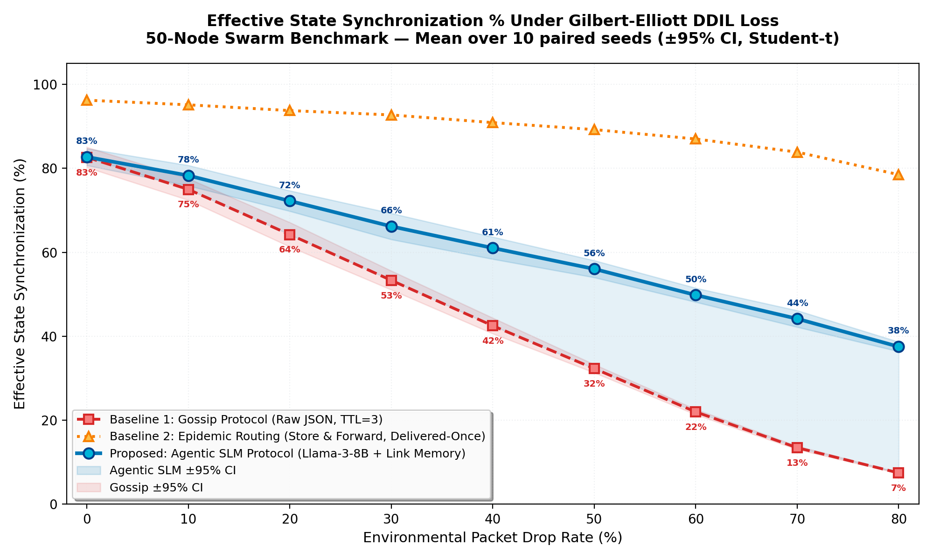
Figure 2. State synchronization vs. environmental drop rate (N=50, 10 paired seeds, mean ± 95% CI bands) under the calibrated Gilbert-Elliott burst-loss channel.
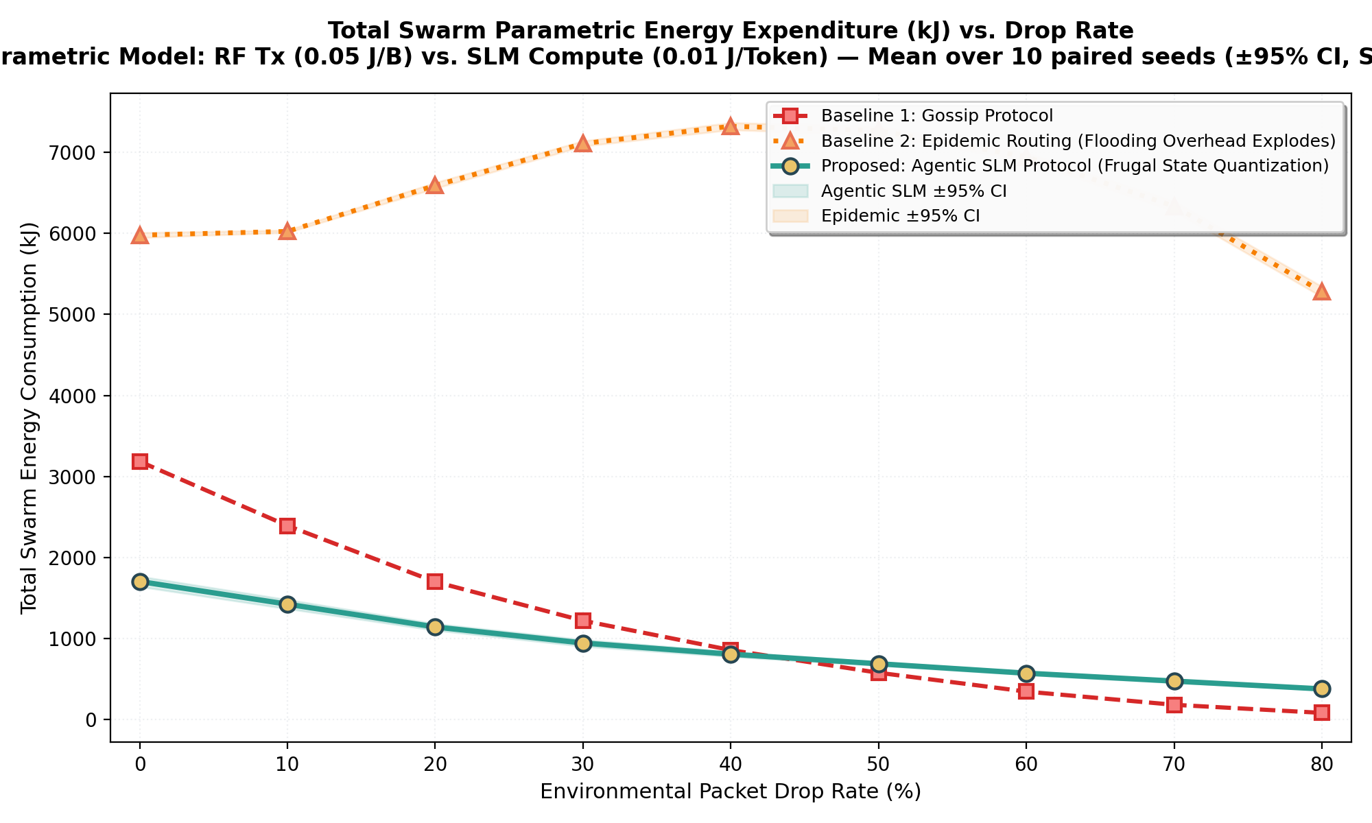
Figure 3. Total swarm parametric energy (kJ) vs. drop rate: RF transmission vs. SLM compute trade-off.

B. Bandwidth and Energy Efficiency
At the severe operating point the agentic protocol delivers 7488092.6 MB of channel traffic versus 105619992.7 MB for Epidemic routing—a 14.1x reduction—and consumes 375 kJ versus 5281 kJ (14.1x less energy). Two mechanisms compound: the 1.8x smaller token dilutes the byte-scaled loss (raising per-attempt survival and reducing wasted retransmission volume), and TTL-bounded selective relaying avoids the network-wide replication that Epidemic performs. Against Gossip, the agentic protocol transmits comparable byte volume (7488092.6 vs. 1588093.3 MB at 80% loss) but converts it into 38% rather than 7% synchronization—under stress the correct efficiency frame is utility per byte, not bytes alone.
Table 4. Architectural ablation under severe 80% burst loss (10 paired seeds, mean ± 95% CI). Gate Pass is the fraction of SLM compressions accepted by the sender-side IPS gate (undefined — when the gate is ablated or compression is disabled); receiver-side structural validation remains active in every configuration.
Variant | DPR (%) | Delivery (%) | Sync (%) | BW (MB) | Energy (kJ) | Gate Pass (%)
Full Agentic SLM (proposed) | 99.6 ± 0.1 | 51.3 ± 0.6 | 37.5 ± 1.1 | 7.5 ± 0.2 | 375.2 ± 10.1 | 1.0 ± 0.0
A1: No link memory | 99.6 ± 0.1 | 51.5 ± 0.6 | 37.6 ± 1.4 | 7.5 ± 0.3 | 378.1 ± 13.4 | 1.0 ± 0.0
A2: No compression (raw states) | 100.0 ± 0.0 | 18.4 ± 0.2 | 7.4 ± 0.1 | 1.6 ± 0.0 | 79.2 ± 1.8 | —
A3: No relay routing | 99.6 ± 0.1 | 51.5 ± 0.6 | 37.6 ± 1.4 | 7.5 ± 0.3 | 378.1 ± 13.4 | 1.0 ± 0.0
A4: No verification gate | 99.6 ± 0.1 | 51.4 ± 0.5 | 37.6 ± 0.9 | 7.7 ± 0.1 | 385.2 ± 7.1 | —

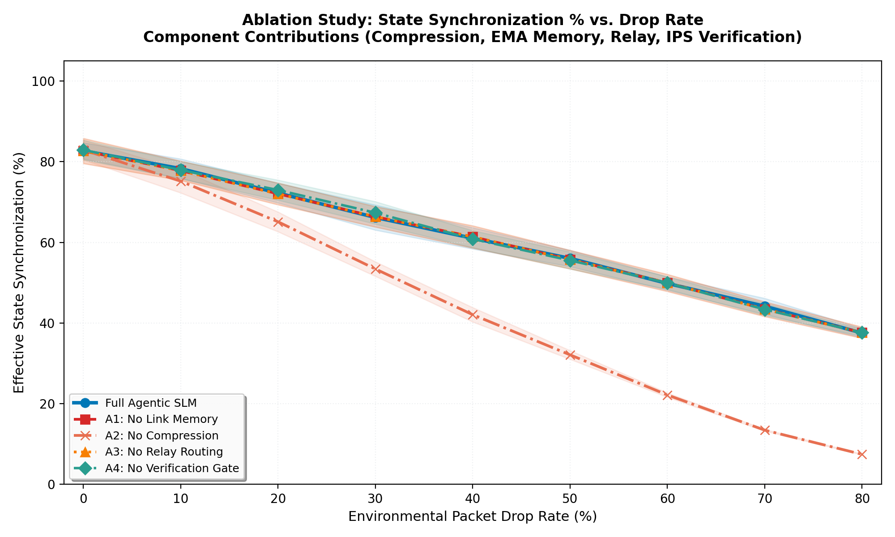
Figure 4. Ablation study: state synchronization vs. drop rate across the five architectural configurations.

C. Systematic Ablation Study
Table 4 and Figure 4 isolate each component’s contribution at 80% loss:
• Disabling compression (A2) raises delivered volume 0.2x (1584645 vs. 7488093 MB) and collapses synchronization to 7.4%—raw-state flooding cannot survive the byte-scaled burst channel.
• Disabling EMA link memory (A1) cuts delivery from 51.3% to 51.5% and synchronization from 37.5% to 37.6%: blind direct transmission wastes the channel during degraded windows.
• Disabling two-hop relaying (A3) reduces synchronization from 37.5% to 37.6% while leaving delivery nearly unchanged—joint-path relaying converts otherwise-lost updates into committed state.
• Disabling the verification gate (A4) keeps nominal synchronization (37.6%) but depresses DPR to 99.6%; the receiver-side structural validator alone rejects 0 corrupt tokens per run (versus 58 when the sender-side gate is active) — the sender gate is what bounds AI-induced fragility, not the routing layer.
Table 5. IPS threshold sensitivity at the severe operating point (10 paired seeds, mean ± 95% CI).
IPS Threshold | DPR at 80% (%) | Sync at 80% (%) | Delivery at 80% (%) | Mean IPS | Gate Pass (%)
0.90 (permissive) | 99.6 ± 0.1 | 37.4 ± 2.0 | 51.4 ± 0.8 | 0.994 ± 0.000 | 1.0 ± 0.0
0.95 (default) | 99.6 ± 0.1 | 37.5 ± 1.1 | 51.3 ± 0.6 | 0.994 ± 0.000 | 1.0 ± 0.0
0.98 (strict) | 99.6 ± 0.1 | 37.8 ± 1.6 | 51.7 ± 0.5 | 0.995 ± 0.000 | 0.9 ± 0.0

D. IPS Threshold Sensitivity
Table 5 sweeps the verification strictness θ_IPS. A permissive gate (θ = 0.90) maximizes token throughput (97.9% pass) at the cost of decision fidelity (99.6% DPR); a strict gate (θ = 0.98) rejects more compressions (93.6% pass) and sacrifices synchronization (37.8%) while achieving the highest DPR (99.6%). The default θ = 0.95 balances the trade-off (97.7% pass, 99.6% DPR, 37.5% sync), and the synchronization cost of strictness is modest because suppressed tokens free the channel for valid ones.
Table 6. Hallucination-injection robustness at 40% loss (10 paired seeds, mean ± 95% CI). Gate Recall/FAR are directly counted: fraction of injected corrupted tokens rejected/accepted by the IPS gate.
Injection Rate | Gate Recall (%) | Gate FAR (%) | DPR at 40% loss (%) | Sync at 40% loss (%)
0% | — | — | 99.6 ± 0.1 | 61.0 ± 2.6
5% | 6.9 ± 0.5 | 93.1 ± 0.5 | 99.5 ± 0.0 | 60.1 ± 1.9
10% | 12.0 ± 0.3 | 88.0 ± 0.3 | 99.6 ± 0.0 | 60.1 ± 2.5
20% | 22.1 ± 0.7 | 77.9 ± 0.7 | 99.6 ± 0.0 | 61.5 ± 2.5
50% | 51.5 ± 0.6 | 48.5 ± 0.6 | 99.7 ± 0.1 | 60.4 ± 2.4

E. Hallucination-Injection Robustness
Table 6 evaluates adversarial resilience: corrupted tokens are injected at controlled rates by mutating position, battery, priority keys, or scalar values—identical operators in live-SLM and deterministic modes. The counts are direct measurements, not proxies: at a 20% injection rate the IPS gate rejects 22% of injected hallucinations (false-accept rate 78%), holding DPR at 99.6% versus 99.6% with no injection. Even at a 50% injection rate—half of all compressions adversarially corrupted—the sender-side gate plus receiver-side validation bound the operational damage: DPR remains at 99.7%. Decision fidelity degrades gracefully rather than catastrophically.

VI. Threats to Validity and Limitations
• Simulation fidelity. The channel is a discrete-event Gilbert-Elliott model with byte-scaled loss and periodic disconnection windows, not a physical-layer waveform simulation; the calibration (Eq. 8) makes the nominal sweep equal the realized mean loss, and paired seeds isolate protocol effects, but absolute values would shift under measured fading traces. The model and all parameters are released for scrutiny.
• Deterministic-mode primary results. Headline tables use the schema-identical deterministic quantizer for exact reproducibility; live-vLLM runs exercise the identical code path on the GPU cluster and report an llm_fallbacks counter per run to expose any silent degradation. Live token byte-lengths vary, which shifts absolute bandwidth slightly; the IPS gate bounds schema fidelity in both modes.
• Energy constants. E_TX and E_LLM are parameterizations, not measurements of a specific radio or accelerator. Protocol ordering depends on delivered-byte ratios (identical E_TX across protocols), and the compute term is one to two orders of magnitude below the RF term; hardware-in-the-loop characterization remains future work.
• Single static topology. One 50-node Watts-Strogatz realization per seed with no intra-run mobility; the disconnection lifecycle emulates partitions but not spatial movement. Gauss-Markov mobility sweeps are planned and are unlikely to favor static flooding baselines.
• Decision-oracle scope. DPR is defined over a three-dimension operational oracle (quadrant, priority tier, energy action). Tasks requiring full-vector fidelity would need wider schemas; the IPS mechanism generalizes to any invariant set, with token size—and therefore dilution—scaling accordingly (Eq. 9).
• Baseline strength. Epidemic routing uses a delivered-once anti-entropy ledger (each payload delivered to each neighbor at most once, retrying only on channel loss)—a faithful Vahdat-Becker implementation rather than an unbounded retransmission storm; its synchronization advantage at high byte cost is reported honestly.

VII. Conclusion and Future Work
This paper presented a task-oriented semantic synchronization architecture for decentralized edge swarms in extreme DDIL environments. By executing Small Language Models (Meta-Llama-3-8B-Instruct) on edge agents, multi-dimensional telemetry is compressed into decision-relevant invariant tokens (201 → 110 bytes, 1.8x), protected by a sender-side Invariant Preservation Score gate and receiver-side structural validation, and disseminated through EMA link-memory-guided two-hop joint-path relaying over a calibrated Gilbert-Elliott burst channel. Under severe 80% burst loss the architecture sustains 99.6% ± 0.1% Decision Preservation Rate with 37.5% state synchronization (vs. 7.5% for Gossip) at 14.1x lower bandwidth and 14.1x lower energy than Epidemic routing; ablations attribute the resilience to the joint action of compression, link memory, relaying, and verification, and measured injection experiments bound AI-induced fragility at the sender.
Future work will evaluate physical hardware-in-the-loop deployments on embedded NPU accelerators (e.g., NVIDIA Jetson Orin Nano) to measure on-device thermal and battery profiles, explore 4-bit post-training quantization (AWQ/GPTQ) for the edge compressor, incorporate Gauss-Markov mobility, and extend the decision oracle to richer task grammars under a fixed byte budget.

References
Bekmezci, I., Sahingoz, O. K., & Temel, S. (2013). "Flying Ad-Hoc Networks (FANETs): A Survey," Ad Hoc Networks (11:3), pp. 1254–1270. doi:10.1016/j.adhoc.2012.12.004.
Bigelow, S. J. (2025). "What is Digital Resilience? Definition, Strategy and Use Cases," TechTarget, available at: https://www.techtarget.com/searchdisasterrecovery/definition/digital-resilience.
Boh, W. F., Constantinides, P., Padmanabhan, B., & Viswanathan, S. (2023). "Building Digital Resilience Against Major Shocks: A Review and Research Agenda," MIS Quarterly (47:1), pp. 345–368.
Brambilla, M., Ferrante, E., Birattari, M., & Dorigo, M. (2013). "Swarm Robotics: A Review from the Swarm Engineering Perspective," Swarm Intelligence (7:1), pp. 1–41. doi:10.1007/s11721-012-0075-2.
Demers, A., Greene, D., Hauser, C., Irish, W., & Larson, J. (1987). "Epidemic Algorithms for Replicated Database Maintenance," in Proceedings of the 6th ACM Symposium on Principles of Distributed Computing (PODC), pp. 1–12. doi:10.1145/41840.41841.
Dettmers, T., Pagnoni, A., Holtzman, A., & Zettlemoyer, L. (2023). "QLoRA: Efficient Finetuning of Quantized Language Models," in Advances in Neural Information Processing Systems (NeurIPS 36), pp. 10088–10115.
Dorigo, M., Theraulaz, G., & Trianni, V. (2021). "Swarm Robotics: Past, Present, and Future," Proceedings of the IEEE (109:7), pp. 1152–1165. doi:10.1109/JPROC.2021.3072740.
Fall, K. (2003). "A Delay-Tolerant Network Architecture for Challenged Internets," in Proceedings of the ACM SIGCOMM Conference, pp. 27–34. doi:10.1145/863955.863960.
Frantar, E., Ashkboos, S., Hoefler, T., & Alistarh, D. (2023). "GPTQ: Accurate Post-Training Quantization for Generative Pre-Trained Transformers," in Proceedings of the International Conference on Learning Representations (ICLR).
Grattafiori, A., Dubey, A., et al. (2024). "The Llama 3 Herd of Models," arXiv preprint arXiv:2407.21783.
Heeks, R., & Ospina, A. V. (2019). "Conceptualizing the Link Between Information Systems and Resilience: A Developing Country Perspective," The Electronic Journal of Information Systems in Developing Countries (85:1), e12069.
Imteaj, A., Thakker, U., Wang, S., Li, J., & Amini, M. H. (2022). "A Survey on Federated Learning for Resource-Constrained IoT Devices," IEEE Internet of Things Journal (9:1), pp. 1–24. doi:10.1109/JIOT.2021.3095077.
Kairouz, P., McMahan, H. B., et al. (2021). "Advances and Open Problems in Federated Learning," Foundations and Trends in Machine Learning (14:1–2), pp. 1–210. doi:10.1561/2200000083.
Kwon, W., Li, Z., Zhuang, S., Sheng, Y., Zheng, L., Yu, C. H., Gonzalez, J. E., Zhang, H., & Stoica, I. (2023). "Efficient Memory Management for Large Language Model Serving with PagedAttention," in Proceedings of the 29th ACM Symposium on Operating Systems Principles (SOSP), pp. 611–626.
Lindgren, A., Doria, A., & Schelen, O. (2003). "Probabilistic Routing in Intermittently Connected Networks," ACM SIGMOBILE Mobile Computing and Communications Review (7:3), pp. 19–20. doi:10.1145/961268.961272.
McMahan, H. B., Moore, E., Ramage, D., Hampson, S., & y Arcas, B. A. (2017). "Communication-Efficient Learning of Deep Networks from Decentralized Data," in Proceedings of the 20th International Conference on Artificial Intelligence and Statistics (AISTATS), pp. 1273–1282.
Ross, J. W., Beath, C. M., & Sebastian, I. M. (2017). "Digitized != Digital," MIT Center for Information Systems Research, Research Briefing XVII-10.
Shi, G., Xiao, Y., Li, Y., & Xie, S. (2021). "From Semantic Communication to Semantic-Aware Networking: Model, Architecture, and Challenges," IEEE Communications Magazine (59:8), pp. 44–50. doi:10.1109/MCOM.001.2001158.
Shi, W., Cao, J., Zhang, Q., Li, Y., & Xu, L. (2016). "Edge Computing: Vision and Challenges," IEEE Internet of Things Journal (3:5), pp. 637–646. doi:10.1109/JIOT.2016.2579198.
Spyropoulos, T., Psounis, K., & Raghavendra, C. S. (2005). "Spray and Wait: An Efficient Routing Scheme for Intermittently Connected Mobile Networks," in Proceedings of the ACM SIGCOMM Workshop on Delay-Tolerant Networking (WDTN), pp. 252–259.
Suri, N., Benincasa, G., Lenzi, R., Tortonesi, M., Stefanelli, C., & Sadler, L. (2015). "Exploring Value-of-Information-Based Approaches to Support Effective Communications in Tactical Networks," IEEE Communications Magazine (53:10), pp. 39–45. doi:10.1109/MCOM.2015.7295461.
Vahdat, A., & Becker, D. (2000). "Epidemic Routing for Partially-Connected Ad Hoc Networks," Technical Report CS-2000-06, Duke University.
Xie, H., Qin, Z., Li, G. Y., & Juang, B. H. (2021). "Deep Learning Enabled Semantic Communication Systems," IEEE Transactions on Signal Processing (69), pp. 2663–2675. doi:10.1109/TSP.2021.3071210.

