Lab Assignment 1: Spinning Up React Native App

STUDENT ID: 892900

SUBMITTED BY: Aadish Jain

* Step 1: Firstly, the project requires installation from <https://nodejs.org/en>.
* Step 2: Open ‘Command Prompt’ by typing **CMD.**
* Step 3: Create Folder CPRG 303 in C drive.
* Step 4: Enter command “cd C:\CPRG-303” and enter the Path.



* Step 5: Check versions for your device with commands “node -v and npm -v”.

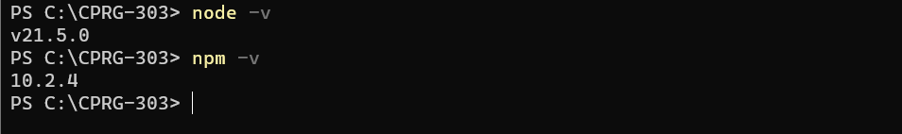

* Step 6: To create app install **expo-cli** package by running the command “**npm install expo-cli –global’.**





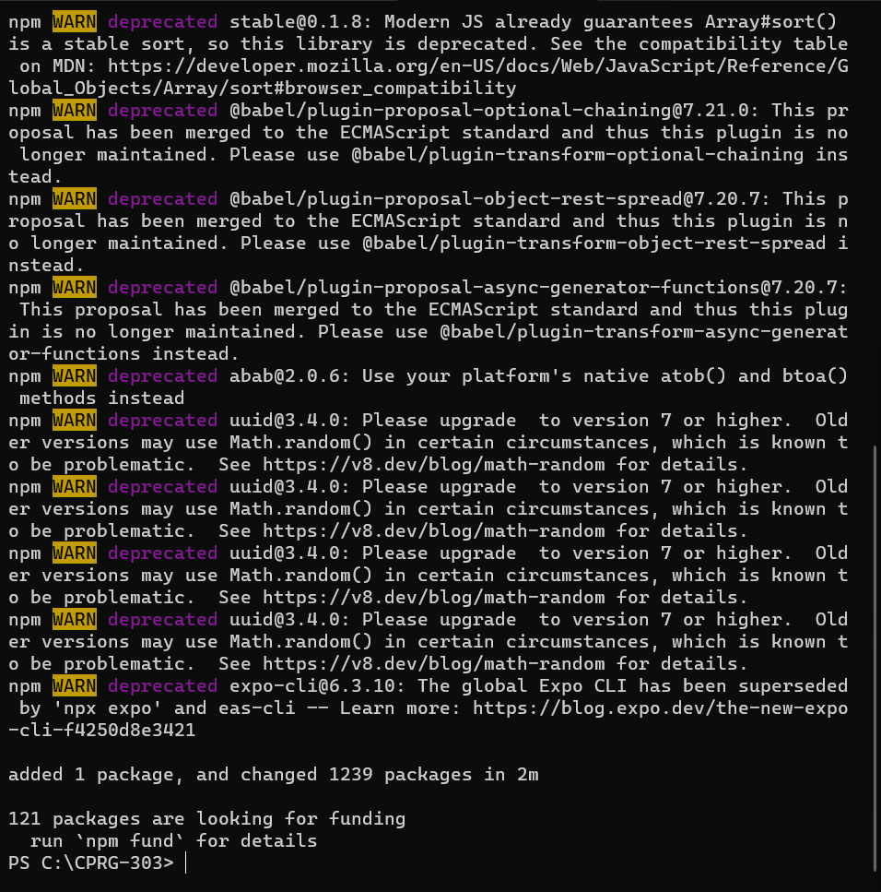

* Step 7: It is now installed and Run command **npx create expo-app “ Project Name**” i.e..”Incredible_To_Do_List ” to create app in desired folder.



* Step 8: Now we are past installation and creation of app. Next step would be running command “npm start” to get the barcode.



* Step 9: Scan the Barcode in your Expo-Go app in your mobile app.

