AIML Assignment – 1

SDG GOALS

Performing various Validation techniques on Dataset “ AIR Quality Check “

**STEP 1**

Deriving the dataset from the Site “ <https://uci.edu/> “

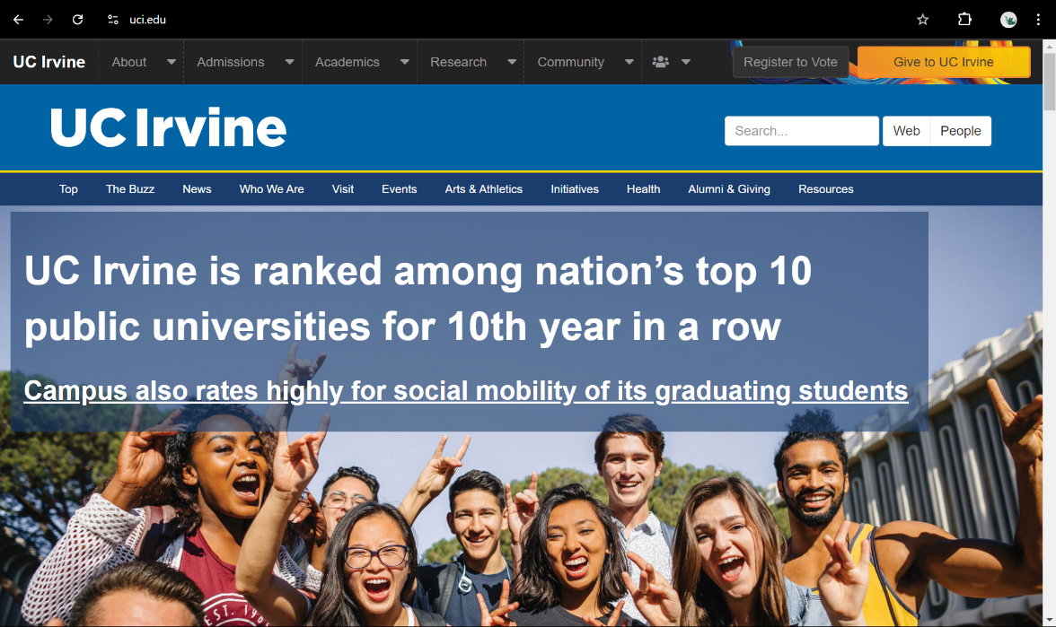

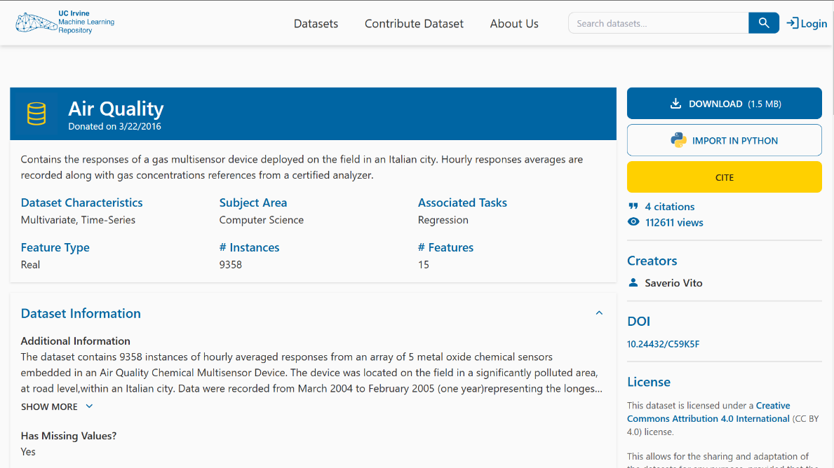

**STEP 2**

Import the Data set in PYTHON

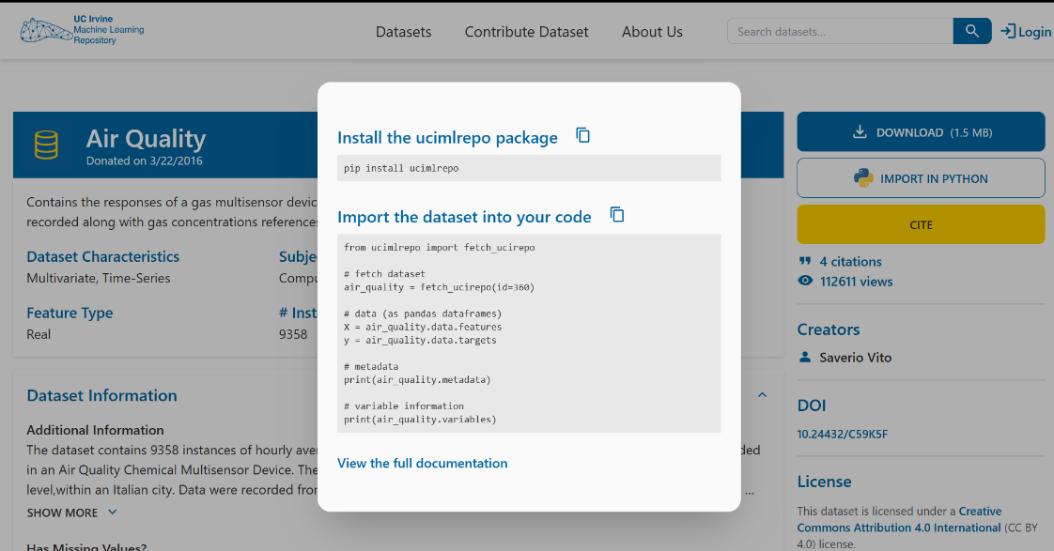

**STEP 3**

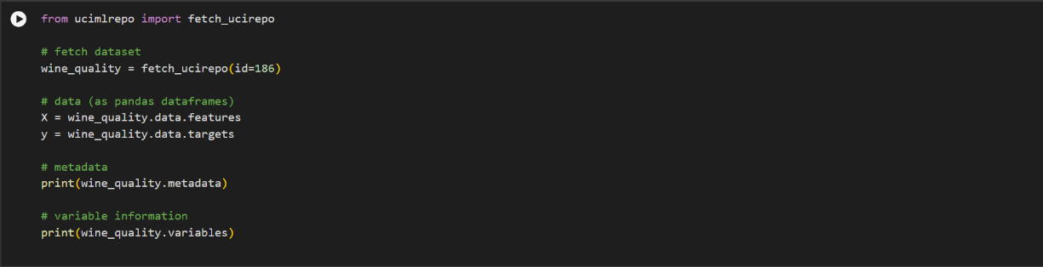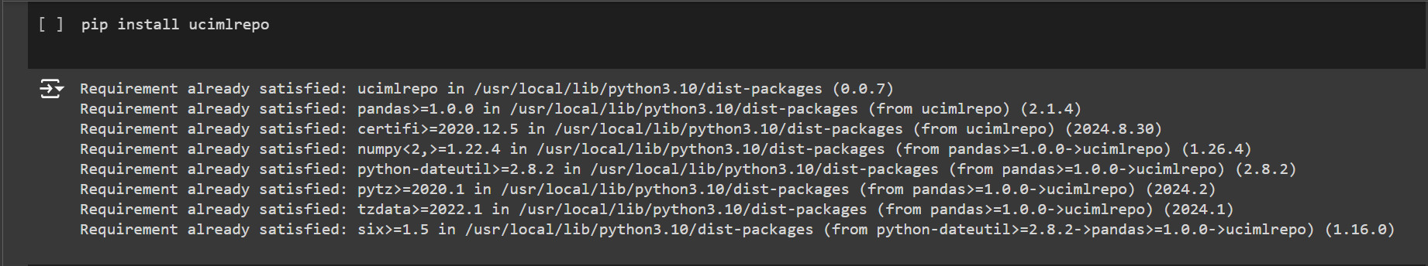Copy the code and run in ‘Google Collab’ file.

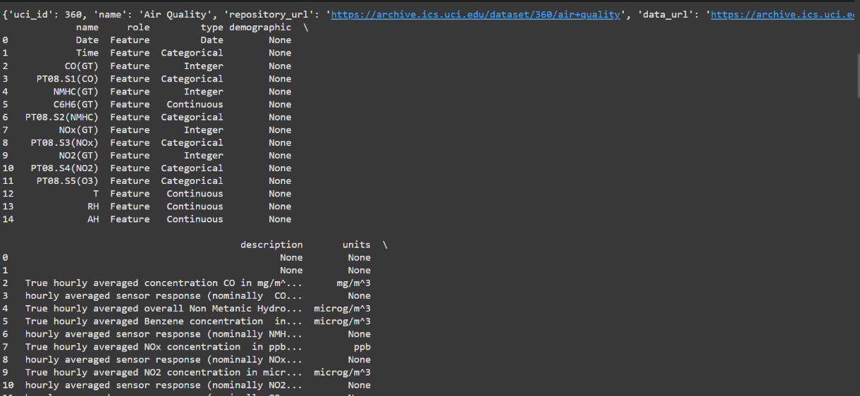**STEP 4**

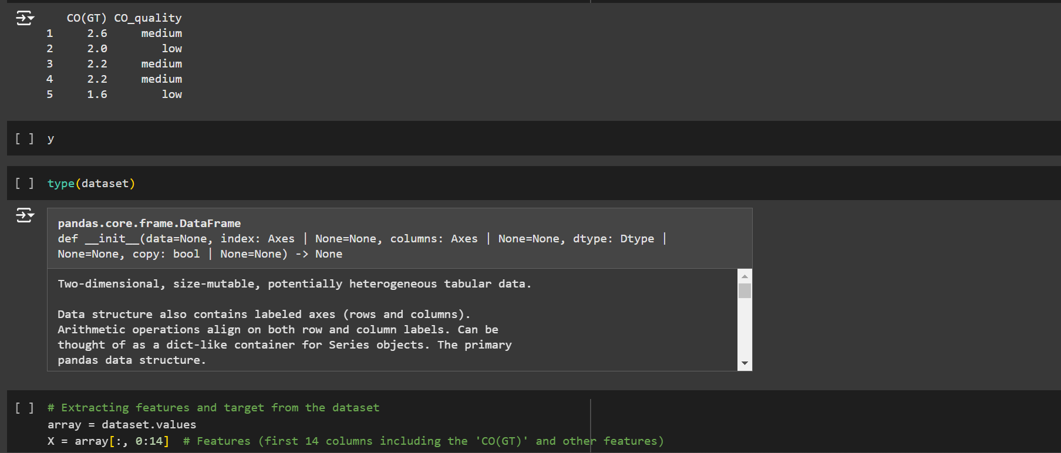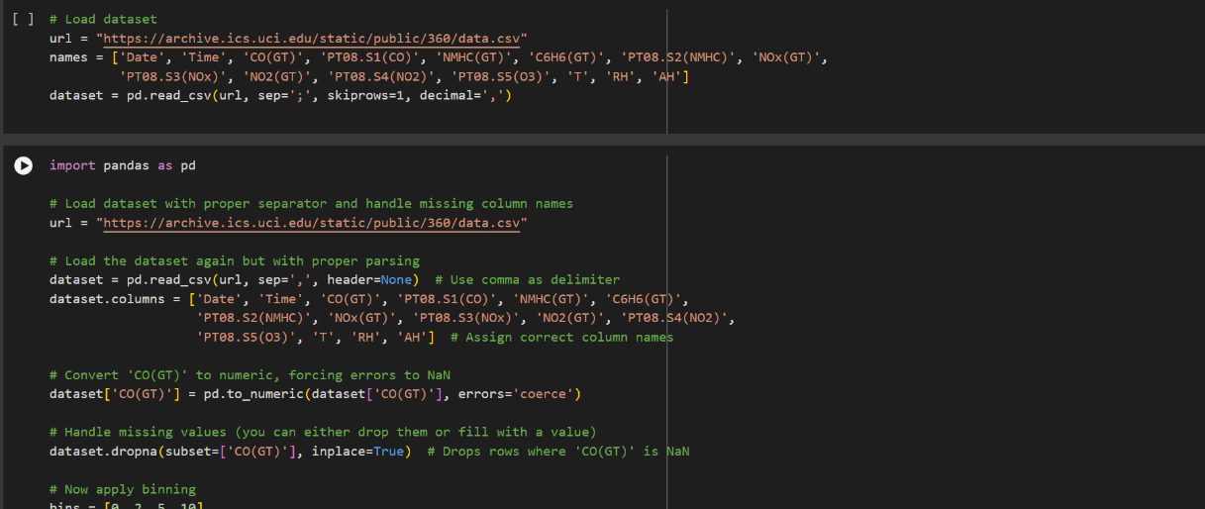Repeat the following tasks and codes to perform the K-Fold Cross Validation on this Dataset.

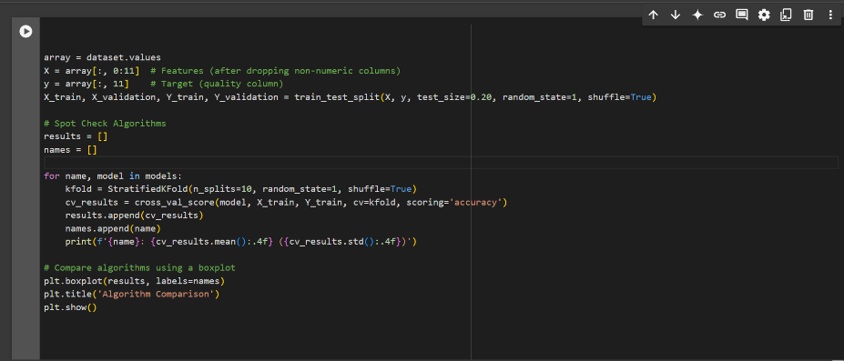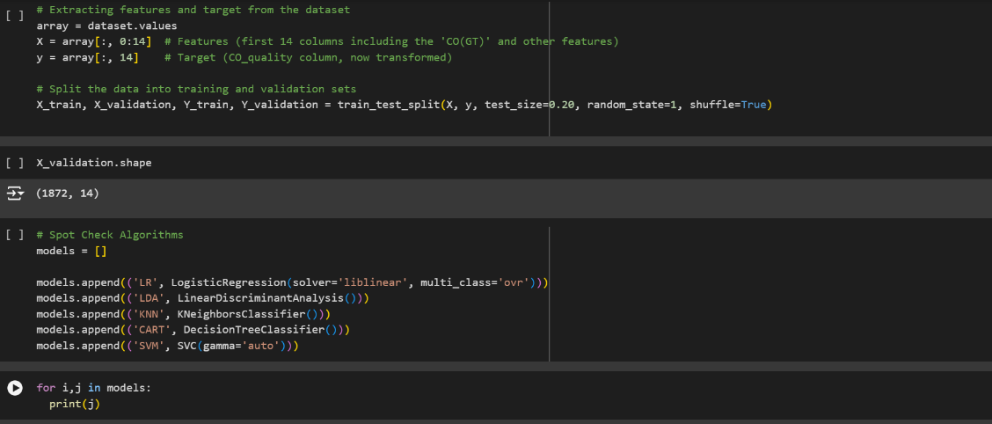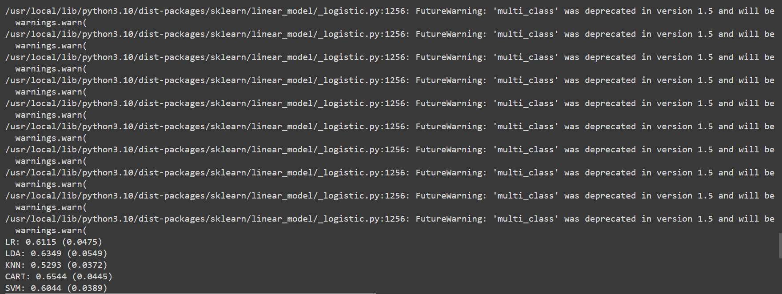NOW THE K FOLD CROSS VALIDATION IS PERFORMED AND OUTPUT WILL BE SHOWN AS BELOW

