CS3235 Course Project — Requirements Document: Third Eye
Working with Large Language Models (LLMs) · Version 1.0 · September 2026

How to use this template
Every team submits one completed copy of this document before building starts. It is the agreement between your team and the instructor on what you will build, how the LLM is used, and how success will be measured.
- Make a copy; do not edit this master version.
- Replace every text in [square brackets] with your own content, then delete the brackets.
- Keep requirement IDs (FR-1, NFR-1, …) — your demo, report and viva will refer back to them.
- Be specific: numbers, model names, dataset names and dates, not adjectives like "fast" or "accurate".
- Anything you have not decided yet goes in the Open questions list at the end, not left blank.
- Cloud deployment (Section 11) is mandatory for every team.
- Suggested length: 6–10 pages. Changes after sign-off need a short note in the Change log.

1. Project overview
Field | Details
Project title | Third Eye
Team ID | [Team ID]
Team members (name, roll no., role) | Aadit Pani — 1RVU23CSE002 — [role, e.g. reasoning lead: spec schema, LLM compiler, checker]  Megh Mavani — 1RVU23CSE260 — [role, e.g. perception lead: calibration, piece matcher, Jenga depth tracker]  Mitul KM — 1RVU23CSE273 — [role, e.g. app lead: FastAPI backend, React UI, cloud deployment]
Faculty mentor | Prof. Manjul K Gupta
Primary course module | 5 — Advanced applications & benchmarking (secondary: 3 — Multimodal; 4 — LLMs in software development)
Version / date | v0.2, 25-09-2026

Problem statement (3–5 sentences): Most mistakes in hands-on procedures are omissions and wrong order, not wrong motions — a skipped check in a lab routine, a step done out of sequence on an assembly line, an illegal move in a game — and usually nobody is watching when they happen. Existing video systems either classify single actions or need a model trained for each task, so every new procedure costs new labelled data. Rule-based checkers need an engineer to hand-code each procedure. There is no system that takes the written instructions people already have and checks a live performance against them.
Why an LLM? The procedure knowledge lives in free text: instruction sheets and rulebooks phrased in everyday language ("never take a block from the top complete layer", "do the border before the middle"). Turning that text into machine-checkable preconditions and step dependencies is a language-understanding problem that rules or classical ML cannot solve for an unseen procedure. The LLM does exactly that, offline and once per procedure, into a strict JSON schema that a validator checks. We deliberately do not use the LLM for the live judgement: a deterministic checker makes every alert, so alerts are fast, repeatable and traceable to a rule. The LLM is used a second time, after the session, to turn the event log into a readable report.
One-line solution summary: "A real-time procedure checker that helps people performing hands-on tasks (a jigsaw, a game of Jenga, and later assembly work) to catch missed, out-of-order and wrong steps as they happen by using an LLM that compiles the written instructions into rules and computer vision that tracks the physical state."

2. Scope and users
In scope — what the finished system will do:
- Compile a plain-text instruction sheet or rulebook with an LLM into a validated procedure spec: an ordered dependency graph (jigsaw) or a constraint set with no fixed order (Jenga).
- Check a jigsaw live with one overhead webcam: identify each piece, its cell and its rotation by matching against the box picture (no detector training), and raise alerts.
- Check a Jenga game live with an iPhone Pro (colour + LiDAR depth) and a second camera: track the 18 × 3 tower lattice, call rule violations and detect a collapse.
- Raise explainable alerts — missed step, out of order, wrong part, wrong position / rotation, removed part, illegal move — each traceable to one rule; low-confidence readings give a yellow warning, never a red alert.
- A web dashboard (deployed on Google Cloud) with the live view, checklist or legality panel, alerts, session history, a replay mode that needs no hardware, and an LLM-written session report.
- An evaluation of compiler accuracy, error-detection precision/recall, false alerts, alert delay and latency, against an end-to-end VLM baseline.
Out of scope — what you are deliberately not building this semester:
- LEGO assembly as a demo procedure — the original plan; its code and tests stay in the repository but it is parked this semester.
- Running perception in the cloud: cameras and CV run on the local demo laptop; only events, alerts and logs go to the cloud.
- Reading picture-only instructions (official LEGO booklets) with a vision model — a stretch goal only.
- Native mobile app, multi-language instructions, several people working at once, a head-mounted (moving) camera, and Jenga physics or stability estimation (we check rule legality, not physics).
Target users
User type | What they need from the system | How they will interact (chat, API, CLI, web UI)
Person doing the procedure (learner, player, trainee) | Immediate, specific feedback when they slip, without false alarms | Web UI live view: checklist / legality panel, red and yellow alerts, ghost of the next placement
Procedure author (instructor, supervisor, us) | Turn an existing instruction sheet or rulebook into checkable rules without writing code | Web UI: paste or upload text → compile → view validator result → edit; CLI for batch compiles
Reviewer (trainer, QA lead, course evaluator) | See what went wrong after a session, with timestamps and consequences | Web UI: session history, alert timeline, LLM session report; replay mode at the public URL

Example user scenario: (1) The author pastes the jigsaw instructions ("Put in the four corners, then the edge pieces, then fill the interior") and clicks Compile; the backend sends the text to Gemini, gets a DAG spec back with three phases, and the validator passes it. (2) The player selects jigsaw_4x3 and presses Start; the laptop's webcam calibrates from the four ArUco markers on the board. (3) The player places the four corners; after each hand leaves the board the piece matcher reads the cell and rotation, and the checklist ticks them off. (4) At t = 11.6 s they drop an interior piece while two edge pieces are still missing: a red alert appears — "Out of order: the instructions finish the corners and the edges before starting on the interior." (5) They finish the border and the interior; one piece is turned 90° and gets a "wrong rotation" alert until they turn it. (6) At the end the session log is saved and the LLM writes a three-line report citing both alerts with timestamps.

3. Functional requirements
List each thing the system must do as one testable statement. Priority uses MoSCoW: Must, Should, Could. Aim for 6–12 requirements, at least 4 of them Must.
ID | Requirement ("The system shall…") | Priority | How it will be verified
FR-1 | The system shall compile a plain-text instruction sheet or rulebook with the LLM into a procedure spec in DAG form (ordered steps, phases, hard/soft dependencies) or constraint form (actions with preconditions and effects, terminal conditions), conforming to the Pydantic JSON schema. (FR-CMP-1…4) | Must | Unit tests with a scripted LLM stand-in; accuracy on the 15–20 manual eval corpus
FR-2 | The system shall validate every spec (schema, dependency cycles, collisions, support, satisfiability), report the failing check and step id, and allow exactly one automatic LLM repair round before a human must intervene. A spec that fails does not run. (FR-CMP-6, 7) | Must | Automated tests (test_validate, test_compile) with seeded faulty specs
FR-3 | The system shall evaluate preconditions only from a fixed predicate vocabulary using an AST interpreter; no Python eval or other arbitrary-code path. (FR-CMP-5) | Must | Code inspection + tests that inject disallowed expressions
FR-4 | The system shall calibrate each camera from four printed ArUco markers to board coordinates, refresh the homography every 10 frames, and report calibration loss instead of emitting wrong coordinates. (FR-CAL-1, 3, 7) | Must | test_calibrate + live demo with a marker covered
FR-5 | The system shall identify each jigsaw piece on the board — its cell and 90° rotation — by matching against the box picture, with no trained detector, and keep the piece-grid world state, emitting ADD / REMOVE events after the hand leaves. | Must | test_pieces (synthetic); placement accuracy on labelled real runs
FR-6 | The checker shall raise missed step, out of order and wrong part alerts, each attributed to one rule or precondition id; an unmet physical (hard) dependency shall never produce a user alert but trigger re-verification. (FR-CHK-1…5, 7, 11) | Must | Scripted replays (jigsaw_missing / early_interior / foreign) + live demo
FR-7 | Every session shall write a timestamped, machine-readable event and alert log from which the alert timeline and the report can be regenerated without video; scripted scenes can be replayed through the same tracker and checker. (FR-CHK-12, IF-LOG-1) | Must | test_session, test_scenarios; replay CLI
FR-8 | The web UI shall show the live view with grid overlay, a checklist (jigsaw) or legality panel (Jenga), and red / yellow alerts with the human-readable rule text, pushed over a WebSocket; it shall be reachable at a public cloud URL. (FR-UI-1…3) | Must | Live demo at the public URL
FR-9 | The checker shall raise wrong position, wrong rotation and removed part alerts, and give a yellow warning (not a red alert) for readings below the confidence threshold. (FR-CHK-6, 9) | Should | Scripted replays (jigsaw_misplaced / rotated) + live demo
FR-10 | The system shall track the Jenga tower as an 18 × 3 slot lattice from iPhone LiDAR colour + depth and a second camera at the opposite corner, and call illegal source layer, layer started early, two-handed move, wrong replacement and collapse. (FR-STA-7, 8, FR-CHK-10) | Should | test_jenga + precision/recall per rule on recorded games
FR-11 | At session end (or on collapse) the system shall send the event log — never video — to the LLM and show a session report citing timestamps, the step and the consequence. (FR-EXP-1, 2) | Should | Manual check of 10 reports against their logs
FR-12 | The web UI shall let an author compile, view, edit and re-validate a spec before a session, and start / stop sessions without editing code or config. (FR-CMP-9, FR-UI-6) | Could | Demo
FR-13 | A step recognizer (generic verbs: grasp, place, adjust, remove, idle) shall be trained and benchmarked on a public procedural-error dataset, as a time-boxed benchmark track off the live path. (FR-TMP-1…6) | Could | Frame accuracy, Edit, F1@{10, 25, 50} on the benchmark

IDs in brackets refer to the detailed specification in Third_Eye_Requirements (v1.0, 18-09-2026), whose IDs are cited in the code and tests.

4. LLM design requirements
This section shows which course concepts your project applies. Fill every row; write "Not used — because …" where a technique does not apply.
Aspect | Your choice | Justification
Base model(s) | Gemini 3.8 Flash (gemini-3.8-flash) on the Gemini API free tier for the compiler and the session report; fallback 1: Claude Sonnet 5 (claude-sonnet-5) on the team’s own API credits; fallback 2: a local open-weight model (Qwen or Llama, 7–8B) via Ollama | Free of charge, with JSON-schema-constrained output; the project needs about 20 calls, well inside the free tier’s daily limits; fits the team’s Google Cloud stack. Claude is the paid fallback if Gemini’s compile accuracy falls short on the eval corpus; the open-weight model covers offline use. All three are compared on the corpus
Access method | Hosted API through the Google Gen AI Python SDK (google-genai), key from Google AI Studio in Secret Manager / untracked .env; Claude fallback through the Anthropic SDK (anthropic ≥ 0.49); local fallback via Ollama | No GPU is needed for the LLM — the local GPU is kept for vision; compiling is offline, so API latency does not matter
Prompting strategy | Zero-shot with a system prompt that gives the rules, the fixed predicate vocabulary and one worked example spec (format only); structured JSON output constrained to the spec schema; one repair prompt listing the validator's exact problems | Schema-constrained output makes missing or invented fields impossible; the validator catches what a schema cannot (cycles, collisions, illegal expressions); one repair round, because a second mostly measures how persuasive the model is
Retrieval (RAG) | No | Not used — because each manual or rulebook is short (under ~2k tokens) and fits in the prompt whole; there is no corpus to retrieve from
Fine-tuning | None | Not used — about 20 calls in total, and schema + validator + repair already meet the targets in early tests; if compiler accuracy on the eval corpus falls short we add few-shot examples first
Agents and tools | No agent framework: a fixed compile → validate → repair loop in plain Python (direct SDK calls); the validator is the one "tool" | The flow is short and deterministic, so a framework adds nothing; the LLM sits behind a one-method interface so the loop is unit-tested without spending calls
Protocols | Not used | Not used — because there is one model and no external tool servers or other agents to connect
Multimodal input | LLM input is text only. Vision is done by CV models: OpenCV ArUco, MediaPipe Hands, box-picture template matching, iPhone LiDAR depth. A VLM (frames + manual) is used only as the evaluation baseline | Keeps alerts fast and traceable, and keeps video out of third-party APIs; the VLM baseline tests whether a single multimodal model could do the job instead
Alignment and safety | LLM output is data, never code: schema-constrained, validated, whitelisted expression vocabulary, no eval. No alert ever comes from the LLM. The report prompt may state only what is in the log; a human can review and edit each spec | Prompt injection through a manual, hallucinated steps or rules, unsupported claims in reports, and blaming the user for our own perception misses

If you fine-tune with LoRA, show the trainable-parameter calculation for one adapted weight matrix of size d × k with rank r:
Trainable parameters = r × (d + k)
Not applicable — Third Eye does not fine-tune the LLM (see Fine-tuning above).
LLM pipeline: Offline: instruction text → system prompt (rules + predicate vocabulary + example) → Gemini 3.8 Flash with JSON-schema output → Pydantic parse → validator (schema, cycles, collisions, support, satisfiability) → one repair round if needed → versioned spec JSON (records compiler version and model). Online, no LLM: camera → calibration → perception → world state → deterministic checker → alerts. After the session: event log (text) → Gemini → session report.

5. Data requirements
List every dataset, document collection or API the project depends on, including test data you will build yourselves.
Dataset / source | Purpose | Size | Format | Licence / permission | Link
Compiler eval corpus (ours) | Compiler accuracy: LLM spec vs hand-written ground truth | 15–20 manuals + truth specs | TXT, JSON | Ours; open release | Repo: manuals/
THIRDEYE-JIGSAW (ours) | Live demo, matcher tuning, error-detection evaluation | 30–40 runs (4 × 3) + 15 runs of an unseen puzzle; ~half with errors | MP4, JSON | Ours; written consent | Team Drive
THIRDEYE-JENGA (ours) | Tower-lattice accuracy, rule-violation evaluation, demo | 20–30 games with planted fouls | RGB-D, JSON | Ours; written consent | Team Drive
Box pictures + instructions | Matcher reference; compiler input | 1 image + 1 text per puzzle | JPG, TXT | Photographed for research use; text ours | —
Jenga rulebook text | Compiler input for the constraint spec | 1 page | TXT | Paraphrased by us (leaflet is copyrighted) | Repo: manuals/
Scripted scenarios (ours) | Regression tests: one scene script per planted error | ~20 scripts, growing | YAML | Ours | Repo: scripts/
Assembly101 | Benchmark for the step recognizer (FR-13) and published baselines | Subset only | Video, labels | Research licence — verify week 1 | assembly-101.github.io
EgoPER | Alternative error-detection benchmark if Assembly101 access is slow | Subset only | Video, labels | Research licence — verify | EgoPER GitHub (robert80203)

- Preprocessing: Recordings trimmed to session length; board images warped by the homography to one square per cell; only the centre of each cell is compared (tabs of neighbours are cropped out); an empty-board photo is taken per session for occupancy. Labels: final state per step and error type per run (from the scenario sheet), plus spot-checked cell labels; depth frames resampled to the lattice.
- Train / test separation: Nothing is fine-tuned, so "training" means tuning matcher thresholds and checker confidence. Tuning uses a fixed dev split of runs; the test split and the unseen puzzle are never used for tuning; splits are frozen before results are reported and never changed after. The compiler corpus manuals are never used as the prompt's example.
- Personal or sensitive data: The camera frames the board or tower, not faces; hands are the only body part in view. Recorded people give written consent (research use, and separately public release). Video stays on the demo laptop and the team drive; the LLM and the cloud receive only text events and logs. API keys live in Secret Manager / an untracked .env, never in git.

6. Non-functional requirements
Give each a measurable target. Delete rows that do not apply.
ID | Category | Requirement | Target
NFR-1 | Latency | Live frame rate and time from a mistake to its alert on screen | ≥ 15 FPS; per-frame critical path ≤ 40 ms; checker < 1 ms per event; median error-to-alert < 2 s
NFR-2 | Cost | LLM API and cloud spend for the whole project | ≈ 20 LLM calls on the Gemini free tier (US$0; < US$5 if the Claude fallback is needed); cloud within the free tier / student credits; ≤ ₹1,000 total
NFR-3 | Hardware | What is needed to run the live demo | One laptop (consumer GPU optional for the jigsaw), one USB webcam, one iPhone Pro with LiDAR + one extra camera; no GPU in the cloud
NFR-4 | Reliability | Behaviour when the LLM, camera, markers or network fail | LLM: retry once, then the Claude fallback, Ollama or the last validated spec; markers lost: freeze state, show "calibration lost", no alerts; network lost: edge keeps judging locally and syncs the log later; ≥ 9 of 10 full sessions without a crash
NFR-5 | Hallucination control | Wrong specs and unsupported report claims | Compiler step accuracy ≥ 0.9, dependency accuracy ≥ 0.8 on the corpus; 0 unvalidated specs run; ≤ 5% of report sentences unsupported by the log
NFR-6 | Safety | Malicious or off-topic manuals and false blame | 100% of injected non-vocabulary expressions rejected; no alert originates from an LLM; ≤ 1.0 false alerts per fully correct run
NFR-7 | Privacy | What user data is logged, stored or sent to third parties | No video leaves the laptop; only text logs go to Firestore / Cloud Storage and text to the LLM API; Gemini free-tier prompts may be used by Google to improve its products, so only instruction text and event logs are sent, never personal data; consent for every recorded person; keys never committed
NFR-8 | Usability | Who can use it without training | A first-time user completes a guided jigsaw using only on-screen information in < 5 min; alerts name the step and the consequence in plain words

7. Evaluation plan and success metrics
The project succeeds if it meets the targets below on a held-out test set. Every Must requirement needs at least one metric.
Metric | What it measures | Method | Baseline | Target | Linked req.
Step / dependency accuracy | Compiler correctness | Diff vs hand-written specs, corpus of 15–20 | No schema, example or repair | ≥ 0.9 / ≥ 0.8 | FR-1, FR-2, NFR-5
Precision at fixed recall, per error type | Errors caught (jigsaw); unseen puzzle target 0.7 / 0.7 | Test-split runs with planted errors | End-to-end VLM (frames + manual) | P ≥ 0.8 at R ≥ 0.8 | FR-6, FR-9
False alerts per correct run | Quietness | Fully correct runs | VLM baseline | ≤ 1.0 | FR-6, NFR-6
Placement accuracy (piece + cell + rotation) | Jigsaw world state | Hand-labelled final state per step | Colour-only matching | ≥ 90% | FR-5
Slot occupancy accuracy; rule P/R | Jenga state and rules | Hand-labelled lattice states; recorded games | Single RGB camera, no depth | ≥ 95%; P, R ≥ 0.8 | FR-10
FPS, per-stage latency, alert delay | Live usability | Timers in the pipeline, 10 sessions | — | See NFR-1 | NFR-1
Report faithfulness | Report claims supported by the log | LLM-as-judge + manual check of 10 reports | — | ≤ 5% unsupported | FR-11, NFR-5
Frame accuracy, Edit, F1@{10, 25, 50} | Step recognition | Benchmark test split | Published MS-TCN++ numbers | Near published | FR-13
User rating | Perceived usefulness of alerts, 1–5 scale | 6+ people outside the team | — | ≥ 4.0 | NFR-8

- Test set: Recorded runs split by person into dev and test; planted errors follow a scenario sheet covering every alert type (skip, early interior, wrong piece, wrong cell, 90° rotation, removed piece; for Jenga each rule). Labels from the scenario sheet, checked by a second team member.
- Standard benchmark (if any): Assembly101 (or EgoPER as fallback) for the step recognizer, because both have step and mistake labels on real procedural video; the compiler corpus is our own benchmark.
- Ablation: LLM-compiled spec vs hand-written spec; with vs without the repair round; with vs without soft (yellow) warnings on the false-alarm rate; RGB-only vs RGB + depth for Jenga; Gemini vs Claude vs local Ollama model on the compiler corpus.

8. Frontend — UI/UX specifications
Item | Your specification
Framework | React 18 + Vite (TypeScript); Streamlit only for early internal views
Styling / component library | Tailwind CSS + shadcn/ui
Target devices | Desktop browser for the live view (≥ 1280 px); mobile browser for history and reports (≥ 360 px)
Response display | Overlays, checklist and alerts streamed over a WebSocket every frame; compile and report show a progress indicator, then the full result
Error and empty states | Banners for "edge node offline", "calibration lost — markers hidden" (yellow, alerts paused), "compile failed" with the validator's problems and a Retry repair button; empty history shows "No sessions yet — start one or open a replay"
Accessibility | Alerts use icon + text + colour (never colour alone); keyboard shortcuts for start / stop; WCAG AA contrast; alt text on overlays
Design tool / wireframes link | Excalidraw — [URL]; mock-up of the live screen below

Screens
Screen | Purpose | Key UI elements | Linked req.
Login | Authenticate team and evaluators | Google sign-in (Firebase Auth) | FR-8
Procedures | Compile and manage specs | Instruction text box / upload, Compile button, validator result, spec viewer and editor | FR-1, FR-2, FR-12
Live session | Main interaction while someone works | Video with grid overlay, checklist or Jenga legality panel, red / yellow alert list, start / stop | FR-6, FR-8, FR-9
History / report | Review past sessions | Session list, alert timeline, LLM report, replay button | FR-7, FR-11

User flow: Sign in → Procedures: pick a spec or paste instructions and compile → Live session: choose the source (live edge node or replay), press Start → alerts and checklist update as the person works; each alert shows its rule text → Stop → History: the timeline and the LLM report.
Wireframes: Live session screen (jigsaw); the Jenga version replaces the checklist with the legality panel.
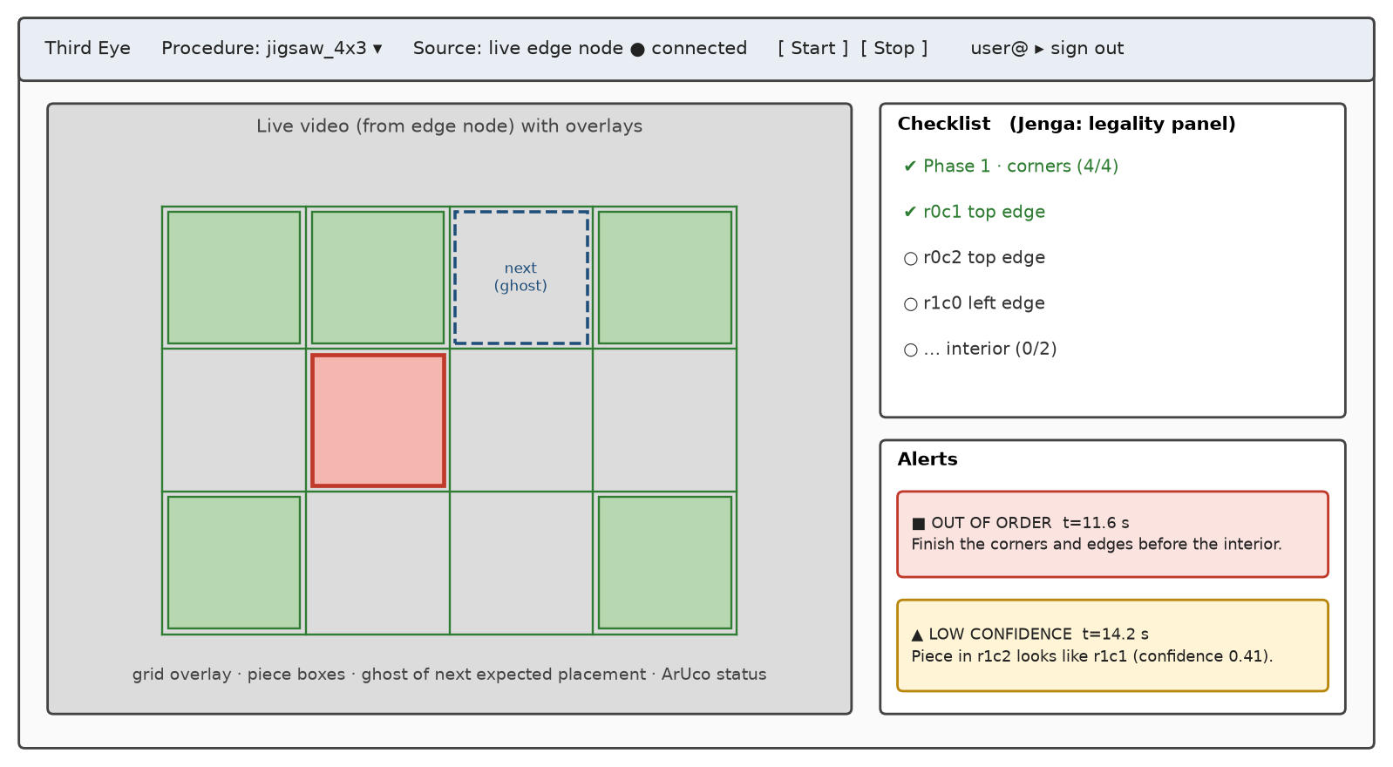

9. Backend specifications
Item | Your specification | Version
Language | Python | 3.11
Web framework | FastAPI + Uvicorn, WebSockets | FastAPI ≥ 0.110, Uvicorn ≥ 0.29
LLM orchestration | Direct SDK calls behind a one-method interface; Pydantic for the spec schema | google-genai; anthropic ≥ 0.49 (fallback); pydantic ≥ 2.6
Model serving | Hosted API (Gemini API free tier, Gemini 3.8 Flash); Claude Sonnet 5 and local Ollama as fallbacks | gemini-3.8-flash
Relational / document DB | Firestore — users, spec metadata, sessions, alerts | Native mode
Vector DB | None — no retrieval is used | —
Cache / queue | None — compile and report are single short calls | —
File / object storage | Google Cloud Storage — spec JSON, session logs, box reference images | —
Authentication | Firebase Auth (Google sign-in) for users; ID tokens verified in FastAPI; a per-device token for the edge node | firebase-admin ≥ 6
Secrets management | Google Secret Manager injected as Cloud Run env vars; locally an untracked .env loaded with python-dotenv; never in the Git repo | —

API endpoints
Method | Endpoint | Purpose | Request → Response | Auth
POST | /api/specs/compile | Compile instruction text into a validated spec | {text, kind: dag | constraints} → {spec_id, spec, problems: list, repaired: bool} | Yes
GET | /api/specs/{id} | Fetch a spec (the edge node pulls it before a session) | — → {spec} | Yes
POST | /api/sessions | Start a session | {spec_id, source: live | replay} → {session_id, ws_url} | Yes
WS | /ws/sessions/{id} | Edge node pushes events and alerts; browsers receive overlays, checklist, alerts | JSON messages {t, type, payload} (versioned schema) | Yes
POST | /api/sessions/{id}/replay | Run a scripted scene through the tracker and checker in the cloud | scenario YAML → {alerts: list, log_url} | Yes
POST | /api/sessions/{id}/report | Generate the LLM session report from the log | — → {report_markdown} | Yes
GET | /api/health | Health check for deployment | — → {status: ok, version} | No

Database schema: users {uid, name, role}; specs {id, procedure, kind, state_model, compiler_version, model, created_by, gcs_uri, valid}; sessions {id, spec_id, source, started_at, ended_at, steps_done, alert_count, log_uri, report}; sessions/{id}/alerts {t, kind, rule_id, violation, severity: red | yellow, step, text}.

10. Architecture diagram
The diagram shows every component, the Google Cloud service it runs on, the numbered flow of one run, and where authentication and secrets sit (yellow boxes).
Your diagram must show:
- Every component: frontend, backend API, LLM (hosted or self-hosted), vector DB, main DB, object storage, external tools/APIs
- The cloud provider and service each component runs on (e.g. "FastAPI on Cloud Run")
- Data flow arrows for one request, numbered in order
- Where authentication and secrets sit
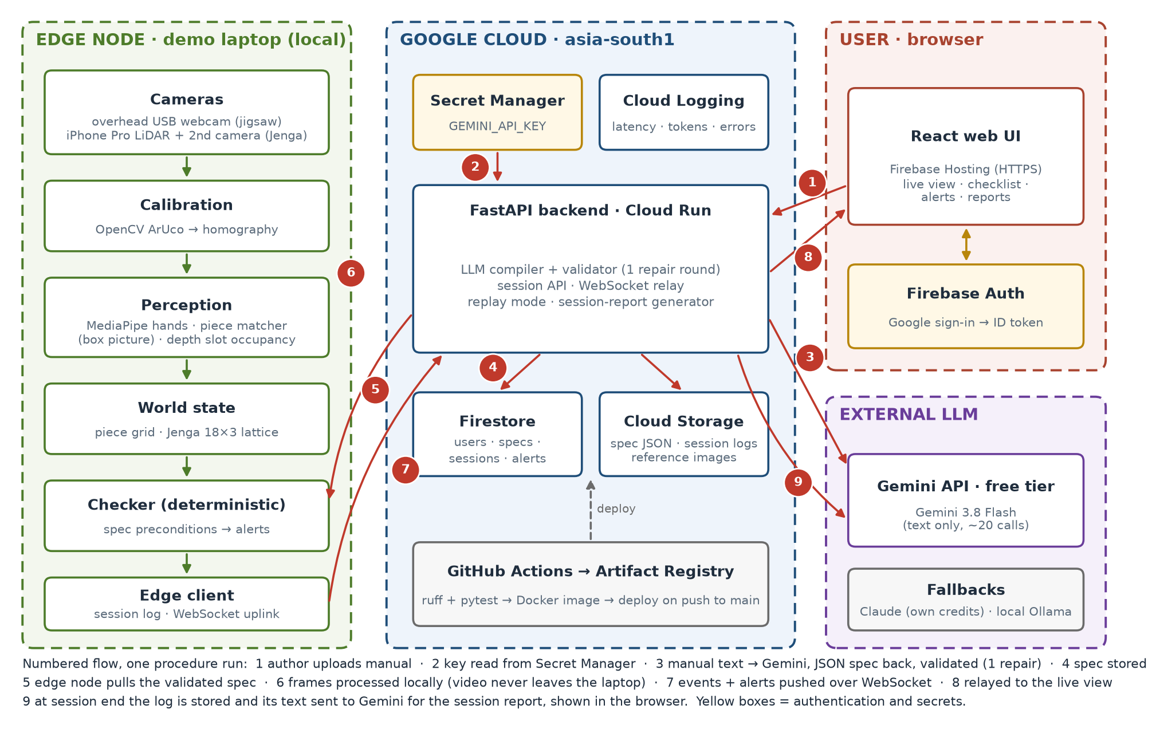

Figure 1 — Third Eye architecture. The numbers trace one procedure run, from compiling the instructions to the session report.
Component description:
Cameras + calibration (edge) — overhead webcam and iPhone LiDAR; ArUco homography maps pixels to board cells so every later stage works in board coordinates.
Perception + world state (edge) — MediaPipe hands, box-picture piece matcher, depth slot occupancy; piece-grid or Jenga-lattice tracker emits ADD / REMOVE events after the hand leaves.
Checker (edge) — deterministic engine running the spec's preconditions; runs locally so alerts stay under 2 s and work without internet.
FastAPI on Cloud Run — compiler + validator, session API, WebSocket relay, replay and report; scales to zero so it costs nothing when idle.
Firestore + Cloud Storage — metadata and alerts; spec JSON and logs. Serverless, inside the free tier.
Secret Manager + Firebase Auth — API key outside the code; Google sign-in for users.
Gemini API, free tier (Gemini 3.8 Flash) — compile and report only, text only; Claude Sonnet 5 (own credits) and local Ollama as fallbacks.
React UI on Firebase Hosting — free HTTPS hosting, same project as Auth.

11. Cloud hosting and deployment (mandatory)
Every project must be deployed on a public cloud and reachable by a public URL for the final demo. A laptop-only or Colab-only demo does not meet this requirement.
Item | Your specification
Cloud provider | Google Cloud (region asia-south1, Mumbai) + Firebase
Free tier / credits used | GCP free tier (Cloud Run, Firestore, Cloud Storage) + Google Cloud education or new-account credits — to confirm; budget alert at ₹500
Frontend hosting | Firebase Hosting
Backend hosting | Cloud Run (FastAPI container), min instances 0; 1 during the demo to avoid cold start
LLM hosting | Hosted API (Gemini API, free tier; Claude as paid fallback); no GPU instance
Managed databases | Firestore (native mode); Cloud Storage bucket for specs and logs
Containerisation | Dockerfile in the repo, base image python:3.11-slim; installs only core + llm + server extras (no torch in the cloud image)
CI/CD | GitHub Actions: ruff + pytest on every push / PR → build image → push to Artifact Registry → deploy to Cloud Run on push to main (Workload Identity Federation, no JSON keys); firebase deploy for the UI
Environment config & secrets | Secret Manager (GEMINI_API_KEY, ANTHROPIC_API_KEY for the fallback, edge device token) mounted as env vars; non-secret config in env vars; nothing committed
Domain and HTTPS | Provider URLs (*.run.app, *.web.app) with Google-managed TLS certificates
Monitoring and logging (LLMOps) | Cloud Logging + Cloud Monitoring: structured log per LLM call (model, tokens, latency, validation result, repaired or not); per-stage latency and FPS sent by the edge node; error-rate alert
Estimated monthly cost | ≈ ₹0–200 per month at demo load (free tiers, scale to zero) + US$0 of LLM calls on the Gemini free tier (< US$5 if the Claude fallback is used); budget alert keeps it within credits
Public demo URL | https://… — to be filled after deployment

Deployment steps:
1. gcloud projects create; enable Cloud Run, Firestore, Secret Manager, Artifact Registry.
2. Store the key: gcloud secrets create gemini-api-key --data-file=-.
3. Push to main — GitHub Actions tests, builds and deploys the Cloud Run service (or run gcloud run deploy thirdeye-api --source . once by hand).
4. cd ui && npm ci && npm run build && firebase deploy --only hosting.
5. On the demo laptop: uv pip install -e ".[live]", set THIRDEYE_API_URL and the device token, run python -m thirdeye.live --spec <id>.
6. Check GET /api/health, then open the public URL and run a replay.
Shutdown plan: Within one week after final evaluation: set Cloud Run to 0 instances and delete the service, export and delete Firestore and the bucket (logs archived to the team drive), delete the secret and revoke the API key, then shut down the GCP project; the budget alert stays on until then.

12. Risks and mitigation
Risk | Likelihood (L/M/H) | Impact (L/M/H) | Mitigation / fallback
Piece-matcher thresholds, tuned on synthetic images, fail on real photos (lighting, glare) | H | H | Collect real photos in week 3; lighting-robust features (normalised correlation, Lab chroma); empty-board photo per session; manual cell-click fallback
Look-alike pieces (plain sky) confused | H | M | Confidence = best vs runner-up gap, so these give yellow warnings only; choose a textured puzzle
Hands block the view while placing | H | M | Freeze state while a hand is over the board; accept a placement only after the hand leaves and the piece is still ≈ 0.5 s
iPhone LiDAR streaming (Record3D) is hard to integrate or too slow | M | H | Fallback: two plain webcams at opposite corners, RGB-only occupancy; Jenga stays Should, not Must
Jenga lattice code assumes face-on views; rig uses diagonal corners | M | M | Add a diagonal mode (two faces per camera); else mount the cameras face-on
LLM specs wrong or hallucinated | L | H | Schema output + validator + one repair; human review / edit; hand-written spec fallback; measured on the corpus
No internet or API outage on demo day | M | M | Specs compiled in advance and stored; edge judges fully offline; Claude and Ollama fallbacks; cloud replay as backup
Cloud cost overrun | L | M | Scale to zero, budget alert at ₹500, shutdown plan
Scope creep: Jenga sinks the jigsaw must-haves | M | H | Go / no-go gate in week 9; Jenga never promoted to Must
Benchmark access (Assembly101 / EgoPER) slow or denied | M | L | Step recognizer is a Could; our own data carries the evaluation
Jenga tower collapses mid-game | H | L | Treated as a terminal event and logged, not a failure

13. Timeline and milestones
Week | Milestone | Deliverable | Owner
1–2 | Requirements approved | This document, signed off (already built: compiler + validator, checker, jigsaw tracker + matcher, Jenga lattice, replay; 267 tests pass) | Reasoning lead
3–5 | Data ready, baseline running | Real jigsaw photos + matcher tuned; eval corpus committed; first recorded runs; compiler accuracy and VLM baseline numbers | Perception, eval
6–9 | Core pipeline + first cloud deployment | Jigsaw live loop end to end; FastAPI + React on Cloud Run / Firebase; latency measured; week 9 Jenga go / no-go with LiDAR rig | App, perception
10–12 | Evaluation and improvement | Splits frozen; metrics table filled; Jenga rules live if green; LLM report; UI polish | Eval lead
13–14 | Final submission (week 13 is reserved slack) | Live cloud demo URL, report, code, slides, demo video | All

14. Final deliverables
- Source code in a public or instructor-shared GitHub repo with a README and setup steps
- Working demo on the deployed public cloud URL (5–7 minutes), plus a backup recording
- Final report with evaluation results mapped to FR/NFR IDs
- Presentation slides
- Individual contribution statement from each member

15. Open questions
- Team ID, and each member’s role (three members, so evaluation duties are shared) — team lead, before sign-off.
- Is a hybrid deployment (cameras and CV on a local edge laptop, backend + UI on Google Cloud, plus a cloud replay mode) acceptable for Section 11? — team lead with the instructor, week 2.
- Primary course module: 5 (advanced apps & benchmarking) or 3 (multimodal)? — with the mentor, week 2.
- Cloud credits: GCP education credits available, or free tier only? — app lead, week 3.
- Which puzzle(s): the 4 × 3 test puzzle plus which real puzzle, and which unseen puzzle for the generality test? — perception lead, week 3.
- Jenga hardware: iPhone Pro availability, Record3D licence, second camera model — perception lead, week 4.
- Keep the step recognizer (FR-13) after the pivot, or drop it? — team, week 5.
- Course review dates, to align the timeline and the week-9 Jenga gate — team lead, week 2.

16. Change log
Date | Version | Change | Reason
18-09-2026 | v0.1 | Plan + detailed requirements v1.0: LEGO must-have, Jenga generality demo | Initial version
23-09-2026 | v0.2 | Demos changed to jigsaw + Jenga (LiDAR); LEGO parked | More general; no LEGO rig needed
25-09-2026 | v0.2 | Moved into the CS3235 template; cloud, frontend, backend sections added | Course template

17. Sign-off
Role | Name | Signature | Date
Team lead
Faculty mentor

