MD2201: Data Science

Name of the student: Aaditya M. Patil Roll No. 58

Div: CS-C Batch: 3

Date of performance:

Experiment No.1

Title: Laboratory on Data Visualization
Aim: i. To explore the dataset for different case study examples with different commands.
ii. To plot the Box plot and scatter plot.

Software used: Programming language R.

Code Statement:
- Write a single R code to display the answers for the following questions.

Case Study: Consider the “pollutant” data set.

- What is the mean of “Temp” when “Month” is equal to 6?
- How many observations are there in the given data?
- Print last two rows of the data.
- What is the value of Ozone in 47th row?
- How many values are missing in Ozone column?
- What is the mean of Ozone column excluding missing values?
- Extract the subset of rows of the data frame where Ozone values are above 31 and Temp values are above 90. What is the mean of Solar.R in this subset?
- What was the maximum ozone value in the month of May (i.e. Month is equal to 5)?

- Write a single R code to display the answers the following questions

Case Study: Hair Eye color Data set

- How many people have brown eye color?
- How many people have Blonde hair?
- How many Brown haired people have Black eyes?
- What is the percentage of people with Green eyes?
- What percentage of people have red hair and Blue eyes?

- Write a single R code to display the answers for the following questions

Case study: Germination Data Set

- What is the average number of seeds germinated for the uncovered boxes with level of watering equal to 4?
- What is the median value for the data covered boxes?

Establish conclusions on the basis of available data and write them in the conclusion part.
a. Association of levels of watering with the number of germinating seeds in case of covered boxes as well as uncovered boxes.
b. Association of number of germinating seeds with the fact that the boxes were covered or uncovered.

- Write a single R code :
- To display the Boxplot for sepal length of iris data set as shown below
- To display the Scatter plot for murders data set present in “dslabs” package as shown below.

Give proper title, x,y axis label etc. to each plot.

Expected Boxplot:
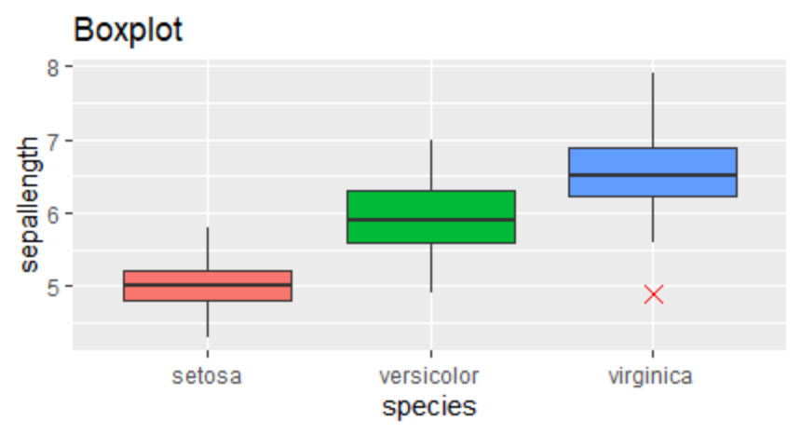

Expected Scatter Plot:
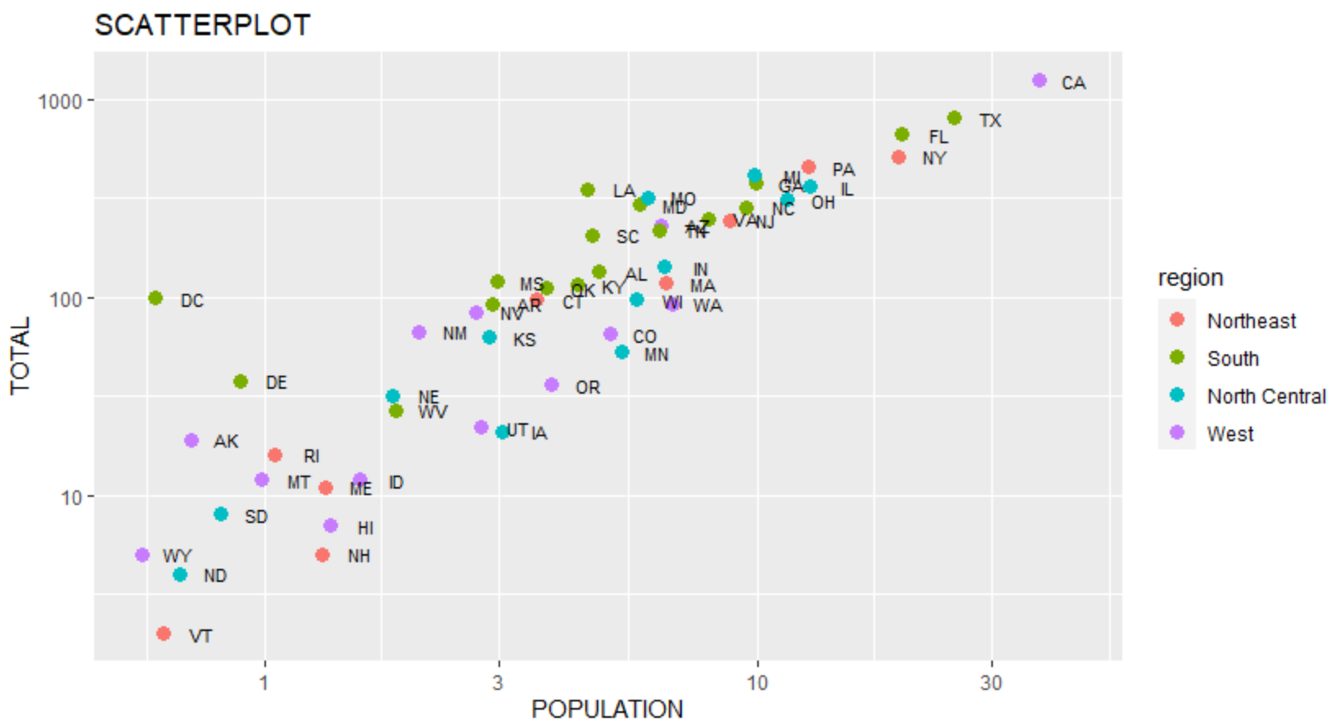
Code:
#Pollutant data ----
f<-read.csv("Dataset_pollutant_csv.csv")
m<-mean(f$Temp[f$Month == 6])
cat("\nMean of temperature when month is 6: ",m)
n<-nrow(f)
cat("\nNo. of observations are: ",n)
t<-tail(f,2)
print(t)
oz<-f$Ozone[47]
cat("\nThe value of ozone at 47 row is: ",oz)
nas<-sum(is.na(f$Ozone))
cat("\nThe number of missing values is: ",nas)
me<-mean(f$Ozone,na.rm = T)
cat("\nThe mean of ozone values not counting the missing values: ",me)
ms<-mean(f$Solar.R[f$Ozone > 31 & f$Temp > 90],na.rm = T)
cat("\nThe subset of rows of the data frame where Ozone values are above 31 and Temp values are above 90 are: ",ms)
mx<-max(f$Ozone[f$Month == 5],na.rm = T)
cat("\nThe maximum ozone value in the month of May: ",mx)

#hair eye color Data set
f1<-read.csv("Datset_haireyecolor.csv")
n <- nrow(f1)
b<- sum(f1$Eye.Color == "Brown")
cat("\nThe number of people with brown eyes are: ",b)
h<-sum(f1$Hair.Color == "Blonde")
cat("\nThe number of people with blonde hair: ",h)
bh_be <- sum(f1$Hair.Color == "Brown" & f1$Eye.Color == "Black")
cat("\nThe people with brown hair with black eyes are: ",bh_be)
g <-sum(f1$Eye.Color == "Green")*100/n
cat("\nthe percentage of people with green eyes: ",g,"%")
r<- sum(f1$Hair.Color == "Red" & f1$Eye.Color == "Blue")*100/n
cat("\npercentage of people with red hair color and blue eyes: ",r,"%")

#germination
f2<-read.csv("Dataset_germination.csv")
n1<-sum(f2$water_amt == 4 & f2$Box == "Uncovered")
avg_seed <- sum(f2$germinated[f2$Box == "Uncovered" & f2$water_amt == 4])/n1
cat("The average of germinated seeds: ",avg_seed)
h<-median(f2$germinated[f2$Box=="Covered"])
cat("\nThe median value for the data covered boxes=",h)

#boxplot
library(ggplot2)
p<-ggplot(iris,aes(Sepal.Length,Species,fill=Species))+geom_boxplot(outlier.shape = 4,outlier.size=3,outlier.color = "red")+theme(legend.position="none")+labs(title = "BOXPLOT",x="Sepal Length",y="Species")+coord_flip()
print(p)

#scatterplot
library(dslabs)
g<-ggplot(murders,aes(population/10^6,total))+geom_point(aes(col=region))+scale_x_log10()+scale_y_log10()+geom_text(aes(label=abb),size=3,nudge_x = 0.02)+labs(title = "SCATTERPLOT",x="POPULATION",y="TOTAL")
print(g)

Results:
Mean of temperature when month is 6: 79.1
No. of observations are: 153 Ozone Solar.R Wind Temp Month Day
152 18 131 8.0 76 9 29
153 20 223 11.5 68 9 30

The value of ozone at 47 row is: 21
The number of missing values is: 37
The mean of ozone values not counting the missing values: 42.12931
The subset of rows of the data frame where Ozone values are above 31 and Temp values are above 90 are: 212.8
The maximum ozone value in the month of May: 115
The number of people with brown eyes are: 10
The number of people with blonde hair: 6
The people with brown hair with black eyes are: 2
the percentage of people with green eyes: 10 %
percentage of people with red hair color and blue eyes: 5 %The average of germinated seeds: 78
The median value for the data covered boxes= 45

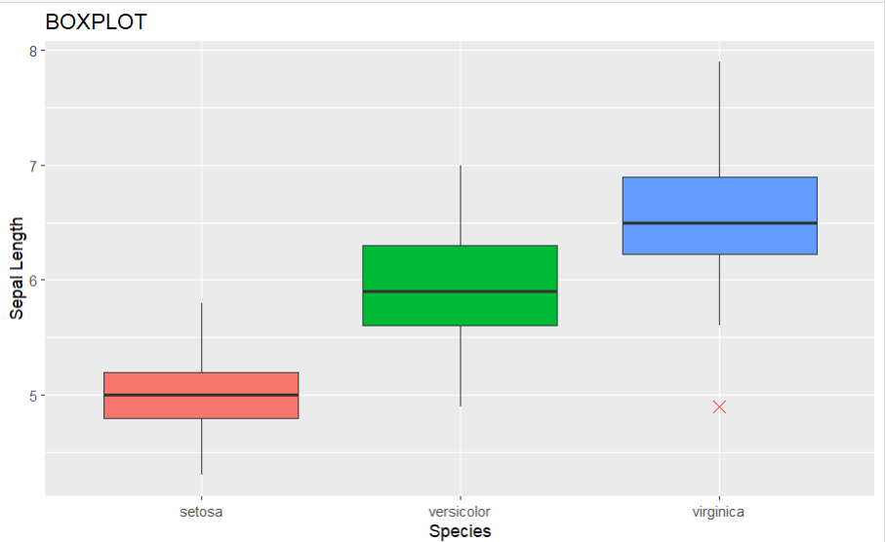

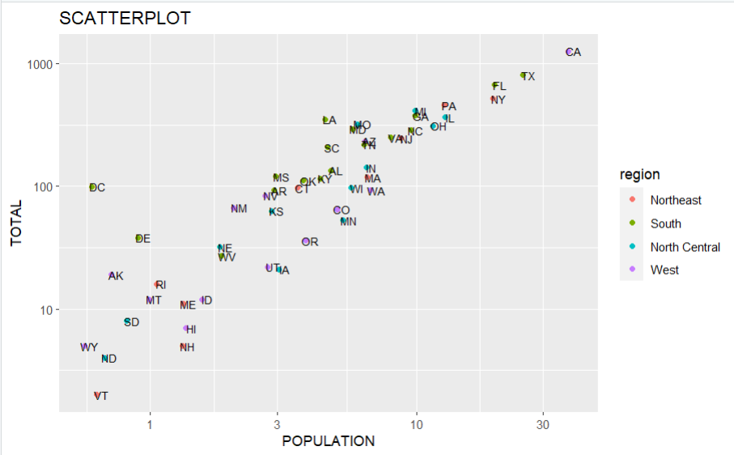

Conclusion: In this experiment we learnt how to read the dataset to calculate the mean, median, find the maximum/minimum, find the number of entries of a specific entry used the library ggplot2() to plot the boxplot and the scatterplot of the different datasets .

