**Aaditya M Patil, 58, 12210643**

**Object-Oriented Programming Assignment 3.**

**CODE**

import java.util.Scanner;

class Shape {

    // Method to calculate the area of a triangle

    public double calculateArea(double base, double height) {

        return 0.5 * base * height;

    }

    // Method to calculate the area of a square

    public double calculateArea(double side) {

        return side * side;

    }

    // Method to calculate the area of a circle

    public double calculateArea(double radius, String shape) {

        if (shape.equalsIgnoreCase("circle")) {

            return Math.PI * radius * radius;

        } else {

            return -1; // Invalid shape

        }

    }

}

public class Assignment3 {

    public static void main(String[] args) {

        Scanner scanner = new Scanner(System.in);

        Shape shape = new Shape();

        System.out.println("Choose a shape: ");

        System.out.println("1. Triangle");

        System.out.println("2. Square");

        System.out.println("3. Circle");

        int choice = scanner.nextInt();

        switch (choice) {

            case 1:

                System.out.print("Enter base length of triangle: ");

                double base = scanner.nextDouble();

                System.out.print("Enter height of triangle: ");

                double height = scanner.nextDouble();

                double triangleArea = shape.calculateArea(base, height);

                System.out.println("Area of triangle: " + triangleArea);

                break;

            case 2:

                System.out.print("Enter side length of square: ");

                double side = scanner.nextDouble();

                double squareArea = shape.calculateArea(side);

                System.out.println("Area of square: " + squareArea);

                break;

            case 3:

                System.out.print("Enter radius of circle: ");

                double radius = scanner.nextDouble();

                double circleArea = shape.calculateArea(radius, "circle");

                System.out.println("Area of circle: " + circleArea);

                break;

            default:

                System.out.println("Invalid choice");

        }

    }

}

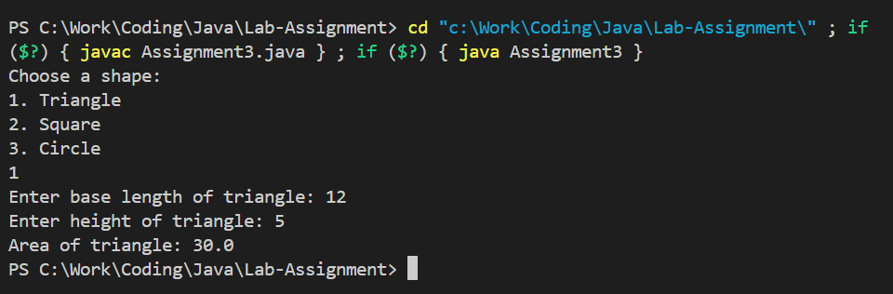**Output**