# Bansilal Ramnath Agarwal Charitable Trust’s

Vishwakarma Institute of Technology, Pune-37

*(An autonomous Institute of Savitribai Phule Pune University)*

**Department of Multidisciplinary Engineering**

|  |  |
| --- | --- |
| **Roll. No** | 58 |
| **Name** | Aaditya M. Patil |
| **Division** | C |
| **Batch** | 3 |
| **GR. No** | 12210643 |

**Assignment No. 5**

**Title:** Execute DDL statements which demonstrate the use of views. Try to update the base table using its corresponding view. Also consider restrictions on updatable views and perform view creation from multiple tables.

**Description:**

1. **View:** Views in SQL are kind of virtual tables. A view also has rows and columns as they are in a real table in the database. We can create a view by selecting fields from one or more tables present in the database. A View can either have all the rows of a table or specific rows based on certain condition.
2. **Syntax to create view from a single table: CREATE** **VIEW** View_Name **AS**

**SELECT** Column_Name1, Column_Name2, ....., Column_NameN

**FROM** Table_Name

**WHERE** condition;

1. **Syntax to create view from multiple tables: CREATE** **VIEW** View_Name **AS**

**SELECT** Table_Name1.Column_Name1, Table_Name1.Column_Name2, Table_Name2.Column_Name2, ....., Table_NameN.Column_NameN

**FROM** Table_Name1, Table_Name2, ....., Table_NameN

**WHERE** condition;

1. **Syntax to update a view:**

**CREATE** OR REPLACE **VIEW** View_Name **AS**

**SELECT** Column_Name1, Column_Name2, ....., Column_NameN

**FROM** Table_Name

**WHERE** condition;

1. **Syntax to drop a view:**

**DROP** **VIEW** View_Name;

1. **Uses of a View :**  
   A good database should contain views due to the given reasons:
2. **Hiding data complexity –**  
   A view can hide the complexity that exists in a multiple table join.
3. **Simplify commands for the user –**  
   Views allows the user to select information from multiple tables without requiring the users to actually know how to perform a join.
4. **Store complex queries –**  
   Views can be used to store complex queries.
5. **Rename Columns –**  
   Views can also be used to rename the columns without affecting the base tables provided the number of columns in view must match the number of columns specified in select statement. Thus, renaming helps to hide the names of the columns of the base tables.
6. **Multiple view facility –**  
   Different views can be created on the same table for different users.

**Screenshots/Output:**

Created First table :

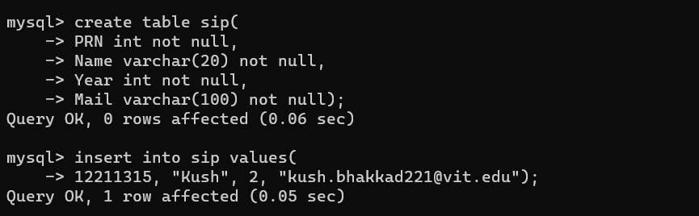 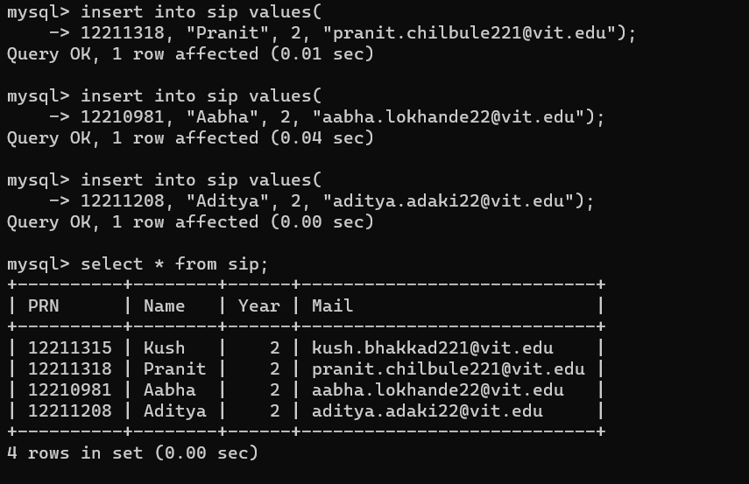

Created second table:

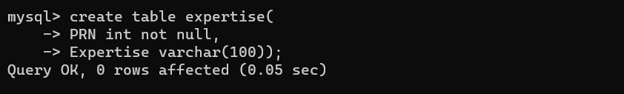 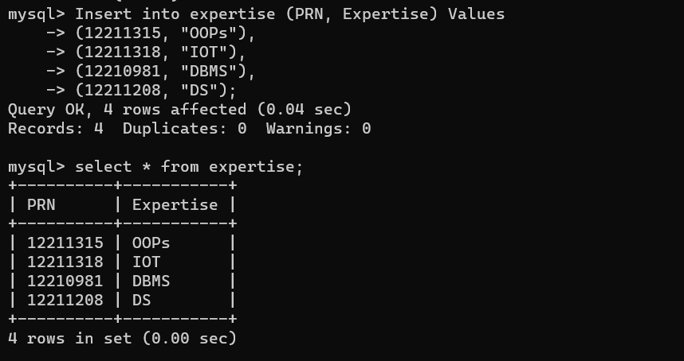

Created Simple view from single table:

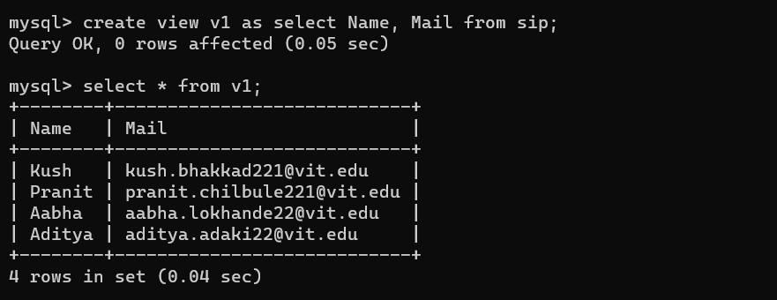

Created Simple view with order by clause:

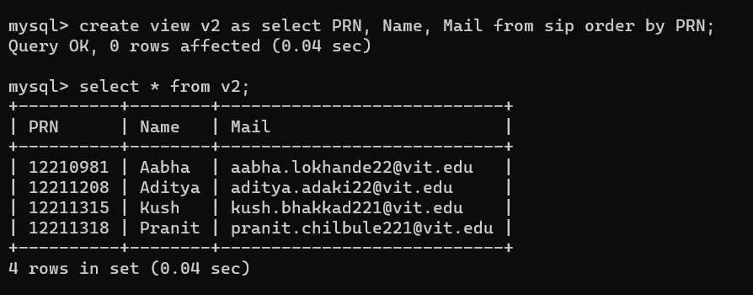

Created view from multiple tables:

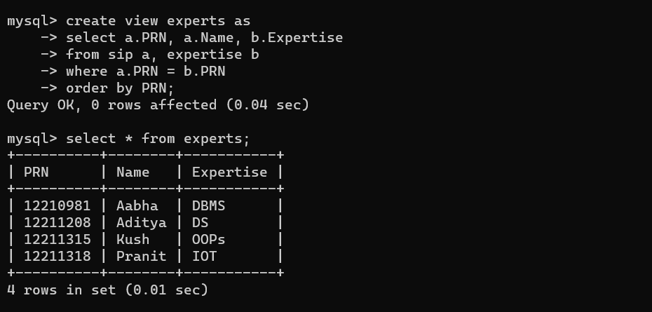

Updated view: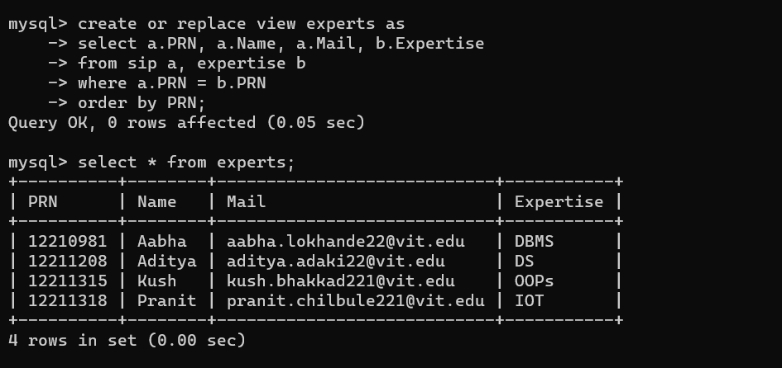

Deleted a row from view:

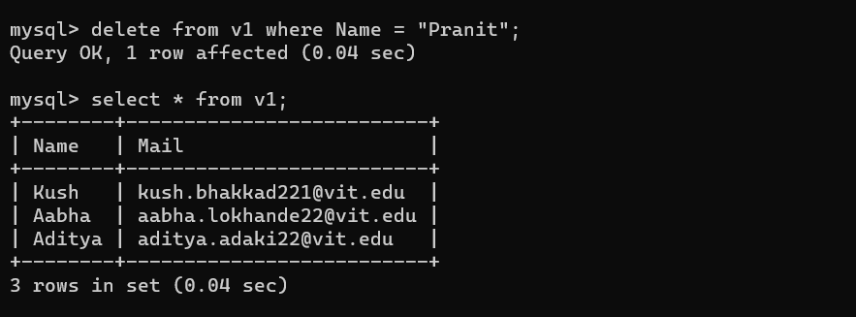

Inserted row in a simple view:

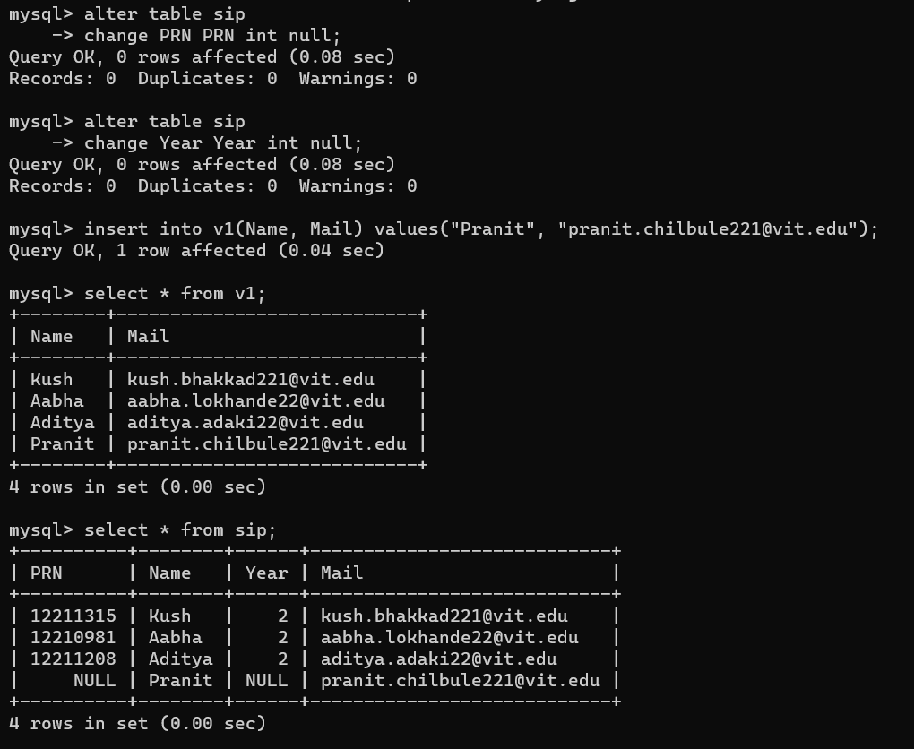

Deleted view:



**Conclusion:**

1. In this lab assignment, we explored the concept of views in SQL, which are virtual tables that can simplify data retrieval and manipulation.
2. We performed various tasks to understand the practical applications of views.
3. Throughout the assignment, we interacted with SQL statements to create, update, delete, and manipulate views.