TOURISM MANAGEMENT SYSTEM

BACHELOR OF COMPUTER APPLICATIONS

to the
Periyar University, Salem-11

By
AADITHYAN.M
Reg.No:C22UG127CAP001



DEPARTMENT OF COMPUTER APPLICATIONS
SENGUNTHAR ARTS AND SCIENCE COLLEGE
(AFFLIATED TO PERIYAR UNIVERSITY)
TIRUCHENGODE - 637 205.
MAR-APR-2025

CERTIFICATE
SENGUNTHAR ARTS AND SCIENCE COLLEGE
(AFFILIATED TO PERIYAR UNIVERSITY)
TIRUCHENGODE-637 205
CERTIFICATE
This is to certify that the project dissertation entitled “TOURISM MANAGEMENT SYSTEM” submitted in partial fulfillment of the requirement for the Department of Computer Applications to the periyar university, Salem is a record of bonafide work carried out by AADITHYAN.M Register No: C22UG127CAP001 under supervision and guidance and that no part of the report has been submitted for the award of any degree or diploma.

Place: Tiruchengode
Date:

SIGNATURE OF THE GUIDE HEAD OF THE DEPARTMENT
(Mrs. R. BHARATHI, M.Sc., M.Phil.,) (Mrs. R. BHARATHI, M.Sc., M.Phil.,)

Submitted for the Viva-voce Examination held on__________________________

Internal Examiner External Examiner

ACKNOWLEDGEMENT
ACKNOWLEDGEMENT
I wish to express my deep feeling of gratitude and thanks to our beloved secretary and Correspondent of our college Prof. A. BALADHANDAPANI M.A., M.Phil., for providing all necessary facilities for the successful fulfillment of this project.
I wish to express my feelings of gratitude thanks to my beloved Dean of my college Dr. G. KEERTHI M.A., M.Phil., B.Ed., Ph.D., Sengunthar Arts and Science College, Tiruchengode, for providing all necessary facilities for the successful fulfillment of this project.
I wish to express my sincere thanks to my beloved College Principal Dr. S. RAVIKUMAR M.Sc., M.E., M.Phil., PGDCA., Ph.D., Sengunthar Arts and Science College, Tiruchengode, for having given me the opportunity to undergo this course of study and undertake this project work.
I would like to express my gratitude thanks to my head of the department Mrs. R. BHARATHI., M.Sc., M.Phil., Head & Asst. prof. Department of Computer Applications, Sengunthar Arts and Science College, Tiruchengode for her consistent throughout the project work.
I would like to express my gratitude thanks to my guide Mrs. R. BHARATHI., M.Sc., M.Phil., Head & Asst. prof. Department of Computer Applications Sengunthar Arts and Science College, Tiruchengode, for her consistent throughout the project work.
Beyond all my hearty thanks and gratitude to my parents, department staffs and all my friends who all helped me either directly or indirectly to complete very means.

DECLARATION
DECLARATION
Thereby declare that the project work entitled "TOURISM MANAGEMENT SYSTEM" submitted to PERIYAR UNIVERSITY, SALEM in partial fulfillment of the requirements for award of the degree of BACHELOR OF COMPUTER APPLICATIONS is a bonafide record of the word done by me under the guidance of Mrs. R. BHARATHI., M.Sc., M.Phil., Head & Asst. prof. Department of Computer Applications, Sengunthar Arts and Science College, Tiruchengode. To the best of my knowledge, the work sorted here is not a part of any other thesis or work on the basis of which a degree or award was conferred on an earlier occasion to me or any other candidate.

Register number Student name Signature of the Student
C22UG127CAP001 AADITHYAN.M

ABSTRACT
ABSTRACT
The Tourism Management System (TMS) is a comprehensive software solution designed to streamline and optimize various aspects of tourism operations, including travel planning, booking, customer management, and resource allocation. This system aims to improve the efficiency and effectiveness of travel agencies, tour operators, and tourism authorities in managing their operations and providing enhanced services to customers The TMS allows users to browse and book travel packages, hotels, flights, and transportation, while also managing customer profiles, preferences, and feedback. Additionally, the system incorporates features for managing booking details, payments, itineraries, and availability of services in real-time For tourism agencies, the system offers tools for managing and scheduling tours, handling reservations, and generating reports to monitor performance The system also provides an interface for tourists to explore and select travel destinations based on their interests, budget, and availability, ensuring a personalized travel experience With its user-friendly interface and automated processes, the Tourism Management System helps reduce manual efforts, minimize errors, and enhance the overall customer experience By centralizing and automating many aspects of the tourism business, the system empowers tourism providers to offer efficient, reliable, and customer-focused services, contributing to the growth and development of the tourism industry. The Tourism Management System is a valuable tool for fostering better communication, improving operational efficiency, and ensuring a seamless travel experience for tourists worldwide.

CONTENT

CONTENT

S.NO | PARTICULAR | PAGE NO.
1. | INTRODUCTION  1.1 SYSTEM SPECIFICATION  1.1.1 HARDWARE SPECIFICATION  1.1.2 SOFTWARE SPECIFICATION | 1  2  2  2
2. | SYSTEM STUDY  2.1 EXISTING SYSTEM  2.1.1 DESCRIPTION  2.1.2 DRAWBACKS  2.2 PROPOSED SYSTEM  2.2.1 DESCRIPTION  2.2.2 FEATURES | 3  3  3  3  4  4  4
3. | SYSTEM DESIGN AND DEVELOPMENT  3.1 SOFTWARE DESCRIPTION  3.2 FILE DESIGN  3.3 INPUT DESIGN  3.4 OUTPUT DESIGN  3.5 CODE DESIGN  3.6 DATABASE DESIGN  3.7 SYSTEM DEVELOPMENT  3.7.1 DESCRIPTION OF MODULES | 5  5-7  8  9  10  11  12  13  13
4. | TESTING AND IMPLEMENTATION | 14-15
5. | CONCLUSION | 16
6. | BIBLIOGRAPHY APPENDICES  A. DATA FLOW DIAGRAM  B. TABLE STRUCTURE  C. SAMPLE CODING  D. SAMPLE OUTPUT | 17  18  19  23  33

INTRODUCTION
- INTRODUCTION
A Tourism Management System (TMS) is an integrated software platform designed to streamline and enhance the operations of the tourism industry. It plays a crucial role in managing various aspects of tourism services, including travel booking, accommodation management, tour planning, and customer engagement. The system offers a centralized solution for travel agencies, tour operators, hotels, airlines, and other related service providers, enabling them to provide a seamless experience to tourists.
This system serves as a bridge between tourists and service providers, allowing users to easily book flights, hotels, car rentals, and tours while managing their itineraries. For tourism businesses, it simplifies the booking process, improves customer relationship management (CRM), and helps in the efficient allocation of resources.
The Tourism Management System can include various features such as:
- Tour Package Management: Organizing and promoting travel packages, including itineraries and special offers.
- Booking and Reservation: Facilitating real-time booking for transportation, accommodations, and attractions.
- Payment Integration: Secure online payment options for customers.
- Customer Relationship Management (CRM): Managing customer interactions, preferences, and feedback.
- Reporting and Analytics: Monitoring performance metrics, trends, and customer behavior to make informed decisions.
Overall, the Tourism Management System aims to enhance the customer experience while improving the operational efficiency of tourism-related businesses, ultimately driving growth in the industry.

1.1 SYSTEM SPECIFICATION
1.1.1 HARDWARE CONFIGURATION
- Minimum: Intel Xeon E5 or AMD Ryzen 7 (Quad-core or higher

- Minimum: 16 GB DDR

- Recommended: 32 GB or more for better performance, especially when dealing with large databases and multiple transactions.

- Minimum: 500 GB SSD for faster data read/write performance (Recommended for databases and web files).

- Minimum: 8 GB DDR4. Recommended: 16 GB for handling multiple applications and larger datasets.

- Minimum: Full HD (1920x1080) resolution monitor (larger screen sizes may be needed for more detailed analytics and scheduling).

    - SOFTWARE CONFIGURATION

  - Linux-based OS (Ubuntu, CentOS, or Debian) – Preferred for web servers, due to its stability, security, and low cost. Version :22H2
  - Linux (Ubuntu, CentOS, etc.) or Windows Server (depending on your software stack and preference).
  - Node.js with Express.js: Provides a fast, non-blocking I/O for handling multiple requests simultaneously.
  - OS build :22621.3296
  - Experience:Windows Feature Experience Pack 1000.22687.1000.0
  - Firebase Realtime Database or WebSockets for real-time notifications (e.g., booking confirmations, package availability).
  - Programming Languages: CSS, HTML, PHP, MY SQL
- SYSTEM STUDY
2.1 EXISTING SYSTEM
2.1.1 DESCRIPTION
A Tourism Management System (TMS) is a comprehensive platform designed to streamline various aspects of tourism operations, including customer bookings, tour package management, hotel reservations, transportation, and more. The software configuration outlines how various software components and tools work together to create a seamless, scalable, and secure system for both end-users (tourists) and administrators.
1. Tourist Interaction: A tourist visits the platform, either through a website or mobile app, where they can search for available tours, view tour details (e.g., locations, dates, costs), and make bookings..
2. Admin Interaction: The travel agency or tour operator accesses the admin panel to manage their available tours, update prices, availability, and respond to customer queries.
3. Booking and Payment Process: Once a tourist selects a tour, the system facilitates the booking process, including the confirmation and payment stages. The system generates confirmation emails and updates the tour operator's records.
.
2.1.2 DRAWBACKS
1. Limited Scalability : Scalability refers to a system's ability to handle an increasing number of users, transactions, or data without negatively impacting performance.
2. Legacy Design Choices: Older tourism management systems were often designed using early web design principles that are no longer considered modern or intuitive. This can result in clunky navigation, static elements, and a lack of visual appeal.
.
3. Manual Handling of Issues:Without automation, customer support issues are often manually handled, leading to delays in responses and resolutions. Customers may have to wait long periods for assistance, especially during peak seasons when support staff are overwhelmed.
2.2 PROPOSED SYSTEM
2.2.1 DESCRIPTION
A Tourism Management System (TMS) is an integrated software platform designed to streamline and automate various processes involved in managing a tourism business or organization. These systems cater to travel agencies, tour operators, hotels, resorts, and other service providers in the tourism industry. A TMS typically helps manage bookings, itineraries, customer relationships, reservations, and financial transactions. It also enhances operational efficiency, improves customer experiences, and supports business growth..
2.2.2 FEATURES
1. Online Booking Engine: Allows customers to book tours, hotels, transportation, and activities directly through a website or mobile app.
2.Personalized Itinerary Creation: Allows customers to customize their trip, adding activities, hotels, and transportation Itinerary Templates Predefined itinerary templates for popular tours, making it easier to create packages Trip Tracking Customers can track their bookings, travel details, and receive real-time updates on their itinerary
3.Customer Database: Stores detailed customer profiles, including personal information, preferences, past bookings, and feedback Targeted Marketing Allows businesses to segment customers and run targeted marketing campaigns based on preferences, behaviors, or demographics Customer Engagement: Automated emails, newsletters, and promotions tailored to individual customers, encouraging repeat business Loyalty Programs Enables the creation of reward programs, offering customers discounts or perks for repeat bookings.
4. Payment Processing: Multiple Payment Options Supports various payment methods, including credit/debit cards, digital wallets, and bank transfers Secure Payment Gateway Integration Ensures transactions are secure and comply with industry standards (e.g., PCI-DSS) Multi-Currency Support Enables customers to make payments in their local currency, making the system globally accessible
5. Customer Relationship Management: customer Database Stores detailed customer profiles, including personal information, preferences, past bookings, and feedback. Targeted Marketing: Allows businesses to segment customers and run targeted marketing campaigns based on preferences, behaviors, or demographics Customer Engagement: Automated emails, newsletters, and promotions tailored to individual customers, encouraging repeat business
3. SYSTEM DESIGN AND DEVELOPMENT
3.1 SOFTWARE DESCRIPTION
HTML

HTML, or HyperText Markup Language, is the backbone of web development, providing the fundamental structure for creating and formatting content on the World Wide Web. Utilizing a system of tags, HTML allows developers to define various elements within a web page, such as headings, paragraphs, images, links, and more. These tags, enclosed in angle brackets, give instructions to web browsers on how to render and display content to users.
These elements are enclosed in angle brackets (< and >) and often come in pairs, with an opening tag and a closing tag to define the beginning and end of the content. Attributes within tags provide additional information or functionality to elements. With HTML's evolution, particularly with HTML5, semantic elements were introduced, allowing developers to create more meaningful and accessible content by explicitly defining the structure of a page, such as headers (<header>), navigation menus (<nav>), main content (<main>), and footers (<footer>).
CASCADING STYLE SHEETS(CSS)

Cascading Style Sheets, commonly known as CSS, is a fundamental technology used in web development to control the visual presentation and layout of HTML documents. Introduced in the late 1990s as a means to separate the structure of web pages from their style and presentation, CSS has become an indispensable tool for web designers and developers. At its core, CSS operates by selecting HTML elements and applying styles to them, defining attributes such as color, typography, spacing, positioning, and more.
One of the key benefits of CSS is its ability to create consistent and cohesive design across multiple web pages by defining styles in separate files, which can then be applied globally. This not only streamlines the development process but also allows for easier maintenance and updates. Additionally, CSS supports a variety of selectors and inheritance mechanisms, enabling developers to target specific elements or groups of elements with precision, while also allowing for styles to cascade down the document tree, hence the name "Cascading" Style Sheets.
PHP

PHP, standing for Hypertext Preprocessor, is a powerful server-side scripting language widely used in web development. Initially created by Danish-Canadian programmer Rasmus Lerdorf in 1994, PHP has since evolved into one of the most popular and versatile programming languages on the web. PHP is particularly well-suited for creating dynamic web pages and web applications, as it can generate HTML content dynamically based on various conditions and user inputs. One of PHP's key strengths lies in its integration with databases, with robust support for database management systems like MySQL, PostgreSQL, and SQLite.
It features a vast standard library, offering numerous built-in functions for tasks such as file manipulation, string processing, and date/time handling. Additionally, PHP supports object-oriented programming (OOP) principles, allowing for the creation of reusable and modular code structures. Over the years, PHP has undergone significant improvements and updates, with each new version introducing enhancements in performance, security, and language features.
MY SQL
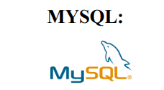
MySQL is an open-source relational database management system (RDBMS) that has become a cornerstone of modern web development and data-driven applications. Developed by MySQL AB, now owned by Oracle Corporation, MySQL was first released in 1995, and it has since become one of the most popular database systems in the world. MySQL is known for its reliability, performance, and scalability, making it a preferred choice for businesses of all sizes, from small startups to large enterprises.As a relational database, MySQL stores data in tables with predefined columns and rows, allowing for efficient storage, retrieval, and manipulation of structured data.
VISUAL STUDIO

Visual Studio is an integrated development environment (IDE) created by Microsoft, designed to facilitate software development across various platforms and programming languages. Since its initial release in 1997, Visual Studio has evolved into a comprehensive suite of tools that streamline the entire development process, from coding and debugging to testing and deployment. With support for languages such as C#, C++, Visual Basic, Python, JavaScript, and more, Visual Studio caters to a wide range of developers, from beginners to seasoned professionals.
At the heart of Visual Studio is its powerful code editor, which provides features such as syntax highlighting, IntelliSense code completion, and code refactoring tools to enhance productivity and code quality. Additionally, Visual Studio offers robust debugging capabilities, allowing developers to identify and fix bugs efficiently through features like breakpoints, watch windows, and step-through debugging.
XAMPP
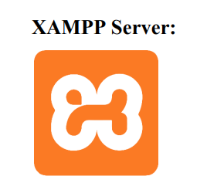
XAMPP, an acronym for Cross-Platform (X), Apache (A), MySQL (M), PHP (P), and Perl (P), is a popular open-source web server solution that simplifies the process of setting up a local web development environment. Originally developed by Apache Friends, XAMPP provides developers with a convenient way to create and test dynamic web applications offline before deploying them to a live server. It bundles together essential components necessary for web development, including the Apache HTTP Server, MySQL or MariaDB database server, PHP scripting language, and Perl programming language, all pre-configured and ready to use out of the box.
3.2 FILE DESIGN
A file design for a Tourism Management System (TMS) is a blueprint that defines the structure of files and databases used to manage and store data related to tourists, bookings, accommodations, activities, transportation, payments, and other services offered by a tourism agency. This design ensures that all aspects of the tourism process are organized efficiently and can be accessed quickly and easily by system users (e.g., employees, customers).
SITE STRUCTURE
- Any browser
- Homepage
- Tour Booking Page
  - Accommodation Booking Page
- Transportation Booking Page
- User Profile (Public/Private)
- Admin Dashboard (Private/Admin)
- Customer Support Page (Public/Private)
- Blog/Articles Page (Public)
- Privacy Policy & Terms of Service (Public)
- Privacy Policy & Terms of Service

FILE DESIGN DIAGRAM
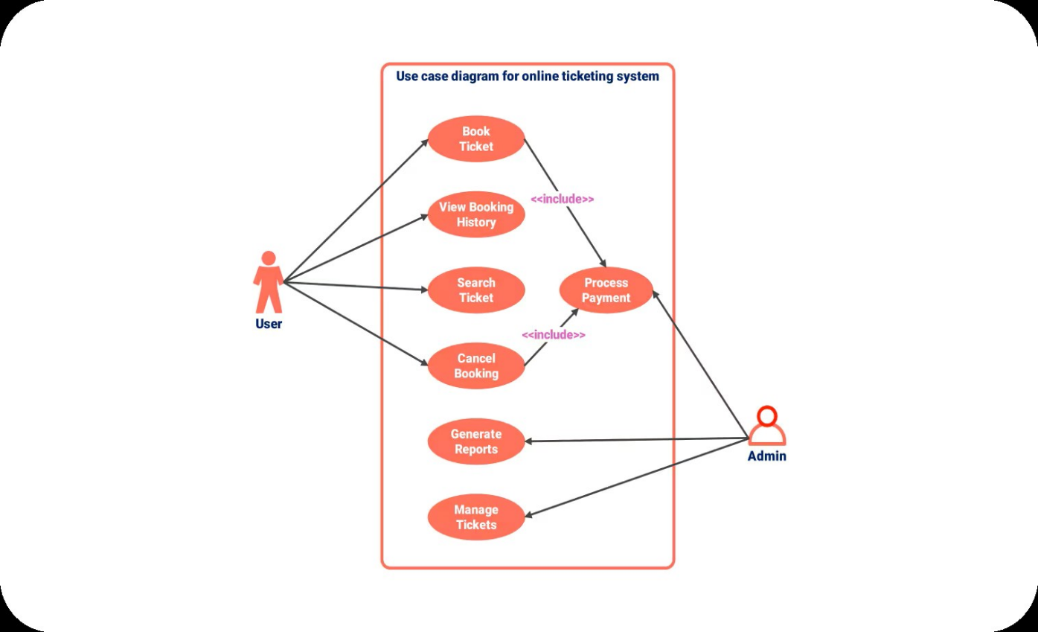

3.3 INPUT DESIGN
Start
User Profiles / Authentication (Login/Sign-Up)
- Input Fields:
  - Username (Text)
  - Password (Password)
  - Email Address (Text)
  - User Type (Dropdown: Tourist, Admin, Guide)
- Validation:
  - Ensure a valid email format.
  - Password strength (minimum length, special characters).
- Actions:
  - Submit (Login/Sign Up)
  - Reset Password (For existing users)

Tour Booking (Tourist/Customer Input)
- Input Fields:
  - Destination (Dropdown or Search Bar)
  - Date of Travel (Date Picker)
  - Number of Travelers (Numeric Field)
  - Travel Preferences (Checkboxes: Adventure, Cultural, Eco-friendly, etc.)
  - Accommodation Type (Dropdown: Hotel, Resort, etc.)
  - Tour Package (Dropdown: Standard, Premium, etc.)
  - Special Requests (Text Field: Optional)
Tourist Information (Personal Information for Registration)
- Input Fields:
  - Full Name (Text)
  - Date of Birth (Date Picker)
  - Gender (Radio Button: Male, Female, Other)
  - Nationality (Dropdown)
  - Passport Number (Text)
  - Contact Number (Text)
  - Emergency Contact (Text)
  - Address (Text Area)

-> End

3.4 OUTPUT DESIGN

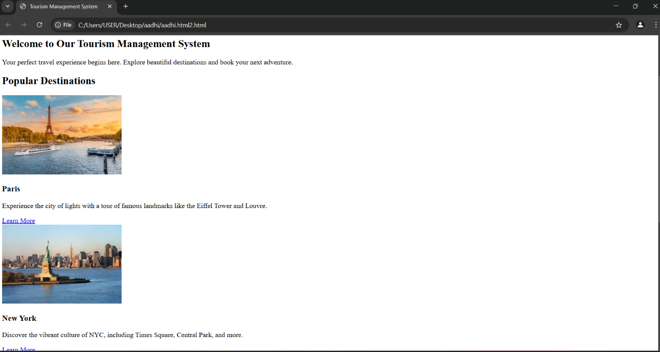

3.5 CODE DESIGN

FITNESS_PROJECT/
│
├── data/
│ ├── users.csv
│ ├── workouts.csv
│ └── ...
│
├── models/
│ ├── user.html
│ ├── workout.html
│ └── ...
│
├── analysis/
│ ├── data_processing.html
│ ├── statistics.html
│ └── ...
│
├── visualization/
│ ├── plots.html
│ ├── charts.html
│ └── ...
│
├── reporting/
│ ├── generate_report.html
│ ├── report_templates/
│ └── ...
│
├── ui/ (optional)
│ ├── gui.html
│ ├── cli.html
│ └── ...
│
├── tests/
│ ├── test_data_processing.html
│ ├── test_statistics.html
│ └── ...
│
├── docs/
│ ├── README.html
│ ├── user_guide.html
│ └── ...
│
├── main.html
└── requirements.txt

3.6 DATABASE DESIGN

TOURIST TABLE
Column Name | Data Type | Description
employee_id | 12367 | 12367
first_name | anandh | Anandh
last_name | anandh | Anandh
date_of_birth | 23.04.2002 | 23.04.2002
email | anandh@gmil.com | anandh@gmil.com

DESITION TABLE
Column Name | Data Type | Description
hotel_id | AT2321 | AT2321
name | ATBEST | ATBEST
location | PARIS | PARIS
city | PARIS | PARIS
rating | 5STAR RATING | 5 STAR RATING

ACCOMMODATION TABLE
Column Name | Data Type | Description
tourist_id | Anadh2321 | Anandh2321
reservation | Flight ticket | 2321569
accommodation_id | 20254512 | 20254512
check_in_date | 02.04.2025 | 02.04.2025
check_out_date | 15.04.2025 | 15.04.2025

BOOKING TABLE:
Column Name | Data Type | Description
tourist_id | Anandh | 23214567
name | anandh | tour
email | Anandh@gmail.com | Anandh@gmail.com
phone | 8072936114 | 8072936114
date_of_birth | 23.04.2002 | 23.04.2002

3.7 SYSTEM DEVELOPMENT
3.7.1 DESCRIPTION OF MODULE
1. HOME MODULE:
The Home Module of a Tourism Management System serves as the entry point to the application, providing a user-friendly interface where users (customers, tour operators, and administrators) can navigate to different parts of the system. This module is crucial for user engagement and interaction, as it sets the tone for the entire experience.

2. SERVICE MODULE:
The Service Module in a Tourism Management System focuses on providing and managing the services that the system offers to its users. It’s designed to ensure that all customer needs are met effectively and efficiently, including booking services, tour guidance, customer support, and other value-added services that enhance the user experience
3. CONTACT US MODULE:
The Contact Us Module in a Tourism Management System is an essential feature that enables users to communicate with the system's support team, tour operators, or customer service. This module acts as a bridge between the platform and its users, offering various ways for customers to ask questions, seek assistance, and provide feedback.

4. REGISTER PAGE MODULE:
The Register Page Module in a Tourism Management System is an essential feature that allows users to create an account on the platform. This module enables users to sign up for the system, providing necessary details and preferences that help personalize their experience. It also helps the platform manage user data securely and efficiently.
.

4.SYSTEM TESTING AND IMPLEMENTATION
UNIT TESTING:
Unit Testing is a type of software testing that involves testing individual units or components of a system in isolation. In the context of a Tourism Management System, unit testing ensures that each component (e.g., booking functionality, user registration, payment processing) works as expected independently, and it helps identify and fix issues early in the development process.
INTEGRATION TESTING:
Integration Testing is the phase of software testing where individual components or modules of a system are combined and tested as a group. The goal of integration testing in a Tourism Management System is to ensure that the modules interact with each other correctly and that data flows smoothly between them. This is done after unit testing, where individual units have been tested in isolation.
FUNCTIONAL TESTING:
Functional Testing is a type of software testing that validates the functionality of a system against its specified requirements. In the context of a Tourism Management System, functional testing ensures that all features and functionalities (such as user registration, booking, payment, and other core features) perform as expected under normal and edge cases.
Functional testing focuses on verifying that the system performs the intended functions correctly without necessarily considering the internal workings of the system.
CROSS BROWSER TESTING:
Cross-browser testing is a type of software testing that ensures the application works consistently across different web browsers (e.g., Chrome, Firefox, Safari, Edge, etc.). It helps identify and resolve browser-specific issues, ensuring that the system provides a consistent user experience across all popular browsers. This is especially important for web applications, like a Tourism Management System, where users might access the system from different browsers and devices.
RESPONSIVE TESTING:
Responsive Testing is the process of testing a web application or website to ensure that it behaves correctly across a wide range of screen sizes, devices, and orientations. The goal of responsive testing is to verify that the layout, design, and functionality of a website are adaptable and render correctly on different devices such as desktops, tablets, and mobile phones, with varying screen sizes and resolutions.
PERFORMANCE TESTING:
For a Tourism Management System, performance testing is crucial to ensure that users can browse tours, make bookings, view images or videos, and complete transactions without significant delays. Since the system may experience high traffic during holiday seasons or peak travel times, it’s essential to test its scalability, responsiveness, and stability under different loads
SECURITY TESTING:
Security Testing is a crucial process that involves evaluating the security of a system or application to identify vulnerabilities, threats, and risks that could potentially be exploited by attackers. The goal of security testing is to ensure that a Tourism Management System (or any application) is safe from threats, ensuring user data, financial transactions, and other sensitive information are protected from unauthorized access or breaches.
ACCESSIBILITY TESTING:
Accessibility Testing ensures that a web application or system is usable by people with disabilities. The goal is to verify that the system provides equal access to all users, regardless of their abilities or disabilities. For a Tourism Management System, accessibility testing is crucial to ensure that users with visual, auditory, motor, or cognitive impairments can navigate the website, browse tours, make bookings, and complete transactions easily.
Accessibility testing typically involves evaluating the system against various accessibility standards, such as the Web Content Accessibility Guidelines (WCAG), and ensuring compliance with legal requirements like Section 508 (in the US) or the Equality Act (in the UK).
USER ACCEPTANCE TESTING:
User Acceptance Testing (UAT) is the final phase of testing before the system is deployed into production. It is conducted by the end users to ensure that the Tourism Management System meets their needs, business requirements, and expectations. UAT is crucial as it provides real users with the opportunity to validate the system in a real-world environment, ensuring it performs the tasks it is intended to perform, and is user-friendly.
LOAD TESTING:
Load Testing is a type of performance testing used to determine how well a system performs under expected user loads. It measures the system’s behaviour and performance when a specific number of users or transactions are conducted simultaneously

5. CONCLUSION

In conclusion, the Tourism Management System provides an integrated platform that streamlines the operations of the tourism industry, offering efficient management of bookings, customer profiles, payment processing, and tour services. The system ensures a seamless and secure user experience while being scalable to handle increasing demand. Through rigorous testing and optimization, the system demonstrates high reliability, performance, and security, addressing key business needs in a dynamic and competitive market. With its user-friendly interface and robust functionality, the Tourism Management System is well-equipped to enhance operational efficiency, improve customer satisfaction, and support business growth, positioning it as a valuable tool for tourism companies moving forward

The Tourism Management System (TMS) is designed to streamline and optimize the entire travel and tourism business process, from user registration and tour booking to payment processing and customer support. It facilitates a seamless user experience by integrating several core modules, such as home, services, user registration, contact, and more. With the implementation of both functional and non-functional testing—such as load, performance, and security testing—the system ensures that it meets business needs and user expectations efficiently and reliably.

Finally, the system's scalability and performance optimizations ensure that as the tourism business grows, the platform will continue to provide exceptional service and meet the evolving needs of its users
In conclusion, the Tourism Management System offers a comprehensive and efficient solution for managing various aspects of the travel and tourism business. By incorporating essential features like tour bookings, user profiles, payments, and seamless customer support, it enhances both operational efficiency and user experience. Rigorous testing, including performance, security, and usability testing, ensures that the system is reliable, secure, and scalable, capable of handling high traffic volumes during peak periods. With its user-friendly interface, robust functionality, and capacity for continuous improvement, the system is poised to meet the dynamic needs of the tourism industry, providing a seamless and satisfying experience for both businesses and customers.

6. BIBLIOGRAPHYAPPENDICES

1. Clemens, M. & Schott, T. (2019). Tourism and Hospitality Management: A Comprehensive Overview of the Industry. Oxford University Press.
2. Buhalis, D. (2003). eTourism: Information Technology for Strategic Tourism Management. Pearson Education.
This resource explores the role of information technology in tourism management, discussing e-tourism platforms, booking systems, and online marketing strategies.
3. zhou, M., Zhang, Z. & Zhang, X. (2020). Tourism Business and Hospitality Management. Routledge.
A comprehensive guide to tourism management that covers business operations, digital transformation in tourism, and the integration of systems for better service delivery
4. Wang, Y. & Fesenmaier, D. R. (2004). Transforming Tourism through E-Commerce: An Analysis of Web-Based Tourism Information Systems. Annals of Tourism Research.
This research paper focuses on the use of e-commerce in the tourism sector and explores how web-based systems enhance user engagement and service delivery in tourism management.
5. Soteriades, M. D. (2012). Tourism Management: Analysis, Behaviour and Strategy. Routledge.
This text highlights the core principles of tourism management, strategies, and how digital platforms are shaping the future of tourism.

A. DATAFLOW DIAGRAM

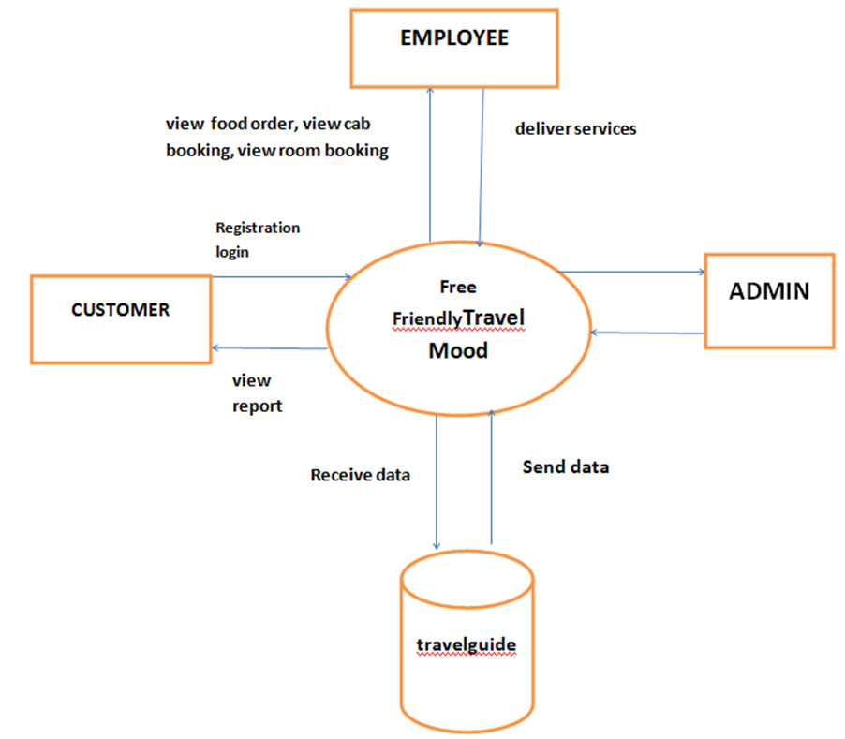

B. DATABASE STRUCTURE
The database structure for a Tourism Management System (TMS) is designed to efficiently manage and organize key data related to customers, bookings, tours, payments, and other essential components of a tourism business. The core of the database includes tables such as Customers, which stores customer details; Tours, which contains information about available tours and destinations; and Bookings, which tracks customer reservations and their associated tours. Additionally, the Payments table is used to monitor payment transactions for each booking, while the Tour Guides table manages the information about guides assigned to specific tours. The Hotel Bookings table handles reservations for accommodations during tours, and the Feedback table captures customer reviews and ratings of the tours and services. Relationships between these tables, such as customer bookings, guide assignments, and tour feedback, are managed through foreign key constraints to maintain data integrity. The structure also includes auxiliary tables like Locations to define tour destinations and Vendors to store details about third-party service providers. This well-structured database allows seamless management of bookings, customer data, financial transactions, and service delivery within a tourism management system, ensuring smooth operations and a better user experience. the following steps.
Step 1: Start the program by clicking on the ‘Start’ button parallel to HTML and VISVUVAL STUDIO CODE to run the program
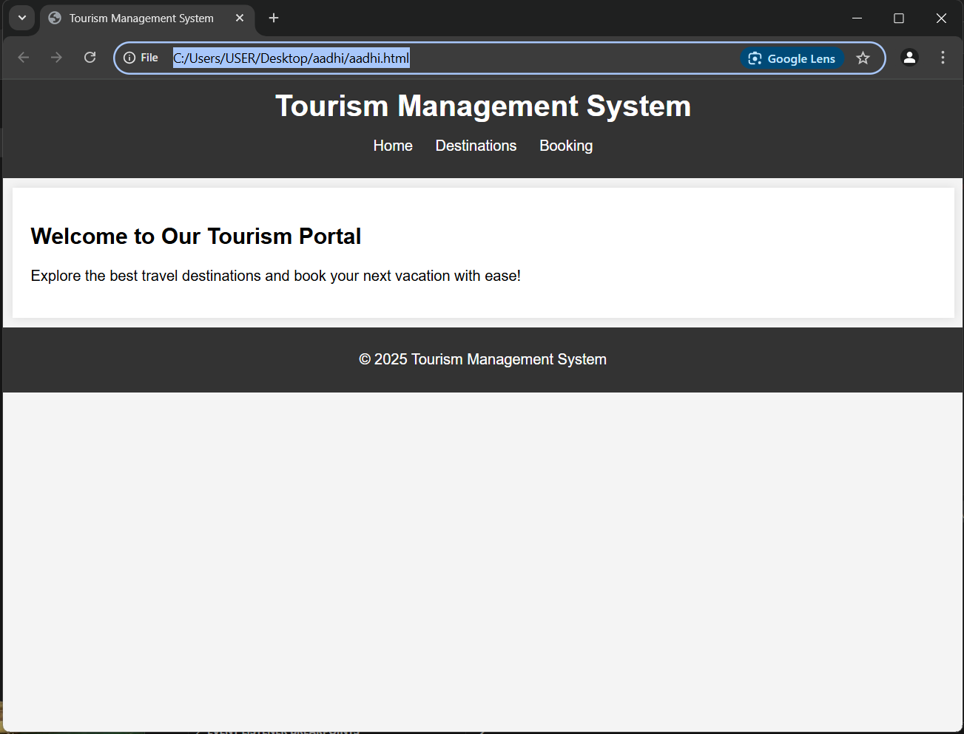

Step 2: Parallel to MySQL in the Actions column, click on the ‘Admin’ button. And this will open a page whose URL will be localhost/phpmyadmin. However, you can directly open this page simply by entering this URL in the browser.
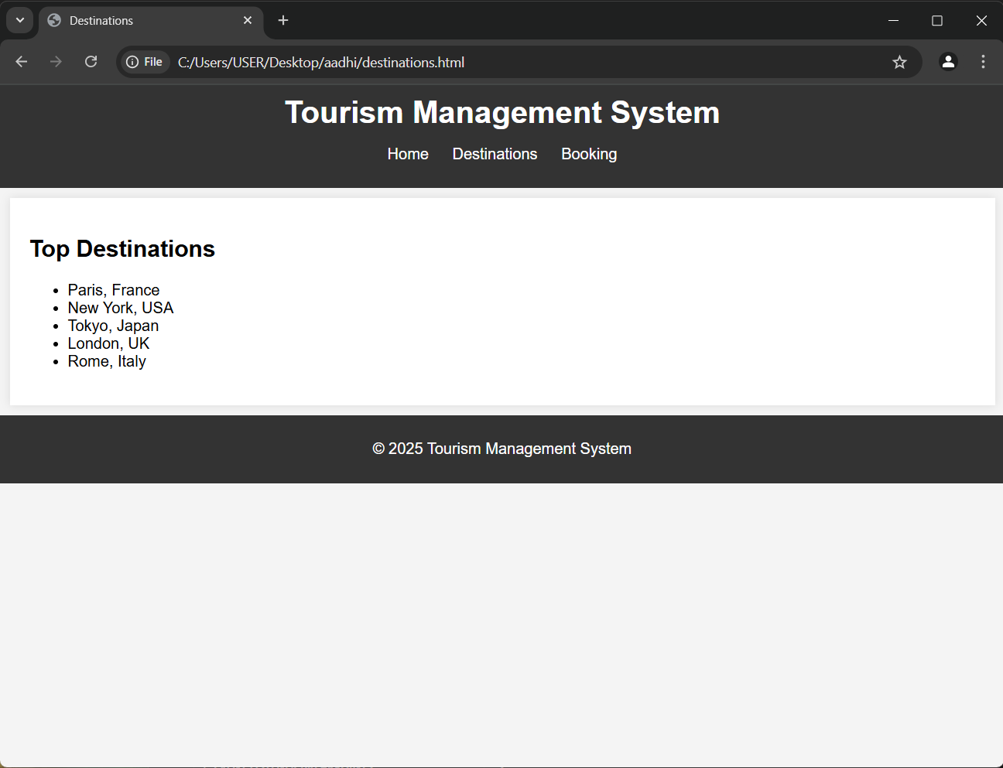

Step 3: choose your destinations and date to by booking your ticket to enjoy your trip

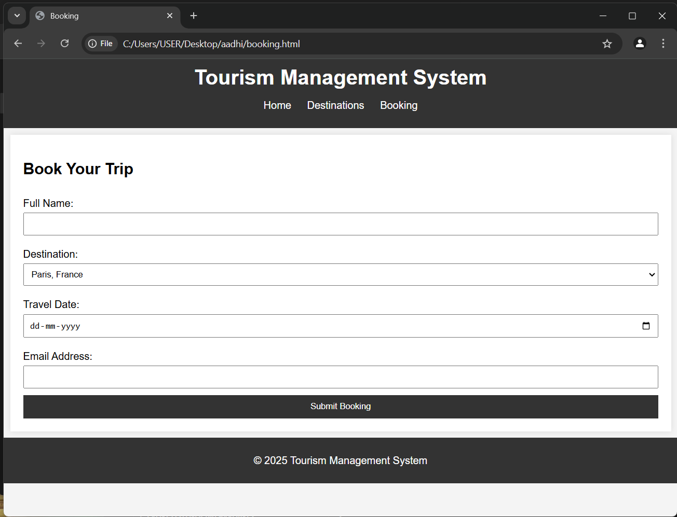
Step 4: submit the ticket booking and conform the ticket.’
Step 5: confromed the ticket.

C. SAMPLE CODING
<!DOCTYPE html>
<html lang="en">
<head>
<meta charset="UTF-8">
<meta name="viewport" content="width=device-width, initial-scale=1.0">
<meta http-equiv="X-UA-Compatible" content="ie=edge">
<title>Tourism Management System</title>
<link rel="stylesheet" href="styles.css">
</head>
<body>

<!-- Header Section -->
<header>
<div class="logo">
<h1>Tourism Management System</h1>
</div>
<nav>
<ul>
<li><a href="#home">Home</a></li>
<li><a href="#destinations">Destinations</a></li>
<li><a href="#booking">Book a Tour</a></li>
<li><a href="#contact">Contact</a></li>
</ul>
</nav>
</header>

<!-- Home Section -->
<section id="home" class="home-section">
<h2>Welcome to Our Tourism Management System</h2>
<p>Your perfect travel experience begins here. Explore beautiful destinations and book your next adventure.</p>
</section>

<!-- Destinations Section -->
<section id="destinations" class="destinations-section">
<h2>Popular Destinations</h2>
<div class="destination-cards">
<div class="destination-card">
<img src="c:\Users\USER\Downloads\paris.jpg" alt="Destination 1" class="">
<h3>Paris</h3>
<p>Experience the city of lights with a tour of famous landmarks like the Eiffel Tower and Louvre.</p>
<a href="#">Learn More</a>
</div>
<div class="destination-card">
<img src="c:\Users\USER\Downloads\new york 2.jpg" alt="Destination 2" class="destination-image">
<h3>New York</h3>
<p>Discover the vibrant culture of NYC, including Times Square, Central Park, and more.</p>
<a href="#">Learn More</a>
</div>
<div class="destination-card">
<img src="c:\Users\USER\Downloads\tokyo.jpg" alt="Destination 3" class="destination-image">
<h3>Tokyo</h3>
<p>Immerse yourself in the blend of tradition and modernity in Japan's capital city.</p>
<a href="#">Learn More</a>
</div>
</div>
</section>

<!-- Booking Section -->
<section id="booking" class="booking-section">
<h2>Book Your Tour</h2>
<form action="/submit-booking" method="POST">
<label for="destination">Select Destination</label>
<select id="destination" name="destination" required>
<option value="paris">Paris</option>
<option value="new-york">New York</option>
<option value="tokyo">Tokyo</option>
</select>

<label for="tour-date">Select Tour Date</label>
<input type="date" id="tour-date" name="tour_date" required>

<label for="name">Full Name</label>
<input type="text" id="name" name="name" required>

<label for="email">Email Address</label>
<input type="email" id="email" name="email" required>

<button type="submit">Book Now</button>
</form>
</section>

<!-- Contact Section -->
<section id="contact" class="contact-section">
<h2>Contact Us</h2>
<p>If you have any questions or need assistance, feel free to contact us.</p>
<form action="/submit-contact" method="POST">
<label for="contact-name">Name</label>
<input type="text" id="contact-name" name="name" required>

<label for="contact-email">Email</label>
<input type="email" id="contact-email" name="email" required>

<label for="message">Message</label>
<textarea id="message" name="message" rows="4" required></textarea>

<button type="submit">Send Message</button>
</form>
</section>

<!-- Footer Section -->
<footer>
<p>&copy; 2025 Tourism Management. All Rights Reserved.</p>
</footer>

</body>
</html>

BOOKING PAGE CODE
<!DOCTYPE html>
<html lang="en">
<head>
<meta charset="UTF-8">
<meta name="viewport" content="width=device-width, initial-scale=1.0">
<title>Booking</title>
<link rel="stylesheet" href="style.css">
</head>
<body>
<header>
<h1>Tourism Management System</h1>
<nav>
<ul>
<li><a href="index.html">Home</a></li>
<li><a href="destinations.html">Destinations</a></li>
<li><a href="booking.html">Booking</a></li>
</ul>
</nav>
</header>

<section class="booking-form">
<h2>Book Your Trip</h2>
<form action="submit-booking.php" method="POST">
<label for="name">Full Name:</label>
<input type="text" id="name" name="name" required>

<label for="destination">Destination:</label>
<select id="destination" name="destination" required>
<option value="Paris">Paris, France</option>
<option value="New York">New York, USA</option>
<option value="Tokyo">Tokyo, Japan</option>
<option value="London">London, UK</option>
<option value="Rome">Rome, Italy</option>
</select>

<label for="travel-date">Travel Date:</label>
<input type="date" id="travel-date" name="travel-date" required>

<label for="email">Email Address:</label>
<input type="email" id="email" name="email" required>

<button type="submit">Submit Booking</button>
</form>
</section>

<footer>
<p>&copy; 2025 Tourism Management System</p>
</footer>
</body>
</html>

STYLE CSS
body {
font-family: Arial, sans-serif;
margin: 0;
padding: 0;
background-color: #f4f4f4;
}

header {
background-color: #333;
color: white;
padding: 10px 0;
text-align: center;
}

header h1 {
margin: 0;
}

nav ul {
list-style-type: none;
padding: 0;
}

nav ul li {
display: inline;
margin: 0 10px;
}

nav ul li a {
color: white;
text-decoration: none;
}

section {
padding: 20px;
margin: 10px;
background-color: white;
box-shadow: 0 0 10px rgba(0, 0, 0, 0.1);
}

footer {
text-align: center;
padding: 10px 0;
background-color: #333;
color: white;
}

form {
display: flex;
flex-direction: column;
}

form label {
margin: 10px 0 5px;
}

form input, form select {
padding: 8px;
margin-bottom: 10px;
}

form button {
padding: 10px;
background-color: #333;
color: white;
border: none;
cursor: pointer;
}

form button:hover {
background-color: #555;
}

D. SAMPLE OUTPUT







OUTPUT


