DAY-3

## EXERCISE:1

Create a S3 Bucket and create a folder in the bucket and upload a file in the folder.

CREATING BUCKET:

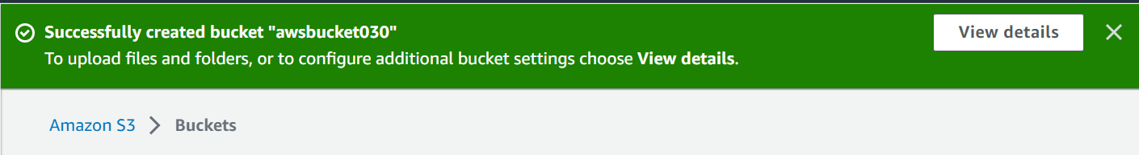

UPLOADING FILE:

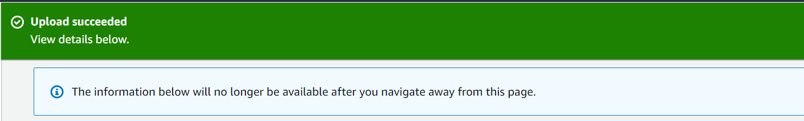

## EXERCISE:2

Disable "Block Public Access" for the bucket and enable public read access for a file.

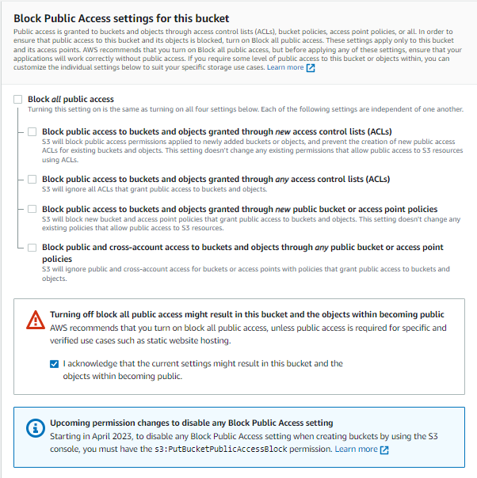

ACCESS CONTROL LIST(READ-ENABLED):

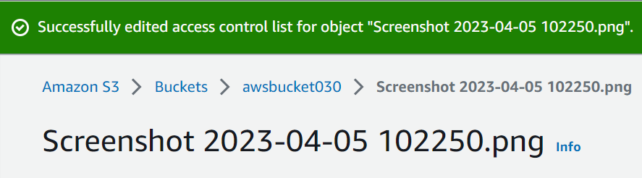

## EXERCISE:3

Create a bucket policy which should deny to read objects under a folder of a bucket.

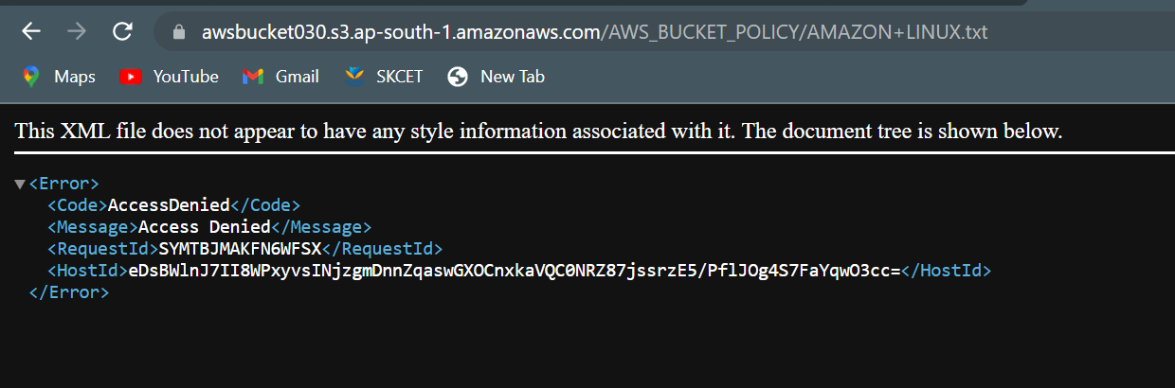

## EXERCISE:4

Enable versioning objects for a bucket and upload objects with multiple versions of it.

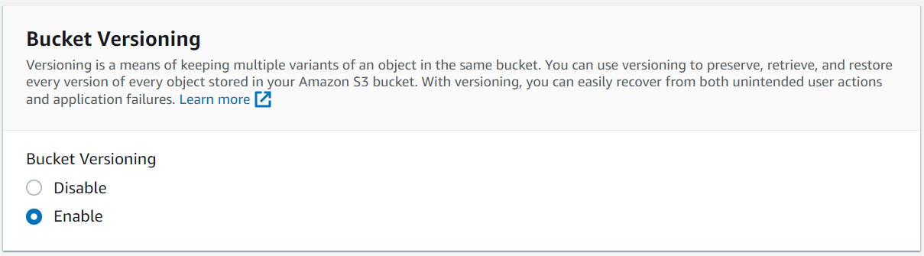

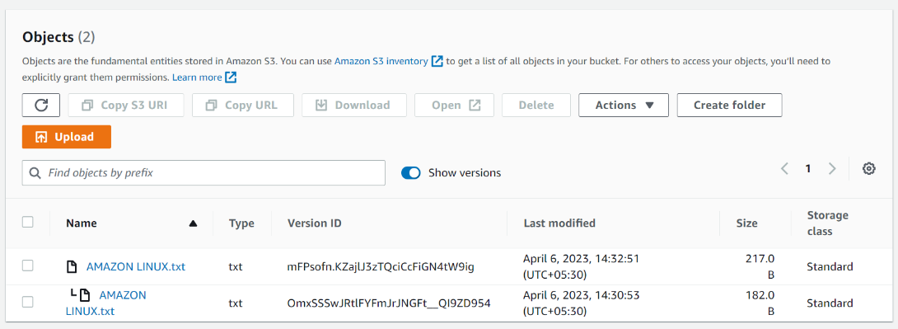

## EXERCISE:5

Host a static webpage in a bucket itself by using static website hosting feature of it.

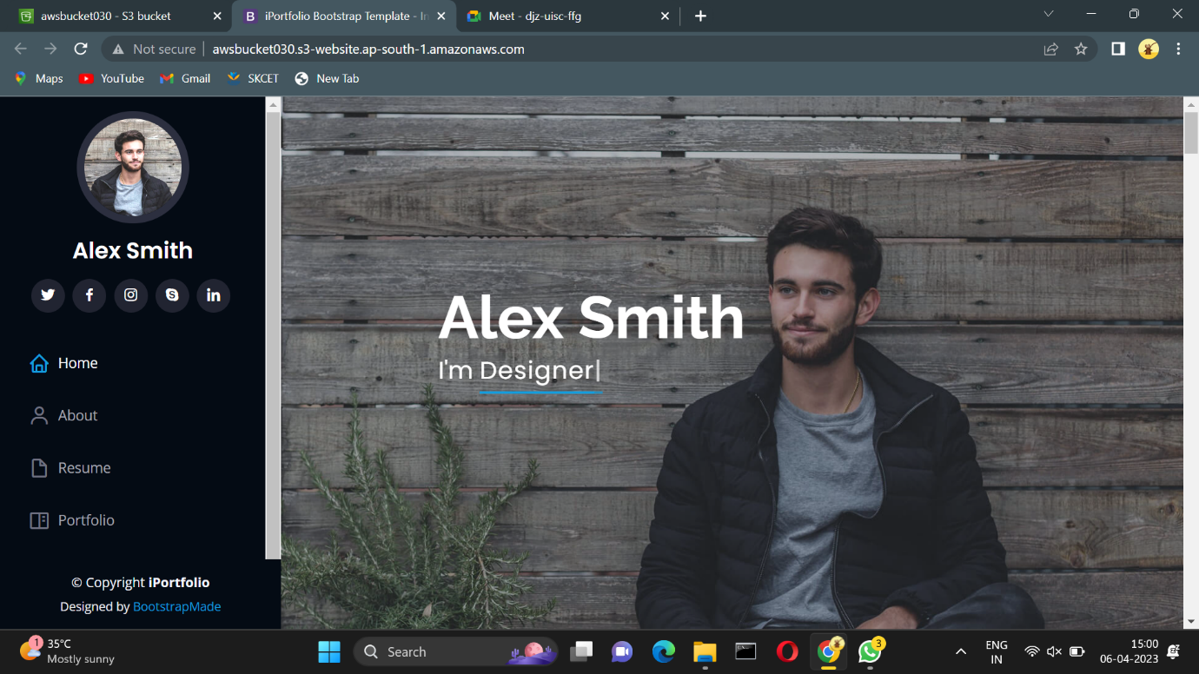

## EXERCISE:6

Enable a lifecycle management rule between various storage classes for a S3 bucket.

