DAY 4

## EXERCISE:1

Create an IAM group called as ‘S3-Admins’ with ‘AmazonS3FullAccess’.

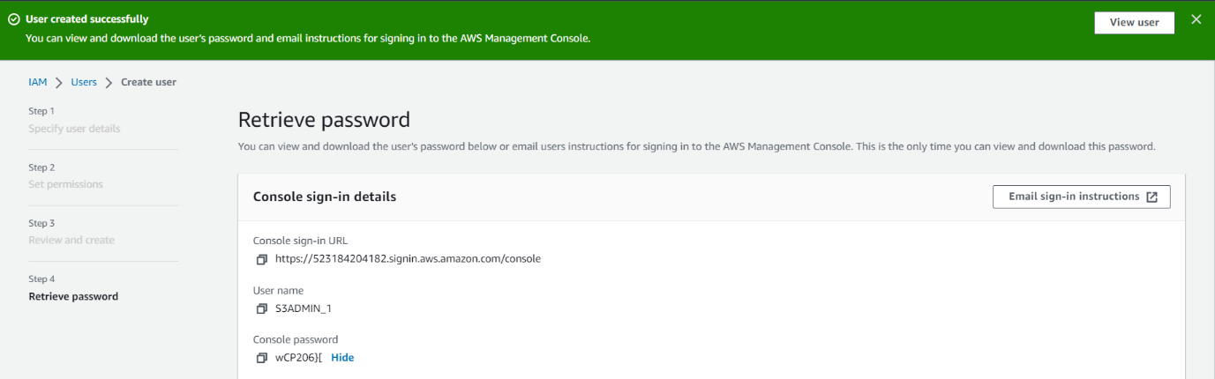

## EXERCISE:2

Create an IAM user called as ‘S3Admin1’ and add it to the ‘S3-Admins’ group.

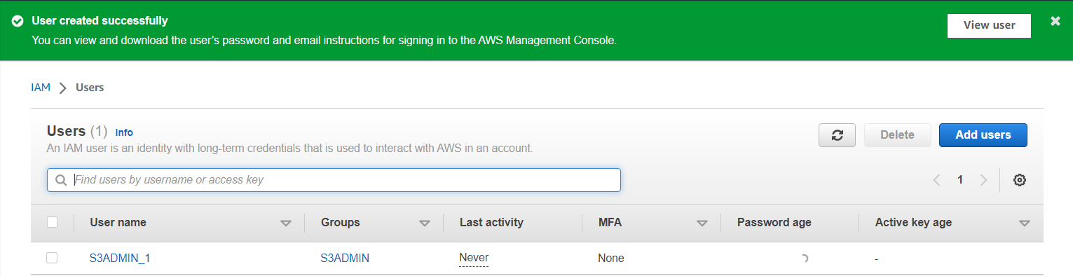

## EXERCISE:3

Attach an IAM custom policy to the ‘S3-Admins’ group which should deny to delete objects.

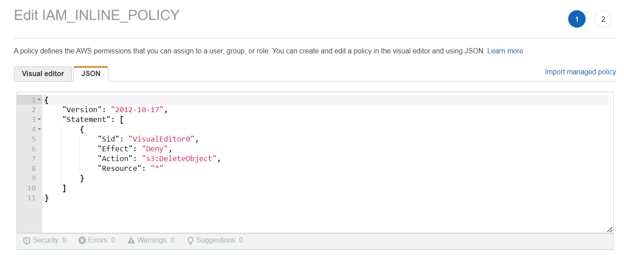

## EXERCISE:4

Create an Inline policy for an IAM user and set some permission boundary for that user.

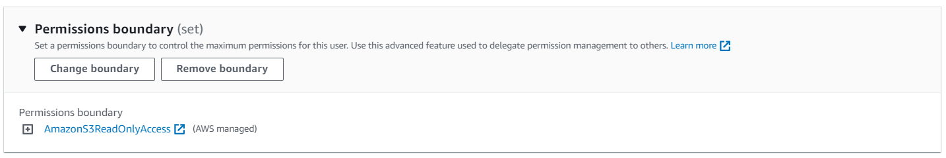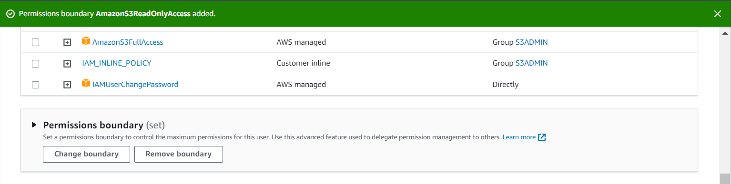

## EXERCISE:5

Create an IAM role with ‘AmazonS3FullAccess’ and attach the role to an EC2 instance.

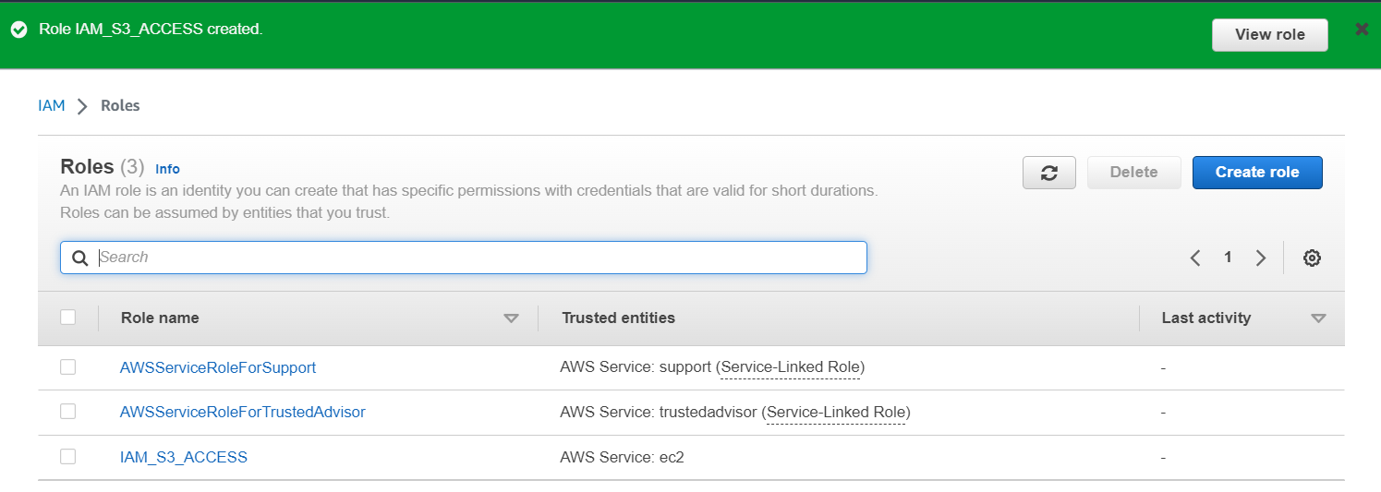

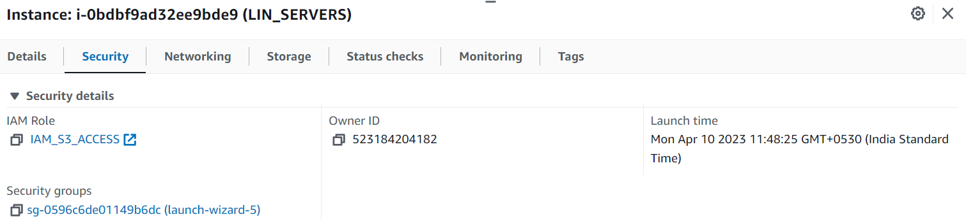

## EXERCISE:6

Activate MFA for an IAM user and Set some Password Policies such as 1 uppercase, 1 lowercase etc

