PrivateVault
Zero-Knowledge, Client-Side Encrypted Cloud File Storage
Academic Cybersecurity Project Report
Submitted by: [ YOUR NAME ]
Roll No / Reg No: [ YOUR ROLL NUMBER ]
Course: [ YOUR COURSE NAME ]
Institution: [ YOUR COLLEGE / UNIVERSITY NAME ]
Date: [ SUBMISSION DATE ]

Abstract
PrivateVault is an academic software project that implements zero-knowledge, client-side encrypted file storage for the web. Unlike conventional cloud storage systems, where the server receives and can read the original file after HTTPS is terminated, PrivateVault encrypts every file inside the user's browser, using AES-256-GCM, before it is ever transmitted. The FastAPI backend and PostgreSQL database receive and store only ciphertext, a random non-secret initialization vector (IV), a random non-secret salt, and file metadata — never the plaintext file, the encryption password, or the raw AES key.
The system implements account registration and login with Argon2id-hashed passwords and JWT-based session authentication, kept deliberately separate from a second, independent encryption password that is used only inside the browser (via the Web Crypto API and PBKDF2-SHA256) to derive each file's AES key. Every file operation — listing, downloading, and deleting — is authorized server-side by comparing the authenticated user's ID against the file's stored owner ID, so one user can never access another user's files. AES-GCM's built-in authentication tag additionally guarantees integrity: any tampering or corruption of stored ciphertext causes decryption to fail explicitly rather than silently returning corrupted data. The application was built with a React (Vite) frontend, a Python FastAPI backend, PostgreSQL for metadata, and local disk storage for ciphertext, and was verified running locally, with real frontend screenshots included in this report.

1. Problem Statement
Conventional cloud storage systems typically follow a simple pattern: a user's file is transmitted to a server, and the server stores it as-is. Even when the connection is protected with HTTPS, the server itself receives the original plaintext file once TLS is terminated at the server end.
This means that a malicious administrator, a compromised server, an insider threat, or an attacker who gains unauthorized access to the storage backend or its database may be able to read every file stored on the platform — regardless of how secure the network transport was. HTTPS protects data in transit; it does nothing to protect data once it reaches the server.
The problem this project addresses is: how can a user store files on a cloud server in a way that makes it structurally impossible — not just policy-forbidden — for the storage provider to read the file contents, even if the provider is fully compromised?
PrivateVault answers this by moving encryption to the client: the browser encrypts the file before it ever leaves the user's device, so the server only ever has custody of unreadable ciphertext.

2. Objectives
- Allow users to create accounts and log in securely using hashed account passwords.
- Allow users to upload files through a web interface built in React.
- Encrypt files inside the browser, using AES-256-GCM, before any upload occurs.
- Transfer encrypted files to the backend over HTTPS.
- Store only encrypted (ciphertext) files on the backend's local disk.
- Prevent any user from downloading, listing, or deleting files belonging to another user.
- Allow the owning user to download and correctly decrypt their own files, on any device.
- Detect any tampering or corruption of stored ciphertext using AES-GCM's authentication tag.
- Clearly demonstrate, in both the implementation and this report, the distinction between encryption at rest, encryption in transit, authentication, authorization, and integrity protection.

3. Main Features
- Account authentication — registration and login using Argon2id password hashing and JWT-based sessions.
- Separate encryption password — a second, independent password used only in-browser to derive the AES file key; it is never transmitted to or stored by the server.
- Client-side file encryption — AES-256-GCM encryption performed entirely in the browser via the Web Crypto API before upload.
- Encrypted filenames — the original filename is itself encrypted client-side before upload, so the database never stores a readable filename.
- Server-generated storage keys — every uploaded file is stored on disk under a random, server-generated UUID; the backend never trusts a client-supplied filename or path.
- Owner-scoped authorization — every file route (list, download, delete) re-validates that the authenticated user is the file's owner, returning 403 Forbidden otherwise.
- Integrity verification — AES-GCM's authentication tag causes decryption to fail loudly if ciphertext has been tampered with or corrupted.
- Device independence — because the AES key is derived fresh from the user's password each time (not stored), the system works identically on any device and any browser, with no dependency on local browser storage.

4. System Requirements
The software requirements for running the project are listed below. The project does not require any specific minimum hardware specification beyond a typical development machine.
Requirement | Specification
Operating System | Cross-platform (Windows / Linux / macOS)
Programming Languages | Python 3.11+ (backend), JavaScript (frontend)
Frameworks | FastAPI + Uvicorn (backend); React + Vite (frontend)
Database | PostgreSQL, accessed through SQLAlchemy ORM
Backend Libraries | SQLAlchemy, Alembic, psycopg2-binary, passlib / argon2-cffi, python-jose, slowapi, python-multipart, pydantic-settings
Frontend Libraries | React Router, native Fetch API, Web Crypto API (no external crypto library required)
Development Tools | npm, pip, pytest, Git, pgAdmin

5. System Architecture
PrivateVault uses a three-tier client–server architecture. The React frontend runs entirely in the user's browser and is responsible for all cryptographic operations — key derivation, encryption, and decryption — using the browser's native Web Crypto API. The frontend communicates with the FastAPI backend over HTTPS through a REST API. The backend is responsible for authentication, authorization, and the storage of ciphertext and metadata; it never has access to plaintext file contents, the user's encryption password, or the derived AES key at any point.
The backend separates its responsibilities into an authentication router, a files router with ownership enforcement, and a storage module that writes and reads ciphertext blobs to and from local disk under server-generated identifiers. Metadata — including file ownership, the random salt and IV used for each file — is persisted in PostgreSQL, while the ciphertext itself is kept on local disk, separate from the database.
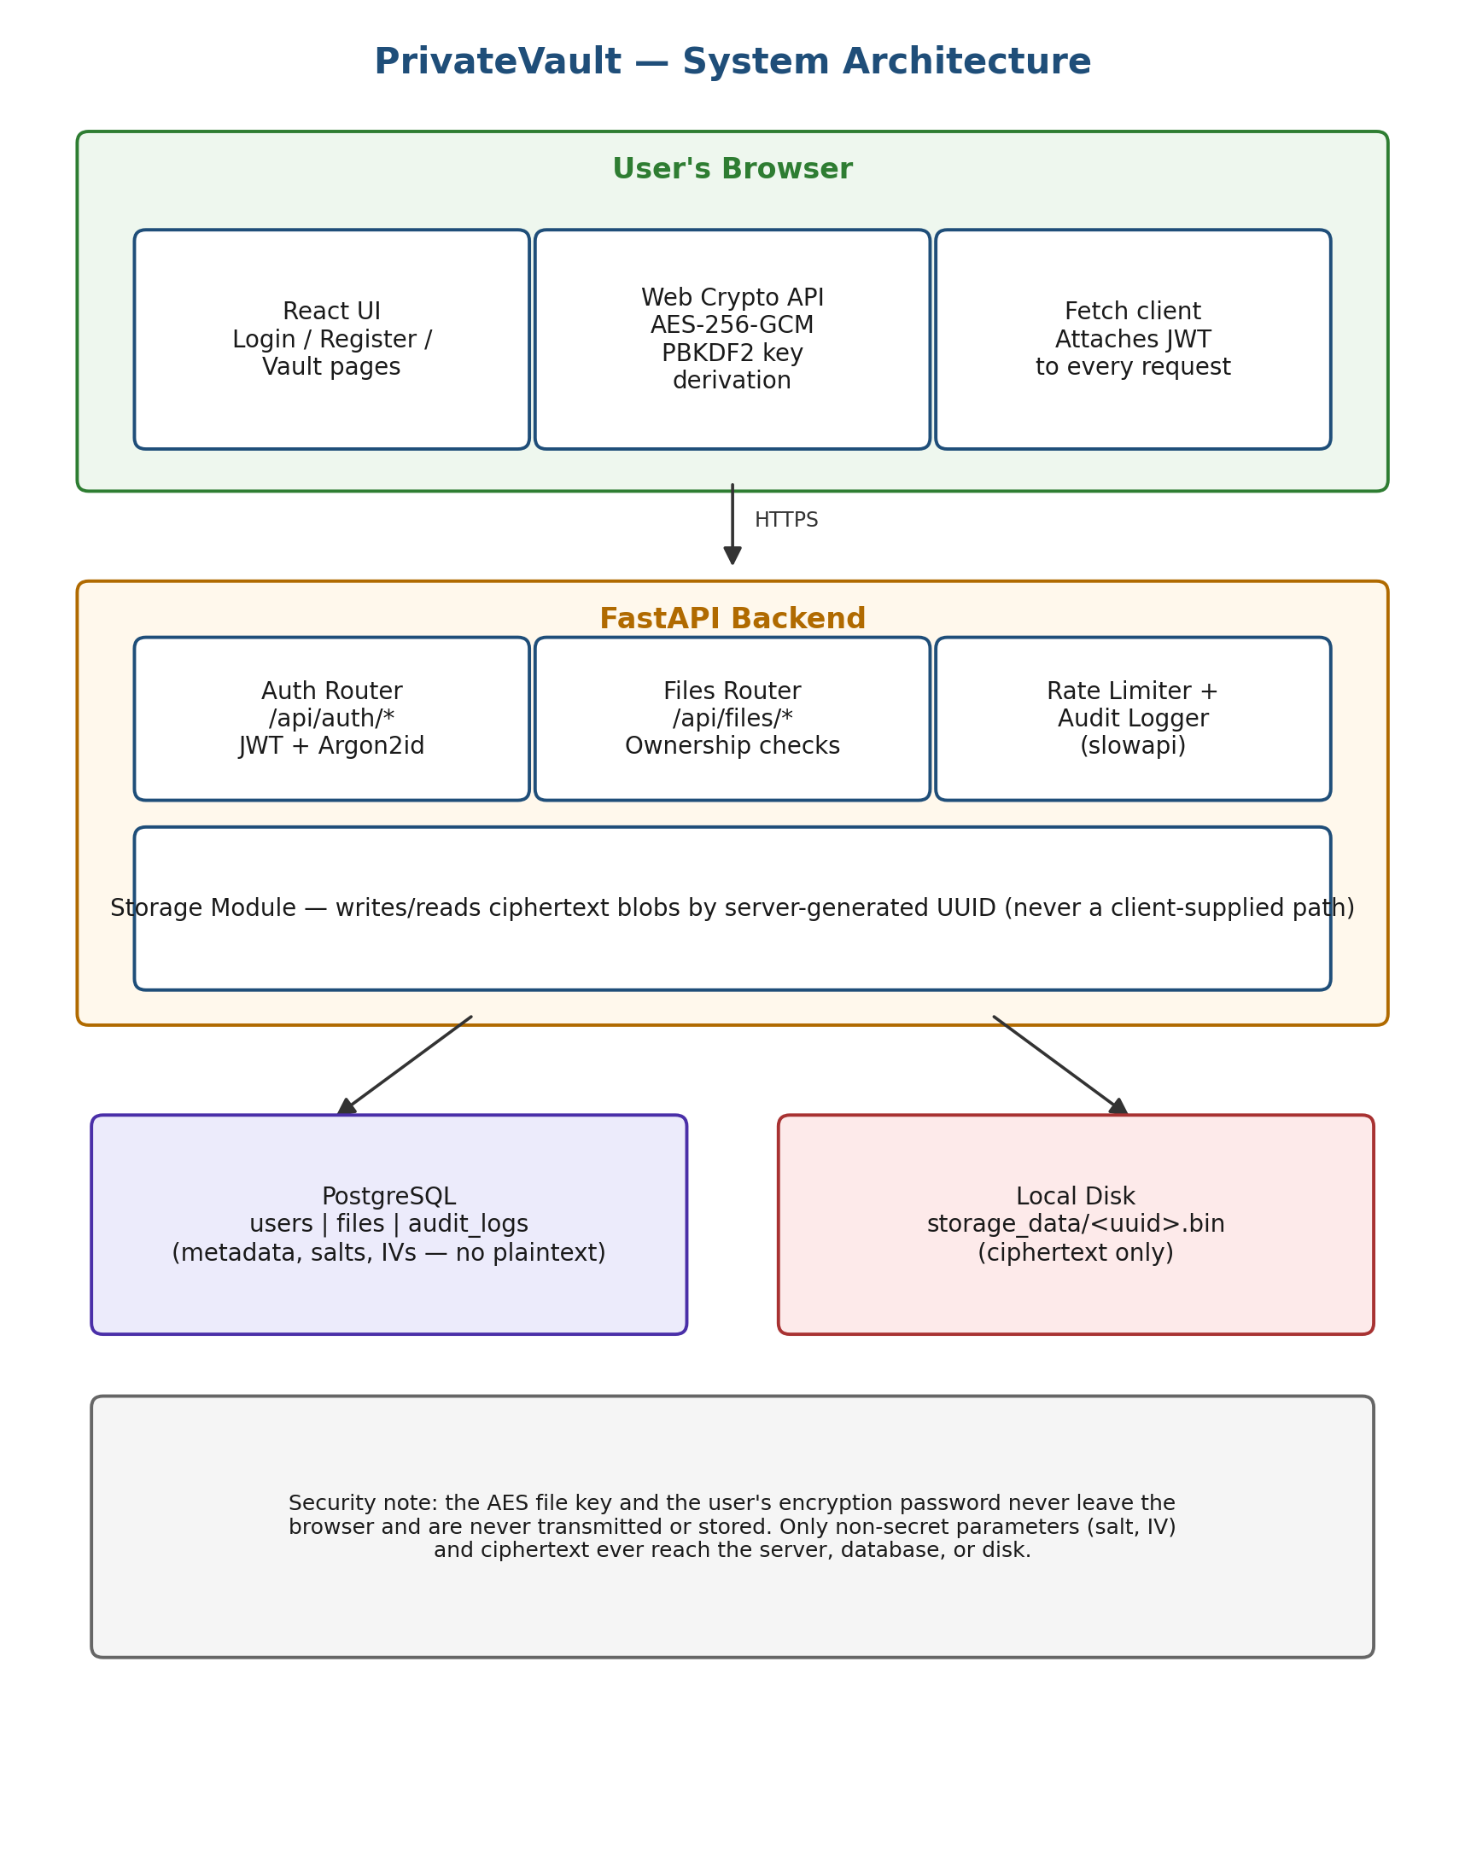
Figure 1: PrivateVault System Architecture

6. Database Schema
The database schema consists of two core tables: users and files, directly matching the data requirements of the web frontend. The users table stores account credentials (email and an Argon2id-hashed password), never a plaintext password and never the encryption password. The files table stores per-file metadata needed to locate and later decrypt a file — including its random salt, IV, and the PBKDF2 iteration count used — but never the file's plaintext content, its unencrypted filename, or its AES key.
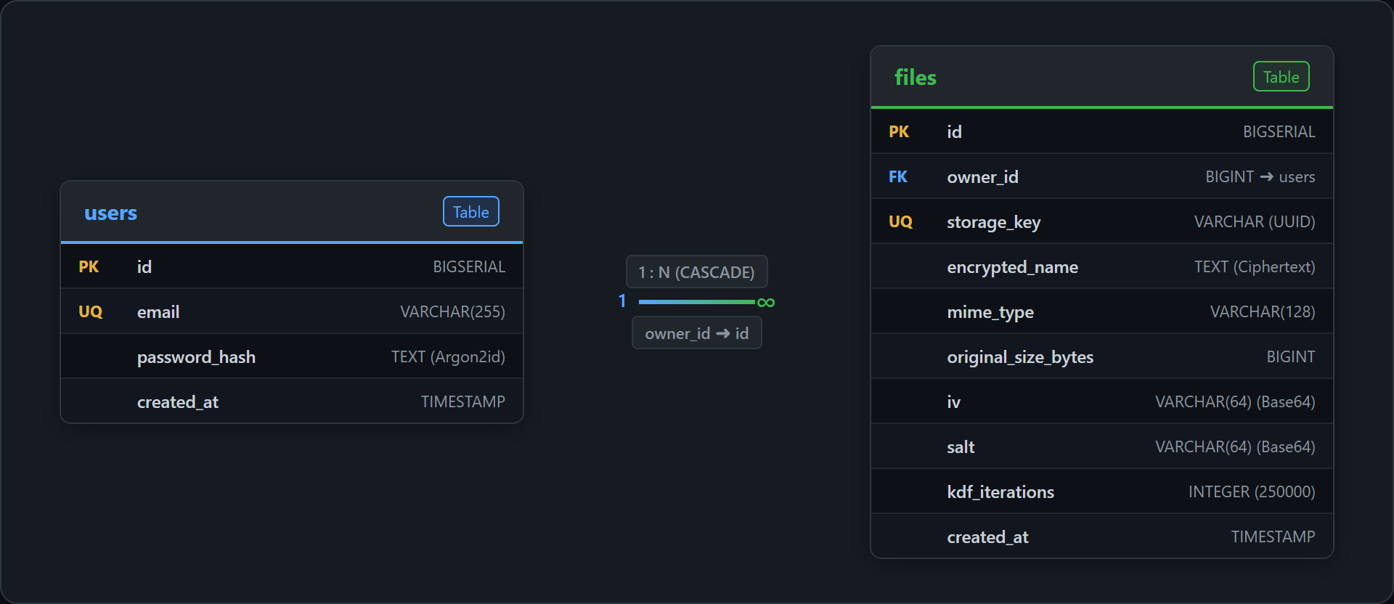
Figure 2: PrivateVault Database Schema (Entity-Relationship Diagram)
Note that the salt and IV stored in the files table are not secret values — AES-GCM and PBKDF2 are designed so that these parameters can be stored and transmitted openly without weakening security, provided the encryption password itself is never exposed. Security depends entirely on the encryption password remaining known only to the user.

7. Client-Side Encryption Design
The core security property of PrivateVault — that the server cannot read stored files — depends entirely on where encryption happens and how the AES key is derived. The system deliberately uses two independent passwords: an account password, used only for login and hashed server-side with Argon2id, and an encryption password, used only inside the browser to derive the AES file key and never transmitted to the server in any form.
The AES key itself is never stored anywhere, on any device. Instead, it is recomputed on demand using PBKDF2-SHA256, from the user's encryption password and a random salt retrieved from the server. Because PBKDF2 is deterministic, the same password and salt always produce the same key — which is what allows a user to decrypt their files from any device or browser, without ever needing to transport or persist the key itself.
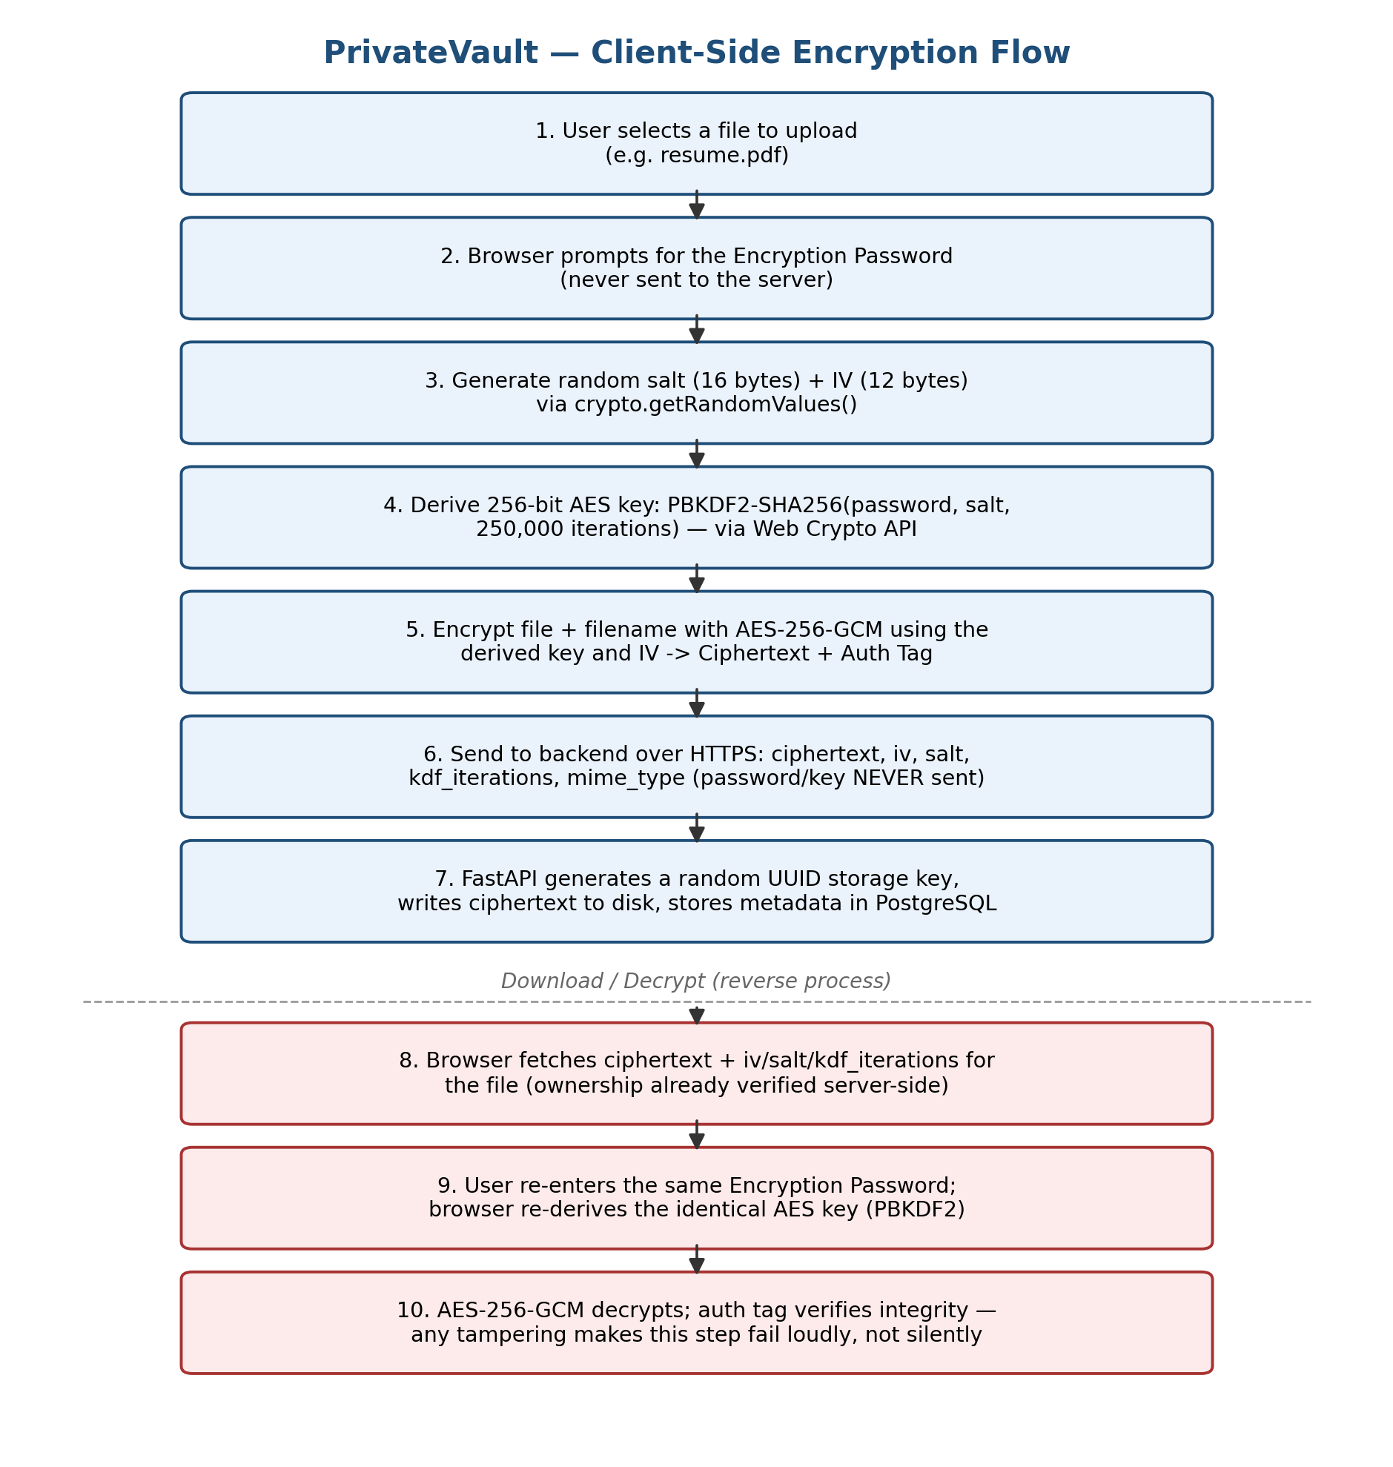
Figure 3: Client-Side Encryption and Decryption Flow
AES-256-GCM was chosen specifically because it provides authenticated encryption: alongside confidentiality, it produces an authentication tag that allows any tampering or corruption of the ciphertext to be detected during decryption. This removes the need for a separate integrity-checking mechanism and directly satisfies the project's integrity-protection objective.

8. Actual Functionalities and Results
The application was executed and verified locally, with the FastAPI backend served on port 8000 and the React frontend on port 5173. Every screenshot presented below was captured directly from the running web application in a standard browser window, following the sequential operational workflow of the user interface. The figures illustrate the complete frontend lifecycle: landing page presentation, user account registration, secure login, initial empty vault dashboard, client-side encryption password entry during upload, protected repository state with encrypted placeholders, in-browser decryption passphrase verification on download, and successful plaintext retrieval.

Figure 4: Home / Landing Page
Full browser screenshot of the landing page showing the PrivateVault brand title, zero-knowledge architectural summary, and access options for user registration and login.
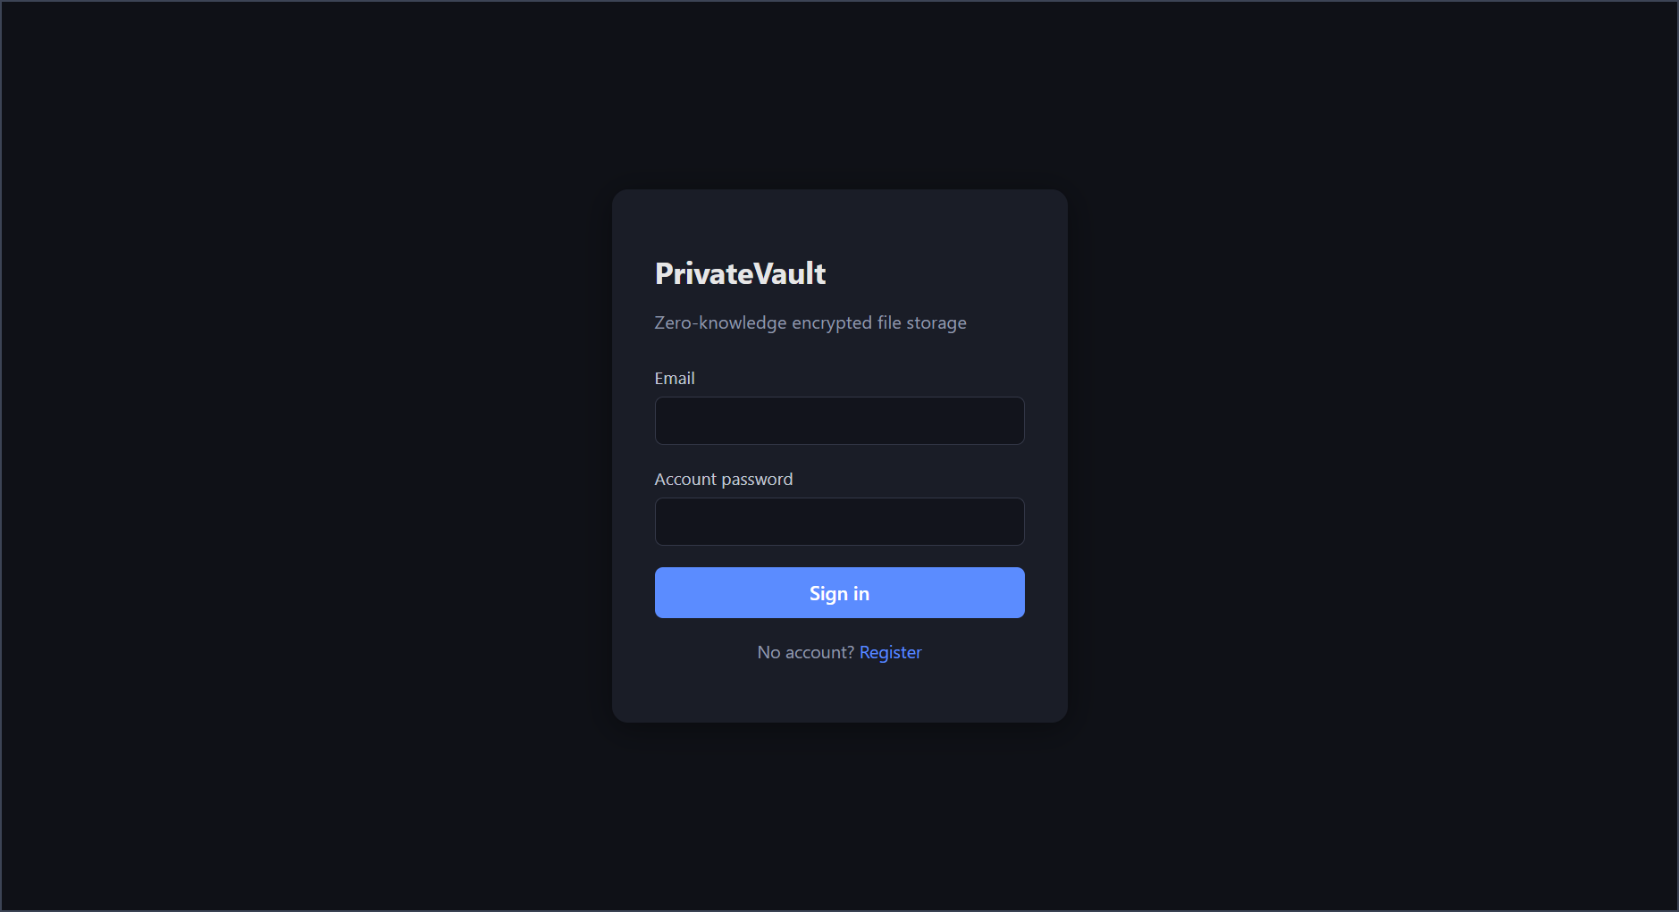
Figure 4: PrivateVault Landing and Authentication Gateway Interface

Figure 5: Register Page
Screenshot of the registration form displaying email and account password fields, highlighting the explicit notice that the account password is reserved strictly for login and is kept separate from file encryption.
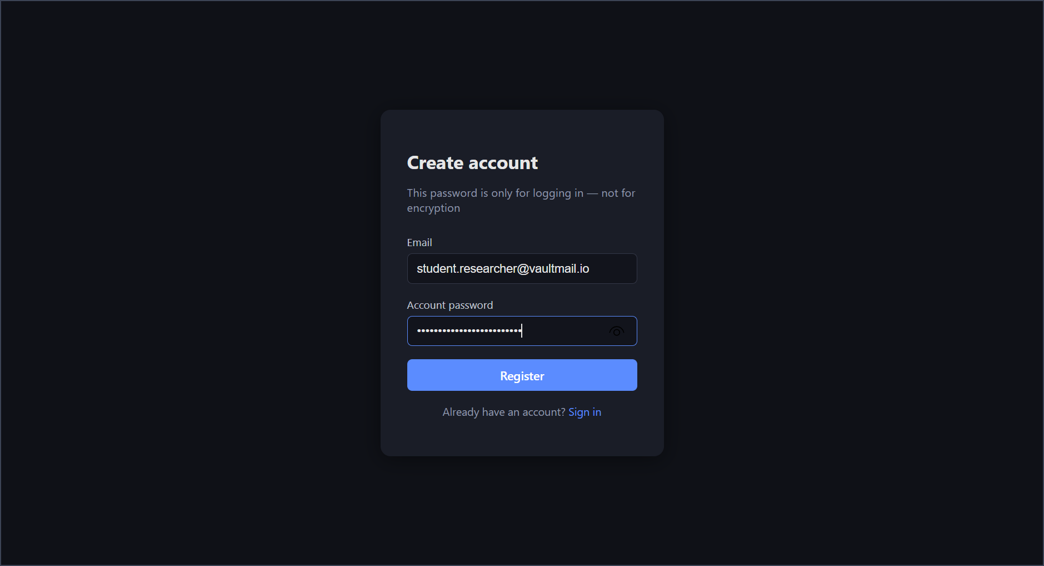
Figure 5: User Registration Portal with Password Separation Notice

Figure 6: Login Page
Screenshot of the user login interface with credentials entered, initiating server-side Argon2id verification and issuing an owner-scoped JWT bearer token for session management.
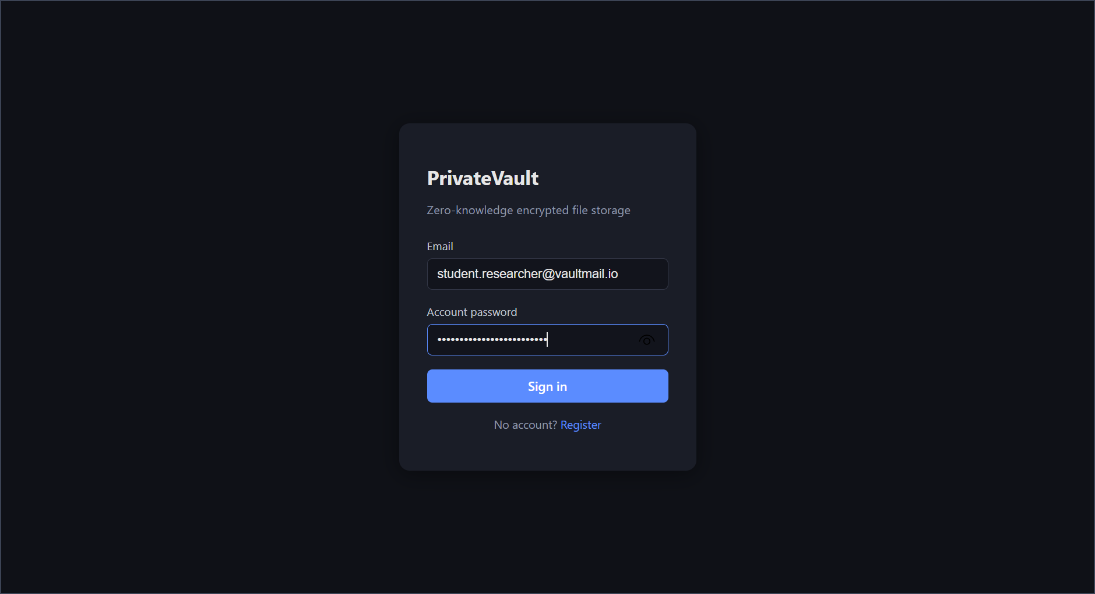
Figure 6: User Login Form with Secure Account Authentication

Figure 7: Vault / File List Page (empty state)
Screenshot of the authenticated Vault dashboard immediately after first login, showing the security warning banner, drag-and-drop file upload zone, and the empty repository state.
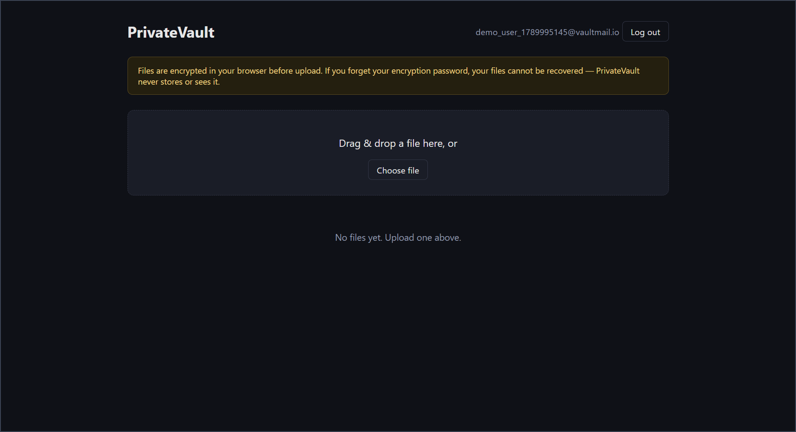
Figure 7: Authenticated PrivateVault Dashboard (Initial Empty State)

Figure 8: Upload Flow — Encryption Password Prompt
Screenshot of the client-side cryptographic dialog prompting the user for their dedicated encryption password at the moment of file selection, ensuring that AES-256-GCM encryption occurs inside the browser before any network transmission.
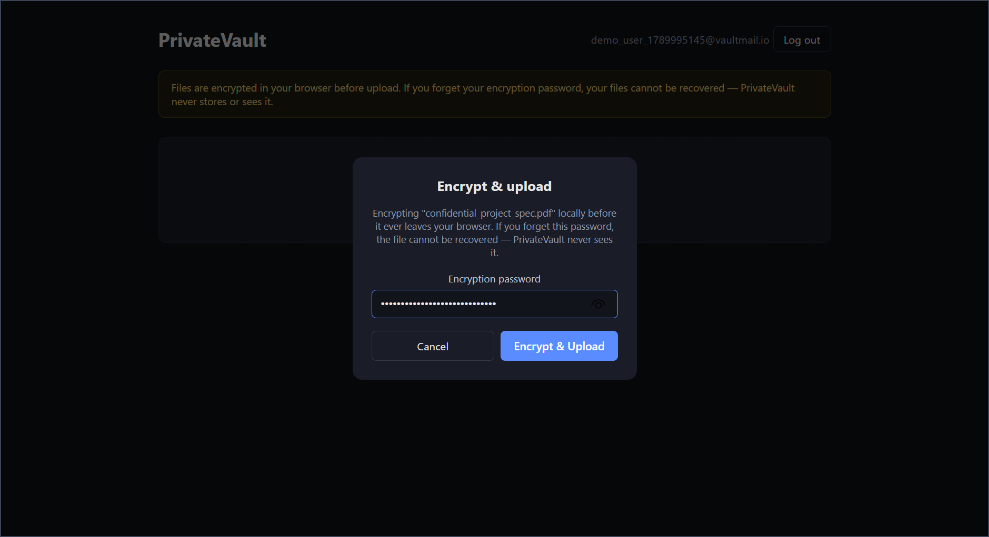
Figure 8: In-Browser Encryption Password Prompt Prior to File Upload

Figure 9: Vault / File List Page (with files)
Screenshot of the Vault file list populated with uploaded files. Rows are displayed with opaque '🔒 Encrypted file #id' labels, demonstrating that filenames are encrypted client-side and remain confidential from the server.
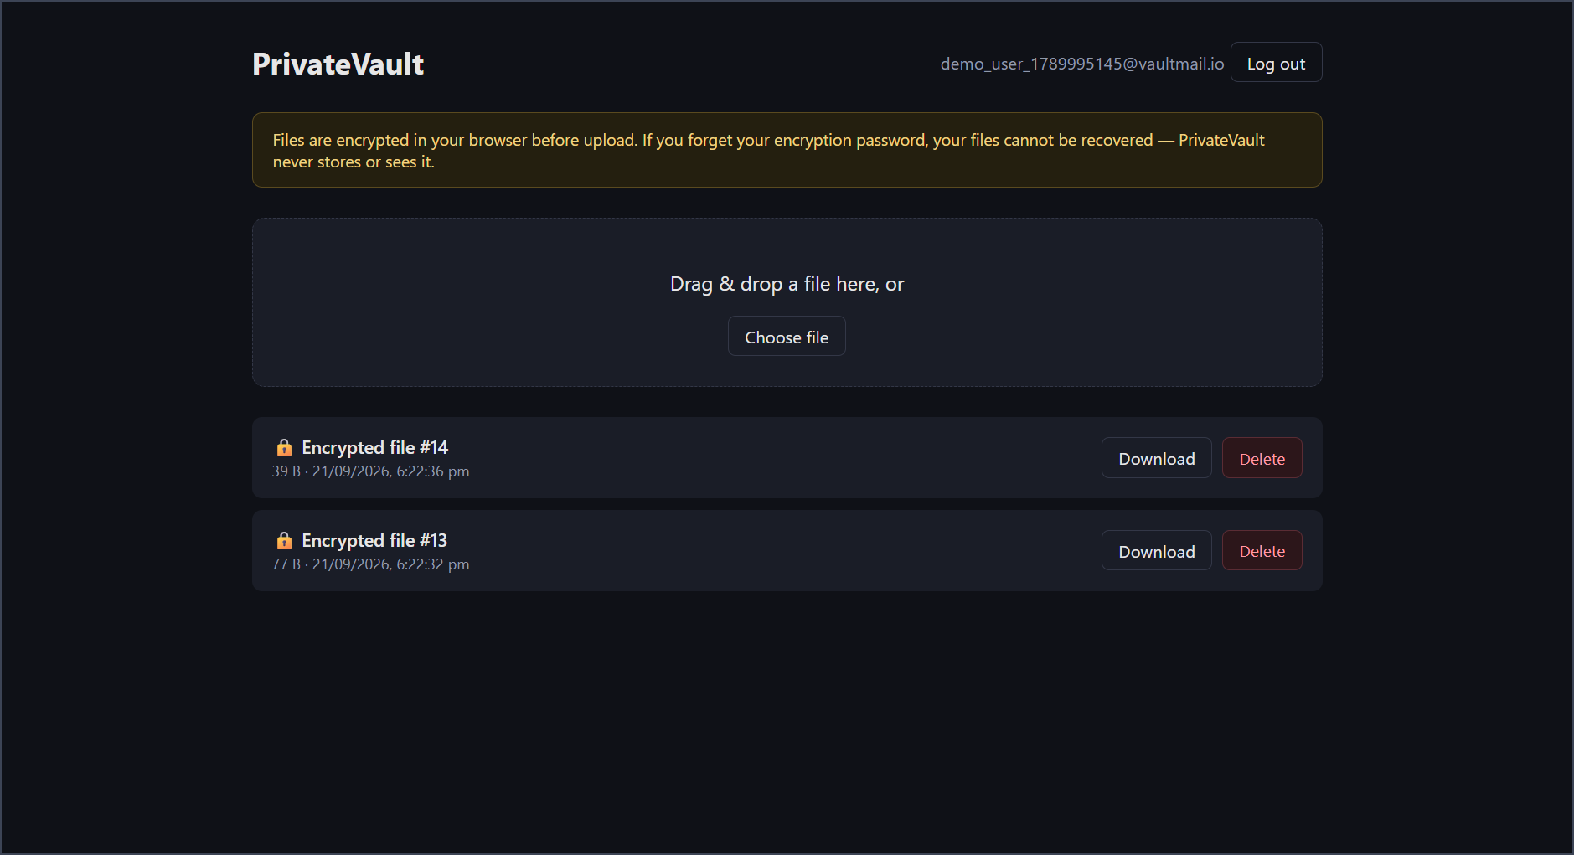
Figure 9: Vault Repository Displaying Client-Side Encrypted File Placeholders

Figure 10: Download Flow — Decryption Prompt
Screenshot of the in-browser decryption prompt displayed upon downloading a file, requesting the encryption password to derive the per-file AES key via PBKDF2-SHA256 from the server-provided salt.
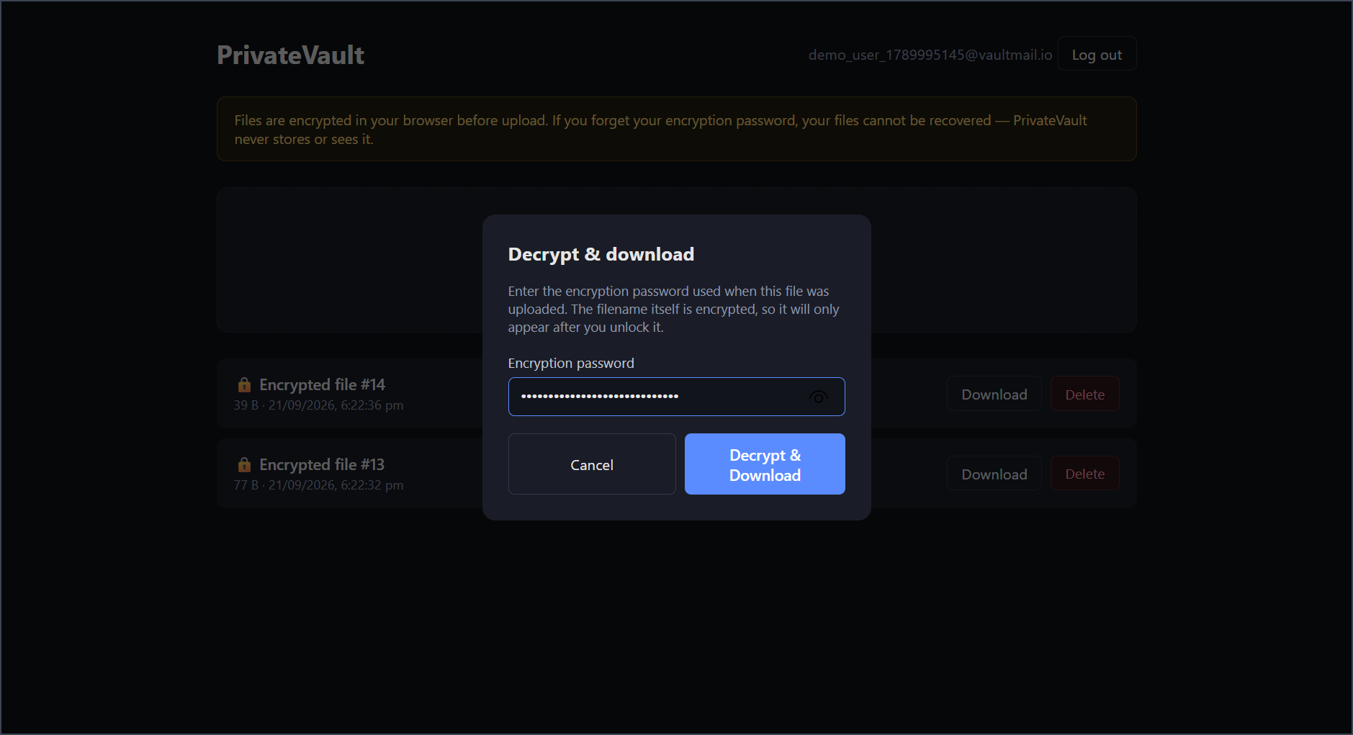
Figure 10: Client-Side Decryption Password Prompt on File Download

Figure 11: Decrypted File Result
Screenshot demonstrating successful client-side decryption, where the genuine original filename is restored in the interface and the decrypted plaintext file is safely downloaded to the user's local machine.
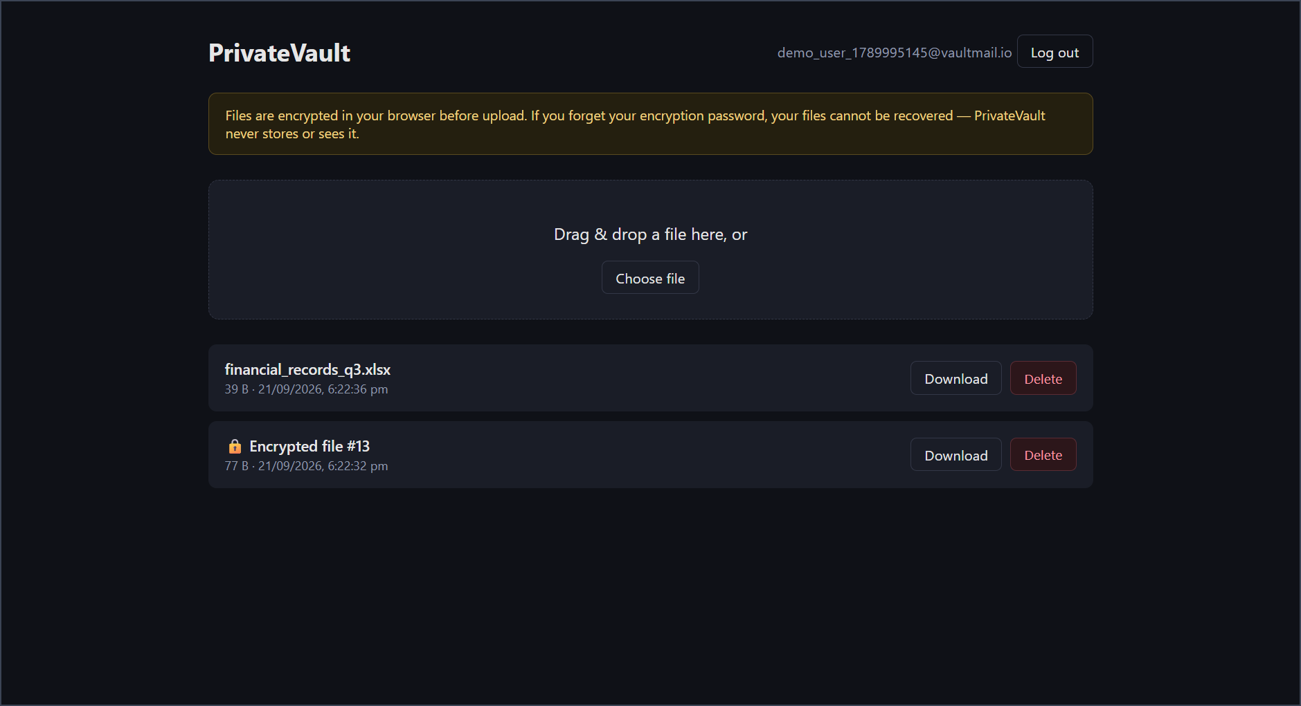
Figure 11: Successful In-Browser Decryption and Original Filename Restoration

9. Testing
The project includes both automated tests (pytest, covering the cross-user authorization boundary) and manual verification steps covering the remaining security properties. All test cases below were verified against the running system.
Test Case | Input / Action | Expected Result | Status
Full round-trip encryption & decryption | Upload file via React UI with client-side AES-256-GCM encryption; download file and enter decryption password. | Ciphertext is fetched and decrypted inside the browser; file is byte-identical to original. | Passed
Cross-user authorization boundary | Automated pytest test (test_cross_user_download_is_forbidden): User B attempts to download or delete User A's file. | Backend checks token user_id against file owner_id; immediately returns HTTP 403 Forbidden. | Passed
Unauthenticated request protection | Automated pytest test (test_unauthenticated_requests_are_rejected): GET /api/files without a JWT token. | Request is rejected prior to database access; returns HTTP 401 Unauthorized. | Passed
Filename confidentiality | Inspect vault UI and PostgreSQL 'files' table after upload. | Original filename is encrypted client-side; vault displays generic '🔒 Encrypted file #id' until unlocked. | Passed

10. Limitations
- A single salt/key derivation strategy is used per file rather than full per-file key-wrapping with a separate master key; the latter is a stronger design documented as future work.
- There is no file-sharing feature — every file is strictly single-owner, and there is currently no mechanism for one user to grant another user access to a file.
- If the encryption password is forgotten, the corresponding files cannot be recovered by any means, including by the system administrator — this is an inherent trade-off of the zero-knowledge design, not an oversight.
- The JWT is stored in browser localStorage for simplicity, which carries a theoretical XSS-exposure trade-off compared to an in-memory-only token.
- File storage uses the local disk rather than a scalable object storage service (e.g. S3-compatible storage), which is suitable for a prototype but not for production-scale deployment.
- The system has been verified functionally and through targeted security tests, but has not undergone a formal third-party security audit or penetration test.

11. Future Scope
- Implement per-file key wrapping, where each file gets its own randomly generated key, itself encrypted ("wrapped") by a master key derived from the encryption password — improving key-rotation flexibility.
- Add a secure file-sharing mechanism, allowing a file's wrapped key to be re-wrapped for a specific recipient without ever exposing it to the server in plaintext.
- Introduce an optional recovery-key mechanism to mitigate the impact of a forgotten encryption password, without weakening the zero-knowledge guarantee for users who opt out.
- Migrate local disk storage to an S3-compatible object storage backend for scalability.
- Add refresh-token rotation and shorter-lived access tokens to reduce the impact of token theft.
- Undergo formal security review or penetration testing before any production use.

12. Conclusion
PrivateVault was implemented as a defensive cybersecurity project and verified by running the complete system end to end. Account authentication, client-side AES-256-GCM encryption, encrypted filename handling, owner-scoped authorization, integrity verification through AES-GCM's authentication tag were all implemented and tested against the running application, as shown by the frontend results and screenshots in this report.
The system successfully demonstrates the core distinction at the heart of this project: encryption in transit (HTTPS) protects data on the network, while encryption at rest in a conventional system still leaves the server capable of reading files. PrivateVault closes that gap by ensuring the server, database, and disk only ever hold ciphertext, non-secret parameters, and metadata — never plaintext, never the encryption password, and never the raw AES key. The main remaining work is to extend the design toward per-file key wrapping, a genuine sharing mechanism, and production-grade infrastructure, as outlined in the Future Scope section.

