

PROJECT REPORT
Course Code: BCSE334L
Course Name: Predictive Analytics
Faculty Name: Pattabiraman V
Slot: B1+TB1
Name: Aaditi Pradeep
Registration number: 23BCE1687

Title
Sprint Intelligence: A Predictive and Prescriptive Analytics Framework for Agile Sprint Risk Assessment

1. Abstract

Agile teams make commitment decisions in the face of uncertainty. Requirements can change for backlog items, they can be resolved significantly longer than anticipated, or they may be reopened after they appear to be resolved. Sprint Intelligence is a predictive and prescriptive analytics framework that can help to detect these risks at an early stage and make more defensible sprint-planning decisions. The study relies on open-source public issue-tracking data and builds a time-safe derived dataset in which only data that can be observed during the first 30 days of an issue is available to a model. There are three prediction tasks: requirement volatility risk, issue resolution risk and issue reopen risk. In addition to a multimodal neural model of resolution risk, classical machine-learning baselines are evaluated. It includes a prediction component, local explanations, a risk aggregation component, and an expected-utility optimisation model that suggests which items are to be committed given the constraints of sprint capacity and dependency. The results indicate that the framework is best used as an early-warning and prioritisation tool, rather than an automatic decision-making tool. The final dashboard reveals the level of risk, evidence-based explanations and suggested actions like Include, Monitor, Split, and Defer.

2. Introduction

2.1 Background and problem statement
The Scrum team needs to determine what items in the backlog are safe to commit to a time-boxed Sprint. This is challenging because the initial stage of an issue may mask unstable requirements, lengthy resolution times, ownership changes or reopen events. Traditional planning is mostly based on experience and manual discussion. That expertise is still needed but historical issue data can be used as a complementary and consistent early-warning signal. The problem addressed by this project is how to transform issue history, comments, workflow events, and early activity into actionable risk information without using information that would only become available after the planning decision.

2.2 Scope
The project studies issue-level risk prediction from public Jira repositories. It encompasses three risks: (i) Requirement Volatility (material requirement related changes after the observation point) (ii) Issue Resolution risk (when an issue is not resolved within the selected horizon) (iii) Issue Reopen risk (when a reopen transition occurs at a later time). The scope includes data engineering, model comparison, local explainability, sprint-level aggregation, and capacity-constrained recommendation.

2.3 Objectives
- Develop leakage-resistant training data from public Jira issue histories using a 30-day observation window.
- Predict requirement volatility risk, issue resolution risk, and issue reopen risk for backlog items.
- Compare interpretable classical models with a multimodal neural model for resolution risk.
- Generate per-issue explanations and aggregate risks into a Sprint Health Score.
- Recommend Include, Monitor, Split, or Defer actions and optimise sprint commitment under capacity and dependency constraints.

2.4 Methodology overview
The work follows a pipeline of collection study, event reconstruction, cutoff-safe feature engineering, label construction, source-aware temporal splitting, feature selection, model development, evaluation, calibration, explainability, risk aggregation, and sprint optimisation. Features are limited to information available at the end of the 30-day observation period at each stage. Later events are only used for labelling and for evaluating predictions.
2.5 Expected results and contribution

The result should be an auditable prototype of a decision support system, not a replacement for Scrum Masters or Product Owners. The framework should include a prioritized list of items to review, describe why they are flagged, measure sprint exposure, and choose a safer candidate portfolio if there is a capacity constraint. Its contribution is the integration of three issue risks, time-aware modelling, multimodal neural learning for resolution risk, and a decision layer based on expected utility, not on arbitrary score weights.

2.6 System workflow
The below figure summarises the end-to-end system. The training pathway reconstructs historical, cutoff-safe data and evaluates models. The inference pathway accepts new candidate items with the same feature schema, scores them without future labels, and presents planning support through the dashboard.
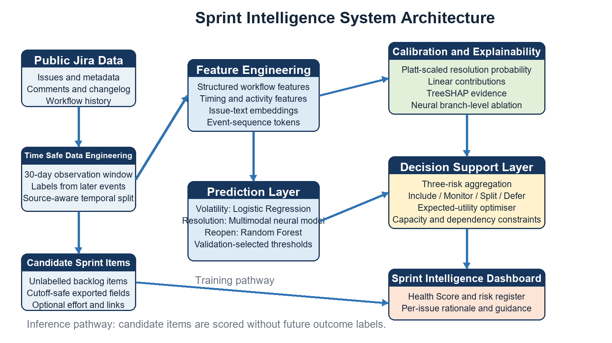

2.6 Conclusion
The rest of this report positions the work in prior research, describes the dataset and methodology, reports experimental outcomes, and discusses limitations and future work.

3. Literature Review
3.1 Overview
Previous research covers software defect prediction, requirements volatility, bug-resolution time, reopened-bug prediction, deep learning, explainable AI, and requirements change management. However, few studies combine all of these components into a single sprint-planning framework.

Study | Main contribution | Limitation or gap
Jayatilleke and Lai, 2018 [1] | Systematically reviews requirement-change management processes, causes, techniques, and decision practices. | Focuses on management practice rather than issue-level machine-learning prediction.
Akbarinasaji et al., 2018 [2] | Replicates bug-fixing-time prediction using Firefox data. | Predicts fixing time, but not broader sprint risk, risk explanation, or mitigation actions.
Soltani et al., 2020 [3] | Shows that report elements such as reproduction steps, stack traces, fix suggestions, and user content can influence bug-resolution time. | Does not combine workflow sequence, text embeddings, probability calibration, and sprint optimisation.
Sepahvand et al., 2020 [4] | Uses word embeddings and deep LSTM networks to classify bugs as fast- or slow-to-fix. | Uses deep learning for time prediction, but not multimodal sprint planning.
Li et al., 2020 [5] | Reviews unsupervised learning techniques for software-defect prediction and highlights reporting-quality concerns. | Does not address supervised issue-level risk labels or planning actions.
Akimova et al., 2021 [6] | Surveys deep-learning methods and open challenges in software-defect prediction. | Primarily focuses on source-code features, not Jira workflow or issue-history data.
Özçelikkan et al., 2022 [7] | Proposes a multi-objective optimisation model for assigning Scrum user stories to sprints. | Plans from known priority and capacity values; it does not estimate per-item delivery risk.
Pachouly et al., 2022 [8] | Reviews AI-based software-defect prediction datasets, validation methods, approaches, and tools. | Identifies shortcomings in feature richness and validation practices rather than delivering an issue-level planning system.
Bhandari et al., 2023 [9] | Reviews data-quality issues in software-fault prediction, including noise, missing values, imbalance, and preprocessing. | Reinforces the need for careful preprocessing and leakage prevention, but does not propose a sprint decision layer.
Zain et al., 2023 [10] | Provides a systematic review and meta-analysis of deep learning in software-defect prediction. | Finds potential for deep learning but stresses parameter tuning, data quality, and study quality.
Mohammad and Kollamana, 2024 [11] | Studies causes and mitigation practices for requirement volatility in Agile projects. | Qualitative study; it does not perform issue-level predictive modelling.
Aversano et al., 2025 [12] | Forecasts weekly bug-resolution time using machine learning and deep learning on GitBugs; Random Forest performs best overall. | Uses weekly aggregates rather than individual issues and excludes unresolved bugs, which can bias results.
ForouzeshNejad et al., 2025 [13] | Uses an artificial neural network with SHAP to predict Agile project status from 22 agility features. | Works at project level using team and process features, not issue-level Jira history.
Alaswad et al., 2026 [14] | Introduces Hybrid Intelligence Effort, showing that story points may miss human oversight effort in LLM-assisted development. | Not a risk-prediction study. It supports the limitation that priority and story points are imperfect value and effort proxies.
Ardimento et al., 2025 [15] | Uses an LLM-based FAST/SLOW bug-fixing-time classifier from Bugzilla bug text and comments. | Uses text-focused prediction; it has no workflow sequence, probability calibration, or sprint decision layer.

3.2 Research gap
The studies reviewed indicate that each of the following aspects has been studied independently: requirement volatility, bug-resolution time, defect prediction, deep learning, explainability, and sprint optimisation. However, there is limited work that integrates them into one practical sprint-planning framework. The studies on requirement-volatility are primarily concerned with change-management processes or qualitative mitigation practices [1, 11]. There are several studies that predict the time to fix bugs based on the content of the bug report, sequential text, or weekly time-series data [2-4, 12, 15]. Deep-learning and defect-prediction reviews indicate the potential for complex learning models, and also highlight the need for data quality, class imbalance, validation design, and parameter tuning [5, 6, 8–10]. Meanwhile, sprint planning optimisation processing chooses user stories based on capacity and priority, but usually takes risks as already known and not predicted [7]. Project-level ANN and SHAP models can give valuable managerial insight but cannot pinpoint the risk of a single backlog item [13].
Therefore, the key gap is the absence of an integrated, issue-level predictive-and-prescriptive system that:
- uses only early, cutoff-safe Jira information
- predicts multiple sprint risks
- integrates workflow data, text and event sequences
- explains why an individual issue was flagged
- calibrates risk probabilities before decision-making
- proposes a capacity-aware sprint action (Include, Monitor, Split, Defer).
Sprint Intelligence tackles this challenge by providing a 30-day observation window, source-aware temporal evaluation, three issue-level risk models, neural multimodal resolution prediction, local explainability and expected-utility optimisation.
3.3 Review summary

The literature chosen supports the design choices of Sprint Intelligence and justifies the design limitations. Deep learning is added because it can learn from complex text and sequence signals [4, 6, 10] and Logistic Regression and Random Forest are important baselines as they are interpretable and perform well on structured data. The literature also demonstrates that model outputs should be used as signals for decision making and not as decisions. As a result, the framework prioritizes and marks issues by using the model, and the Scrum Master or Product Owner still has the final say on what to commit to a sprint.vc

4. Dataset and Data Engineering

4.1 Dataset selection
The primary data source is a public Jira issue-tracking dataset assembled from multiple public projects. It contains issue metadata, descriptions, comments, changelog/history records, status transitions, assignee changes, priorities, and related workflow information. The multi-project design improves diversity relative to an Apache-only sample, while the collection structure still permits source-aware evaluation.
Derived dataset version | Records / purpose | Main contribution
V1 training dataset | 40,013 issues across SecondLife, JiraEcosystem, IntelDAOS, and Hyperledger. | Time-safe engineered features and three task labels.
V1.2 effort-enhanced dataset | v1 plus safely reconstructed story-point / effort coverage where available. | Enables capacity-aware sprint optimisation for eligible items.

4.2 Source composition
Source collection | Approximate records
SecondLife | 1,867
JiraEcosystem | 5,000
IntelDAOS | 5,000
Hyperledger | 28,146
Total | 40,013

4.3 Observation window and leakage prevention

The first 30 calendar days of each issue are observed. For instance, if an issue is created on 1 January, the model can include the text, comments, status changes, and assignee changes that occurred up to 31 January. It cannot use an input of a later reopen, a later requirement update, or a final resolution time. The later events are reserved for labels. The 30-day timeframe is a practical early warning time, long enough to see planning and workflow activity at the beginning, but short enough to allow for an early sprint-planning intervention.

4.4 Feature engineering
Feature group | Examples available by cutoff | Purpose
Issue text | Summary, description, comment text, text length. | Captures issue context and requirement language.
Workflow activity | History count, changelog item count, status changes, assignee changes, priority changes. | Represents early process instability and coordination load.
Timing and velocity | Days to first comment, days to first assignee change, inactivity gap, active days, events per day. | Captures response speed and early momentum.
Participation | Unique commenters, changelog authors, developer activity count. | Approximates communication and coordination patterns.
Categorical state | Priority, issue type, status, assignee availability, snapshot reconstruction status. | Represents initial operational state.
Effort | Story points or effort estimate when reconstructable at cutoff. | Supports sprint-capacity optimization, missing values remain explicit.

4.5 Sample derived records
The below table presents an structural sample based on early records in the derived dataset. Long text has been abbreviated for readability.
Field | Example
Issue Key | FAB-353
Source | Hyperledger
Story Points | 24
Priority | High
Early Comment Count | 5
Early Status Changes | 4
Early Assignee Changes | 2
Maximum Inactivity Gap | 8 days
Event Sequence | Created → Assigned → Status Changed → Commented → Reassigned
Resolution Label | 1, delayed-resolution outcome observed after cutoff

The label is shown only to illustrate the training schema.

4.6 Label construction
Future requirement related updates are labelled as requirement volatility. Resolution risk is tagged when the problem is not resolved by the chosen resolution deadline since it was created (180 days). Reopen risk is labelled from a future reopen transition within the defined horizon. Historical records are kept with label eligibility flags since not all historical records have adequate follow up for all tasks.

5. Methodology and Models

5.1 Data preparation and splitting

Numerical values are imputed in the training pipeline. Categorical values such as priority, issue type, source, and status are one-hot encoded. Numerical features are scaled as needed and text is transformed separately. The data is partitioned source-aware and temporally i.e. earlier issues in every source form the training data, followed by validation and test stages. This will not allow a model to get an unrealistic advantage by learning from future problems from the same source. Each source collection is sorted by time and divided into 70% training data, 15% validation data and 15% test data.

5.2 Baseline models
Model | Role in study | Reason for inclusion
Logistic Regression | Requirement volatility selected model. | Interpretable linear baseline, coefficients enable per-feature contributions.
Random Forest | Resolution and reopen baseline / selected classical model. | Handles non-linear tabular interactions and mixed feature groups.
Gradient boosting models | Comparative baseline candidates. | Tests whether boosted trees improve ranking over linear and bagged-tree models.

5.3 Multimodal neural model for issue resolution risk

The neural model is coded in TensorFlow and Keras. It has 3 input branches.

i) The preprocessed numerical and categorical Jira features are fed into the structured branch via dense layers.

ii) The text branch is composed of all-MiniLM-L6-v2 SentenceTransformers encoder embeddings followed by dense layers.

iii) Early workflow-event sequences are fed into the event-sequence branch via a gated recurrent unit (GRU).

The three learned representations are concatenated and fed into dense layers with dropout before an output sigmoid estimate the resolution risk. This design is multimodal as it uses tabular, textual and sequential evidence, instead of all evidence being a flat feature vector.
The neural model uses binary cross-entropy loss.
Loss = -[ylog(p) + (1-y)log(1-p)]
Where, y is the true label and p is the predicted probability.

5.4 Model selection and thresholding
Precision, recall, F1-score, ROC-AUC and Accuracy are used to compare models, as appropriate. F1-score is appropriate when precision and recall need to be balanced, ROC-AUC gives an idea of ranking capability and PR-AUC is informative for rare positive events. Thresholds are chosen based on validation data and not on the final test labels, depending on the decision context. For resolution risk, recall is weighted more heavily because missing a likely delayed item can be costly during planning.

5.5 Explainability
The framework generates local rather than only global explanations. Logistic Regression explanations use a feature contribution relative to the training reference value. Random Forest explanations use local TreeSHAP-style contributions. For the neural resolution model, branch-level ablation is used- the complete prediction is computed first, then one branch at a time is replaced with its neutral training reference while the other branches remain unchanged. The change in probability indicates the sensitivity of that prediction to the structured, text, or event-sequence evidence. These are explanations of model behaviour, not proven causal statements about project outcomes.

5.6 Risk aggregation and action recommendation
A combined risk score aggregates volatility, resolution, and reopen probabilities with a higher emphasis on resolution risk. The dashboard maps the profile to an action: Include for low exposure, Monitor for targeted follow-up, Split for work that should be decomposed, and Defer for high exposure. The action is a deterministic planning rule and is separate from free-form mitigation guidance.
Rule | Action
High Resolution Risk or high combined risk | Defer
High Requirement Volatility Risk | Split
High Reopen Risk | Monitor
No major threshold crossed | Include

5.7 Sprint optimisation

A binary decision variable x_{i} is used for effort-qualified candidate items to represent the commitment of the item (1) or its placement in reserve (0). The optimiser is designed to maximize the expected utility given a capacity constraint and named dependency constraints. The utility is

U_{i} = V_{i}(1-r_{i}) - V_{i,}r_{i}

where V_{i} is a normalised value proxy based on the priority, r_{i} is the calibrated probability of resolution risk.

6. Results and Discussion

6.1 Selected model results
Prediction task | Selected model | Precision | Recall | F1-score | Accuracy | ROC-AUC | Interpretation
Requirement volatility | Logistic Regression | 0.415 | 0.671 | 0.512 | 0.847 | 0.689 | Targeted early-warning signal for a relatively infrequent outcome.
Issue resolution | Random Forest | 0.307 | 0.805 | 0.444 | 0.495 | 0.615 | High-sensitivity screening model; detects about 9 of 10 likely delayed issues.
Issue reopen | Random Forest | 0.356 | 0.588 | 0.443 | 0.745 | 0.684 | Rare-event ranking signal, suitable for review prioritisation.

6.2 Neural resolution model results
Model | Precision | Recall | F1-score | ROC-AUC | Accuracy | PR-AUC | Use in framework
Multimodal neural resolution model | 0.389 | 0.853 | 0.534 | 0.626 | 0.505 | 0.467 | Used in dashboard for multimodal resolution-risk explanation.
Random Forest resolution model | 0.307 | 0.805 | 0.444 | 0.615 | 0.495 | 0.425 | High-sensitivity screening model; detects about 9 of 10 likely delayed issues.

The neural model performs better than the Random Forest (ROC-AUC 0.626 vs. 0.615) and shows a higher PR-AUC, which means that it provides good separation of positive cases. The final framework thus states that neural learning is useful for multimodal modelling and branch-level explanation, whereas the calibrated tree model is still a viable option for the portfolio experiment for current expected-utility.

6.3 Discussion
The highest practical performance is achieved by the high recall of the resolution-risk model. In a sprint-planning environment, an extra review of a flagged item is typically cheaper than not noticing a probable delayed item. Volatility and reopen prediction are more difficult because the positive events are comparatively rare. The ROC-AUC values of 0.68 for volatility and 0.68 for reopen still show useful values for the risk ranking.
The data is not inherently invalid because the scores are modest. Instead, the tasks are noisy, the labels are partial approximations to actual planning risk, the story point coverage is incomplete, and the public repositories vary significantly in conventions. A more complex model cannot recover signals absent from the data. Improvements should therefore prioritise richer cutoff-safe features, better project-level context, threshold calibration, and prospective evaluation over simply adding neural-network depth.

6.4 Optimisation interpretation
The expected-utility optimiser is evaluated retrospectively on pseudo-sprints constructed from held-out, effort-qualified records. It tends to lower the share of failed commitments and the capacity wasted on failed work, at the cost of some realised value. It is the natural and correct response of a risk-aware planner, when the risk of failure is high, it is deliberately conservative. It is not evidence of the system altering historical outcomes, but rather a measure of the quality of the selections in a replay experiment.

7. System Prototype

7.1 Technology stack
Layer | Technology | Purpose
Data and ML | Python, pandas, scikit-learn | Dataset construction, baselines, preprocessing, calibration, evaluation.
Neural learning | TensorFlow and Keras | Multimodal dense and GRU resolution-risk model.
Text representation | SentenceTransformers all-MiniLM-L6-v2 | Compact semantic issue-text embeddings.
Explainability | Coefficient contributions, TreeSHAP, branch ablation | Per-issue evidence for classical and neural predictions.
Optimisation | PuLP | Capacity-constrained binary programme.
Application | Python backend, HTML, CSS, JavaScript | Interactive sprint-planning dashboard.

7.2 Dashboard workflow
A user uploads model-ready candidate items. The backend provides risk probabilities, risk bands, recommended actions, explanations, and sprint level statistics, based on the optimisation probability. The dashboard displays sprint capacity and recommended committed work, a Sprint Health Score, action distribution, a filterable backlog table, and a per-issue drill-down. The drill-down links the action to observed model evidence while mitigation guidance is separated from the deterministic decision rule.

8. Conclusion and Future Work

8.1 Conclusion

Sprint Intelligence shows the entire journey of transforming public issue-tracking data into a usable planning decision-support prototype. It is capable of creating time-safe features, forecasting three different risks, comparing classical and neural models, calibrating probabilities, explaining individual predictions, and translating issue-level risk to capacity-aware sprint suggestions. The resolution-risk model is the most robust operational model, and volatility and reopen models provide helpful but prudent ranking signals. The system should not be used to replace the judgment of Scrum Masters or Product Owners, rather support the discussion and review.

8.2 Future work
- Collect a larger and more complete set of repositories with reliable story points, sprint membership, links, and cutoff-safe dependency graphs.
- Improve rare-event modelling through cost-sensitive learning, better temporal representations, and project-adaptive calibration.
- Incorporate real business value, team capacity, skills, and explicit dependency uncertainty into the optimisation model.

9. References
[1] S. Jayatilleke and R. Lai, “A systematic review of requirements change management,” Information and Software Technology, vol. 93, pp. 163–185, 2018.
[2] S. Akbarinasaji, B. Caglayan, and A. B. Bener, “Predicting bugfixing time: A replication study using an open source software project,” Journal of Systems and Software, vol. 136, pp. 173–186, 2018.
[3] M. Soltani, F. Hermans, and T. Bäck, “The significance of bug report elements,” Empirical Software Engineering, vol. 25, pp. 5255–5294, 2020.
[4] R. Sepahvand, R. Akbari, and S. Hashemi, “Predicting the bug fixing time using word embedding and deep long short term memories,” IET Software, vol. 14, no. 3, pp. 203–212, 2020.
[5] Z. Li, M. Shepperd, and Y. Guo, “A systematic review of unsupervised learning techniques for software defect prediction,” Information and Software Technology, vol. 122, art. no. 106287, 2020.
[6] E. N. Akimova, A. Y. Bersenev, A. A. Deikov, K. S. Kobylkin, A. V. Konygin, I. P. Mezentsev, and V. E. Misilov, “A survey on software defect prediction using deep learning,” Mathematics, vol. 9, no. 11, art. no. 1180, 2021.
[7] N. Özçelikkan, G. Tuzkaya, C. Alabas-Uslu, and B. Sennaroglu, “A multi-objective agile project planning model and a comparative meta-heuristic approach,” Information and Software Technology, vol. 151, art. no. 107023, 2022.
[8] J. Pachouly, S. Ahirrao, K. Kotecha, G. Selvachandran, and A. Abraham, “A systematic literature review on software defect prediction using artificial intelligence: Datasets, data validation methods, approaches, and tools,” Engineering Applications of Artificial Intelligence, vol. 111, art. no. 104773, 2022.
[9] K. Bhandari, K. Kumar, and A. L. Sangal, “Data quality issues in software fault prediction: A systematic literature review,” Artificial Intelligence Review, vol. 56, no. 8, pp. 7839–7883, 2023.
[10] Z. M. Zain, S. B. Sakri, and N. H. A. Ismail, “Application of deep learning in software defect prediction: Systematic literature review and meta-analysis,” Information and Software Technology, vol. 158, art. no. 107175, 2023.
[11] A. Mohammad and J. M. Kollamana, “Causes and mitigation practices of requirement volatility in agile software development,” Informatics, vol. 11, no. 1, art. no. 12, 2024.
[12] L. Aversano et al., “Time series forecasting for bug resolution using machine learning and deep learning models,” Frontiers in Big Data, vol. 8, 2025.
[13] A. A. ForouzeshNejad, F. Arabikhan, A. Gegov, R. Jafari, and A. Ichtev, “Data-driven predictive modelling of agile projects using explainable artificial intelligence,” Electronics, vol. 14, no. 13, art. no. 2609, 2025.
[14] F. Alaswad, E. Poovammal, K. Ramana, G. S. Narayana, A. A. Khan, and M. Faheem, “Hybrid intelligence effort for software effort estimation in LLM assisted development,” Discover Computing, vol. 29, no. 1, 2026.
[15] P. Ardimento, M. Capuzzimati, G. Casalino, D. Schicchi, and D. Taibi, “A novel LLM-based classifier for predicting bug-fixing time in bug tracking systems,” Journal of Systems and Software, vol. 230, art. no. 112569, 2025.

10. Appendix
Code snippets:
Neural_model.ipynb:
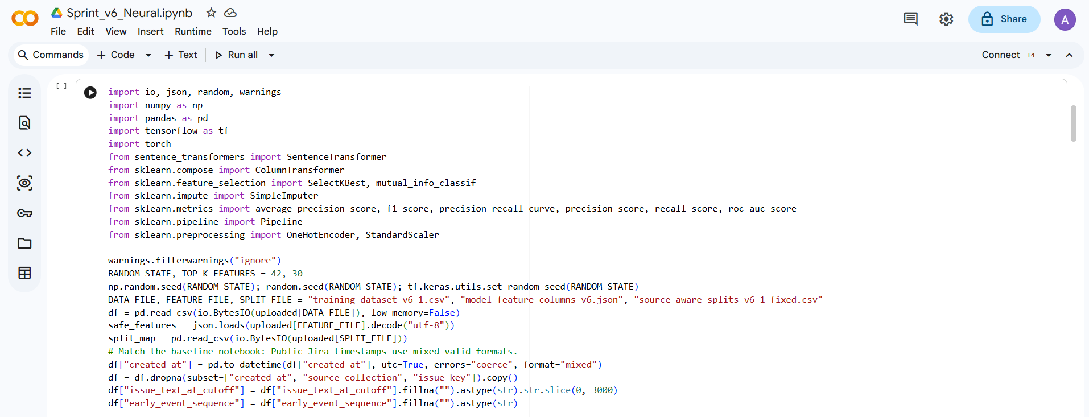
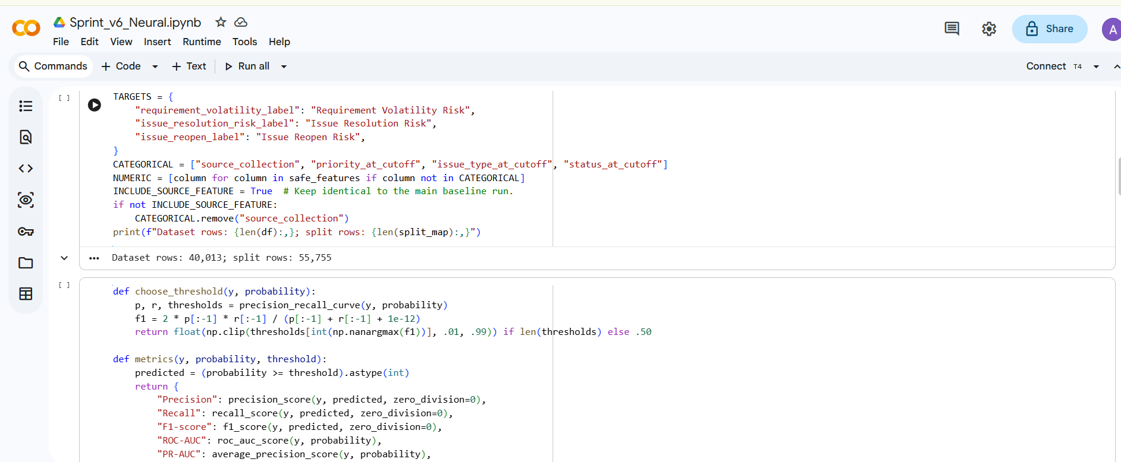
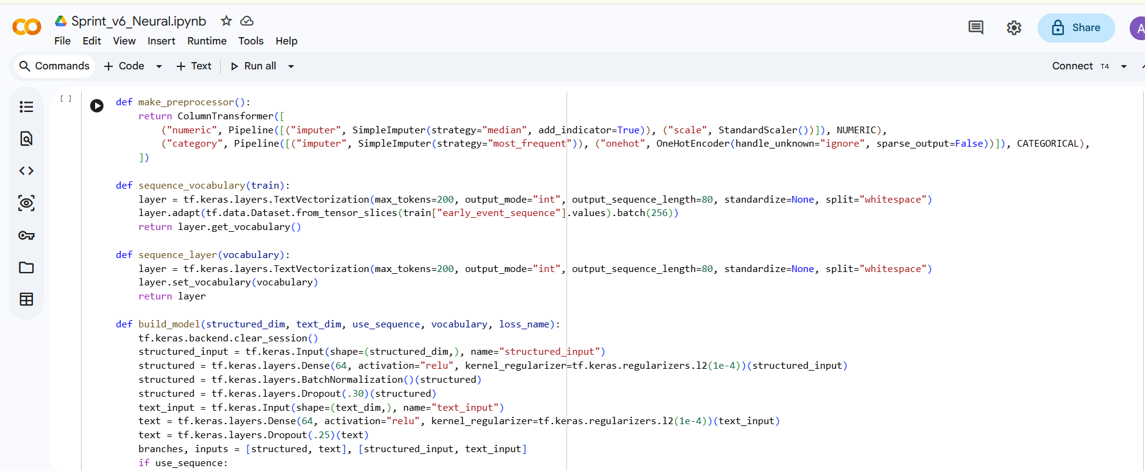
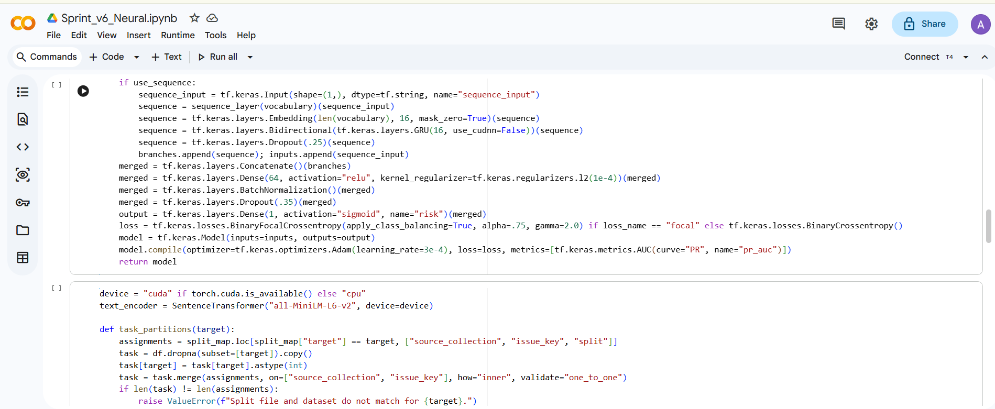
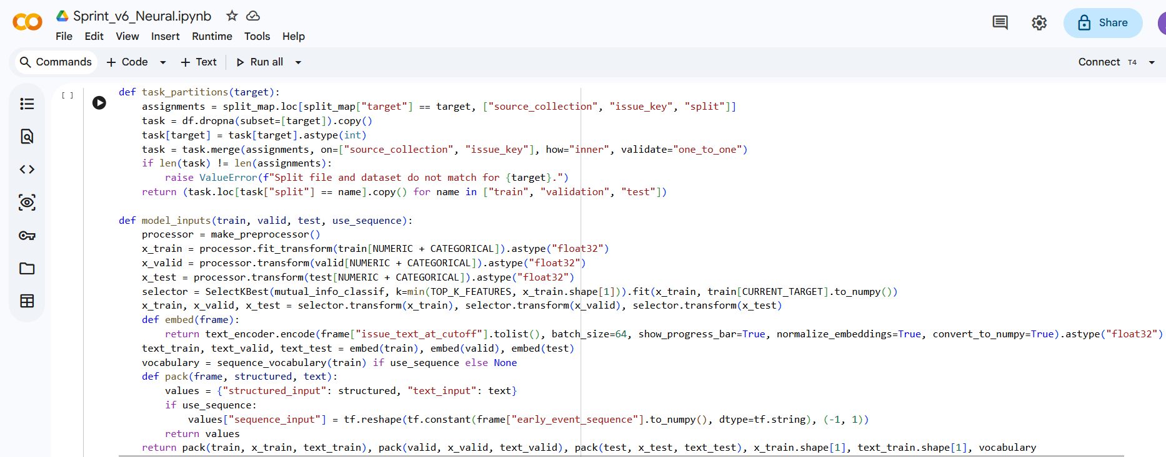
Classical model:
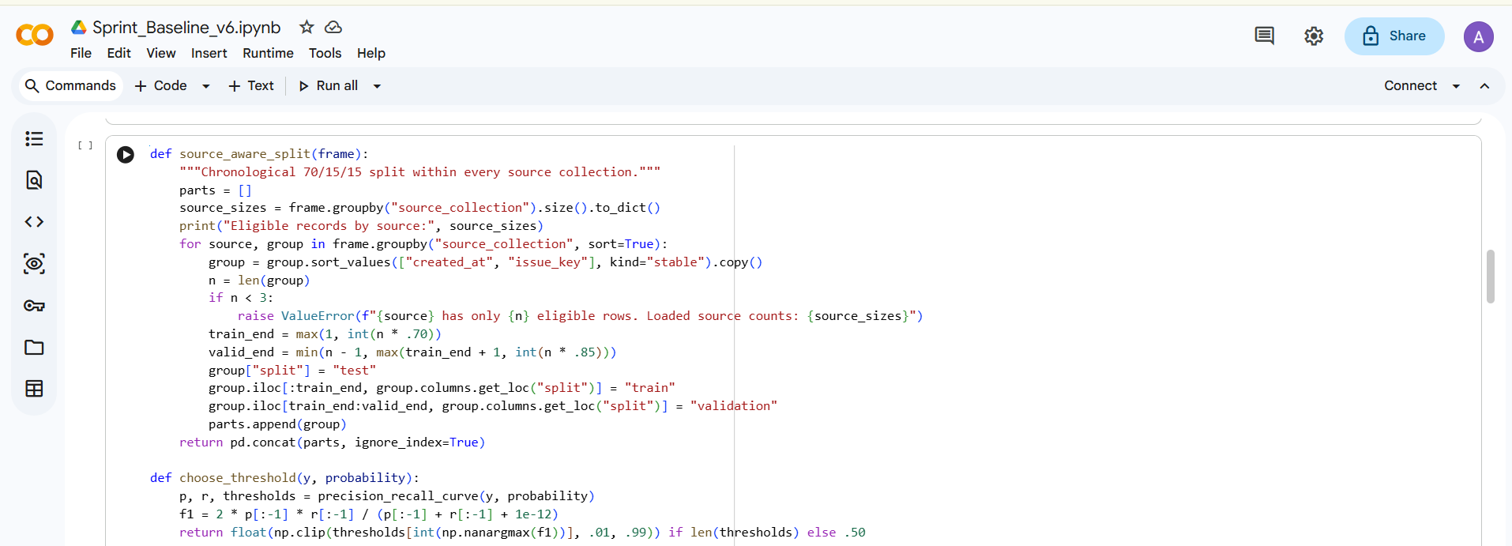
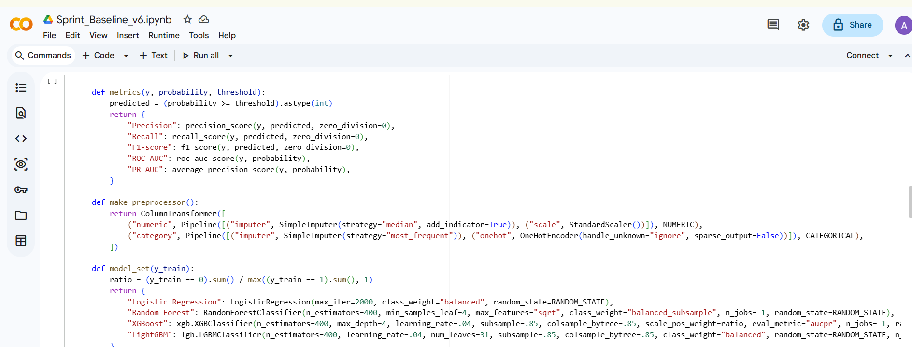
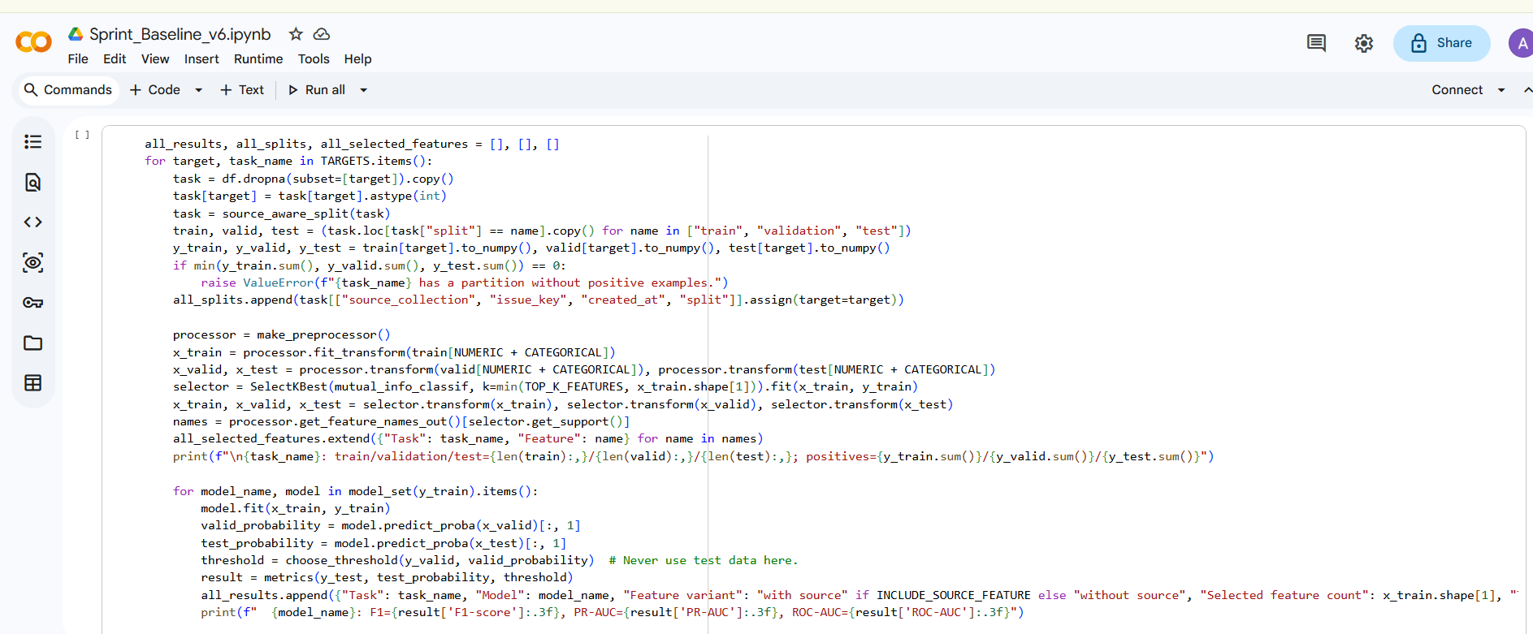
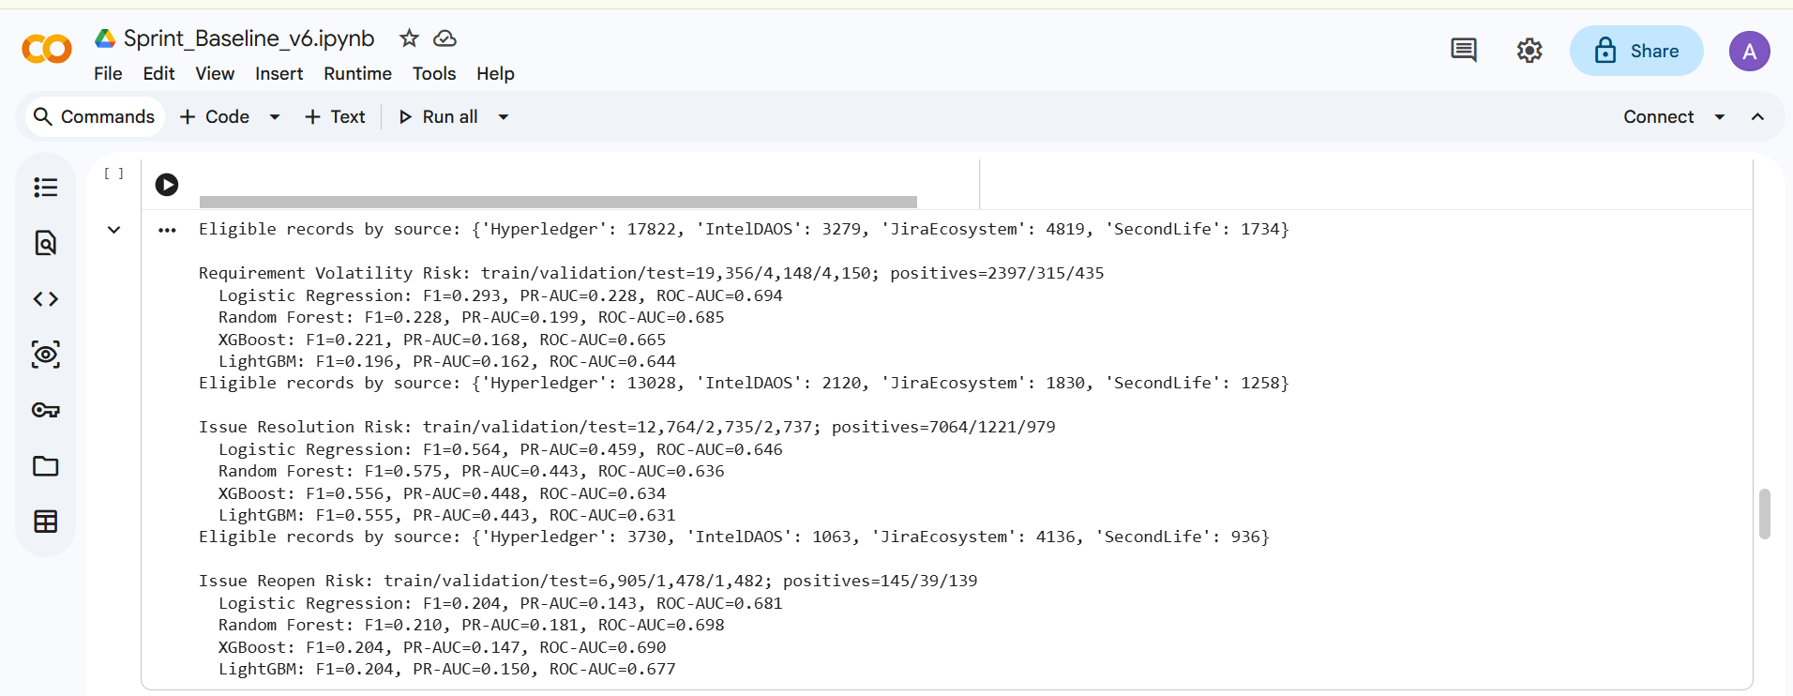
Output:


