**ASSIGNMENT 0**

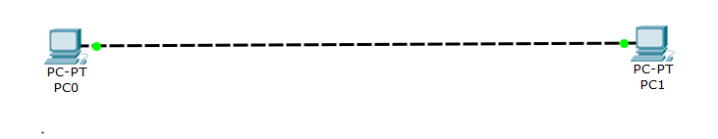

IP Address -- 192.168.1.1 IP Address -- 192.168.1.2

Self ping -- ping 192.168.1.1 Self ping -- ping 192.168.1.2

Cross ping -- ping 192.168.1.2 Cross ping -- ping 192.168.1.1

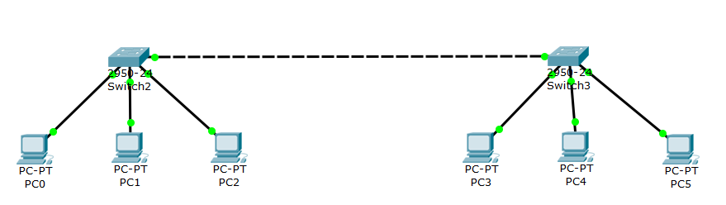

192.168.1.1 192.168.1.2 192.168.1.3 192.168.1.4 192.168.1.5 192.168.1.6

**SELF PING**

ping 192.168.1.1 ping 192.168.1.2 ping 192.168.1.3 ping 192.168.1.4 ping 192.168.1.5 ping 192.168.1.6

**CROSS PING**

ping 192.168.1.2 || ping 192.168.1.1 ||ping 192.168.1.1 ping 192.168.1.1 || ping 192.168.1.1 || ping 192.168.1.1

ping 192.168.1.3 || ping 192.168.1.3 || ping 192.168.1.2 ping 192.168.1.2 || ping 192.168.1.2 || ping 192.168.1.2

ping 192.168.1.4 || ping 192.168.1.4 || ping 192.168.1.4 ping 192.168.1.3 || ping 192.168.1.3 || ping 192.168.1.3

ping 192.168.1.5 || ping 192.168.1.5 || ping 192.168.1.5 ping 192.168.1.5 || ping 192.168.1.4 || ping 192.168.1.4

ping 192.168.1.6 || ping 192.168.1.6 || ping 192.168.1.6 ping 192.168.1.6 || ping 192.168.1.5 || ping 192.168.1.5

**ASSIGNMENT 1**

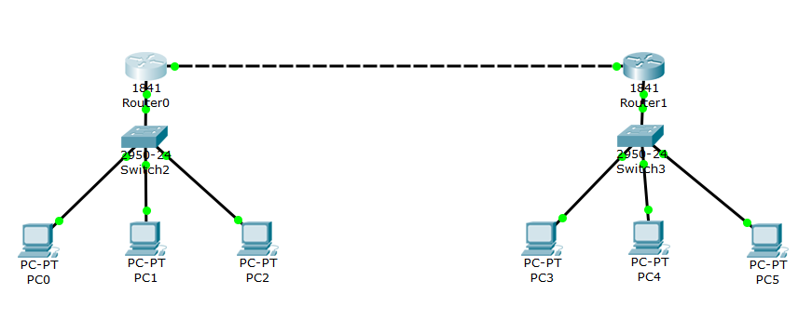

10.10.1.1 10.10.1.2 10.10.1.3 192.168.1.1 192.168.1.2 192.168.1.3

**SELF PING**

ping 10.10.1.1 ping 10.10.1.2 ping 10.10.1.3 ping 192.168.1.1 ping 192.168.1.2 ping 192.168.1.3

**CROSS PING**

ping 10.10.1.2 || ping 10.10.1.1 ||ping 10.10.1.1 ping 10.10.1.1 || ping 10.10.1.1 || ping 10.10.1.1

ping 10.10.1.3 || ping 10.10.1.3 || ping 10.10.1.2 ping 10.10.1.2 || ping 10.10.1.2 || ping 10.10.1.2

ping 192.168.1.1 || ping 192.168.1.1 || ping 192.168.1.1 ping 10.10.1.3 || ping 10.10.1.3 || ping 10.10.1.3

ping 192.168.1.2 || ping 192.168.1.2 || ping 192.168.1.2 ping 192.168.1.2 || ping 192.168.1.1 || ping 192.168.1.1

ping 192.168.1.3 || ping 192.168.1.3 || ping 192.168.1.3 ping 192.168.1.3 || ping 192.168.1.3 || ping 192.168.1.2

**GATEWAY**

10.10.1.4 10.10.1.4 10.10.1.4 192.168.1.4 192.168.1.4 192.168.1.4

**ROUTERS**

**IP ADDRESS:** Class A – 10.10.1.4 Class B – 172.16.1.1 Class C – 192.168.1.4 Class B – 172.16.1.2

**ASSIGNMENT 2**

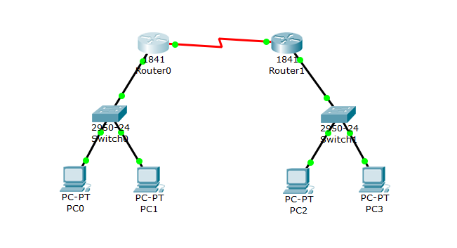

10.10.1.1 10.10.1.2 192.168.30.1 192.168.30.2

**SELF PING**

ping 10.10.1.1 ping 10.10.1.2 ping 192.168.30.1 ping 192.168.30.2

**CROSS PING**

ping 10.10.1.2 || ping 10.10.1.1 ping 10.10.1.1 || ping 10.10.1.1

ping 192.168.30.1|| ping 192.168.30.1 ping 10.10.1.2 || ping 10.10.1.2

ping 192.168.30.2|| ping 192.168.30.2 ping 192.168.30.2|| ping 192.168.30.1

**GATEWAY**

10.10.1.3 10.10.1.3 192.168.30.3 192.168.30.3

**ROUTERS**

**IP ADDRESS:** Class A – 10.10.1.3 Class B – 172.16.0.1 Class C – 192.168.30.3 Class B – 172.16.0.2

**ASSIGNMENT 3**

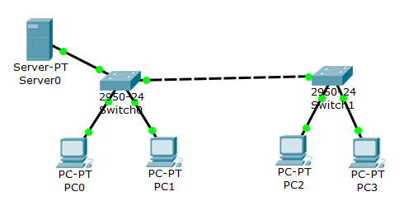 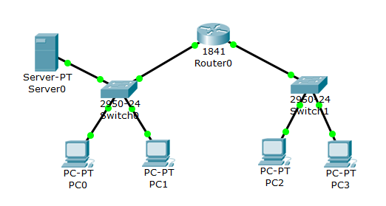

192.168.1.1 192.168.1.2 192.168.1.3 192.168.1.4 192.168.1.1 192.168.1.2 10.10.0.1 10.10.0.2

**SELF PING**

ping 192.168.1.1 ping 192.168.1.2 ping 192.168.1.3 ping 192.168.1.4 ping 192.168.1.1 ping 192.168.1.2 ping 10.10.0.1 ping 10.10.0.2

**CROSS PING**

ping 192.168.1.2 ping 192.168.1.1 ping 192.168.1.1 ping 192.168.1.1 ping 192.168.1.2 ping 192.168.1.1 ping 10.10.0.2 ping 10.10.0.1

ping 192.168.1.3 ping 192.168.1.3 ping 192.168.1.2 ping 192.168.1.2 ping 10.10.0.1 ping 10.10.0.1 ping 192.168.1.1 ping 192.168.1.1

ping 192.168.1.4 ping 192.168.1.4 ping 192.168.1.4 ping 192.168.1.3 ping 10.10.0.2 ping 10.10.0.2 ping 192.168.1.2 ping 192.168.1.2

**SERVER**

IP ADDRESS: 192.168.1.5 IP ADDRESS: 192.168.1.3

**ROUTER:** Class A -- 10.10.0.3 Class C -- 192.168.1.4