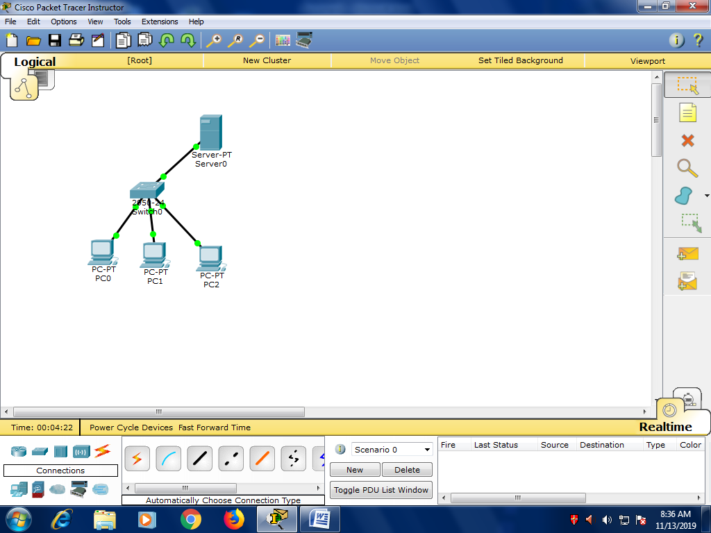

Packet Tracer PC Command Line 1.0

PC>ping 172.16.26.126

Pinging 172.16.26.126 with 32 bytes of data:

Reply from 172.16.26.126: bytes=32 time=0ms TTL=128

Reply from 172.16.26.126: bytes=32 time=0ms TTL=128

Reply from 172.16.26.126: bytes=32 time=0ms TTL=128

Reply from 172.16.26.126: bytes=32 time=0ms TTL=128

Ping statistics for 172.16.26.126:

Packets: Sent = 4, Received = 4, Lost = 0 (0% loss),

Approximate round trip times in milli-seconds:

Minimum = 0ms, Maximum = 0ms, Average = 0ms

PC>ping 172.16.26.128

Pinging 172.16.26.128 with 32 bytes of data:

Reply from 172.16.26.128: bytes=32 time=1ms TTL=128

Reply from 172.16.26.128: bytes=32 time=0ms TTL=128

Reply from 172.16.26.128: bytes=32 time=0ms TTL=128

Reply from 172.16.26.128: bytes=32 time=0ms TTL=128

Ping statistics for 172.16.26.128:

Packets: Sent = 4, Received = 4, Lost = 0 (0% loss),

Approximate round trip times in milli-seconds:

Minimum = 0ms, Maximum = 1ms, Average = 0ms