|  |  |  |
| --- | --- | --- |
| EVENT MANAGEMENT SYSTEM | 16th July  2017 | |
| **Prepared by Vaishali Prajapati** | |

**PROJECT TOPIC**

**EVENT MANAGEMENT SYSTEM**

**Abstract:**

The need for event management system is client can easily get information about event at his home. Anyone can see gallery in which user can see photoshoot, decoration, birthday celebration images, college event’s images , anniversary celebration images etc. Every user has their own user id & password by using they can log into user area and pay for decoration charges , hall booking etc. By using this online event management system project it reduce many worries of the user.

User can book what they want according to their requirements and also pay online. Everything is done at only one place.

**ACKNOWLEDGEMENT**

The project work on “**Event Management System**” has been

given me to as part of of the Master Degree in computer Application.

I have tried my best to present this information as clearly as possible. Firstly I want to give my hearty thanks to all mighty who made the world and me also. There are many other people without whom the completion of the project would not have been possible.

I would like to thank to **Mr. Kalpesh Gundigara** who guide me every stage of project. I will be failed in my duty if I do not acknowledge the esteemed scholarly guidance , assistance and knowledge.

Mere acknowledgement may not redeem the debt I owe to my parents for their direct/ indirect support during the entire course of this project.

I also thankful to my friends who helped me a lot in the completion of this project.

Vaishali Prajapati

**INDEX**

**Contents**

**CHAPTER-1 INTRODUCTION**

* 1. Objective of the project
  2. Purpose and Scope of the project

**CHAPTER-2 SURVEY OF TECHNOLOGY**

**CHAPTER-3 REQUIREMENTS AND ANALYSIS**

3.1 Problem Definition

3.2 Requirements specification

3.2.1 Functional Requirements

3.2.1.1 Administrative Module

3.2.1.2 User Module

3.2.2 Non-functional Requirements

**CHAPTER-4 SOFTWARE & HARDWARE REQUIREMENTS**

4.1 Software Requirements

4.2 Hardware Requirements

**CHAPTER-5 UML DIAGRAMS**

**CHAPTER-6 DATA DICTIONARY**

**CHAPTER-7 MODULE AND THEIR DESCRIPTION**

**CHAPTER-8 FUTURE SCOPE AND PROPOSED ENHACEMENT OF THE PROJECT**

**CHAPTER-9 INPUT DESIGN**

**CHAPTER-10 SAMPLE CODE OF WEBSITE**

**CHAPTER-11 BIBILIOGRAPHY**

**TABLE OF FIGURE:**

* 1. Usecase diagram for user
  2. Usecase diagram for admin
  3. Class diagram for user
  4. Class diagram for admin
  5. Sequential diagram
  6. Activity diagram for client
  7. Activity diagram for admin
  8. Statechart diagram

1. **INTRODUCTION**

**1.1 OBJECTIVE OF THE PROJECT:**

This project performs the task of developing a website that enables the

Students , faculties and other client to retrieve the data very easily. The main purpose of event management system is to provide a platform for the user to view the information about the events that took place in the past and the ones which are about to take place in the near future. The user can be student , faculty and administror.They can first login to the website and see the information.

**1.2PURPOSE AND SCOPE OF THE PROJECT**

The scope of the project is just limited to a laptop , a PC and mobile with an internet connection. Firstly the user, whoever it may be ( student , faculty or other client ) need to register to the website. After the registration process is completed each one of them gets a password and have their own id.

* 1. **EXISTING SYSTEM AND NEED FOR SYSTEM**

The existing system is manual /machine systems where the users must have to perform their manually. It will take more time and this whole procedure is very tedious and takes a lot of time.

Problems of the existing system

* It is limited to a single system.
* It has lot of manual work (Manual work does not mean working with pen or paper, rather includes working on spread sheets and other simple software.)
* The present system is very less secure.
* It unable to generate different kinds of reports.
* It is difficult to maintain phone bookings and cancellations.
* Does not provide global support. User cannot do the reservation from remote place.
* Retrieval of information is difficult and time consuming.
* A lot of time and manual effort is required

**ACHIEVEMENTS**

After completion of this project I achieved practical knowledge of event management system. How actually works in organization event handling

is only possible by managing this project. By using this project anyone can interested to organize the event can visit our website and get related information. Everything is make possible with our website they can also pay online.

**2.SURVEY OF TECHNOLOGIES**

Survey of the technology is an important part for project proposal. This is because, at this point in time, not too many detailed design of the system, making it difficult to access issues like performance, costs on (on account of the kind of technology to be deployed) etc.A number of issues have to be considered while doing a technical analysis.

* Understand the different technologies involved in the proposed system:

Before commencing the project, we have to be very clear about what are the technologies that are to be required for the development of the new system.

* Find out whether the organization currently possesses the required technologies:
* Is the required technology available with the organization?
* If so is the capacity sufficient?

**3.REQUIREMENTS AND ANALYSIS**

**3.1 PROBLEM DEFINITION :-**

In the existing system lot of paper work was required and it was time consuming process. As it was manual process retrieving data was very difficult. More than one person cannot access the data.

**Event Management System** (**EMS**) is a web based application that supports online registration and feedback evaluation for event training programs such as games, seminars and workshops. It helps program attendees, organizers, the authors and the reviewers in their respective activities.

**3.2 REQUIREMENT SPECIFICATION :-**

Computer hardware will require to be maintained on a host that is available 24X7. There will be data backups that need to be kept for the different forums as well as user data that will need to be kept so some form of database maintenance will be required. An new or software glitches will need to be reported and DRs written for fixes so some form of follow on maintenance contract for fixes will need to be built in or negotiated.

Motivation - To make everyone aware of the maintenance needs of the product.

Examples

* New User accounts must be available upon creation on webpage
* All data must be maintained for security reasons.

### Supportability Requirements

* The product shall allow users to create new workflows without the need for additional programming.
* The product shall allow effective and efficient maintenance and support of the system.
* The product shall have installation and maintenance of the system done by the systems administrators.
* The product shall designate systems administrators as the help desk for the wedding planning clients.

## 

## Security Requirements(Access requirements)

This website must have members-only areas. I want my visitors to have to sign in to see and access to our whole website. Some of the users can go for specific areas of my website.

**3.2.1 FUNCTIONAL REQUIREMENTS:-**

Functional requirements include administrator, user.

**3.2.1.1 ADMINISTRATOR MODULE** :- This module is the one who organizes all the users data, allow the various users to create the id function.

**3.2.1.2 USER MODULE :**- A user is the one that create an id and then login with the help of it and performs various activities like view events, register for the events, checks the events status.

**3.2.2 NON FUNCTIONAL REQUIREMENTS:-**

**SECURITY REQUIREMENTS :-**

To ensure security from unauthorized access, use, modification, destruction, or disclosure from other persons, authentication should be performed by establishing login procedure.

**ERROR CONDITIONS :-**

Upon detection of an error condition, the system should generate a suitable error message that should be displayed to the user. Make sure that system is still reliable with large number of users.

**4 SOFTWARE AND HARDWARE REQUIREMENTS:-**

**4.1: SOFTWARE REQUIREMENTS :-**

|  |  |
| --- | --- |
| **SERVER SIDE REQUIREMENTS** | |
| Operating System | Windows Server 2007 or any compatible OS |
| Web Server | Internet Information Services 6.0 |
| Runtime Environment | Localhost |
| Back End | Mysql |
| Front End | PHP, CSS, JAVASCRIPT |

|  |  |
| --- | --- |
| **CLIENT SIDE REQUIREMENTS** | |
| Operating System | Windows Server 2007 or any compatible OS |
| Web Browser | Google chrome, Mozila Firefox |

**4.2: HARDWARE REQUIREMENTS :-**

|  |  |
| --- | --- |
| **SERVER SIDE REQUIREMENTS** | |
| Processor | Core i3 |
| RAM | 2 GB |
| Hard Disk | 20 GB disk space |

|  |  |
| --- | --- |
| **CLIENT SIDE REQUIREMENTS** | |
| Processor | Core i3 |
| RAM | 2 GB |
| Hard Disk | 20 GB disk space |

**5. SYSTEM DESIGN**

**5.1 DATA DESIGN**

5.1.1 DATA INTEGRITY AND CONSTRAINTS:

|  |  |  |
| --- | --- | --- |
| **FIELD** | **DATA TYPE** | **CONSTRAINTS** |
| Uid | Int(11) | Primary key |
| Email | Varchar(255) | NOT NULL |
| Password | Varchar(255) | NOT NULL |
| Cpassword | Varchar(255) | NOT NULL |

1.1Constraints on signup table

|  |  |  |
| --- | --- | --- |
| **FIELD** | **DATA TYPE** | **CONSTRAINTS** |
| Uid | Int(11) | Primary key |
| Email | Varchar(255) | NOT NULL |
| Password | Varchar(255) | NOT NULL |

1.2Constraints on login table

**PROJECT PLANNING (GHANNT CHART)**

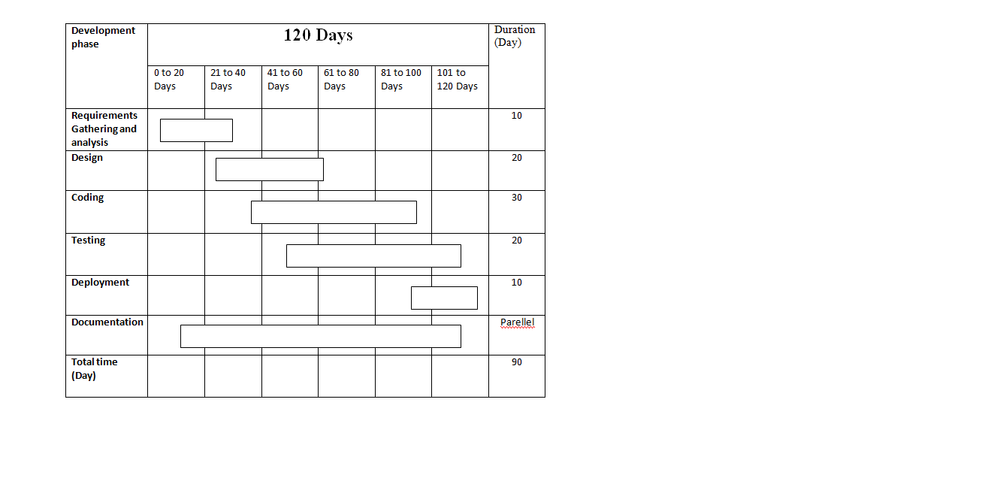

**5.1.2 DATA SECURITY**

**The security measures have been taken in a bid to make the software full proof in terms of various activities:-**

1. Authorization of the user as well as administrator
2. Input Validations of the forms
3. Output Validations of the result
4. Login timing to maintain the Session management
5. Logout timing of the user
6. Data Security
7. Software Security
8. Hardware Security
9. Illegal copying should be restricted

These are the few measures that are taken into account to meet the security measures while developing a project for an organization.

**5.2 PROCEDURAL DESIGN:**

**5.2.1. USE-CASE DIAGRAM:-**

The use case diagram is used to identify the primary elements and processes that form the system. The primary elements are termed as "actors" and the processes are called "use cases." The use case diagram shows which actors interact with each use case.



1.1 Usecase diagram for user



Fig. 1.2 Usecase diagram for administrator

Use case of administrator first login then upload event if any wrong it delete event then goes to verify registered events add logout.

**5.2.2. CLASS DIAGRAM:-**

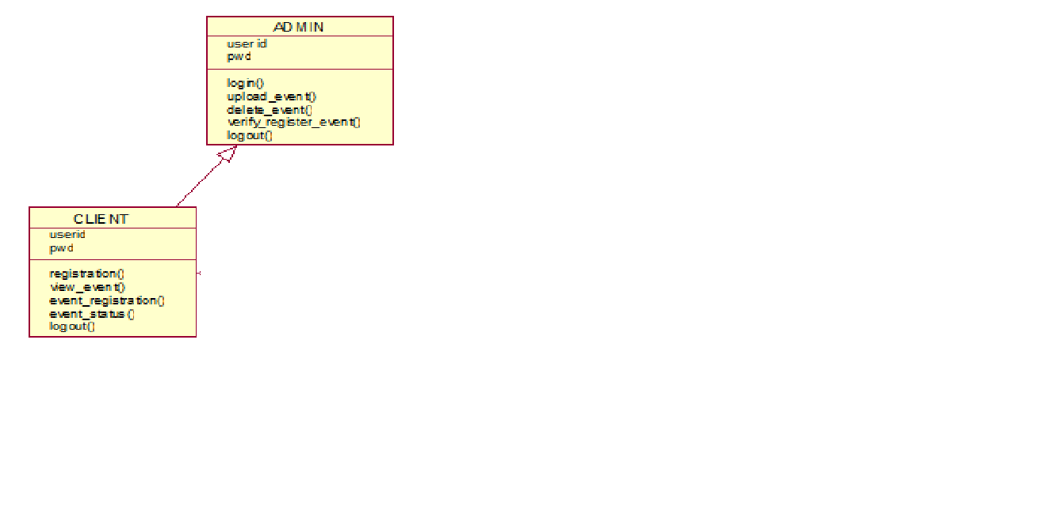

Fig: 1.3 Class Diagram

**5.2.3 SEQUENTIAL DIAGRAM :-**

****1.4sequence diagram of administrator

1.5 SEQUENCE DIAGRAM FOR CLIENT LOGIN

Client

event management

system

database

1: register

2: retrieve login data

3: login data

4: validate

5: home page

6: view events

7: register events

8: response

9: display status

10: logout

**5.2.4 ACTIVITY DIAGRAM :-**

Figure : 1.6 Activity Diagram for client

CLIENT

login

home

page

yes

perform

activity

view

event

event

registration

event

status

logout

valid

**5.2.5 ACTIVITY DIAGRAM FOR ADMIN**



1.7 Activity diagram for admin

**5.2.6 STATECHART DIAGRAM**

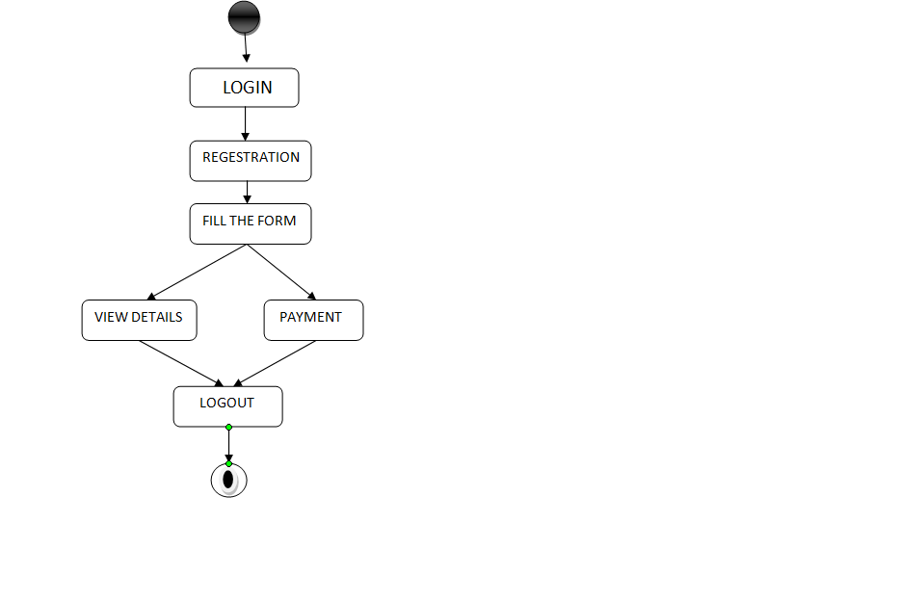

1.8 State chart diagram

**6. DATA DICTIONARY:-**

**6.1 Signup Table:**

|  |  |  |  |
| --- | --- | --- | --- |
| **FIELD** | **DATATYPE** | **CONSTRAINTS** | **DESCREPTION** |
| Uid | Int(11) | Primary Key | It is unique key  Of the table. |
| Email | Varchar(255) | Not NULL | Unique email id of the user. |
| Password | Varchar(255) | Not NULL | Password for the security. |
| cpassword | Varchar(255) | Not NULL | It verify password is match or not. |

**6.2 Login Table:**

|  |  |  |  |
| --- | --- | --- | --- |
| **FIELD** | **DATATYPE** | **CONSTRAINTS** | **DESCREPTION** |
| Uid | Int(11) | Primary Key | It is unique key  Of the table. |
| Email | Varchar(255) | Not NULL | Unique email id of the user. |
| Password | Varchar(255) | Not NULL | Password for the security. |

**6.3 ContactUs Table:**

|  |  |  |  |
| --- | --- | --- | --- |
| **FIELD** | **DATATYPE** | **CONSTRAINTS** | **DESCREPTION** |
| Uid | Int(11) | Primary Key | It is unique key  Of the table. |
| Name | Varchar(255) | Not NULL | Name of the user who give feedback. |
| Email | Varchar(255) | Not NULL | Unique email id of the user. |
| Message | Varchar(255) | Not NULL | Message which is sent by the user. |

**6.4 Payment Table:**

|  |  |  |  |
| --- | --- | --- | --- |
| **FIELD** | **DATATYPE** | **CONSTRAINTS** | **DESCREPTION** |
| Uid | Int(11) | Primary Key | It is unique key  Of the table. |
| Name | Varchar(255) | Not NULL | Name of the user who give feedback. |
| Ac_num | Int(30) | Not NULL | Unique email id of the user. |
| Card_num | Int(30) | Not NULL | Card number of the card. |
| Exp_date | Date() | Not NULL | Expiry date of the card. |
| Cvv_num | Int(30) | Not NULL | Cvv number of the card. |

**6.5 Feedback Table:**

|  |  |  |  |
| --- | --- | --- | --- |
| **FIELD** | **DATATYPE** | **CONSTRAINTS** | **DESCREPTION** |
| Uid | Int(11) | Primary Key | It is unique key  Of the table. |
| Name | Varchar(255) | Not NULL | Name of the user who give feedback. |
| Email | Varchar(255) | Not NULL | Unique email id of the user. |
| Feedback | Varchar(255) | Not NULL | Feedback of the message which is sent by the user. |

**7. Modules & Their Description**

The Online Event management system is a event services provider that offers wedding plans , corporate events, anniversary planning, birthday party celebration and college events planning services.

Online Event management System deals with the information System for Bookings. This project explains about the booking of the Party Places from a short event to a complete combination of activities, including meetings, conferences, exhibitions etc. This website helps any authorized person to book the places, photoshoot , hall decoration flower decorators etc. from internet and also shows the availability of a particular requirement at the chosen date and time. The project is divided into different modules. They are follows:-

1. **Administration: This module is divided into different sub-modules, they are:-**
   * Booking
   * Venues
   * Menus
   * Photoshoot
   * Reports
   * Search
   * Decoration
   * payments
2. **Users: This module is specially for Customers:-**
   * Service Details (Photoshoot, decoration, Music system, hall booking)
   * Availability
   * Booking

**Client Details:** Once the user click on this module he/she will be able to know the client details who have taken the services through the website.

**Admin Login:** In this module, this website is for multiple users. If a User enters a password and the software checks its validity. If the password is valid then option is given to change the password, otherwise “Invalid User/Password” message is displayed. There is an option for password recovery, log out, login, new users sign in. The Administrator can also update changes in the site after login.

**Feedback:** This module keeps track of all the feedbacks given by the users for future records.

**ContactUs:** This module keeps the track of all the messages given by the users for future records.In this module user can ask any query and get the answer from the admin. He/She also able to know contact details of service provider.

**Payment Module:**  This module provide payment information. Using this module user can pay for services like decoration charges, photoshoot charges, hall booking charges.

**8. FUTURE SCOPE & PROPOSED ENHANCEMENT OF THE PROJECT**

**DRAWBACKS:**

1. No automatic backup facilities available.

2. To run the application Internet Explorer 5.0 and above is required.

3. High bandwidth is required for as the transaction rate is high and third party gateway.

**PROPOSED ENHANCEMENT:**

1. Data backup facility will be introduced.
2. Graphical richness is required for the more user interactivity.
3. **INPUT DESIGN**

**9.1 Home Page**

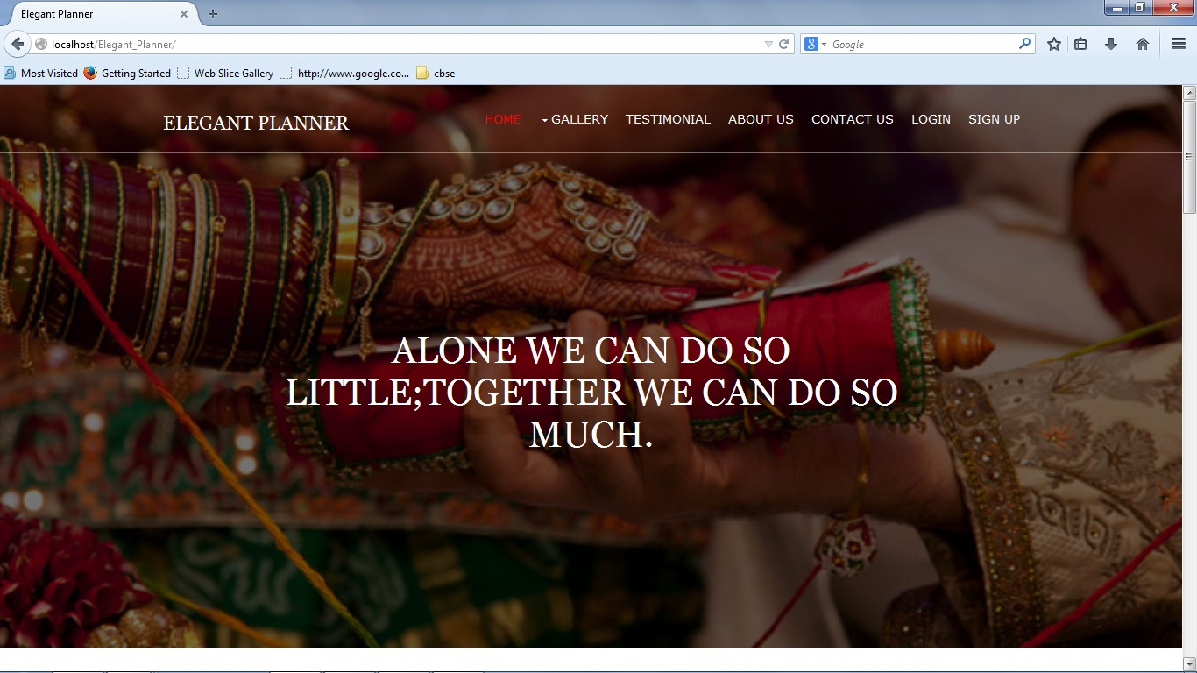

**Description :-**

This is home page of the website. It contains various menu like gallery, testimonial, about us, contact us, login,

Signup etc. User can move on any page from here.

9.2 Signup Page:-

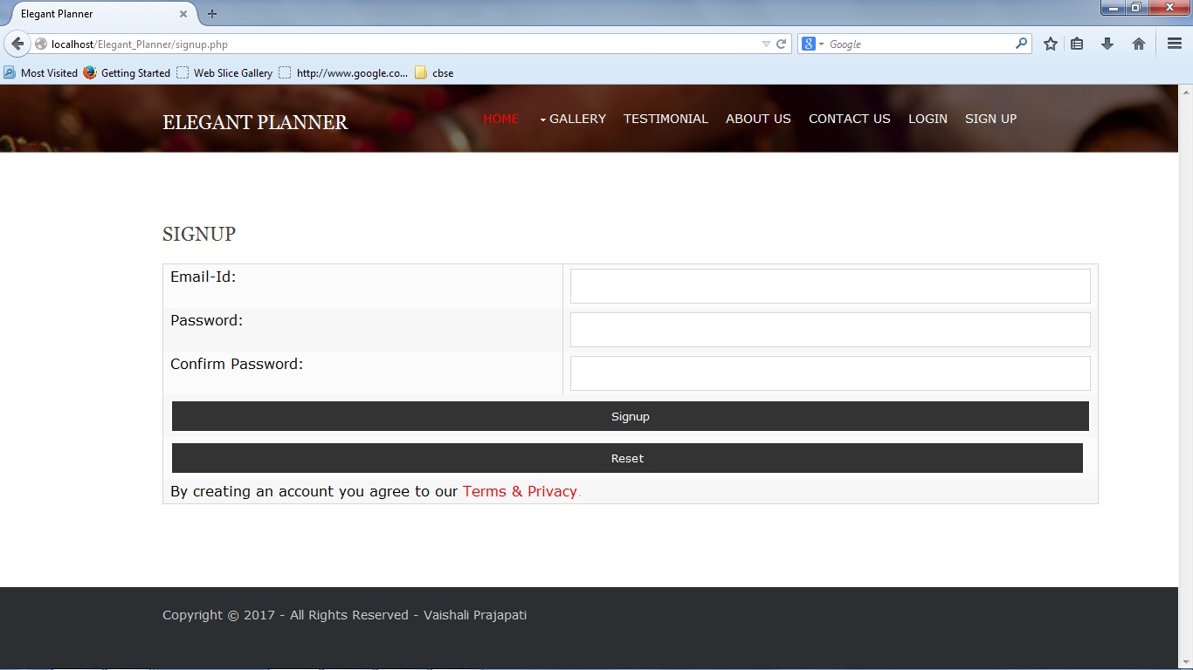

**Description:-**

This is signup page of the website form which user can signup using email-id , password and confirm password. By using this valid information user can create account in website.

* 1. **Login Page**

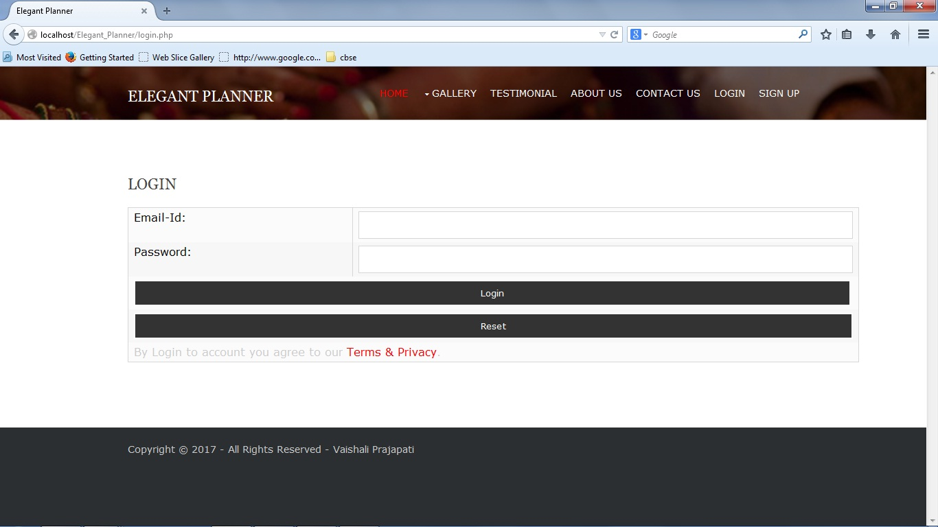

**Description:-**

This is login page of the website in which user can login using his/her email-id and password.

* 1. **Photoshoot (Gallery)**

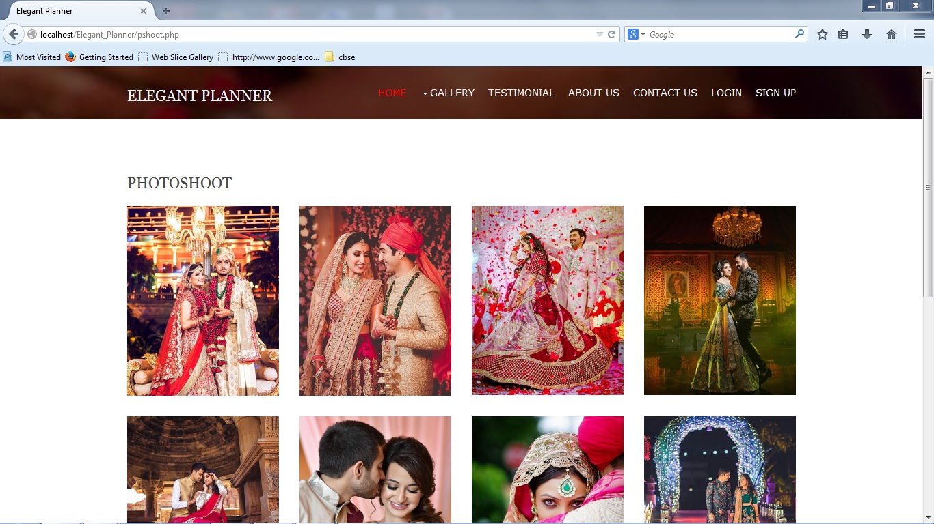

**Description:-**

This is photoshoot page of the gallery in website. It describe and show user Photoshoot of the bride and groom.We also provide awesome photoshoot.

* 1. **Decoration**

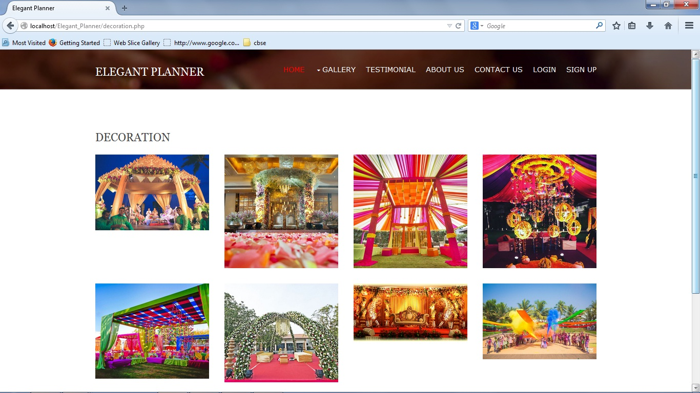

**Description:-**

This page provide images of the decoration of hall and event places. User can able to customize decoration according to their wish.

**9.6 Corporate Event**

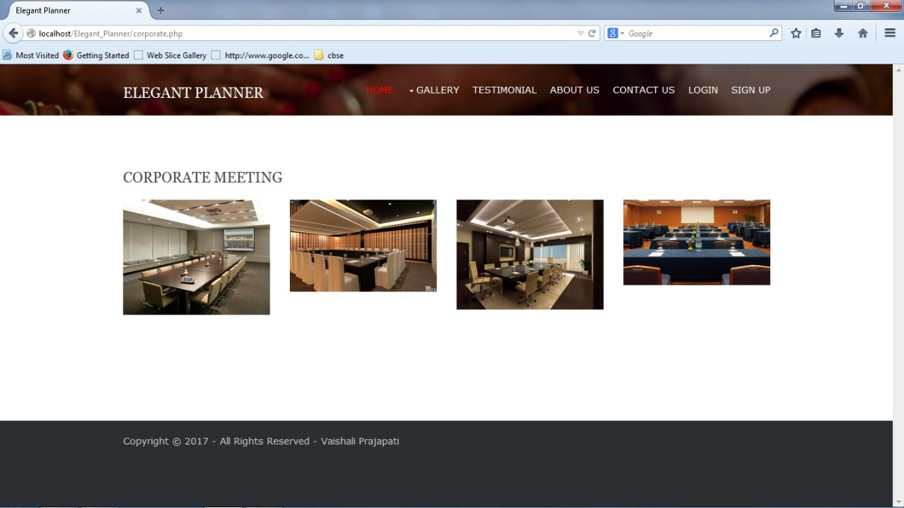

**Description:-**

This page provides images related to corporate event planning. When corporate companies want to organize event at that time we are manage event for them**.**

**9.7 Anniversary Celebration**

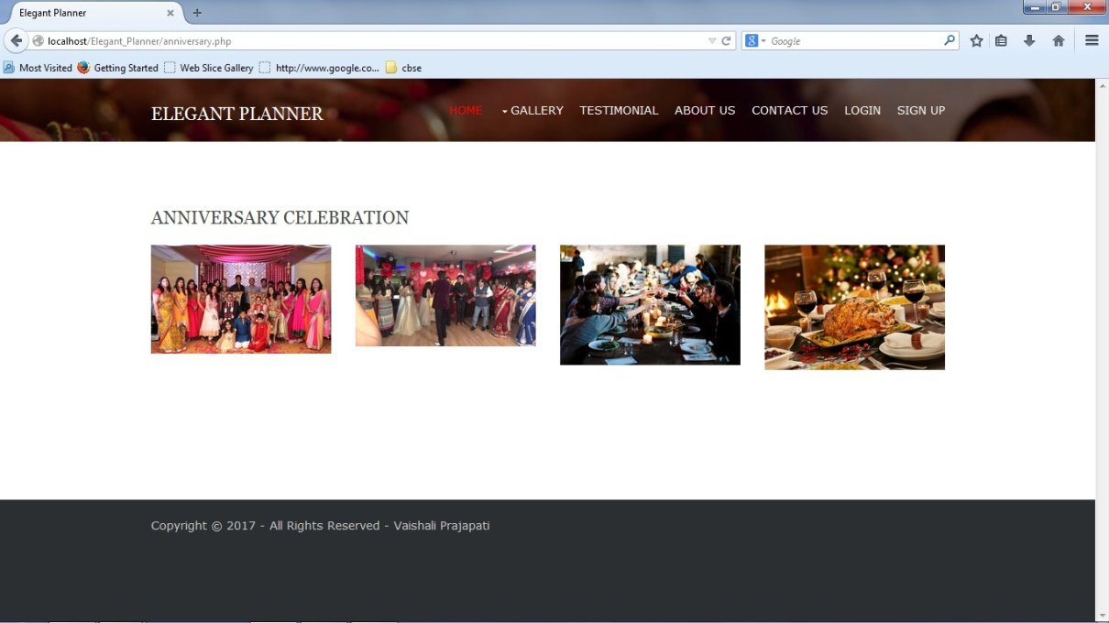

**Description:-**

This page show the images of the anniversary celebration of the user. User can celebrated their special moment with our elegant event handling.

**9.8 BIRTHDAY CELEBRATION**

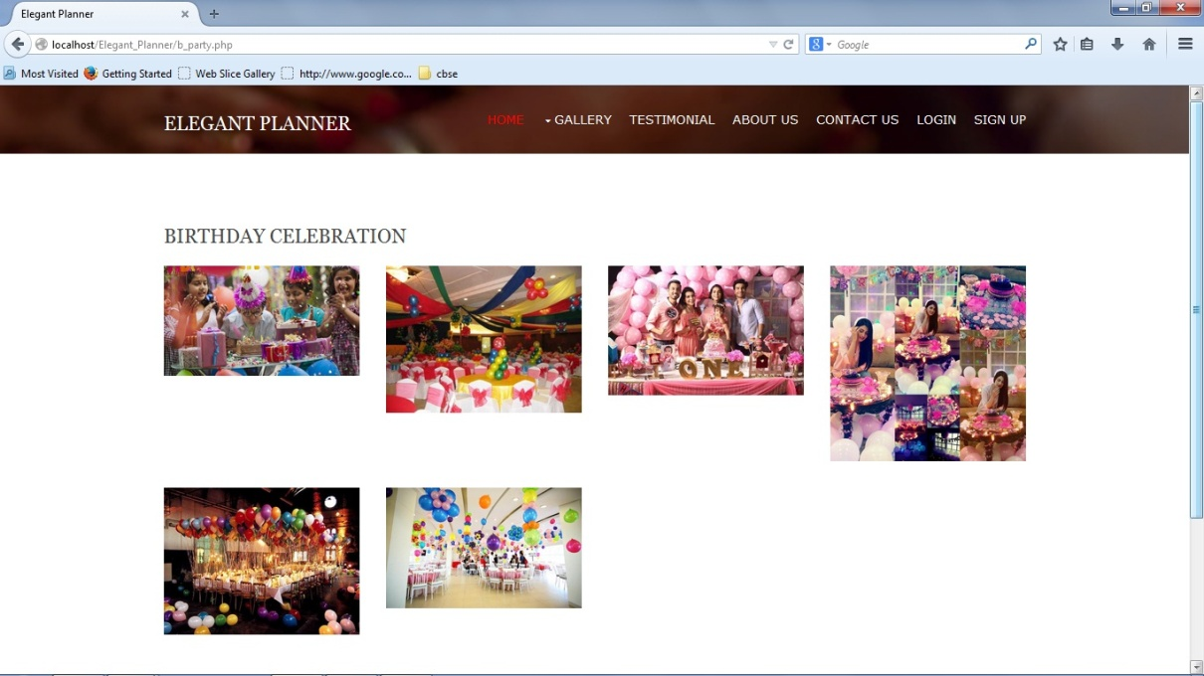

**Dscription:-**

This page show the images of the birthday celebration of the user. User can celebrated their special moment with our elegant event handling.

**9.9 College Events**

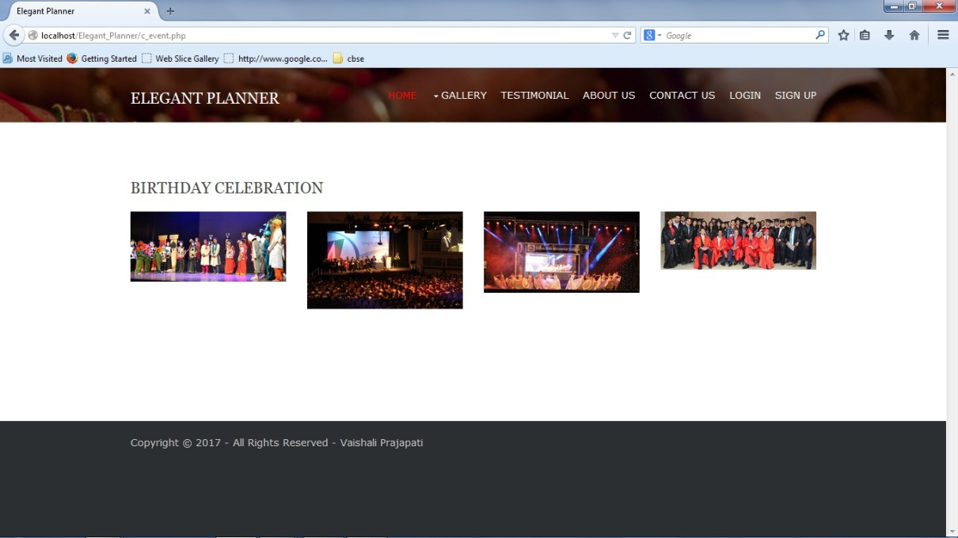

**Description:-**

This web page show the emage of the different kind of events organize by the colleges.

**9.10 Testimonial Page**

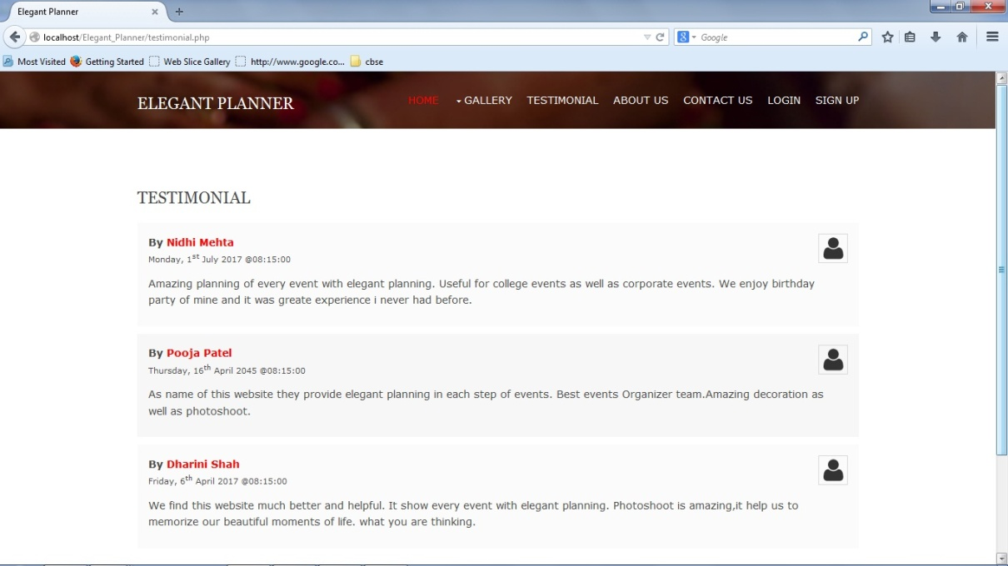

**Description :-**

This is the website page of the testimonial in this page user share their reviews and explain what kind of experience they had.

**9.11 About Us Page**

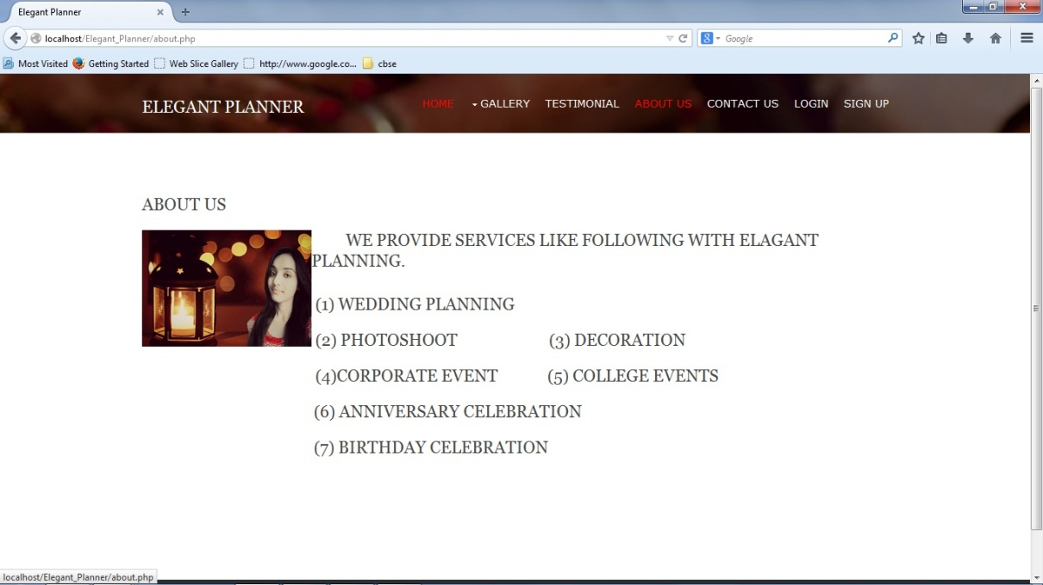

**Description:-**

This page give information related to what kind of event is organize here. User can show the list of events which is organize.

**9.12 Contact Us Page**

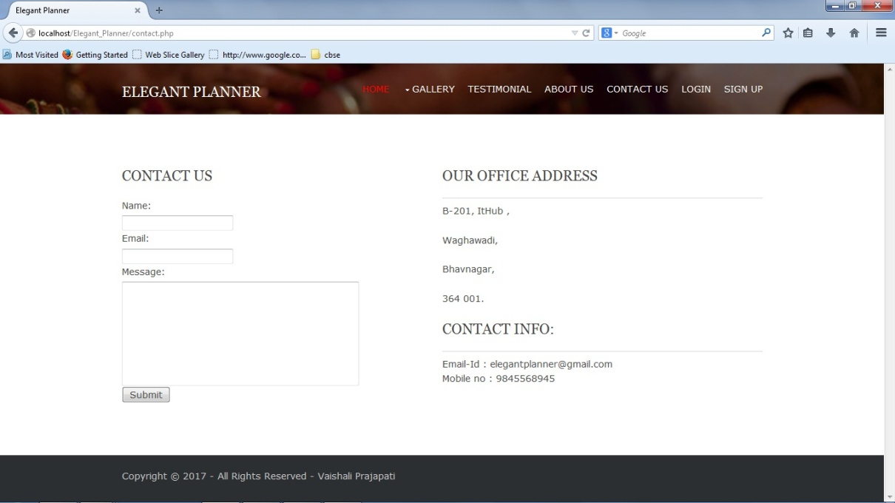

**Description:-**

This page of the website is provide contact information of the event service provider. Here address and contact information both are mentioned.

**9.13 Login_user Page:**

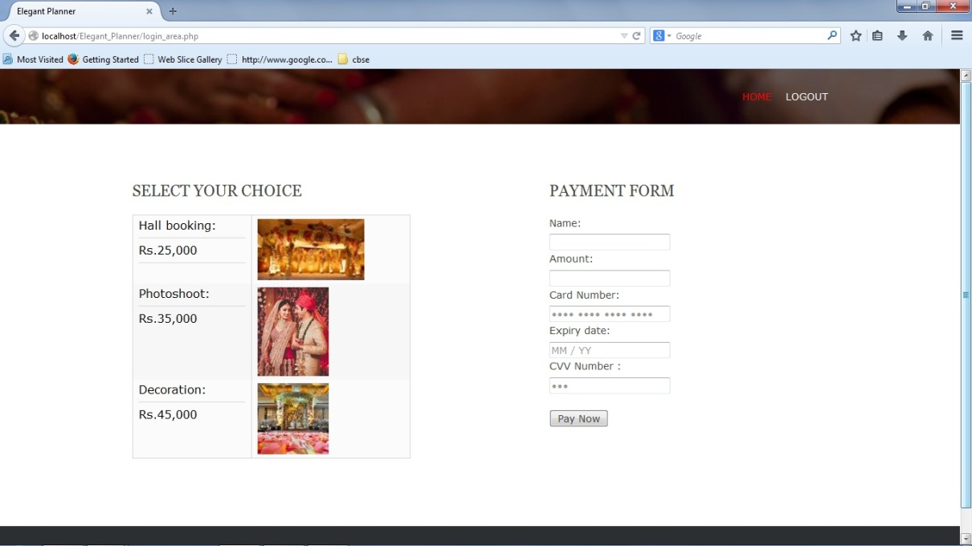

**Description:-**

After log in , user can book for the hall, decoration and photoshoot. User can also able to pay online charges to the service provider.

1. **SAMPLE CODE OF WEBSITE**

**10.1 Signup Page Code:-**

<?php

<table align=”center” border=2>

<tr><td>Email</td>

<td><input type=”text” name=”email”></td>

</tr>

<tr><td>Password</td>

<td><input type=”password” name=”password”></td>

</tr>

<tr><td>Confirm Password</td>

<td><input type=”password” name=”cpassword”></td>

</tr>

<tr><td><input type=”submit” name=”submit”>SignUp</td>

</tr>

</table>

?>

**10.2 Login Page Code**

<?php

<table>

<tr><td>Email</td>

<td><input type=”text” name=”email”></td>

</tr>

<tr><td>Password</td>

<td><input type=”password” name=”password”></td>

</tr>

<tr><td>

<input type=”submit”name=”submit”>Login</td></tr>

</table>

?>

* 1. **Header Page Code:**

<html lang="">

<head>

<title>Elegant Planner</title>

<meta charset="utf-8">

<meta name="viewport" content="width=device-width, initial-scale=1.0, maximum-scale=1.0, user-scalable=no">

<link href="layout/styles/layout.css" rel="stylesheet" type="text/css" media="all">

</head>

<body id="top">

<!-- Top Background Image Wrapper -->

<div class="bgded overlay" style="background-image:url('images/demo/backgrounds/01.jpg');">

<!-- ############################################ -->

<div class="wrapper row1">

<header id="header" class="hoc clear">

<div id="logo" class="fl_left">

<h1><a href="index.html">Elegant Planner</a></h1>

</div>

<nav id="mainav" class="fl_right">

<ul class="clear">

<li class="active"><a href="index.php">Home</a></li>

<li><a class="drop" href="#">Gallery</a>

<ul>

<li><a href="pshoot.php">Photoshoot</a></li>

<li><a href="decoration.php">Decoration</a></li>

<li><a href="corporate.php">Corporate Events</a></li>

<li><a href="anniversary.php">Anniversary Celebration</a></li>

<li><a href="b_party.php">Birthday Celebration</a></li>

<li><a href="c_event.php">College Events</a></li>

</ul>

</li>

<li><a href="testimonial.php">Testimonial</a></li>

<li><a href="about.php">About Us</a></li>

<li><a href="contact.php">Contact Us</a></li>

<li><a href="login.php">Login</a></li>

<li><a href="signup.php">Sign Up</a></li>

</ul>

</nav>

</header>

</div>

* 1. **Footer Page Code:-**

<?php

<div class="wrapper row5">

<div id="copyright" class="hoc clear">

<p class="fl_left">Copyright &copy; 2017 - All Rights Reserved - <a href="#">Vaishali Prajapati</a></p>

</div>

</div>

<a id="backtotop" href="#top"><i class="fa fa-chevron-up"></i></a>

<!-- JAVASCRIPTS -->

<script src="layout/scripts/jquery.min.js"></script>

<script src="layout/scripts/jquery.backtotop.js"></script>

<script src="layout/scripts/jquery.mobilemenu.js"></script>

?>

* 1. **Index Page Code:-**

<? php include('header.php') ;?>

<div id="pageintro" class="hoc clear">

<article>

<!-- ###################################### -->

<h3 class="heading">Alone we can do so little;

together we can do so much.</h3>

<!-- ###################################### -->

</article>

</div>

<!-- ###################################### -->

</div>

<!-- End Top Background Image Wrapper -->

<div class="wrapper row3">

<main class="hoc container clear">

<div class="clear"></div>

</main>

</div>

<!-- ######################## -->

<div class="wrapper row2">

<section class="hoc container clear">

<!-- ###################################### -->

<div class="sectiontitle">

<h6 class="heading">Our Services</h6>

</div>

<div class="group">

<div class="one_third first"><img src="p2.jpg" alt=""></a></div>

<div class="two_third">

<figure class="group">

<div class="one_half first btmspace-30"><img src="m2.jpg" alt=""></a></div>

<div class="one_half btmspace-30"><img src="b1.jpg" alt=""></a></div>

<div class="one_half first"><a class="imgover" href="#"><img src="d1.jpg" alt=""></a></div>

<div class="one_half"><img src="a3.jpg" alt=""></a></div>

</figure>

</div>

</div>

<!-- ###################################### -->

</section>

</div>

</div>

<!-- ###################################### -->

<? php include('footer.php') ; ?>

**10.5 Config.php (Database Connection)**

<?php

$hostname='localhost';

$user = 'root';

$password = '';

$mysql_database = 'event';

$db = mysql_connect($hostname, $user, $password,$mysql_database);

mysql_select_db("event", $db);

?>

1. **BIBILIOGRAPHY**

|  |  |
| --- | --- |
| **Book Name** | **Publisher Name** |
| PHP and MySQL Web Development | Laura Thomasan |
| Java Script & Jquery | Jon Duckett |

**Reference Websites:-**

* 1. [www.W3school.com](http://www.W3school.com)
  2. [www.shubhevent.com](http://www.shubhevent.com)
  3. [www.Rajpathclub.com](http://www.Rajpathclub.com)
  4. [www.codeacademy.com](http://www.codeacademy.com)