Python + PowerBI – TeleCom Customer Churn Project

The Telecom Customer Churn Analysis project is an end-to-end data analytics project developed using Python and Power BI. The main objective of this project is to analyze customer data, identify patterns related to customer churn, and understand the factors that influence customer retention.
Python was used for data cleaning, preprocessing, and preparation, including handling missing values, correcting data inconsistencies, and preparing a structured dataset for analysis. The cleaned dataset was then imported into Microsoft Power BI to develop an interactive dashboard with KPIs, visualizations, and filters.
Project Details:
Project Title: Telecom Customer Churn Project
Domain: Telecommunications
Dataset Size: 75,000 customer records
Total Columns: 18
Data Analysis Tools: Python and Power BI
Python Environment: Jupyter Notebook
Dashboard: Single-page interactive Power BI dashboard
Project Type: Data Cleaning, Exploratory Data Analysis, Data Visualization, Business Intelligence (BI), Descriptive Analytics

Dataset Preparation Using Python

Column No – 1 (CustomerID)
1) Importing the data and checking datatype
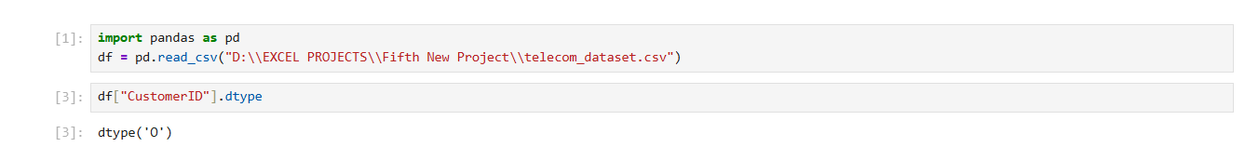
2) Checking missing and duplicate customers
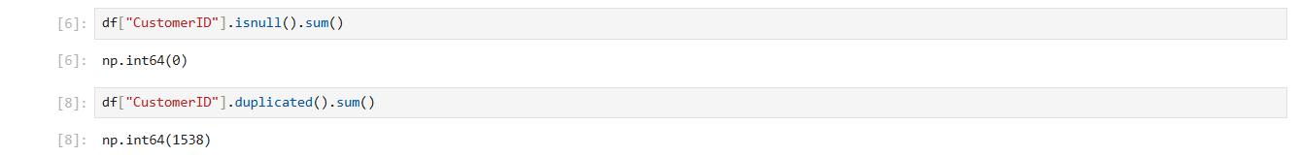
3) Total value count
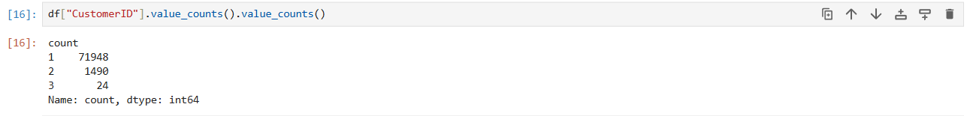
4) Checking unique customers and customers who’s ids are repeated
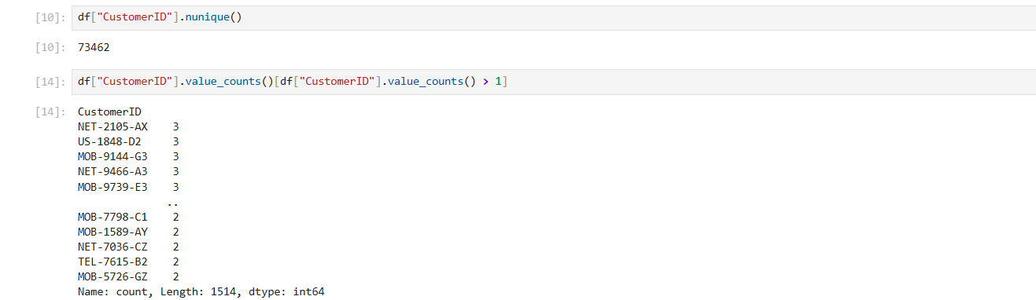
Here, the ids of some of the customers are repeated.
5) Inspect repeated IDs – checking are they really duplicates or also contains other information that is different then the same one

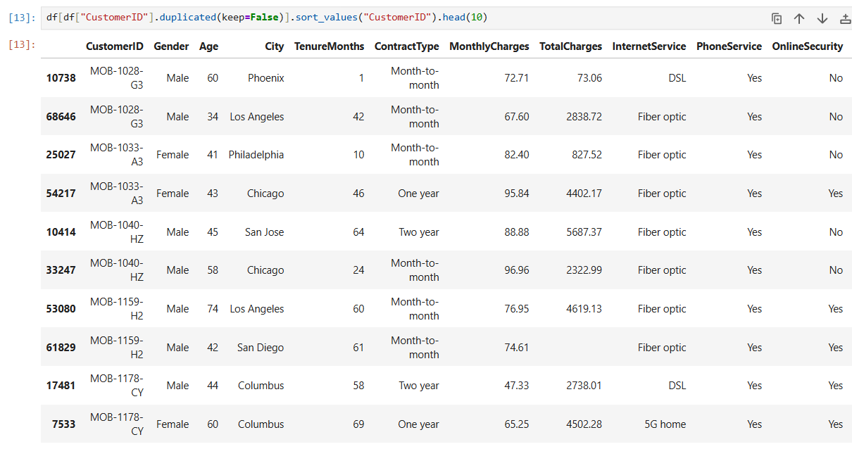
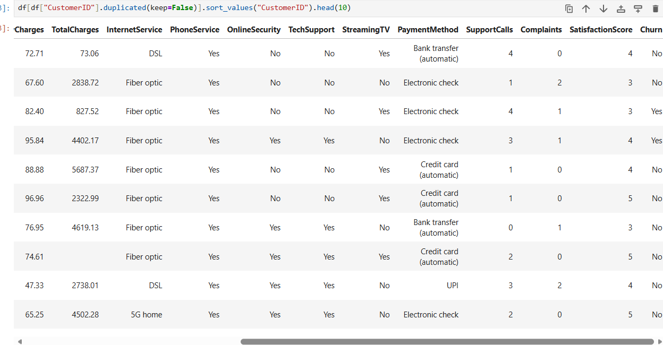
Here, output confirms that CustomerID has no missing values, but some IDs are assigned to different customer records.
(For example: MOB-1028-G3 appears twice with different ages, cities, tenure, and charges. These are not exact duplicate rows.)
6) Checking exact duplicate records
Here, the output is 0 meaning there is no single ID that is exactly the same each duplicate IDs contains different customer information.
So, I am not deleting this rows because the repeated IDs have different customer details and I cannot determine whether the repeated IDs are intentional or data errors.
Column No – 2 (Gender)
1) Importing dataset and checking datatype, missing values, unique values present and value count of gender
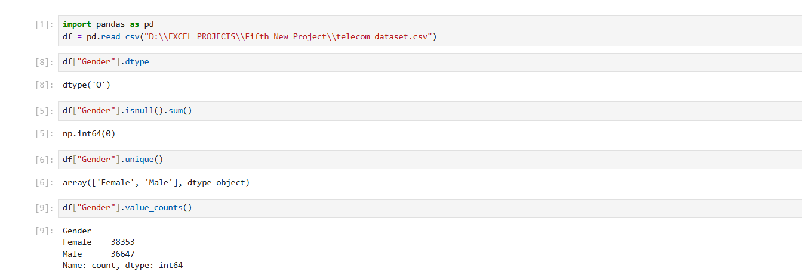
2) Churn by gender and churn rate by gender – checking the churn percentage
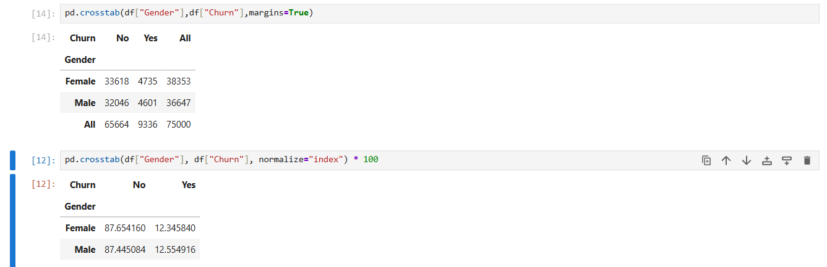
Here, male and female customers have very similar churn rates in the dataset.
Column No 3 – (Age)
1) Importing the dataset and checking datatype, null values, minimum and maximum age in the dataset

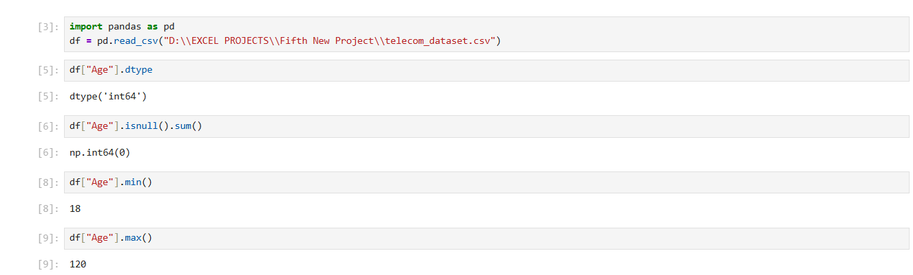
Here, the minimum age 18 is correct but the maximum age is showing 120 that does not look correct.
2) Checking for unusual ages
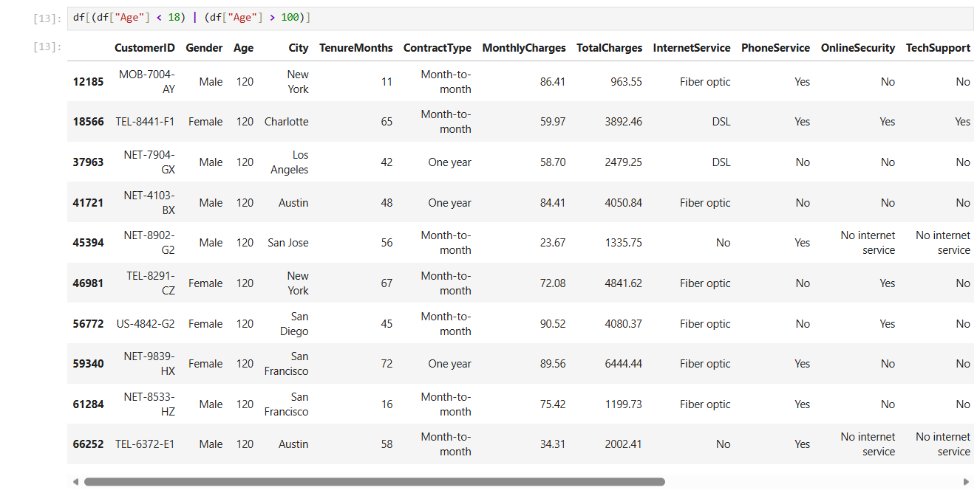
There, are in total 10 records with very unusual ages.
3) Checking the basic statistics and all the values present in the dataset
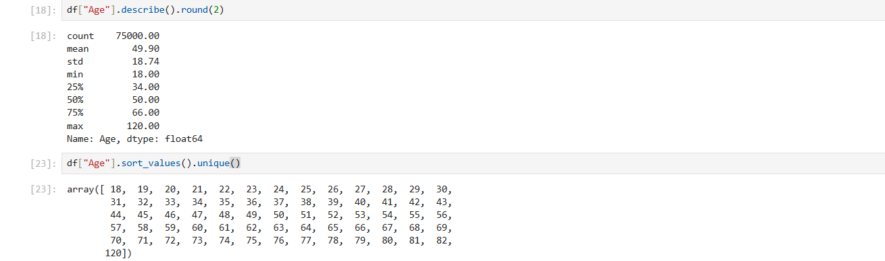
4) Checking total number of people in each age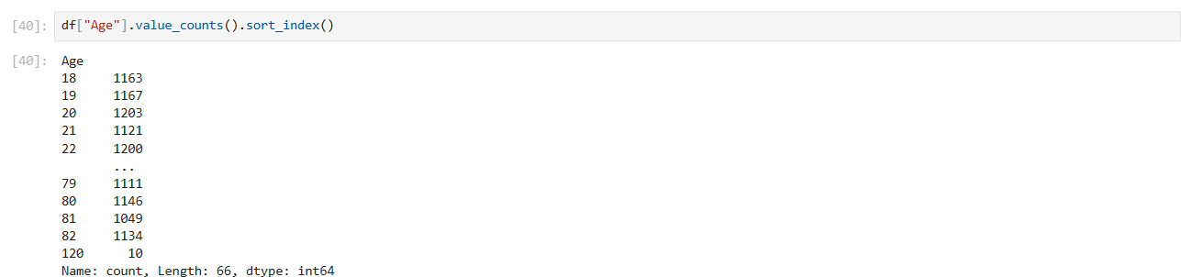
We can also use “pd.set_option("display.max_rows", None) df["Age"].value_counts().sort_index()” to see all the rows.
5) Comparing the average age of customers who churned and didn't churn, and creating age groups that tells us the churn percentage for each age group.
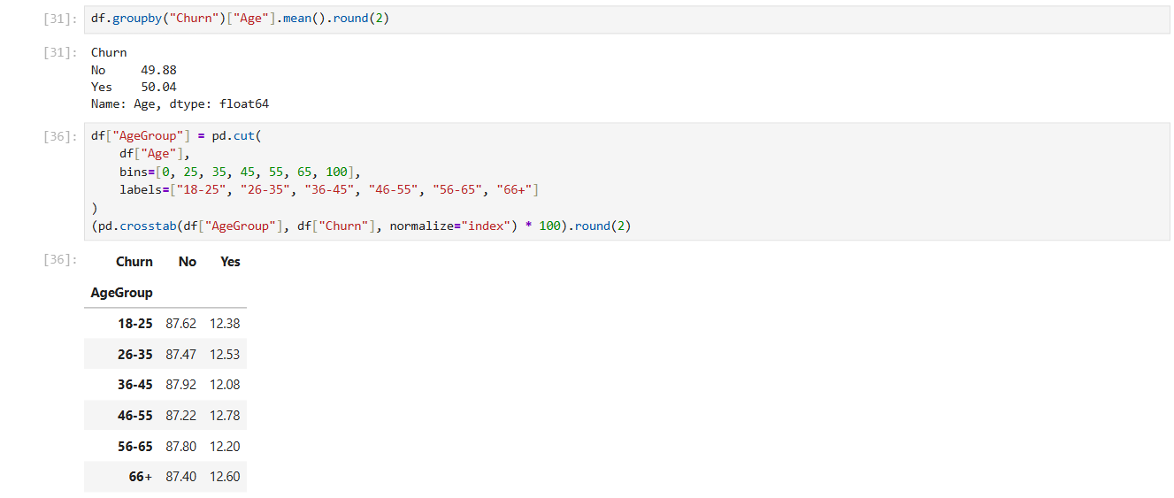
6) Replacing the 10 ages of the people who’s age is 120 with the median age which is 50 because it seems to be something valid and checking the maximum age
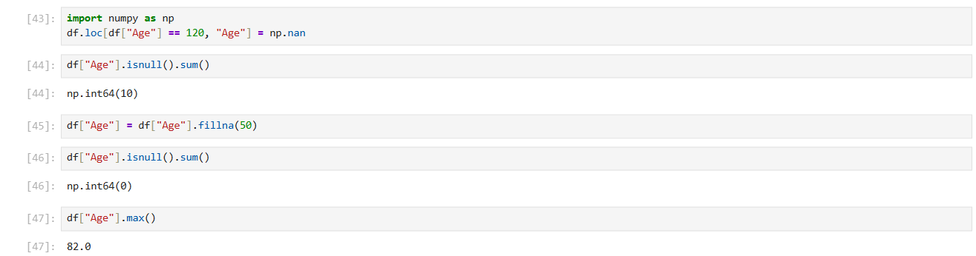
Now, the maximum age 82 seems to be correct and the age 120 is also changed to 50.

Column No 4 – (City)
1) Importing dataset and checking datatype, null values, unique values and value count of different cities
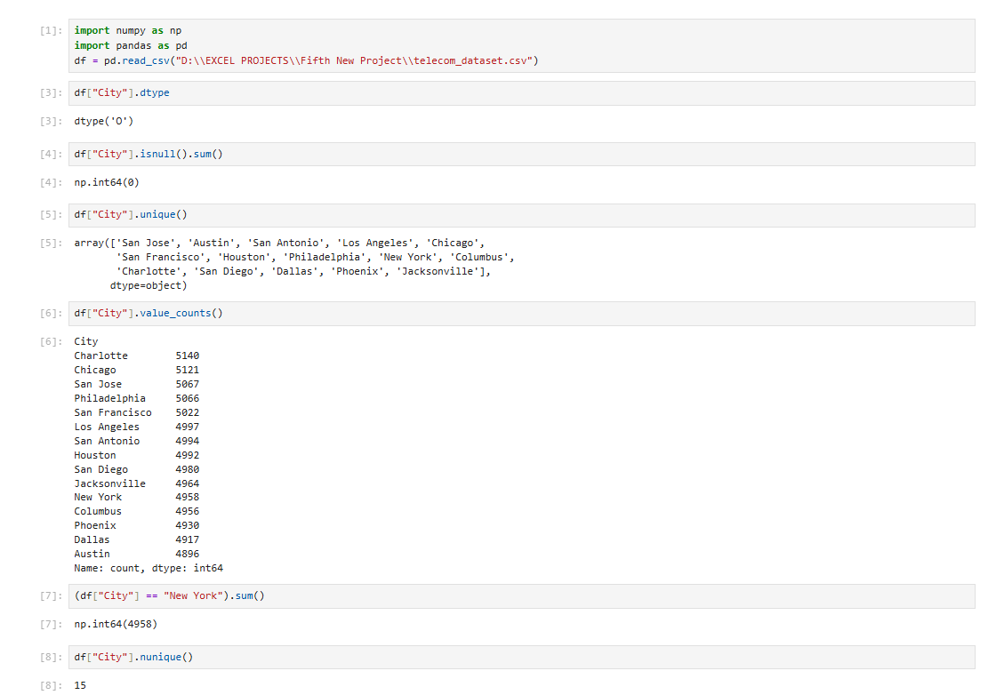
2) Checking customer churn by city and calculating churn percentage by city
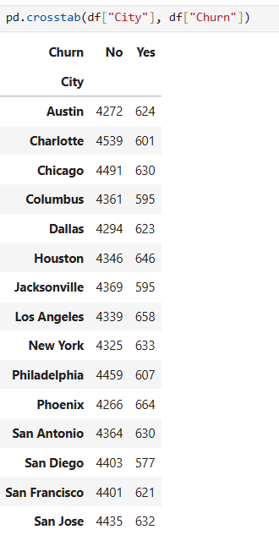
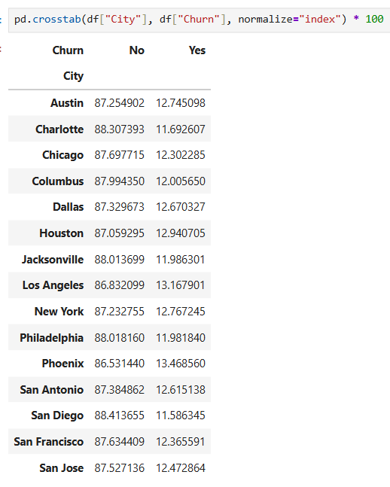
3) Visualizing customers by city
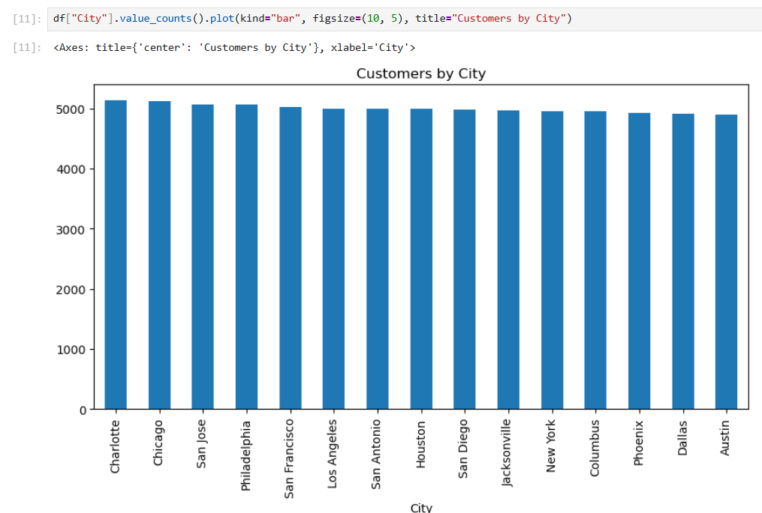
Column No 5 – (TenureMonths)
1) Importing dataset and checking datatype, missing values, minimum and maximum values, basic statistics, total negative values, zero-tenure customers
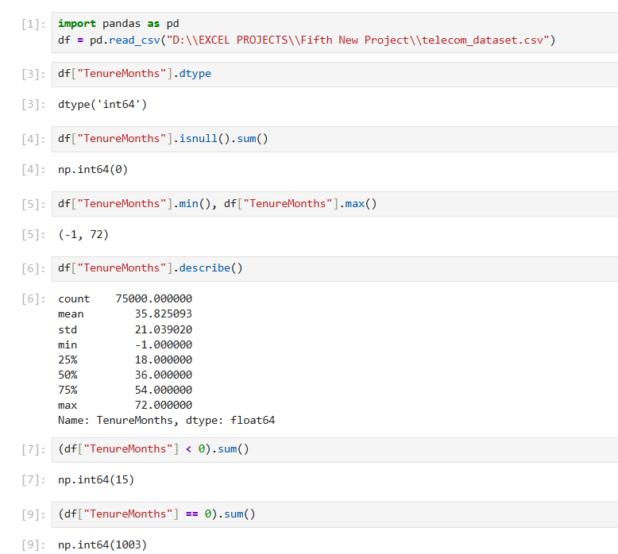
Here, there are 15 values that are less then 0 which is -1 and tenure months can not be in negative and around 1003 values are 0 which is potentially valid because the dataset may includes brand-new customers.
2) Checking churn by tenure and creating tenure group for analysis
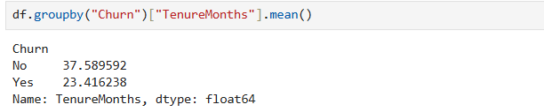
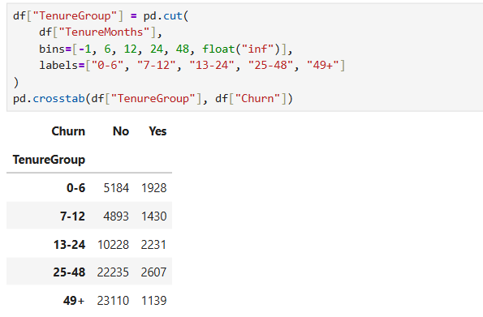
3) Checking churn percentage by tenure group
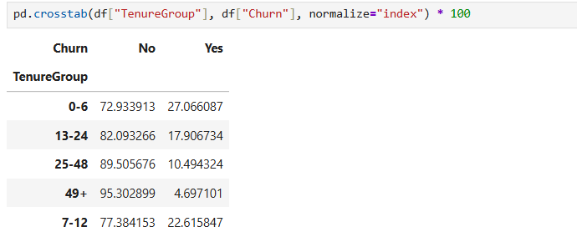
4) Examine -1 tenure months value and Replacing -1 values with 0 because it can represents new customers and since -1 value seems to be incorrect it might be an input error
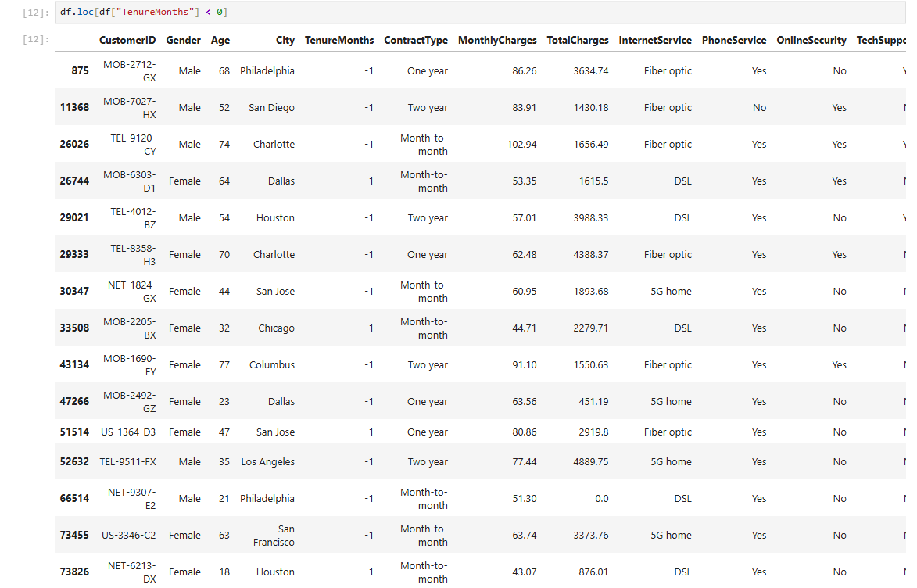
# Only shows CustomerID and TenureMonths columns
df.loc[df["TenureMonths"] < 0, ["CustomerID", "TenureMonths"]]
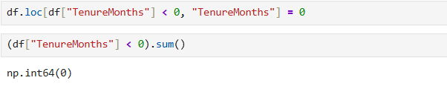
Column No 6 – (ContractType)
1) Importing dataset and checking missing values, datatype, unique values and value count of customers by contract type
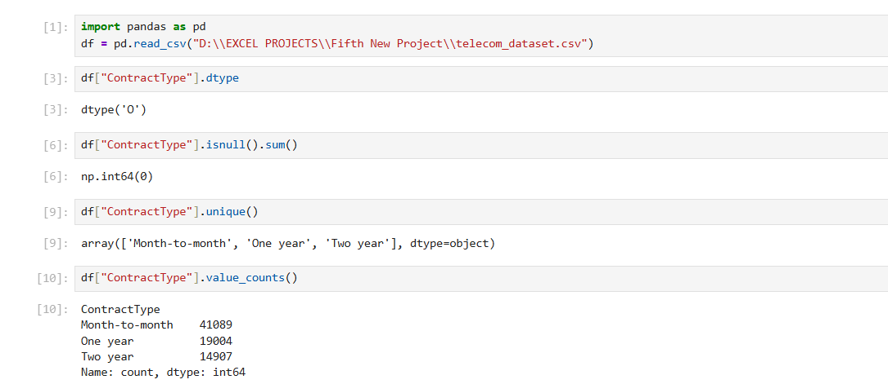
2) Checking churn counts by contract type and churn rate (percentage)
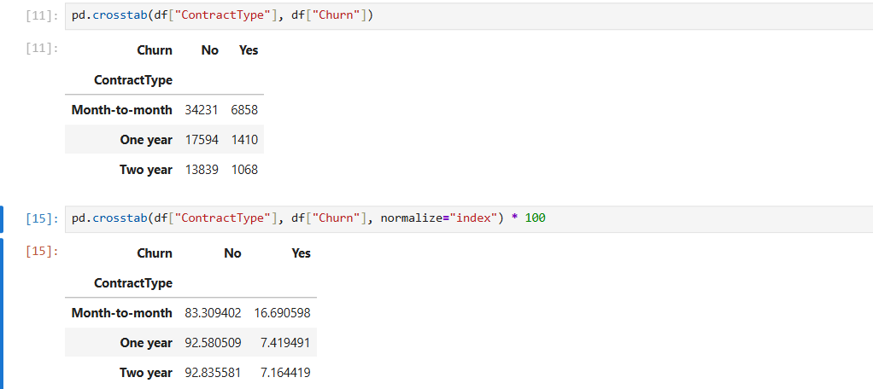
3) Visualizing churn by contract type
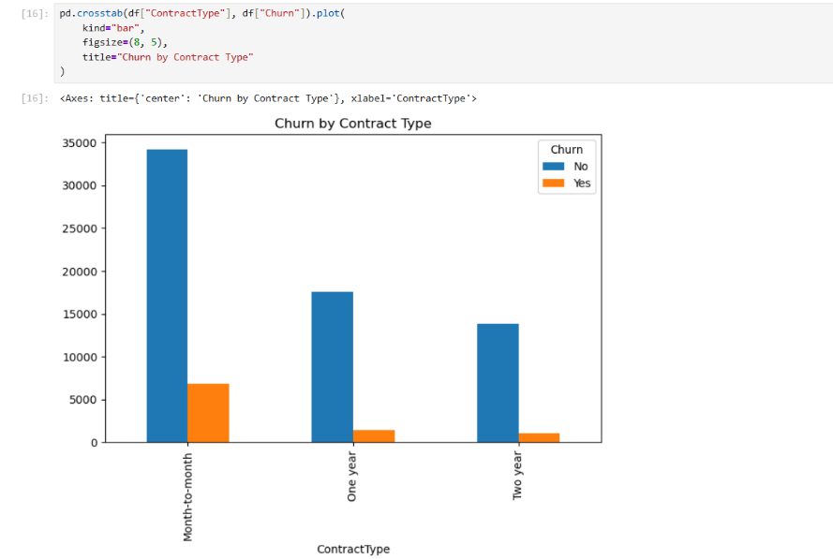

Column No 7 – (MonthlyCharges)
1) Importing dataset and checking datatype, missing values, minimum and maximum values, basic statistics and checking that less then 0 values exists or not and comparing average monthly charges by churn
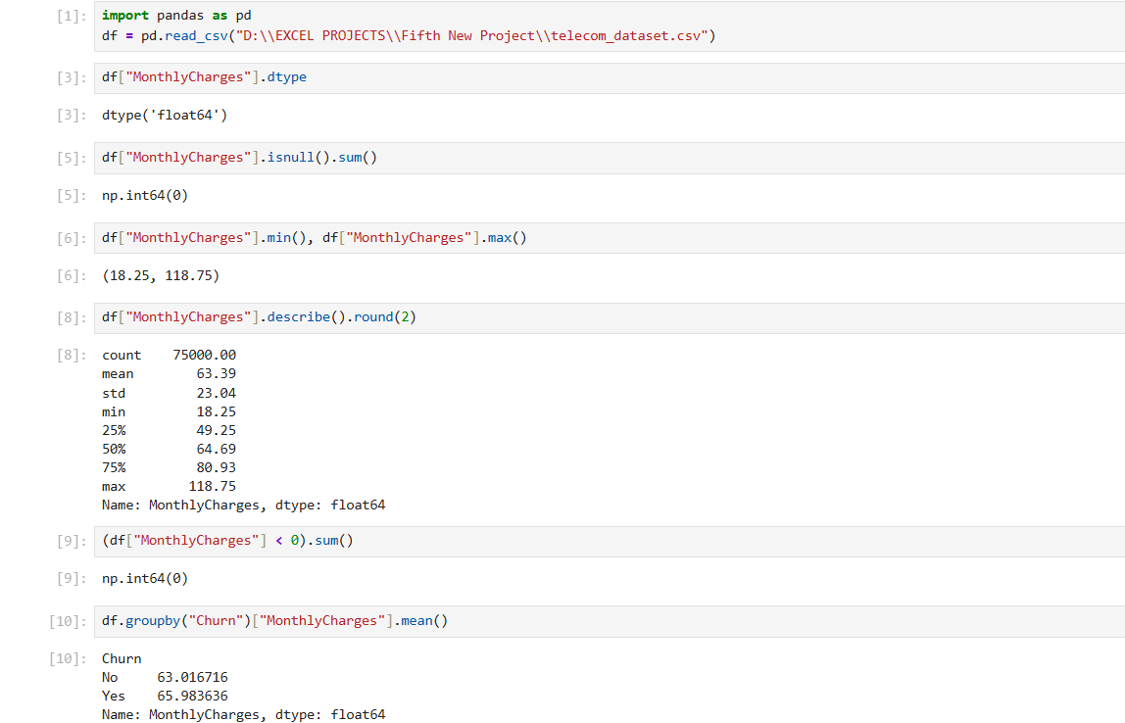
2) Grouping monthly charges and Calculating churn percentage by charge group
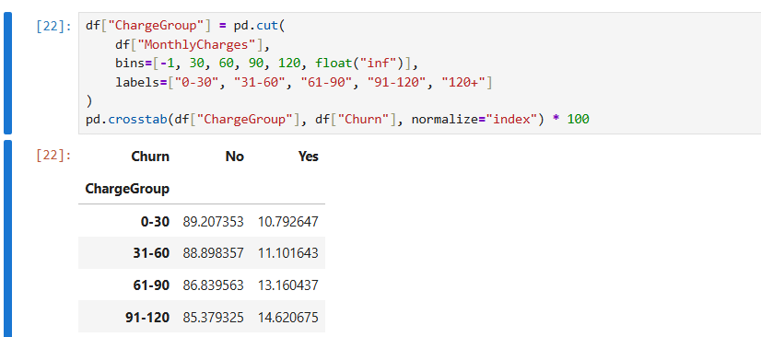

Column No 8 – (TotalCharges)
1) Importing dataset and checking datatype, missing values, blank-space values, unique values (which displays the first 20 unique values) and basic statistics
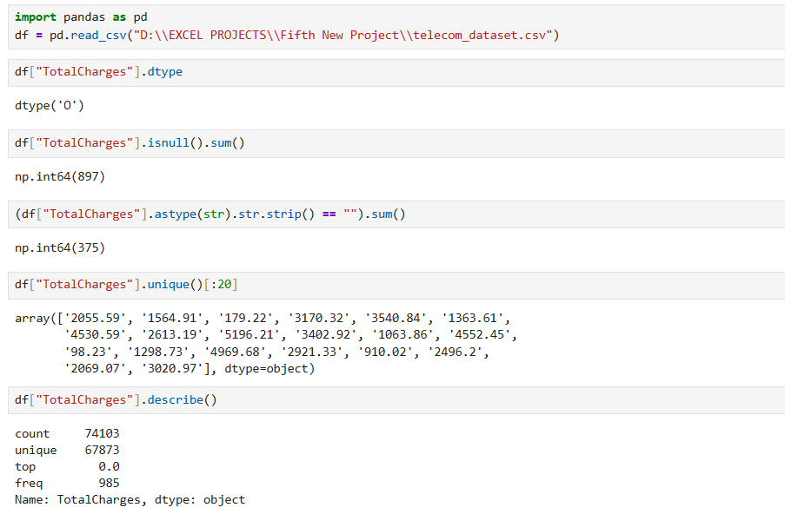
Here, the datatype is object which is incorrect because total charges contains numeric/decimal values and also there are some 897 null values and 375 blank values.
2) Converting the column to numeric
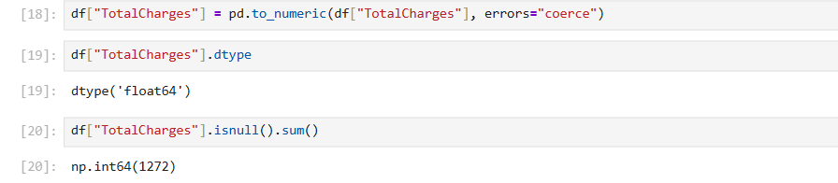
Here, blank spaces become missing values.
3) Investigating the missing values
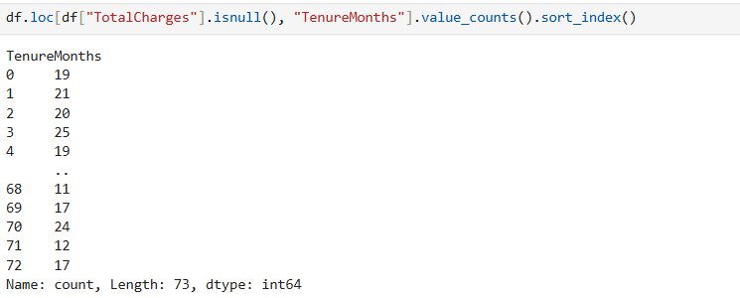
Here, output shows that 1,272 missing total charges values occur across tenure months values from 0 to 72 months.
4) Checking missing charges for customers with zero tenure
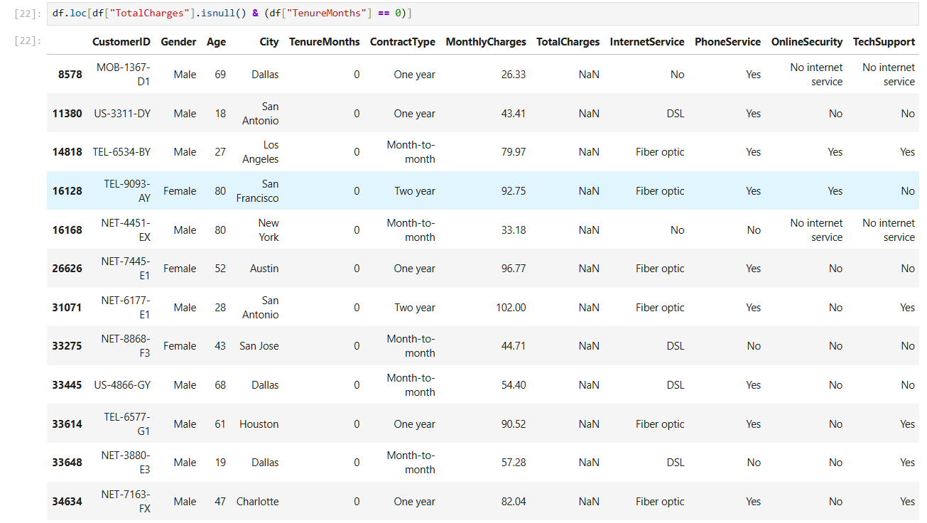
Here, around 19 customers are with missing total charges and having 0 tenure months
So, either these customers may be new who have not yet generated a total charge.
5) Checking the other 1,253 missing values with positive tenure months but have missing total charges
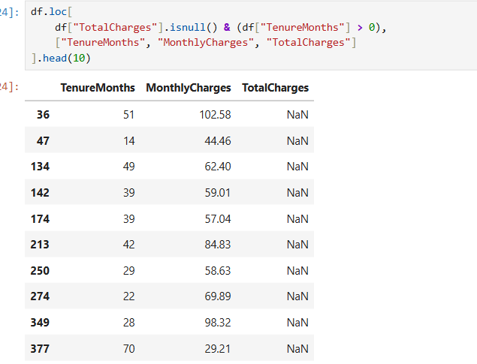
Here, I can fill the total charges values with the median who’s tenure month is > 0
through:
median_value = df["TotalCharges"].median()
df.loc[(df["TotalCharges"].isnull()) & (df["TenureMonths"] > 0), "TotalCharges"]=median_value
and fill 0 for the customers who’s tenure month and total charges are 0 through:
df.loc[(df["TotalCharges"].isnull()) & (df["TenureMonths"] == 0), "TotalCharges"] = 0
So, for now I will replace all the null values with the median value which is 1960.94 because it is difficult to determine if they are new customers or old ones.
6) Filling the missing values with the median and finally checking the current stats.
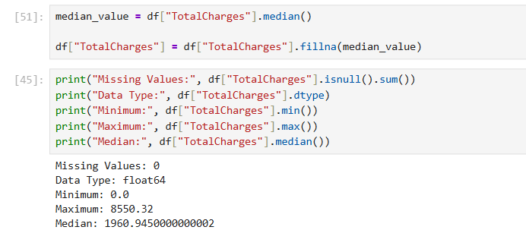

Column No 9 – (InternetService)
1) Importing dataset and checking datatype, missing values, unique values and value count by internet services
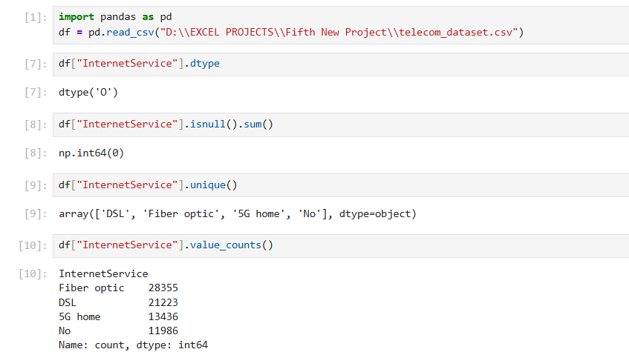
2) Checking churn counts by internet service and calculating churn percentages
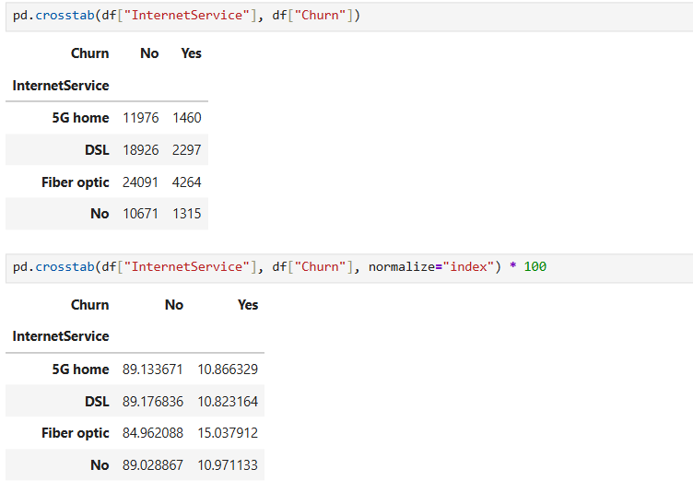

Column No 10 – (PhoneService)
1) Importing dataset and checking datatype, missing values, unique values, and value count of phone service
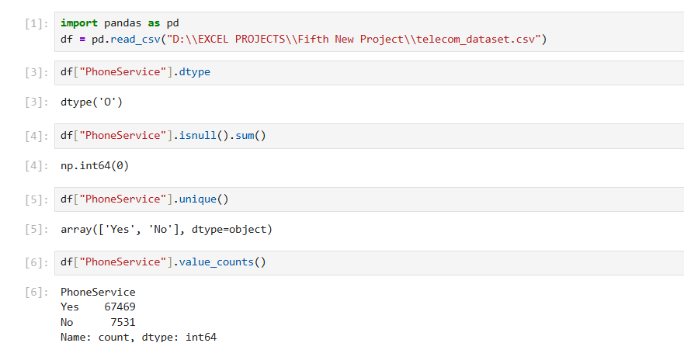
2) Checking churn count and calculating churn percentages
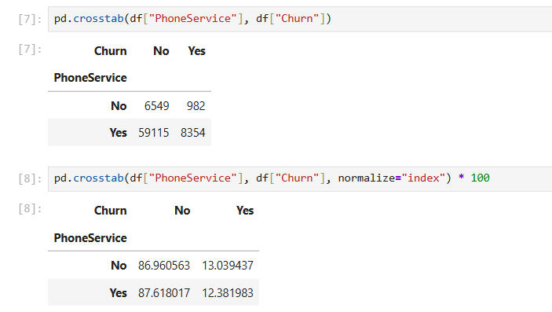

Column No 11 – (OnlineSecurity)
1) Importing dataset, checking datatype, missing values, unique values, value counts of online security
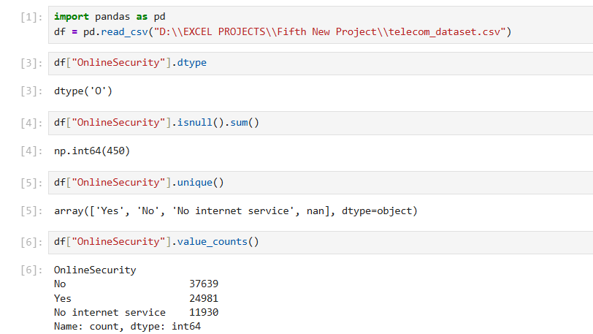
2) Checking online security against churn and calculating churn percentage
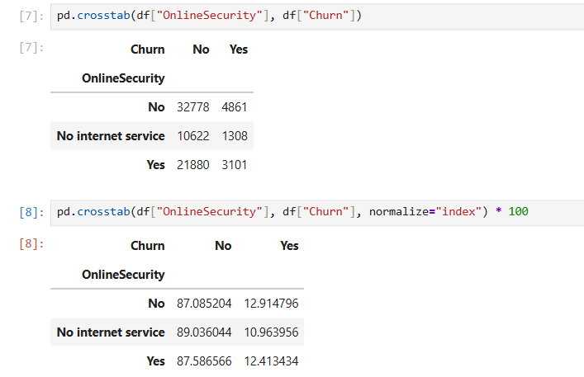
Here, there are 450 missing values.
3) Checking whether those customers have internet service
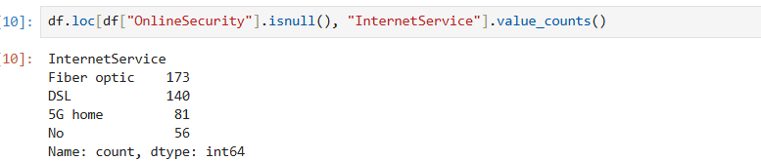
Here, 56 customers don’t use or have any internet service So, I cannot assume the missing values because it might be a data-entry issue.
4) Checking the other services columns
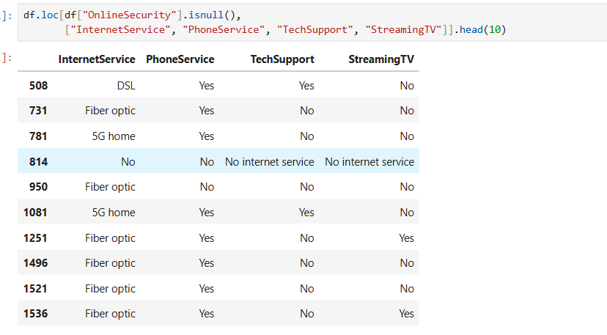
Here, output shows that the missing Online Security values occurs alongside different combinations of other service values. So, i cannot guess replacements based on these rows alone.
5) Filling missing values with "Unknown" because, I cannot reliably determine whether those 450 customers have online security or not.
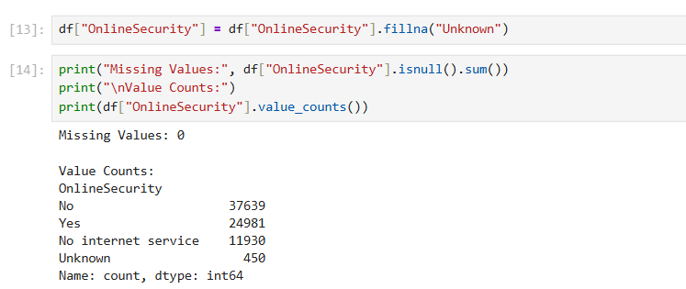

Column No 12 – (TechSupport)
1) Importing dataset and checking datatype, missing values, unique values, and each value count
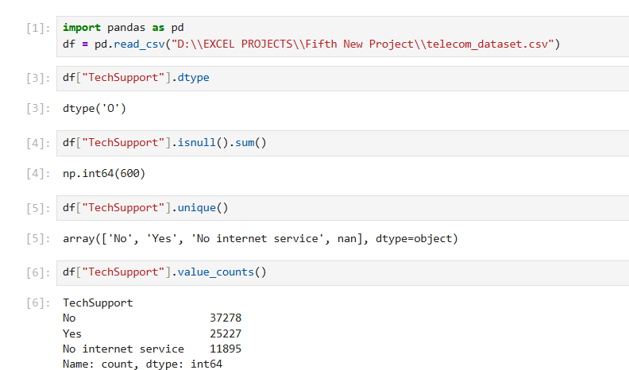
2) Checking tech support against churn and calculating churn percentage
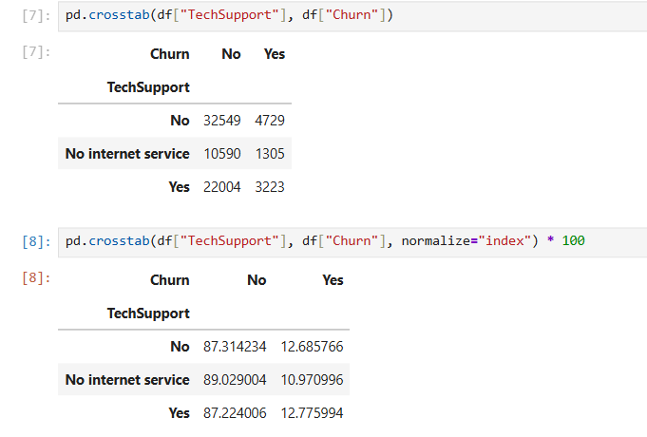
Here, 600 are the original actual missing values.
3) Filling missing values with "Unknown" because, I cannot reliably determine whether those 600 customers have tech support or not.
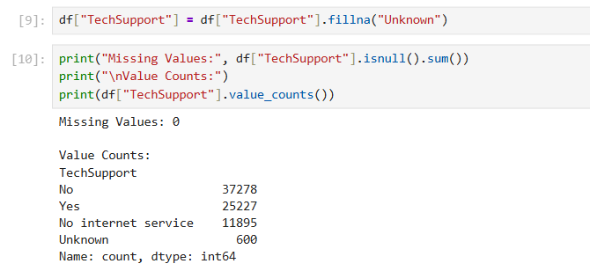
Column No 13 – (StreamingTV)
1) Importing dataset and checking datatype, missing values, unique values and value count of streaming tv
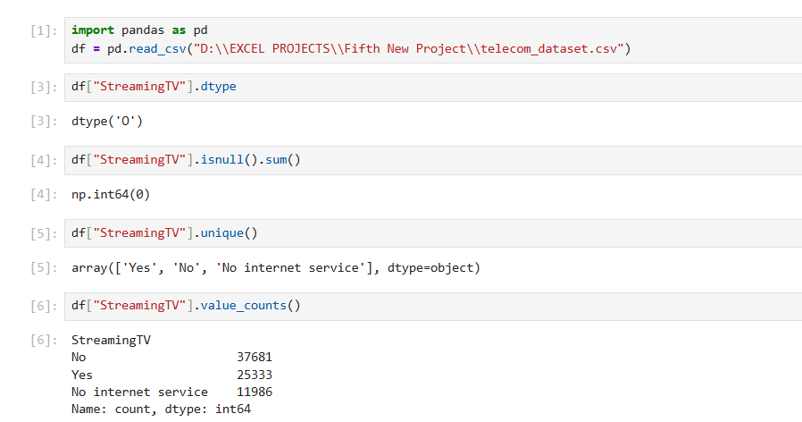
2) Checking Streaming TV against churn and Calculating churn percentage
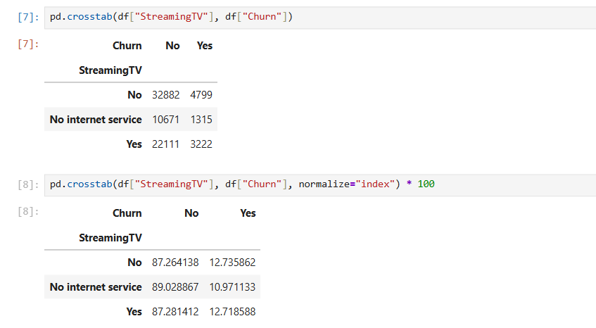

Column No 14 – (PaymentMethod)
1) Importing dataset and checking datatype, missing values, unique values and value count of payment method
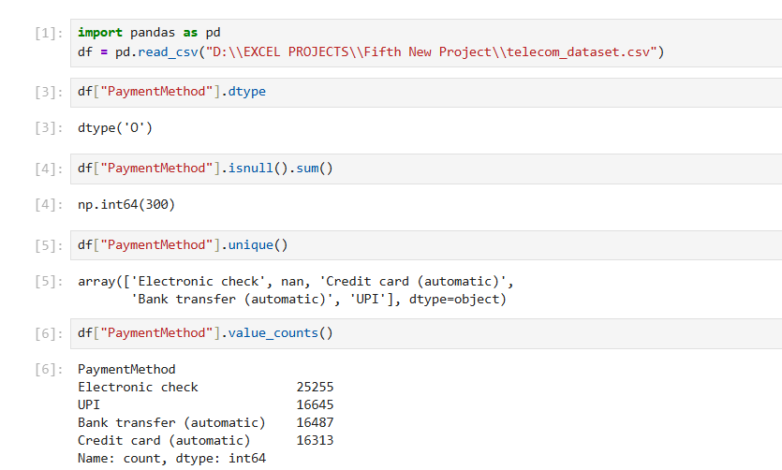
2) Checking payment method against churn and calculating churn percentage
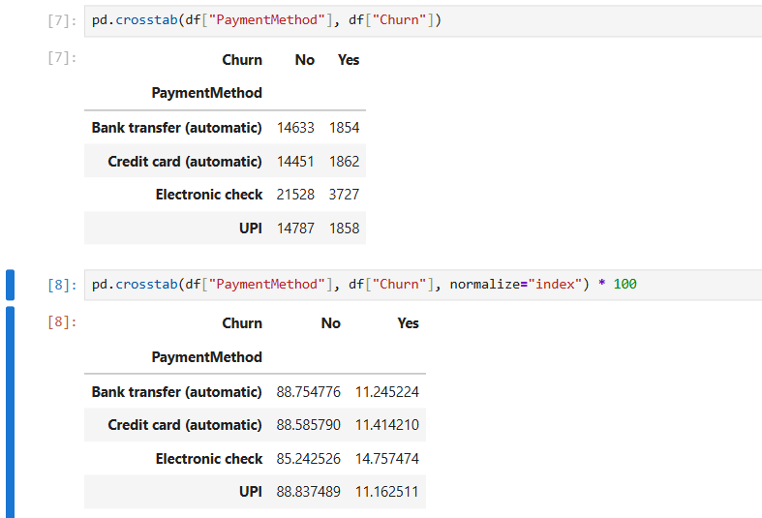
Here, there are in total 300 missing values.
3) Inspecting null payment method records
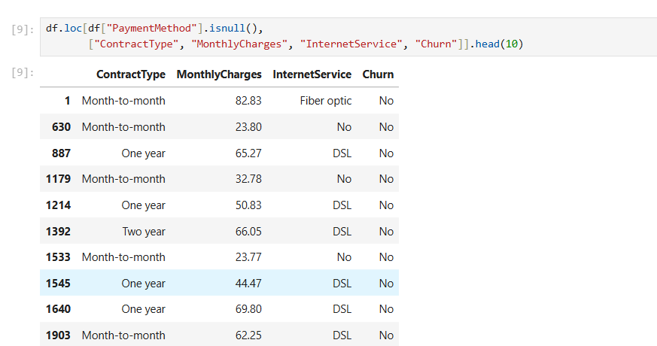
These outputs show that the customers with missing payment method values have different contract types, monthly charges, and internet services. So, I cannot determine which payment methods this customers used.
4) Filling the 300 missing values with “Unknown” and checking the value counts of each value
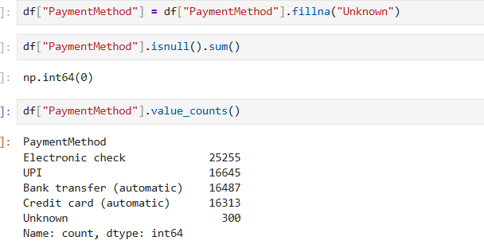

Column No 15 – (SupportCalls)
1) Importing dataset and checking datatype, missing values, unique values, basic statistics and unusual values (<0)
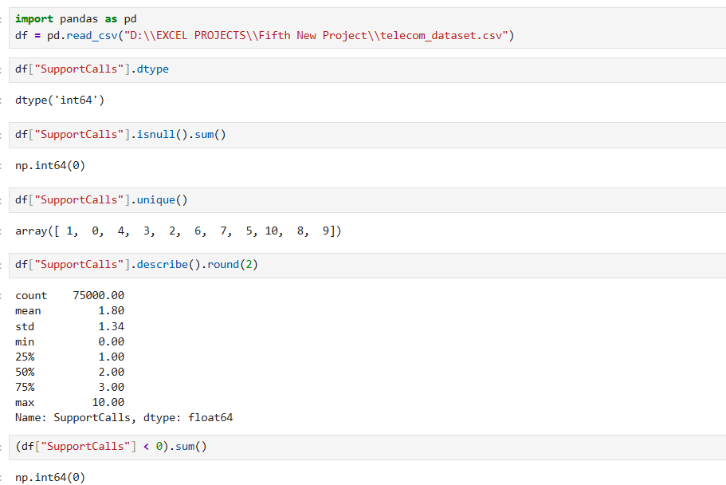
2) Checking support calls against churn and calculating churn percentage
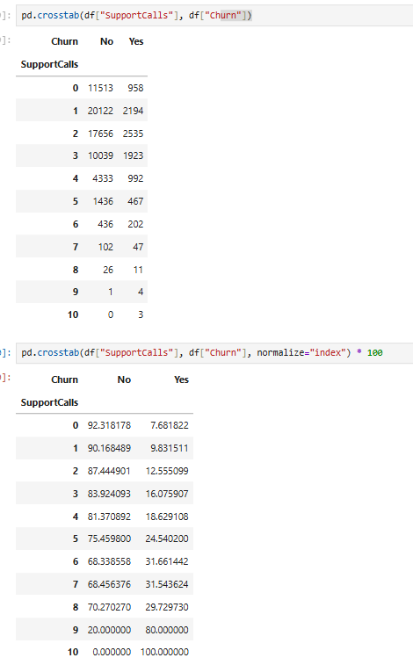
3) Creating a chart – churn by support calls
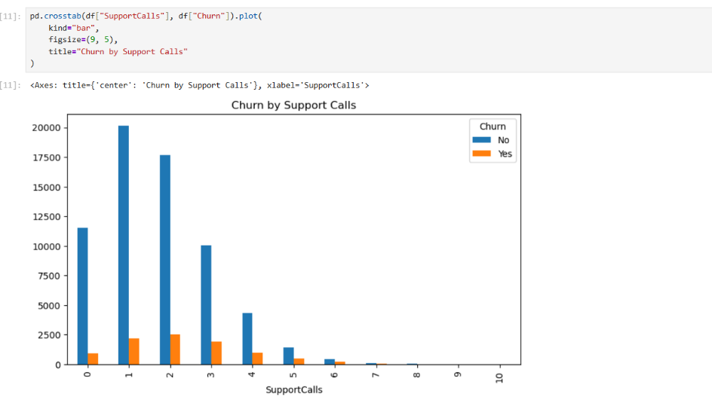
Column No 16 – (Complaints)
1) Importing dataset and checking datatype, missing values, unique values, and value counts of complaints
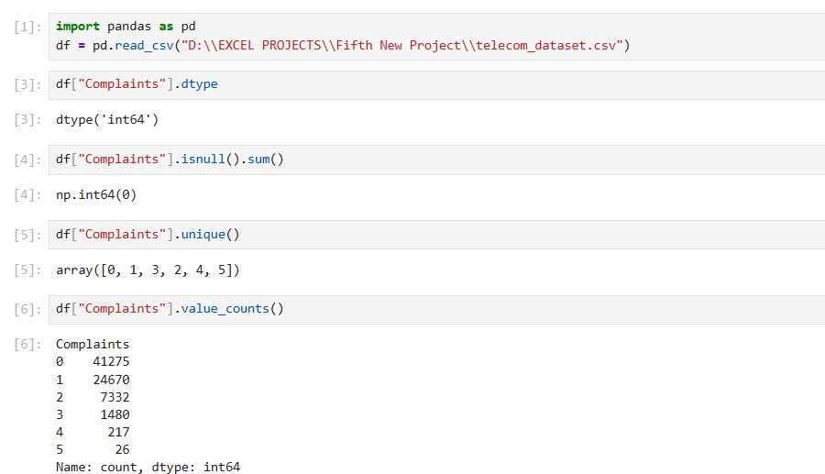
2) Checking basic statistics and unusual values (<0)
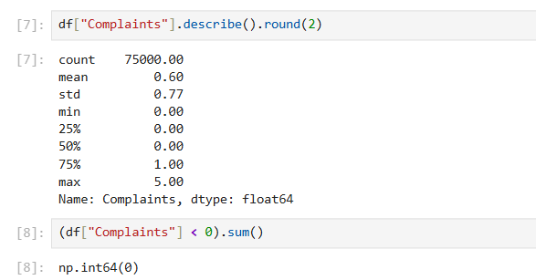
3) Checking complaints against churn and calculating churn percentage
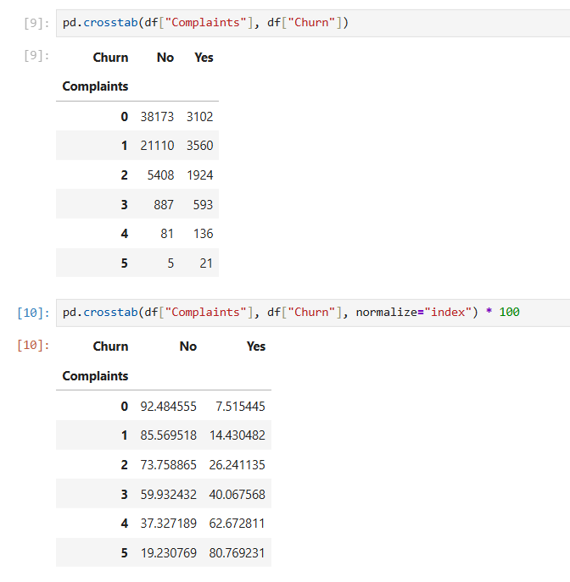
Column No 17 – (SatisfactionScore)
1) Importing dataset and checking datatype, missing values, unique values, and value counts of each value
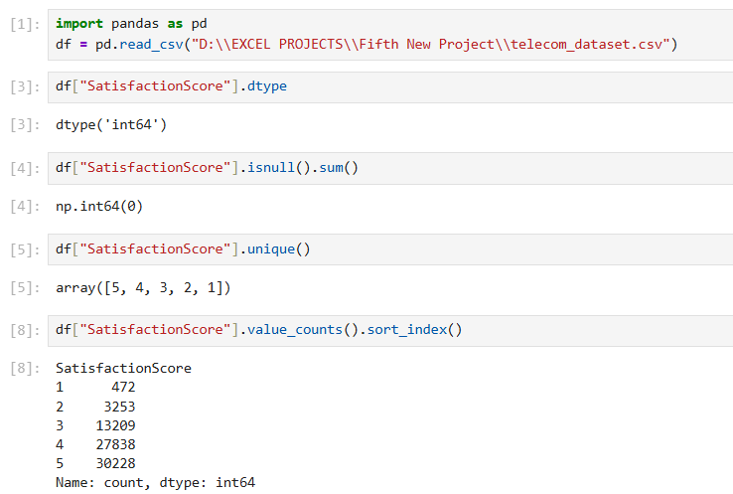
2) Checking basic statistics and invalid values
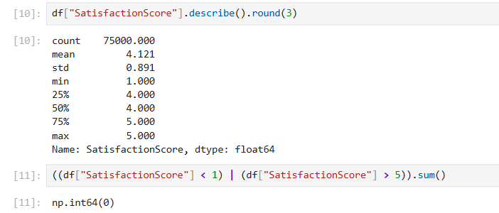
3) Checking satisfaction against churn and calculating churn percentage
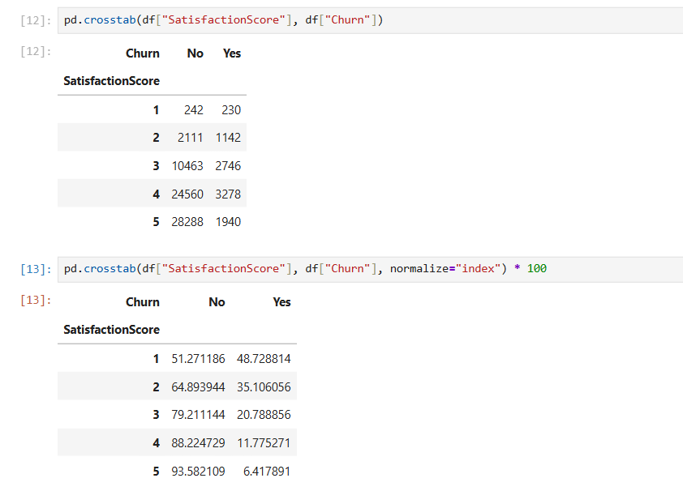
Column No 18 – (Churn)
1) Importing dataset and checking datatype, missing values, unique values, value count of each value and calculating churn percentages and checking for invalid values
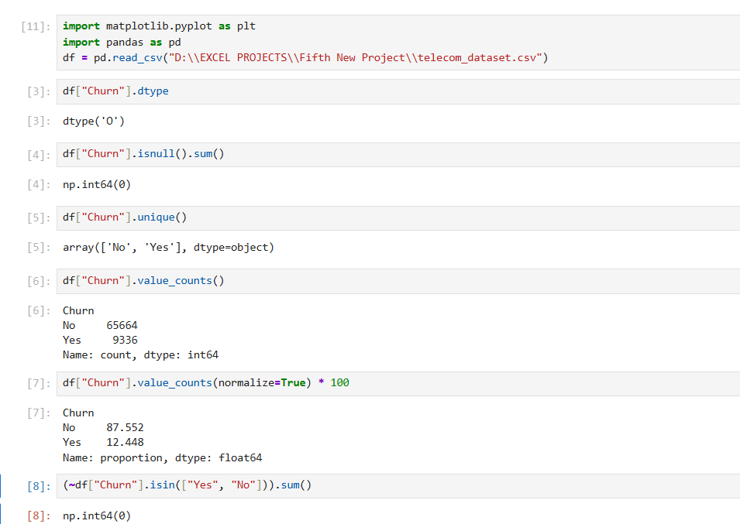
2) Creating a pie chart - customer churn distribution
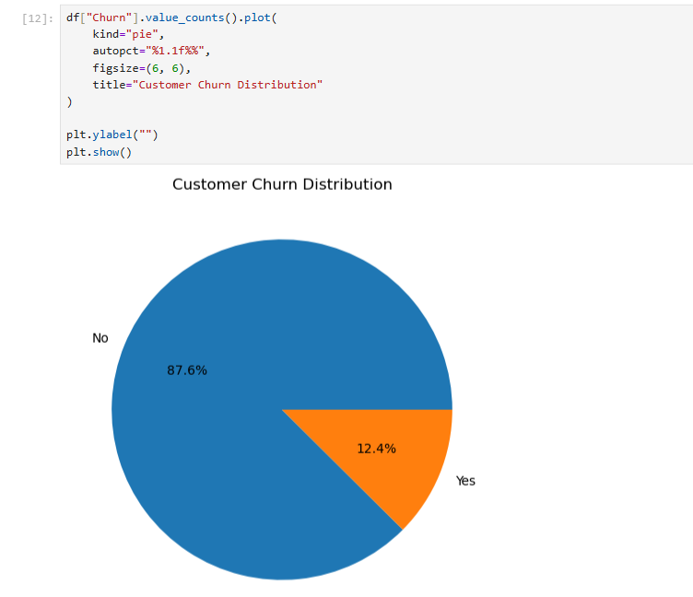

Exporting The Cleaned File In The Local System:
1) Checking whether the current data frame is actually cleaned or not
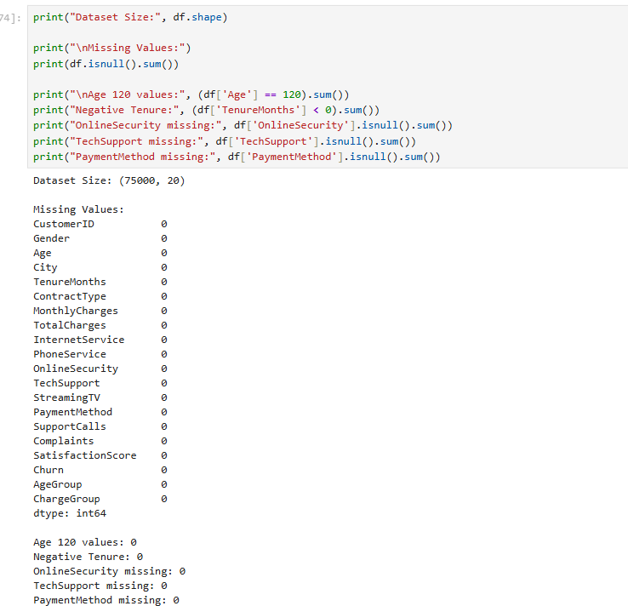
2) Hence, the agegroup and chargegroup columns where already created during the dataset cleaning stage but, I am creating them again properly.
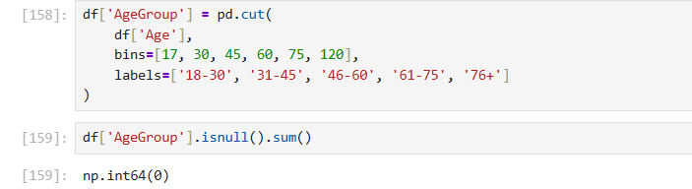
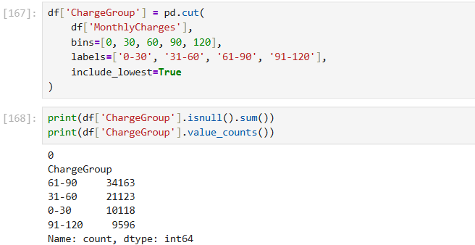
Now, the current (df) has been cleaned and prepared successfully.
3) Exporting the file and verify that the file is saved and returning the size of the file.
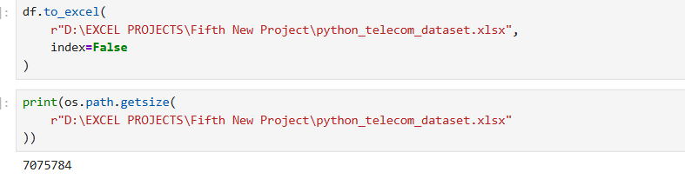
Here, the “os” module was already imported.

