PROJECT REPORT
School Management System Database
Relational Database Design and Implementation using MySQL
Class: Grade 12 Computer Science
Name: _______________________________
Date: _______________________________

1. Introduction
This report documents the design and implementation of a relational database for a School Management System, built as part of the Grade 12 Computer Science database project. The system manages data for departments, teachers, students, courses, and student enrollments.
The database was implemented in MySQL using XAMPP and phpMyAdmin. The project demonstrates the full database development lifecycle: schema design and normalization, table creation with primary and foreign key constraints, population with realistic sample data, and analytical querying using joins, subqueries, and aggregate functions.
The domain chosen is Option A: School Management System. The design uses five related tables rather than the minimum of three to more clearly demonstrate one-to-many and many-to-many relationships.

2. Entity-Relationship (ER) Diagram
The database consists of five entities:
- Department — an academic department (e.g. Computer Science, Mathematics).
- Teacher — a staff member who belongs to a department and may teach courses.
- Student — a learner who belongs to a department (their major/stream).
- Course — a course offered by a department and taught by one teacher.
- Enrollment — an associative (junction) entity representing the many-to-many relationship between Students and Courses: a student can take many courses, and a course can have many students.
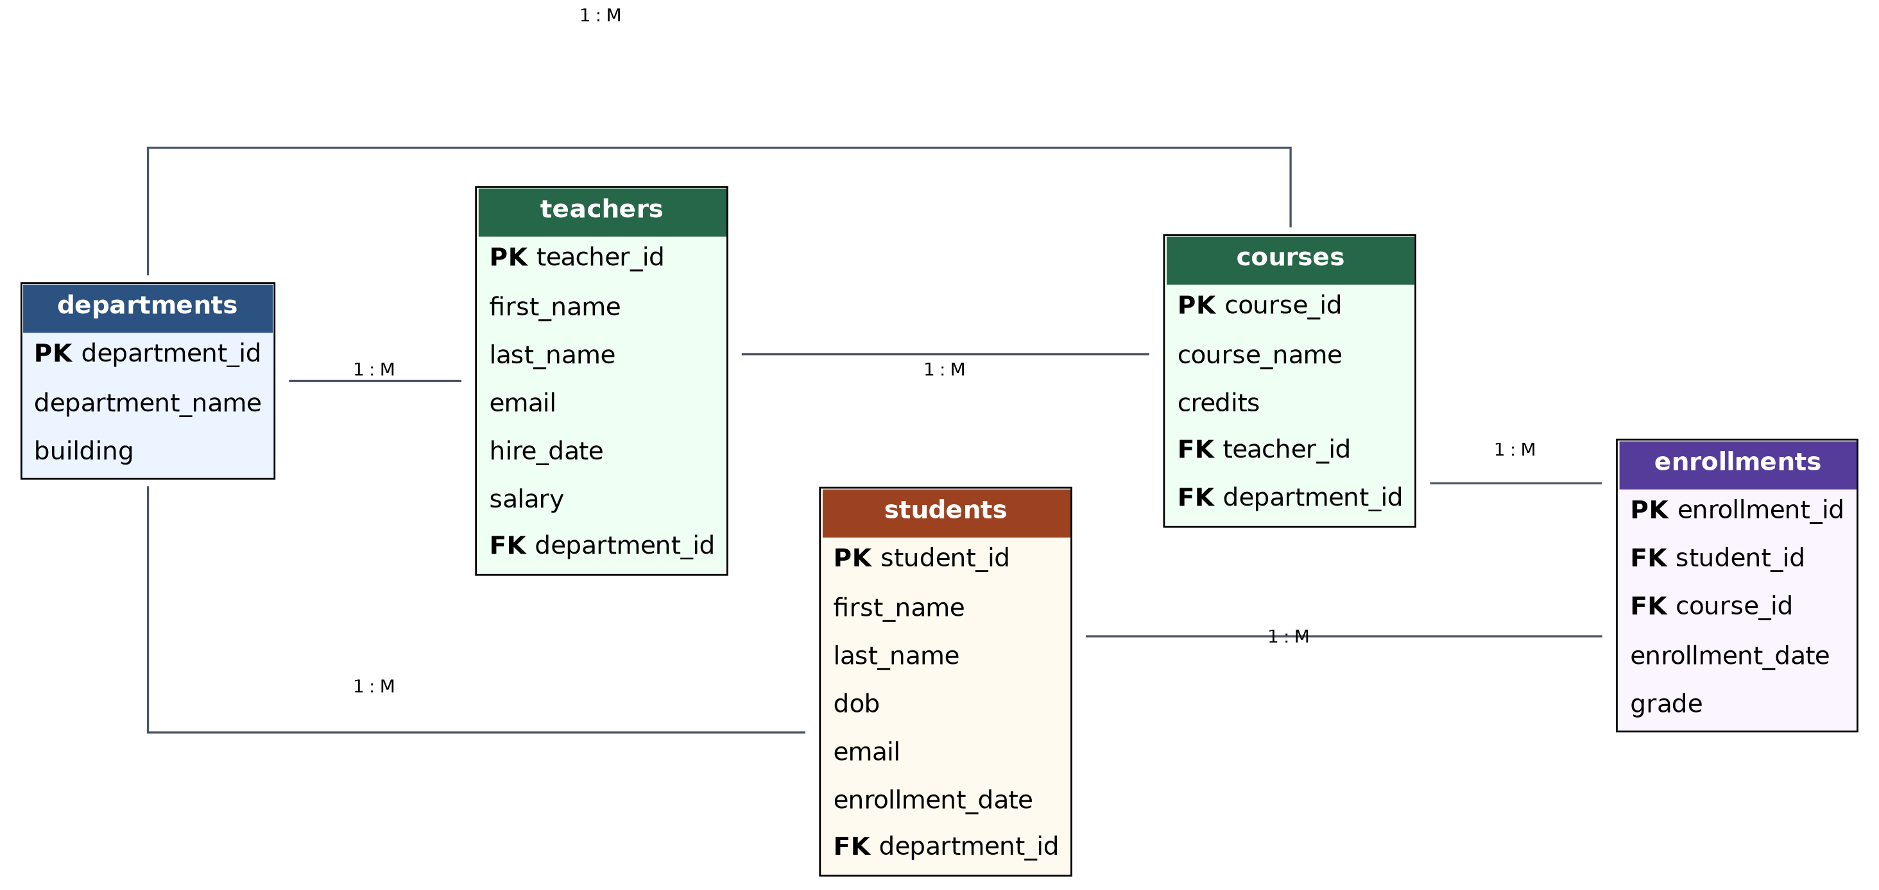
Figure 1: Entity-Relationship diagram showing all five tables and their key relationships.
Departments has a one-to-many relationship with teachers, students, and courses (one department can have many of each, but each teacher/student/course belongs to at most one department). Teachers has a one-to-many relationship with courses. Students and courses share a many-to-many relationship, resolved through the enrollments junction table.

3. Table Structure, Data Types, and Constraints
The following five tables implement the ER design above. All constraints enforce data integrity at the database level.

Table 1: departments
Column | Data Type | Constraints | Description
department_id | INT | PRIMARY KEY, AUTO_INCREMENT | Unique identifier for each department.
department_name | VARCHAR(50) | NOT NULL, UNIQUE | Name of the department.
building | VARCHAR(30) | DEFAULT 'Main Block' | Building where the department is located.

Table 2: teachers
Column | Data Type | Constraints | Description
teacher_id | INT | PRIMARY KEY, AUTO_INCREMENT | Unique identifier for each teacher.
first_name | VARCHAR(30) | NOT NULL | Teacher's first name.
last_name | VARCHAR(30) | NOT NULL | Teacher's last name.
email | VARCHAR(100) | NOT NULL, UNIQUE | Teacher's email address.
department_id | INT | FOREIGN KEY → departments | Department the teacher belongs to.
hire_date | DATE | NOT NULL | Date the teacher was hired.
salary | DECIMAL(10,2) | CHECK (salary > 0) | Monthly salary.

Table 3: students
Column | Data Type | Constraints | Description
student_id | INT | PRIMARY KEY, AUTO_INCREMENT | Unique identifier for each student.
first_name | VARCHAR(30) | NOT NULL | Student's first name.
last_name | VARCHAR(30) | NOT NULL | Student's last name.
dob | DATE | NOT NULL | Student's date of birth.
email | VARCHAR(100) | NOT NULL, UNIQUE | Student's email address.
department_id | INT | FOREIGN KEY → departments | Student's major/stream.
enrollment_date | DATE | NOT NULL, DEFAULT CURRENT_DATE | Date the student joined the school.

Table 4: courses
Column | Data Type | Constraints | Description
course_id | INT | PRIMARY KEY, AUTO_INCREMENT | Unique identifier for each course.
course_name | VARCHAR(60) | NOT NULL | Name of the course.
credits | INT | NOT NULL, CHECK (1–6) | Credit value of the course.
teacher_id | INT | FOREIGN KEY → teachers | Teacher assigned to the course.
department_id | INT | FOREIGN KEY → departments | Department offering the course.

Table 5: enrollments (associative entity)
Column | Data Type | Constraints | Description
enrollment_id | INT | PRIMARY KEY, AUTO_INCREMENT | Unique identifier for each enrollment.
student_id | INT | NOT NULL, FOREIGN KEY → students | The enrolled student.
course_id | INT | NOT NULL, FOREIGN KEY → courses | The course enrolled in.
enrollment_date | DATE | NOT NULL, DEFAULT CURRENT_DATE | Date of enrollment.
grade | VARCHAR(2) | DEFAULT NULL | Final grade (NULL if not yet graded).
A UNIQUE constraint on (student_id, course_id) in enrollments prevents a student from being enrolled in the same course more than once — an extra data-integrity safeguard beyond the minimum requirement.

4. Database Implementation (SQL Script)
The full script is submitted separately as database_setup.sql. Key excerpts are shown below; see the script file for the complete, runnable version including all comments.

4.1 Database and Table Creation (excerpt)
CREATE DATABASE school_management_system;
USE school_management_system;

CREATE TABLE departments (
department_id INT AUTO_INCREMENT PRIMARY KEY,
department_name VARCHAR(50) NOT NULL UNIQUE,
building VARCHAR(30) DEFAULT 'Main Block'
);

CREATE TABLE teachers (
teacher_id INT AUTO_INCREMENT PRIMARY KEY,
first_name VARCHAR(30) NOT NULL,
last_name VARCHAR(30) NOT NULL,
email VARCHAR(100) NOT NULL UNIQUE,
department_id INT,
hire_date DATE NOT NULL,
salary DECIMAL(10,2) CHECK (salary > 0),
FOREIGN KEY (department_id) REFERENCES departments(department_id)
);

-- students, courses, and enrollments follow the same pattern
-- (full definitions in database_setup.sql)
📷 PASTE SCREENSHOT HERE
SHOW TABLES; / DESCRIBE output for each table

4.2 Data Insertion (excerpt)
Each table was populated with realistic sample records. Example from students:
INSERT INTO students (first_name, last_name, dob, email, department_id, enrollment_date) VALUES
('Aayush', 'Basnet', '2008-04-12', 'aayush.basnet@student.edu', 1, '2023-06-01'),
('Sujata', 'Rai', '2008-09-23', 'sujata.rai@student.edu', 2, '2023-06-01'),
('Prakash', 'Thapa', '2007-11-05', 'prakash.thapa@student.edu', 1, '2023-06-01');
-- full 8-record set in database_setup.sql
📷 PASTE SCREENSHOT HERE
SELECT * FROM students; / teachers / courses / enrollments

5. Database Querying & Analytics
The following queries are included in database_setup.sql and demonstrate the required query types.

5.1. Basic Retrieval (WHERE, ORDER BY, LIMIT)
Retrieves the 3 most recently hired teachers earning above 45,000, demonstrating filtering, sorting, and limiting results.
SELECT first_name, last_name, hire_date, salary
FROM teachers
WHERE salary > 45000
ORDER BY hire_date DESC
LIMIT 3;
📷 PASTE SCREENSHOT HERE
Query result: Basic Retrieval (WHERE, ORDER BY, LIMIT)

5.2. Aggregate Functions (GROUP BY, HAVING)
Finds departments with more than one teacher, showing the teacher count and average salary per department.
SELECT d.department_name,
COUNT(t.teacher_id) AS teacher_count,
AVG(t.salary) AS avg_salary
FROM departments d
JOIN teachers t ON d.department_id = t.department_id
GROUP BY d.department_name
HAVING COUNT(t.teacher_id) > 1;
📷 PASTE SCREENSHOT HERE
Query result: Aggregate Functions (GROUP BY, HAVING)

5.3. Subquery
Finds students enrolled in more courses than the average number of courses per student, using a correlated subquery nested inside the WHERE clause.
SELECT s.first_name, s.last_name,
(SELECT COUNT(*) FROM enrollments e
WHERE e.student_id = s.student_id) AS course_count
FROM students s
WHERE (SELECT COUNT(*) FROM enrollments e
WHERE e.student_id = s.student_id) >
(SELECT COUNT(*) FROM enrollments) /
(SELECT COUNT(*) FROM students);
📷 PASTE SCREENSHOT HERE
Query result: Subquery

5.4a. INNER JOIN
Lists every enrollment together with the student's name, the course name, and the grade. INNER JOIN returns only rows where matching records exist in both joined tables.
SELECT s.first_name, s.last_name, c.course_name, e.grade
FROM enrollments e
INNER JOIN students s ON e.student_id = s.student_id
INNER JOIN courses c ON e.course_id = c.course_id
ORDER BY s.last_name;
📷 PASTE SCREENSHOT HERE
Query result: INNER JOIN

5.4b. LEFT JOIN
Lists all courses and how many students are enrolled in each, including courses with zero enrollments. An extra course (“Advanced Statistics”) with no enrollments was inserted specifically to prove this differs from an INNER JOIN, which would have excluded that course entirely.
SELECT c.course_name,
COUNT(e.enrollment_id) AS total_enrolled
FROM courses c
LEFT JOIN enrollments e ON c.course_id = e.course_id
GROUP BY c.course_name
ORDER BY total_enrolled DESC;
Note: “Advanced Statistics” appears with total_enrolled = 0, which would not appear at all under an INNER JOIN — this is the visual proof that the LEFT JOIN is functioning as intended.
📷 PASTE SCREENSHOT HERE
Query result: LEFT JOIN

5.5a. UPDATE
Assigns a final grade to a student whose enrollment previously had a NULL grade.
UPDATE enrollments
SET grade = 'B'
WHERE student_id = 8 AND course_id = 1;
📷 PASTE SCREENSHOT HERE
Query result: UPDATE

5.5b. DELETE
Removes a specific enrollment record (e.g. representing a student dropping a course). The WHERE clause targets one exact row using both student_id and course_id to prevent accidental data loss.
DELETE FROM enrollments
WHERE student_id = 8 AND course_id = 2;
📷 PASTE SCREENSHOT HERE
Query result: DELETE

6. Conclusion
This project successfully designed, implemented, and queried a relational database for a School Management System using MySQL. The five-table schema (departments, teachers, students, courses, enrollments) demonstrates normalized design with clear primary and foreign key relationships, including both one-to-many relationships (department to teachers/students/courses) and a many-to-many relationship (students to courses, resolved through the enrollments junction table).
The accompanying database_setup.sql script implements this design end-to-end: table creation with constraints, realistic sample data, and analytical queries covering filtering and sorting, aggregate functions with GROUP BY/HAVING, a correlated subquery, both INNER and LEFT JOINs, and safe UPDATE/DELETE operations. Together, the schema and queries demonstrate the core principles of relational database design and SQL querying covered in this unit.

