CC-01

Q1.

Code:

package pkg;

import java.util.List;

import org.openqa.selenium.By;

import org.openqa.selenium.WebDriver;

import org.openqa.selenium.WebElement;

import org.openqa.selenium.edge.EdgeDriver;

import org.openqa.selenium.edge.EdgeOptions;

import io.github.bonigarcia.wdm.WebDriverManager;

public class q1 {

public static void main(String[] agrs) throws InterruptedException {

WebDriverManager.*edgedriver*().setup();

EdgeOptions co=new EdgeOptions();

co.addArguments("--remote-allow-origins=*");

WebDriver driver=new EdgeDriver(co);

driver.get("https://www.saucedemo.com/checkout-step-two.html");

driver.findElement(By.*id*("user-name")).sendKeys("standard_user");

driver.findElement(By.*id*("password")).sendKeys("secret_sauce");

driver.findElement(By.*id*("login-button")).click();

Thread.*sleep*(1500);

driver.findElement(By.*id*("add-to-cart-sauce-labs-backpack")).click();

Thread.*sleep*(1500);

if(driver.findElement(By.*id*("remove-sauce-labs-backpack")).isDisplayed())

{

System.***out***.println("Add to cart is working");

}

else {

System.***out***.print("Add to cart not working");

}

driver.findElement(By.*xpath*("//*[@id=\"shopping_cart_container\"]/a")).click();

String l=driver.getCurrentUrl();

String lt="https://www.saucedemo.com/cart.html";

if(l.equals(lt)) {

System.***out***.println("Cart can be viewed");

}

else {

System.***out***.println("Cart connot be viewed");

}

driver.findElement(By.*id*("checkout")).click();

if(driver.findElement(By.*xpath*("//*[@id=\"header_container\"]/div[2]/span")).isDisplayed()) {

System.***out***.println("Information is displayed");

}

else {

System.***out***.print("Info is not displayed");

}

driver.findElement(By.*id*("first-name")).sendKeys("Aadita");

driver.findElement(By.*id*("last-name")).sendKeys("B P");

driver.findElement(By.*id*("postal-code")).sendKeys("602201");

driver.findElement(By.*id*("continue")).click();

String url2=driver.getCurrentUrl();

String urlt2="https://www.saucedemo.com/checkout-step-two.html";

if(url2.equals(urlt2)) {

System.***out***.println("Product overview is displayed");

}

else {

System.***out***.println("Product overview is not displayed");

}

System.***out***.println("Name:");

List<WebElement> l1=driver.findElements(By.*xpath*("//*[@id=\"item_4_title_link\"]/div"));

for(WebElement link:l1) {

System.***out***.println(link.getText()+" ");

}

System.***out***.println("Price:");

List<WebElement> l2=driver.findElements(By.*xpath*("//*[@id=\"checkout_summary_container\"]/div/div[1]/div[3]/div[2]/div[2]/div"));

for(WebElement link:l2) {

System.***out***.println(link.getText()+" ");

}

String aTitle="Swag Labs";

String title=driver.getTitle();

if(aTitle.equals(title)) {

System.***out***.println("Title is correct");

};

String aURL="https://www.saucedemo.com/checkout-step-two.html";

String URL=driver.getCurrentUrl();

if(aURL.equals(URL)) {

System.***out***.println("URl is correct");

};

}

Console Output:

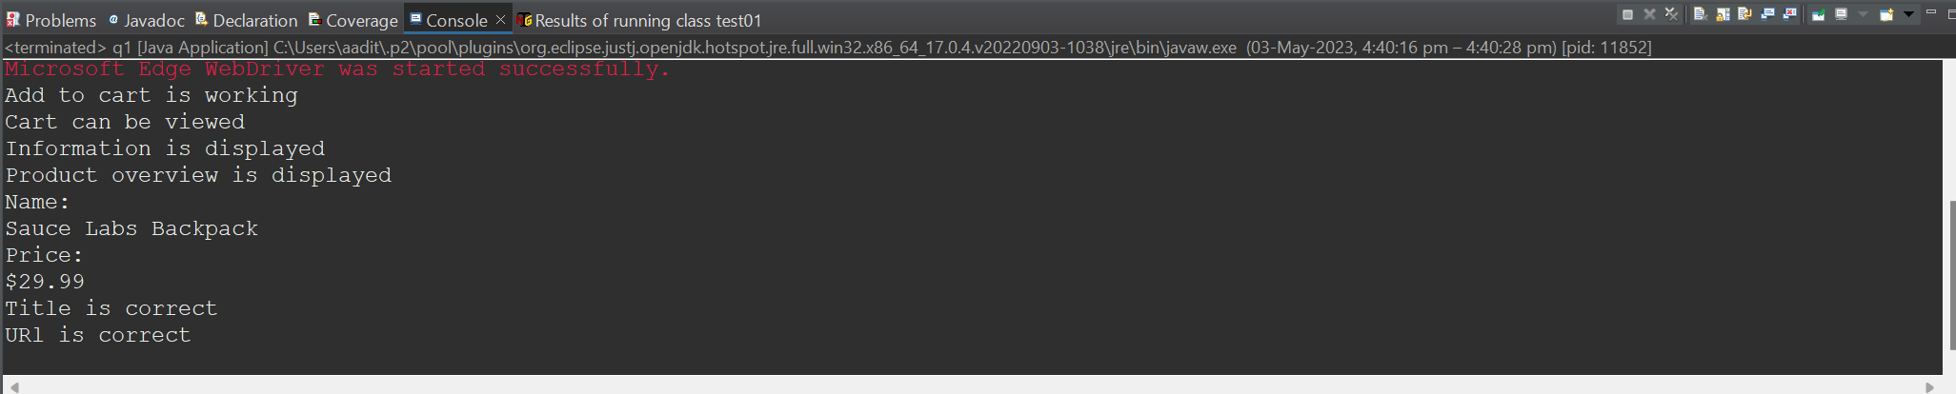

Output:

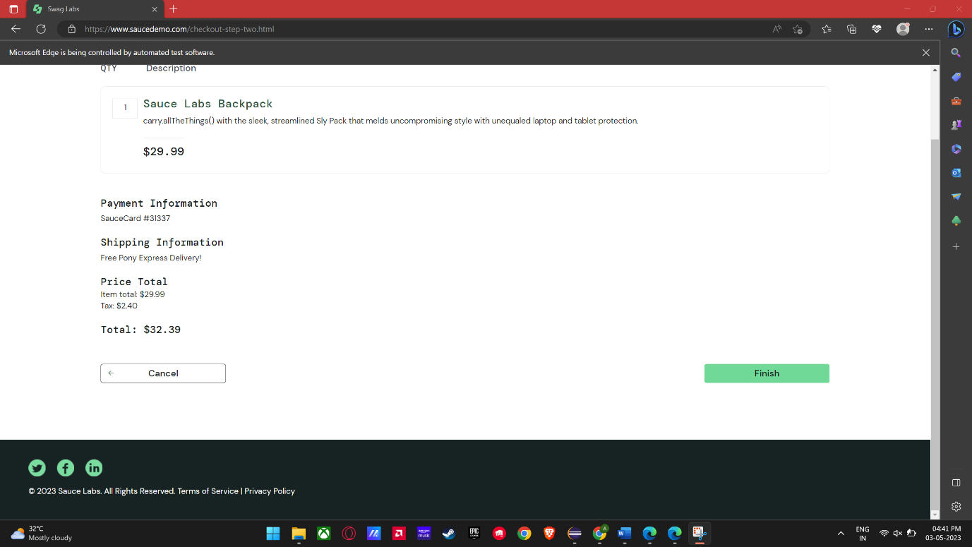

Q2.

Code:

package pkg;

import org.openqa.selenium.By;

import org.openqa.selenium.WebDriver;

import org.openqa.selenium.WebElement;

import org.openqa.selenium.edge.EdgeDriver;

import org.openqa.selenium.edge.EdgeOptions;

import io.github.bonigarcia.wdm.WebDriverManager;

public class q2 {

public static void main(String[] agrs) throws InterruptedException {

WebDriverManager.*edgedriver*().setup();

EdgeOptions co=new EdgeOptions();

co.addArguments("--remote-allow-origins=*");

WebDriver driver=new EdgeDriver(co);

driver.get("https://www.saucedemo.com/checkout-step-two.html");

driver.findElement(By.*id*("user-name")).sendKeys("standard_user");

driver.findElement(By.*id*("password")).sendKeys("secret_sauce");

driver.findElement(By.*id*("login-button")).click();

Thread.*sleep*(1500);

driver.findElement(By.*xpath*("//*[@id=\"header_container\"]/div[2]/div/span/select")).click();

if(driver.findElement(By.*xpath*("//*[@id=\"header_container\"]/div[2]/div/span/select/option[1]")).isDisplayed())

{

System.***out***.println("A-Z works");

}

else {

System.***out***.print("A-Z not working");

}

driver.findElement(By.*xpath*("//*[@id=\"header_container\"]/div[2]/div/span/select/option[1]")).click();

Thread.*sleep*(1500);

String temp1=driver.findElement(By.*xpath*("//*[@id=\"item_4_title_link\"]/div")).getText();

System.***out***.println(temp1);

driver.findElement(By.*xpath*("//*[@id=\"header_container\"]/div[2]/div/span/select")).click();

if(driver.findElement(By.*xpath*("//*[@id=\"header_container\"]/div[2]/div/span/select/option[2]")).isDisplayed())

{

System.***out***.println("Z-A works");

}

else {

System.***out***.print("Z-A not working");

}

driver.findElement(By.*xpath*("//*[@id=\"header_container\"]/div[2]/div/span/select/option[2]")).click();

Thread.*sleep*(1500);

String temp2=driver.findElement(By.*xpath*("//*[@id=\"item_3_title_link\"]/div")).getText();

System.***out***.println(temp2);

driver.findElement(By.*xpath*("//*[@id=\"header_container\"]/div[2]/div/span/select")).click();

if(driver.findElement(By.*xpath*("//*[@id=\"header_container\"]/div[2]/div/span/select/option[3]")).isDisplayed())

{

System.***out***.println("price high-low works");

}

else {

System.***out***.print("price high-low not working");

}

driver.findElement(By.*xpath*("//*[@id=\"header_container\"]/div[2]/div/span/select/option[3]")).click();

Thread.*sleep*(1500);

String temp3=driver.findElement(By.*xpath*("//*[@id=\"inventory_container\"]/div/div[1]/div[2]/div[2]/div")).getText();

System.***out***.println(temp3);

driver.findElement(By.*xpath*("//*[@id=\"header_container\"]/div[2]/div/span/select")).click();

if(driver.findElement(By.*xpath*("//*[@id=\"header_container\"]/div[2]/div/span/select/option[4]")).isDisplayed())

{

System.***out***.println("price low to high works");

}

else {

System.***out***.print("price high to low not working");

}

driver.findElement(By.*xpath*("//*[@id=\"header_container\"]/div[2]/div/span/select/option[4]")).click();

Thread.*sleep*(1500);

String temp4=driver.findElement(By.*xpath*("//*[@id=\"inventory_container\"]/div/div[1]/div[2]/div[2]/div")).getText();

System.***out***.println(temp4);

}

}

Console Output:

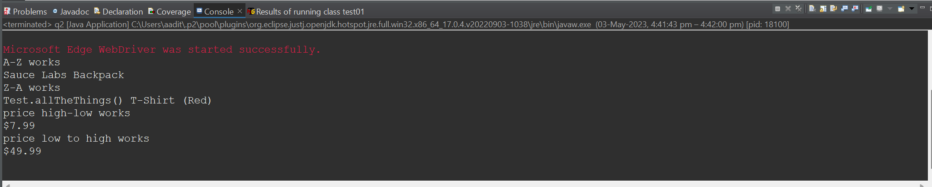

Output:

