

2025 - 26

COURSE CODE: CMSE11431
TITLE: Prescriptive Analytics with Mathematical Programming

ASSIGNMENT TITLE: Home Healthcare Routing & Scheduling Problem

GROUP NUMBER: Group 9

Word count: 2485

Home Healthcare Routing & Scheduling Problem

Introduction
Home healthcare services are becoming vital as healthcare systems shift toward patient-centred care models. With ageing populations and a growing preference of at-home medical assistance, healthcare providers face significant challenges in efficiently routing and scheduling home visits. Effective routing and scheduling reduce travel time, optimise staff utilisation, and improve patient satisfaction, and lower operational costs.

Delivering high-quality home healthcare while minimising travel costs is complex due to various practical constraints (Atta et al., 2025). Agencies must provide timely and consistent services despite increasing patient demand and limited staff availability (Zhao et al., 2024). Each patient requires specific care which is to be given by appropriately trained staff within narrow time windows, making the scheduling process error-prone. Traditional manual scheduling often fails to account for multiple factors, such as varying staff skills, travel time, and time-dependent patient needs, resulting in suboptimal assignments, excessive travel, and unbalanced workloads.
Mathematical programming, particularly Mixed Integer Linear Programming (MILP), provides a structured and effective method for addressing these challenges. It allows decision-makers to incorporate numerous operational constraints, such as staff availability, skill levels, travel distance, and overtime, into a single optimised framework. As Xiao et al., (2018) demonstrate, “The MILP formulation enables realistic staff assignments and routing based on daily visits, minimising overtime and travel cost within well-defined operational rules”. This model structure and objective function, i.e., cost = travel + overtime + penalty on unattended patients, aligns with the typical requirements of real-world agencies and is supported by validated published research. The scheduling approach based on MILP provides higher efficiency, consistency, and fairness in assignments, outperforming manual planning in both quality and cost (Xiao et al., 2018).
This report aims to analyse how mathematical programming can optimise home healthcare routing and scheduling by integrating staff skills and operational constraints, thereby improving overall service quality and resource productivity.

Problem Description
Healthcare organisations face a universal challenge of delivering efficient home care services as the population is rapidly growing, given existing resource constraints (Atta et al., 2025). This report addresses the home healthcare routing and scheduling problem (HHCRSP), by developing a MILP approach to coordinate 10 caregivers to visit 30 patients from a central depot over a 7-day planning horizon, balancing quality care delivery and efficiency.
The model incorporates multiple operational constraints that home healthcare agencies face. Caregivers must have a skill set that matches the patient’s clinical needs while respecting the specified durations for medical procedures such as insulin administration (Fikar and Hirsch, 2017). Caregivers work a maximum of a 10-hour shift per day, but home visit demands may change, incurring overtime penalty costs. Patients are prioritised based on mandated weekly visits. Each caregiver must not exceed 5 visits per day to prevent burnout and maintain quality services. These operational realities shape our mathematical model.
To ensure the problem remains computationally manageable, certain complexities are intentionally excluded, such as stochastic travel times, multiple daily visits per patient, and multi-caregiver synchronisation. While including these elements could add more realistic constraints, omitting them maintains a focused analysis of fundamental trade-offs documented by Atta et al. (2025).
This report uses synthetic data designed to reflect real-world conditions in modern home healthcare delivery. The dataset includes 10 skill-classified caregivers and distributed across five skills, 30 patients geographically distributed with different priority levels, and distance-based travel times. These data allow transparent parameter testing and reproducible analysis while reflecting operational complexities observed in actual healthcare routing and scheduling problems.
The objective function of our model is to minimise total operational costs, which include travel costs, regulatory penalties of £500 for unmet mandatory patient visits, and overtime wages at twice the standard rate. This formulation aligns with the validated healthcare optimisation frameworks (Xiao et al., 2018; Braekers et al., 2016).

Mathematical Formulation I and Analysis
The formulation addresses a home healthcare routing and scheduling problem involving 10 caregivers visiting 30 patients over a 7-day period. The MILP model minimises operational costs while ensuring complete patient coverage, combining vehicle routing with healthcare-specific constraints.

Mathematical Formulation:

Sets:
$K$: caregivers {N1..., N10}
$P$: patients {P1..., P30}
$D$: {1, … ,7} (one week)
$N = \left\{0\right\}∪ P$: (0 = depot, P = patient nodes)

Parameters:
${\text{tt}}_{ij}≥0$: travel time (min)
${\text{compat}}_{kp}∈\{0,1\}$ : skill compatibility (0/1)
$m_{pd}∈\left\{0,1\right\}$: mandatory flag for patients requiring a visit (0/1)
$e_{pd}≥0$ , $l_{pd}≥0$ : earliest/latest visit times
$s_{pd}≥0$: service duration = 30 min
$S^{\text{start}}$: 480 min (08:00)
$S^{\text{len}}$: 600 min (10 hours)
MAX_DAILY_PATS: 5 (daily patients)
MAX_NURSES_PER_PATIENT: 2

Costs Parameters:
$c^{\text{trav}}>0$: cost per unit travel time = 1.0
$c^{\text{unatt}}$ > 0: penalty cost if a mandatory patient visit is left unattended = 500
$c^{\text{ot}}>0$: cost per unit overtime = 2.0

Constants:
$M^{\text{time}}$: large constant for time propagation (e.g. 100,000)
$M^{\text{MTZ}}$: large constant for subtour elimination (e.g. 100,000)
$T^{max}$: upper bound on time in a day (e.g. 1,440 minutes)
Define service time at node $i$ on day $d$ as
$${\text{serv}}_{id}=\{\begin{matrix}0, & i=0\text{ (depot)} \\ s_{pd}, & i=p∈P.\end{matrix}$$

Decision variables:
For each caregiver $k∈K$, day $d∈D$, nodes $i,j∈N$, patients $p∈P$:
$x_{kdij}∈\{0,1\}$:
1 if caregiver $k$travels directly from node $i$ to node $j$on day $d$; 0 otherwise.
$y_{kdp}∈\{0,1\}$:
1 if caregiver $k$ serves patient $p$ on day $d$; 0 otherwise.
${\hat{u}}_{dp}∈\{0,1\}$:
1 if mandatory patient $p$ is left unattended on day $d$; 0 otherwise.
$u_{kdp}≥0$:
MTZ ordering variable for subtour elimination (used only on patient nodes).
$t_{kdi}∈[0,T^{max}]$:
start-of-service time at node $i$ for caregiver $k$ on day $d$.
${\text{ot}}_{kd}≥0$:
overtime minutes for caregiver $k$ on day $d$.
$z_{kp}∈\{0,1\}$:
1 if caregiver $k$serves patient $p$ on at least one day of the week (continuity of care indicator).

Objective function:
Minimise total travel cost, unattended penalty, and overtime cost:
$$min⁡ \sum_{k∈K}{}\sum_{d∈D}{}\sum_{i∈N}{}\sum_{j∈N}{}c^{\text{trav}} {\text{tt}}_{ij} x_{kdij} + \sum_{d∈D}{}\sum_{p∈P}{}c^{\text{unatt}} {\hat{u}}_{dp} + \sum_{k∈K}{}\sum_{d∈D}{}c^{\text{ot}} {\text{ot}}_{kd}$$

Constraints with Justifications:
- Demand Satisfaction
$\sum_{k∈K}{}y_{kdp}+{\hat{u}}_{dp}=1 \text{for all }(p,d)\text{ with }m_{pd}=1$
for mandatory patients; $û_{dp = 0 ∀ \left(p,d\right) with m_{pd}=0}$for optional patients. Each
mandatory patient is visited by one caregiver or marked as unattended (500-unit
penalty). This ensures regulatory compliance in healthcare service delivery
(Rasmussen et al., 2012).
- Depot Flow Conservation
$\sum_{j∈P}{}x_{kd0j}=\sum_{i∈P}{}x_{kdi0}$for each k, d. Closed routes ensure caregivers return to
the depot for vehicle handoff and reporting.
- Patient Capacity
$\sum_{p∈P}{}y_{kdp}≤\text{MAX_DAILY_PATS}$: 5 for each k, d. Prevents burnout, maintains care
quality. Research links excessive workload to increased medical errors (Aiken et al., 2002).
- Shift Duration
$\sum_{i∈N}{}\sum_{j∈N}{}{\text{tt}}_{ij}x_{kdij} + \sum_{p∈P}{}s_{pd} y_{kdp} ≤ S^{\text{len}}+{\text{ot}}_{kd}$for each k, d. Work time ≤
600 min plus overtime. Reflects labour regulations; overtime penalised at 2×
cost reflecting real labour agreements.

- Skill Compatibility
$y_{kdp}≤{\text{compat}}_{kp}$for all k, p. Only qualified caregivers serve patients. Enforces licensing requirements; violating scope-of-practice exposes organisations to liability.
- Flow Conservation
$\sum_{i∈N}{}x_{kdip}=y_{kdp}$and $\sum_{j∈N}{}x_{kdpj}=y_{kdp}$for each k, d, p. If a patient is visited,
exactly one incoming and outgoing arc. Basic routing logic (Toth & Vigo, 2014).
- Time at Depot
$t_{kd0}=S^{\text{start}}$: 480 for each k, d. All routes start at depot at shift start (08:00). Synchronized starts facilitating supervision.
- Time Windows
For each $k∈K$, $d∈D$, $p∈P$: $t_{kdp}≥e_{pd} y_{kdp}$ and $t_{kdp}≤l_{pd}+T^{max}\left(1-y_{kdp}\right)$for each l k, d, p If $y_{kdp}=1$, then $t_{kdp}∈[e_{pd},l_{pd}]$; if not visited, these constraints become no-binding. Respects patient scheduling preferences and medical requirements.
- Time Propagation
For each caregiver $k∈K$, day $d∈D$, nodes $i,j∈N$with $i≠j$ and $j≠0$, If, this enforces that arrival at $j$ is at least departure from $i$plus service and travel; if no arc,
the constraint is relaxed by the big-$M$.
- Subtour Elimination (MTZ)
$u_{kdj} ≥ u_{kdi}+1-M^{\text{MTZ}}\left(1-x_{kdij}\right)$for patients i ≠ j.
Miller-Tucker-Zemlin formulation prevents invalid loops (Miller et al., 1960). Essential for implementable routes.
- No Self-Loops
$x_{kdii}=0$for all k, d, i. Prevents traveling from node to itself. Tightened formulation.
- Continuity of Care
$y_{kdp}≤z_{kp}$for all k, p, d and $\sum_{k∈K}{}z_{kp} ≤\text{ MAX_NURSES_PER_PATIENT}$:
2 for each p. Limits caregivers per patient. Clinical research demonstrates improved patient outcomes with continuity (Cabana and Jee, 2004). Limited impact on single- day models but demonstrates extensibility.
- Variable Domains
$$x_{kdij}∈\left\{0, 1\right\}, y_{kdp}∈\left\{0, 1\right\}, û_{dp}∈\left\{0, 1\right\}, z_{kp}∈\left\{0, 1\right\}, u_{kpd}≥0, t_{kdi}∈\left[0, T^{max}\right], ot_{kd}≥0$$

Solution Results
Model: 74,221 variables (69,880 binary), 139,191 constraints. Solved optimally in 299.68 seconds using GAMS.

Optimal Solution:
The MILP model achieved an optimal solution with Z = 2,598 minutes (43.3 hours) total travel time and a 14.9% optimality gap.

Performance Metrics:
- Patient coverage: 109/109 mandatory patient visits across 7 days
- Unattended penalty costs: 0 (complete coverage)
- Overtime: 0 minutes (all caregivers within 10-hour shifts)
- Continuity: all operational constraints satisfied (skills, time windows, workload limits)

Solution Analysis:
The solution achieves complete coverage of all 109 mandatory patient visits across the 7 day planning horizon without constraint violations. All caregivers operate within 10 hours shift window while respecting skill requirements and workload limits. The 14.9% optimality gap is acceptable for this NP-hard vehicle routing problem with additional healthcare constraints
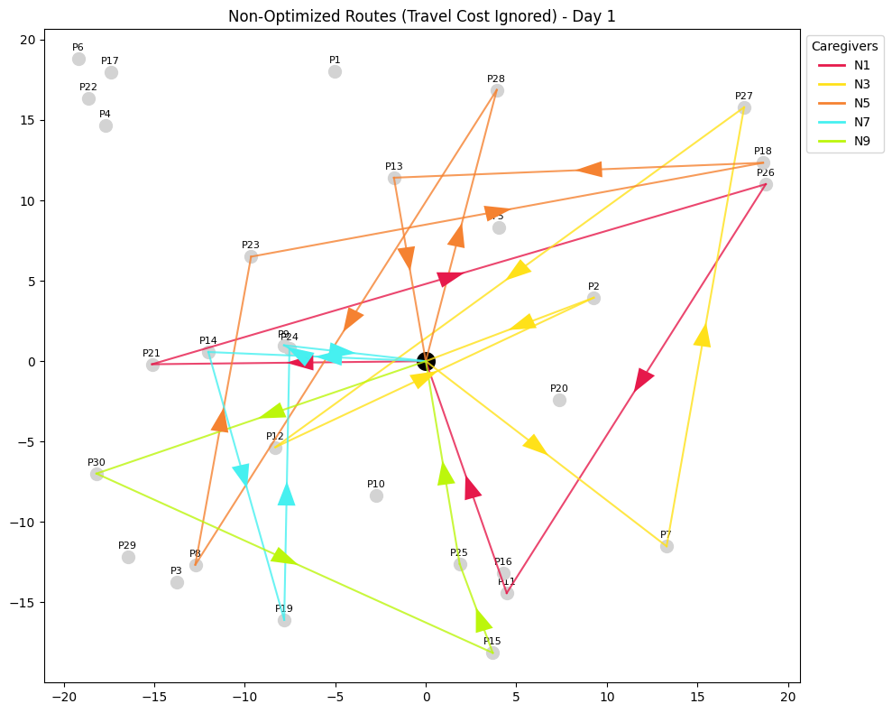 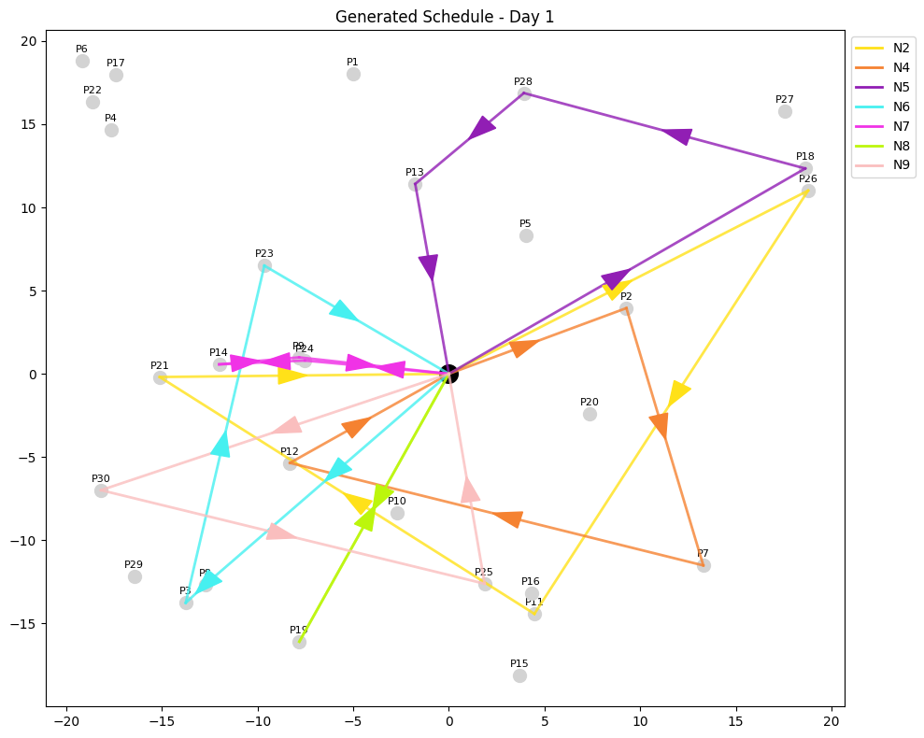Figure.1 Non-Optimized Route Figure.2 Optimized Route
The graphs show the results for the first of the seven days that were optimised. As shown in Figure 1, which was the non-optimised travel, where there is no penalty for unattended patients, appears more complex. On the other hand, in Figure 2, the optimised solution looks simpler, with all mandatory patients being covered. The major difference can be seen for patient 3, labelled as P3 in the bottom left, which remained unattended when the problem was not optimised, but this is not the case in Figure 2. The total time in minutes for 7 days was 3,721 minutes (62.02 hours), but after optimisation, it is 2,598 minutes (43.3 hours) with no penalty.

Sensitivity Analysis
Three sensitivity analyses examined the impact of operational parameters (number of caregivers, service time and shift hours) on system performance for a 7-day home healthcare routing problem (10 caregivers, 30 patients, 109 required visits).

Results
Caregivers | Objective | Change | Status
5 | 20,848 | +703% | Critical shortage
7 | 12,845 | +394% | Insufficient
10 (Base) | 2,598 | — | Adequate

Service Time | Objective | Change | Impact
30 min (Base) | 2,598 | — | Standard
60 minutes | 2,606 | +0.3% | Minimal
90 minutes | 2,648 | +1.9% | Minimal

Shift Hours | Objective | Change | Impact
5 hours | 2,658 | +2.3% | Minimal
8 hours | 2,590 | -0.3% | Optimal
10 hours (Base) | 2,598 | — | Current

Analysis
The system operates at 49% capacity utilisation (109 visits / 220 theoretical maximum). Staffing level variations produce exponential cost escalation, while operational parameters (service time, shift hours) show minimal impact. It is recommended to: maintain 9-10 caregivers as the operational minimum; never operate below 8 staff; expand service to 140-150 visits to utilise spare capacity (revenue opportunity); implement an 8-hour shift immediately (improves efficiency & work-life balance); and offer variable service duration (30-90 minutes) based on patient complexity.

Mathematical Formulation Extension
The most important conceptual extension of the deterministic weekly home healthcare routing and scheduling model can be multi-caregiver visits and repeat visits to the same patient on the same day. These two characteristics are realistic and operationally necessary in the home nursing, elderly services, and rehabilitation services in terms of clinical requirements (Fikar and Hirsch, 2017).
Firstly, multiple caregiver visits involve cases where two caregivers must visit the patient simultaneously or in a sequence. Examples of such tasks are mobility assistance, specialised clinical procedures, or safety requirements. When this need is included in the model it will make it more realistic since this kind of joint service is common in ensuring safety, minimising the chances of injury and adherence to medical protocols (Borsani et al., 2006). The model would require additional constraints on the arrival times of different caregivers that would ensure the presence of strict simultaneity or precedence relationships based on the needs of the patient and that skill sets meet the clinical requirements.
Secondly, there are numerous home care environments that involve visiting the same patient more than once in a day. This occurs in the case of drug administration, post -surgery care or time-dependent treatments. The continuity of care and reduction of handover errors can be achieved by allowing the same caregiver to go back several times a day. Adding this extension would require patient-specific visit frequencies, time separation between visits, and routing with the ability to make a caregiver leave, attend to other patients, and return later. In this scenario, each patient-day would be turned into a series of dependent service tasks, not one.
These extensions were omitted in the main model because they would have a significant influence on complexity, data needs, as well as, on feasibility in terms of assignments.
Synchronised visits for more than one patient together will establish dependencies amongst the schedules of the caregivers and routing decisions by caregivers are constrained by schedules of other caregivers which could make the model large and computationally infeasible (Bredström and Rönnqvist, 2008). Similarly, visiting the same patient more than once in the same day would make every visit into its own node, increasing service node count and time window limits.
In the current model, this enlargement would probably push memory boundaries and solver time constraints. Additionally, such extensions would require more specific datasets such as frequency of clinical visits, multi-staff needs and procedural ordering policies, which are not available in the current dataset. It would undermine validity and interpretability of the results if synthetic assumptions were introduced for these variables. Thus, coordinated multi-caregiver visits and repeat daily visits would make the model more realistic and clinically relevant, but they were not included due to solvability, transparency and the depth of analysis that were part of this coursework.

Conclusion
The analysis indicates that the mathematical optimisation model can effectively address and coordinate home healthcare routing, scheduling, and skill-based allocation decisions, while incorporating realistic limitations and remaining computationally solvable. As a result, costs are reduced through the coordinated optimisation of these elements.
Results show that the optimised structured schedule reduces unnecessary travel time while maintaining service quality. In practice, this means that decision-makers can make informed decisions in routing and resource allocation, ensuring high-quality care is delivered within patients’ acceptable time windows. The model met its goal as it was able to balance the travel time, compatibility of the skill set, and length of shift while addressing the needs of the patients.
Although it is a useful model, it is simplified by omitting complexities such as repetitive daily visits, synchronized multi-caregiver visits, and stochastic travel time. These omissions helped make the problem manageable but limited its applicability on a broader scale. The extension suggested adding all these excluded elements, which would add realism but would be computationally costly and require a significant amount of data.

Recommendations
The model can be improved in terms of the operational data and structure flexibility to facilitate decision-making effectively. Incorporating stochastic travel time will help as weather conditions and traffic cannot be estimated beforehand and can disrupt scheduled time windows and affect feasibility.
A scenario-based extension would then allow planners to develop schedules that are robust to uncertainty. The scope of data collection must be extended to include the requirements discussed in the model extension to ensure that more realistic care pathways are supported by the model. Lastly, a small-scale pilot using actual shift patterns and the daily patient list would help evaluate how effectively the model integrates with planning workflows, identify usability gaps, and guide future refinement.

Appendix

Section A: Conversion of CSV Data to GDX for GAMS Execution
The conversion of all external datasets to GDX format was undertaken before the execution of the optimisation model to facilitate effective and organised data management in GAMS. This preprocessing procedure loaded node coordinates, caregiver data, travel time, compatibility matrices, patient-day requests, time window variables, service time and caregiver shift time using the utility csv2gdx. All CSVs were converted to the corresponding GDX file with properly set indices and value fields.
This conversion enabled sets, parameters and subsets to be loaded in a clean manner at the start of the model, so that the next formulation could then be developed (including routing variables, time-window constraints, workload limits and continuity-of-care logic) with references to consistent and error-free data throughout the optimisation run.

Section B: Running the GAMS model on NEOS Server
The NEOS Server was used to implement the optimisation model to scale to the computational demands of the weekly HHCRSP instance, which generates output files with more than 5,000 lines. The GAMS has an in-built NEOS interface that can be invoked via the Run menu with the option ‘Run Remote with NEOS Server’. Once this option is selected the , the ‘submitting data to NEOS’ dialog box will appear, in which the user is required to enter the email address that is linked to the GAMS licence and select long priority. Once the submission has been confirmed the model is uploaded to NEOS and then a unique process log with a job ID and temporary password is automatically created. The NEOS solver typically requires approximately 300 seconds to process the entire model and provide the output.

Section C: Graphs for all 7 days both non-optimized and optimized
All the graphs were generated using Python. In all the non-optimized graphs no penalty for unattended patients and overtime along with other constraints were included whereas, the optimized graphs were achieved after the modelling was undertaken.

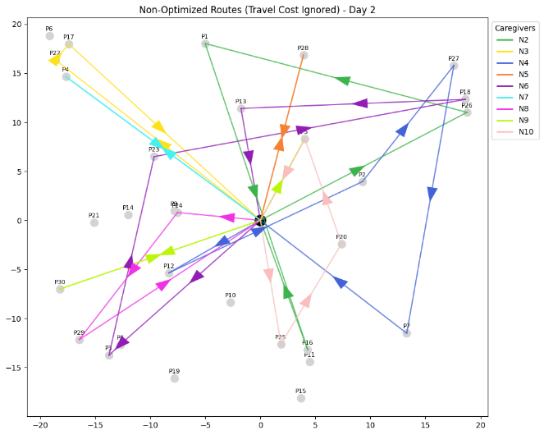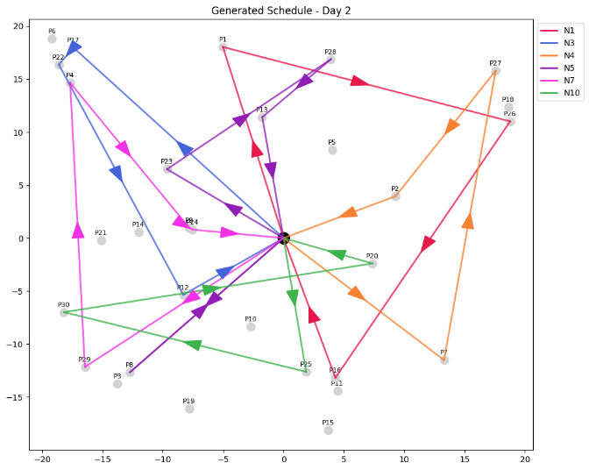

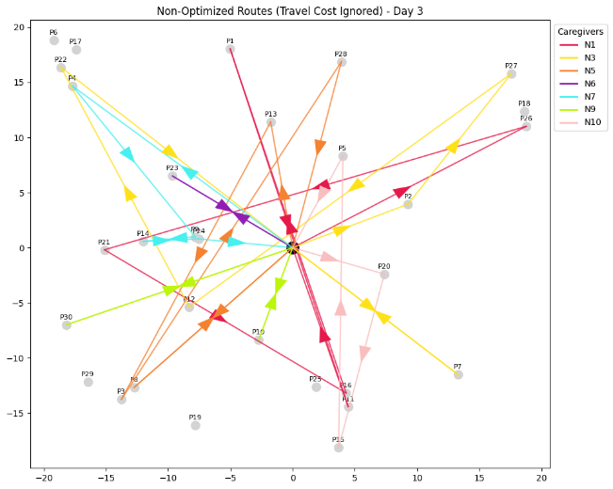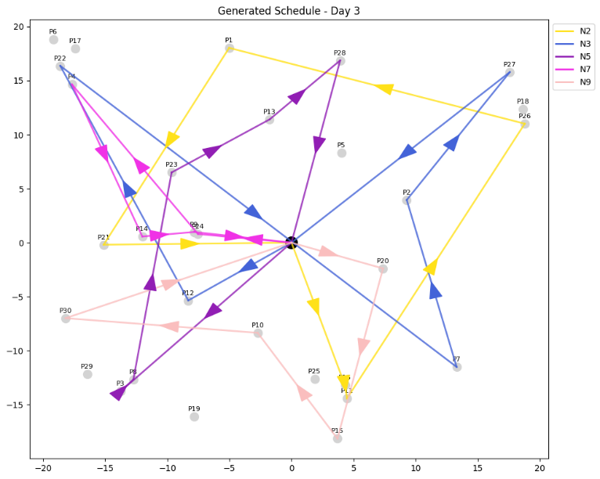

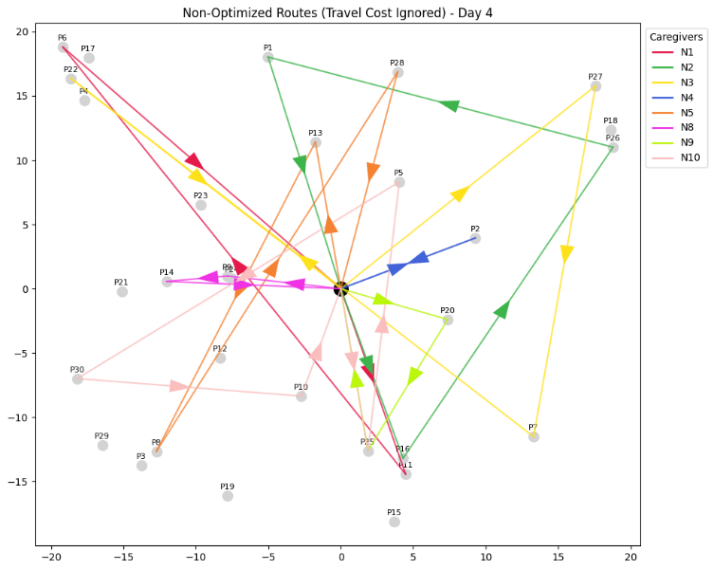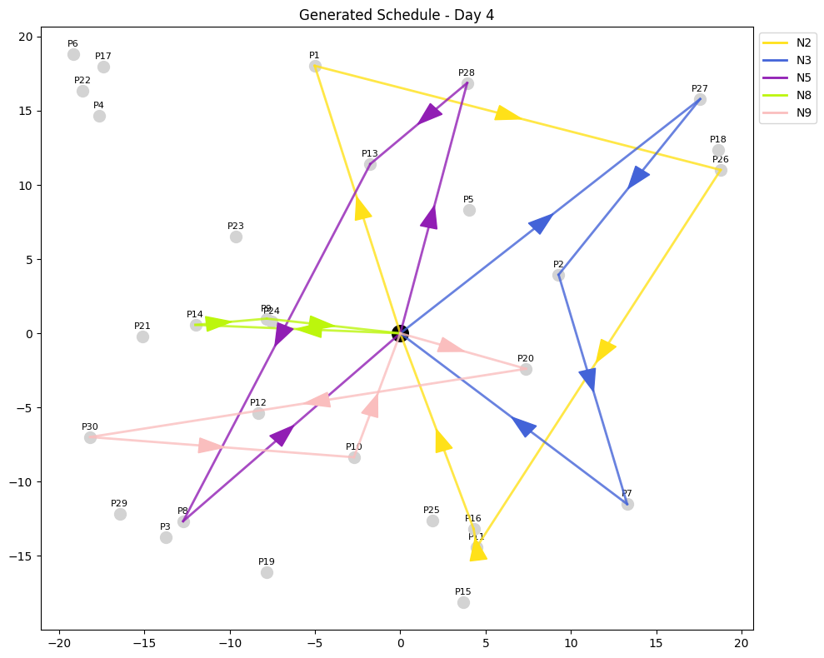

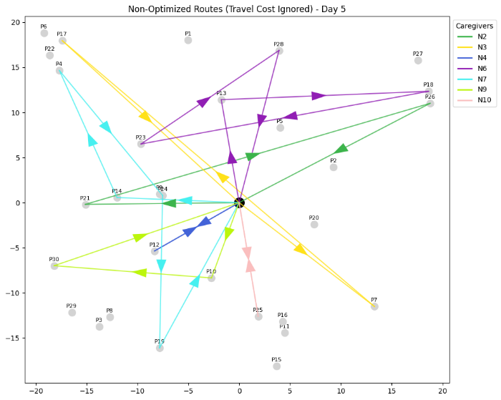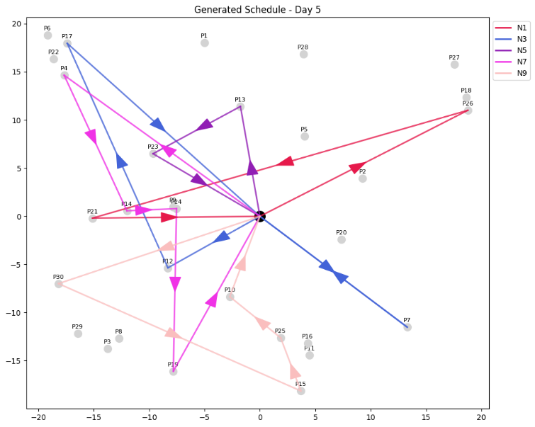
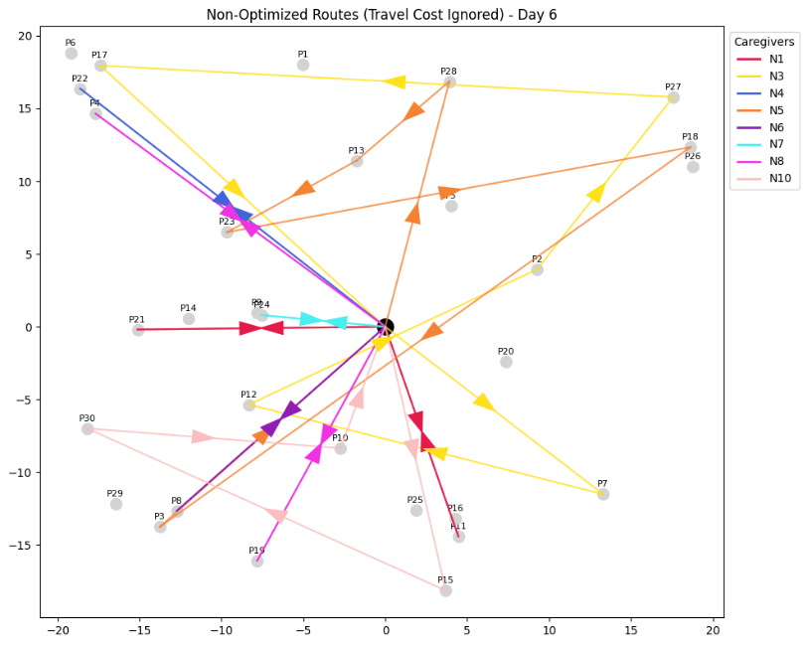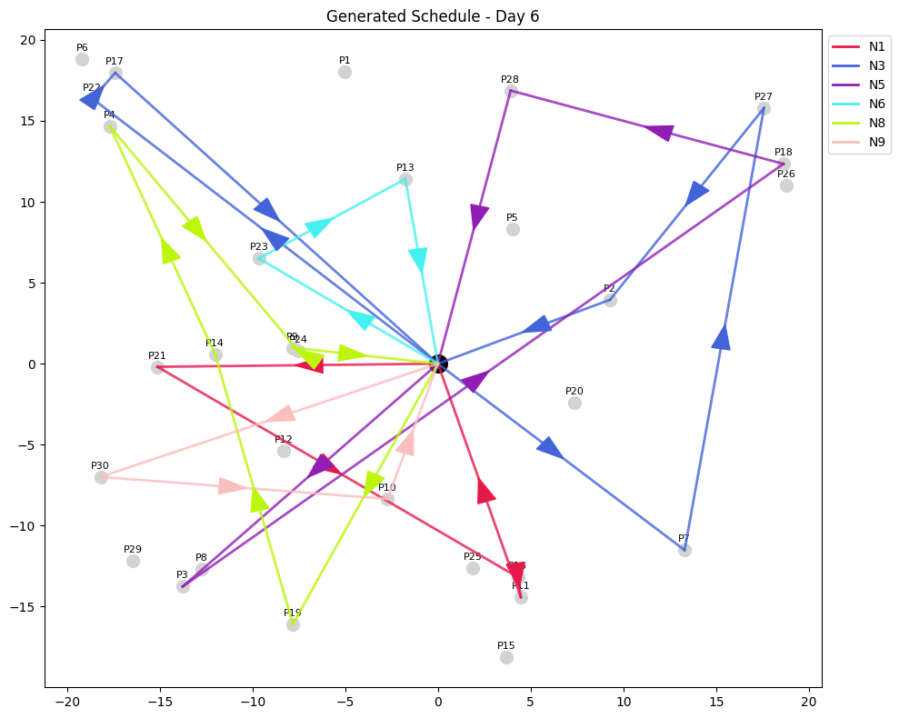
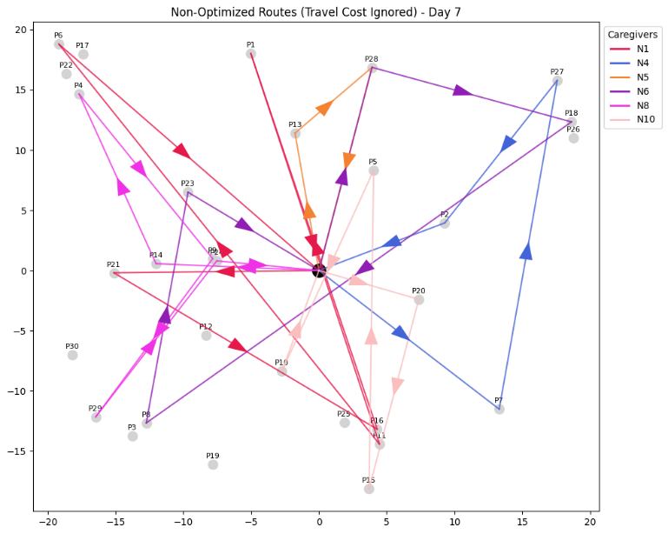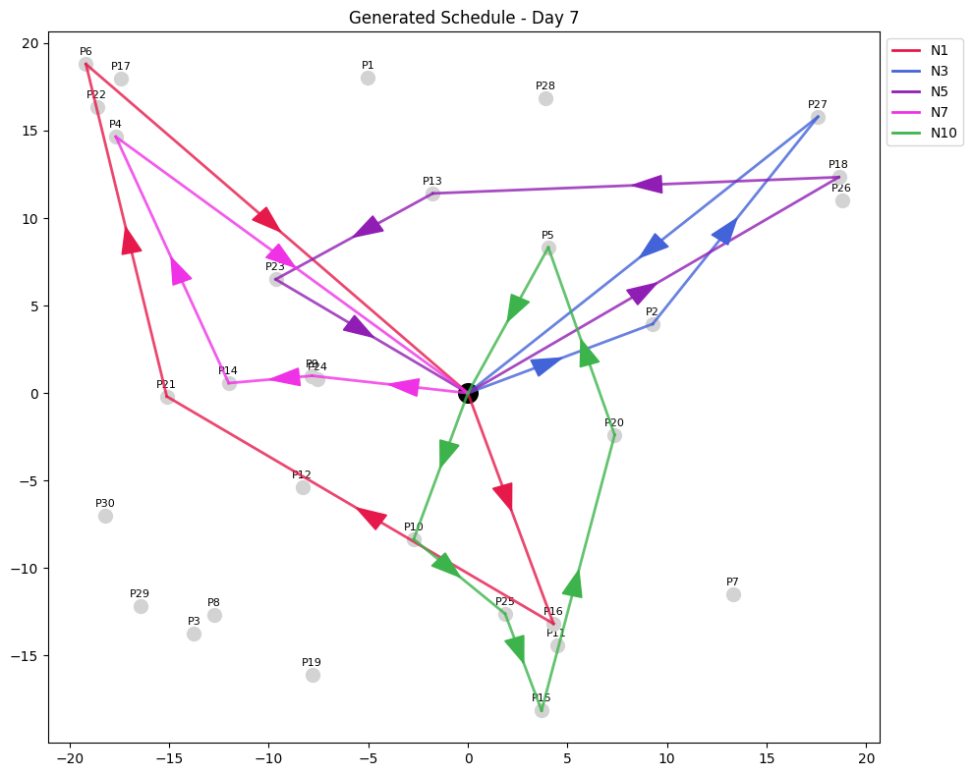

References
Aiken, L.H., Clarke, S.P., Sloane, D.M., Sochalski, J. and Silber, J.H. (2002) ‘Hospital Nurse Staffing and Patient Mortality, Nurse Burnout, and Job Dissatisfaction’, JAMA, 288(16), pp. 1987-1993. Available at: https://doi.org/10.1001/jama.288.16.1987 (Accessed: 1 December 2025).
Atta, S., Basto-Fernandes, V., and Emmerich, M. (2025) ‘A Concise Review of the Home Health Care Routing and Scheduling Problem’, Operations Research Perspectives, 15, 100347. Available at: https://doi.org/10.1016/j.orp.2025.100347 (Accessed: 1 December 2025).
Borsani, V., Matta, A., Beschi, G. and Sommaruga, F (2006), ‘A Home Care Scheduling Model for Human Resources’, 2006 International Conference on Service Systems and Service Management (ICSSSM), Troyes, France, pp. 449-454. Available at: https://doi.org/10.1109/ICSSSM.2006.320504 (Accessed: 1 December 2025).
Braekers, K., Hartl, R.F., Parragh, S.N. and Tricoire, F. (2016) ‘A bi-objective home care scheduling problem: Analyzing the trade-off between costs and client inconvenience’, European Journal of Operational Research, 248(2), pp. 428-443. Available at: https://doi.org/10.1016/j.ejor.2015.07.028 (Accessed: 1 December 2025).
Bredström, D. and Rönnqvist, M. (2008), ‘Combined vehicle routing and scheduling with temporal precedence and synchronization constraints’, European Journal of Operational Research, 191(1), pp. 19-31. Available at: https://doi.org/10.1016/j.ejor.2007.07.033 (Accessed: 1 December 2025).
Cabana, M.D. and Jee, S.H. (2004), ‘Does continuity of care improve patient outcomes?’, Journal of Family Practice, 53(12), pp. 974-980. Available at: https://pubmed.ncbi.nlm.nih.gov/15581440/ (Accessed: 1 December 2025).
Fikar, C. and Hirsch, P. (2017), ‘Home health care routing and scheduling: A review’, Computers & Operations Research, 77, pp. 86-95. Available at: https://doi.org/10.1016/j.cor.2016.07.019 (Accessed: 1 December 2025).
Miller, C.E., Tucker, A.W. and Zemlin, R.A. (1960), ‘Integer Programming Formulation of Traveling Salesman Problems’, Journal of the ACM, 7(4), pp. 326-329. Available at: https://doi.org/10.1145/321043.321046 (Accessed: 1 December 2025).
Rasmussen, M.S., Justesen, T., Dohn, A. and Larsen, J. (2012) ‘The Home Care Crew Scheduling Problem: Preference-based visit clustering and temporal dependencies’, European Journal of Operational Research, 219(3), pp. 598-610. Available at: https://doi.org/10.1016/j.ejor.2011.10.048 (Accessed: 1 December 2025).
Toth, P. and Vigo, D. (2014), Vehicle Routing: Problems, Methods, and Applications, 2nd edn. Philadelphia: SIAM. Available at: https://doi.org/10.1137/1.9781611973594 (Accessed: 1 December 2025).
Xiao, L., Dridi, M. and El Hassani, A.H. (2018), ‘Mathematical model for the Home Health Care Scheduling and Routing Problem with Flexible Lunch Break Requirements’, IFAC-PapersOnLine, 51(11), pp. 334–339. Available at: https://doi.org/10.1016/j.ifacol.2018.08.305 (Accessed: 1 December 2025).
Zhao, A. and Bard, J. F. (2024), ‘Weekly home healthcare routing and scheduling with overlapping patient clusters’, Health Systems, 14(2), pp. 145–165. Available at: https://doi.org/10.1080/20476965.2024.2422494 (Accessed: 1 December 2025).

