Concept of Programming-Exercise I

01_Aaditya Sudhir Joshi

1. Write a program to print Hello World. Compile and run it using command prompt.

Answer: class java{

public static void main(String[] args){

System.out.println("Hello world");

}

}

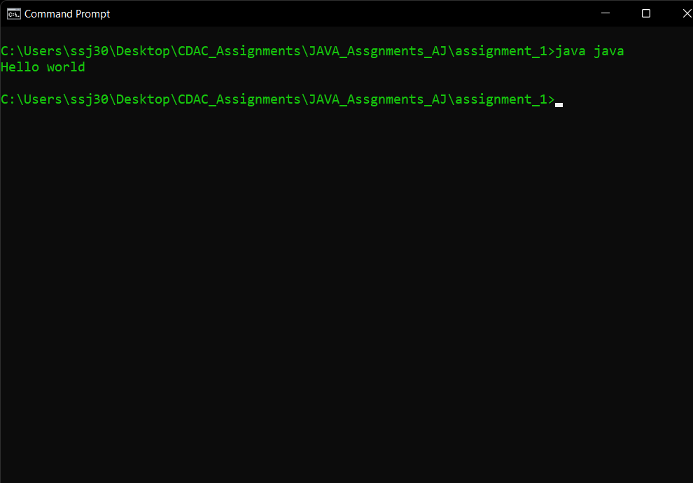

2. Write a program to declare a variable named rollNo of integer type. Assign it a value (let say 100) to it and print the following statement roll no = 100 .

Anwer:- class rollno{

public static void main(String[] args){

int roll_no = 100;

System.out.println("roll no = " + roll_no);

}

}

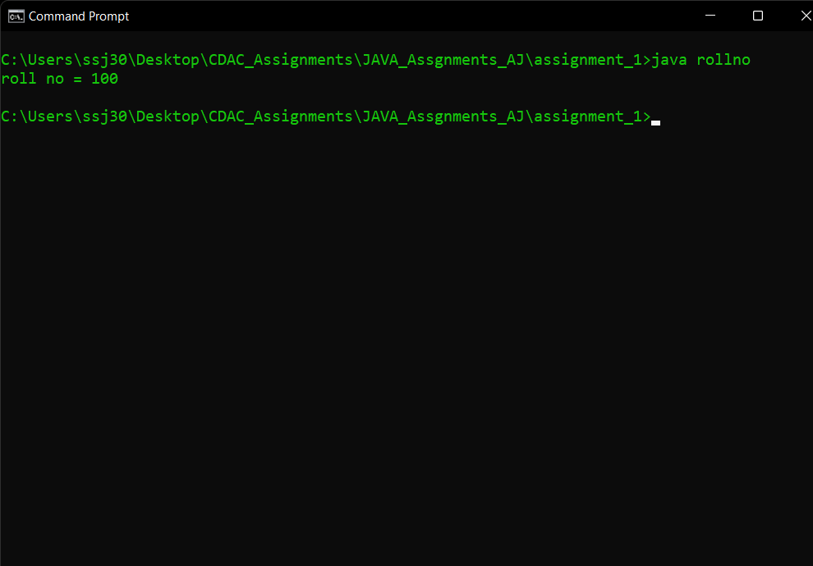

3. Find the result of following expressions. You need to determine the primitive data type of

the variable by looking carefully the given expression and initialize variables by any

random value.

A. y = x 2 + 3x - 7 (print value of y)

B. y = x++ + ++x (print value of x and y)

C. z = x++ - --y - --x  +  x++ (print value of x ,y and z)

D. z = x &amp;&amp; y || !(x || y)  (print value of z) [ x, y, z are boolean variables ]

Answer:

class prim{

public static void main(String[] args){

int y = 0;

int x = 2;

y = (x*x)+3*x-7;

System.out.println(y);

y = x++ + ++x;

System.out.println(x+" "+y);

int z = x++ - --y - --x + x++;

System.out.println(x+" "+y+" "+z);

boolean m,n=true,o=true;

m = n && o || !(n||o) ;

System.out.println(m+" "+n+" "+o);

}

}

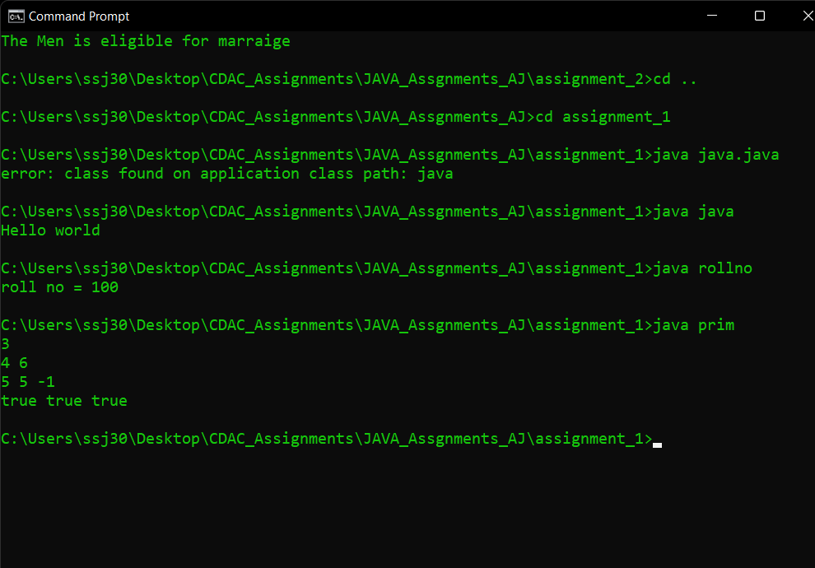

4. Write a program that initializes 2 byte type of variables. Add the values of these variables

and store in a byte type of variable. [Note: primitive down casting is required in this program]

Answer:

class downcast{

public static void main(String[] args){

final byte b1=20;

final byte b2=127;

byte b3=(byte)(b1+b2);

System.out.println(b3);

}

}

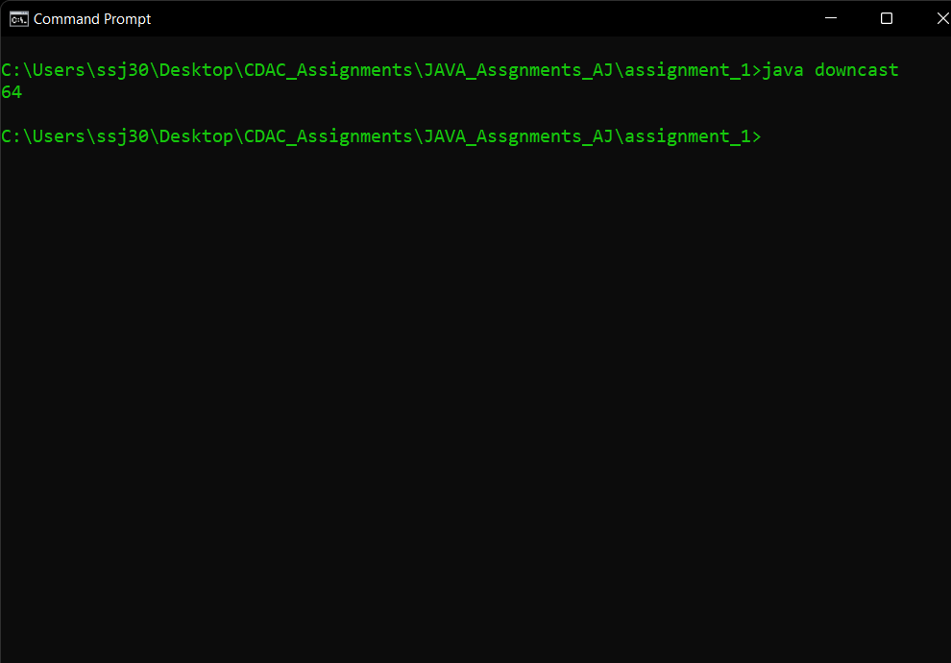

5. Find out Simple Interest

Answer:

import java.util.*;

class simpleinterest{

public static void main(String[] args){

Scanner scn = new Scanner(System.in);

float p=scn.nextInt();

float n=scn.nextInt();

float r=scn.nextInt();

float interest = (p*n*r)/100;

System.out.println(interest);

}

}

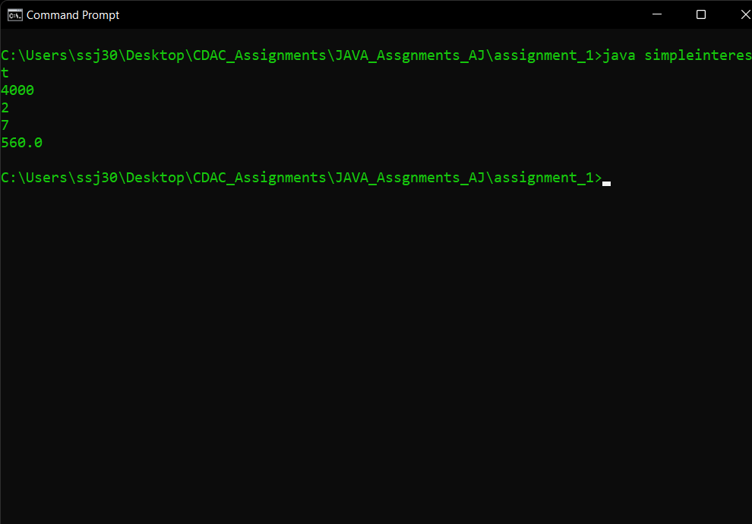

6. Write a program that takes user’s name as command line argument and prints Welcome <entered user name>.

Answer:

class commandline{

public static void main(String[] args){

String ans = args[0];

System.out.println("welcome "+ ans);

}

}

