Cop_excercise2

01_Aaditya Sudhir Joshi

1. Write a program that takes radius of a circle as input. Read the entered radius using Scanner class. Then calculate and print the area and circumference of the circle.

Answer:-

Code:-

import java.util.*;

class areaofcircle{

public static void main(String[] args){

Scanner scn = new Scanner(System.in);

System.out.println("Enter the radius of circle");

int r=scn.nextInt();

System.out.println("Area of Circle = " + 3.142*r*r);

System.out.println("Circumference of circle = " + r*3.142*2);

}

}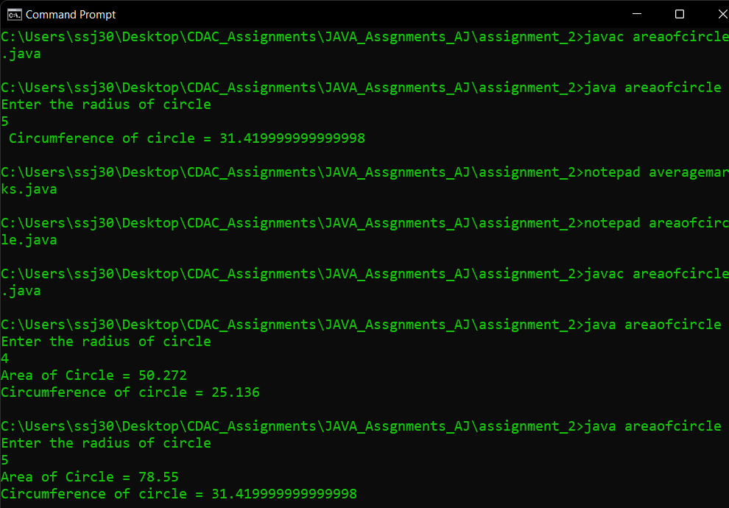

2. Write a program to calculate sum of 5 subject’s marks & find percentage. Take the obtained marks from user using Scanner class. Output should be in this format [ percentage marks = 99 % ]. Use concatenation operator here.

Answer:-

import java.util.*;

class averagemarks{

public static void main(String[] args){

Scanner scn = new Scanner(System.in);

int[] ans = new int[5];

int sum=0;

float avg=0;

for(int i=0;i<5;i++){

ans[i] = scn.nextInt();

sum+=ans[i];

}

avg = sum/5;

System.out.println("Average of All Marks :- " + avg + "%");

}

}

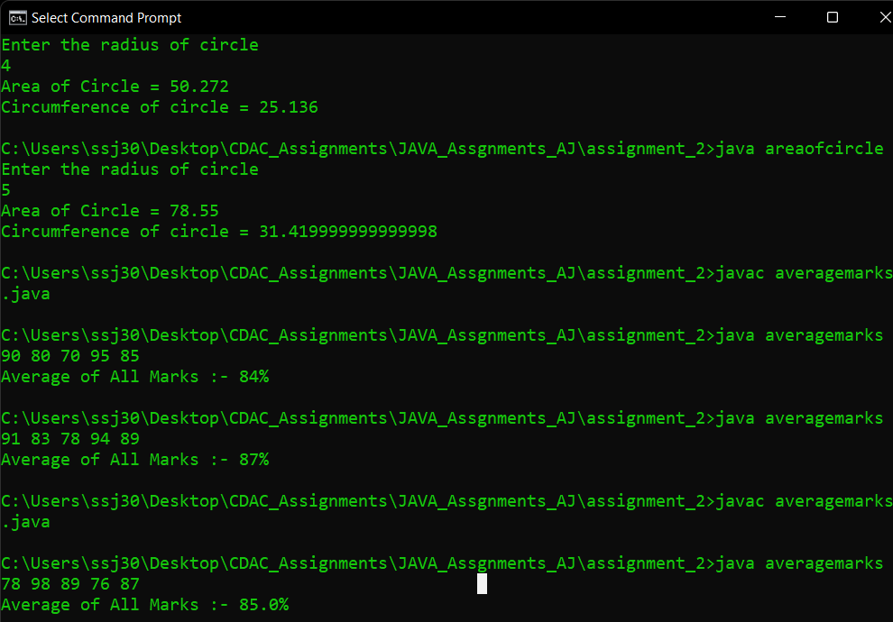

3. Write a program to find the simple interest. Take the principle amount, rate of interest and time from user using Scanner class.

Answer:-

import java.util.*;

class simpleinterest{

public static void main(String[] args){

Scanner scn = new Scanner(System.in);

System.out.print("Enter Principle amount ");

float p=scn.nextInt();

System.out.print("Enter time period in Years ");

float t=scn.nextInt();

System.out.print("Enter Rate of Interest ");

float r=scn.nextInt();

float interest = (p*t*r)/100;

System.out.println("Simple Interest will be = " +interest);

}

}

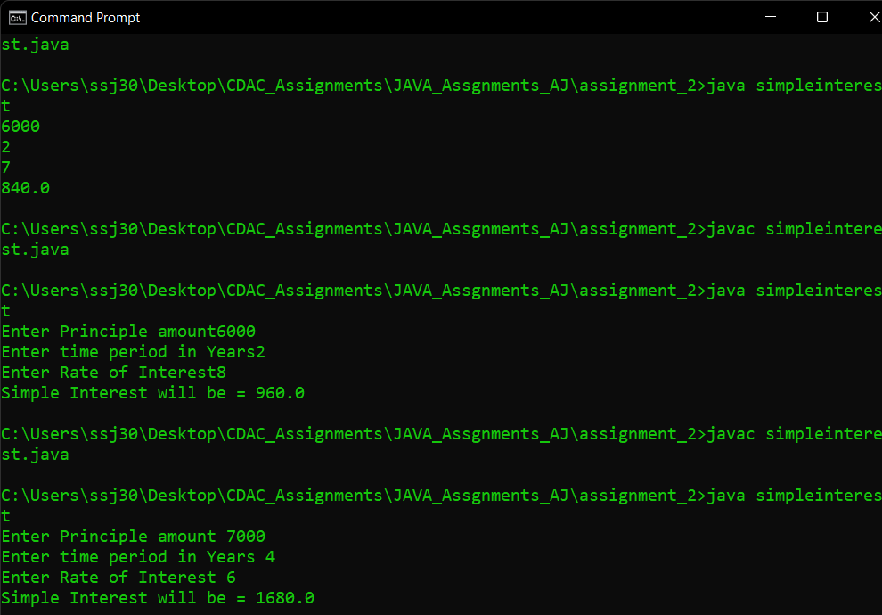

4. Write a program to read the days (eg. 670 days) as integer value using Scanner class. Now convert the entered days into complete years, months and days and print them.

Answer:-

import java.util.*;

class daystoyears{

public static void main(String[] args){

Scanner scn = new Scanner(System.in);

System.out.print("Enter the Days ");

int n = scn.nextInt();

int years = 0 , months = 0 , days = 0;

years = n/365;

n%=365;

months = n/30;

days = n%=30;

System.out.println("Years: "+years+" Months: "+months+" Days: "+days);

}

}

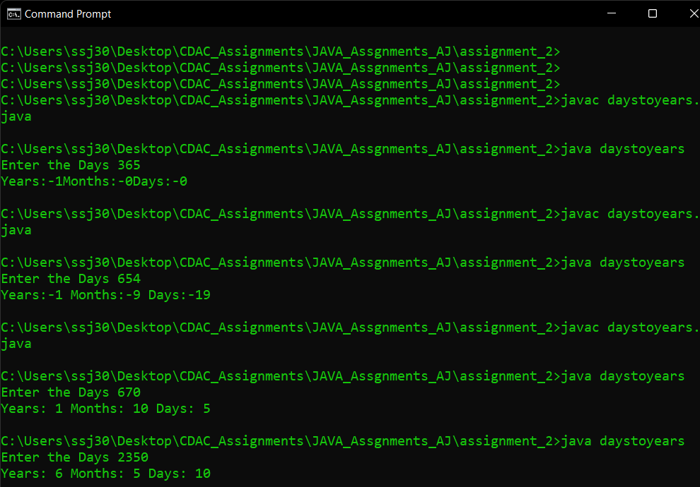

5. Write a program to convert temperature from Fahrenheit to Celsius. Take Fahrenheit as input using Scanner class. [ formula : C= 5*(f-32)/9 ]

Answer:

import java.util.*;

class fartocel{

public static void main(String[] args){

Scanner scn = new Scanner(System.in);

System.out.print("Enter the Degree in Fahrenheit ");

float far = scn.nextFloat();

float cel = (5*(far-32))/9;

System.out.println("Degeree in Celsius = "+ cel);

}

}

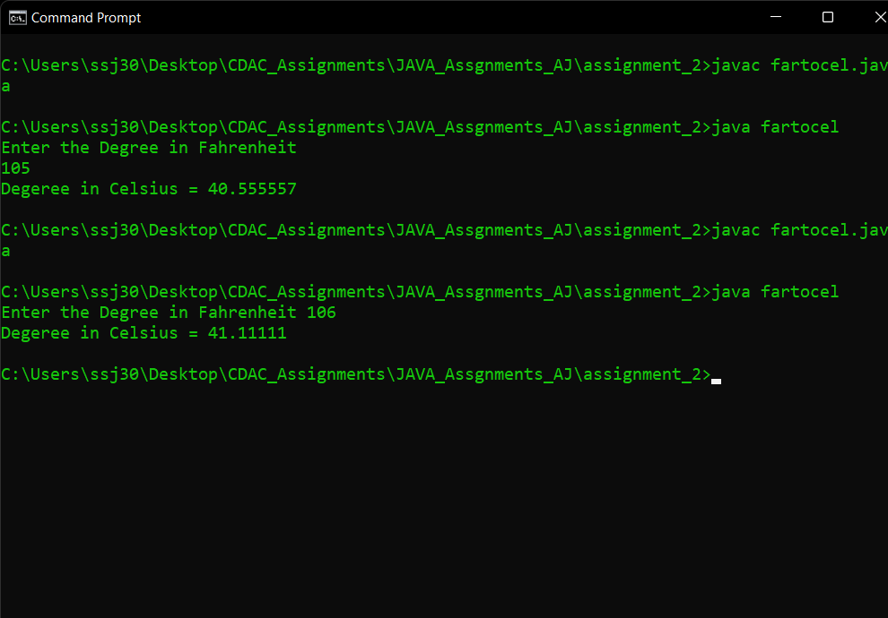

6. Write a program to swap two numbers without using third variable.

Answer:-

import java.util.*;

class swapwithout3rd{

public static void main(String[] args){

Scanner scn = new Scanner(System.in);

System.out.println("Enter Two Numbers");

int a = scn.nextInt();

int b = scn.nextInt();

System.out.println( "Before Swapping: "+ a +" "+ b);

a = a+b;

b = a-b;

a = a-b;

System.out.println( "AFter Swapping: "+ a +" "+ b);

}

}

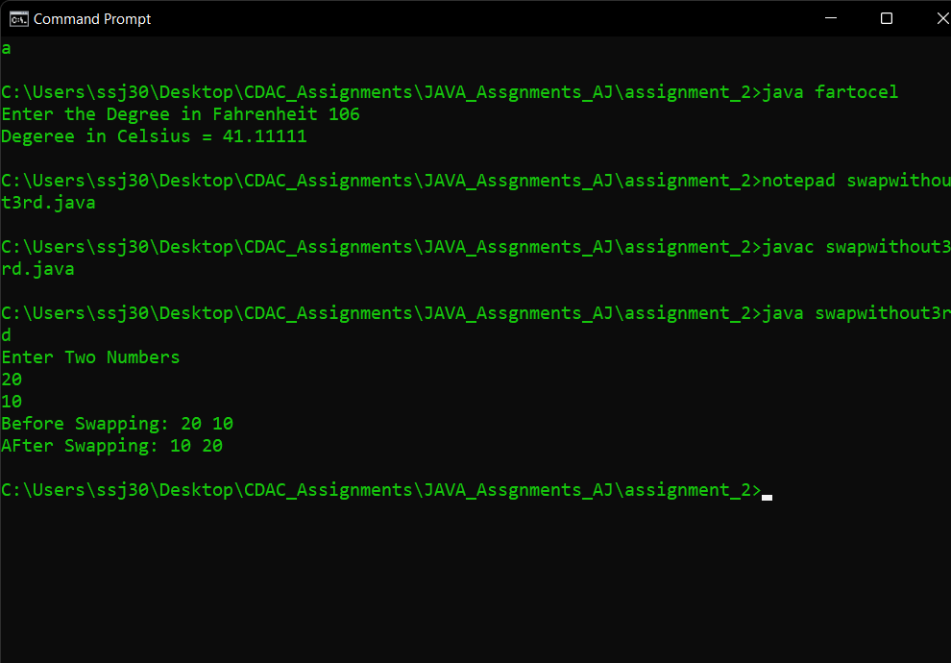

7. In a company an employee is paid as under: If his basic salary is less than Rs. 10000, then HRA = 10% of basic salary and DA = 90% of basic salary. If his salary is either equal to or above Rs. 10000, then HRA = Rs. 2000 and DA = 98% of basic salary. If the employees salary is input by the user write a program to find his gross salary. [ formula : GS= Basic + DA + HRA ]

Anwer:-

import java.util.*;

class employee{

public static void main(String[] args){

Scanner scn = new Scanner(System.in);

System.out.print("Enter basic the salary = ");

int bsalary = scn.nextInt();

int gsalary=0;

if(bsalary<10000){

gsalary = bsalary+((10*bsalary)/100)+((90*bsalary)/100);

}else if(bsalary>=10000){

gsalary = bsalary+2000+((98*bsalary)/100);

}

System.out.println("Gross Salary of employee is = "+gsalary);

}

}

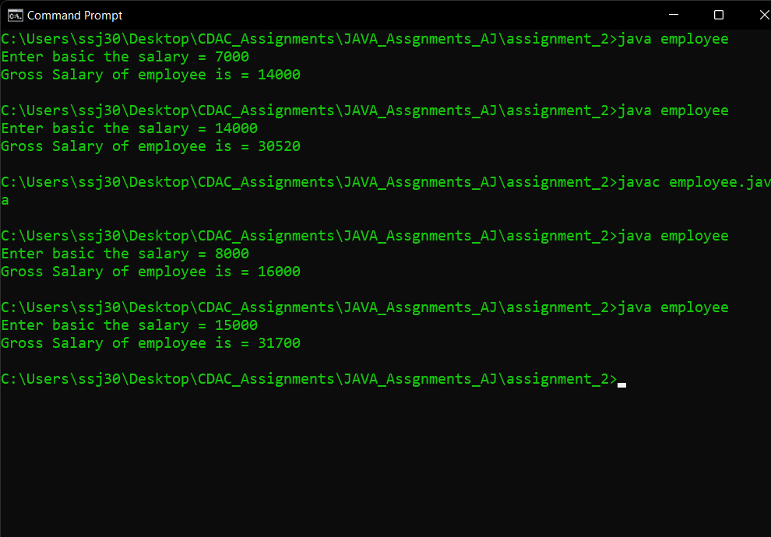

8. Program to find greatest in 3 numbers. [ once using if else statement and then using ternary operator ( logical operator) ]

Answer:-

import java.util.*;

class greater{

public static void main(String[] args){

Scanner scn = new Scanner(System.in);

System.out.println("Enter three numbers ");

int a = scn.nextInt();

int b = scn.nextInt();

int c = scn.nextInt();

int gbyif=0;

int gbyop=0;

if(a>=b && a>=c){

gbyif=a;

}else if(b>=a && b>=c){

gbyif=b;

}else{

gbyif=c;

}

System.out.println("Greatest number is = " + gbyif);

gbyop = c>(a>b ?a:b) ? c:((a>b) ?a:b);

System.out.println("Greatest number by ternary operator = " + gbyop);

}

}

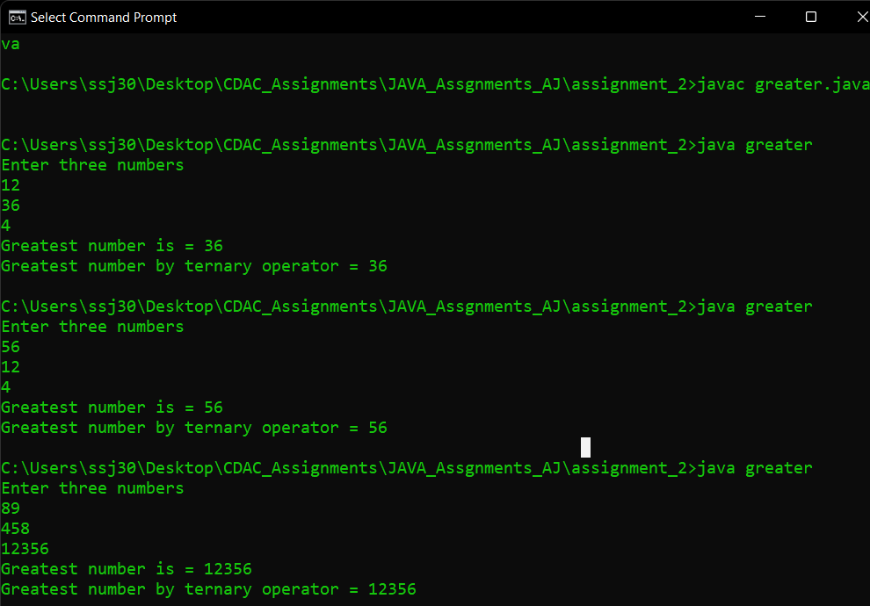

9. Program to check that entered year is a leap year or not.

Answer:

import java.util.*;

class leap{

public static void main(String[] args){

Scanner scn = new Scanner(System.in);

System.out.print("Enter the year ");

int n = scn.nextInt();

if(n%4 == 0 && n%100!=0 || n%400==0){

System.out.println(n+ " is leap year");

}else{

System.out.println(n+ " is not leap year");

}

}

}

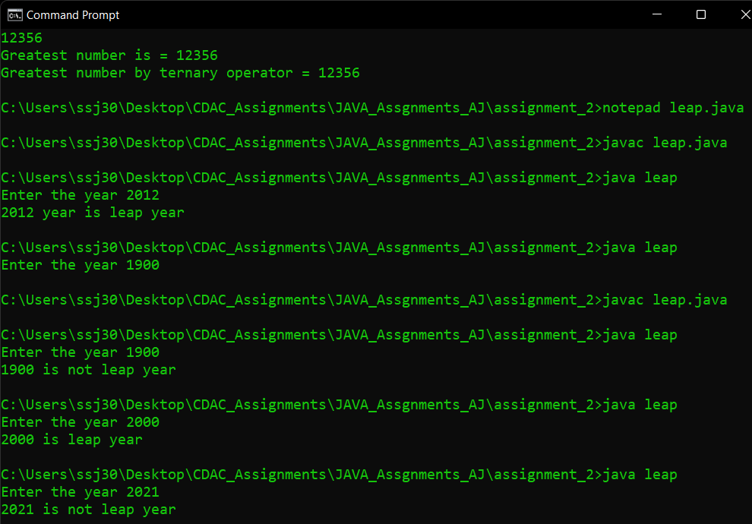

10. Accept person’s gender (character m for male and f for female), age (integer), as input and then check whether person is eligible for marriage or not.

Answer:

import java.util.*;

class marriage{

public static void main(String[] args){

Scanner scn = new Scanner(System.in);

System.out.println("Enter the gender (m/f) ");

char ch = scn.next().charAt(0);

System.out.println("Enter the age");

int age = scn.nextInt();

if(ch == 'm' && age >=21 ){

System.out.println("The Men is eligible for marraige");

}else if(ch == 'f' && age >=18){

System.out.println("The Women is eligible for marraige");

}else{

System.out.println("Not eligible for marraige");

}

}

}

