Java Assignment No.3

01_Aaditya Sudhir Joshi

1.Write a program to print table of any entered number using loop.

Answer:

import java.util.*;

class tables{

public static void main(String[] args){

Scanner scn = new Scanner(System.in);

System.out.println("Enter the number ");

int n = scn.nextInt();

for(int i=1;i<=10;i++){

System.out.println(n+" x "+i+" = "+i*n);

}

}

}

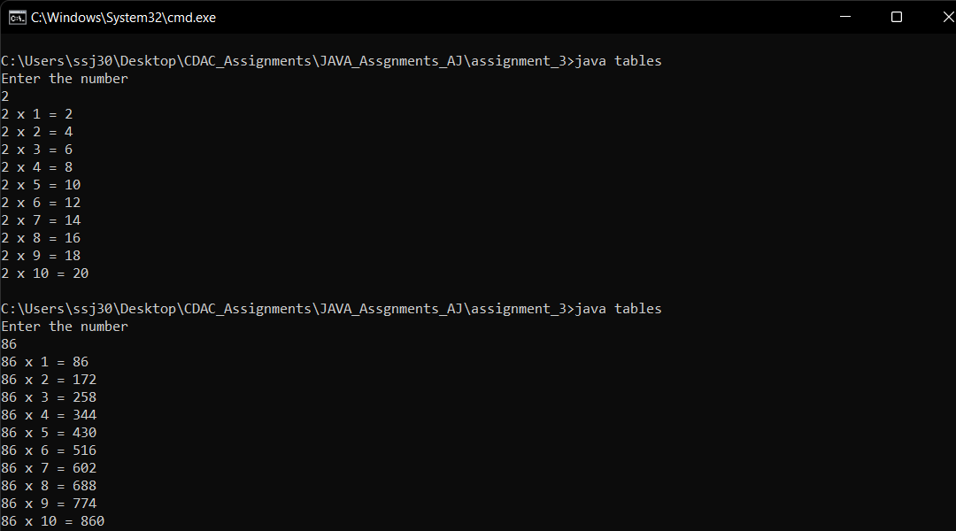

2.Write a program to reverse a given number.

import java.util.*;

class reverseno{

public static void main(String[] args){

Scanner scn = new Scanner(System.in);

System.out.println("Enter the Number ");

int n = scn.nextInt();

int m=0;

int x=1;

while(n!=0){

int rem = n % 10;

n /=10;

System.out.print(rem);

}

}

}

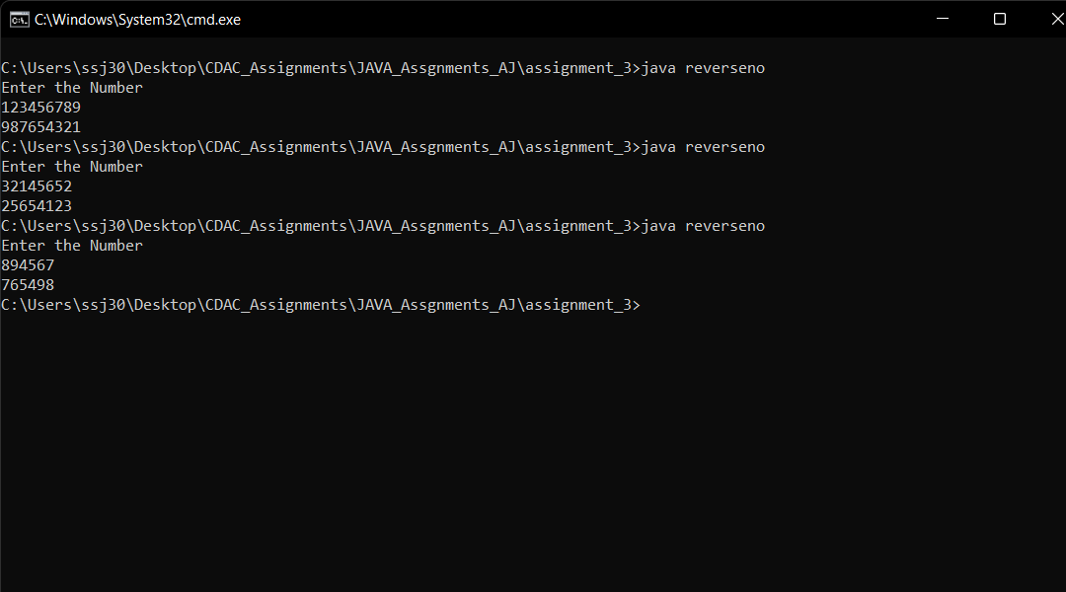

3.Program to check whether number is prime or not.

Answer:

import java.util.*;

class prime{

public static void main(String[] args){

Scanner scn = new Scanner(System.in);

System.out.println("Enter the number ");

int n = scn.nextInt();

int div=2;

while(div*div<=n){

if(n%div==0){

break;

}

div++;

}

if(div*div >n){

System.out.println("Prime");

}else{

System.out.println("Not Prime");

}

}

}

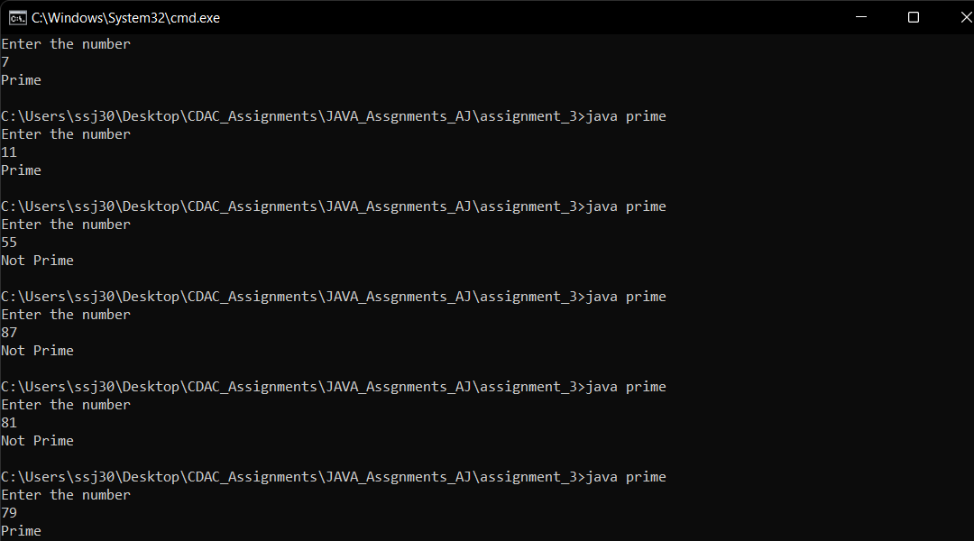

4.Calculate series : 1^2 +2^2 +3^2 +4^2 +.........+n^2

Answer:

import java.util.*;

class series{

public static void main(String[] args){

Scanner scn = new Scanner(System.in);

System.out.println("Enter the Number ");

int n = scn.nextInt();

System.out.println("Sum of series Using Formula = "+(n*(n+1)*(2*n+1))/6);

int sum=0;

for(int i=1;i<=n;i++){

sum+=i*i;

System.out.print(i+"^2 + ");

}

System.out.println("Sum of series using looping = "+sum);

}

}

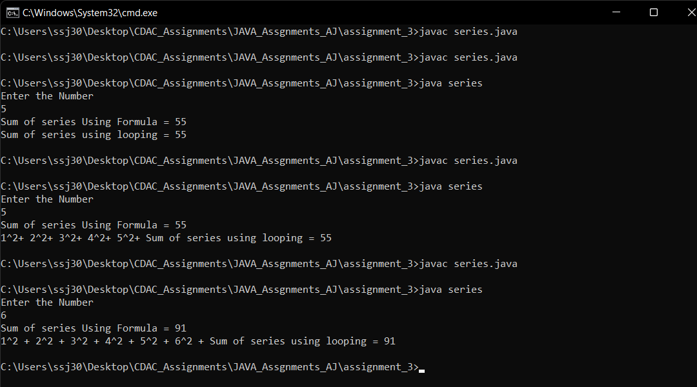

5.Print all prime numbers between two given numbers. [ break continue ]

Answer:

import java.util.*;

class primeinrange{

public static void main(String[] args){

Scanner scn = new Scanner(System.in);

System.out.println("Enter starting number ");

int n1 = scn.nextInt();

System.out.println("Enter starting number ");

int n2 = scn.nextInt();

for(int i=n1;i<=n2;i++){

int div=2;

while(div*div <= i){

if(i%div == 0){

break;

}

div++;

}

if(div*div>i){

System.out.print(i+" ");

}

}

}

}

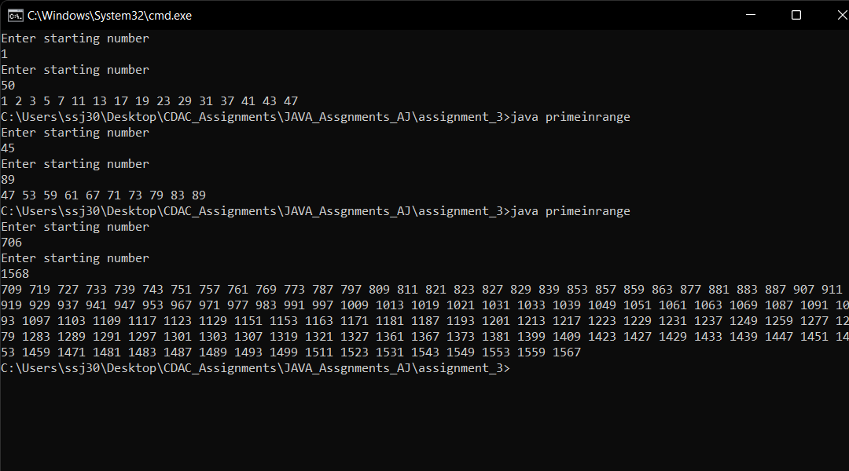

6.Program to show sum and average of 10 element array. Accept array elements from user.

Answer:

import java.util.*;

class sumavgofarray{

public static void main(String[] args){

Scanner scn = new Scanner(System.in);

System.out.println("Enter the ArraySize ");

int n = scn.nextInt();

int[] array = new int[n];

System.out.println("Enter elements in array");

int sum=0;

for(int i=0;i<n;i++){

array[i] = scn.nextInt();

sum += array[i];

}

System.out.println("Sum is = " + sum + " And Average is = " + (float)sum/n);

}

}

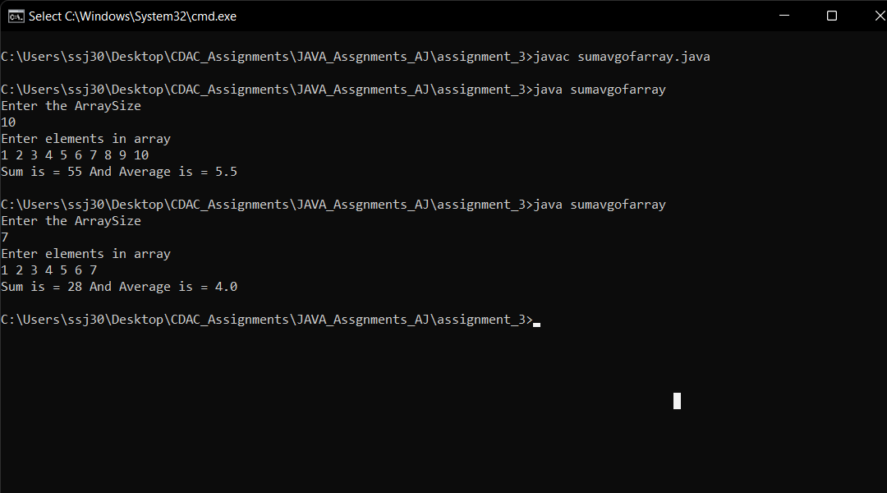

7.Sort a ten element array in descending order.

Answer:

import java.util.*;

class sortdec{

public static void main(String[] args){

Scanner scn = new Scanner(System.in);

System.out.println("Enter the arraysize ");

int n = scn.nextInt();

int[] arr = new int[n];

for(int i=0;i<n;i++){

arr[i] = scn.nextInt();

}

for(int i=0;i<arr.length;i++){

for(int j=i+1;j<arr.length;j++){

if(arr[i] < arr[j]){

int temp = arr[i];

arr[i] = arr[j];

arr[j] = temp;

}

}

}

System.out.println();

System.out.println("decending order");

for(int i=0;i<arr.length;i++){

System.out.print(arr[i]+" ");

}

}

}

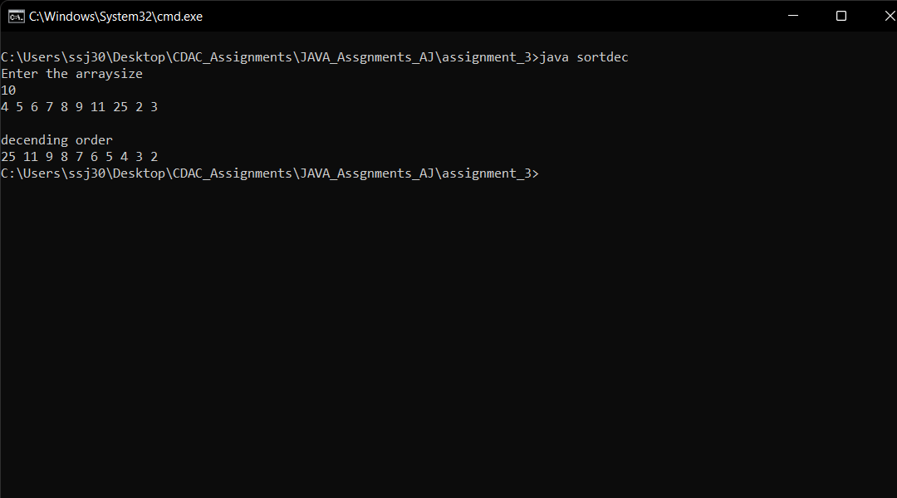

8.Write a program to reverse the array elements.

Answer:

import java.util.*;

class reversearray{

public static void main(String[] args){

Scanner scn = new Scanner(System.in);

System.out.println("Enter the Arraysize");

int n = scn.nextInt();

int[] arr = new int[n];

for(int i=0;i<n;i++){

arr[i] = scn.nextInt();

}

for(int i=0,j=n-1;i<j;i++,j--){

int temp = arr[i];

arr[i] = arr[j];

arr[j] = temp;

}

for(int i=0;i<n;i++){

System.out.print(arr[i]+" ");

}

}

}

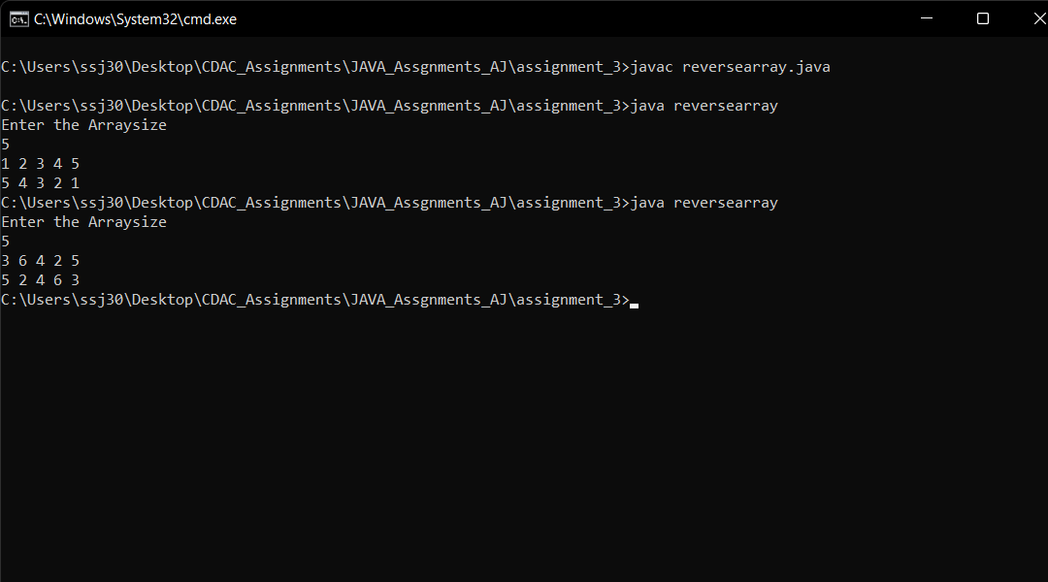

9.Write a program to search an element in the array.

Answer:

import java.util.*;

class findelement{

public static void main(String[] args){

Scanner scn = new Scanner(System.in);

System.out.println("Enter the Arraysize");

int n = scn.nextInt();

int[] arr = new int[n];

for(int i=0;i<n;i++){

arr[i] = scn.nextInt();

}

System.out.println("Enter the number to find ");

int find = scn.nextInt();

int place=0;

boolean bool = false;

for(int i=0;i<n;i++){

if(arr[i] == find){

place = i;

bool = true;

}

}

if(bool){

System.out.println("The Number "+find+" Found at "+place);

}

else{

System.out.println("Number Not found");

}

}

}

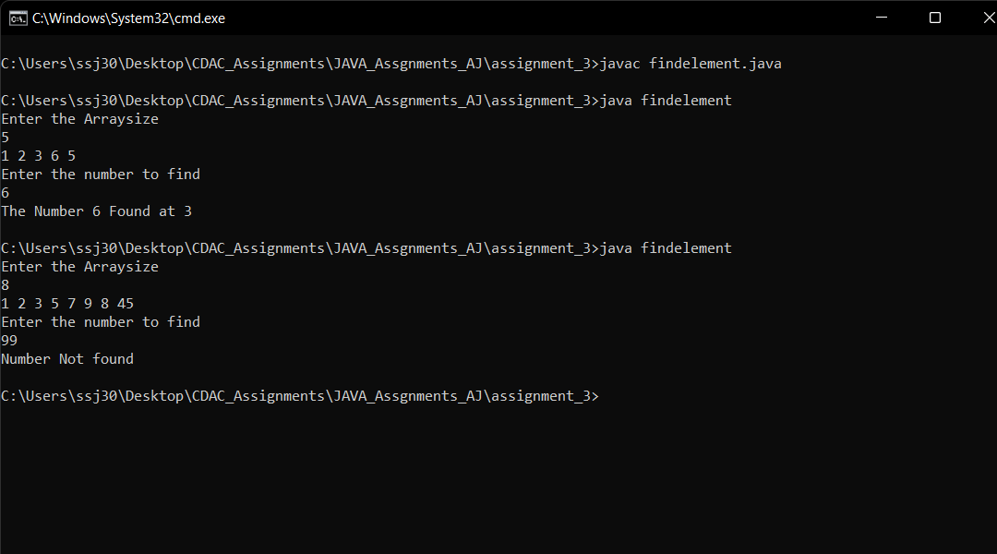

10.Write the program to find the sum of even elements and sum of odd elements present in the array of integer type.

Answer:

import java.util.*;

class sumevenodd{

public static void main(String[] args){

Scanner scn = new Scanner(System.in);

System.out.println("Enter the Arraysize");

int n = scn.nextInt();

int[] arr = new int[n];

for(int i=0;i<n;i++){

arr[i] = scn.nextInt();

}

int evensum=0,oddsum=0;

for(int i=0;i<n;i++){

if(arr[i]%2==0){

evensum+=arr[i];

}else{

oddsum+=arr[i];

}

}

System.out.println("Sum of Even numbers : " + evensum );

System.out.println("Sum of Odd Numbers : " + oddsum );

}

}

