COP Exercise 4

01_Aaditya Sudhir Joshi

1. Write a program to find the smallest and greatest number present in the array of integer type.

Answer:

import java.util.*;

class smallgreat{

public static void main(String[] args){

Scanner scn = new Scanner(System.in);

System.out.print("Enter the Array Size = ");

int n = scn.nextInt();

System.out.print("Enter the Element in Array = ");

int[] arr = new int[n];

for(int i=0;i<n;i++){

arr[i] = scn.nextInt();

}

int max = Integer.MIN_VALUE;

int min = Integer.MAX_VALUE;

for(int i=0;i<n;i++){

if(max<arr[i]) max = arr[i];

if(min>arr[i]) min = arr[i];

}

System.out.println("Max Number = " + max + " And Min Number = " + min);

}

}

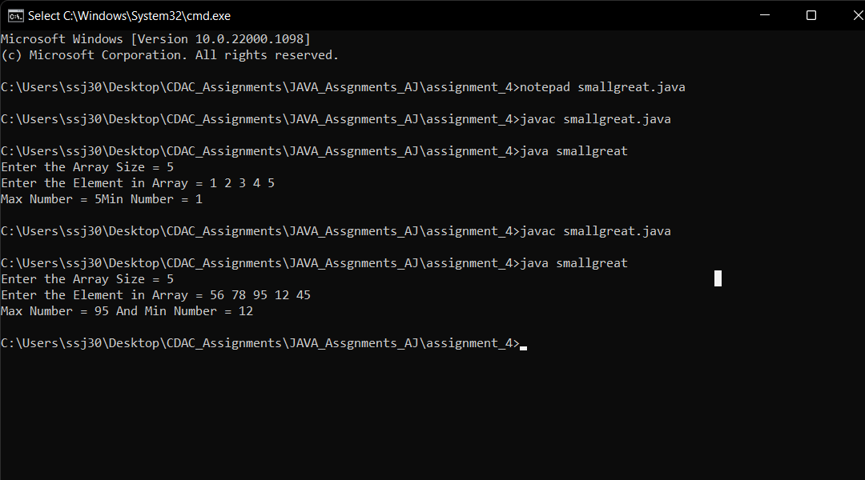

2. Create an array of 10 elements in 5 rows. And calculate sum of all elements.

Answer:

import java.util.*;

class multidim{

public static void main(String[] args){

Scanner scn = new Scanner(System.in);

int[][] arr = new int[2][5];

for(int i=0;i<arr.length;i++){

for(int j=0;j<arr[0].length;j++){

arr[i][j] = scn.nextInt();

}

}

int sum=0;

for(int i=0;i<arr.length;i++){

for(int j=0;j<arr[0].length;j++){

sum += arr[i][j] ;

}

}

for(int i=0;i<arr.length;i++){

for(int j=0;j<arr[0].length;j++){

System.out.print( arr[i][j] +" ");

}

}

System.out.println(sum);

}

}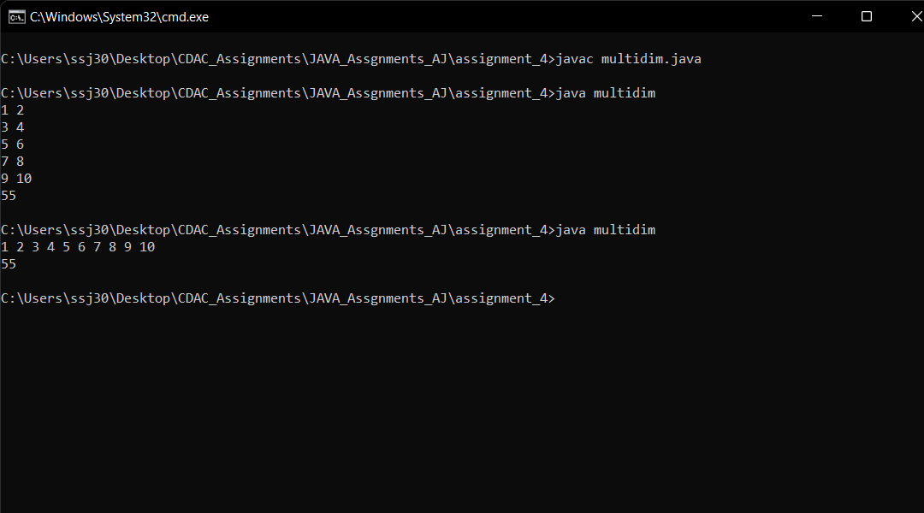

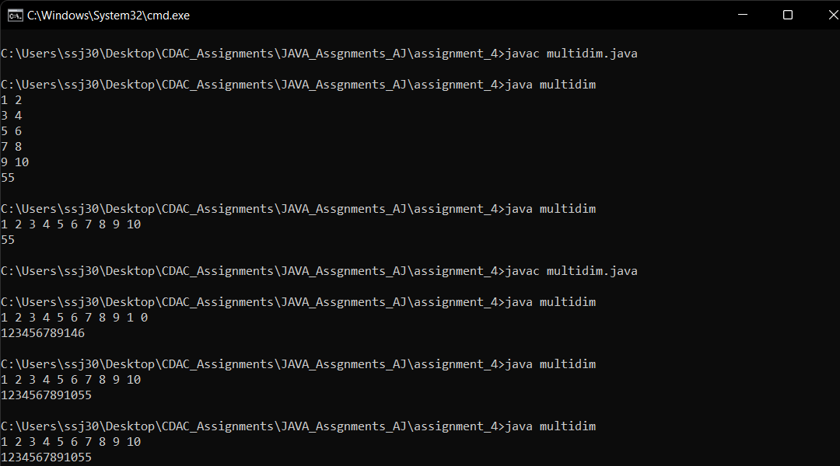

3. Initialize one String type of array and print the elements using for each loop.

Answer:-

Character Array:-

import java.util.*;

class characters{

public static void main(String[] args){

char[] arr = {'a','e','i','o','u'};

for(char ch : arr){

System.out.print(ch+" ");

}

}

}

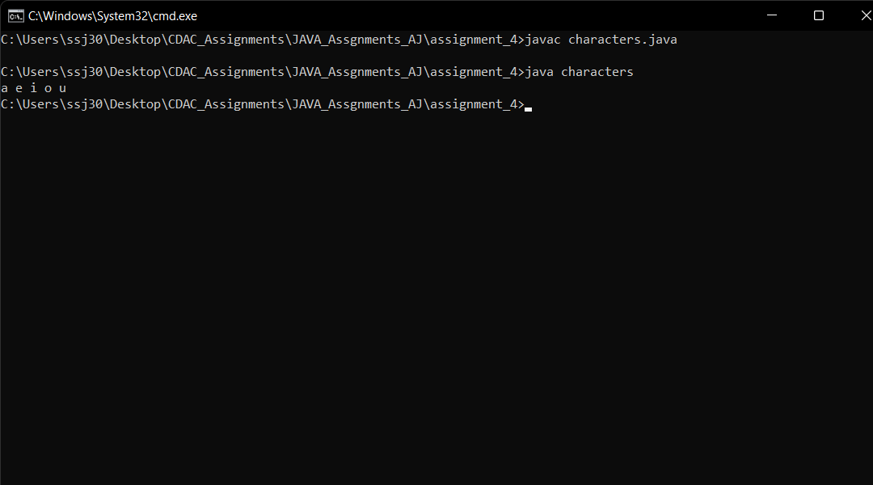

String Array:-

import java.util.*;

class characters{

public static void main(String[] args){

String[] arr = {"Hello","Everyone","how","are","you"};

for(String ch : arr){

System.out.print(ch+" ");

}

}

}

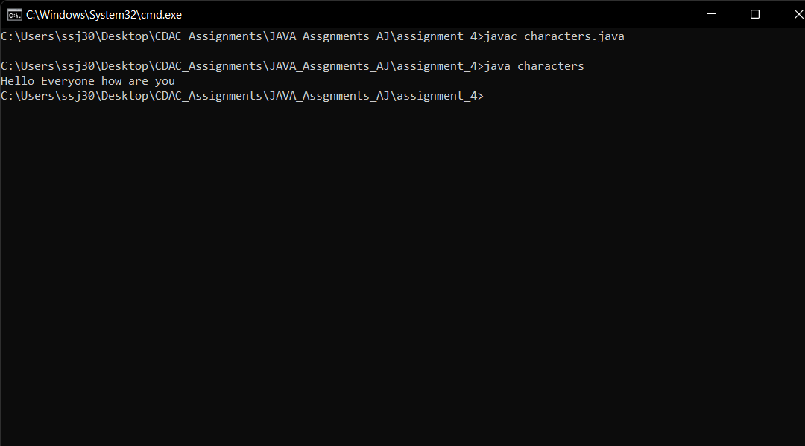

4. Write a program to print the total number of one-D arrays in a two-D array and the number of elements in every one-D array present in the two-D arrays.

Answer:-

import java.util.*;

class arrayscount{

public static void main(String[] args){

Scanner scn = new Scanner(System.in);

int[][] arr = {

{1,2,3,4,5,7,8},

{6,7,8,9,10,11,19},

{12,13,14,15},

};

int row = 0;

int count = 0;

for(int i=0;i<arr.length;i++){

for(int j=0;j<arr[i].length;j++){

count=j;

}

row++;

System.out.println("Elements in "+i+"th row is "+count );

}

System.out.println("Total number of rows in matix = "+row);

}

}

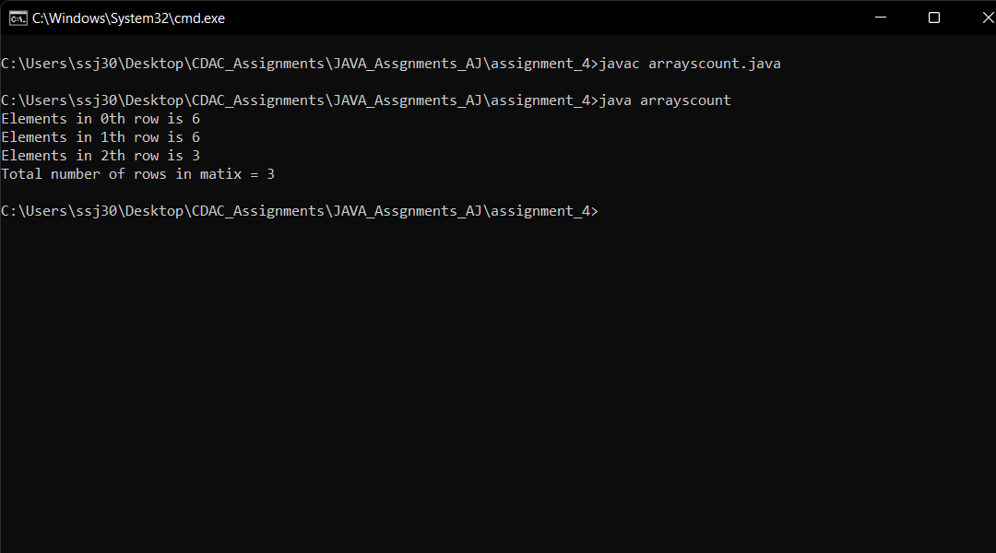

5. Create an integer type 2-D array of size [3X3]. Take the elements from the user and then calculate the sum of the elements present in the diagonal.

Answer:

import java.util.*;

class diagonalsum{

public static void main(String[] args){

Scanner scn = new Scanner(System.in);

int[][] arr = new int[3][3];

for(int i=0;i<arr.length;i++){

for(int j=0;j<arr[i].length;j++){

arr[i][j] = scn.nextInt();

}

}

int sum=0;

for(int i=0;i<arr.length;i++){

for(int j=0;j<arr[i].length;j++){

if(i==j) sum += arr[i][j];

}

}

System.out.println(sum);

}

}

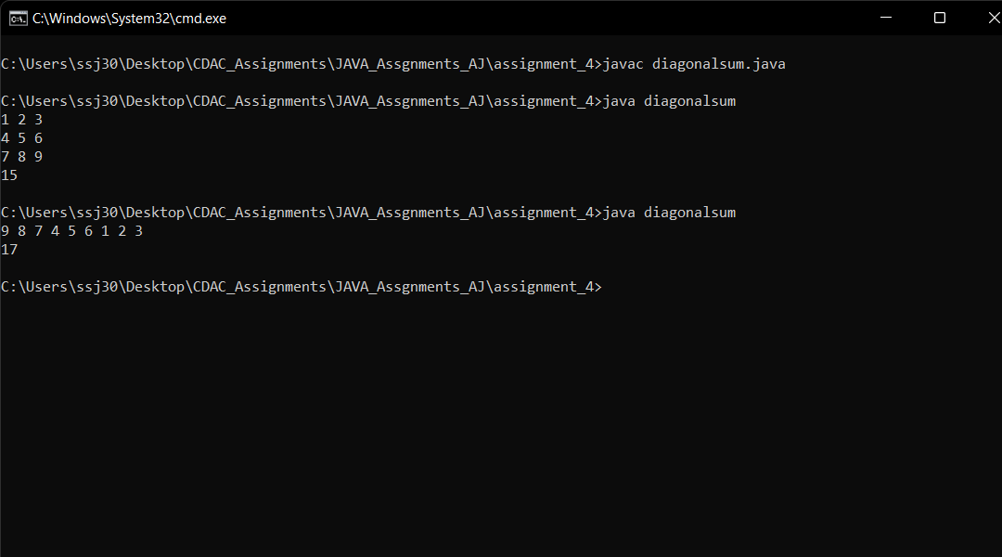

Write the following using Functions

1. to do sum of first N natural numbers.

Answer:-

import java.util.*;

class sumofn{

public static void main(String[] args){

Scanner scn = new Scanner(System.in);

int n = scn.nextInt();

System.out.println("Sum = " + addition(n));

}

public static int addition(int n){

int sum=0;

for(int i=0;i<=n;i++){

sum+=i;

}

return sum;

}

}

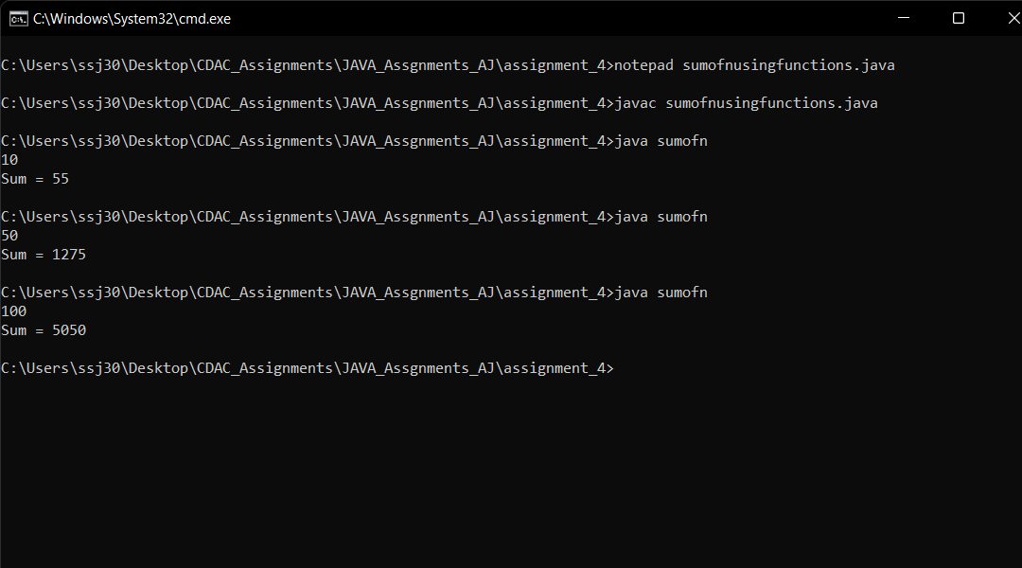

2. to check the given number is odd or even

Answer:-

import java.util.*;

class oddoreven{

public static void main(String[] args){

Scanner scn = new Scanner(System.in);

int n = scn.nextInt();

if(oddeven(n)) System.out.println(" Even ");

else System.out.println(" odd ");

}

public static boolean oddeven(int n){

return n%2==0;

}

}

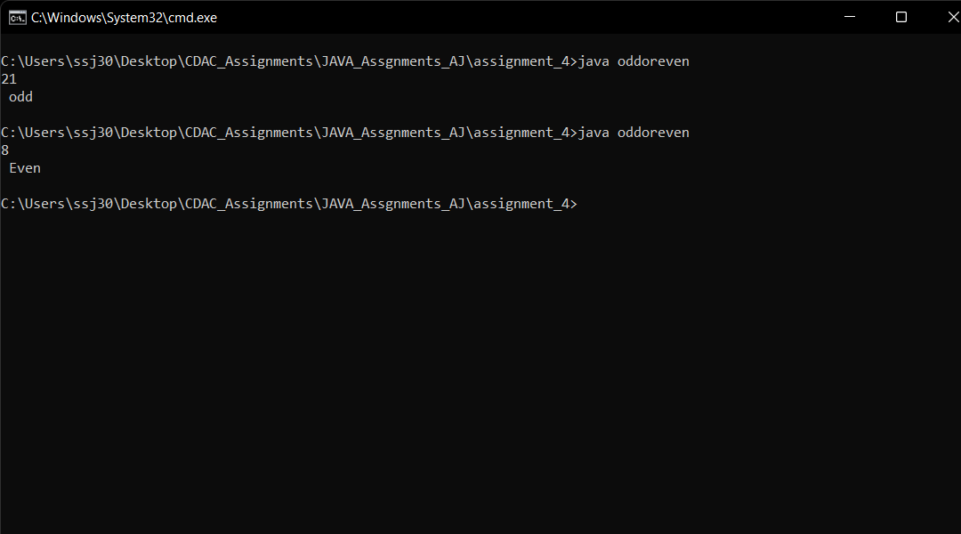

3. Find the greatest number among two numbers

Answer:

import java.util.*;

class greater{

public static void main(String[] args){

Scanner scn = new Scanner(System.in);

System.out.println("Enter the two numbers to check greater among them ");

int n1 = scn.nextInt();

int n2 = scn.nextInt();

System.out.println(" The Greater Number is = "+greatest(n1,n2));

}

public static int greatest(int n1,int n2){

return n1>n2? n1:n2;

}

}

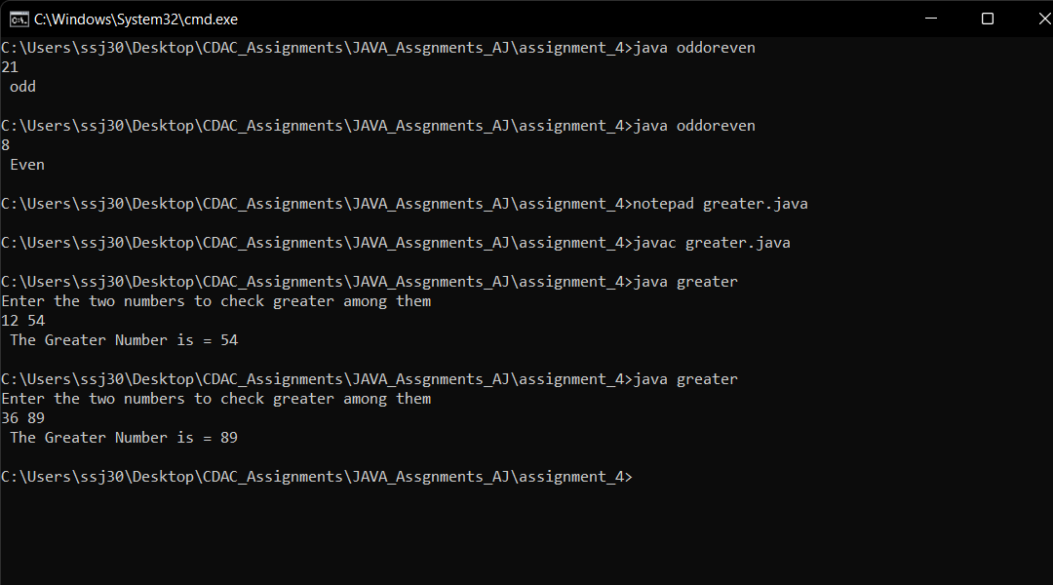

4. keep taking the numbers from user until user prints ‘y’ then print sum of all entered numbers

Answer:

import java.util.*;

class takeuntily{

public static void main(String[] args){

Scanner scn = new Scanner(System.in);

System.out.println("Enter the numbers (y) to exit ");

int sums=0;

while(scn.hasNext()){

if(scn.hasNextInt()){

System.out.println("Enter number again ");

int n = scn.nextInt();

sums += sum(n);

}else break;

}

System.out.println("Sum is : " + sums);

}

public static int sum(int n){

int sum=0;

sum+=n;

return sum;

}

}

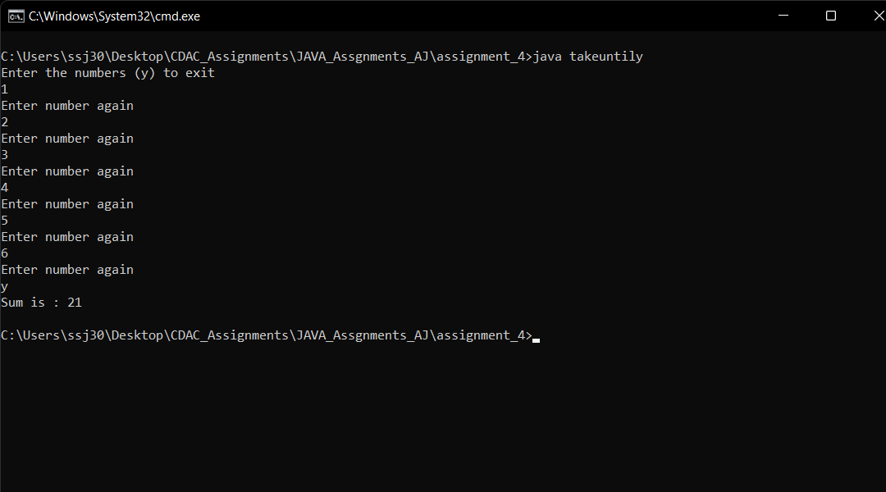

5. to check the number is prime number or not

Answer:

import java.util.*;

class prime{

public static void main(String[] args){

Scanner scn = new Scanner(System.in);

System.out.println("Enter the numbers ");

int n = scn.nextInt();

if(primeornot(n)) System.out.println("Prime Number");

else System.out.println("Not Prime Number");

}

public static boolean primeornot(int n){

int div=2;

while(div*div<=n){

if(n%2==0){

break;

}

div++;

}

if(div*div > n) return true;

else return false;

}

}

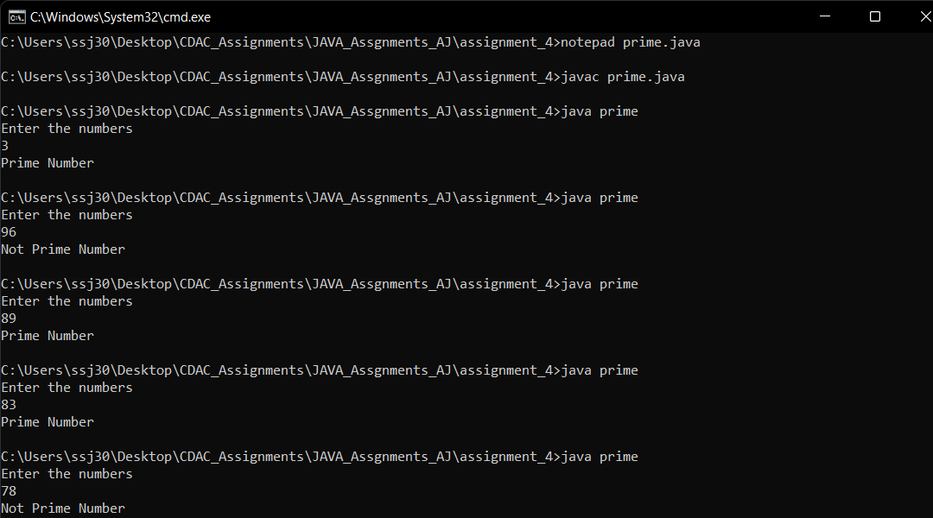

6.to count odd numbers between 1 and 100

Answer:

import java.util.*;

class odd{

public static void main(String[] args){

Scanner scn = new Scanner(System.in);

System.out.println("Enter the the two numbers numbers ");

int n1 = scn.nextInt();

int n2 = scn.nextInt();

System.out.println("Count of odd numbers are " + countodd(n1,n2) );

}

public static int countodd(int n1,int n2){

int count=0;

for(int i=n1;i<=n2;i++){

if(i%2!=0) count++;

}

return count;

}

}

