Assignment NO 5

01_Aaditya Sudhir Joshi

1. Create a class Student with 2 data members’ rno and name. Create one method setData() that takes roll number and student name as parameter and stores them in data members rno and name. Create one more method showData() to print the data member values. Create another class ( main class) StudentDemo that creates Student class object and calls setData() and showData() methods.

Answer:

class Student{

int rno;

String name;

void setData(int rno,String name){

this.rno = rno;

this.name = name;

}

void showData(){

System.out.println(rno+" "+name);

}

}

class StudentDemo{

public static void main(String[] main){

Student s = new Student();

s.setData(1,"Aaditya");

s.showData();

}

}

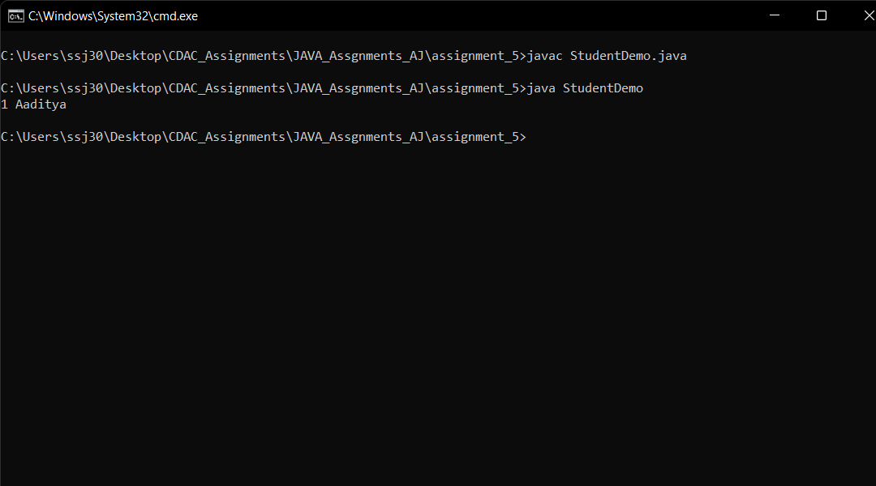

2. Modify the above program (no. 31) to count the no of Student objects created. [ In this program static variable is required ]

Answer:

class Student{

int rno;

String name;

static int count=0;

void setData(int rno,String name){

this.rno = rno;

this.name = name;

count++;

}

void showData(){

System.out.println(rno+" "+name);

}

}

class Studentupdate{

public static void main(String[] main){

Student s = new Student();

Student s1 = new Student();

s.setData(1,"Aaditya");

s1.setData(2,"Atharva");

System.out.println(Student.count);

}

}

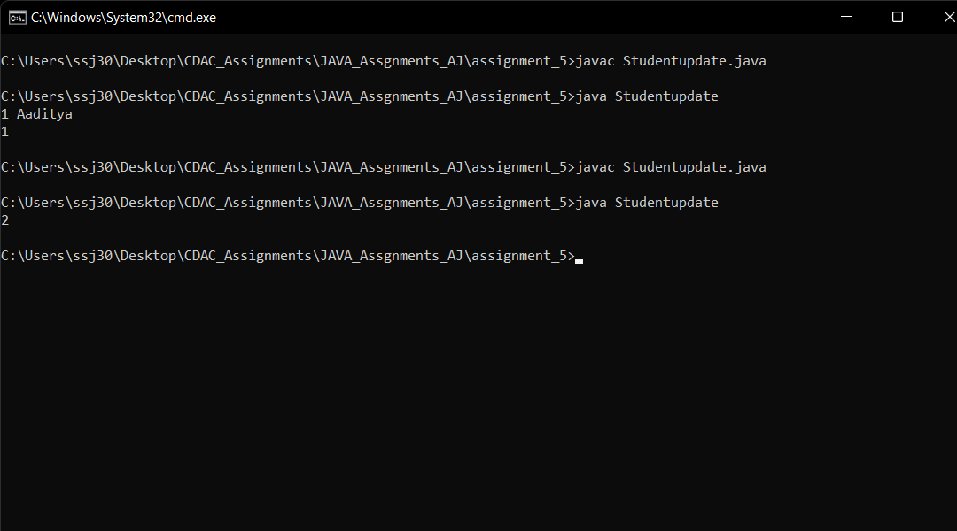

3. Write a program to demonstrate functionalities of this keyword in java.

Answer:

class Student{

int rno,roll_no;

String name,stu_name;

static int count=0;

void insertData(int roll_no , String stu_name){

this.roll_no = roll_no;

this.stu_name = stu_name;

}

void setData(int rno,String name){

rno = rno;

name = name;

count++;

}

void showData(){

System.out.println(rno+" "+name);

System.out.println(roll_no+" "+stu_name);

}

}

class Studentupdate{

public static void main(String[] main){

Student s = new Student();

Student s1 = new Student();

s.insertData(1,"Aaditya");

s1.insertData(2,"Atharva");

s.setData(1,"Aaditya");

s1.setData(2,"Atharva");

s.showData();

s1.showData();

System.out.println(Student.count);

}

}

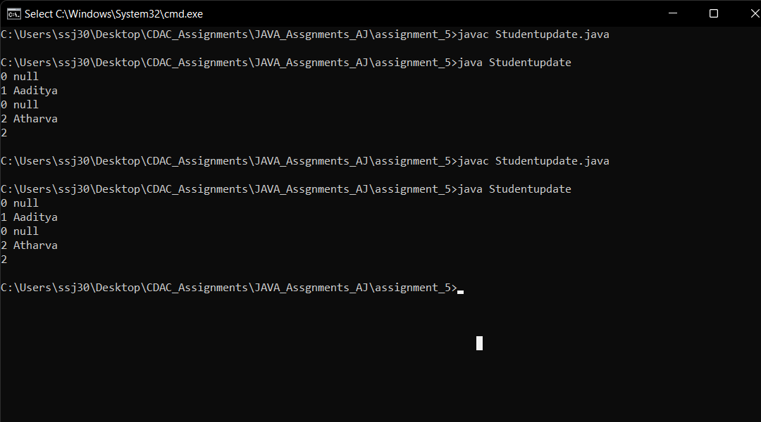

4. Create a class Circle that has two data members, one to store the radius and another to store area and three methods first init() method to input radius from user, second calculateArea() method to calculate area of circle and third display() method to display values of radius and area. Create class CircleDemo ( main class) that creates the Circle object and calls init(), calculateArea() and display() methods.

Answer:

class Circle{

int radius;

float area;

void intocircle(int radius){

this.radius = radius;

}

void calculatearea(int r){

this.area = (float)3.142*r*r ;

}

void display(){

System.out.println(radius+" "+area);

}

}

class circles{

public static void main(String[] args){

Circle c = new Circle();

Circle c1 = new Circle();

Circle c2 = new Circle();

c.intocircle(23);

c.calculatearea(23);

c.display();

c.intocircle(78);

c.calculatearea(78);

c.display();

c.intocircle(15);

c.calculatearea(15);

c.display();

}

}

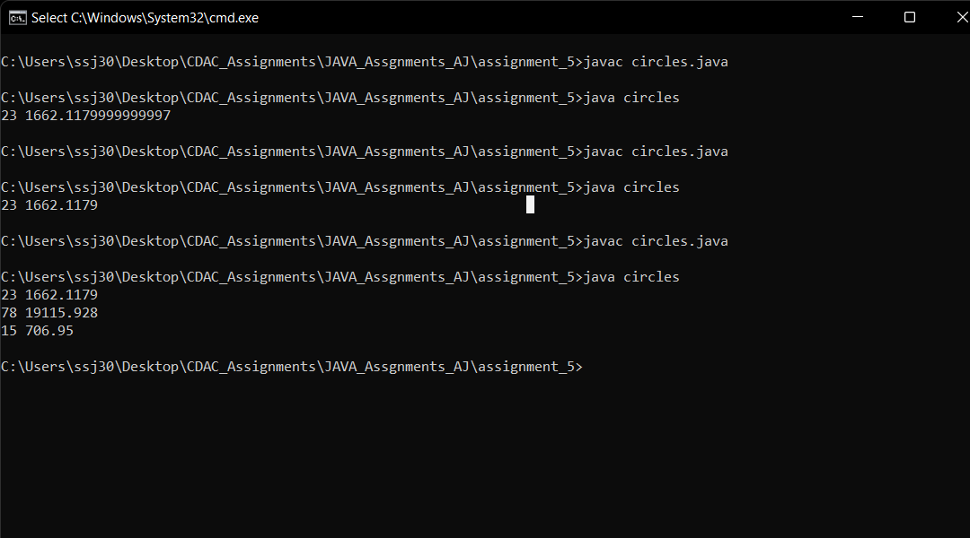

5. Create a class MathOperation that has four static methods. add() method that takes two integer numbers as parameter and returns the sum of the numbers. subtract() method that takes two integer numbers as parameter and returns the difference of the numbers. multiply() method that takes two integer numbers as parameter and returns the product. power() method that takes two integer numbers as parameter and returns the power of first number to second number. Create another class Demo (main class) that takes the two numbers from the user and calls all four methods of MathOperation class by providing entered numbers and prints the return values of every method.

Answer:

import java.util.*;

class MathOperations{

int n1;

int n2;

static int add(int n1,int n2){

return n1+n2;

}

static int substract(int n1, int n2){

return n1-n2;

}

static int multiply(int n1 , int n2){

return n1*n2;

}

static int powers(int n1,int n2){

return (int)Math.pow(n1,n2);

}

}

class demo{

public static void main(String[] args){

Scanner scn = new Scanner(System.in);

System.out.println("Enter the two Number = ");

int n1 = scn.nextInt();

int n2 = scn.nextInt();

System.out.println("Addition:= "+MathOperations.add(n1,n2));

System.out.println("Substraction:= "+MathOperations.substract(n1,n2));

System.out.println("Multiplication:= "+MathOperations.multiply(n1,n2));

System.out.println("Power:= "+MathOperations.powers(n1,n2));

}

}

