01_Aaditya Sudhir Joshi

1) Create a class Tile to store the edge length of a square tile, and create another class Floor to store length and width of a rectangular floor. Add method totalTiles(Tile t) in Floor class with Tile as argument to calculate the whole number of tiles needed to cover the floor completely.

Answer:-

**class** Tile{

**int** edge;

**int** area;

Tile(**int** edge){

**this**.edge=edge;

**this**.area=edge*edge;

}

**int** areas() {

**return** area;

}

}

**class** Floors{

**int** l;

**int** w;

Floors(**int** l,**int** w){

**this**.l=l;

**this**.w=w;

}

**void** totaltile(Tile t) {

**double** tiles = t.areas();

**double** areaofrec = l*w;

**double** totalt = areaofrec/tiles;

System.***out***.println(totalt);

}

}

**class** Floor {

**public** **static** **void** main(String[] args) {

// **TODO** Auto-generated method stub

Tile m = **new** Tile(1);

Floors f = **new** Floors(12,5);

f.totaltile(m);

}

}

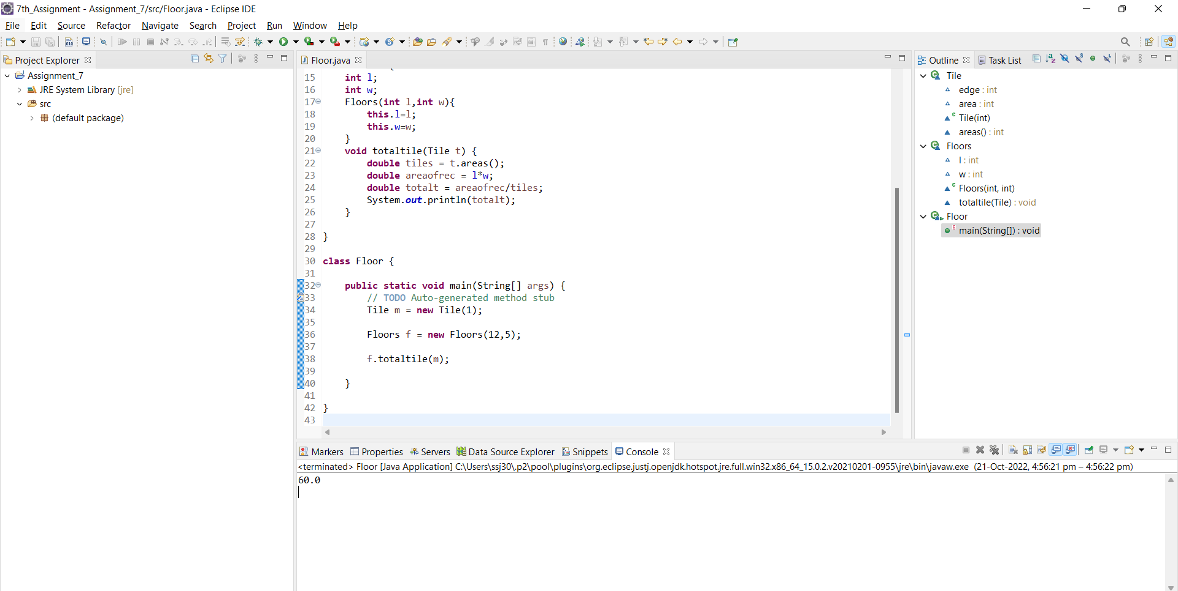

2) Create a class OneBHK with instance variables roomArea, hallArea and price. Then create default constructor that initializes instance variables with some values and a parameterized constructor that takes values for all instance variables and stores them in instance variables. Now create a method named show()  to print OneBHK’s instance variable values.

Create another class TwoBHK which has [(inherites)](https://youtu.be/Xtj8XLWiKlA) all the properties and behaviors of OneBHK and a new instance variable room2Area. Then create default constructor to initialize all 4 instance variables and a parameterized constructor to take the values for initialization of all instance variables. Override show() method to print all data member information.

Write main method in another class (Say Demo) and store three TwoBHK flat’s information and print information using show method. Also print total amount of all flats.

Answer:

**package** assignment_7th;

**import** java.util.*;

**class** OneBhk{

**int** roomArea;

**int** hallArea;

**int** price;

**static** **int** *count*=0;

OneBhk(){

roomArea=0;

hallArea=0;

price=0;

}

OneBhk(**int** roomArea,**int** hallArea,**int** price){

**this**.roomArea=roomArea;

**this**.hallArea=hallArea;

**this**.price=price;

*count*++;

}

**void** show() {

System.***out***.print("Area of Room = "+roomArea+" Area of Hall = "+hallArea+" Price = "+price);

}

}

**class** TwoBhk **extends** OneBhk{

**int** room2Area;

TwoBhk(**int** roomArea, **int** hallArea, **int** price,**int** room2Area) {

**super**(roomArea, hallArea, price);

**this**.room2Area=room2Area;

}

**void** show() {

**super**.show();

System.***out***.println(" Area of room 2 = "+room2Area);

}

**static** **int** counts() {

**return** *count*;

}

}

**public** **class** Demo {

**public** **static** **void** main(String[] args) {

// **TODO** Auto-generated method stub

Scanner scn = **new** Scanner(System.***in***);

System.***out***.println("Enter the array Size");

**int** n = scn.nextInt();

TwoBhk[] arr = **new** TwoBhk[n];

**for**(**int** i=0;i<arr.length;i++) {

System.***out***.print("Enter the Area of room ");

**int** roomArea = scn.nextInt();

System.***out***.print("Enter the Area of hall ");

**int** halArea = scn.nextInt();

System.***out***.print("Enter the price ");

**int** price = scn.nextInt();

System.***out***.print("Enter the Area of room 2 ");

**int** room2Area = scn.nextInt();

arr[i] = **new** TwoBhk(roomArea,halArea,price,room2Area);

System.***out***.println("=================================================");

}

**for**(TwoBhk b:arr) {

b.show();

}

System.***out***.println(TwoBhk.*counts*());

}

}

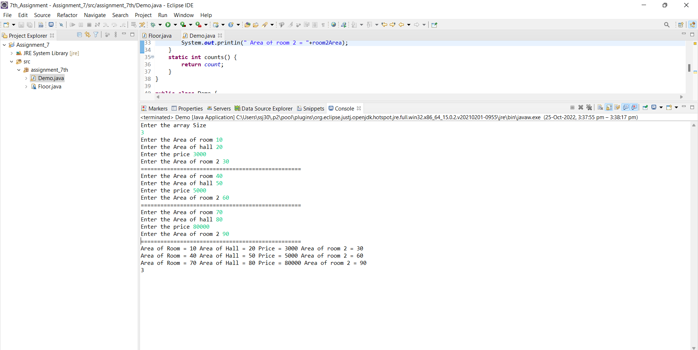

3) Create three classes

* Faculty with two data members facultyId and salary and two methods, one intput() method for accepting facultyId as input and another printSalary() to print salary.
* FullTimeFaculty that [inherits](https://youtu.be/iF6fw004RAw) class Faculty with two data members’ basicSalary and allowance. Override input() method in this class that calls super class inut() method and accepts basicSalary and allowance as input. Salary should not be accepted as input but should be calculated using formula (basicSalary + allowance)
* PartTimeFaculty that [inherits](https://youtu.be/k0oaIxwpdz0) class Faculty with two data members’ workingHours, ratePerHour. [Override](https://youtu.be/2cbzGNLaCtY) input() method in this class that calls super class inut() method and accepts workingHours and ratePerHour as input. Salary should not be accepted as input but should be calculated using formula ( workingHour * ratePerHour )

Answer:

**package** assignment_7th;

**class** Faculty{

**double** facultyid;

**double** salary;

**void** input(**double** facultyid) {

**this**.facultyid=facultyid;

}

**void** inputsalary(**double** salary) {

**this**.salary=salary;

}

**void** printSalary() {

System.***out***.println("Salary = "+salary);

}

}

**class** FullTimeFaculty **extends** Faculty{

**double** basicsalary;

**double** allowance;

**void** input(**double** facultyid,**double** basicsalary, **double** allowance) {

// **TODO** Auto-generated method stub

**super**.input(facultyid);

**this**.basicsalary=basicsalary;

**this**.allowance=allowance;

inputsalary(basicsalary+allowance);

}

}

**class** ParttimeFaculty **extends** Faculty{

**double** workhr;

**double** rateperhr;

**void** input(**double** facultyid,**double** workhr,**double** rateperhr) {

**super**.input(facultyid);

**this**.workhr=workhr;

**this**.rateperhr=rateperhr;

inputsalary(workhr*rateperhr);

}

}

**public** **class** InheritanceDemo1 {

**public** **static** **void** main(String[] args) {

FullTimeFaculty f = **new** FullTimeFaculty();

f.input(1,10000,2000);

ParttimeFaculty p = **new** ParttimeFaculty();

p.input(2,24,400);

f.printSalary();

p.printSalary();

}

}

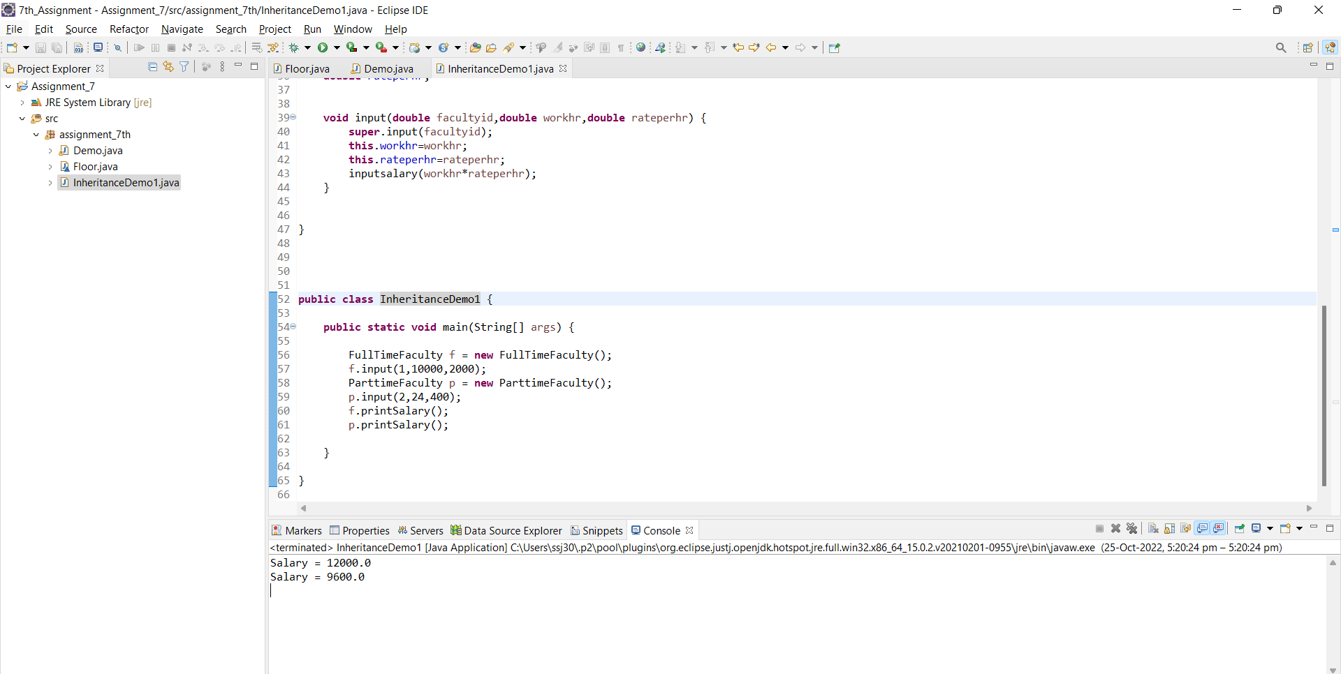

4) Create a class Student with two members : rollno and percentage.

Create default and parameterized constructors.

Create method show() to display information.

Create another class CollegeStudent inherits Student class. Add a new member semester to it.

Create default and parameterized constructors. [Also override](https://youtu.be/2cbzGNLaCtY) show() method that calls [super](https://youtu.be/saWlv18bw_U) class show() method and displays semester.

Create another class SchoolStudent inherits Student class. Add a new member className(eg 12th ,10th etc.) to it.

Create default and parameterized constructors. Also [override](https://youtu.be/2cbzGNLaCtY) show() method that calls [super](http://aishwary) class show() method and displays className.

Create a class( say Demo) with main method that carries out the operation of the project :

-- has array to store objects of any class(Student,  CollegeStudent or SchoolStudent)

–create two CollegeStudent  and three SchoolStudent objects and store them inside the array

-- display all records from the array

-- search record on the basic of rollno and check given rollno is of SchoolStudent or of CollegeStudent.

– count how many students are having A grade, if for A grade percentage >75.

Answer:

**package** assignment_7th;

**import** java.util.*;

**class** Student{

**int** rollno;

**double** percentage;

**int** count=0;

Student(){

rollno=0;

percentage=0;

}

Student(**int** rollno,**double** percentage){

**this**.rollno=rollno;

**this**.percentage=percentage;

}

**void** show() {

System.***out***.print("Student no = "+rollno+" and Percentage = "+percentage);

}

**void** find(**int** rollno,Student[] arr1) {

**for**(**int** i=0;i<arr1.length;i++) {

**if**(arr1[i].rollno == rollno)

System.***out***.println("Inside Student "+arr1[i].rollno+" "+arr1[i].percentage);

}

}

**int** countA(Student[] arr) {

**for**(**int** i=0;i<arr.length;i++) {

**if**(arr[i].percentage>75) count++;

}

**return** count;

}

}

**class** CollegeStudent **extends** Student{

**int** sem;

CollegeStudent(){

sem=0;

}

CollegeStudent(**int** rollno,**double** percentage,**int** sem){

**super**(rollno,percentage);

**this**.sem=sem;

}

**void** show() {

**super**.show();

System.***out***.print(" Semister = "+sem);

}

**void** find(**int** rollno,Student[] arr2) {

**for**(**int** i=0;i<arr2.length;i++) {

**if**(arr2[i].rollno == rollno)

System.***out***.println("Inside College Student = "+arr2[i].rollno+" "+arr2[i].percentage+" ");

}

}

**int** countA(Student[] arr) {

**for**(**int** i=0;i<arr.length;i++) {

**if**(arr[i].percentage>75) count++;

}

**return** count;

}

}

**class** SchoolStudent **extends** Student{

String classname;

SchoolStudent (){

classname="";

}

SchoolStudent(**int** rollno,**double** percentage,String classname){

**super**(rollno,percentage);

**this**.classname=classname;

}

**void** show() {

**super**.show();

System.***out***.println(" Classname = "+classname);

}

**void** find(**int** rollno,Student[] arr3) {

**for**(**int** i=0;i<arr3.length;i++) {

**if**(arr3[i].rollno == rollno)

System.***out***.println("Inside School Student"+arr3[i].rollno+" "+arr3[i].percentage+" ");

}

}

**int** countA(Student[] arr) {

**for**(**int** i=0;i<arr.length;i++) {

**if**(arr[i].percentage>75) count++;

}

**return** count;

}

}

**public** **class** StudentDemo {

**public** **static** **void** main(String[] args) {

// **TODO** Auto-generated method stub

Scanner scn = **new** Scanner(System.***in***);

String v;

**do** {

System.***out***.println("Enter the Number you want to insert data:\n 1) To insert into Student Enter (1) \n 2) To insert into CollegeStudent Enter (2)\n 3) To Insert into SchoolStudent Enter (3) ");

**int** s = scn.nextInt();

**switch**(s) {

**case** 1:

System.***out***.println("Enter Array Size for Student ");

**int** n1 = scn.nextInt();

Student[] arr1 = **new** Student[n1];

**for**(**int** i=0;i<arr1.length;i++) {

System.***out***.println("Enter Roll No and Percentage ");

**int** roll = scn.nextInt();

**double** per = scn.nextDouble();

arr1[i] = **new** Student(roll,per);

}

**for**(Student i:arr1) {

i.show();

System.***out***.println();

}

System.***out***.print("\nEnter the roll no to find data ");

**int** m = scn.nextInt();

Student x = **new** Student();

x.find(m,arr1);

System.***out***.println();

System.***out***.println(x.countA(arr1)+" Students have A grade");

**break**;

**case** 2:

System.***out***.println("Enter Array Size for CollegeStudent ");

**int** n2 = scn.nextInt();

Student[] arr2 = **new** Student[n2];

**for**(**int** i=0;i<arr2.length;i++) {

System.***out***.println("Enter Roll No and Percentage and Semister ");

**int** roll = scn.nextInt();

**double** per = scn.nextDouble();

**int** sem = scn.nextInt();

arr2[i] = **new** CollegeStudent(roll,per,sem);

}

**for**(Student i:arr2) {

i.show();

System.***out***.println();

}

System.***out***.print("\nEnter the roll no to find data ");

**int** z = scn.nextInt();

CollegeStudent x1 = **new** CollegeStudent();

x1.find(z,arr2);

System.***out***.println();

System.***out***.println(x1.countA(arr2)+" Students have A grade");

**break**;

**case** 3:

System.***out***.println("Enter Array Size for SchoolStudent ");

**int** n3 = scn.nextInt();

Student[] arr3 = **new** Student[n3];

**for**(**int** i=0;i<arr3.length;i++) {

System.***out***.println("Enter Roll No and Percentage and classname ");

**int** roll = scn.nextInt();

**double** per = scn.nextDouble();

String name = scn.next();

arr3[i] = **new** SchoolStudent(roll,per,name);

}

**for**(Student i:arr3) {

i.show();

System.***out***.println();

}

System.***out***.print("\nEnter the roll no to find data ");

**int** o = scn.nextInt();

SchoolStudent x2 = **new** SchoolStudent();

x2.find(o,arr3);

System.***out***.println();

System.***out***.println(x2.countA(arr3)+" Students have A grade");

**break**;

**default** : System.***out***.println("Enter Valid Option");

}

System.***out***.println();

System.***out***.println("Do you wish to continue(y/n)?");

v = scn.next();

}**while**(v.equals("y"));

}

}

