**Industrial Internship Report on**

**”Automatic Door Control system ”**

**Prepared by**

**Aaditya Rajendra Bhise**

|  |
| --- |
| *Executive Summary* |
| This report provides details of the Industrial Internship provided by upskill Campus and The IoT Academy in collaboration with Industrial Partner UniConverge Technologies Pvt Ltd (UCT).  This internship was focused on a project/problem statement provided by UCT. We had to finish the project including the report in 6 weeks’ time.  My project was Automatic door control system is designed to automate the process of opening and closing doors based on the detection of nearby objects or individuals.  This internship gave me a very good opportunity to get exposure to Industrial problems and design/implement solution for that. It was an overall great experience to have this internship. |

**TABLE OF CONTENTS**

1 Preface 3

2 Introduction 4

2.1 About UniConverge Technologies Pvt Ltd 4

2.2 About upskill Campus 8

2.3 Objective 10

2.4 Reference 10

3 Problem Statement 11

4 Existing and Proposed solution 12

5 Proposed Design/ Model 13

5.1 High Level Diagram (if applicable) 13

5.2 Low Level Diagram (if applicable) 13

5.3 Interfaces (if applicable) 14

6 Performance Test 16

6.1 Test Plan/ Test Cases 16

6.2 Test Procedure 16

6.3 Performance Outcome 17

7 My learnings 18

8 Future work scope 19

# Preface

Summary of the whole 6 weeks’ work.

About need of relevant Internship in career development.

Brief about Your project/problem statement.

Opportunity given by USC/UCT.

How Program was planned

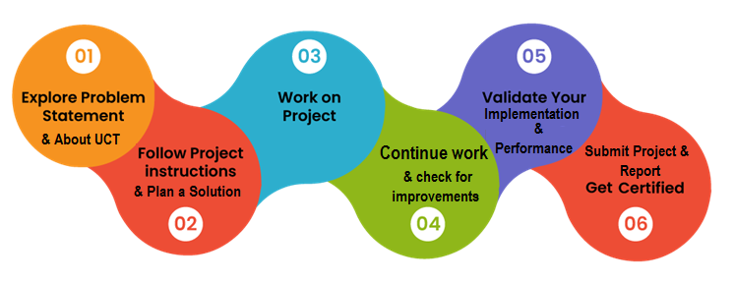

Your Learnings and overall experience.

Thank to all (with names), who have helped you directly or indirectly.

Your message to your juniors and peers.

# Introduction

## About UniConverge Technologies Pvt Ltd

A company established in 2013 and working in Digital Transformation domain and providing Industrial solutions with prime focus on sustainability and RoI.

For developing its products and solutions it is leveraging various**Cutting Edge Technologies e.g. Internet of Things (IoT), Cyber Security, Cloud computing (AWS, Azure), Machine Learning, Communication Technologies (4G/5G/LoRaWAN), Java Full Stack, Python, Front end**etc.

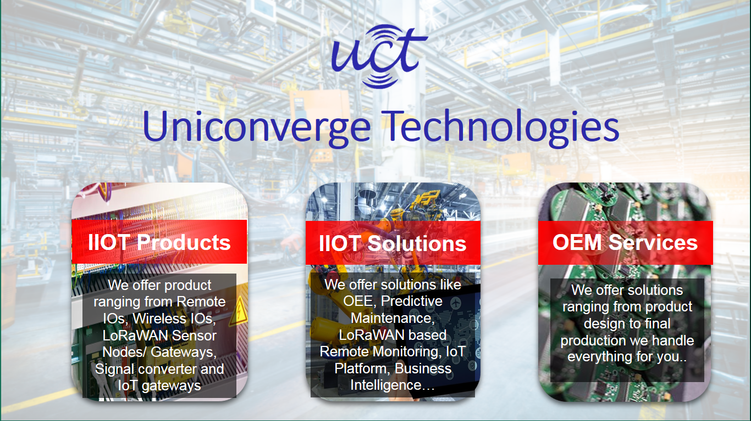

1. UCT IoT Platform **(****)**

**UCT Insight** is an IOT platform designed for quick deployment of IOT applications on the same time providing valuable “insight” for your process/business. It has been built in Java for backend and ReactJS for Front end. It has support for MySQL and various NoSql Databases.

* It enables device connectivity via industry standard IoT protocols - MQTT, CoAP, HTTP, Modbus TCP, OPC UA
* It supports both cloud and on-premises deployments.

It has features to  
• Build Your own dashboard  
• Analytics and Reporting  
• Alert and Notification  
• Integration with third party application(Power BI, SAP, ERP)  
• Rule Engine

 

1. **Smart Factory Platform (****)**

Factory watch is a platform for smart factory needs.

It provides Users/ Factory

* with a scalable solution for their Production and asset monitoring
* OEE and predictive maintenance solution scaling up to digital twin for your assets.
* to unleased the true potential of the data that their machines are generating and helps to identify the KPIs and also improve them.
* A modular architecture that allows users to choose the service that they what to start and then can scale to more complex solutions as per their demands.

Its unique SaaS model helps users to save time, cost and money.

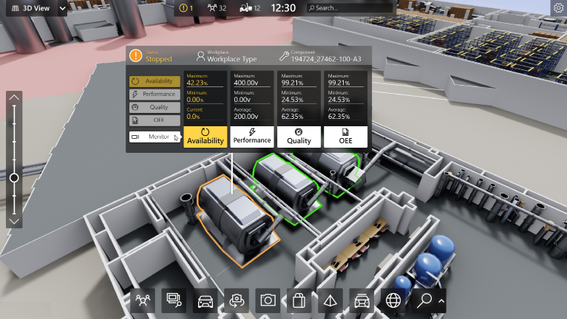

1.  based Solution

UCT is one of the early adopters of LoRAWAN teschnology and providing solution in Agritech, Smart cities, Industrial Monitoring, Smart Street Light, Smart Water/ Gas/ Electricity metering solutions etc.

1. Predictive Maintenance

UCT is providing Industrial Machine health monitoring and Predictive maintenance solution leveraging Embedded system, Industrial IoT and Machine Learning Technologies by finding Remaining useful life time of various Machines used in production process.



## About upskill Campus (USC)

upskill Campus along with The IoT Academy and in association with Uniconverge technologies has facilitated the smooth execution of the complete internship process.

USC is a career development platform that delivers **personalized executive coaching** in a more affordable, scalable and measurable way.



Seeing need of upskilling in self paced manner along-with additional support services e.g. Internship, projects, interaction with Industry experts, Career growth Services

<https://www.upskillcampus.com/>

upSkill Campus aiming to upskill 1 million learners in next 5 year





Seeing need of upskilling in self paced manner along-with additional support services e.g. Internship, projects, interaction with Industry experts, Career growth Services

upSkill Campus aiming to upskill 1 million learners in next 5 year

<https://www.upskillcampus.com/>

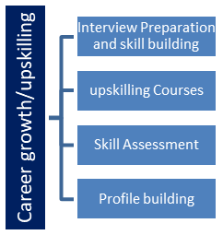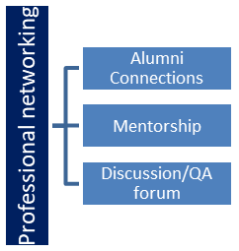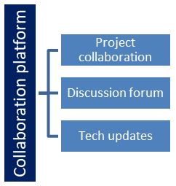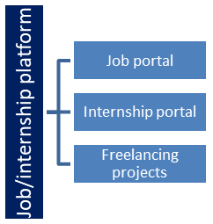

## The IoT Academy

The IoT academy is EdTech Division of UCT that is running long executive certification programs in collaboration with EICT Academy, IITK, IITR and IITG in multiple domains.

## Objectives of this Internship program

The objective for this internship program was to

 ☛ get practical experience of working in the industry.

 ☛ to solve real world problems.

 ☛ to have improved job prospects.

 ☛ to have Improved understanding of our field and its applications.

 ☛ to have Personal growth like better communication and problem solving.

## Reference

[1] Recommended books on sensor by John Wiley & Sons.

[2] project-using-arduino https://en.wikipedia.org/wiki/Passive_infrared_sensor

[3] https://www.elprocus.com/pirsensorbasicapplication

# Problem Statement

The Automatic Door Control System is designed to automate the process of opening and closing doors based on the detection of nearby objects or individuals. This system is crucial for enhancing accessibility, convenience, and security in various environments such as buildings, hospitals, and retail stores. The problem statement involves integrating components like Arduino microcontroller, Motor Driver (L293D), DC Motor, and sensors such as PIR and Ultrasonic Sensors to develop a reliable and efficient automatic door control solution. Challenges include seamless integration of components, designing logic for precise door control, and ensuring consistent performance in different environments.

# Existing and Proposed solution

Existing Solutions: Existing solutions in the field of automatic door control systems primarily rely on similar components and principles. However, they often face limitations in terms of flexibility, customization, and responsiveness. Many solutions lack robust integration of sensors, leading to inconsistent performance.

Proposed Solution: Our proposed solution aims to address these limitations by developing a more versatile and reliable Automatic Door Control System. We plan to optimize sensor integration, refine programming logic for efficient door control, and conduct thorough testing to ensure consistent performance.

Value Addition: Our solution seeks to add value by offering a more flexible and customizable system that can adapt to diverse environments. By prioritizing seamless sensor integration and efficient programming, we aim to enhance user experience and reliability.

## Code submission (Github link) :

## Report submission (Github link) :

# Proposed Design/ Model

Given more details about design flow of your solution. This is applicable for all domains. DS/ML Students can cover it after they have their algorithm implementation. There is always a start, intermediate stages and then final outcome.

## High Level Diagram

Figure 1: HIGH LEVEL DIAGRAM OF THE SYSTEM

## Low Level Diagram

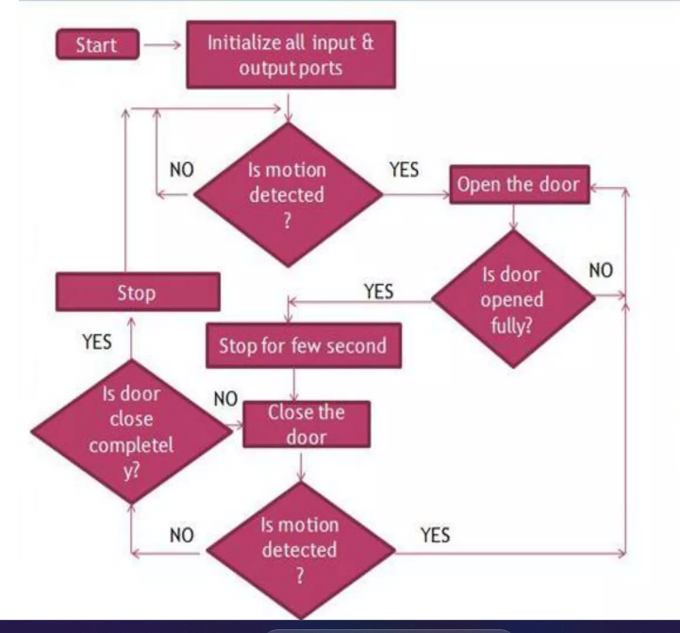

Figure 2: LOW LEVEL DIAGRAM OF THE SYSTEM

## Interfaces

**LCD**

Figure 3: BLOCK DIAGRAM OF THE SYSTEM

**DOOR**

**L293D**

**ARDUINO UNO**

**PIR**

**SENSOR**

# Performance Test

Constraints:

* Memory: The microcontroller's limited memory capacity may restrict the complexity of the implemented algorithms.
* Speed: Real-time response requirements demand efficient processing to ensure timely door operations.
* Accuracy: Sensor readings must be accurate and consistent to avoid false detections or missed events.
* Power Consumption: Energy efficiency is essential to minimize power consumption and prolong battery life in portable applications.
* How Constraints Were Addressed:
* Memory Optimization: Code optimization techniques were employed to minimize memory usage and maximize efficiency.
* Speed Enhancement: Algorithms were designed and implemented for fast and responsive sensor data processing.
* Accuracy Improvement: Calibration and filtering methods were applied to enhance sensor accuracy and reliability.
* Power Management: Power-saving features and strategies were implemented to minimize energy consumption during idle and active states.

## Test Plan/ Test Cases

Test cases were defined to evaluate the system's performance under various scenarios, including different sensor inputs, environmental conditions, and user interactions. Each test case outlined specific conditions, expected outcomes, and success criteria for validation.

## Test Procedure

Tests were conducted following the defined test cases, with careful observation and documentation of system behavior and performance metrics. Procedures included setup configuration, data collection, analysis, and result interpretation to assess the system's effectiveness and reliability.

## Performance Outcome

Performance outcomes were measured based on metrics such as response time, accuracy, energy consumption, and system stability. Results were analyzed to identify strengths, weaknesses, and areas for improvement, guiding further optimization and refinement efforts.

# My learnings

Throughout the internship, I gained valuable insights into embedded systems, IoT technologies, and soft skills essential for professional growth. Technical learnings encompassed programming, circuit design, sensor integration, and system optimization, while soft skills development focused on communication, teamwork, and problem-solving abilities. These learnings have equipped me with a comprehensive skill set and mindset for success in the embedded systems and IoT domain.

# Future work scope

Future work may involve exploring advanced techniques for system optimization, security enhancement, and feature expansion. Additionally, opportunities for research and development in emerging technologies such as machine learning and edge computing could further broaden the scope and impact of automatic door control systems.