Explainable Next-Period Readmission Analytics for California Hospitals: Temporally Aligned CABG Prediction, Stroke Outcome Analysis and Population Trends

Aaditya Bhure
Dept. of Computer Science Engineering
Symbiosis Institute of Technology, Nagpur
Symbiosis International (Deemed University)
Nagpur, India
PRN: 23070521034
Bhargav Sor
Dept. of Computer Science Engineering
Symbiosis Institute of Technology, Nagpur
Symbiosis International (Deemed University)
Nagpur, India
PRN: 23070521031

Abstract—Thirty-day readmission rates are widely used to judge hospital quality, yet most predictive studies work with patient records or same-period information. We ask whether a hospital's published history can estimate its next-period risk-adjusted 30-day readmission rate after isolated coronary artery bypass grafting (CABG), using California hospital performance data for 2018–2023, and we analyse ischemic stroke outcomes (2011–2015) and statewide all-cause readmissions (2011–2024) alongside. Inputs from one reporting window were paired with the outcome of the next window without bridging missing periods. A persistence baseline (next = previous), a training-mean baseline, Linear Regression and Random Forest were trained on 124 hospital transitions and evaluated once on a held-out later window (118 hospitals) with hospital-grouped cross-validation and paired bootstrap intervals. Persistence reached a mean absolute error (MAE) of 2.49 percentage points, Linear Regression 2.54 and Random Forest 2.74; no model was reliably better than persistence (95% CI of the Linear Regression gap -0.23 to +0.34). We show that the published two-year windows overlap by one calendar year, which raises the lag-1 correlation to 0.72 versus 0.47 for non-overlapping windows. On a non-overlapping horizon persistence error rose to 3.96 while Linear Regression achieved 3.52, better in 88% of folds. A separate stroke model reduced error relative to persistence by 6.4%. Results are delivered through an explainable five-page dashboard.
Keywords—hospital readmission, CABG, ischemic stroke, temporal validation, persistence baseline, grouped cross-validation, regression to the mean, explainable AI, healthcare analytics

Introduction
An unplanned readmission within 30 days of discharge is costly and often signals an incomplete recovery or a poor transition from hospital to home. About one in five Medicare beneficiaries was rehospitalised within 30 days in a landmark study [1], and readmission rates now drive public reporting and financial penalties in the United States [2]. Predicting readmission remains difficult: most published risk models show only modest discrimination [3].
Hospital-level forecasting raises a different problem from patient-level prediction. A hospital's rate in a reporting window is an estimate from a limited number of patients, so changes between windows partly reflect chance [4], and unusually high or low rates tend to move back toward the average in the next period, a phenomenon known as regression to the mean [5]. A credible model must therefore be compared with simple baselines and its uncertainty must be reported.
This project builds and evaluates an explainable, reproducible analytics framework on four California datasets. Its contributions are:
- a temporally aligned design that pairs inputs from one reporting window with the next window's rate and never bridges a missing period;
- a baseline-first, leakage-aware evaluation (forward hold-out, hospital-grouped cross-validation, paired bootstrap);
- the discovery that overlapping two-year windows inflate persistence, quantified with a non-overlapping design;
- a separate ischemic-stroke model and statewide, county and population-group trend analysis;
- an interactive dashboard that runs exactly the evaluated models, with automated tests and a CI pipeline.

Related Work
Readmission risk models. A systematic review of 26 models found that most achieved only moderate discrimination and relied on administrative variables [3]. Such models predict individual patients; estimating a hospital's future aggregate rate is less studied.
Hospital performance measurement. Small hospital samples make outcome rates unstable [4]; procedure volume is associated with surgical outcomes [6]; and hospital readmission and mortality rates are largely uncorrelated, so the two measures rank hospitals differently [7].
Validation for structured data. When the same unit contributes several rows, random cross-validation is optimistic and grouped or blocked validation is recommended [8]. Target leakage through features or preprocessing is a common cause of inflated results [9].
Forecast baselines. Naive forecasts such as persistence are standard benchmarks that a useful model must beat [10]; regression to the mean predicts that extreme values partly revert [5].
Research gap. We found no student-scale study that combines next-period hospital readmission forecasting, explicit handling of overlapping reporting windows, persistence-based evaluation and population-level context in one reproducible framework.

Dataset Description
Sources. Four CSV files were supplied for the project; their structure follows public reports of the California Department of Health Care Access and Information distributed through the CHHS Open Data Portal [11] (Table I). The raw files are stored unchanged and all fixes are applied in code.
- Datasets and their roles in the project
Data | Granularity | Period | Rows | Role
A CABG | hospital x window x measure | 2018–2023 | 1,937 | primary model
B Stroke | hospital x window x measure | 2011–2015 | 2,188 | stroke model
C All-cause | year x stratum x county | 2011–2024 | 1,057 | population trends
D Synthetic | synthetic hospital | – | 120 | tests only

CABG performance. 127 hospitals report four measures: isolated CABG 30-day readmission, post-operative stroke and operative mortality, and CABG+valve mortality. Each has a risk-adjusted rate (RAAER), 95% confidence limits and case counts. Readmission and stroke are published for two-year windows 2018-2019 (123 hospitals); 2019-2020 (123 hospitals); 2020-2021 (2 hospitals); 2021-2022 (120 hospitals); 2022-2023 (119 hospitals), while operative mortality is published for single years.
Ischemic stroke. 288 hospitals report risk-adjusted 30-day readmission and mortality for four two-year windows from 2011–2012 to 2014–2015, which do not overlap in time with the CABG data.
All-cause readmissions. Statewide and county counts and rates for 2011–2024, with age, sex, race/ethnicity and expected-payer strata at state level. Rates use ICD-9 coding up to 2015 and ICD-10 from 2016 [12].
Synthetic records. 120 flagged synthetic CABG rows were used only for schema and smoke tests, never for training or evaluation. Fig. 1 summarises coverage.
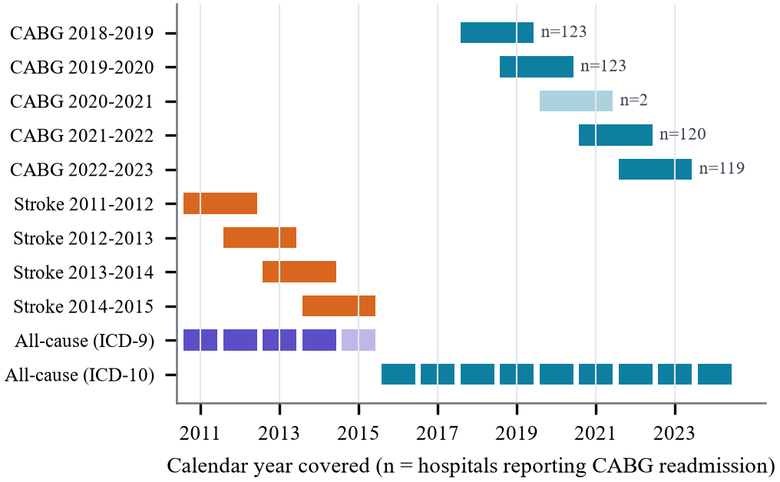
- Reporting periods per source. CABG and stroke windows overlap by one year; the faded 2020–2021 CABG window holds only 2 hospitals; 2015 is a partial ICD-9 year.

Data Preprocessing
Encoding and text. The CABG and stroke files are Windows-1252 encoded. Line breaks inside names, double spaces and typographic dashes were normalised, and the rating typo “Not Appplicable” was fixed. The 127 CABG hospitals appear under 168 name spellings, so the stable facility identifier is the panel key.
Missing and suppressed values. Values reported as “.” or suppressed (e.g., Alpine County 2017) were kept missing and never set to zero. Rates stored as text (“13.80%”) and counts with separators (“1,877,198”) were parsed.
Column transposition. In the 2013–2014 stroke window all 545 rows reported more deaths/readmissions than cases. The two count columns were swapped back; afterwards the observed rates agree with the published risk-adjusted rates as in the other windows.
Coding eras. ICD-9 and ICD-10 rows were combined into one table with an explicit coding-system label and are never pooled without it; 2015 is flagged as partial because ICD-9 ended on 1 October 2015 [12].
Validation. 35 automated checks ran on the raw and cleaned data: 32 passed, 3 produced documented warnings (sparse 2020–2021 window, stroke transposition, small counties) and 0 failed.

Proposed Methodology
The workflow (Fig. 2) is: validation and cleaning, a hospital-by-window panel, temporally aligned transitions, a forward temporal split, model selection inside the training data, a single evaluation on held-out data, and sensitivity analyses.
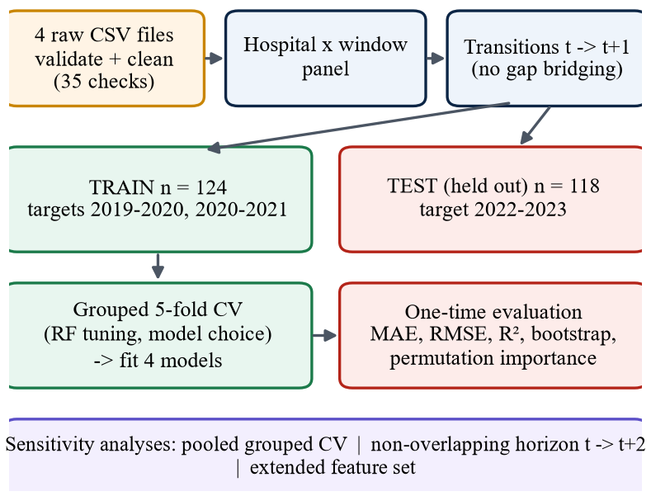
- Training and evaluation workflow. The held-out window is used once.

Temporal Alignment
A transition pairs features from window t with the readmission rate of the same hospital in window t+1 and is created only when the target window starts exactly one year later. Because 2020–2021 is almost empty, the pair 2019–2020 to 2021–2022 is not formed in the main design; it is used only in a separate, labelled non-overlapping design whose horizon is two years. Two transitions out of 2020–2021 were excluded because no post-operative stroke measure was published, leaving 124 training and 118 test transitions.

Features and Target
Table II lists the inputs. Identifiers, names, counties and any target-window field are excluded.
Operative mortality is published for single years only, so it was aligned to the last year of the input window and tested only as an extended-feature sensitivity analysis.
- Model inputs and target (CABG)
Variable | Definition | Unit
prev_readmit_rate | readmission RAAER in window t | %
prev_stroke_rate | post-operative stroke RAAER in window t | %
prev_cabg_volume | hospital CABG cases in window t (log1p in model) | cases
next_readmit_rate | target: readmission RAAER in window t+1 | %

Models and Validation
The baselines are persistence (next = previous) [10] and the training-set mean. The learned models are Linear Regression on standardised inputs and Random Forest [13]. Median imputation, the log transform of volume and scaling are inside scikit-learn pipelines, so they are fitted on training rows only.
Training transitions have targets 2019-2020, 2020-2021 and the test set is the 2022-2023 window. Random Forest hyper-parameters and the recommended model were chosen by hospital-grouped 5-fold cross-validation inside the training set [8], before the test set was used. Differences between models were assessed with a paired bootstrap over test hospitals (2,000 resamples) [14] and explanations use permutation importance on held-out data [15]. Sensitivity analyses repeat grouped cross-validation over all 242 one-step transitions and over 120 non-overlapping transitions.

Novelty
The baseline is the naive assumption that a hospital's rate stays the same. We contribute (1) strict temporal alignment without gap bridging, (2) baseline-first evaluation with paired uncertainty intervals, (3) detection and quantification of the overlapping-window artefact, and (4) a multi-level view that links hospital surgical, hospital stroke and population outcomes without merging incompatible measures. No new algorithm is claimed.

Implementation
The project uses Python with pandas, NumPy, scikit-learn [16], Matplotlib and Plotly, organised as modules for loading, validation, preprocessing, feature alignment, modelling, evaluation and reporting. One command runs the whole pipeline in under a minute and writes processed data, models, metrics and auto-derived findings. A five-page Streamlit dashboard [17] loads the same saved models and verifies that they reproduce the stored test predictions exactly (Fig. 3). A GitHub Actions workflow runs 49 automated tests, the pipeline and report generation on demand. Table III lists model settings.
- Models, search spaces and selected settings
Model | Settings / search space | Selected
Persistence | next rate = previous rate | –
Training mean | mean of training targets | –
Linear Reg. | OLS, standardised inputs | –
Random Forest | 300 trees; depth {3, 5, none}; leaf {5, 10, 20}; features {all, sqrt} | CABG: depth 5, leaf 10, features 1.0; stroke: depth 3, leaf 20, features 1.0

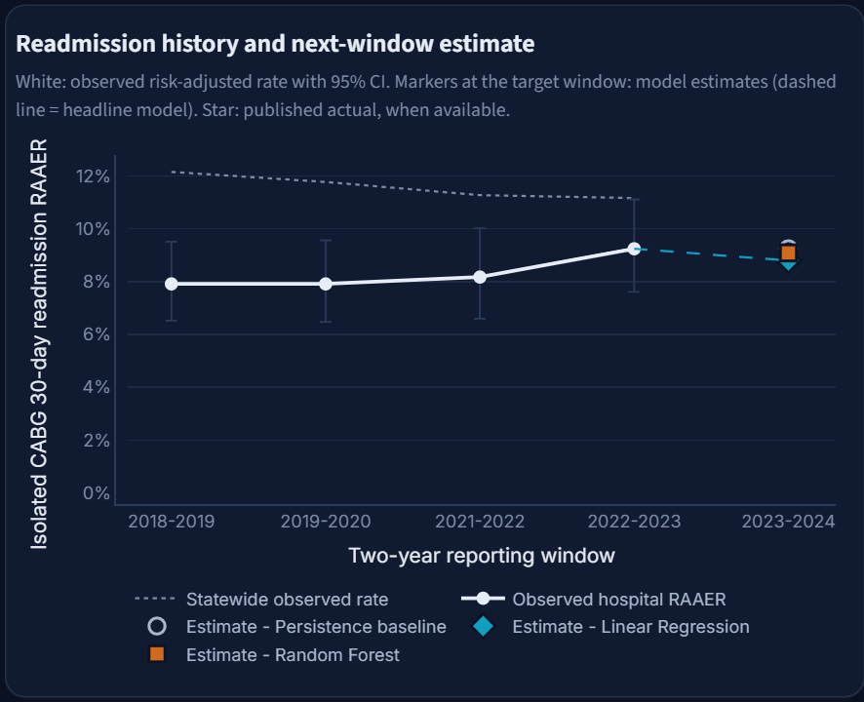
- Dashboard CABG page: a hospital's readmission history with 95% CIs, statewide rate and next-window estimates of all saved models.

Experimental Results

Held-Out Temporal Test
Table IV reports the single evaluation on the 2022-2023 window. Persistence had the lowest MAE (2.487 pp), followed by Linear Regression (2.543) and Random Forest (2.741). All were far better than the training mean (R² -0.030).
- CABG next-window readmission, held-out 2022-2023 (n = 118)
Model | MAE | RMSE | R² | Bias
Persistence | 2.487 | 3.348 | 0.544 | +0.172
Linear Regression * | 2.543 | 3.438 | 0.519 | +0.416
Random Forest | 2.741 | 3.637 | 0.462 | +0.266
Training mean | 3.919 | 5.033 | -0.030 | +0.859

* recommended model, chosen by grouped cross-validation on training data. MAE, RMSE and bias are in percentage points of the readmission rate.

Why Persistence Is Hard to Beat
Consecutive two-year windows share one calendar year of patients, so half of the target already sits in the input. Fig. 4 shows that hospital rates in consecutive windows correlate at r = 0.72, but only r = 0.47 when the windows share no year.
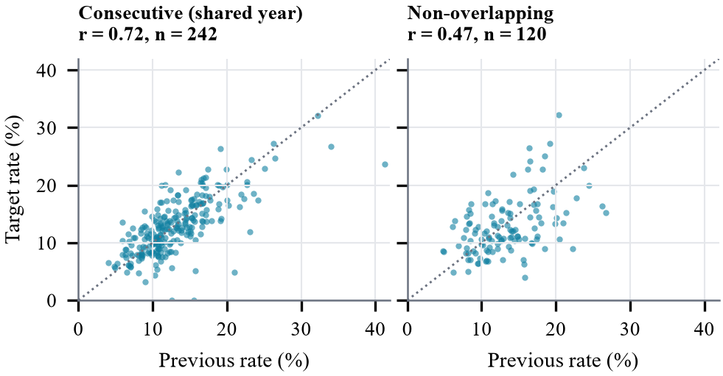
- Previous versus target readmission rate per hospital. Dotted line: persistence.

Non-Overlapping Horizon and Grouped Cross-Validation
Table V and Fig. 5 compare the designs. Across all one-step transitions Linear Regression was slightly better than persistence on average (-0.064 pp; better in 68% of folds). When the overlap is removed, persistence degrades to 3.96 pp (R² -0.19) while Linear Regression (3.52) and Random Forest (3.49) hold up; Linear Regression wins in 88% of folds.
- CABG MAE (pp) across evaluation designs
Design | n | Persist. | Lin. Reg. | Rand. For.
Temporal hold-out | 118 | 2.49 | 2.54 | 2.74
Grouped CV, one-step | 242 | 2.68 | 2.61 | 2.77
Grouped CV, non-overlap | 120 | 3.96 | 3.52 | 3.49

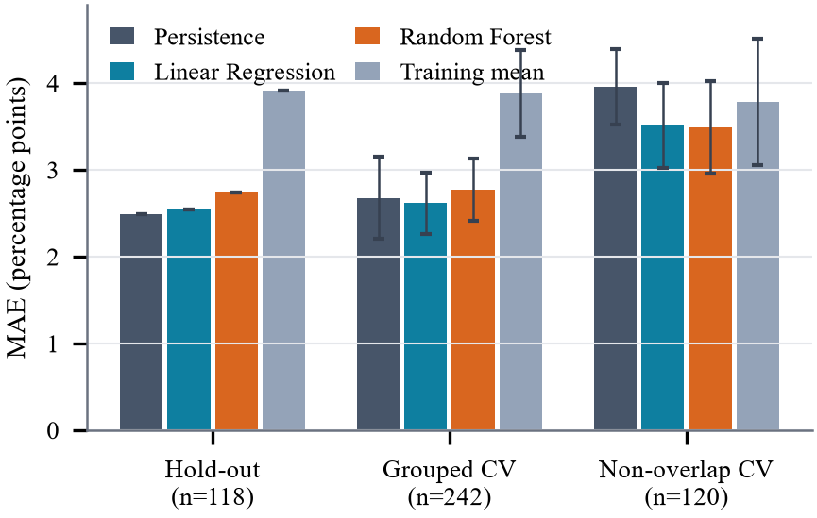
- CABG MAE by model and evaluation design (error bars: SD over 25 grouped folds).
Uncertainty. The paired bootstrap (Fig. 6) gives a Linear Regression minus persistence difference of +0.055 pp (95% CI -0.229 to +0.335) and +0.254 pp for Random Forest (-0.038 to +0.593): on the one-step horizon the evidence is insufficient to name a winner. Adding final-year operative mortality, CABG+valve mortality and expected readmission changed test MAE only to 2.515 (Linear Regression) and 2.861 (Random Forest).
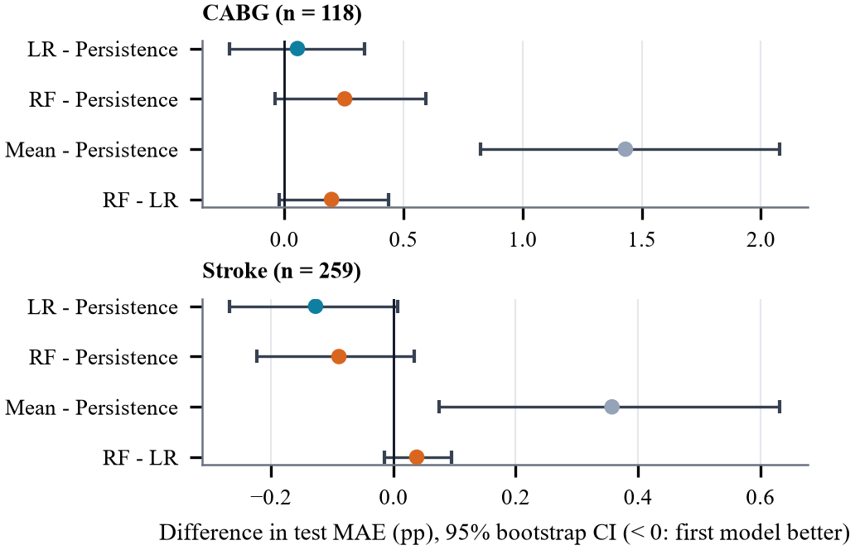
- Paired bootstrap 95% intervals of test-MAE differences for CABG and stroke.

Separate Stroke Model
The stroke data are larger (532 training transitions, 259 test hospitals). Using previous readmission, previous mortality and volume, Linear Regression reduced held-out MAE from 1.981 to 1.853 pp (-6.4%; 95% CI -0.268 to +0.007) and beat persistence in 100% of grouped folds (Table VI).
- Stroke next-window readmission, held-out 2014-2015 (n = 259)
Model | MAE | RMSE | R² | CV MAE
Persistence | 1.981 | 2.760 | 0.138 | 2.073
Linear Regression | 1.853 | 2.453 | 0.319 | 1.839
Random Forest | 1.892 | 2.522 | 0.280 | 1.879
Training mean | 2.338 | 2.982 | -0.007 | 2.453

Comparison with the Baseline
For CABG, Linear Regression changed MAE relative to persistence by +2.2% on the one-step hold-out, -2.4% in pooled grouped CV and -11.2% on the non-overlapping horizon. For stroke the change was -6.4% on the hold-out and -11.3% in grouped CV (non-overlapping: 2.88 vs 2.30). Learned models add value when the target window contains genuinely new patients or when more hospitals are available.

Visual Analysis and Healthcare Insights

Explainability
Permutation importance on the test window (Fig. 7) shows that the previous readmission rate carries almost all signal: shuffling it raises Linear Regression MAE by 1.76 pp, versus 0.13 for volume and 0.00 for post-operative stroke. Standardised coefficients agree: +3.08 pp per SD of previous readmission and -0.75 pp per SD of log volume, so larger programmes are estimated slightly lower, consistent with volume-outcome findings [6] but only an association.
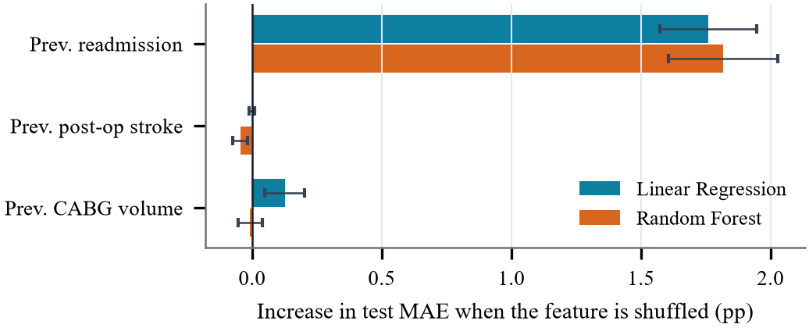
- Permutation importance on held-out CABG hospitals (mean ± SD).
Fig. 8 shows the learned relationship. The Linear Regression line is flatter than the persistence diagonal: a hospital at 20.2% is expected to fall to 17.3%, and one at 8.1% to rise to 10.1%, toward the training mean of 13.3%: regression to the mean [5].
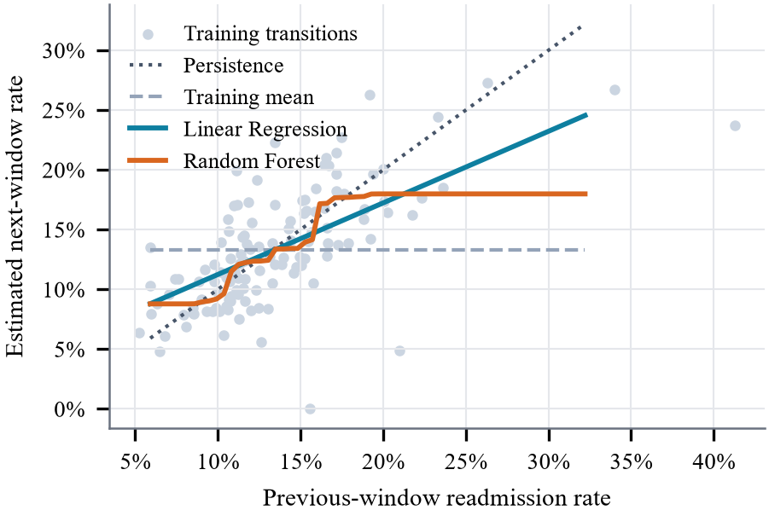
- Estimated next-window rate versus previous rate (other inputs at training medians).

Error Analysis
Errors concentrate in small hospitals (Fig. 9). Linear Regression MAE is 3.35 pp for low-volume, 2.69 pp for medium-volume, 1.57 pp for high-volume hospitals (persistence 3.19 to 1.63), matching the small-sample instability of hospital rates [4].
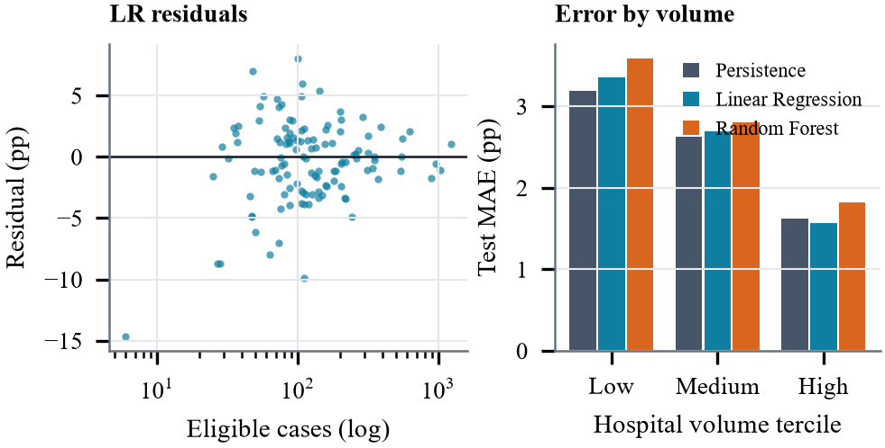
- Linear Regression residuals versus cohort size and test MAE by volume tercile.

Stroke Outcomes
Statewide risk-adjusted stroke readmission fell from 12.80% to 11.80% and mortality from 10.55% to 9.81% between 2011–2012 and 2014–2015. Hospital readmission and mortality were nearly uncorrelated (r from -0.12 to +0.05; Fig. 10), as reported nationally [7].
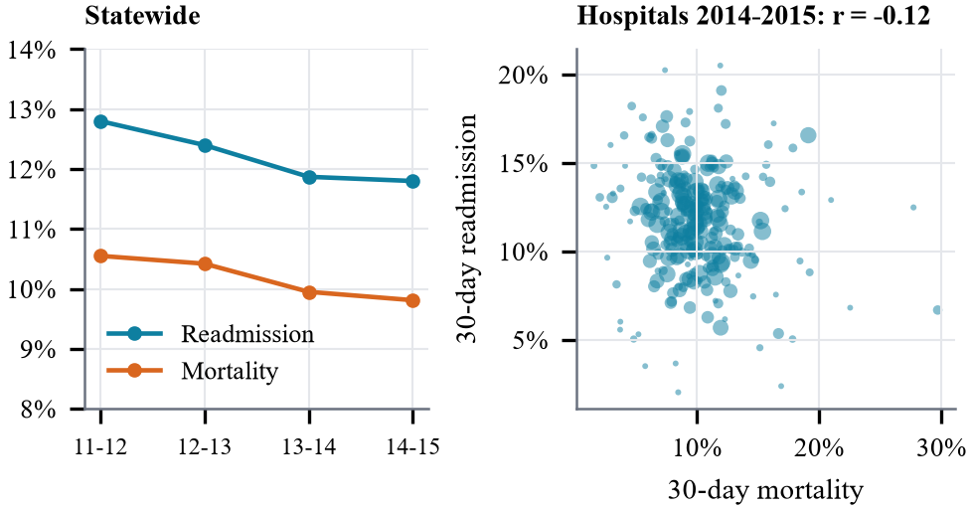
- Ischemic stroke: statewide trends and hospital readmission versus mortality.

Population and County Trends
The statewide all-cause rate was 14.48% in 2016 and 15.95% in 2024 (+1.47 pp; Fig. 11); admissions fell 13.0% from 2019 to 2020, coinciding with the COVID-19 pandemic. Among 50 counties with at least 1,000 admissions, rates ranged from 10.19% (Siskiyou) to 18.78% (Butte) (Fig. 12). By payer, Medicare patients had the highest rate (17.02%) and Self-Pay the lowest (6.98%) (Fig. 13).
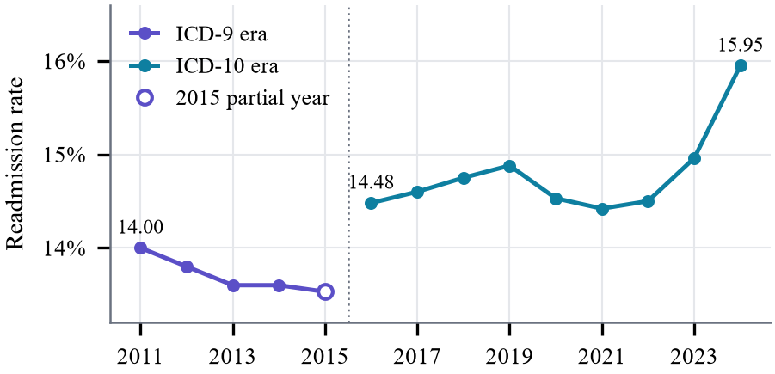
- Statewide all-cause 30-day readmission rate by coding era.
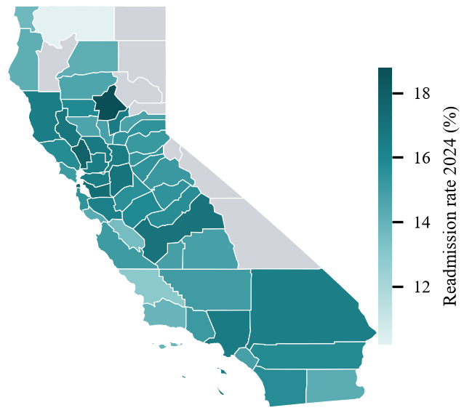
- County readmission rates, 2024 (grey: fewer than 1,000 admissions).
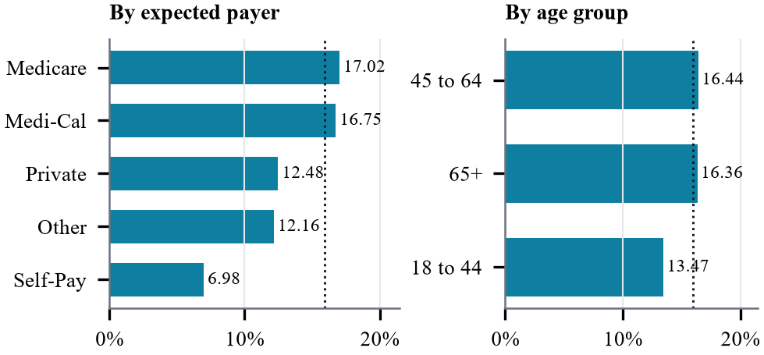
- Readmission rate by expected payer and age group, 2024 (dotted: all patients).

Insights Supported by the Data
- The previous rate dominates every model; volume adds a little and post-operative stroke adds nothing.
- Overlapping windows make persistence look strong (r = 0.72); without overlap the learned models win in 88% of folds.
- Regression to the mean explains the gain: extreme hospitals move part of the way back to the average.
- Small hospitals carry the largest errors (3.35 vs 1.57 pp MAE).
- Stroke readmission and mortality capture different aspects of quality and should be reported side by side.
- Population gaps: Medicare 17.02% vs self-pay 6.98%; ages 45 to 64 16.44% vs 18 to 44 13.47%; African-American 19.51%. These are associations, not causes.

Discussion and Limitations
Why the results look this way. A hospital's next rate is mostly its previous rate plus noise. When the two windows share patients, copying the previous rate is already close to optimal; when they do not, shrinking extreme rates toward the average is better. Random Forest never beat the linear model because the relationship is close to linear and about 120 training rows leave little room for extra flexibility.
Limitations. (1) Only two usable one-step CABG transitions exist and the 2020–2021 window covers two hospitals. (2) Overlapping windows limit how independent any test can be. (3) Rates for small hospitals are noisy and the risk-adjusted outcome is itself an estimate. (4) ICD-9 and ICD-10 eras are not directly comparable. (5) The data are aggregate: estimates are hospital-level rates, not patient probabilities, do not identify causes and are not clinically validated. (6) Group differences must not be read as causal.

Conclusion and Future Scope
Historical hospital performance carries real information about future readmission rates, and learned models that shrink extreme rates outperform persistence when the target window contains new patients or more hospitals are available. For the CABG one-step horizon the published windows overlap and no model reliably beat persistence on held-out data; we report this as a finding rather than hide it. Readmission patterns also differ by condition, county and population group.
Future work includes adding new CABG windows as they are published, hierarchical or empirical-Bayes shrinkage using case counts, calibrated prediction intervals, and linking hospital outcomes to county context only where reporting periods overlap.

Acknowledgment
The authors thank Dr. Prerna Mishra, course instructor, Healthcare Analytics, for guidance. This is a mini-project report; the system estimates hospital-level readmission rates from aggregate public statistics and is not a clinical decision-support tool.

References
- S. F. Jencks, M. V. Williams, and E. A. Coleman, “Rehospitalizations among patients in the Medicare fee-for-service program,” N. Engl. J. Med., vol. 360, no. 14, pp. 1418–1428, 2009.
- C. K. McIlvennan, Z. J. Eapen, and L. A. Allen, “Hospital readmissions reduction program,” Circulation, vol. 131, no. 20, pp. 1796–1803, 2015.
- D. Kansagara et al., “Risk prediction models for hospital readmission: a systematic review,” JAMA, vol. 306, no. 15, pp. 1688–1698, 2011.
- J. B. Dimick, H. G. Welch, and J. D. Birkmeyer, “Surgical mortality as an indicator of hospital quality: the problem with small sample size,” JAMA, vol. 292, no. 7, pp. 847–851, 2004.
- A. G. Barnett, J. C. van der Pols, and A. J. Dobson, “Regression to the mean: what it is and how to deal with it,” Int. J. Epidemiol., vol. 34, no. 1, pp. 215–220, 2005.
- J. D. Birkmeyer et al., “Hospital volume and surgical mortality in the United States,” N. Engl. J. Med., vol. 346, no. 15, pp. 1128–1137, 2002.
- H. M. Krumholz et al., “Relationship between hospital readmission and mortality rates for patients hospitalized with acute myocardial infarction, heart failure, or pneumonia,” JAMA, vol. 309, no. 6, pp. 587–593, 2013.
- D. R. Roberts et al., “Cross-validation strategies for data with temporal, spatial, hierarchical, or phylogenetic structure,” Ecography, vol. 40, no. 8, pp. 913–929, 2017.
- S. Kaufman, S. Rosset, C. Perlich, and O. Stitelman, “Leakage in data mining: formulation, detection, and avoidance,” ACM Trans. Knowl. Discov. Data, vol. 6, no. 4, Art. 15, 2012.
- R. J. Hyndman and G. Athanasopoulos, Forecasting: Principles and Practice, 3rd ed. Melbourne, Australia: OTexts, 2021.
- California Health and Human Services Agency, “CHHS Open Data Portal.” [Online]. Available: https://data.chhs.ca.gov
- U.S. Dept. of Health and Human Services, “Administrative simplification: change to the compliance date for the International Classification of Diseases, 10th Revision (ICD-10-CM and ICD-10-PCS) medical data code sets,” Federal Register, vol. 79, no. 149, p. 45128, Aug. 2014.
- L. Breiman, “Random forests,” Mach. Learn., vol. 45, no. 1, pp. 5–32, 2001.
- B. Efron and R. J. Tibshirani, An Introduction to the Bootstrap. New York, NY, USA: Chapman & Hall, 1993.
- A. Fisher, C. Rudin, and F. Dominici, “All models are wrong, but many are useful: learning a variable's importance by studying an entire class of prediction models simultaneously,” J. Mach. Learn. Res., vol. 20, no. 177, pp. 1–81, 2019.
- F. Pedregosa et al., “Scikit-learn: machine learning in Python,” J. Mach. Learn. Res., vol. 12, pp. 2825–2830, 2011.
- Streamlit, “Streamlit documentation.” [Online]. Available: https://docs.streamlit.io

