BTech Healthcare Analytics - Mini Project Report
Explainable California Hospital Readmission Analytics: CABG Prediction, Stroke Outcome Analysis, and Population-Level Trends
Temporally aligned next-period prediction, stroke outcome analysis and population-level trend analytics with an interactive Streamlit dashboard

Submitted by: [Student name(s) and roll number(s)]
Guide: [Faculty guide name]
Department / Institution: [Department, Institution]
Date: October 2026
Live dashboard: https://<your-app-name>.streamlit.app
Source code: https://github.com/AadityaBhure/HealthCare-Readmission-Analytics

Table of Contents
Abstract 3
1. Introduction and Background 3
2. Problem Statement 3
3. Research Question and Objectives 3
4. Project Scope and Contributions 4
5. Dataset Descriptions and Data Dictionary Summary 4
5.1 Key fields 5
6. Exploratory Data Analysis 5
6.1 Data quality findings 5
6.2 Distributions and trends 6
7. Data Cleaning and Preprocessing Methodology 6
8. Feature Engineering and Temporal Alignment 8
9. Machine Learning Algorithms and Baselines 8
10. Training and Evaluation Methodology 9
11. Comparative Model Performance 9
12. Results and Discussion 10
13. Explainability and Important Features 11
14. CABG Hospital-Level Prediction Analysis 13
15. Stroke Outcome Analysis 14
16. County and Population-Level Trends 15
17. Dashboard Design and Functionality 17
18. GitHub Actions and Streamlit Deployment Architecture 20
19. Synthetic Dataset Testing Methodology 20
20. Limitations, Ethics and Responsible Interpretation 21
21. Conclusion and Future Improvements 21
References 22
Appendix A. Reproducing the Project 23
Appendix B. Run Configuration 23
Appendix C. Validation Checks 23

Abstract
Thirty-day readmission is a widely used indicator of hospital quality, but most student projects predict it from same-period information or from patient-level benchmark data. This project builds an explainable, reproducible analytics framework on four California datasets supplied for the project: hospital-level coronary artery bypass graft (CABG) surgery outcomes (2018-2023), hospital-level ischemic stroke outcomes (2011-2015), county- and population-level all-cause readmissions (2011-2024) and a synthetic CABG test file. The primary experiment estimates each hospital's next reporting-window risk-adjusted isolated CABG 30-day readmission rate from its previous window. Models were trained on 124 hospital transitions and evaluated once on a held-out later window (2022-2023, n = 118 hospitals). A persistence baseline achieved MAE 2.49 percentage points (pp), Linear Regression 2.54 pp and Random Forest 2.74 pp; the bootstrap 95% interval for the Linear Regression minus persistence difference was [-0.23, +0.34] pp, so no model reliably beat persistence on this one-step horizon. We show why: the published two-year windows overlap by one calendar year, inflating window-to-window correlation (r = 0.72 vs 0.47 for non-overlapping windows). On a non-overlapping horizon, persistence error rose to 3.96 pp while Linear Regression achieved 3.52 pp, better in 88% of hospital-grouped cross-validation folds. A separate stroke model with more hospitals reduced error relative to persistence by 6.4% (MAE 1.85 vs 1.98 pp). Population analysis shows the statewide all-cause readmission rate reached 15.95% in 2024, with marked differences by payer, age group and county. Results are delivered through a five-page Streamlit dashboard, a GitHub Actions pipeline and automated tests. All estimates are hospital-level rates, not patient-level probabilities, and are not clinically validated.

1. Introduction and Background
An unplanned readmission within 30 days of discharge is costly for health systems and is often taken as a signal of incomplete recovery, poor care transitions or inadequate follow-up. Large studies of Medicare patients reported that about one in five beneficiaries were rehospitalised within 30 days [1], and readmission rates became the basis of public reporting and financial penalties in the United States [3]. California's Department of Health Care Access and Information (HCAI, formerly OSHPD) publishes risk-adjusted hospital performance reports for selected procedures and conditions and population-level readmission statistics; the datasets analysed here follow those reporting formats.
Predicting readmission is difficult: a systematic review of 26 readmission risk models found most had only modest discrimination [2]. At the hospital level, an additional problem is statistical noise. Rates for low-volume hospitals rest on few patients, so year-to-year changes partly reflect chance [10], and extreme values tend to move back toward the average in the next period - regression to the mean [9]. A credible forecasting project must therefore compare any machine-learning model with simple baselines and must report uncertainty honestly.

2. Problem Statement
Given only information that would have been available at the end of a reporting window, how accurately can we estimate a hospital's risk-adjusted CABG readmission rate in the next window, and does a machine-learning model add value over the naive assumption that the rate stays the same? In parallel, how do readmission patterns differ between a surgical procedure (CABG), a medical condition (ischemic stroke) and the general inpatient population, across counties and population groups?

3. Research Question and Objectives
Research question. Can historical hospital performance help estimate future 30-day readmission rates, and how do readmission patterns differ across clinical conditions, counties, and population groups?
- Audit the four datasets, document their structure, coverage and defects, and build reproducible cleaning code.
- Construct temporally aligned (previous window -> next window) training data without bridging missing periods.
- Compare a persistence baseline, a training-mean baseline, Linear Regression and Random Forest on identical held-out data with leakage-aware validation and uncertainty intervals.
- Explain the models with permutation importance, coefficients, learned response curves and error analysis.
- Analyse ischemic stroke readmission and mortality separately, including a separate temporal model.
- Describe statewide, county and population-group all-cause readmission trends, respecting the ICD-9/ICD-10 break.
- Deliver an interactive, deployable dashboard, an automated pipeline, tests and this report.

4. Project Scope and Contributions
The project does not propose a new algorithm. Its contribution is a healthcare-specific analytical and evaluation workflow:
- Temporal alignment. Each training example pairs inputs from window t with the outcome in window t+1; a transition is created only when the target window starts exactly one year after the input window.
- Baseline-first evaluation. Every model is judged against persistence on the same hospitals, with a paired bootstrap interval for the difference.
- Discovery and correction of a design artefact. The published windows overlap, which flatters persistence; a non-overlapping sensitivity design quantifies this.
- Multi-level view. Hospital surgical outcomes, hospital stroke outcomes and population trends are analysed side by side without merging incompatible measures.
- Transparent delivery. A dashboard that loads exactly the evaluated models (verified by an integrity check), a one-command pipeline, CI workflow and an automated pytest suite.

5. Dataset Descriptions and Data Dictionary Summary
Four CSV files were supplied (Table 1). Their column structures correspond to HCAI public reports distributed through the California Health and Human Services Open Data Portal [19]; the exact download dates were not recorded with the files, so provenance should be confirmed by the project team. The raw files are stored unchanged in data/raw/ and every transformation is applied in code.
Table 1. The four datasets and their roles (computed from the files).
ID | Dataset | Rows | Cols | Coverage | Granularity | Role in project
A | California CABG hospital performance | 1,937 | 20 | 2018-2019, 2023 | Hospital x reporting period x performance measure | Primary supervised ML experiment (next-period isolated CABG readmission rate)
B | California ischemic stroke 30-day outcomes | 2,188 | 10 | 2011-2012, 2014-2015 | Hospital x reporting period x measure (readmission / mortality) | Separate stroke-specific analytics and temporal model
C | California all-cause unplanned 30-day readmissions | 1,057 | 10 | 2011-2024 | Year x stratum x county (strata other than 'Overall' are statewide only) | Population-level trends, county comparison and strata breakdowns
D | Synthetic CABG scenario data | 120 | 10 | synthetic | One synthetic hospital per row | Schema validation, smoke tests and hypothetical scenarios ONLY (never training/evaluation)

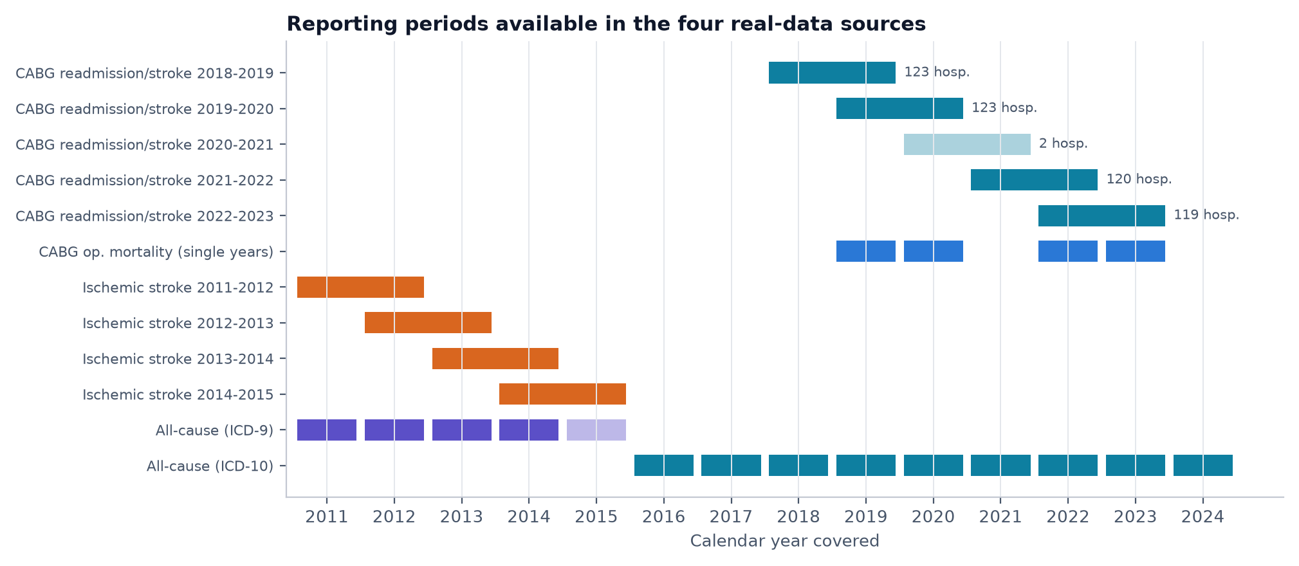
Figure 1. Reporting periods available in each source. CABG readmission and stroke data use overlapping two-year windows; the 2020-2021 CABG readmission window contains only 2 hospitals; all-cause data switch from ICD-9 to ICD-10 after 2015 (2015 is a partial year).

5.1 Key fields
Table 2. Key fields after cleaning. The complete auto-generated dictionary is in DATA_DICTIONARY.md.
Dataset | Field (cleaned name) | Meaning / unit
A | hospital_id | 9-digit facility identifier; stable panel key (127 IDs, many renamed hospitals)
A | period / period_start / period_years | Reporting window, e.g. 2021-2022 (start 2021, 2 years)
A | measure_code | readmission, postop_stroke, iso_mortality (single year), cabg_valve_mortality
A | raaer, raaer_ci_low/high | Risk-adjusted adverse-event rate (%) and 95% CI
A | hospital_cabg_cases, hospital_measure_cases | CABG volume; eligible cases for the measure
B | risk_adjusted_rate, events, cases | Stroke readmission or mortality rate (%), counts
B | rating | Better / As Expected / Worse than expected
C | coding_system | ICD-9 (2011-2015) or ICD-10 (2016-2024)
C | admits, readmits, rate | Index admissions, 30-day readmissions, rate (%)
C | strata / strata_name / county | Overall, Age, Sex, Race-Ethnicity, Expected Payer; county or State
D | prev_readmit_rate, prev_stroke_rate, prev_cabg_volume | Synthetic inputs mapped to the model schema

6. Exploratory Data Analysis

6.1 Data quality findings
- CABG: 1,937 rows, 127 hospital IDs but 168 different name spellings (line breaks inside names, Windows-1252 dashes, rebranding). Eleven CABG+Valve rows report '.' instead of a rate. Readmission coverage: 2018-2019: 123 hospitals; 2019-2020: 123 hospitals; 2020-2021: 2 hospitals; 2021-2022: 120 hospitals; 2022-2023: 119 hospitals.
- Rolling windows: statewide case totals show each two-year window equals the sum of its two single years (e.g. 2019-2020 = 2019 + 2020), so consecutive windows share one calendar year of patients.
- Stroke: in the 2013-2014 window all 545 rows have the '# of Deaths/Readmissions' and '# of Cases' columns transposed (events exceeded cases in every row). After swapping, the observed rates agree with the published risk-adjusted rates as in other periods.
- All-cause: rates are stored as text ('13.80%'), ICD-10 counts contain thousands separators, one county-year is suppressed (Alpine 2017), 'Multiracial' appears from 2019 and 'Unknown County' only in 2019.
- Validation: 32 automated checks passed, 3 produced warnings (documented limitations) and 0 failed.

6.2 Distributions and trends
Figure 2 shows that hospital CABG readmission rates are widely dispersed around the statewide rate, with a long upper tail driven mainly by small hospitals. The statewide observed rate declined from 12.15% (2018-2019) to 11.16% (2022-2023).
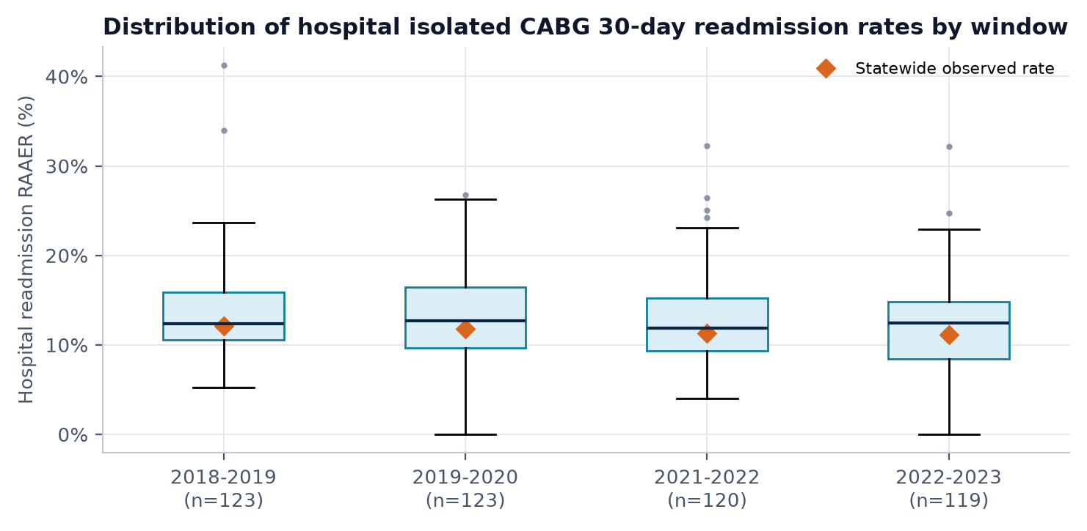
Figure 2. Distribution of hospital risk-adjusted isolated CABG readmission rates per window (boxes: quartiles; diamonds: statewide observed rate). The sparse 2020-2021 window is omitted.
Figure 3 is the most important exploratory result for the modelling design. Rates in consecutive windows correlate at r = 0.72, but only r = 0.47 when the windows do not share a year. Part of the apparent stability is therefore shared data, not persistent hospital performance.
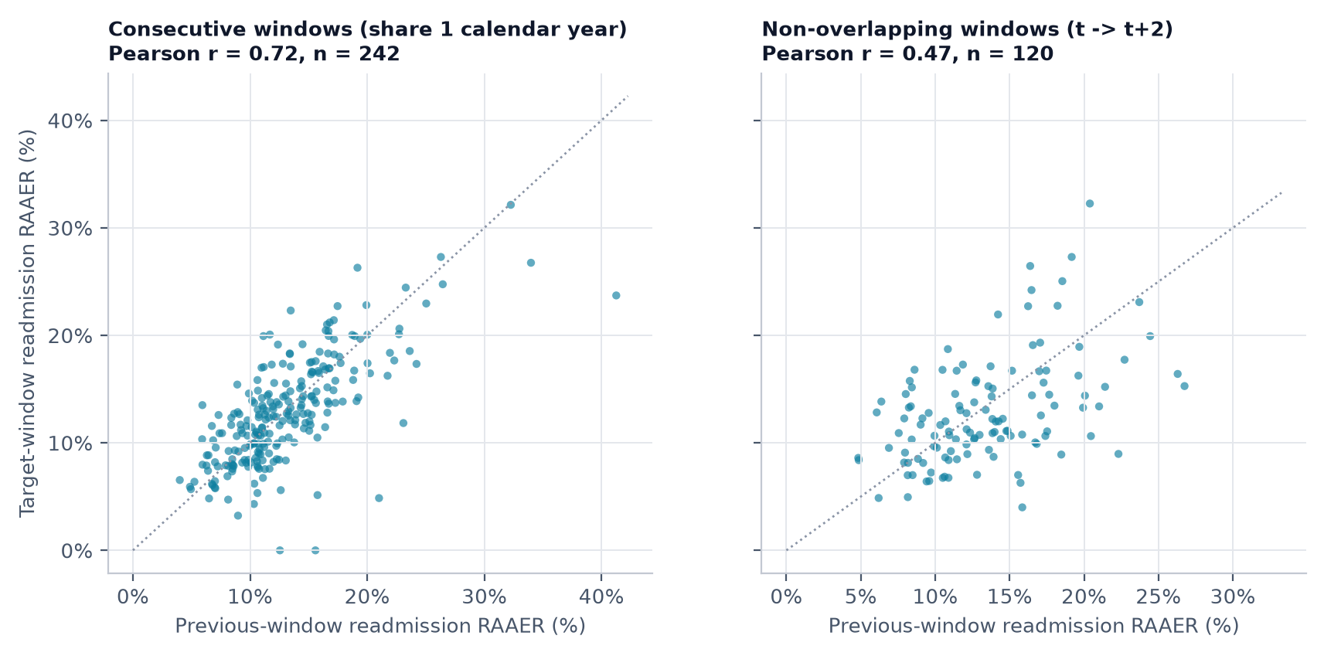
Figure 3. Previous vs next readmission rate for consecutive (overlapping) and non-overlapping window pairs. Dotted line: persistence (next = previous).

7. Data Cleaning and Preprocessing Methodology
Figure 4 summarises the cleaning workflow and Table 3 lists the logged decisions. Three principles were applied throughout: missing or suppressed values remain missing (never zero); raw files are never modified; and each dataset keeps its own tidy table rather than being forced into one master table.
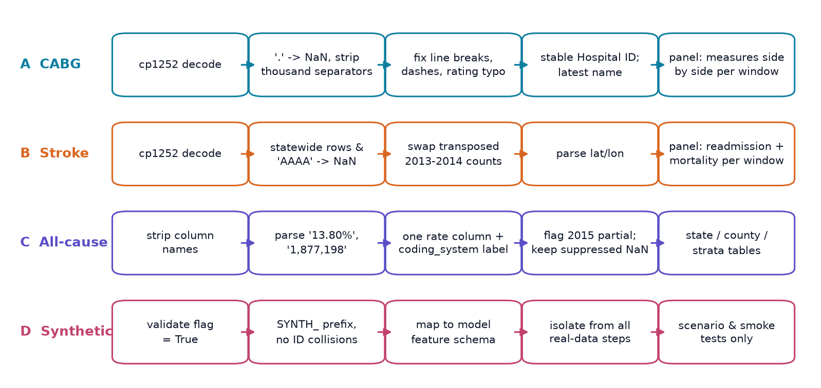
Figure 4. Dataset-specific preprocessing steps implemented in src/preprocessing.py.
Table 3. Preprocessing decisions recorded by the pipeline (artifacts/preprocessing_log.csv).
Dataset | Step | Rows | Decision
cabg | duplicates | 0 | Removed 0 exact duplicate rows
cabg | missing_markers | 11 | Converted '.' (not reported) to NaN in rate/count fields; 11 rows had no RAAER (all 'CABG+Valve Operative Mortality', rating 'Not Applicable'). Missing values were NOT set to 0.
cabg | numeric_parsing |  | Removed thousands separators (e.g. '31,086') and cast counts/rates to float.
cabg | text_normalisation |  | Collapsed embedded line breaks/double spaces in County, Hospital and Rating (e.g. 'San\nBernardino', 'Contra Costa'); mapped Windows-1252 en dashes to '-'; fixed rating typo 'Not Appplicable' -> 'Not Applicable'.
cabg | hospital_identity |  | 168 reported name variants map to 127 stable Hospital IDs; the most recent name per ID is used for display. Hospital ID (not name) is the panel key.
cabg | range_check | 0 | RAAER outside [0, 100] set to NaN: 0 rows
cabg | events_le_cases | 0 | Rows with adverse events > eligible cases: 0
stroke | duplicates | 0 | Removed 0 exact duplicate rows
stroke | statewide_rows | 8 | Identified 8 'Statewide' summary rows; their county placeholder 'AAAA' / blank and ID '.' were set to NaN.
stroke | missing_rates | 10 | 10 hospital-measure rows have no published rate/counts; kept as NaN (not 0).
stroke | column_swap_fix | 545 | Period 2013-2014: 100% of rows had '# of Deaths/Readmissions' > '# of Cases' (impossible). The two count columns are systematically transposed in this period; they were swapped back. Risk-adjusted rates were unaffected. Verified: after the swap the observed rate correlates with the risk-adjusted rate at the same level as in other periods.
stroke | hospital_identity |  | 396 reported names map to 288 OSHPD IDs; most recent name used for display.
stroke | location_parsing |  | Parsed 'Location 1' '(lat, lon)' text into numeric latitude/longitude.
allcause | column_names |  | Stripped trailing spaces from column names (e.g. '30-day Readmits (ICD-9) ').
allcause | duplicates | 0 | Removed 0 exact duplicate rows
allcause | icd_eras |  | ICD-9 fields populated for 375 rows (years 2011-2015); ICD-10 fields for 682 rows (2016-2024). Combined into one tidy table with an explicit 'coding_system' column; the two eras are never pooled without that label.
allcause | rate_parsing |  | Parsed rates such as '14%', '13.80%' into percentage points; removed thousands separators from ICD-10 counts (e.g. '1,877,198').
allcause | suppressed_values | 1 | 1 row(s) report admissions but no readmissions/rate (small-cell suppression, e.g. Alpine 2017); left as NaN.
allcause | transition_year |  | 2015 is the final ICD-9 year. Its statewide admissions are ~25% below the prior year, consistent with ICD-9 coding ending on 1 Oct 2015 (no ICD-10 rows exist for that year in this file). It is flagged 'coding_transition_year' and treated as a partial year.
synthetic | schema_mapping |  | Mapped synthetic columns onto the CABG model feature schema: Previous_CABG_Readmission_Rate_Pct -> prev_readmit_rate, Postoperative_Stroke_Rate_Pct -> prev_stroke_rate, CABG_Case_Volume -> prev_cabg_volume. 'Operative_Mortality_Rate_Pct' has no aligned real-data counterpart in the primary model and is reported but not used.
synthetic | isolation |  | All synthetic rows are tagged is_synthetic=True and are excluded from training, testing and every real-data statistic.

Learned transformations (median imputation, log transform of case volume and standardisation) are part of each scikit-learn Pipeline, so they are fitted on training rows only; a unit test checks that the scaler's means equal the training-set means.

8. Feature Engineering and Temporal Alignment
The CABG panel has one row per hospital and two-year window, with readmission, post-operative stroke and CABG+valve mortality side by side. A transition links window t (inputs) to window t+1 (target) only when the target window starts exactly one year later. Because 2020-2021 is almost empty, the pair 2019-2020 -> 2021-2022 is not created in the main design; it is used only in the explicitly labelled non-overlapping sensitivity design, where the horizon is defined as two years.
Table 4. Features and target for the CABG model. Identifiers, names, counties and any target-window field are excluded.
Name | Definition | Unit | Used in
prev_readmit_rate | Readmission RAAER in the input window | % | Primary + baseline
prev_stroke_rate | Post-operative stroke RAAER in the input window | % | Primary
prev_cabg_volume | Total hospital CABG cases in the input window (log1p inside the model) | cases | Primary
prev_iso_mortality_final_year | Isolated CABG mortality for the final calendar year of the input window | % | Extended (sensitivity)
prev_cabg_valve_mortality_rate | CABG+Valve mortality RAAER (different cohort) | % | Extended (sensitivity)
prev_expected_readmit_rate | Expected readmission rate (case-mix severity) | % | Extended (sensitivity)
next_readmit_rate (target) | Readmission RAAER in the next window | % | Target

Operative mortality is published for single years only, so it cannot be treated as a two-year rate. It is aligned to the final calendar year of the input window and kept out of the primary model; Section 13 reports its effect as a sensitivity analysis. Two transitions out of 2020-2021 were excluded because no post-operative stroke measure was published for that window; 124 training and 118 test transitions remain.

9. Machine Learning Algorithms and Baselines
- Persistence baseline: next rate = previous rate. A standard naive forecast [6]; any useful model must beat it.
- Training-mean baseline: predicts the training-set mean for every hospital; anchors the R² scale.
- Linear Regression: ordinary least squares on standardised inputs. Its slope on the previous rate shows how strongly extreme hospitals are expected to move back toward the average.
- Random Forest [4]: an ensemble of 300 regression trees able to capture non-linearity; hyper-parameters (selected: {'model__min_samples_leaf': 10, 'model__max_depth': 5, 'model__max_features': 1.0}) were tuned by grid search with hospital-grouped 5-fold CV on training data only.
Ridge regression was not added: with three standardised inputs and over a hundred rows the ordinary least squares fit is already stable, so shrinkage would change little. Models were implemented with scikit-learn [5].

10. Training and Evaluation Methodology
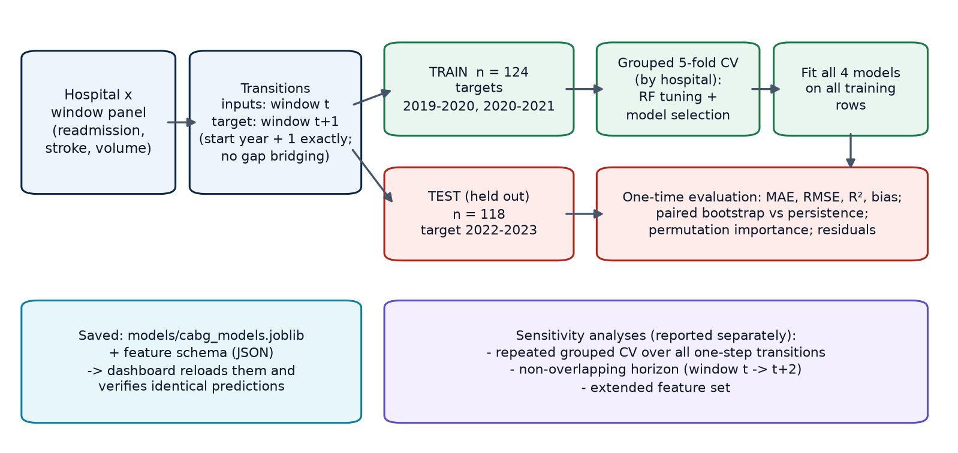
Figure 5. Training and evaluation workflow. The held-out window is used once, after model selection.
Table 5. Evaluation designs and sample counts (CABG).
Design | Data | Rows | Purpose
Temporal hold-out (primary) | train targets 2019-2020, 2020-2021; test target 2022-2023 | 124 / 118 | Realistic forward evaluation; one-shot test
Grouped CV within training | hospital-grouped 5-fold, 3 repeats | 124 | RF tuning and choice of recommended model
Pooled grouped CV | all valid one-step transitions, 5-fold x 5 repeats | 242 | Stability across hospitals
Non-overlapping horizon | window t -> t+2 (no shared calendar year) | 120 | Removes the overlap artefact
Extended features | same temporal split, 6 inputs | 124 / 118 | Value of mortality and case-mix inputs

Grouped cross-validation ensures that no hospital appears in both a training and a validation fold, which is necessary when the same hospital contributes several rows [7]. Metrics are mean absolute error (MAE), root mean squared error (RMSE), R² (relative to the evaluation-set mean, so it can be negative) and mean bias, all in percentage points (pp) of the readmission rate. Differences between models are assessed with a paired bootstrap over test hospitals (2,000 resamples) [8]. The recommended model was chosen before looking at the test window: Linear Regression had the lowest grouped-CV MAE within the training data.

11. Comparative Model Performance
Table 6. CABG next-window readmission: performance on the held-out 2022-2023 window (pp; lower MAE/RMSE is better).
Model | MAE | RMSE | R² | Bias | Train n | Test n | MAE vs persistence
Training-mean baseline | 3.919 | 5.033 | -0.030 | +0.859 | 124 | 118 | +57.6%
Persistence baseline | 2.487 | 3.348 | 0.544 | +0.172 | 124 | 118 | +0.0%
Linear Regression (recommended) | 2.543 | 3.438 | 0.519 | +0.416 | 124 | 118 | +2.2%
Random Forest | 2.741 | 3.637 | 0.462 | +0.266 | 124 | 118 | +10.2%

Table 7. Pooled hospital-grouped CV over all 242 one-step transitions (5 folds x 5 repeats).
Model | MAE (mean ± SD) | RMSE (mean ± SD) | R² (mean ± SD) | Folds
Training-mean baseline | 3.878 ± 0.499 | 4.930 ± 0.648 | -0.031 ± 0.030 | 25
Persistence baseline | 2.678 ± 0.475 | 3.665 ± 0.724 | 0.382 ± 0.291 | 25
Linear Regression | 2.615 ± 0.350 | 3.503 ± 0.559 | 0.453 ± 0.202 | 25
Random Forest | 2.769 ± 0.359 | 3.663 ± 0.568 | 0.406 ± 0.210 | 25

Table 8. Non-overlapping horizon (window t -> t+2, n = 120), hospital-grouped CV.
Model | MAE (mean ± SD) | RMSE (mean ± SD) | R² (mean ± SD) | Folds
Training-mean baseline | 3.784 ± 0.725 | 4.888 ± 0.958 | -0.050 ± 0.094 | 25
Persistence baseline | 3.959 ± 0.437 | 4.918 ± 0.491 | -0.194 ± 0.552 | 25
Linear Regression | 3.515 ± 0.490 | 4.412 ± 0.685 | 0.114 ± 0.200 | 25
Random Forest | 3.492 ± 0.536 | 4.381 ± 0.706 | 0.121 ± 0.234 | 25

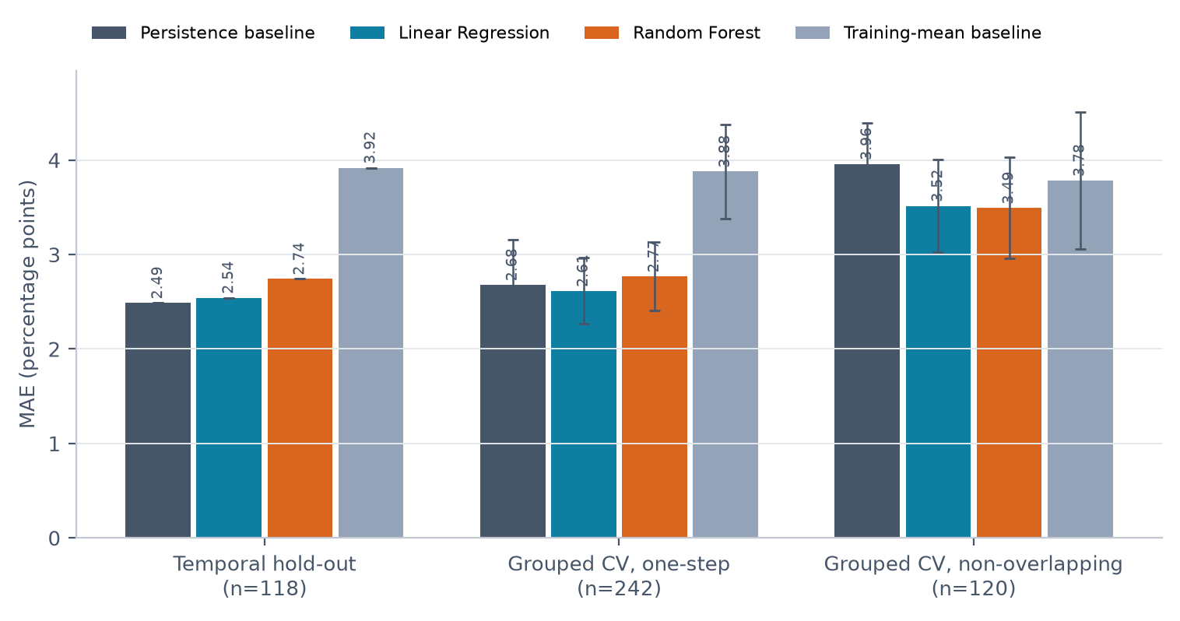
Figure 6. CABG MAE by model across the three evaluation designs (error bars: SD over 25 grouped-CV folds).
Table 9. Paired bootstrap of test-set MAE differences for CABG (negative = first model more accurate).
Comparison | MAE difference | 95% CI | P(first better) | Relative change
Linear Regression - Persistence baseline | +0.055 | [-0.229, +0.335] | 36% | +2.2%
Random Forest - Persistence baseline | +0.254 | [-0.038, +0.593] | 5% | +10.2%
Training-mean baseline - Persistence baseline | +1.432 | [+0.825, +2.080] | 0% | +57.6%
Random Forest - Linear Regression | +0.198 | [-0.020, +0.439] | 4% | +7.8%

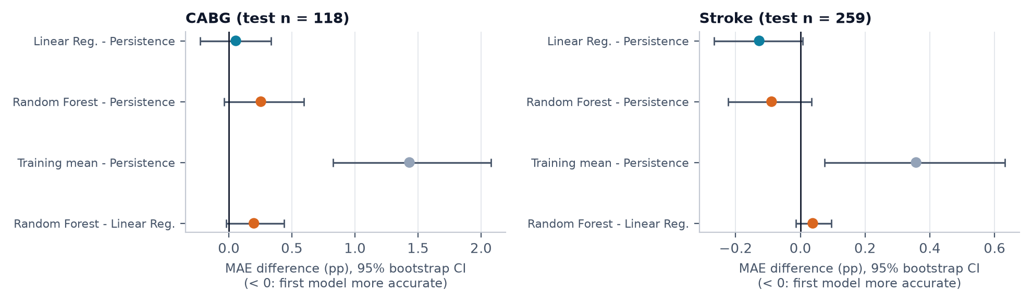
Figure 7. Paired bootstrap 95% intervals of MAE differences for the CABG and stroke hold-out sets.

12. Results and Discussion
Primary result. On the held-out window, persistence achieved the lowest MAE (2.487 pp), followed by Linear Regression (2.543 pp) and Random Forest (2.741 pp). Linear Regression is statistically indistinguishable from persistence (difference +0.055 pp, 95% CI [-0.229, +0.335]), and Random Forest is statistically indistinguishable from it ([-0.038, +0.593]). The evidence is therefore insufficient to name a reliable winner for the one-step horizon; all three are far better than the training-mean baseline (MAE 3.919 pp, R² -0.030).
Why persistence is hard to beat here. Consecutive two-year windows share a calendar year, so half of the target already sits inside the input. Across all one-step transitions (pooled grouped CV) Linear Regression was slightly better than persistence on average (-0.064 pp, better in 68% of folds). When the overlap is removed, persistence degrades sharply (MAE 3.96 pp, R² -0.19) while Linear Regression (3.52 pp) and Random Forest (3.49 pp) hold up; Linear Regression is better in 88% of folds. The learned models help most when the future is genuinely new information, because they shrink extreme rates toward the average.
Random Forest vs Linear Regression. The forest never outperformed the linear model. With 124 training rows and one dominant input, the relationship is close to linear and the extra flexibility mostly fits noise; grid search accordingly chose shallow, heavily regularised trees.
Extended features. Adding final-year operative mortality, CABG+valve mortality and expected readmission rate changed the Linear Regression test MAE from 2.543 to 2.515 pp and Random Forest from 2.741 to 2.861 pp. Given the bootstrap uncertainty of about ±0.3 pp, these inputs do not add reliable predictive value, which supports keeping the simpler primary model.
Should the results be trusted? The test set is a single later window of about 120 hospitals, the outcome is itself an estimate with wide confidence intervals for small hospitals, and only one year separates train and test targets. The results are a fair, leakage-free comparison but not proof of performance in future years.
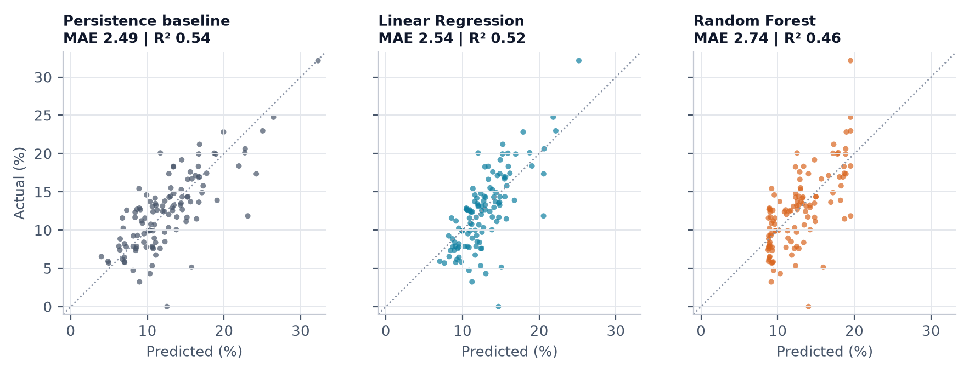
Figure 8. Actual vs predicted next-window CABG readmission rates on the held-out window.

13. Explainability and Important Features
Permutation importance on the test window (Figure 9) shows that the previous readmission rate carries almost all predictive signal: shuffling it raises Linear Regression MAE by 1.76 pp, whereas shuffling case volume raises it by 0.13 pp and post-operative stroke by -0.00 pp [12]. The standardised Linear Regression coefficients agree: +3.08 pp per standard deviation of previous readmission and -0.75 pp per standard deviation of log case volume, i.e. larger programmes are estimated to have slightly lower future rates, consistent with the volume-outcome literature [11] but only an association here.
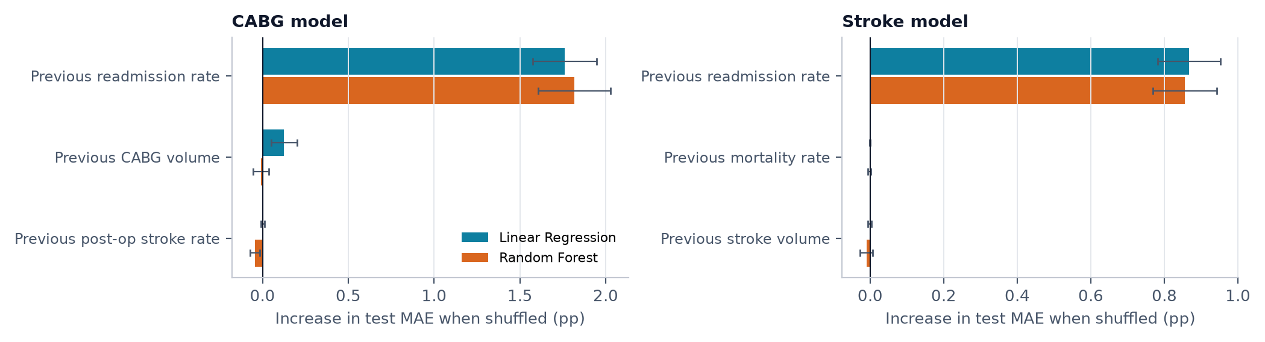
Figure 9. Permutation importance (increase in test MAE when a feature is shuffled; mean ± SD).
Figure 10 shows the learned relationship. The Linear Regression line is flatter than the persistence diagonal: a hospital with an unusually high or low rate is expected to move part of the way back toward the state average in the next window - regression to the mean [9].
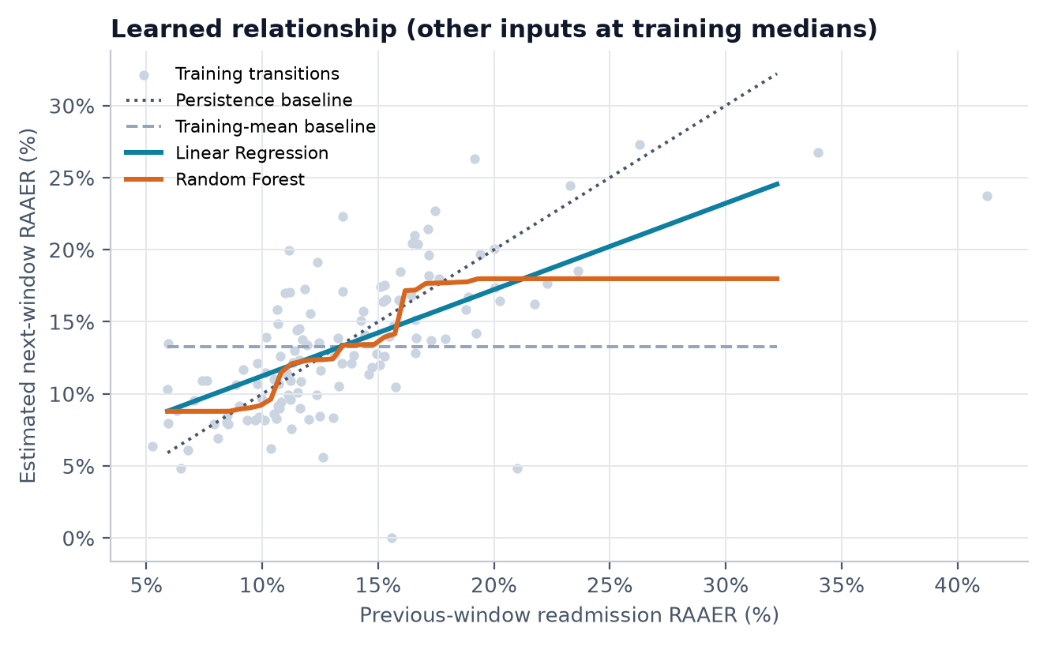
Figure 10. Estimated next-window rate as a function of the previous rate (other inputs at training medians).
Errors are concentrated in small hospitals (Figure 11): Linear Regression MAE is 3.35 pp for low volume hospitals, 2.69 pp for medium volume hospitals, 1.57 pp for high volume hospitals. This is expected because a rate based on a few dozen patients is very noisy [10].
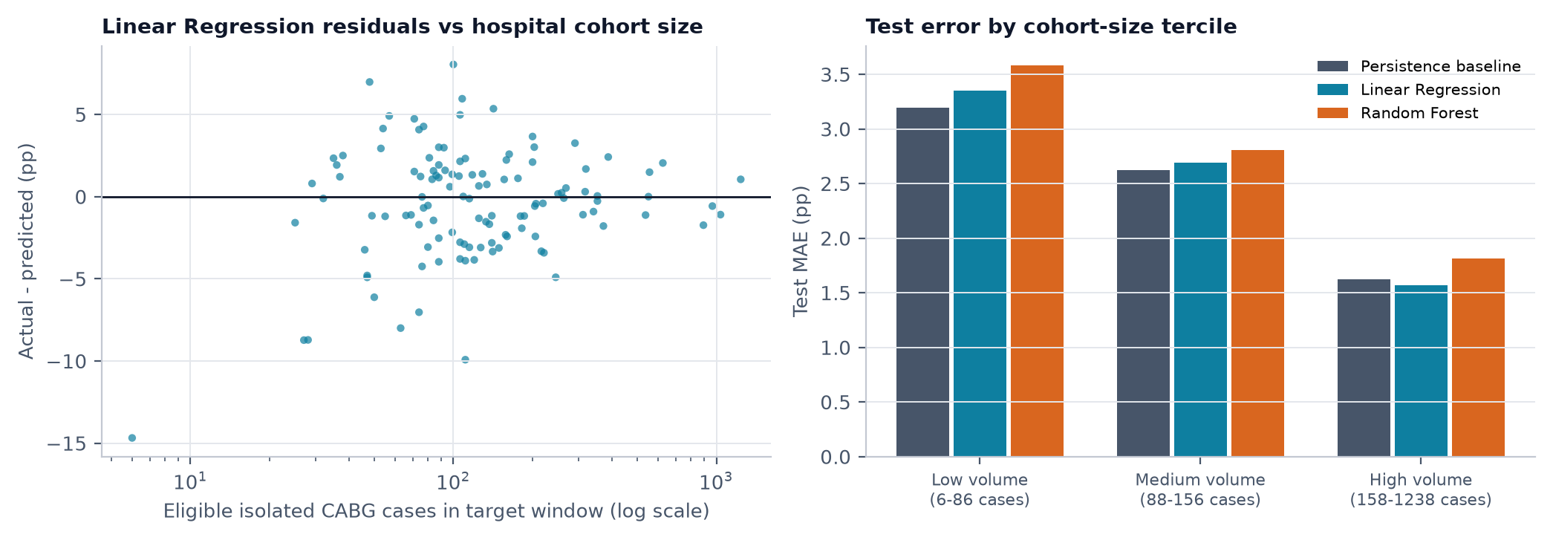
Figure 11. Residuals vs target-window cohort size and test MAE by cohort-size tercile.

14. CABG Hospital-Level Prediction Analysis
Figure 12 applies the evaluated models to the four highest-volume hospitals in the test set. For each, the inputs come from 2021-2022 only; the published 2022-2023 value was hidden from the models. In the dashboard, the same view is available for every hospital and window, labelled as an in-sample back-test, an out-of-sample back-test or a forward estimate for 2023-2024, together with the statewide benchmark (the statewide observed rate for the target window, or the latest published rate when the target is not yet available).
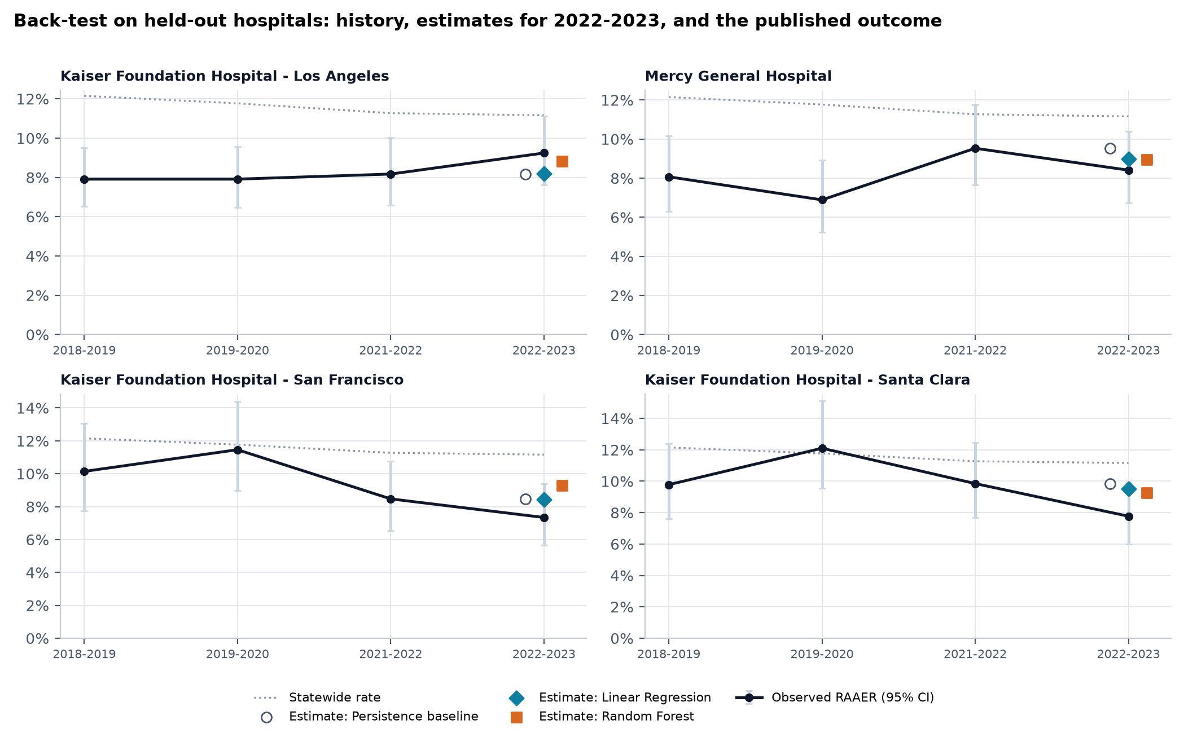
Figure 12. Historical readmission RAAER (95% CI), statewide rate, model estimates for 2022-2023 and the published outcome (last observed point) for the four largest test-set hospitals.
Interpretation. An estimate such as '8.8%' means the model expects about 8.8% of that hospital's eligible isolated CABG patients in the next window to be readmitted within 30 days after risk adjustment. It is not the probability that any individual patient will be readmitted, and it does not identify causes.

15. Stroke Outcome Analysis
Statewide risk-adjusted ischemic stroke readmission fell from 12.80% (2011-2012) to 11.80% (2014-2015) and mortality from 10.55% to 9.81% (Figure 13). Across 288 hospitals, readmission and mortality were nearly uncorrelated (r from -0.12 to +0.05), matching national findings that the two measures rank hospitals differently [13]. Mortality and readmission describe different patients: those who die cannot be readmitted.
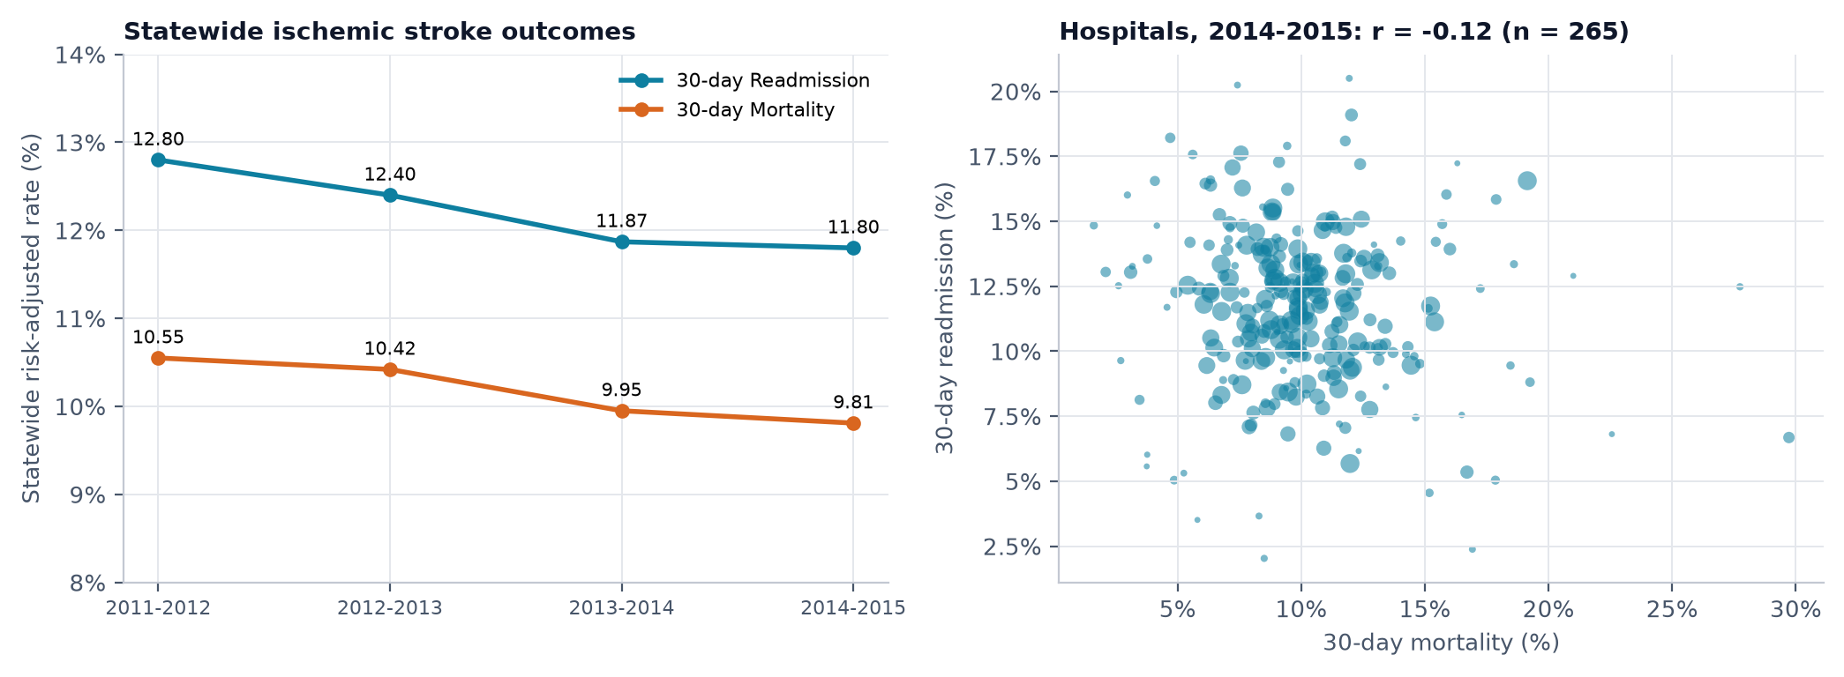
Figure 13. Statewide stroke outcomes and hospital readmission vs mortality in the latest window.
Because the stroke data are larger (532 training transitions, 259 test hospitals), a separate model was trained with the same protocol (inputs: previous readmission rate, previous mortality rate, previous case volume). Linear Regression reduced test MAE from 1.981 to 1.853 pp (-6.4%; 95% CI [-0.268, +0.007] pp). In pooled grouped CV it beat persistence in 100% of folds and on the non-overlapping horizon persistence MAE rose to 2.88 pp vs 2.30 pp. With more hospitals, the benefit of shrinkage becomes visible even on the overlapping horizon. Previous mortality added no predictive value.
Table 10. Stroke next-window readmission: held-out 2014-2015 window (pp).
Model | MAE | RMSE | R² | Bias | Train n | Test n | MAE vs persistence
Training-mean baseline | 2.338 | 2.982 | -0.007 | +0.243 | 532 | 259 | +18.0%
Persistence baseline | 1.981 | 2.760 | 0.138 | +0.021 | 532 | 259 | +0.0%
Linear Regression (recommended) | 1.853 | 2.453 | 0.319 | -0.137 | 532 | 259 | -6.4%
Random Forest | 1.892 | 2.522 | 0.280 | -0.097 | 532 | 259 | -4.5%

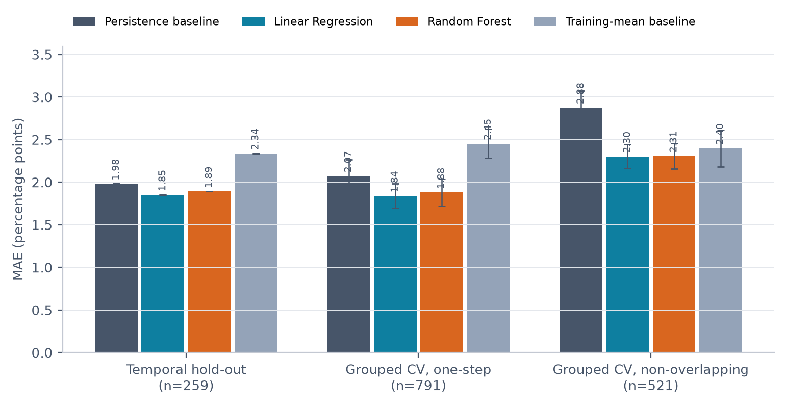
Figure 14. Stroke model MAE across evaluation designs.
The stroke data (2011-2015) do not overlap in time with the CABG data (2018-2023) and concern a different condition, so they were not used to test the CABG model.

16. County and Population-Level Trends
The statewide all-cause 30-day readmission rate (Figure 15) was 14.48% in 2016, the first ICD-10 year, and 15.95% in 2024 (+1.47 pp). The ICD-9 years (2011-2015) are plotted as a separate series because the coding change, effective 1 October 2015 [14], can shift case definitions. Admissions fell 13.0% from 2019 to 2020, coinciding with the COVID-19 pandemic.
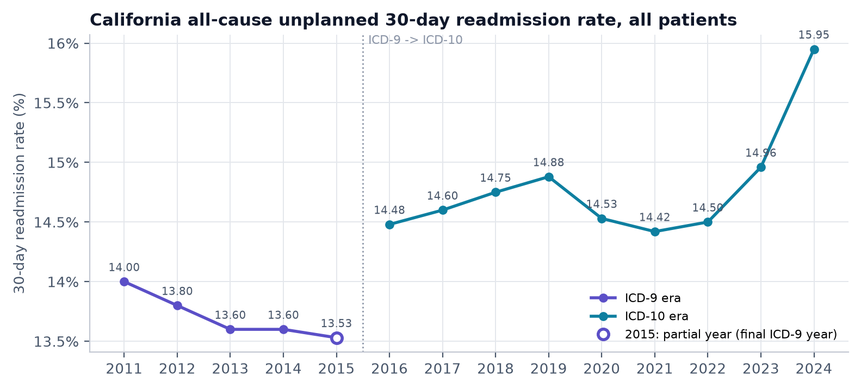
Figure 15. Statewide all-cause 30-day readmission rate by coding era.
Among 50 counties with at least 1,000 admissions in 2024, rates ranged from 10.19% (Siskiyou) to 18.78% (Butte); 8 smaller counties were not ranked because their rates are unstable (Figures 16 and 17).
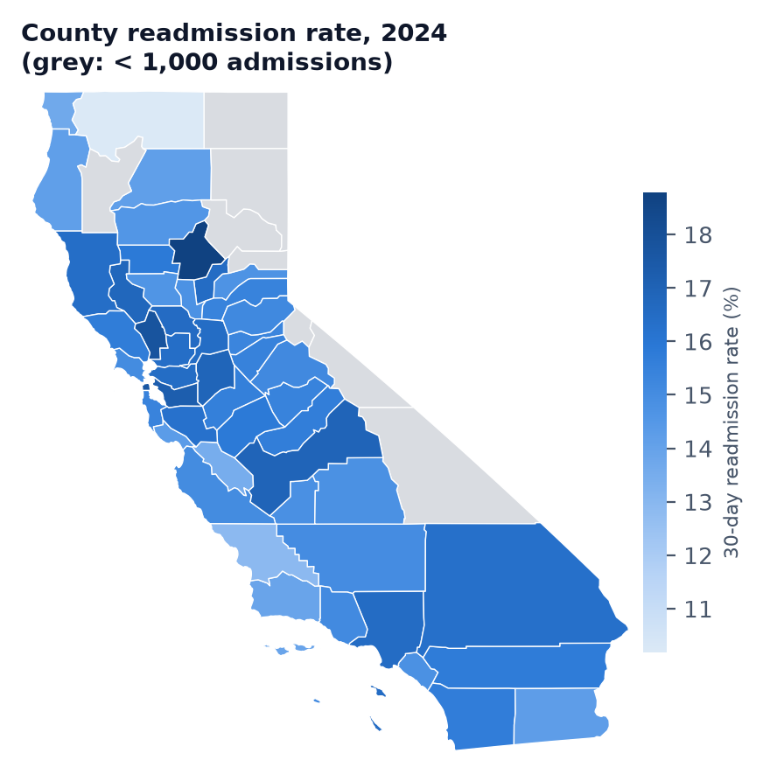
Figure 16. County all-cause readmission rates (counties below the admissions threshold in grey).
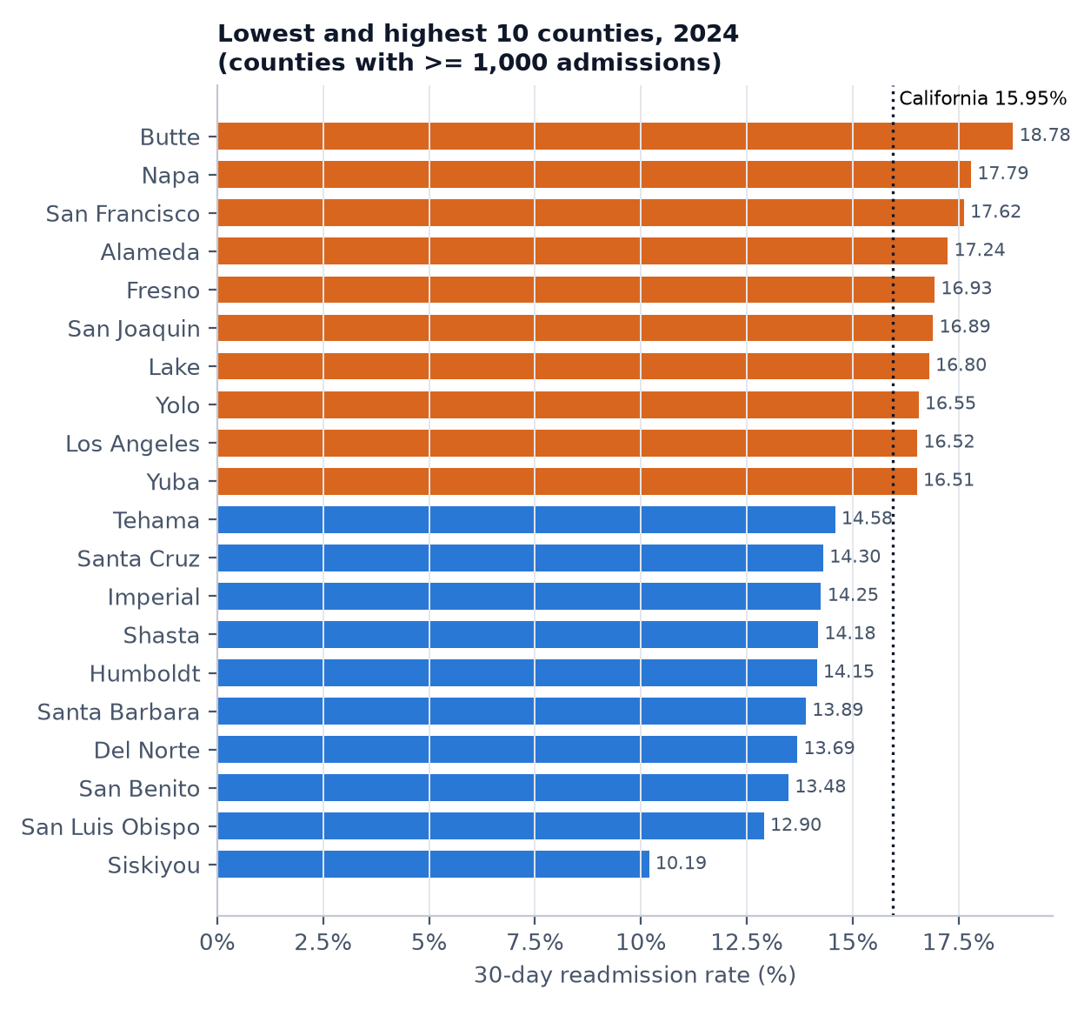
Figure 17. Lowest and highest ten counties by readmission rate.
By expected payer, MediCare patients had the highest rate (17.02%) and Self-Pay the lowest (6.98%); by age, 45 to 64 years had the highest (16.44%) and 18 to 44 years the lowest (13.47%) (Figure 18). These differences describe who is readmitted; they reflect differences in health status, insurance and access and do not show that any characteristic causes readmission.
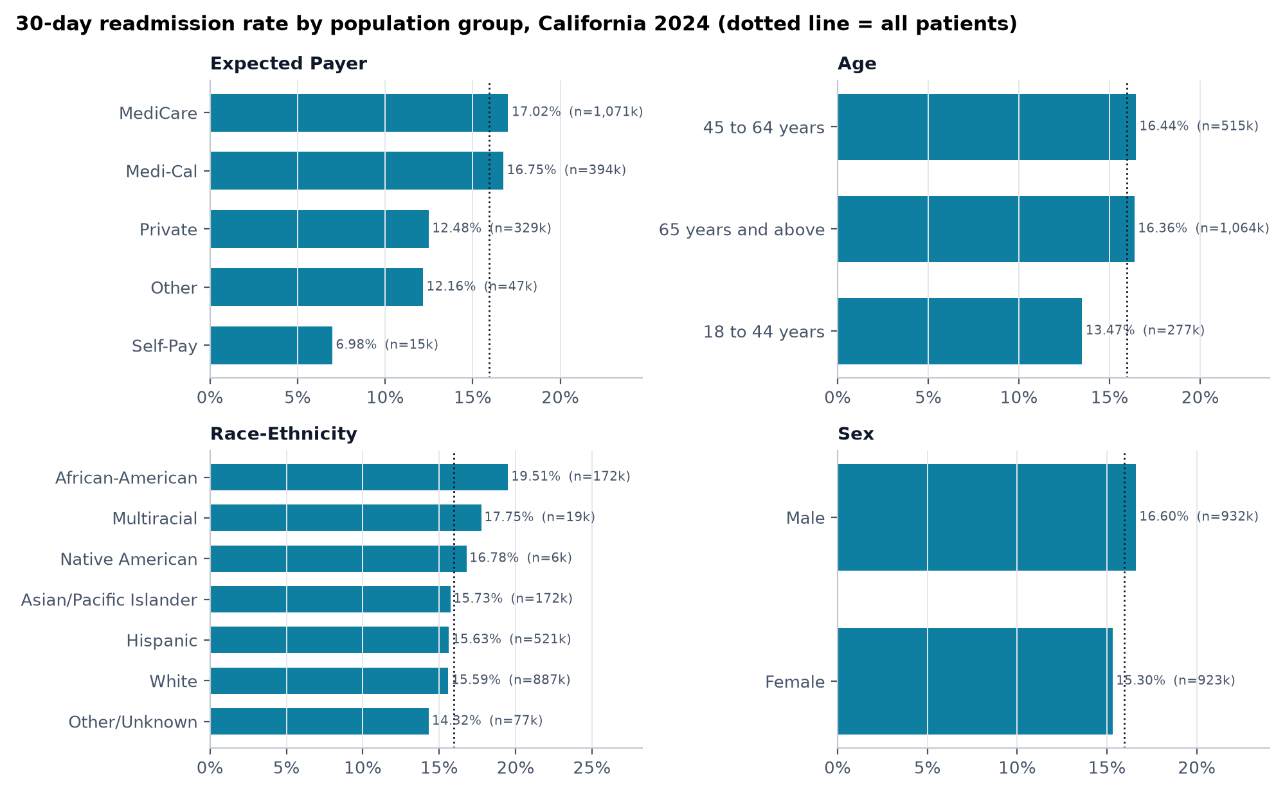
Figure 18. Readmission rate by population group, 2024.

17. Dashboard Design and Functionality
The dashboard (Streamlit [15] with Plotly [16]) uses a dark navy and cyan theme, a left navigation sidebar, a filter bar above each page's charts, KPI cards with units and comparison periods, and interactive charts with tooltips. The categorical palette was checked for colour-vision-deficiency separation, colours follow entities (each model and coding era keeps its colour) and every chart avoids dual axes. Only measures that exist in the data are shown; KPIs from the reference images that the data cannot support (length of stay, satisfaction, patient-level counts) were deliberately omitted.
Table 11. Dashboard pages.
Page | Main content
1 California Overview | KPIs per data source, statewide trend, coverage timeline, condition trends, auto-derived findings, model summary, data-quality indicators
2 CABG Hospital Prediction | Searchable hospital and window selectors, history with CIs, live estimates from all saved models, benchmark, LR contribution chart, volume, statewide position, hospital map; separate hypothetical scenario tab with extrapolation warnings
3 Ischemic Stroke Analytics | Window/measure/county filters, statewide trends, ranked hospitals coloured by rating, readmission vs mortality scatter, county comparison, hospital explorer, stroke model summary
4 Population & County Trends | Year, threshold, group and county filters, county choropleth, ranking, county trends, strata bars, admissions/readmissions, small multiples, data notes
5 Model Evaluation & Testing | Methodology, comparison tables, design comparison, bootstrap intervals, actual vs predicted, residuals, error by size, importance, learned curve, validation checks, preprocessing log, synthetic tests

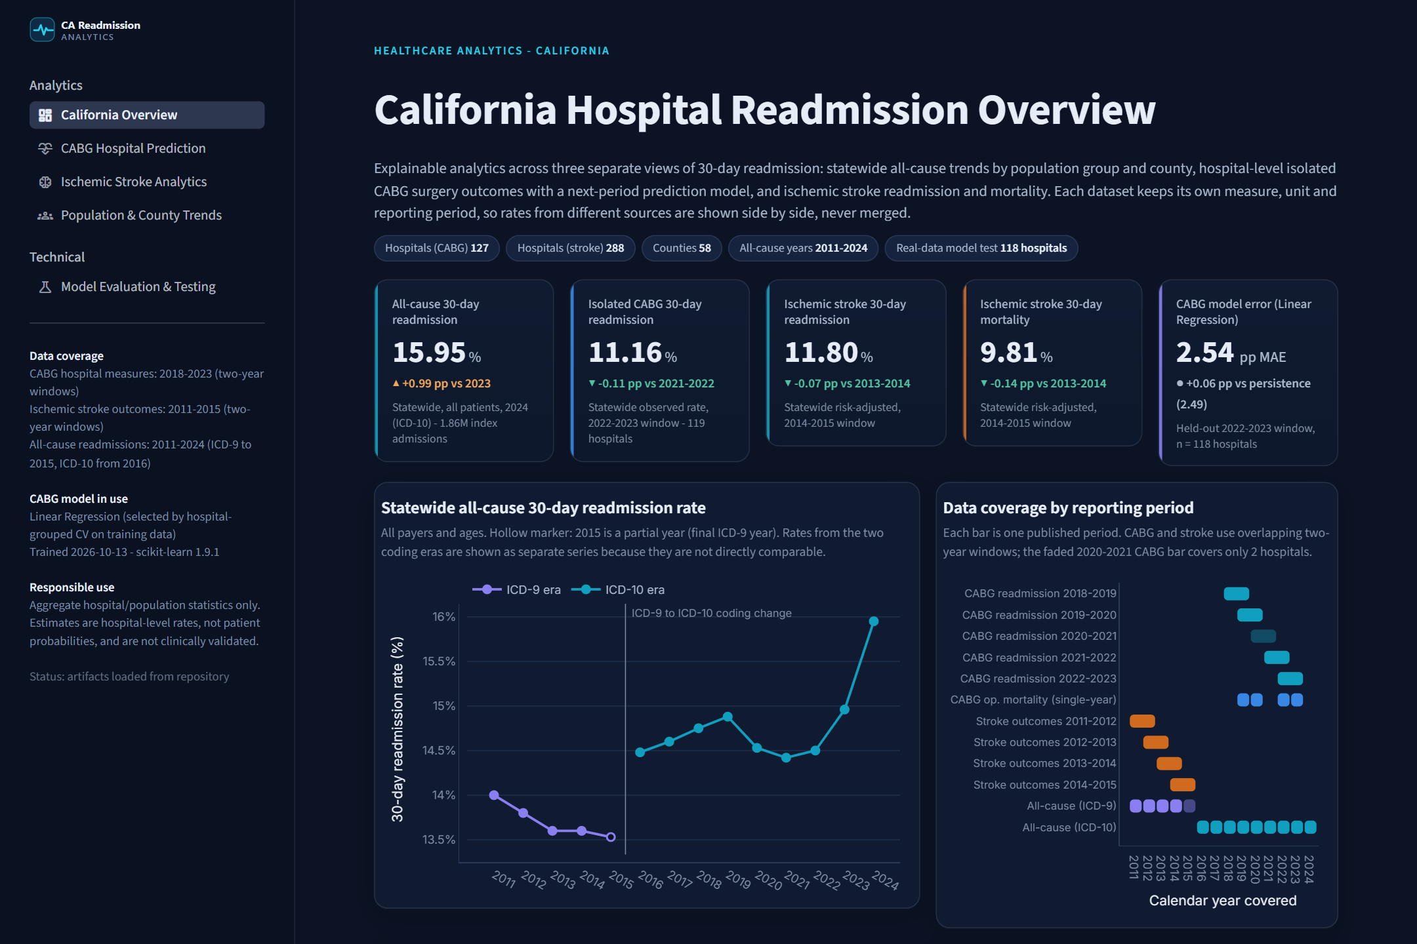
Figure 19. Dashboard page 1 - California Overview (screenshot of the running app).
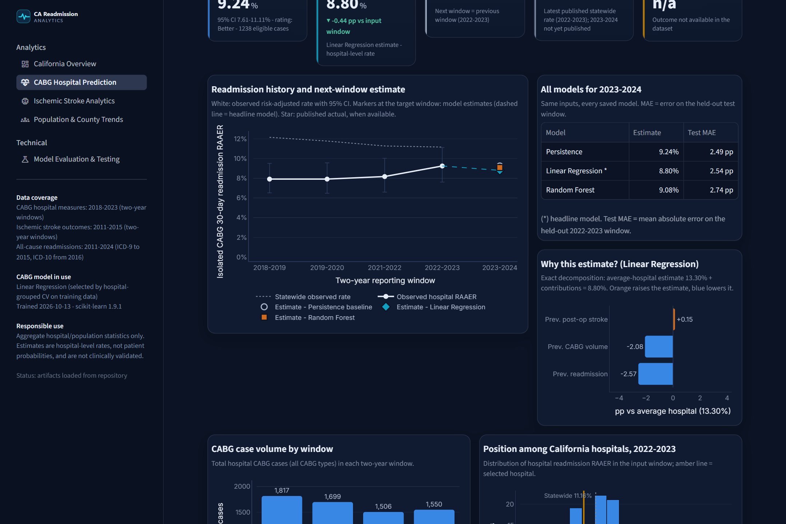
Figure 20. Dashboard page 2 - CABG hospital history, model estimates and Linear Regression explanation.
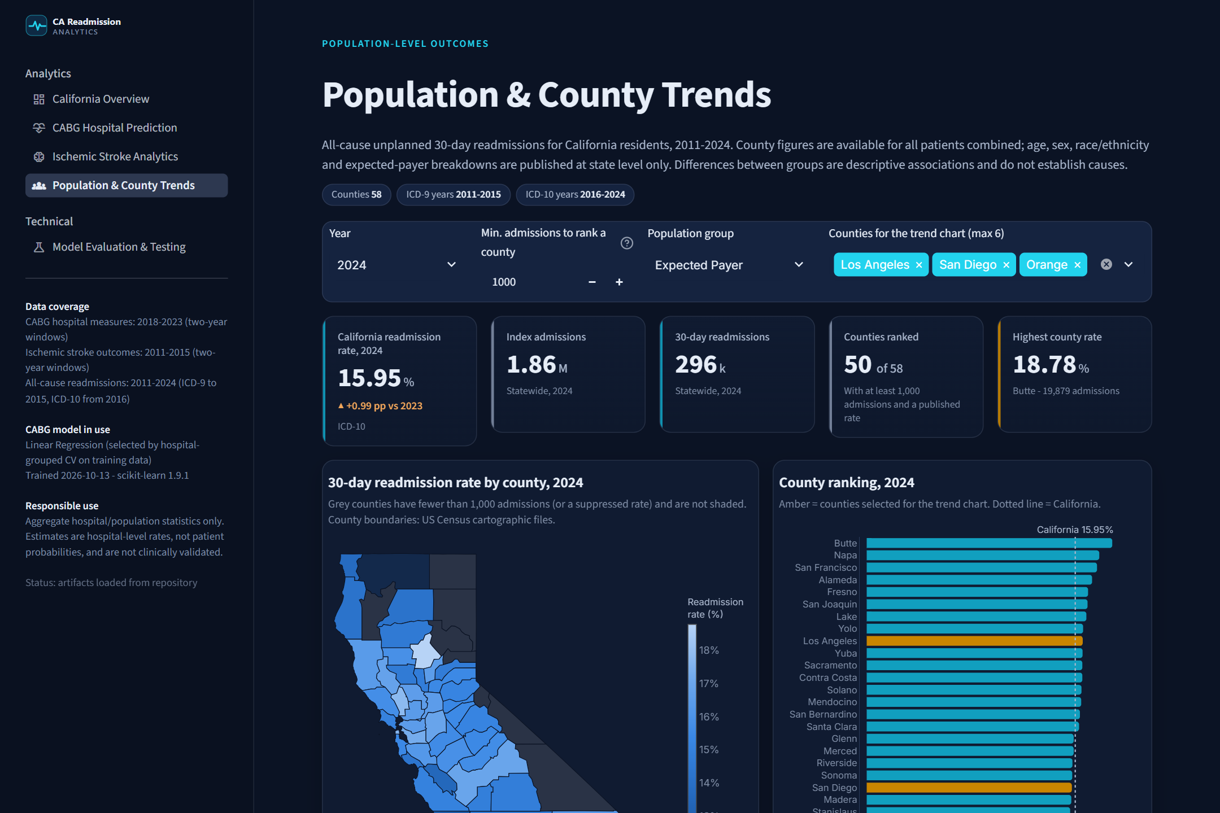
Figure 21. Dashboard page 4 - Population & County Trends with county choropleth.
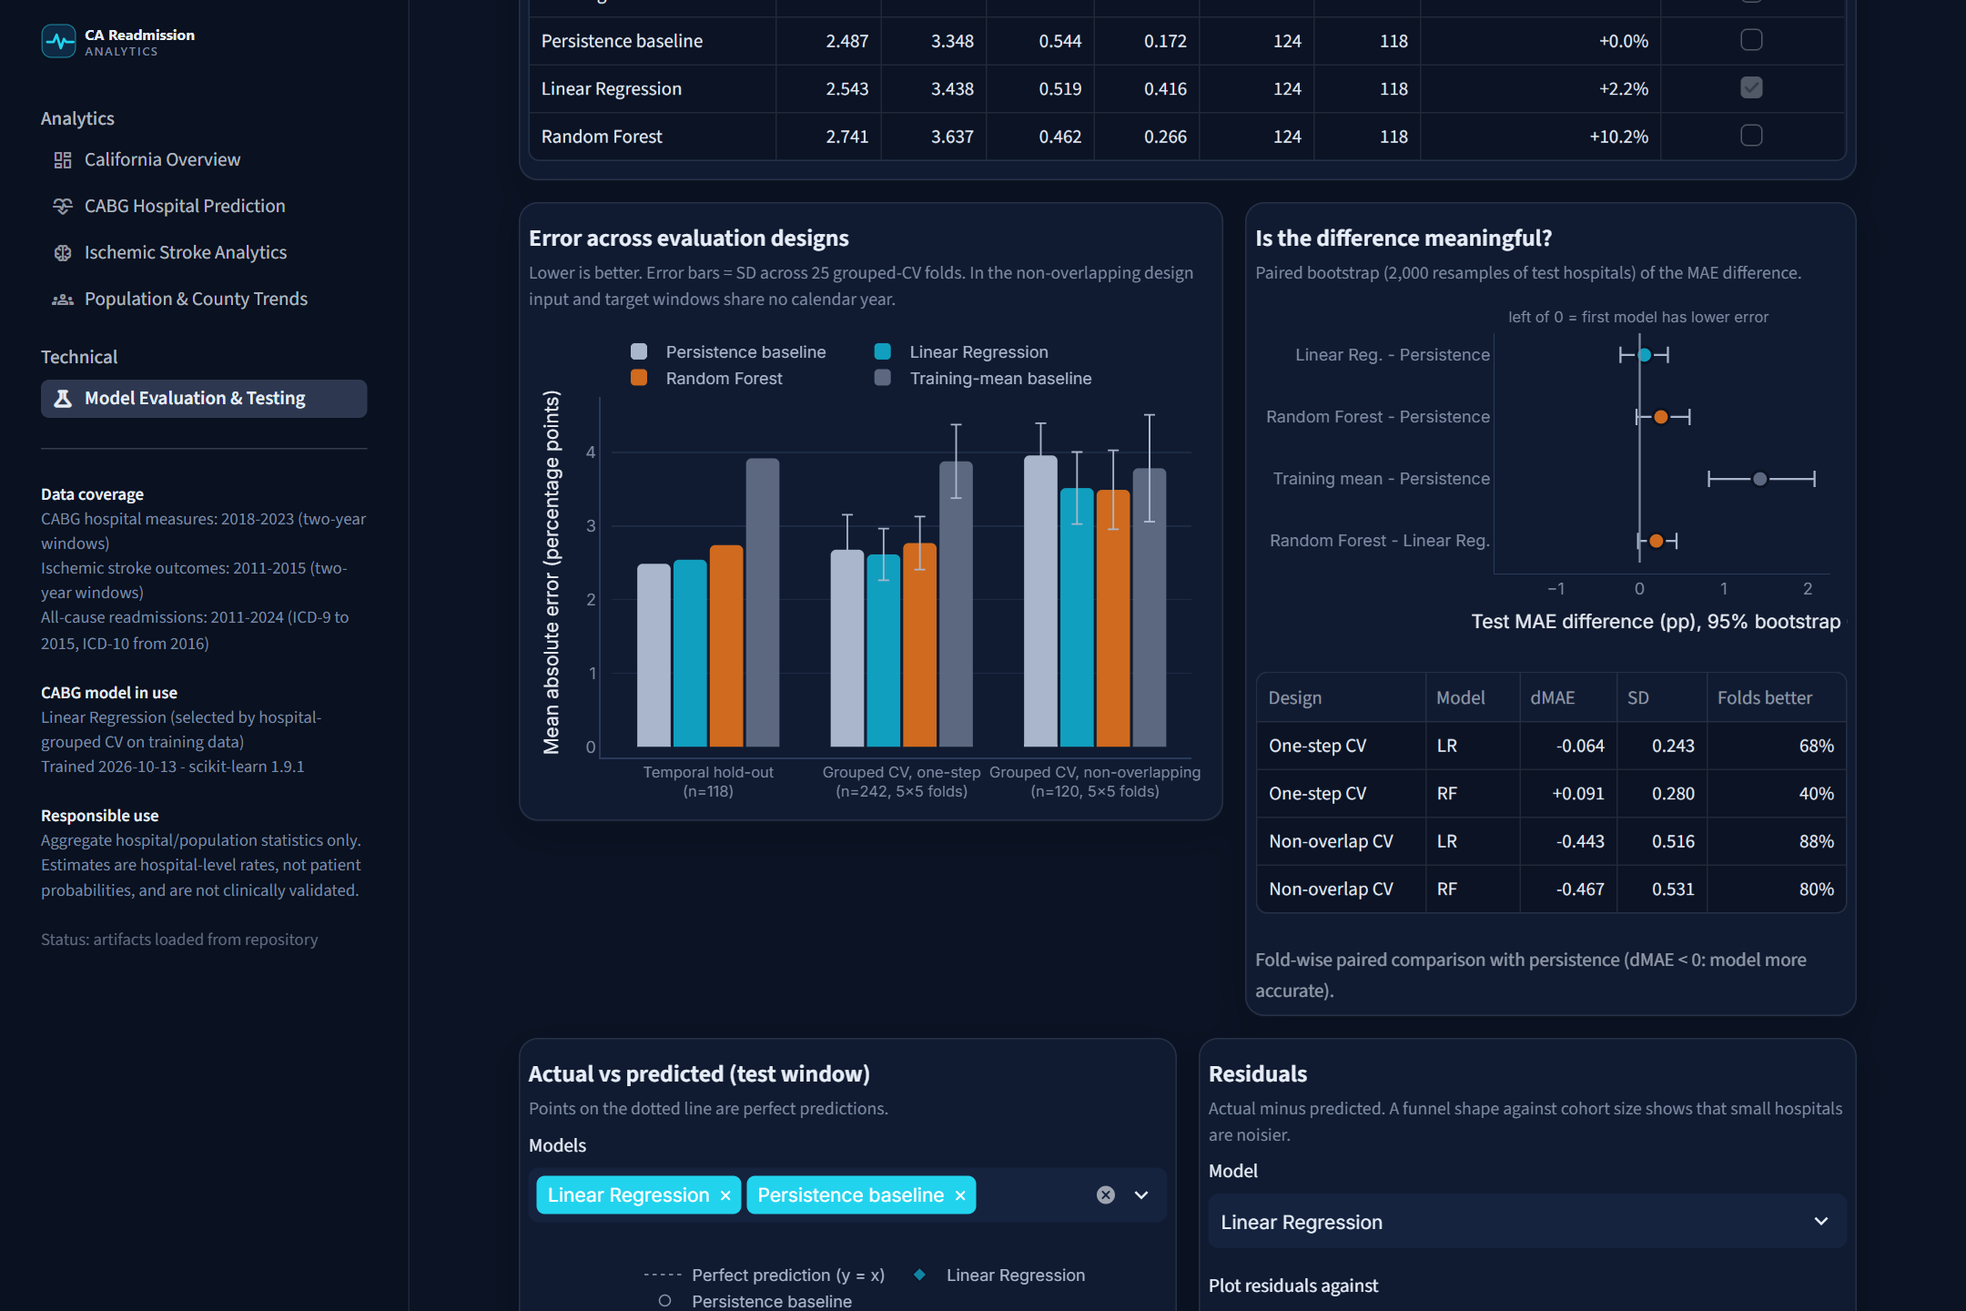
Figure 22. Dashboard page 5 - Model evaluation across designs and bootstrap intervals.

18. GitHub Actions and Streamlit Deployment Architecture
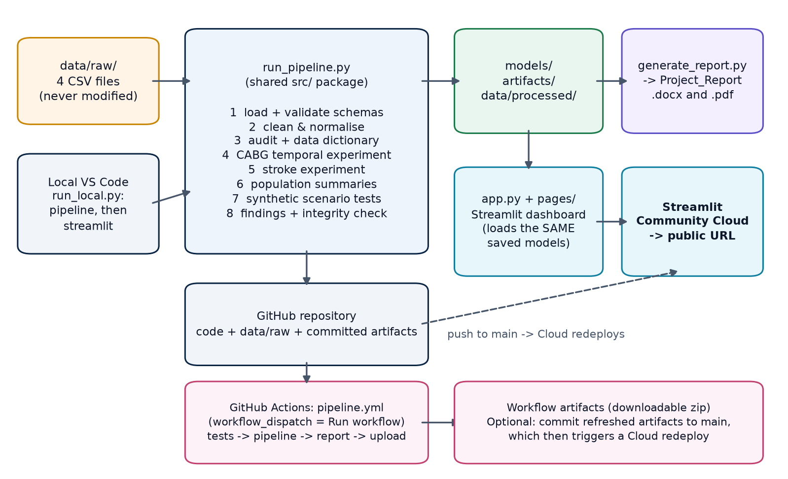
Figure 23. Project architecture: one shared code base for the local pipeline, CI and the deployed dashboard.
- Local: run_pipeline.py writes processed data, models and artifacts; app.py starts the dashboard; run_local.py does both.
- Repository: raw CSVs (about 0.7 MB in total), code, trained models and artifacts are committed, so Streamlit Community Cloud can serve the dashboard immediately from a public URL without any download by the viewer. If artifacts are missing, the app runs the pipeline once at start-up.
- GitHub Actions (pipeline.yml): a manually triggered (workflow_dispatch) workflow installs dependencies, checks that required files exist, runs the test suite and the pipeline, regenerates this report and uploads outputs as workflow artifacts. Optionally it commits refreshed artifacts to the main branch, and Streamlit Community Cloud redeploys on that push. The workflow and the website are separate services; the workflow does not 'open' the website.
- Integrity: the dashboard re-predicts the stored test set with the loaded models; the check passed (maximum difference 0).

19. Synthetic Dataset Testing Methodology
The 120 synthetic CABG records (all flagged synthetic, IDs prefixed SYNTH_) were mapped onto the model's feature schema and passed through the saved models. Checks: schema mapping, finite predictions within 0-100%, deterministic output and range checks (2 record(s) had an input outside the real training range and are flagged as extrapolations). The synthetic 'Operative_Mortality_Rate_Pct' column was not used because the primary model has no aligned counterpart.
Table 12. Agreement with synthetic labels - a consistency check only, NOT evidence of real-world accuracy.
Model | MAE vs synthetic labels | R² vs synthetic labels
Training-mean baseline | 2.892 | -0.000
Persistence baseline | 2.605 | 0.223
Linear Regression | 1.959 | 0.473
Random Forest | 2.237 | 0.359

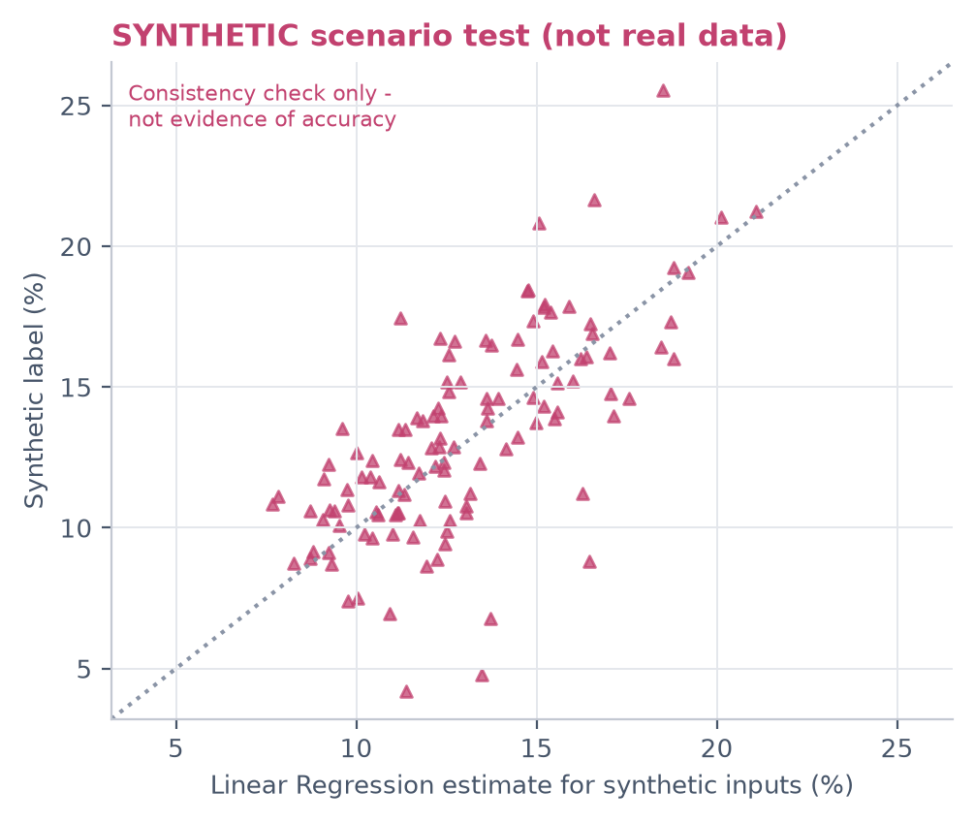
Figure 24. Synthetic scenario test, clearly separated from real-data evaluation.
Synthetic records were never used for training, model selection or any real-data statistic. Their labels come from an unknown generating process, so agreement with them only shows that the pipeline runs consistently on schema-compatible inputs.

20. Limitations, Ethics and Responsible Interpretation
- Aggregate data only. No patient records were used; estimates are hospital-level rates, not individual probabilities, and cannot identify causes of readmission.
- Short and overlapping history. Only two usable one-step CABG transitions exist (2018-2019 -> 2019-2020 and 2021-2022 -> 2022-2023); the 2020-2021 window covers 2 hospitals. Overlapping windows inflate apparent stability.
- Small samples. Many hospitals have fewer than 100 eligible cases per window, giving wide confidence intervals; errors concentrate in these hospitals.
- Outcome is an estimate. Risk-adjusted rates depend on the publisher's risk model; changes in that model over time are not visible in the data.
- Coding change. ICD-9 and ICD-10 eras are not directly comparable; 2015 is partial.
- Associations are not causes. Differences between payers, age groups, races or counties reflect many factors and must not be read as causal or used to stigmatise groups.
- Not clinically validated. The dashboard is an educational analytics tool, not a medical decision-support system.
- Provenance. Dataset download dates and licences should be confirmed by the project team before redistribution.

21. Conclusion and Future Improvements
Historical hospital performance does carry information about future readmission rates: the previous rate dominates every model, and learned models that shrink extreme rates toward the average outperform the naive persistence assumption whenever the future window contains genuinely new patients (non-overlapping CABG horizon, and the larger stroke dataset). For the CABG one-step horizon, however, the published windows overlap, and on the held-out window no model reliably beat persistence; this is reported as a finding rather than hidden. Readmission patterns differ by condition (CABG and stroke rates both declined over their periods), by county and by population group, while stroke readmission and mortality capture different aspects of quality.
Future work: add newer CABG windows as they are published to obtain more independent test periods; model the uncertainty of each hospital's rate explicitly (e.g. hierarchical or empirical-Bayes shrinkage using case counts); calibrate prediction intervals; and link hospital outcomes with county-level population context only where reporting periods overlap.

References
- Jencks SF, Williams MV, Coleman EA. Rehospitalizations among patients in the Medicare fee-for-service program. N Engl J Med. 2009;360(14):1418-1428. doi:10.1056/NEJMsa0803563
- Kansagara D, Englander H, Salanitro A, et al. Risk prediction models for hospital readmission: a systematic review. JAMA. 2011;306(15):1688-1698. doi:10.1001/jama.2011.1515
- McIlvennan CK, Eapen ZJ, Allen LA. Hospital readmissions reduction program. Circulation. 2015;131(20):1796-1803. doi:10.1161/CIRCULATIONAHA.114.010270
- Breiman L. Random forests. Machine Learning. 2001;45(1):5-32. doi:10.1023/A:1010933404324
- Pedregosa F, Varoquaux G, Gramfort A, et al. Scikit-learn: machine learning in Python. J Mach Learn Res. 2011;12:2825-2830.
- Hyndman RJ, Athanasopoulos G. Forecasting: Principles and Practice. 3rd ed. Melbourne: OTexts; 2021. https://otexts.com/fpp3/
- Roberts DR, Bahn V, Ciuti S, et al. Cross-validation strategies for data with temporal, spatial, hierarchical, or phylogenetic structure. Ecography. 2017;40(8):913-929. doi:10.1111/ecog.02881
- Efron B, Tibshirani RJ. An Introduction to the Bootstrap. New York: Chapman & Hall; 1993.
- Barnett AG, van der Pols JC, Dobson AJ. Regression to the mean: what it is and how to deal with it. Int J Epidemiol. 2005;34(1):215-220. doi:10.1093/ije/dyh299
- Dimick JB, Welch HG, Birkmeyer JD. Surgical mortality as an indicator of hospital quality: the problem with small sample size. JAMA. 2004;292(7):847-851. doi:10.1001/jama.292.7.847
- Birkmeyer JD, Siewers AE, Finlayson EVA, et al. Hospital volume and surgical mortality in the United States. N Engl J Med. 2002;346(15):1128-1137. doi:10.1056/NEJMsa012337
- Fisher A, Rudin C, Dominici F. All models are wrong, but many are useful: learning a variable's importance by studying an entire class of prediction models simultaneously. J Mach Learn Res. 2019;20(177):1-81.
- Krumholz HM, Lin Z, Keenan PS, et al. Relationship between hospital readmission and mortality rates for patients hospitalized with acute myocardial infarction, heart failure, or pneumonia. JAMA. 2013;309(6):587-593. doi:10.1001/jama.2013.333
- U.S. Department of Health and Human Services. Administrative Simplification: Change to the Compliance Date for the International Classification of Diseases, 10th Revision (ICD-10-CM and ICD-10-PCS) Medical Data Code Sets. Final rule. Federal Register. 2014;79(149):45128.
- Streamlit documentation. Snowflake Inc. https://docs.streamlit.io
- Plotly Technologies Inc. Collaborative data science. Montreal, QC; 2015. https://plot.ly
- Hunter JD. Matplotlib: a 2D graphics environment. Computing in Science & Engineering. 2007;9(3):90-95.
- McKinney W. Data structures for statistical computing in Python. Proceedings of the 9th Python in Science Conference. 2010:56-61.
- California Health and Human Services Agency. CHHS Open Data Portal (HCAI datasets). https://data.chhs.ca.gov

Appendix A. Reproducing the Project
python -m venv .venv
.venv\Scripts\activate (Windows) | source .venv/bin/activate (macOS/Linux)
pip install -r requirements.txt
python run_pipeline.py # validate, clean, train, evaluate (about 1 minute)
python -m pytest # automated tests
streamlit run app.py # dashboard at http://localhost:8501
python reports/generate_report.py # rebuild this report from artifacts
python run_local.py # pipeline (if needed) + dashboard in one command

Appendix B. Run Configuration
Table 13. Software versions, settings and raw-file hashes for this report.
Item | Value
Pipeline run (UTC) | 2026-10-13T07:27:45+00:00
Mode | full
Python | 3.14.2
pandas / numpy | 3.0.6 / 2.5.4
scikit-learn | 1.9.1
Streamlit | 1.65.0
Random seed | 42
RF hyper-parameters | {'model__min_samples_leaf': 10, 'model__max_depth': 5, 'model__max_features': 1.0}
Recommended CABG model | Linear Regression
Validation | 32 pass / 3 warn / 0 fail
SHA-256 cabg | e42406d31c93317a7a5baff4...
SHA-256 stroke | 2327c6adb2f6608d334cc23c...
SHA-256 allcause | 17e8610b80ed451ecf3484e1...
SHA-256 synthetic | 8585469a7fe21353059686bc...

Appendix C. Validation Checks
Table 14. All automated data-validation checks.
Status | Dataset | Check | Detail
PASS | cabg | All required columns present | 20 required columns found
PASS | cabg | Dataset is non-empty | 1,937 rows; encoding cp1252
PASS | cabg | No exact duplicate rows | 0 duplicate rows
PASS | stroke | All required columns present | 10 required columns found
PASS | stroke | Dataset is non-empty | 2,188 rows; encoding cp1252
PASS | stroke | No exact duplicate rows | 0 duplicate rows
PASS | allcause | All required columns present | 10 required columns found
PASS | allcause | Dataset is non-empty | 1,057 rows; encoding utf-8
PASS | allcause | No exact duplicate rows | 0 duplicate rows
PASS | synthetic | All required columns present | 10 required columns found
PASS | synthetic | Dataset is non-empty | 120 rows; encoding utf-8
PASS | synthetic | No exact duplicate rows | 0 duplicate rows
PASS | cabg | One row per hospital x period x measure | 0 duplicate keys
PASS | cabg | Every row has a valid 9-digit Hospital ID | 0 missing IDs; 127 unique IDs
PASS | cabg | All measures recognised | CABG+Valve Operative Mortality, Isolated CABG 30-Day Readmission, Isolated CABG Operative Mortality, Isolated CABG Post-Operative Stroke
PASS | cabg | Risk-adjusted rates within [0, 100] % | min 0.00, max 97.55
PASS | cabg | Lower CI <= RAAER <= Upper CI | 0 rows violate CI ordering
PASS | cabg | Adverse events <= eligible cases | 0 violations
WARN | cabg | Readmission periods have comparable hospital coverage | 2018-2019: 123 hospitals; 2019-2020: 123 hospitals; 2020-2021: 2 hospitals; 2021-2022: 120 hospitals; 2022-2023: 119 hospitals -> sparse: 2020-2021
PASS | cabg | Two-year periods are overlapping rolling windows (statewide cases = sum of single years) | 2019-2020: 29,877 vs 2019+2020 = 29,877; 2022-2023: 31,086 vs 2022+2023 = 31,094. Consecutive two-year periods share one calendar year of patients.
PASS | stroke | One row per hospital x period x measure | 0 duplicate keys
PASS | stroke | Hospital rows have valid OSHPD IDs | 0 missing; 288 unique
PASS | stroke | Risk-adjusted rates within [0, 100] % | min 0.00, max 29.72
PASS | stroke | Deaths/readmissions <= cases (after correction) | 0 violations remain; 545 rows corrected by column swap
WARN | stroke | Source count columns consistent across periods | 545 rows in 2013-2014 had transposed count columns in the source file (corrected in memory).
PASS | stroke | Missing hospital rates are kept as NaN | 10 hospital-measure rows without a published rate (not imputed)
PASS | allcause | One row per year x stratum x county | 0 duplicate keys
PASS | allcause | Each row uses exactly one coding system | min max; coding_system ; ICD-10 2016 2024; ICD-9 2011 2015
PASS | allcause | Published rate agrees with readmits / admits (rounding tolerance 0.5 pp) | max abs difference 0.050 pp; mean 0.009 pp
PASS | allcause | Rates within [0, 100] % | min 0.00, max 40.00
WARN | allcause | County rates based on >= 1,000 admissions | 117 county-years below threshold (e.g. Alpine, Colusa, Del Norte, Inyo, Lassen, Mariposa); flagged in dashboard rankings
PASS | synthetic | Every synthetic row has Synthetic_Record_Flag = True | 120/120 flagged
PASS | synthetic | Synthetic IDs use the SYNTH_ prefix | all IDs start with SYNTH_
PASS | synthetic | No synthetic ID collides with a real hospital ID | 0 collisions
PASS | synthetic | Synthetic model inputs are numeric and finite | prev_readmit_rate, prev_stroke_rate, prev_cabg_volume, synthetic_label_next_rate

