
A PROJECT REPORT
ON
“MULTI-MODAL GRAPHRAG: A CONTROLLED STUDY OF CONTEXT MANAGEMENT, CROSS-MODAL FUSION AND RETRIEVAL CONTROL”
A project report submitted in partial fulfillment of the requirements for the degree of Bachelor of Technology in Computer Science and Engineering
BACHELOR OF TECHNOLOGY COMPUTER SCIENCE AND ENGINEERING
Submitted By
Aaditya Bhure (PRN: [PRN])
UNDER THE GUIDANCE OF
[Guide Name]
[Designation]
DEPARTMENT OF COMPUTER SCIENCE AND ENGINEERING
AY 2025-26

DEPARTMENT OF COMPUTER SCIENCE AND ENGINEERING
CERTIFICATE
This is to certify that the Project work entitled “Multi-Modal GraphRAG: A Controlled Study of Context Management, Cross-Modal Fusion and Retrieval Control over Text, Graph and Structured Knowledge” is carried out by Aaditya Bhure, in partial fulfillment for the award of the degree of Bachelor of Technology in Computer Science and Engineering, Symbiosis International (Deemed University), Pune during the academic year 2025-2026.
Dr. Giridhar Urkude  PBL Guide |  | Dr. Giridhar Urkude  PBL Coordinator
Dr. Sagarkumar S. Badhiye  Head of Department, CSE |  | Dr. Nitin Rakesh  Director, SIT Nagpur
DECLARATION
I hereby declare that the project titled “Multi-Modal GraphRAG: A Controlled Study of Context Management, Cross-Modal Fusion and Retrieval Control over Text, Graph and Structured Knowledge” submitted to Symbiosis Institute of Technology, Constituent of Symbiosis International (Deemed University) Pune for the award of the degree of Bachelor of Technology in Computer Science and Engineering is a result of original research carried out by me. I understand that my report may be made electronically available to the public. It is further declared that the project report or any part thereof has not been previously submitted to any University or Institute for the award of any degree or diploma.
Name of the Student : Aaditya Bhure
PRN : [PRN]
Degree : Bachelor of Technology in CSE
Department : Computer Science and Engineering
Title of the project : Multi-Modal GraphRAG: A Controlled Study of Context Management, Cross-Modal Fusion and Retrieval Control over Text, Graph and Structured Knowledge
_________________________________
(Signature of the Student)
Date:
ACKNOWLEDGEMENT
I want to express my sincere gratitude to everyone who supported me throughout this project.
First and foremost, I would like to thank my project guide, [Guide Name], for the valuable guidance, encouragement and feedback throughout the project.
I am deeply thankful to Prof. (Dr.) Nitin Rakesh, Director, Symbiosis Institute of Technology, Nagpur, for providing me with the necessary facilities, resources and continuous support throughout this project.
I would also like to extend my heartfelt gratitude to Dr. Sagar Kumar Badhiye, Head of the Department (CSE), for his consistent guidance, encouragement and valuable insights that greatly contributed to the successful completion of this work.
I would also like to thank my family and friends for their unconditional love, care and encouragement.
Lastly, I thank Symbiosis Institute of Technology, Nagpur, for providing me with this wonderful opportunity to work on the project and enhance my skills and knowledge.
ABSTRACT
Retrieval-augmented generation (RAG) lets large language models (LLMs) answer from external evidence, and real collections increasingly hold the same entities as unstructured text, knowledge graphs and structured records. Systems that combine these sources change how sources are queried, how evidence is fused and how the context is managed all at once, so it remains unclear which design decision matters.
This project builds a reproducible platform for a controlled, one-variable-at-a-time study of multi-modal GraphRAG. Three strictly isolated views (text, graph, structured) of the STaRK-MAG scholarly corpus (700,244 papers, 1.87 million entities, 19.9 million relations) are joined only by a global identifier, and a benchmark is constructed whose answers are computed before questions are worded and whose multi-source questions provably require every source. With frozen retrievers and one locally served LLM, fifteen strategies are compared (five each for context management, cross-modal fusion and retrieval control, including adaptations of nine published methods), and the best are integrated. Every model call is stored and replay-verified, differences are tested with family-clustered paired statistics and Holm correction, and an interactive application replays every recorded run.
No literature-inspired method improved answer quality with statistical support. A deterministic rule router selected sources significantly better than querying every source (source-selection F1 0.876 vs. 0.700, Holm-adjusted p = 0.014) at the lowest cost, whereas learned and agentic controllers spent up to 6,096 more tokens per question for identical answers. The winners of the three components combine into the integrated system selected by a rule fixed in advance. Answer quality is bounded upstream: on average at most 34% of the correct papers reached the model’s context.
Keywords: Retrieval-augmented generation, GraphRAG, knowledge graphs, heterogeneous data fusion, context management, adaptive retrieval, LLM agents, reproducibility, statistical testing
TABLE OF CONTENTS

 |  | Page
Certificate |  | i
Declaration |  | ii
Acknowledgement |  | iii
Abstract |  | iv
Table of Contents |  | v
List of Tables |  | vii
List of Figures |  | viii
List of Abbreviations |  | ix
CHAPTER 1: INTRODUCTION |  | 1
1.1 | Introduction | 1
1.2 | Problem Statement | 1
1.3 | Scope of Research | 2
1.4 | Research Hypotheses | 2
1.5 | Objectives | 3
1.6 | Organization of the Report | 3
CHAPTER 2: LITERATURE REVIEW |  | 4
2.1 | Background | 4
2.2 | Summary of Literature Review and Research Gap | 5
CHAPTER 3: SOFTWARE REQUIREMENTS SPECIFICATION |  | 7
3.1 | Software Tool Platform, Tools and Frameworks Used | 7
3.2 | Hardware Tools | 7
3.3 | Work Breakdown Structure | 7
3.4 | Functional Requirements | 8
3.5 | Non-Functional Requirements | 10
3.6 | Project Cost Estimation | 10
CHAPTER 4: METHODOLOGY |  | 11
4.1 | System Architecture | 11
4.2 | Module Description | 12
4.3 | Experimental Design and Evaluation | 15
4.4 | Execution Protocol and Reproducibility | 16
4.5 | Testing and Validation | 16
CHAPTER 5: RESULTS AND DISCUSSION |  | 18
5.1 | Retrieval Ceiling | 18
5.2 | Context Management (RQ1) | 18
5.3 | Cross-Modal Fusion (RQ2) | 19
5.4 | Retrieval Control (RQ3) | 20
5.5 | Integrated System (RQ4) and Overall Ranking | 22
5.6 | Interactive Application | 23
5.7 | Discussion | 23
5.8 | Summary of Results and Discussion | 24
CHAPTER 6: CONCLUSION AND FUTURE SCOPE |  | 25
6.1 | Conclusion | 25
6.2 | Future Scope | 25
REFERENCES |  | 26
APPENDICES
A | Grounding Prompt and Rule-Router Cues | 29
B | Research Paper, Similarity and AI Plagiarism Reports | 30
LIST OF TABLES

 |  | Page
Table 1.1 | Research questions of the project | 2
Table 1.2 | Research hypotheses | 3
Table 2.1 | Literature synthesis of the method papers and their role in this project | 5
Table 2.2 | Research gaps derived from the literature review | 6
Table 3.1 | Software tools and frameworks | 7
Table 3.2 | Functional requirements | 9
Table 3.3 | Non-functional requirements and how they are met | 10
Table 3.4 | Measured computational usage of the four studies | 10
Table 4.1 | Corpus and benchmark statistics | 13
Table 4.2 | Design of the four studies (programmatically verified validation questions) | 15
Table 4.3 | Validation activities and outcomes | 17
Table 5.1 | RQ1 context management: means over 32 questions (★ Pareto-optimal; best in bold) | 19
Table 5.2 | RQ2 cross-modal fusion: means over 24 bundles (★ Pareto-optimal; best in bold) | 20
Table 5.3 | RQ3 retrieval control: means over 28 questions (★ Pareto-optimal; best in bold) | 20
Table 5.4 | RQ4 integrated system compared with AR-B0 and AR-B1 | 22
Table 5.5 | Overall winners (rank totals over the Pareto axes; lower is better) | 22
Table 5.6 | Summary of results and hypothesis outcomes | 24
Table 6.1 | Future scope | 25
Table A.1 | Cue words of the rule router AR-B1 (matched after normalisation; default: text) | 29
LIST OF FIGURES

 |  | Page
Figure 1.1 | Candidate papers satisfying the conditions of one three-source question, per source and intersection (log scale); only the paper in the triple intersection is correct | 2
Figure 2.1 | Research framework: gaps, research questions, strategies compared and findings | 6
Figure 3.1 | Work breakdown structure: seven work packages and their main tasks | 8
Figure 3.2 | Project timeline, 4–18 October 2026 | 8
Figure 3.3 | Use-case diagram of the platform | 9
Figure 4.1 | The seven layers of the system | 11
Figure 4.2 | Controlled framework: retrieval control (RQ3), context management (RQ1) and fusion (RQ2) are studied one at a time and then combined (RQ4) | 12
Figure 4.3 | Data-flow diagram (level 1): processes 1.0–7.0 and data stores D1–D5 | 12
Figure 4.4 | The five context-management strategies on a schematic candidate graph | 14
Figure 4.5 | Context layouts of the five fusion strategies on the same evidence bundle | 14
Figure 4.6 | Control flow of the five retrieval-control policies | 15
Figure 4.7 | Execution protocol: freeze, call once per request, store, replay, analyse | 16
Figure 4.8 | Distribution of the 327 automated tests over the areas of the platform | 17
Figure 5.1 | Retrieval-only gold coverage of the baselines (top) and RQ3 answer F1 (bottom) by the sources a question needs | 18
Figure 5.2 | RQ1 answer F1, MRR, gold coverage and input tokens with 95% family-bootstrap intervals | 19
Figure 5.3 | RQ3 paired differences with 95% intervals and Holm-adjusted p-values: source F1, tokens and latency | 21
Figure 5.4 | Application: the rule router (left) and the agent (right) on the same question; both are correct, at one model call and 7.3 s versus three calls and 24.2 s | 21
Figure 5.5 | Cost of all sixteen strategies: tokens and latency per question (winners outlined) and model calls | 22
Figure 5.6 | Pages of the interactive application (problem, four studies, data, conclusions) | 23
LIST OF ABBREVIATIONS
Abbreviation | Full form
API | Application programming interface
AR | Adaptive retrieval (retrieval-control policy)
CF | Cross-modal fusion (strategy)
CI | Confidence interval
CM | Context management (strategy)
COCOMO | Constructive Cost Model
CRAG | Corrective retrieval-augmented generation
CSR | Compressed sparse row
DFD | Data-flow diagram
EM | Exact match
FAISS | Facebook AI Similarity Search
FR / NFR | Functional / non-functional requirement
GC | Gold coverage
GPU | Graphics processing unit
INT-1 | The integrated system of this project
JSON | JavaScript Object Notation
KAG | Knowledge-augmented generation
KG | Knowledge graph
KLOC | Thousands of lines of code
LLM | Large language model
MAG | Microsoft Academic Graph
MRR | Mean reciprocal rank
PCST | Prize-collecting Steiner tree
QAFD | Query-aware flow diffusion
RAG | Retrieval-augmented generation
RG / RQ | Research gap / research question
SAG | SQL-retrieval augmented generation
SF1 | Source-selection F1
SQL | Structured Query Language
SRS | Software requirements specification
WBS | Work breakdown structure
WR | Wasted retrieval

Chapter 1

Introduction

1.1 Introduction
Large language models (LLMs) answer questions fluently but cannot consult facts they were never shown, and they can state wrong facts with confidence. Retrieval-augmented generation (RAG) retrieves evidence from an external collection and asks the model to answer only from that evidence [1], [2]. Real collections, however, describe the same entities in several forms. A scholarly corpus contains what each paper says (title and abstract), how papers and people are connected (authorship, affiliation, citation, topic) and facts recorded about each paper (year, citation count, rank, venue). A question such as “papers whose abstract states X, written by an author affiliated with institution Y, published in a journal with a rank of at most Z” needs all three representations: dense text retrieval, graph retrieval (GraphRAG) and structured retrieval.
A system that answers such questions must decide which sources to query, in what order and when to stop (retrieval control), how to combine evidence of very different shapes (cross-modal fusion) and which evidence survives a limited context budget (context management). Each decision has attracted elaborate methods [3]–[11], but each is proposed inside its own pipeline and evaluated on its own corpus, retrievers, model and budget. This project started as a small demonstration comparing traditional RAG with basic GraphRAG over twelve papers and was rebuilt into a research platform that compares these decisions under strictly controlled conditions.

1.2 Problem Statement
Because integrated systems change several design decisions at once, a reported gain cannot be attributed to any single component. Formally, let a corpus offer a text, a graph and a structured view of the same papers, joined only by a global identifier. Each question $q$ has a verified answer set $G\left(q\right)$ of paper identifiers, possibly empty. A system queries some views, builds a context within a fixed budget and asks a fixed LLM for an answer set $A\left(q\right)$ containing only identifiers present in the context. For each component in turn, with all others fixed, the task is to find the strategy that makes $A\left(q\right)$ match $G\left(q\right)$ most closely at low cost, to accept differences only when a paired, correlation-aware test supports them, and finally to measure the combination of the chosen strategies (Table 1.1). Figure 1.1 shows why such questions are hard: each source alone admits between 111 and 130,859 papers, while exactly one paper satisfies all conditions.
Table 1.1: Research questions of the project
ID | Component | Research question
RQ1 | Context management | How should retrieved graph evidence be selected, ordered and trimmed to survive a fixed context budget?
RQ2 | Cross-modal fusion | How should text, graph and structured evidence be combined into one context?
RQ3 | Retrieval control | Can a policy decide which sources to query, in what order and when to stop, without losing answers?
RQ4 | Integration | What is the combined effect of the best choice for each component?

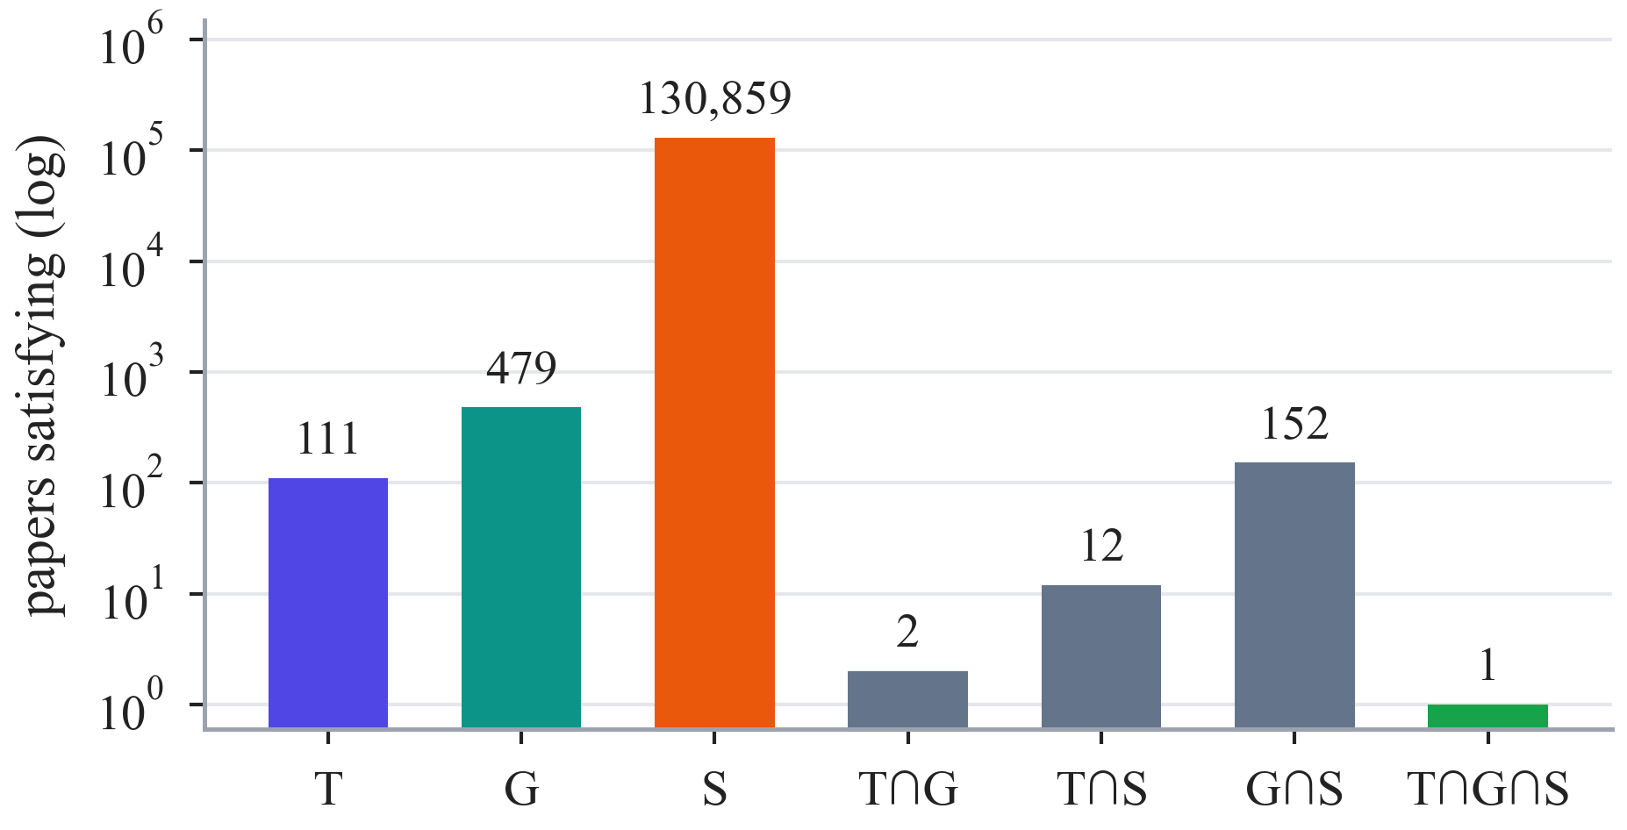
Figure 1.1: Candidate papers satisfying the conditions of one three-source question, per source and intersection (log scale); only the paper in the triple intersection is correct

1.3 Scope of Research
The project covers the full path from a raw public dataset to a statistically analysed comparison and an interactive presentation. In scope: the official STaRK-MAG corpus; three isolated views; a verified benchmark with noisy, conflicting and unanswerable variants; fifteen strategies and one integrated system; one locally served LLM; quality and cost metrics with paired statistics; a replay-verified protocol and an interactive application. Out of scope: other corpora or languages, LLM-extracted graphs (which would entangle the sources), training new retrievers or fine-tuning the LLM, comparisons across LLMs, and the locked test split, which awaits human review.

1.4 Research Hypotheses
Each research question gives a hypothesis reflecting the expectation from the literature that more elaborate mechanisms help (Table 1.2); the null hypothesis in each case is that they make no difference. Outcomes are reported in Section 5.8.
Table 1.2: Research hypotheses
ID | Hypothesis | Tested by
H1 | A graph-aware context strategy yields higher answer F1 than fixed top-K selection under the same budget | RQ1, 8 families
H2 | Entity-aligned, selective or late fusion yields higher answer F1 than labelled source sections | RQ2, 8 families
H3 | Learned, corrective or agentic control selects sources better, or more cheaply, than a rule router | RQ3, 14 families
H4 | Combining the best components selects sources better than querying every source, without losing answers | RQ4, 14 families

1.5 Objectives
1. To acquire and audit the official STaRK-MAG release and convert it into three isolated views joined only by the global identifier.
2. To construct a benchmark whose answers are computed before wording and whose multi-source questions provably require every source.
3. To implement simple retrievers, a grounded answer generator and fifteen strategies, including adaptations of nine published methods, behind one frozen interface.
4. To execute all studies under a protocol that freezes every input by checksum and verifies every result by replay.
5. To evaluate quality and cost with family-clustered paired statistics, Pareto sets and an overall ranking, and to integrate the winners.
6. To build an interactive application that presents every result from a checksummed data bundle.

1.6 Organization of the Report
Chapter 2 reviews related work and derives the research gaps. Chapter 3 specifies tools, hardware, work breakdown, requirements and cost. Chapter 4 describes the architecture, modules, algorithms, experimental design, execution protocol and testing. Chapter 5 reports and discusses the results, and Chapter 6 concludes with the future scope.
Chapter 2

Literature Review

2.1 Background
Retrieval-augmented generation. RAG conditions a generator on retrieved passages [1]; surveys organise its many variants [2]. Models use long contexts unevenly [12], and selecting or compressing evidence can cut cost without losing answers [13]; active and self-reflective variants decide during generation what to retrieve [14], [15]. Dense retrieval embeds questions and passages with sentence encoders [16], [17] and searches them with vector indexes such as FAISS [18].
Graph-based RAG. GraphRAG builds an entity graph with an LLM and summarises its communities [19]; G-Retriever selects a subgraph as a prize-collecting Steiner tree [3], [20], [21]; KG²RAG expands semantic seeds through a knowledge graph and organises them into reranked paragraphs [4]; QAFD-RAG diffuses relevance along query-aware edge weights [5], [22]; Think-on-Graph and HippoRAG explore the graph by LLM beam search and personalised propagation [23], [24]; a survey reviews the area [25].
Fusion of heterogeneous knowledge. UniK-QA linearises tables and triples [26], StructGPT reasons over structured interfaces [27], HybridRAG concatenates vector and graph retrieval [28], KAG aligns graph entities with text chunks [6], SAG selects structural evidence through SQL [7], MegaRAG reasons per modality before fusing [8], and query-driven multimodal GraphRAG builds local graphs on demand [29].
Adaptive and agentic retrieval control. Adaptive-RAG routes questions with a small T5 classifier [9], [30]; CRAG triggers corrections from a retrieval evaluator [10]; interleaved and reasoning-acting agents choose the next retrieval step [31], [32]; AGENT-G adds a retriever bank with validator and commentor critics [11]; and agent-orchestrated RAG adds decomposition and reflection [33].
Benchmarks and statistics. STaRK evaluates retrieval over semi-structured knowledge bases, including the Microsoft Academic Graph used here [34], [35]. Methodological work stresses significance testing on dependent samples [36]; clustered resampling, permutation tests, the bootstrap and Holm correction address this [37]–[40].
Table 2.1 summarises the methodology, datasets, main results and role in this project of the method papers that the project draws on.
Table 2.1: Literature synthesis of the method papers and their role in this project
Work | Methodology | Key datasets | Main results | Role here
KG²RAG [4] | Semantic seeds, KG-guided expansion and organisation | HotpotQA and variants | Better response and retrieval quality | CM-01
G-Retriever [3] | PCST subgraph, GNN encoder, soft prompt | GraphQA (ExplaGraphs, SceneGraphs, WebQSP) | Scales beyond the context window | CM-02
QAFD-RAG [5] | Training-free query-aware flow diffusion | UltraDomain, HotpotQA, MuSiQue, Spider 2.0 | Gains over graph RAG baselines | CM-03
KAG [6] | Mutual indexing, logical-form reasoning | HotpotQA, 2WikiMultiHopQA, MuSiQue | +19.6% / +33.5% relative F1 | CF-01
SAG [7] | Event–entity SQL index, dynamic hyperedges | HotpotQA, 2WikiMultiHopQA, MuSiQue | 80.36% Recall@5 on MuSiQue | CF-02
MegaRAG [8] | Multimodal KG, two-stage generation | UltraDomain, multimodal documents | Beats GraphRAG, LightRAG | CF-03
Adaptive-RAG [9] | T5 classifier routes retrieval depth | SQuAD, NQ, TriviaQA, MuSiQue, HotpotQA | Better accuracy–efficiency balance | AR-01
CRAG [10] | Evaluator triggers corrective retrieval | PopQA, Biography, PubHealth, ARC | Gains for RAG approaches | AR-02
AGENT-G [11] | Agent, retriever bank, critic | STaRK (MAG, PRIME), CRAG | +47% Hit@1 on STaRK-MAG | AR-03
Think-on-Graph [23] | LLM beam search over a KG | CWQ, WebQSP, GrailQA | Traceable multi-hop reasoning | design
QD-MM GraphRAG [29] | Query-driven local graph construction | MultimodalQA, WebQA | Best unsupervised method | design
STaRK [34] | Semi-structured retrieval benchmark | STaRK-MAG, Amazon, PRIME | Benchmark for LLM retrieval | data

2.2 Summary of Literature Review and Research Gap
The literature offers many candidate answers to RQ1–RQ3 but no common ground on which to compare them: effects are not attributable to a single component, sources are often entangled (a graph extracted from the same text that is also retrieved), multi-source questions are rarely verified to need every source, and cost and statistical uncertainty are under-reported [36]. Table 2.2 lists the resulting research gaps and Figure 2.1 connects them to the research questions, strategies and findings.
Table 2.2: Research gaps derived from the literature review
Gap | Description | Addressed by
RG1 | No controlled comparison of graph-context strategies under one budget with identical evidence | RQ1
RG2 | No controlled comparison of fusion strategies on byte-identical multi-source evidence | RQ2
RG3 | No controlled comparison of source-selection policies with the same retrievers | RQ3
RG4 | Unknown combined effect of empirically chosen components | RQ4

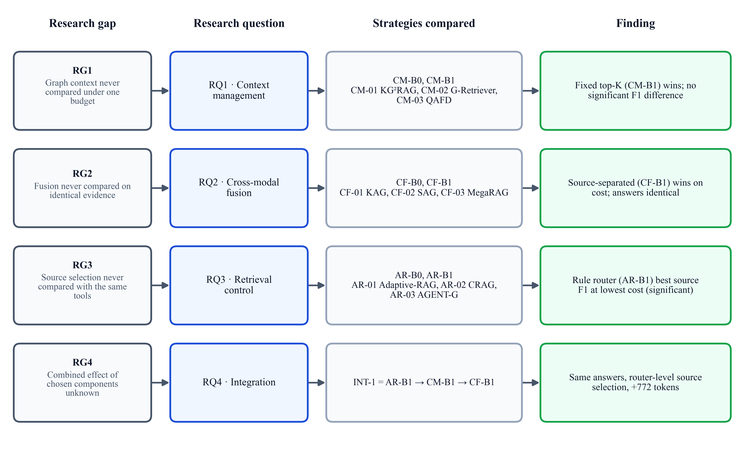
Figure 2.1: Research framework: gaps, research questions, strategies compared and findings
Chapter 3

Software Requirements Specification

3.1 Software Tool Platform, Tools and Frameworks Used
The platform is written in Python and uses only open-source software with pinned versions (Table 3.1).
Table 3.1: Software tools and frameworks
Tool / framework | Version | Purpose
Python | 3.12.14 | Research code, experiments, analysis
Ollama, gpt-oss:20b | 0.40.5; 20.9 B, MXFP4 | Local serving of the shared answer model [41], [42]
PyTorch, Transformers | 2.14.0, 5.17.0 | T5 classifier, cross-encoders, rerankers
sentence-transformers, ONNX Runtime | 6.1.0, 1.23.2 | MiniLM embeddings exported to ONNX
FAISS, DuckDB | 1.15.1, 1.5.6 | Exact vector index; read-only structured retrieval
NumPy, SciPy, scikit-learn | 2.5.3, 1.18.1, 1.9.1 | CSR graph, statistics, Platt scaling
NetworkX, pcst_fast | 3.6.1, 1.0.10 | Graph algorithms; Steiner tree solver
Pydantic, pytest | 2.13.5, 9.1.1 | Typed contracts; 327 automated tests
Streamlit, Altair, pandas | 1.64.0, 6.3.0, 3.0.6 | Interactive application and charts
Git, Matplotlib | —, 3.10.7 | Version control; figures

3.2 Hardware Tools
All work ran on one laptop; the LLM was served locally, so no data left the machine: Intel Core i7-13650HX processor, 16 GB RAM, NVIDIA GeForce RTX 4060 Laptop GPU (8 GB), Windows 11. The frozen data occupy 7.17 GB in 695 checksummed files, and a cooling guard paused requests while the GPU was above 80 °C (never counted as latency).

3.3 Work Breakdown Structure
The work was organised into seven work packages (Figure 3.1) executed in strictly ordered phases between 4 and 18 October 2026 (Figure 3.2). Every phase ended with a review report, a checkpoint commit and an explicit approval; earlier results were preserved rather than overwritten.
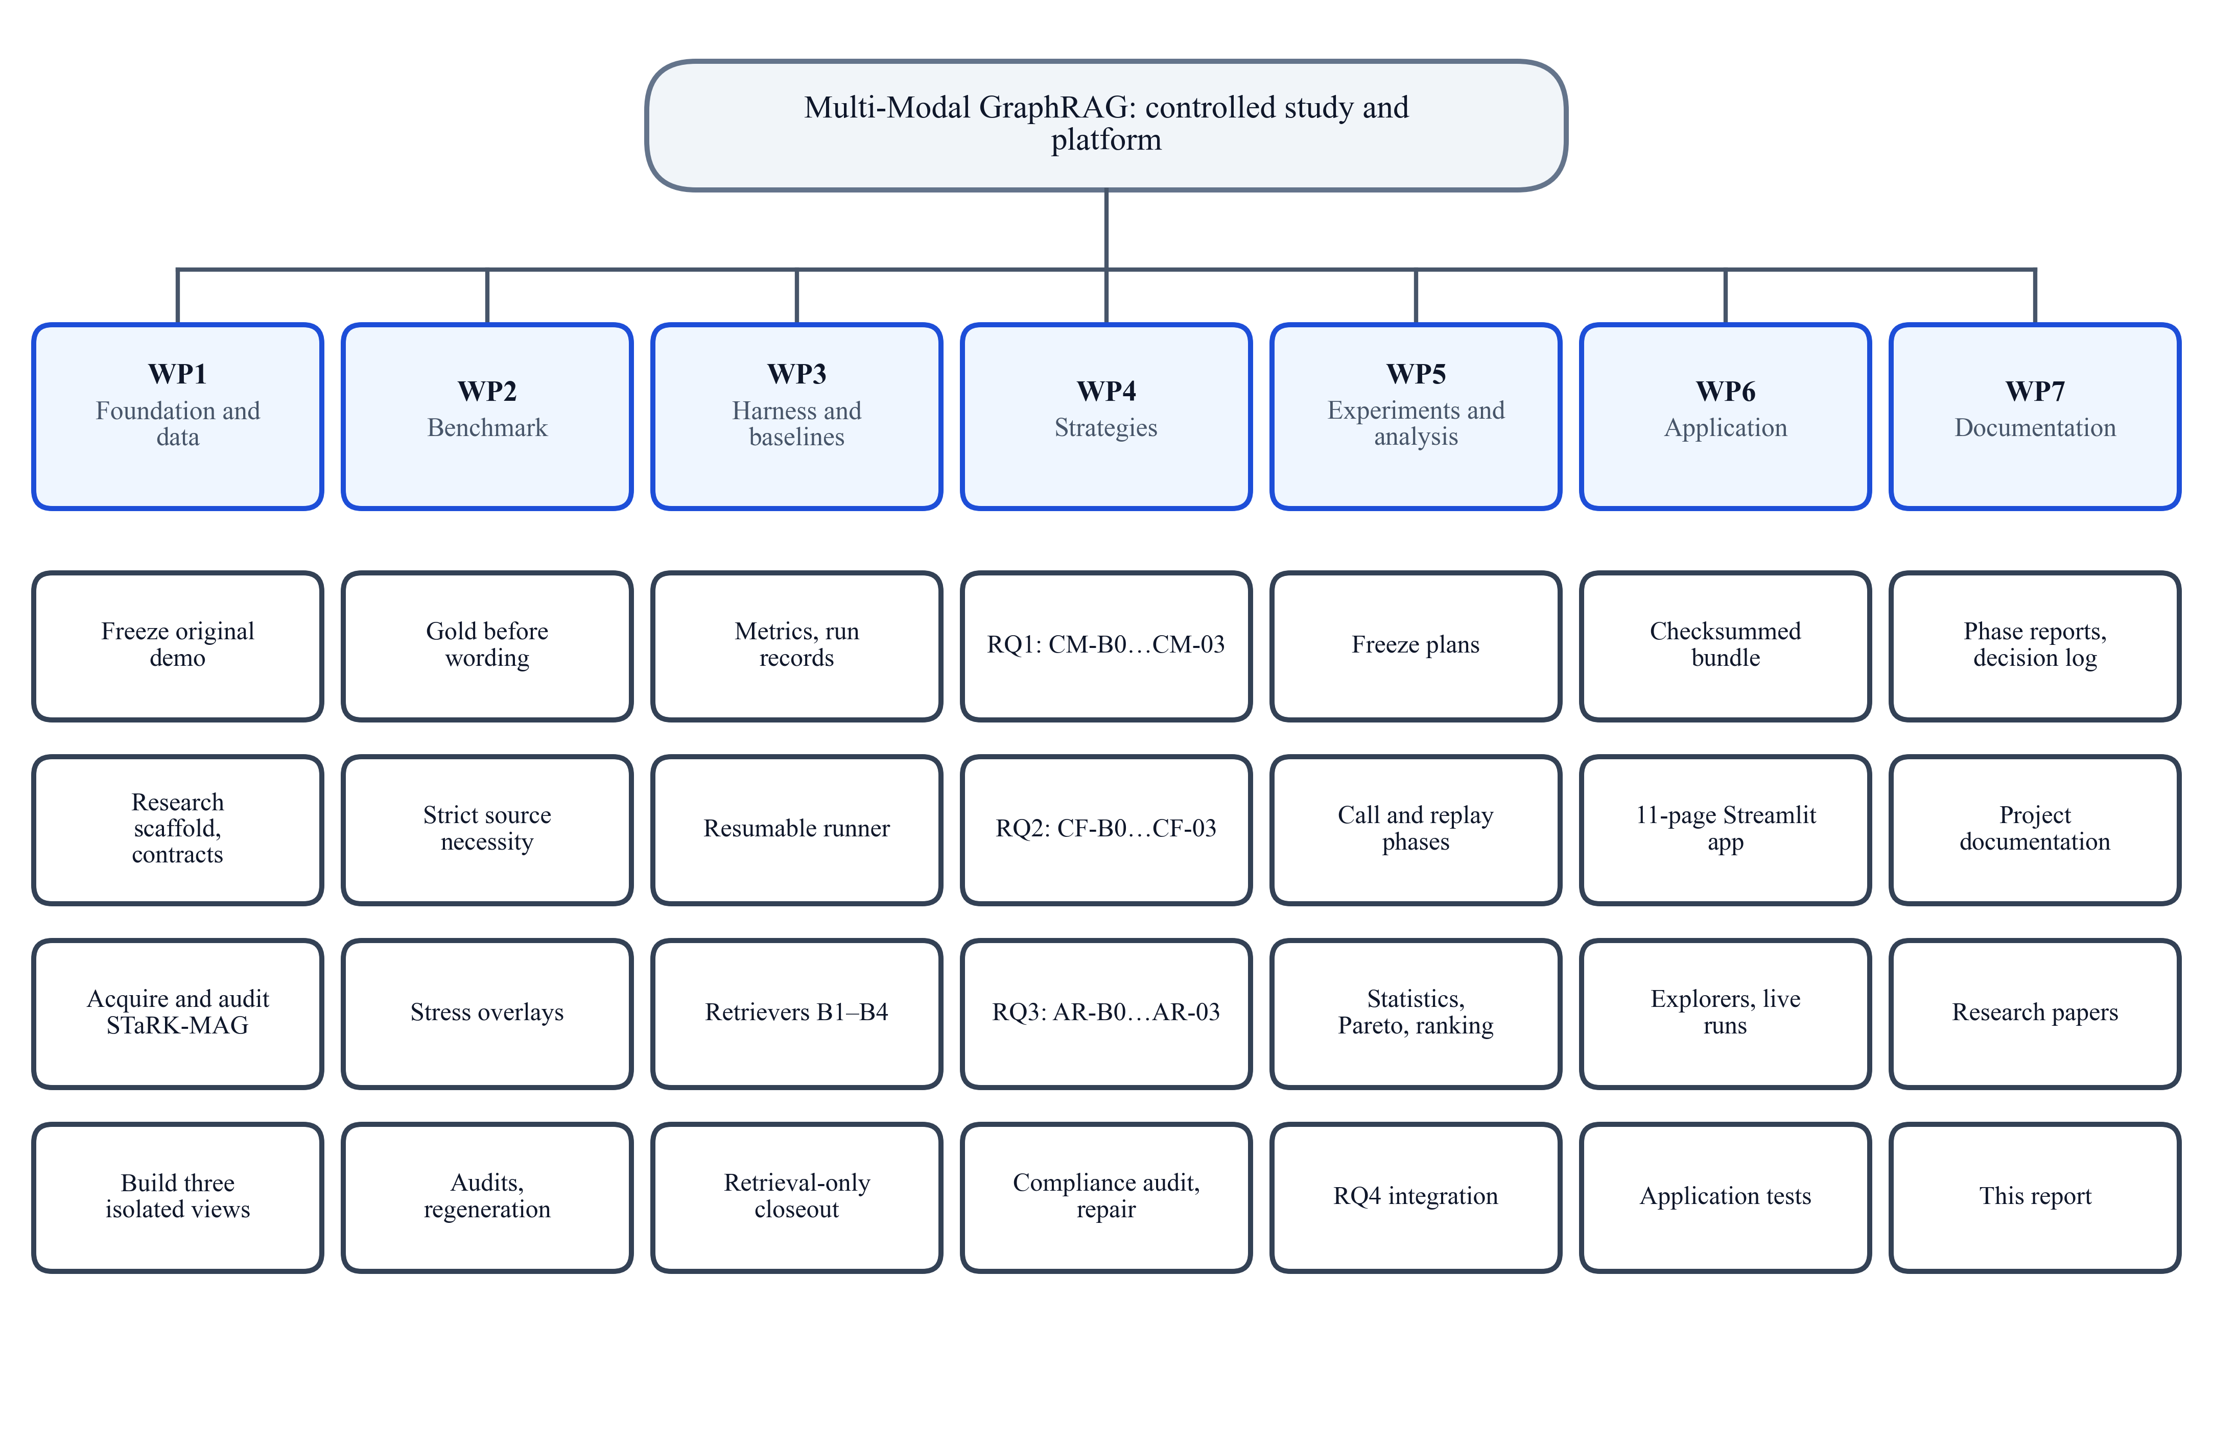
Figure 3.1: Work breakdown structure: seven work packages and their main tasks
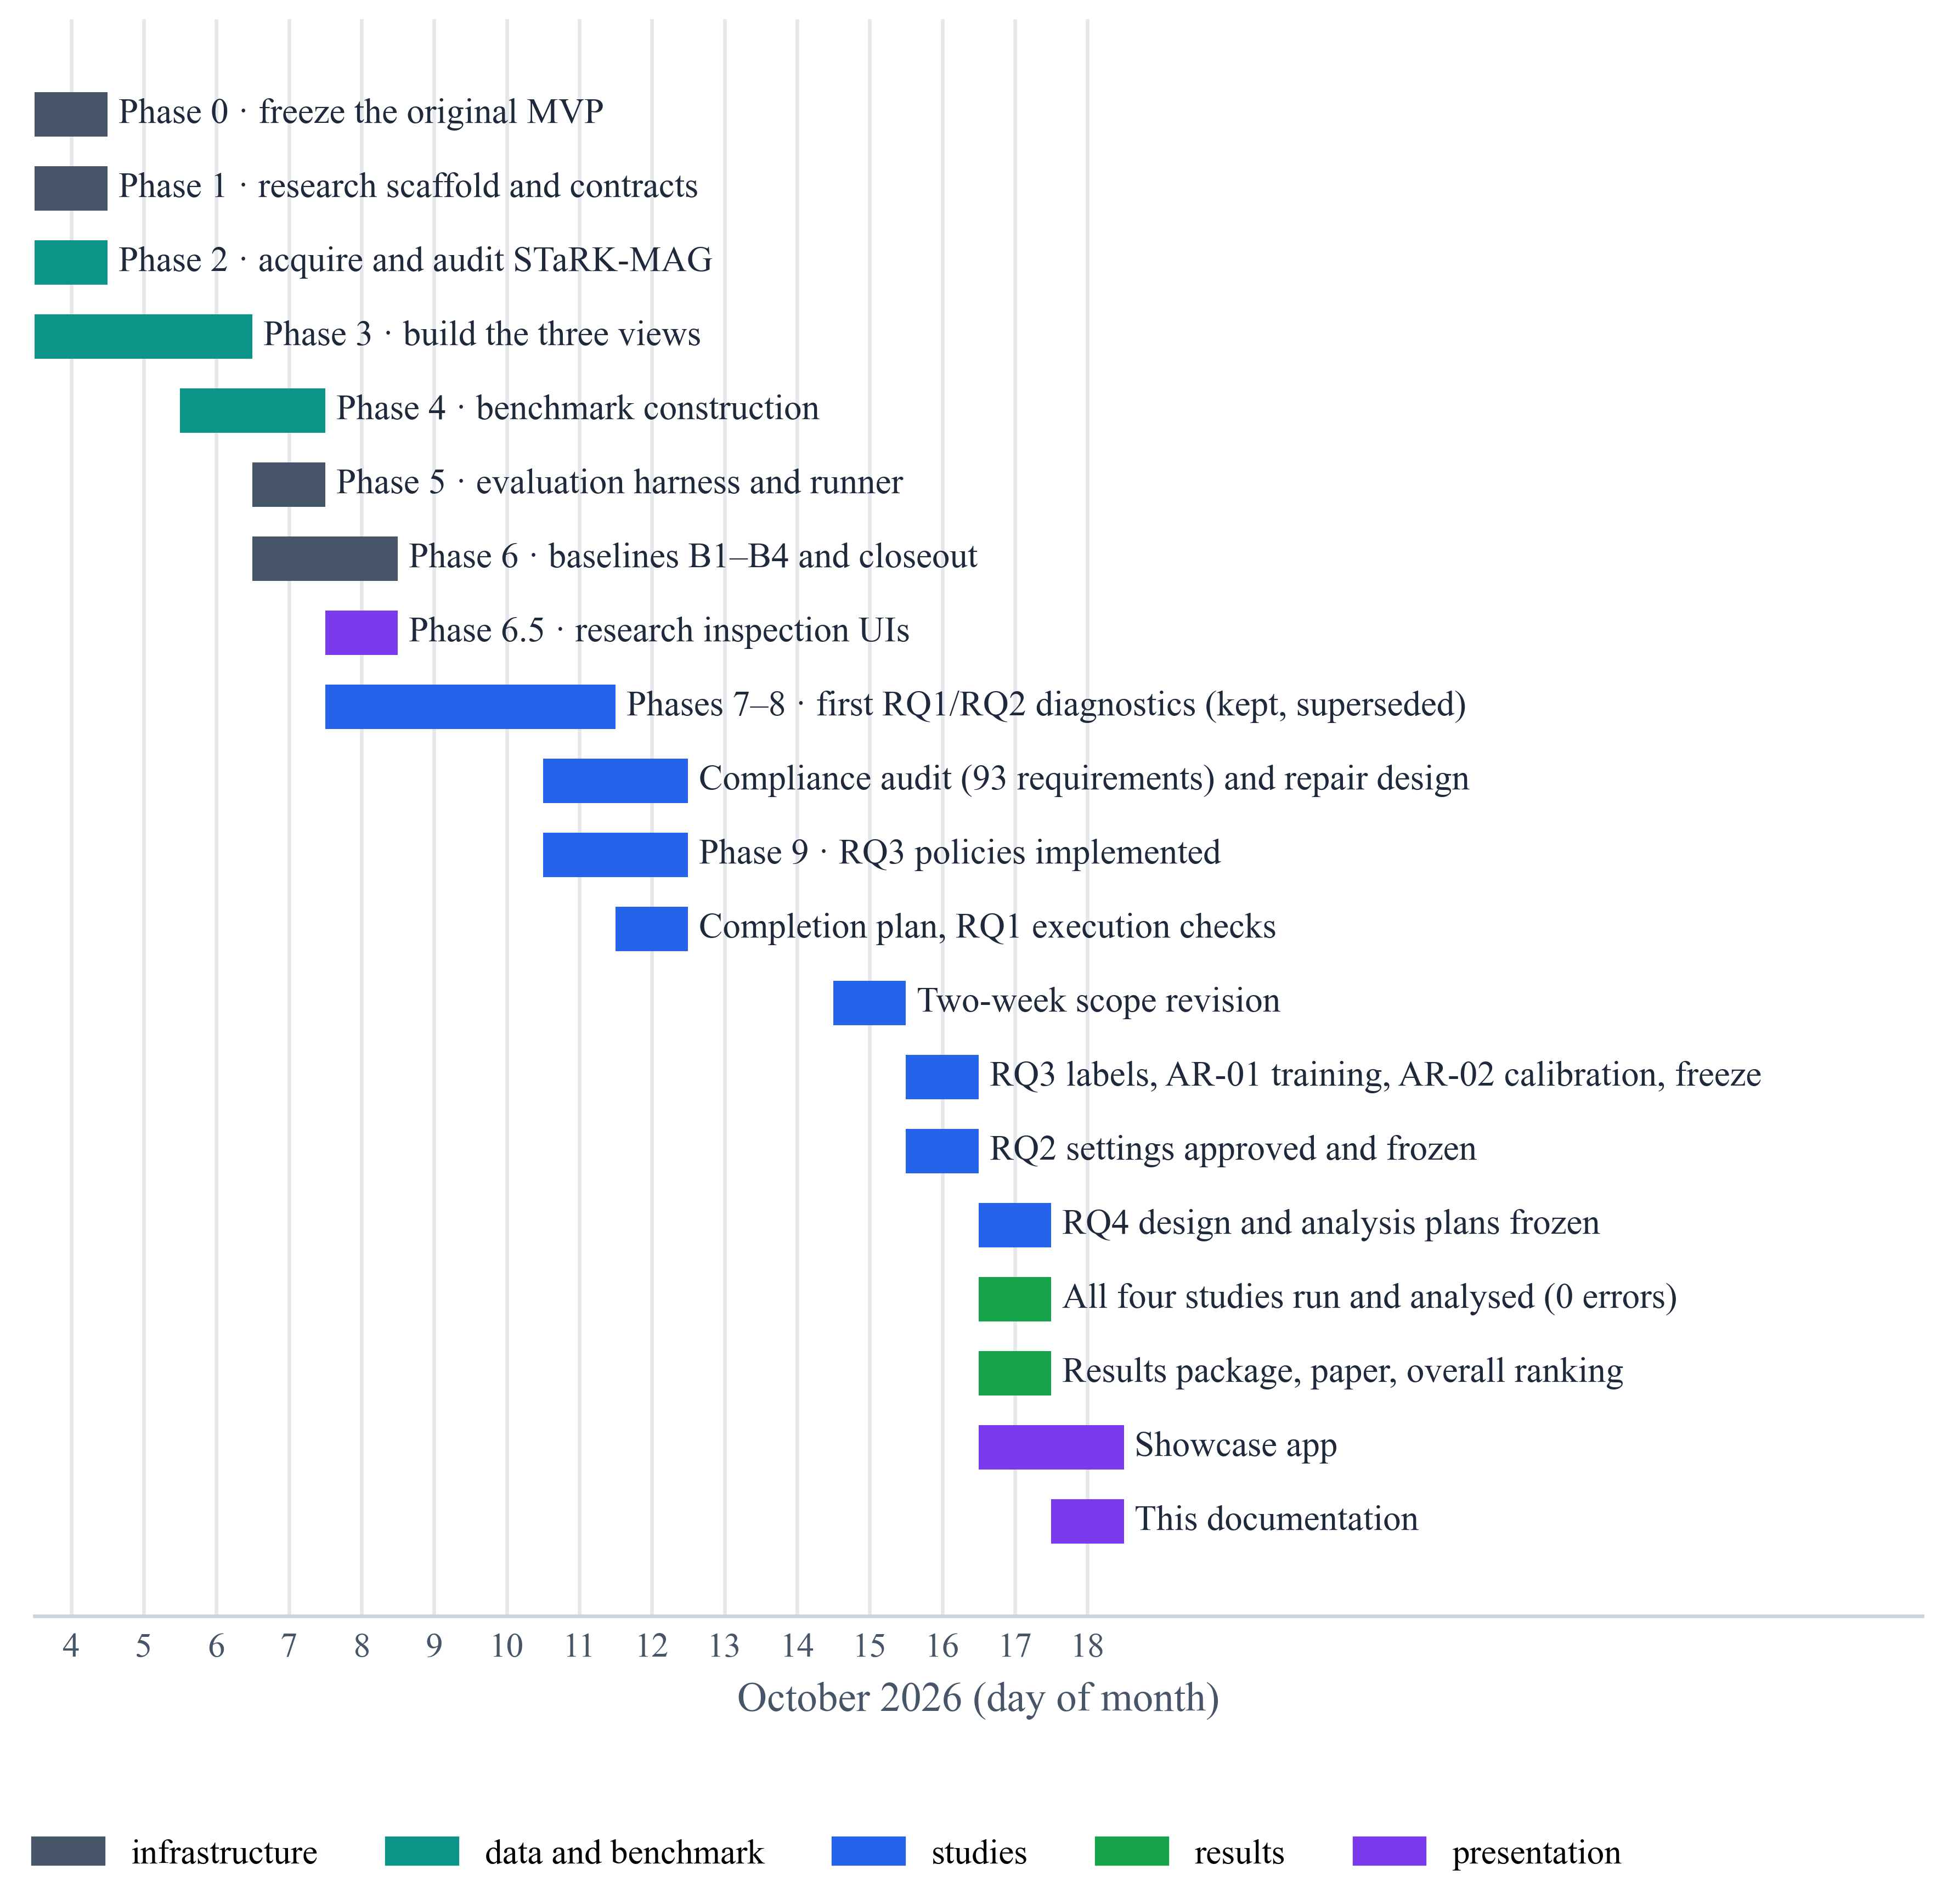
Figure 3.2: Project timeline, 4–18 October 2026

3.4 Functional Requirements
Table 3.2 lists the functional requirements and Figure 3.3 the use cases of the two kinds of user.
Table 3.2: Functional requirements
ID | Requirement | Layer
FR1 | Download the pinned STaRK-MAG release and audit every record without modifying it | Data
FR2 | Build three views sharing only the global identifier and audit their isolation | Data
FR3 | Compute gold answers before wording, verify source necessity, add stress variants | Benchmark
FR4 | Provide one retriever per source (B1–B3) and a fixed multi-source baseline (B4) | Retrieval
FR5 | Provide fifteen strategies behind one frozen interface | Components
FR6 | Answer with one grounded prompt; accept only identifiers present in the context | Generation
FR7 | Freeze studies by checksum; store every model request; rebuild results by replay | Execution
FR8 | Compute metrics, paired family-clustered tests, Pareto sets and an overall ranking | Analysis
FR9 | Export a checksummed bundle; present, explore and replay every recorded run | Application

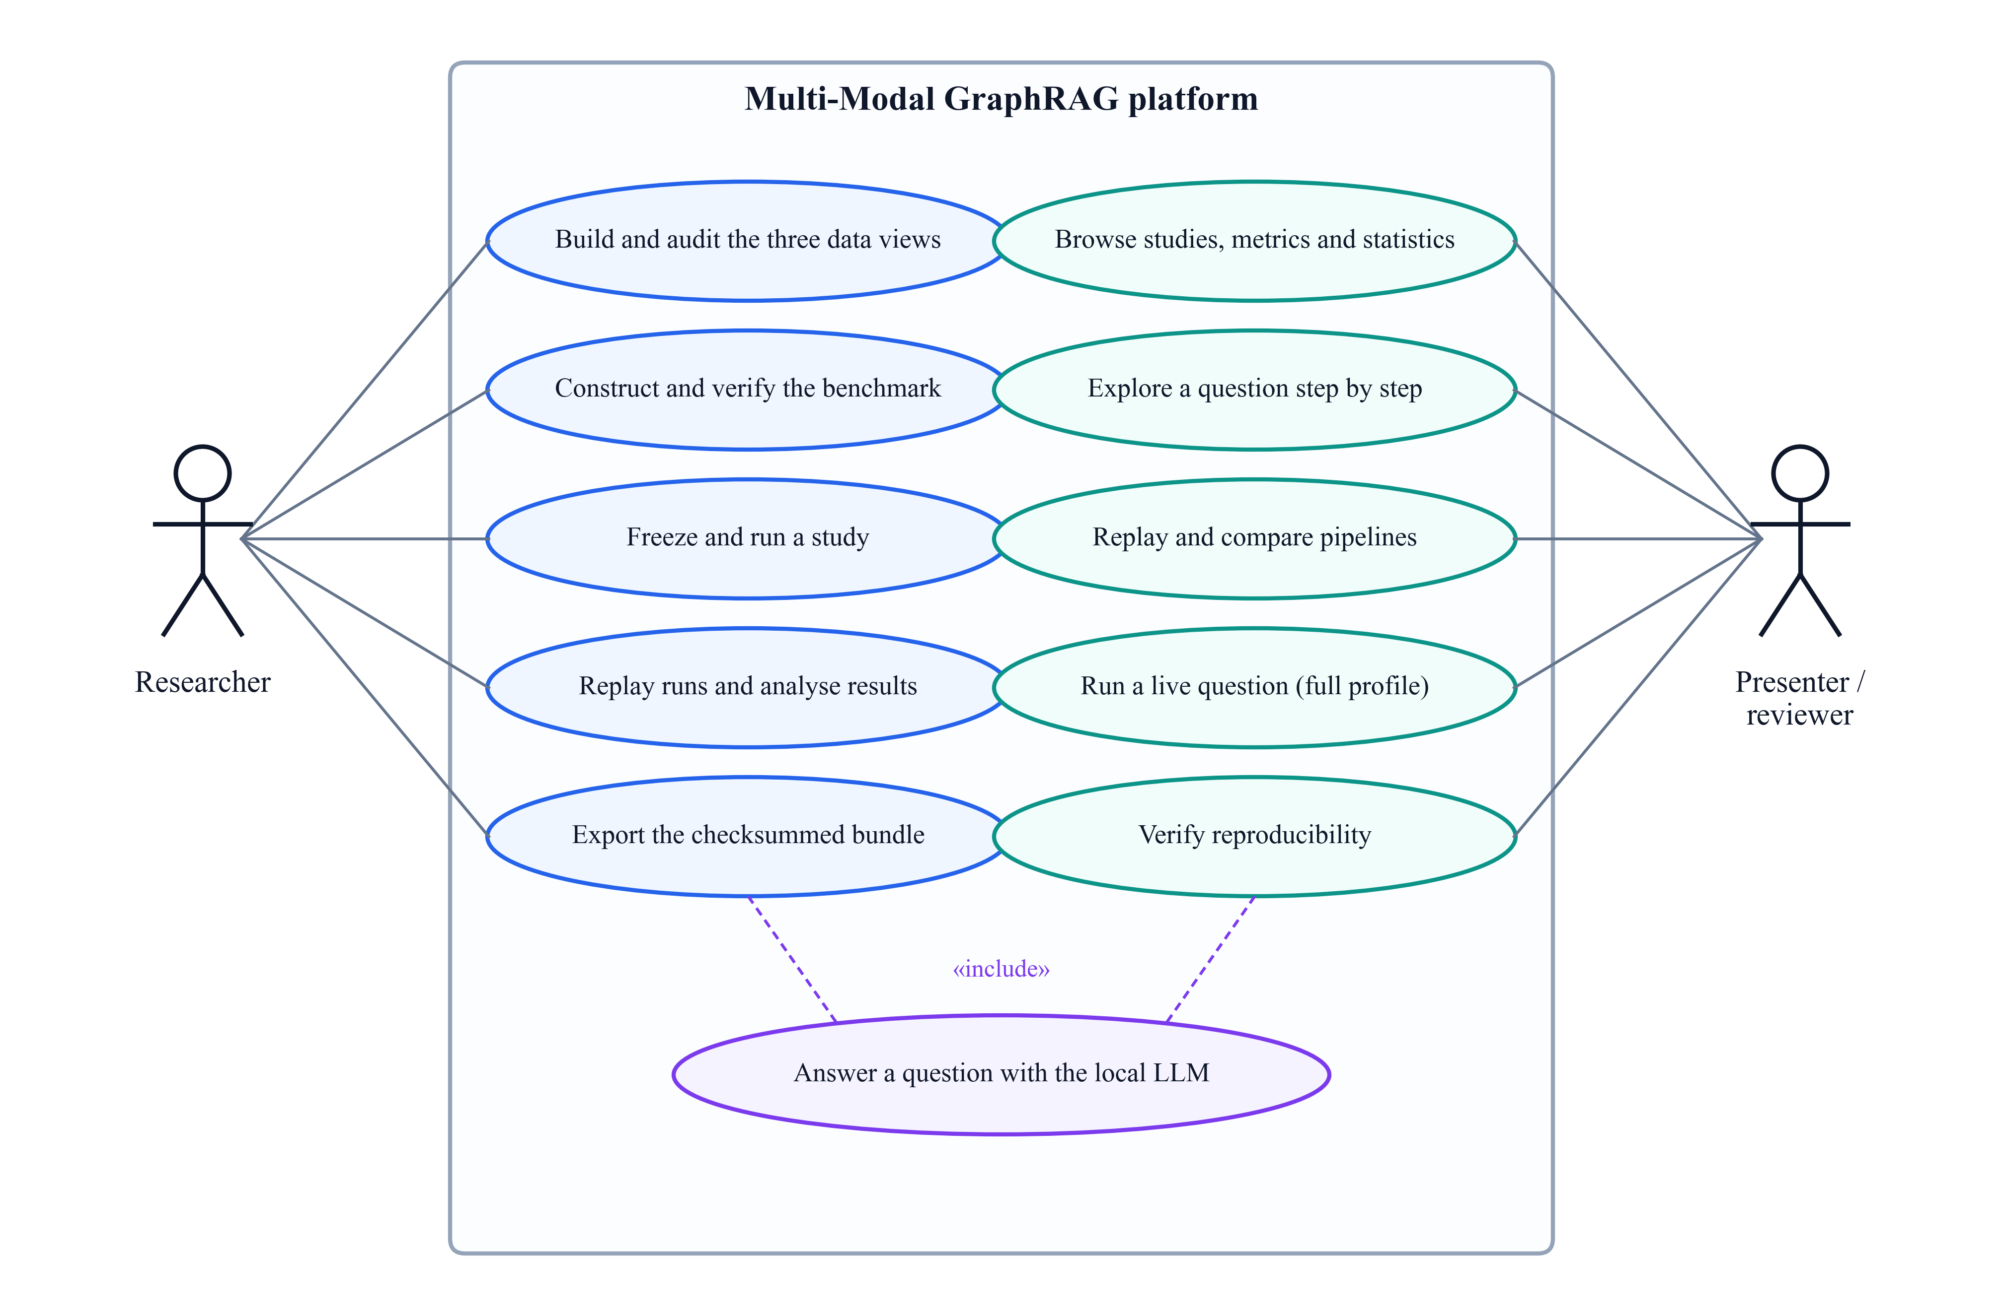
Figure 3.3: Use-case diagram of the platform

3.5 Non-Functional Requirements
Table 3.3: Non-functional requirements and how they are met
Quality | How it is met
Reproducibility | Pinned versions and revisions; SHA-256 manifests; stored model requests; byte-identical replay
Determinism | Temperature 0, per-question seeds, deterministic tie-breaking and serialisation
Isolation | Identity-only joins; isolation audits; one variable per study; no gold answers at inference
Integrity and security | Read-only database; evidence treated as data, not instructions; checksummed bundle
Performance and scalability | Exact search over 700,244 papers; memory-mapped graph; capped traversal; 6–45 s per question
Reliability and maintainability | Resumable runner with atomic records; modular packages; 327 automated tests
Usability and portability | Guided application with presentation mode; showcase profile runs from the bundle alone

3.6 Project Cost Estimation
The delivered code comprises 244 Python files with 17,390 non-blank, non-comment lines (KLOC = 17.39). The basic COCOMO model for an organic project estimates effort $E$ (person-months), development time $D$ (months) and staffing $S$:
$$\begin{aligned}E=2.4·{\text{KLOC}}^{1.05}, D=2.5·E^{0.38}, S=\frac{E}{D}\#\left(3.1\right)\end{aligned}$$
giving $E$ ≈ 48.1 person-months, $D$ ≈ 10.9 months and $S$ ≈ 4.4 persons; the project itself was completed in about two weeks by one student with AI-assisted tools. All reported runs used a locally served open-source model, so no licence or API charges were incurred (Table 3.4).
Table 3.4: Measured computational usage of the four studies
Study | Run records | Model calls | Tokens | Compute time
RQ1 context management | 160 | 192 | 529,332 | 0.73 h
RQ2 cross-modal fusion | 120 | 210 | 501,768 | 0.40 h
RQ3 retrieval control | 140 | 343 | 501,674 | 0.77 h
RQ4 integrated system | 28 | 28 | 67,037 | 0.08 h
Total | 448 | 773 | 1,599,811 | 1.99 h

Chapter 4

Methodology

4.1 System Architecture
The system has seven layers (Figure 4.1): data (pinned release, three isolated views, benchmark), retrieval (one fixed retriever per view), studied components (strategies of the four studies), generation (one answer model, grounding prompt and strict parser), execution (frozen plans, durable request store, replay), analysis (metrics, statistics, ranking) and presentation (checksummed bundle and application). Figure 4.2 shows how the studied components meet in the pipeline, and Figure 4.3 shows the data flow between processes and stores.
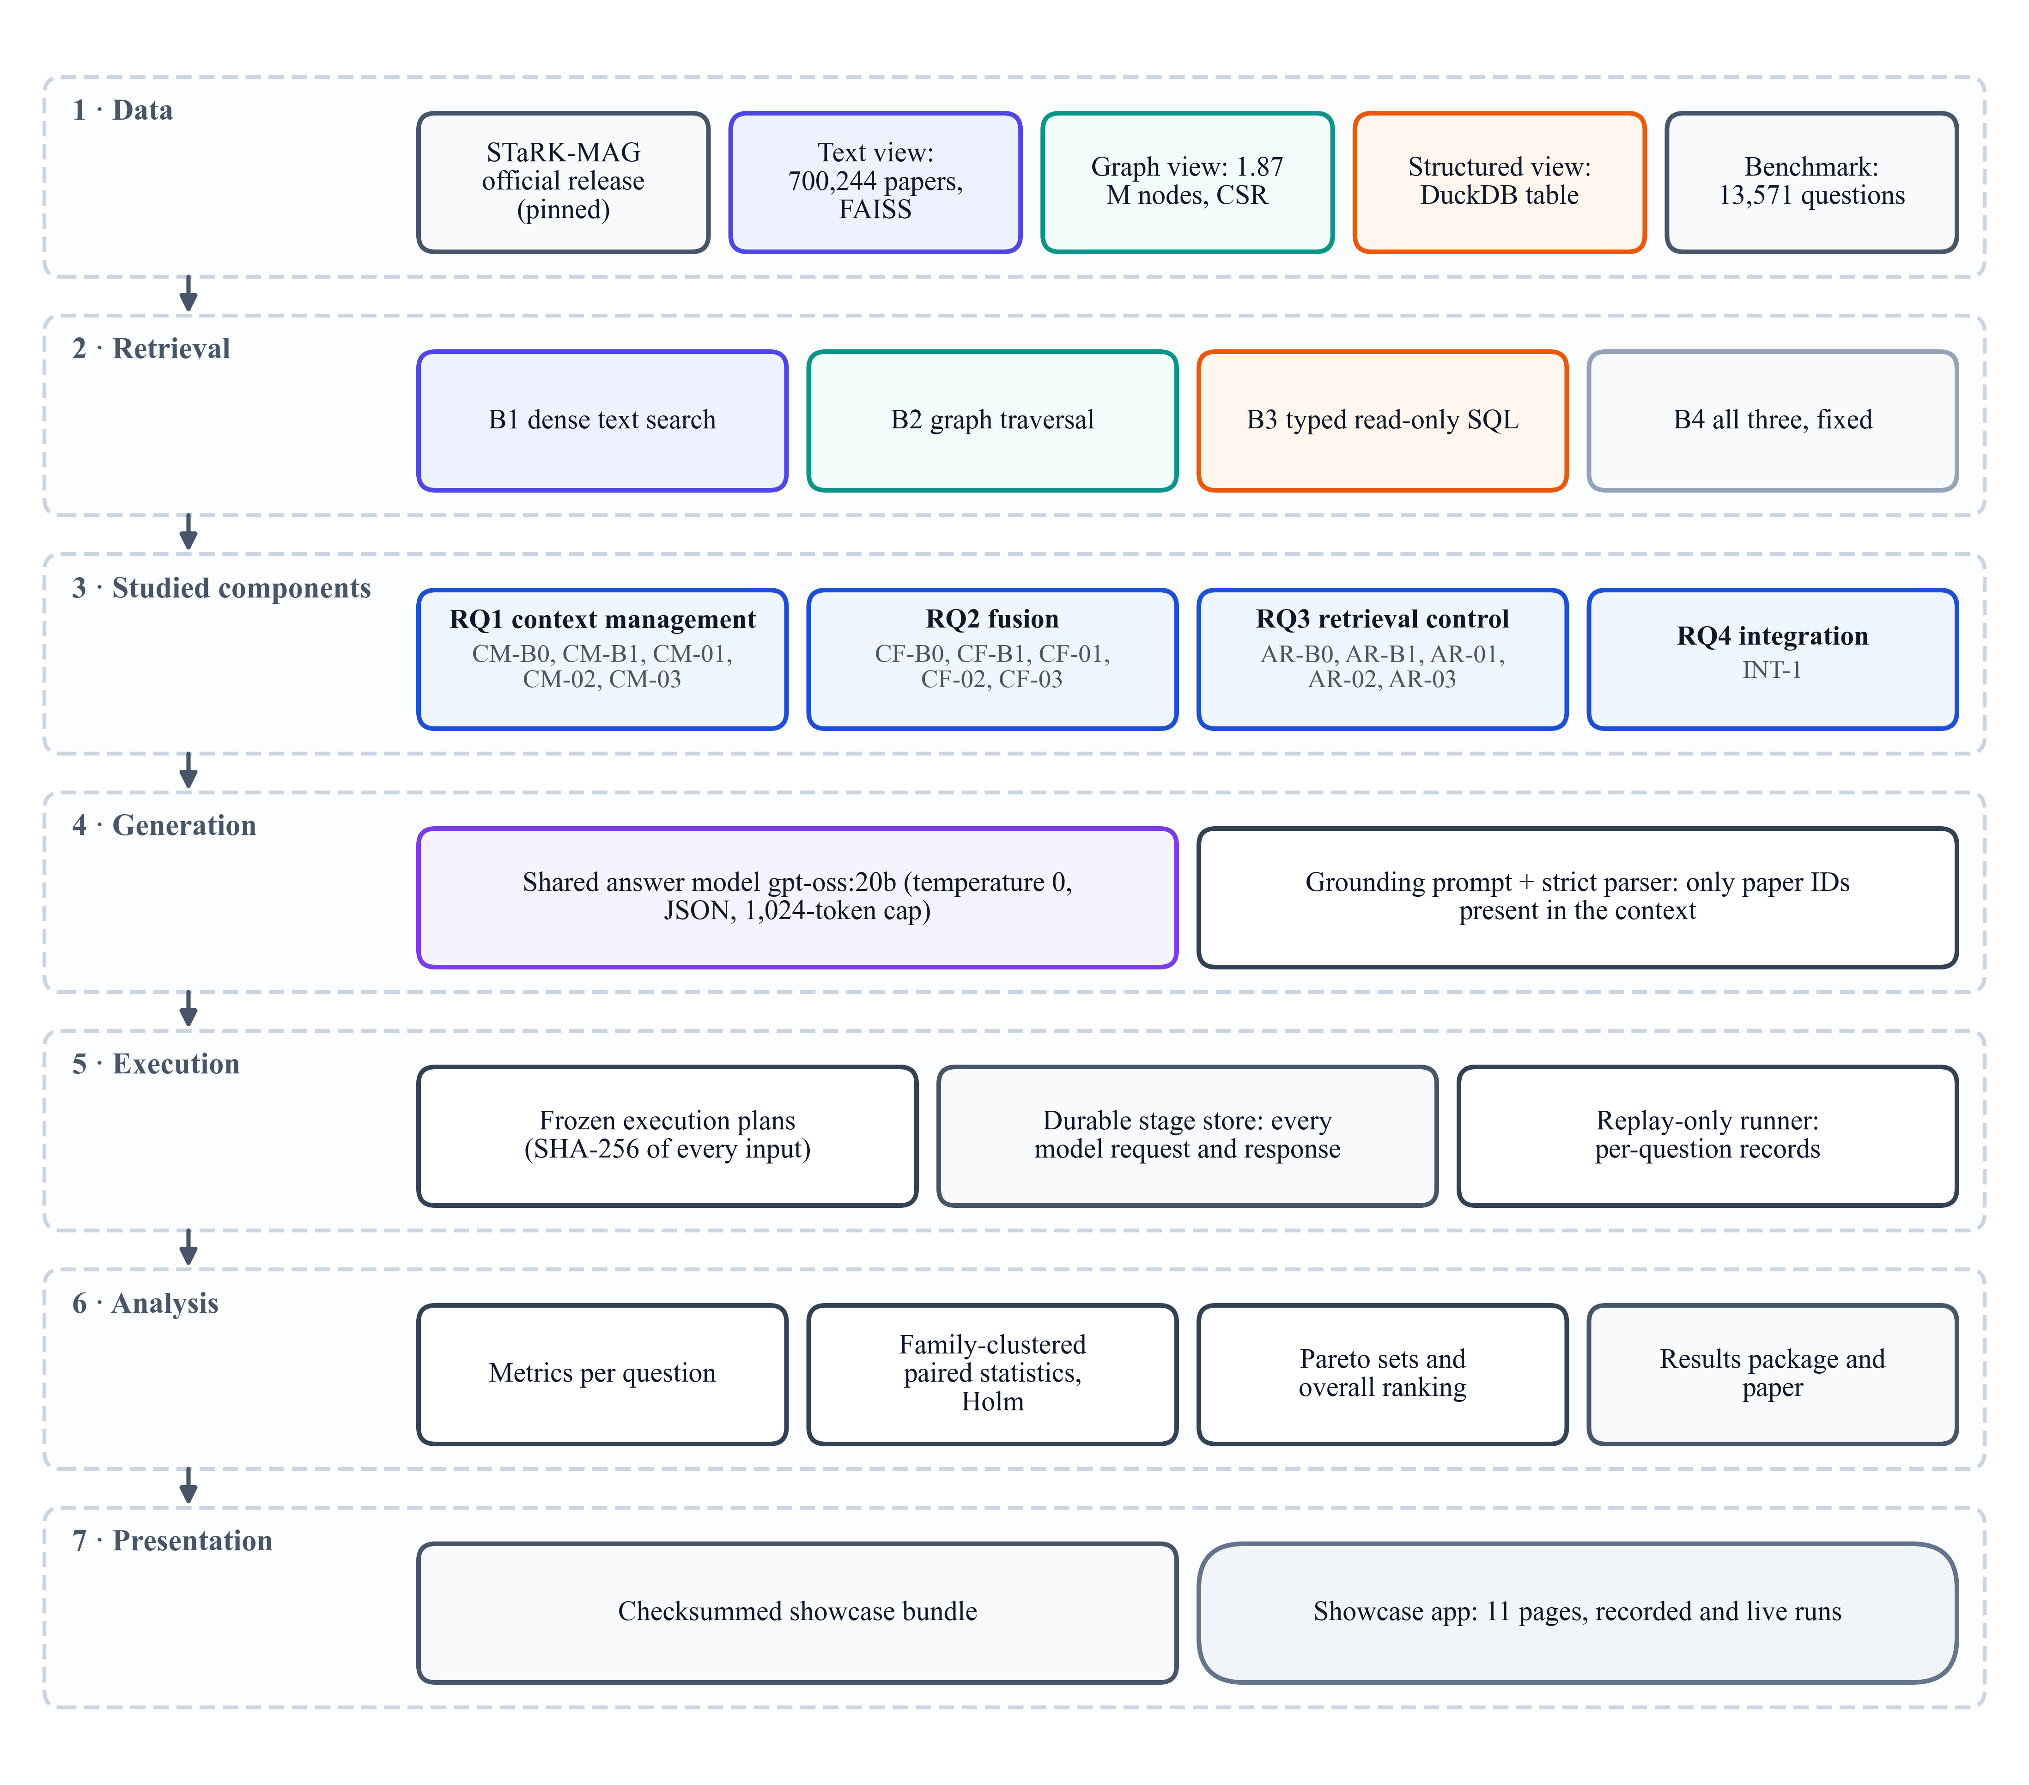
Figure 4.1: The seven layers of the system
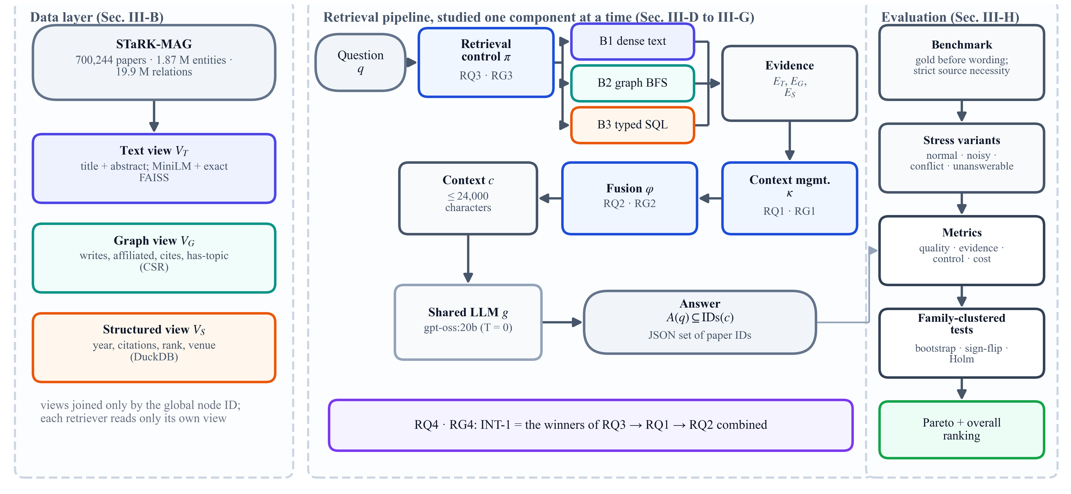
Figure 4.2: Controlled framework: retrieval control (RQ3), context management (RQ1) and fusion (RQ2) are studied one at a time and then combined (RQ4)
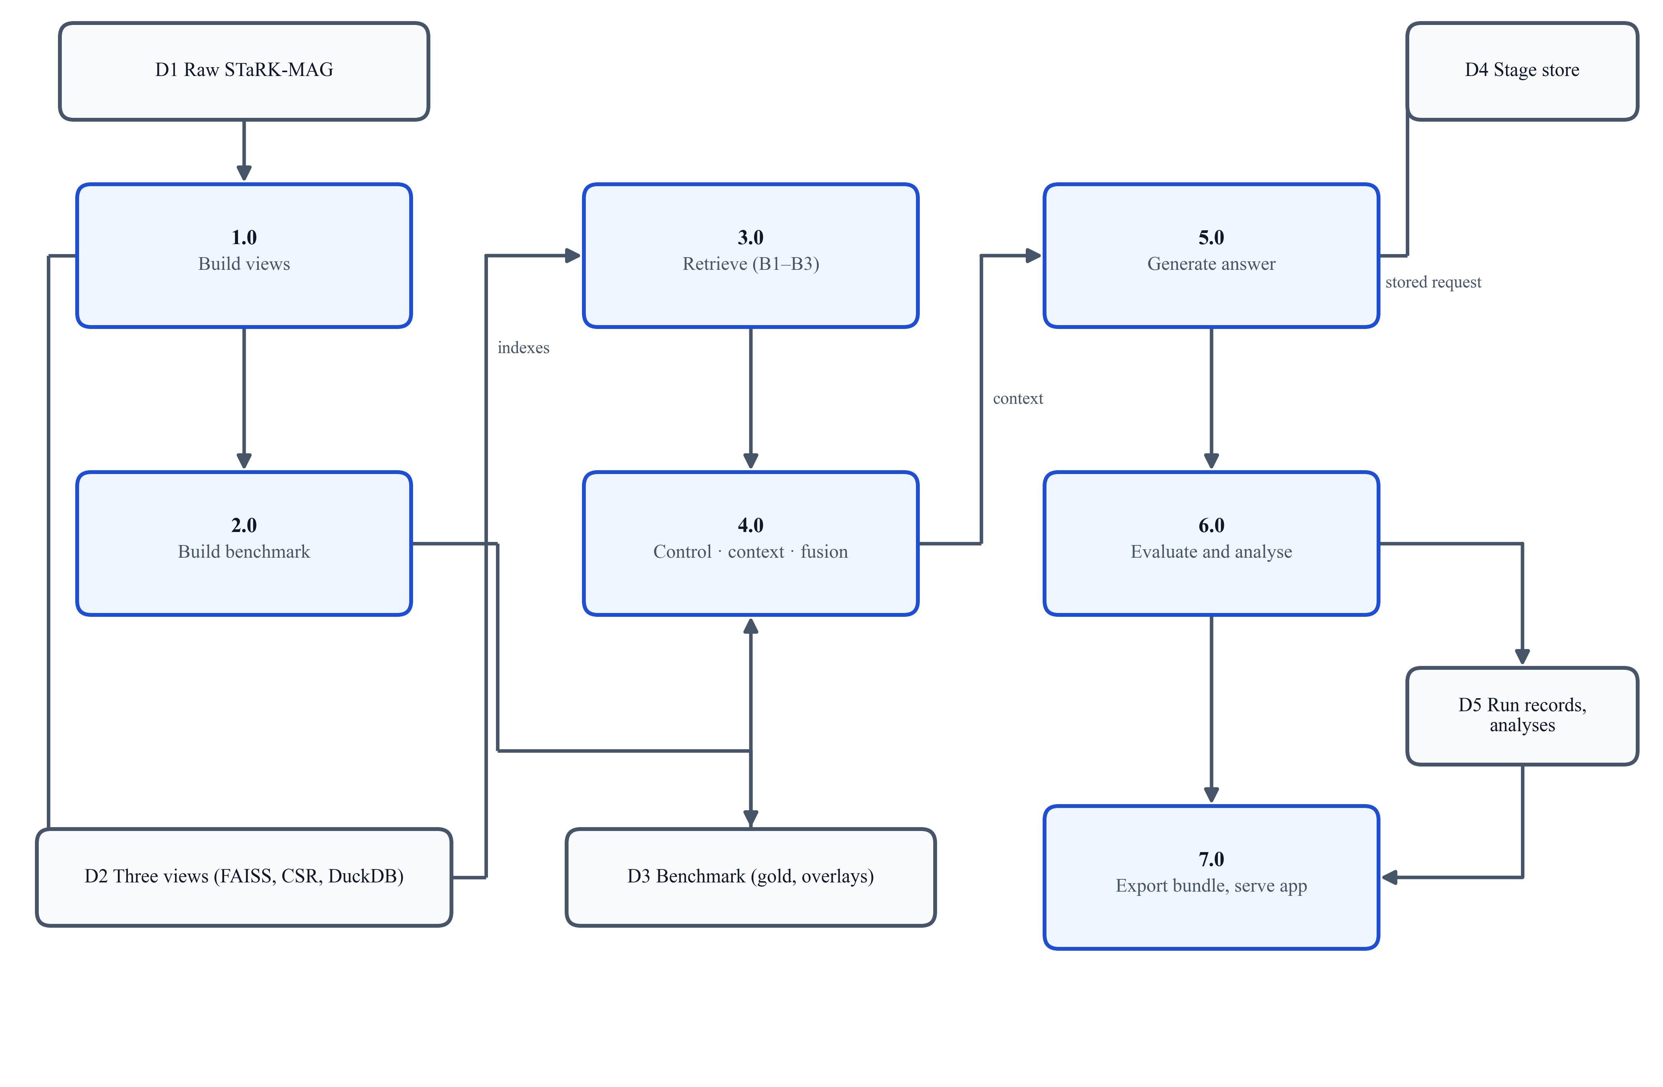
Figure 4.3: Data-flow diagram (level 1): processes 1.0–7.0 and data stores D1–D5

4.2 Module Description
Data views. The text view $V_{T}$ holds the exact title and abstract of each paper, embedded with a frozen MiniLM encoder (384 dimensions) and indexed exactly with FAISS. The graph view $V_{G}=\left(N,E\right)$ holds the four official relation types (19,919,698 edges plus tagged inverse rows) as memory-mapped compressed sparse rows. The structured view $V_{S}$ is a DuckDB table of nullable attributes; 22,049 papers without year or rank stay NULL. The views share nothing but the identifier (Table 4.1).
Table 4.1: Corpus and benchmark statistics
Item | Value
Papers / authors / institutions / fields of study | 700,244 / 1,104,554 / 8,701 / 59,469
Official directed relations (traversal rows) | 19,919,698 (39,839,396)
Benchmark questions (train / validation / test / human) | 13,571 (8,049 / 2,721 / 2,720 / 81)
Generated, verified questions | 167

Benchmark. Each generated question $q$ requires sources $M\left(q\right)⊆\left\{T,G,S\right\}$; a condition per source is evaluated on the frozen view, giving candidate sets $C_{m}\left(q\right)$, and the gold set is their intersection. Every multi-source question must satisfy strict source necessity:
$$\begin{aligned}G\left(q\right)=\bigcap_{m∈M\left(q\right)}{C_{m}\left(q\right)}, ∀m:G_{-m}\left(q\right)⊋G\left(q\right)\#\left(4.1\right)\end{aligned}$$
Questions are worded from templates without answer identifiers, and each has normal, noisy, conflict and unanswerable variants; the variants of one question form a family, the independent unit of all statistics. An independent audit recomputed every gold set and a full regeneration reproduced all 323 benchmark files byte for byte.
Retrievers and generator. B1 returns the five papers with the highest embedding similarity $h_{q}^{⊤}h_{p}$; B2 traverses breadth-first to depth 2 from up to three seed entities under fixed caps; B3 compiles recognised conditions into read-only SQL; B4 runs all three. A question is answered as
$$\begin{aligned}A\left(q\right)=g\left(q,φ\left(E_{T},κ\left(E_{G}\right),E_{S}\right)\right)\#\left(4.2\right)\end{aligned}$$
where the policy $π$ decides which retrievers produce the evidence $E$, $κ$ manages graph evidence, $φ$ fuses the three streams and $g$ is gpt-oss:20b (temperature 0, JSON output, 1,024-token cap) with a 24,000-character budget. A strict parser accepts only paper identifiers present in the context.
Context management (RQ1). All five strategies receive the same candidate pool (Figure 4.4). CM-B0 keeps records in raw order; CM-B1 keeps the five top-ranked papers with their paths. CM-01 (KG²RAG-inspired) [4] weights one provenance sentence per relation by $w\left(e\right)=\cos\left(h_{q},h_{u_{e}}\right)$ and organises components as maximum spanning trees [43]; CM-02 (G-Retriever-inspired) [3] solves a prize-collecting Steiner tree; CM-03 (QAFD-RAG-inspired) [5] diffuses mass from keyword seeds along query-aware conductance:
$$\begin{aligned}T^{*}={\text{arg min}}_{T}\left(\sum_{e∈E\left(T\right)}{c_{e}}+\sum_{v∉V\left(T\right)}{π_{v}}\right)\#\left(4.3\right)\end{aligned}$$
$$\begin{aligned}w\left(u,v\right)=H\left(u,v\right)\left(1+\frac{1}{4}\left(H\left(u,q\right)+H\left(v,q\right)\right)\right)\#\left(4.4\right)\end{aligned}$$
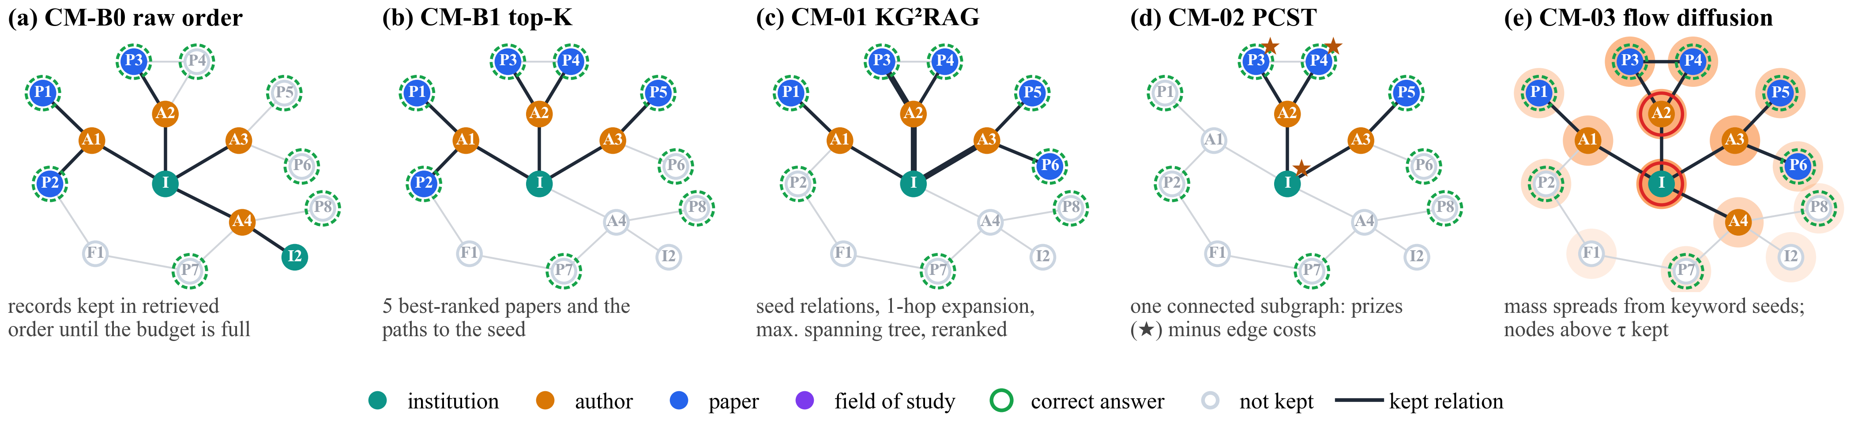
Figure 4.4: The five context-management strategies on a schematic candidate graph
Cross-modal fusion (RQ2). Every method receives the byte-identical evidence bundle of a question (Figure 4.5). CF-B0 concatenates; CF-B1 writes labelled TEXT, GRAPH and STRUCTURED sections of 8,000 characters; CF-01 (KAG-inspired) [6] groups evidence by aligned entity; CF-02 (SAG-inspired) [7] lets an LLM select up to five structural items; CF-03 (MegaRAG-inspired) [8] reasons per source, then fuses.
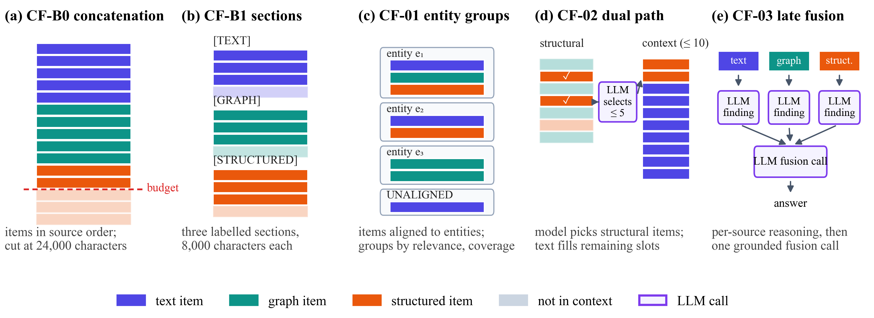
Figure 4.5: Context layouts of the five fusion strategies on the same evidence bundle
Retrieval control (RQ3). All policies share retrievers B1–B3 and a fixed downstream context (Figure 4.6). AR-B0 queries every source; AR-B1 is a rule router matching frozen cue words (Appendix A); AR-01 (Adaptive-RAG-inspired) [9] routes with a T5 classifier trained on oracle labels (best epoch 7 of 10); AR-02 (CRAG-inspired) [10] rates evidence with a cross-encoder calibrated by Platt scaling [44] and corrects; AR-03 (AGENT-G-inspired) [11] lets an LLM agent pick tools while a validator and commentor critique drafts.
$$\begin{aligned}p=\frac{1}{1+e^{-\left(a s+b\right)}}, a=0.376, b=0.102\#\left(4.5\right)\end{aligned}$$
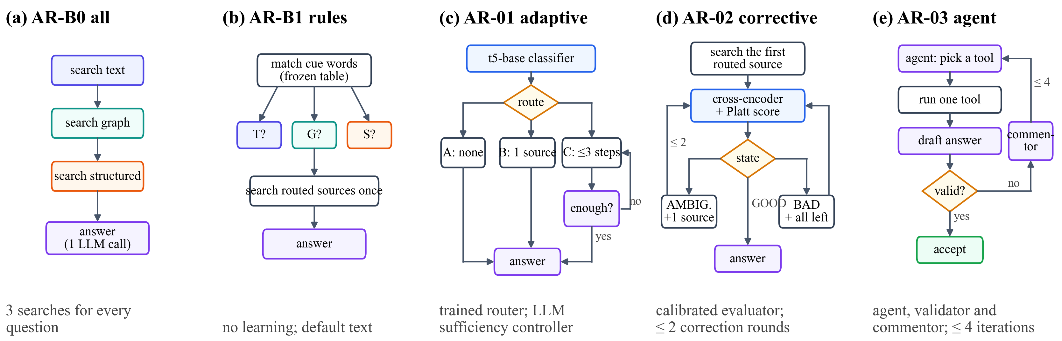
Figure 4.6: Control flow of the five retrieval-control policies
Integration (RQ4) and application. INT-1 chains the selected policy, CM-B1 and the selected fusion; the policy and fusion were chosen by a rule fixed before any RQ2 or RQ3 result: the Pareto-optimal strategy with the highest answer F1. The application reads only a checksummed bundle of nine files, verifies every checksum at start-up and presents eleven pages (Section 5.6).

4.3 Experimental Design and Evaluation
Table 4.2: Design of the four studies (programmatically verified validation questions)
Study | Cohort | What changes | Primary and secondary metrics
RQ1 | 32 questions: 8 families × 4 variants | graph evidence selection | F1; MRR, gold coverage, cost
RQ2 | 24 frozen bundles: 8 families × 3 variants | combination of the three streams | F1; EM, MRR, cost
RQ3 | 28 questions: 14 families × 2 variants | sources, order and stopping | F1; source F1, wasted retrieval, cost
RQ4 | the 28 questions of RQ3 | combination of the winners | F1; source F1, cost

For a returned set $A$ and gold set $G$, answer quality is set F1; evidence quality is gold coverage, the share of correct papers in the context $c\left(q\right)$; and source selection is the F1 between the queried sources $S$ and the required sources $R$:
$$\begin{aligned}F_{1}=\frac{2PR}{P+R}, \text{GC}\left(q\right)=\frac{\left|G\left(q\right)∩\text{IDs}\left(c\left(q\right)\right)\right|}{\left|G\left(q\right)\right|}, {\text{SF}}_{1}=\frac{2\left|S∩R\right|}{\left|S\right|+\left|R\right|}\#\left(4.6\right)\end{aligned}$$
Cost is measured by tokens, model calls, searches and intrinsic latency (retrieval, model compute and local time, excluding waiting). Two methods are always compared on the same questions; with $S_{f}$ the sum of per-question differences over family $f$, the exact two-sided sign-flip test [38] and Holm’s correction over the $k$ pre-specified pairs [40] are
$$\begin{aligned}p=\frac{1}{2^{F}} \sum_{σ∈{\left\{±1\right\}}^{F}}{1\left[\left|\sum_{f}{σ_{f}S_{f}}\right|≥\left|\sum_{f}{S_{f}}\right|\right]}, {\tilde{p}}_{\left(i\right)}=\min\left\{1,\max_{j≤i}\left(k-j+1\right)p_{\left(j\right)}\right\}\#\left(4.7\right)\end{aligned}$$
and 95% intervals come from 10,000 family-bootstrap resamples [37], [39]. A strategy is Pareto-optimal if no other is at least as good on every axis and better on one; the overall winner of a study minimises the sum of its ranks over the Pareto axes.

4.4 Execution Protocol and Reproducibility
Each study runs under a protocol that separates producing model responses from computing results (Figure 4.7): an execution plan records the SHA-256 of every code file, prompt, input and artefact, and the runner refuses to start if any differs; every model request is stored under the hash of its payload; calls are made question by question for all methods; and the unchanged runner then replays every method from the store, stopping on any request that differs. One record per question and method is written atomically, and failures are recorded, never retried silently.
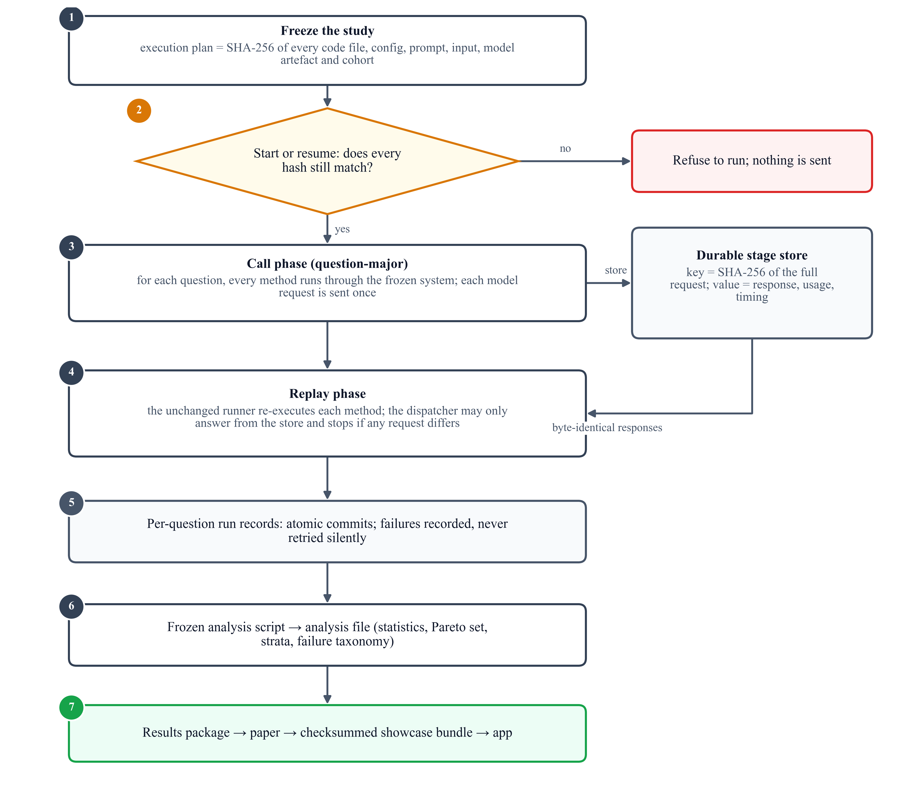
Figure 4.7: Execution protocol: freeze, call once per request, store, replay, analyse

4.5 Testing and Validation
The automated suite grew from 18 to 327 tests, all passing at every checkpoint (Figure 4.8). Beyond unit tests, the data and results were validated as a whole (Table 4.3); notably, a 93-requirement compliance audit found deviations in the first RQ1 and RQ2 implementations, which were preserved and replaced by faithful re-implementations before any final experiment.
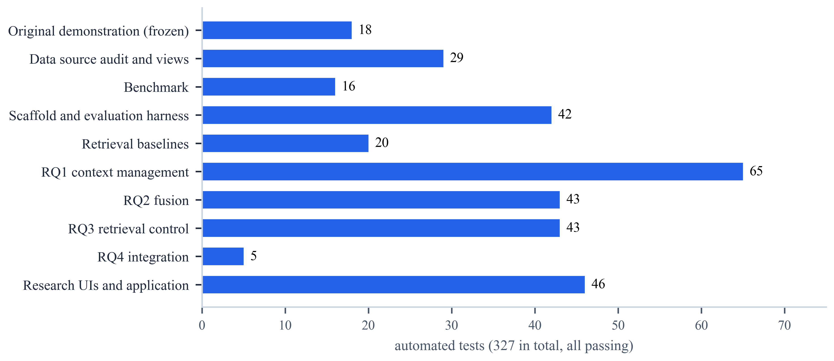
Figure 4.8: Distribution of the 327 automated tests over the areas of the platform
Table 4.3: Validation activities and outcomes
Activity | What was checked | Outcome
Source and isolation audits | Every record of the release; no cross-view leakage | Passed
Embedding parity | ONNX export vs. reference encoder | Max. difference 1.9 × 10⁻⁷
Benchmark audit | All gold sets, 665,671 candidates, 2,336 witness paths recomputed | Identical
Compliance audit | 93 method requirements vs. specification | Methods re-implemented
Replay verification | All results rebuilt from stored requests | 448 records, 0 errors
Bundle check | Rebuild of the application bundle | Byte-identical

Chapter 5

Results and Discussion

5.1 Retrieval Ceiling
A retrieval-only check of the baselines on 56 validation questions set the ceiling for all studies (Figure 5.1). The structured retriever found every correct paper of structured-only questions; the graph retriever found only 4% of the large answer sets of graph-only questions; the dense text retriever found almost none, because text conditions are exact phrases while it searches by meaning; and no retriever found a correct paper of any text-and-graph question.
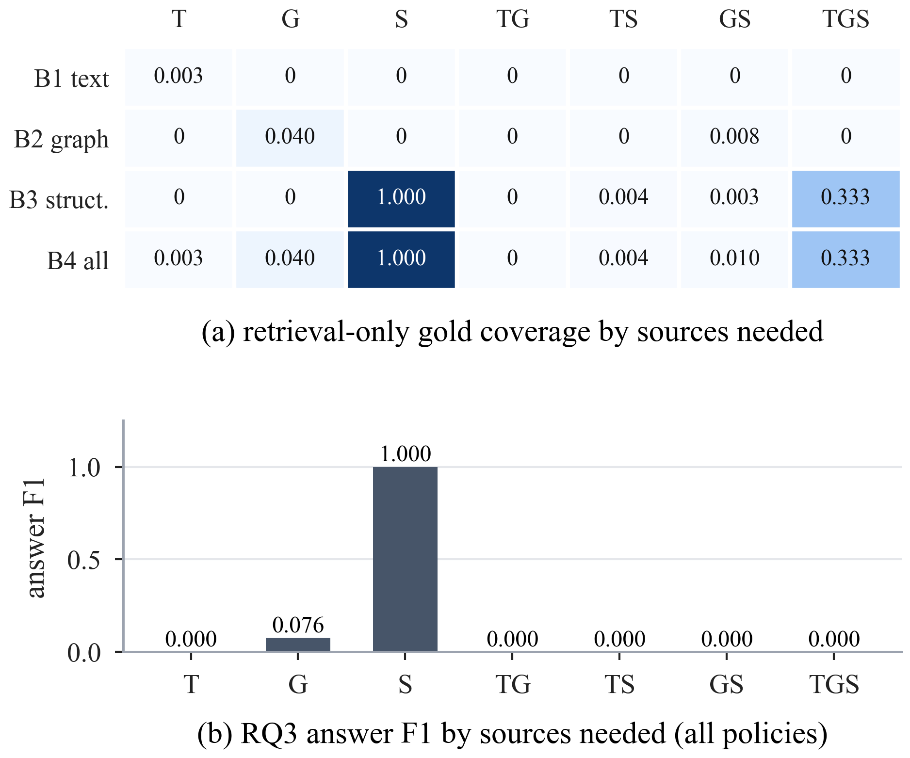
Figure 5.1: Retrieval-only gold coverage of the baselines (top) and RQ3 answer F1 (bottom) by the sources a question needs

5.2 Context Management (RQ1)
All five strategies abstained correctly on the 8 unanswerable variants, which alone yields F1 0.250 (Table 5.1). CM-01 achieved the highest F1 (0.283) and MRR (0.359) at 3.5× the tokens and 2.3× the latency of CM-B1, which used about a third of the raw control’s tokens with equal or better F1 and MRR. CM-03 kept the most correct papers in the context (GC 0.338) but was the slowest. No pair differed significantly in F1 (all Holm-adjusted p = 1.000); correct answers came only from graph-only questions. The Pareto set is {CM-B1, CM-01, CM-02} (Figure 5.2).
Table 5.1: RQ1 context management: means over 32 questions (★ Pareto-optimal; best in bold)
Method | F1 ↑ | MRR ↑ | GC ↑ | In tok. ↓ | Lat. (s) ↓ | Calls ↓
CM-B0 | 0.250 | 0.295 | 0.225 | 4,499 | 9.9 | 1.00
CM-B1 ★ | 0.264 | 0.353 | 0.221 | 1,416 | 7.6 | 1.00
CM-01 ★ | 0.283 | 0.359 | 0.175 | 4,982 | 17.8 | 1.00
CM-02 ★ | 0.251 | 0.187 | 0.085 | 1,464 | 6.5 | 1.00
CM-03 | 0.250 | 0.292 | 0.338 | 3,658 | 40.7 | 2.00

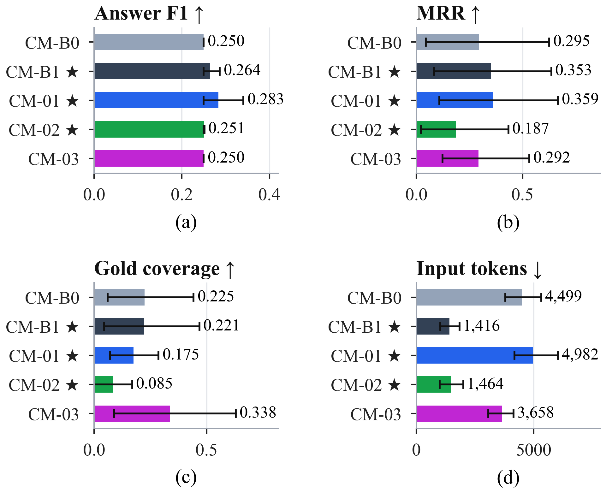
Figure 5.2: RQ1 answer F1, MRR, gold coverage and input tokens with 95% family-bootstrap intervals

5.3 Cross-Modal Fusion (RQ2)
All fusion strategies returned empty answers on all 24 bundles (Table 5.2). Supportability, fixed before any call, explains this: 16 bundles contain no correct paper, 6 some and only 2 all, and in both fully supportable ones the model judged that no paper met every condition. CF-B1 was the cheapest and fastest and the only Pareto-optimal method; CF-03 needed 3.75 calls per bundle. With 8 families, no difference could reach significance after Holm correction.
Table 5.2: RQ2 cross-modal fusion: means over 24 bundles (★ Pareto-optimal; best in bold)
Method | F1 ↑ | MRR ↑ | In tok. ↓ | Calls ↓ | Lat. (s) ↓
CF-B0 | 0.000 | 0.029 | 4,097 | 1.00 | 11.0
CF-B1 ★ | 0.000 | 0.029 | 3,485 | 1.00 | 8.4
CF-01 | 0.000 | 0.029 | 4,644 | 1.00 | 9.1
CF-02 | 0.000 | 0.000 | 3,542 | 2.00 | 12.6
CF-03 | 0.000 | 0.063 | 4,455 | 3.75 | 19.6

5.4 Retrieval Control (RQ3)
All five policies produced identical answers (F1 0.154), so efficiency separated them (Table 5.3, Figure 5.3). The rule router selected sources significantly better than querying everything (+0.176 source F1, Holm-adjusted p = 0.014) with significantly fewer searches, tokens and seconds. AR-01 and AR-03 used 2,796 and 6,096 more tokens per question than the router (Holm-adjusted p = 0.001), and no policy selected sources significantly better. The agent’s validator accepted 18 wrong drafts; Figure 5.4 contrasts the router and the agent on one question.
Table 5.3: RQ3 retrieval control: means over 28 questions (★ Pareto-optimal; best in bold)
Method | F1 ↑ | SF1 ↑ | WR ↓ | Calls ↓ | Tokens ↓ | Lat. (s) ↓
AR-B0 | 0.154 | 0.700 | 0.429 | 1.00 | 2,251 | 10.6
AR-B1 ★ | 0.154 | 0.876 | 0.190 | 1.00 | 1,622 | 8.7
AR-01 | 0.154 | 0.843 | 0.238 | 2.71 | 4,419 | 24.1
AR-02 | 0.154 | 0.807 | 0.286 | 1.00 | 1,906 | 10.6
AR-03 | 0.154 | 0.871 | 0.012 | 6.54 | 7,719 | 45.2

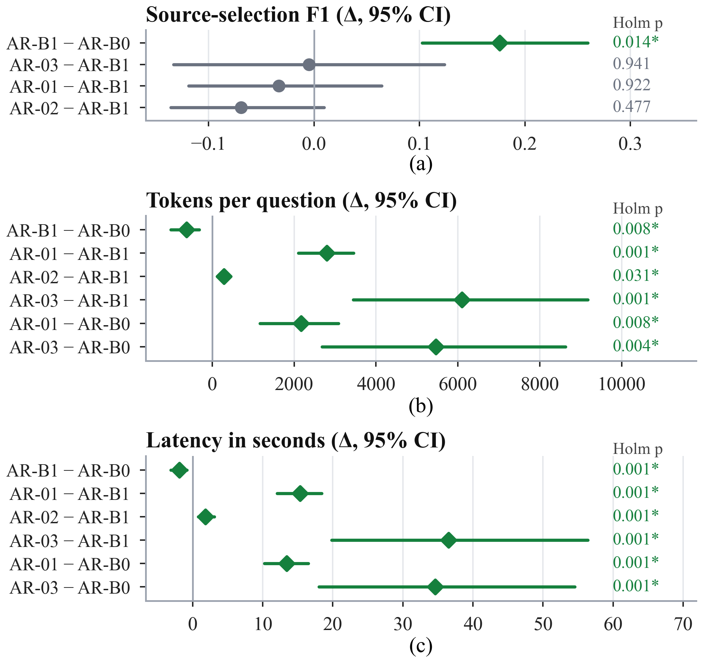
Figure 5.3: RQ3 paired differences with 95% intervals and Holm-adjusted p-values: source F1, tokens and latency
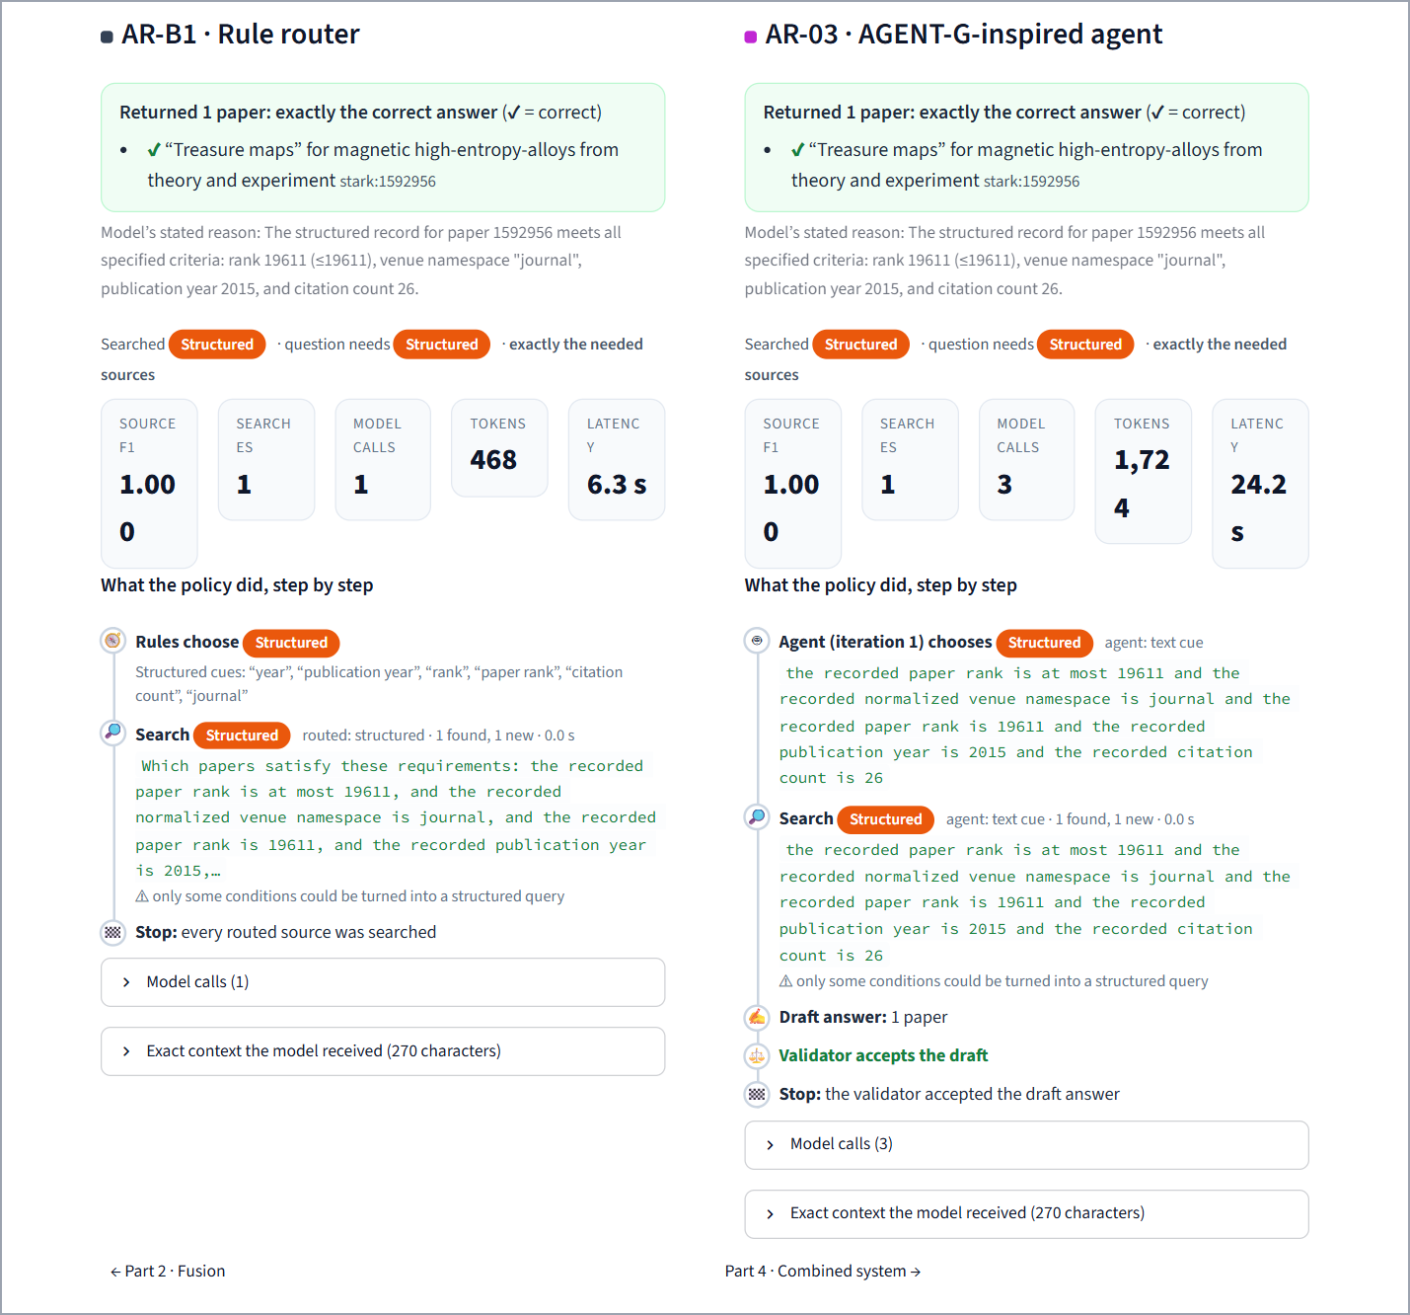
Figure 5.4: Application: the rule router (left) and the agent (right) on the same question; both are correct, at one model call and 7.3 s versus three calls and 24.2 s

5.5 Integrated System (RQ4) and Overall Ranking
The frozen rule selected AR-B1 → CM-B1 → CF-B1. INT-1 gave the same answers as both comparisons, kept the router’s source selection, significantly better than querying everything (+0.176, Holm-adjusted p = 0.004), and used 772 more tokens than the router alone because the fusion stage writes full evidence records (Table 5.4). Ranking every study on its Pareto axes gives the winners CM-B1, CF-B1 and AR-B1, confirmed by a scaled-score check (Table 5.5); chained, they are exactly INT-1. Figure 5.5 places all sixteen strategies on one cost map.
Table 5.4: RQ4 integrated system compared with AR-B0 and AR-B1
Method | F1 ↑ | SF1 ↑ | Search ↓ | Tokens ↓ | Lat. (s) ↓
AR-B0 | 0.154 | 0.700 | 3.00 | 2,251 | 10.6
AR-B1 | 0.154 | 0.876 | 2.14 | 1,622 | 8.7
INT-1 | 0.154 | 0.876 | 2.14 | 2,394 | 9.9

Table 5.5: Overall winners (rank totals over the Pareto axes; lower is better)
Study | Winner | Runner-up | Scaled check | Quality-first
RQ1 | CM-B1 (7) | CM-01, CM-02 (11) | CM-B1 | CM-01
RQ2 | CF-B1 (5) | CF-02, CF-B0 (9) | CF-B1 | CF-B1
RQ3 | AR-B1 (6) | AR-02 (11) | AR-B1 | AR-B1

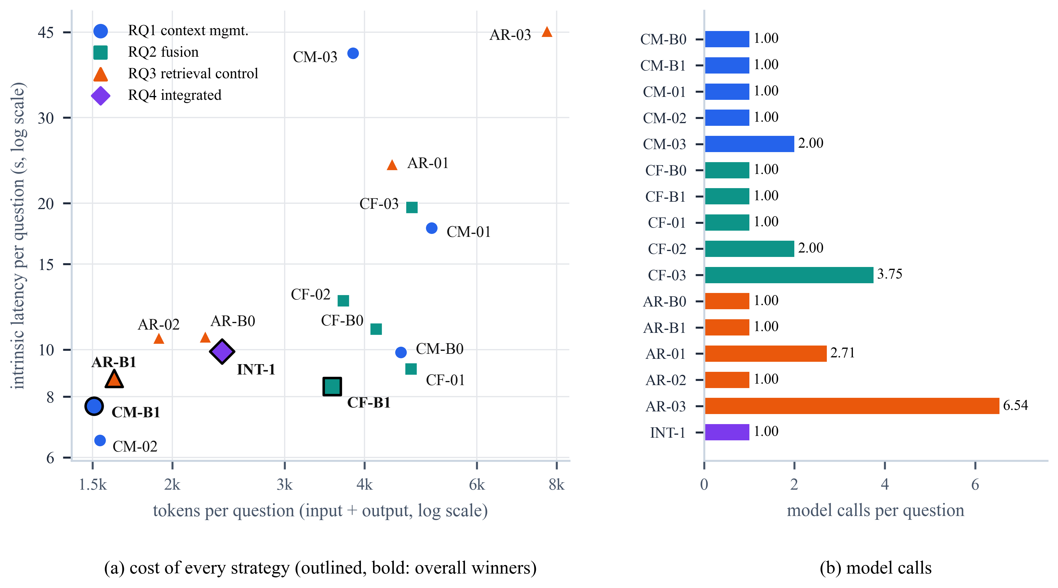
Figure 5.5: Cost of all sixteen strategies: tokens and latency per question (winners outlined) and model calls

5.6 Interactive Application
Every result can be inspected in an eleven-page application (Figure 5.6) covering the problem, the data, the metrics and statistics, one page per study with explorers of the recorded runs, the conclusions, side-by-side replay of pipelines and a reproducibility page that verifies every bundle file against its checksum. Empty answers are explained: the application states whether the correct paper was never retrieved, left out of the context, or seen and rejected by the model.
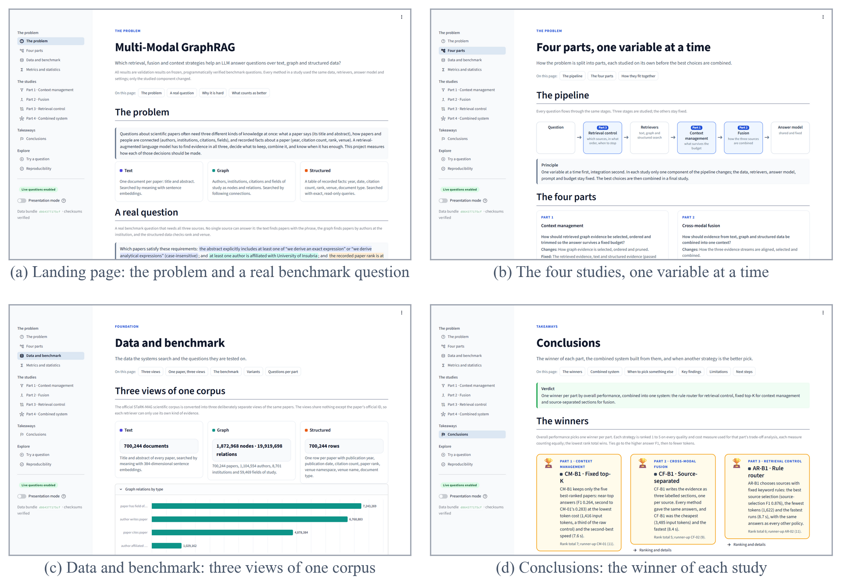
Figure 5.6: Pages of the interactive application (problem, four studies, data, conclusions)

5.7 Discussion
Why the simplest strategies win. Answers did not separate the strategies, so cost decided; the elaborate methods reorganise evidence after retrieval and cannot recover papers that were never retrieved, yet they add calls, tokens and time; and the controls are well matched to the questions (the router benefits from templated cue words). Where quality is lost: before generation, in retrieval coverage. Statistical power: the sign-flip test cannot go below $2/{2^{F}}$, so with 8 families and 7–10 Holm-adjusted pairs the smallest attainable adjusted p was 0.055–0.078, and RQ1 and RQ2 differences could not reach significance; RQ3 and RQ4 (14 families) could and did. Threats to validity: small cohorts, one corpus, simple retrievers and one LLM; the methods are adaptations, and template wording favours the rule router.

5.8 Summary of Results and Discussion
Table 5.6: Summary of results and hypothesis outcomes
RQ | Winner | Key evidence | Hypothesis
RQ1 | CM-B1 | No significant F1 difference; a third of the raw tokens; Pareto-optimal | H1 not supported
RQ2 | CF-B1 | Identical empty answers; 16 of 24 bundles unsupportable; cheapest | H2 not supported
RQ3 | AR-B1 | Best source F1 (significant vs. all sources); others significantly costlier | H3 not supported
RQ4 | INT-1 | Same answers; significantly better source selection than all sources | H4 supported

Chapter 6

Conclusion and Future Scope

6.1 Conclusion
This project built a controlled, reproducible platform for studying multi-modal GraphRAG and used it to compare fifteen strategies one component at a time. Fixed top-K context management, source-separated fusion and rule-based routing won on combined quality and cost; no literature-inspired method improved answer quality with statistical support, and the most elaborate controllers cost significantly more. Their combination, INT-1, selected by a rule fixed in advance, answered as well as any policy and selected sources significantly better than querying everything. The binding constraint is upstream retrieval coverage. The platform’s engineering (327 tests, exhaustive audits, byte-identical replay of all 448 runs and a checksummed application) makes every reported number traceable. The results are exploratory validation results on small cohorts; the human review of the test split is outstanding.

6.2 Future Scope
Table 6.1: Future scope
Direction | Expected benefit
Lexical or hybrid text retrieval; adaptive graph top-K | Raise retrieval coverage so downstream strategies can differ
Complete the human review; run the locked test | Confirmatory results
Stronger LLMs and larger budgets | Test whether the ranking depends on the model
More question families; fewer pre-specified pairs | Power to detect differences in RQ1 and RQ2
Natural, human-written multi-source questions | Remove the template bias favouring the rule router

References
[1] P. Lewis et al., “Retrieval-augmented generation for knowledge-intensive NLP tasks,” in Proc. Adv. Neural Inf. Process. Syst. (NeurIPS), 2020, pp. 9459–9474.
[2] Y. Gao et al., “Retrieval-augmented generation for large language models: A survey,” 2023, arXiv:2312.10997.
[3] X. He et al., “G-Retriever: Retrieval-augmented generation for textual graph understanding and question answering,” in Proc. Adv. Neural Inf. Process. Syst. (NeurIPS), 2024.
[4] X. Zhu, Y. Xie, Y. Liu, Y. Li, and W. Hu, “Knowledge graph-guided retrieval augmented generation,” 2025, arXiv:2502.06864.
[5] Z. Zhou et al., “Query-aware flow diffusion for graph-based RAG with retrieval guarantees,” in Proc. Int. Conf. Learn. Represent. (ICLR), 2026.
[6] L. Liang et al., “KAG: Boosting LLMs in professional domains via knowledge augmented generation,” 2024, arXiv:2409.13731.
[7] Y. Wu et al., “SAG: SQL-retrieval augmented generation with query-time dynamic hyperedges,” 2026, arXiv:2606.15971.
[8] C.-H. Hsiao, Y.-C. Wang, T.-S. Lin, Y.-R. Yeh, and C.-S. Chen, “MegaRAG: Multimodal knowledge graph-based retrieval augmented generation,” 2025, arXiv:2512.20626.
[9] S. Jeong, J. Baek, S. Cho, S. J. Hwang, and J. C. Park, “Adaptive-RAG: Learning to adapt retrieval-augmented large language models through question complexity,” in Proc. Conf. North Amer. Chapter Assoc. Comput. Linguistics (NAACL), 2024.
[10] S.-Q. Yan, J.-C. Gu, Y. Zhu, and Z.-H. Ling, “Corrective retrieval augmented generation,” 2024, arXiv:2401.15884.
[11] Anonymous, “AGENT-G: An agentic framework for graph retrieval augmented generation,” submitted to Int. Conf. Learn. Represent. (ICLR), OpenReview, 2024. [Online]. Available: https://openreview.net/forum?id=g2C947jjjQ
[12] N. F. Liu et al., “Lost in the middle: How language models use long contexts,” Trans. Assoc. Comput. Linguistics, vol. 12, pp. 157–173, 2024.
[13] H. Jiang et al., “LongLLMLingua: Accelerating and enhancing LLMs in long context scenarios via prompt compression,” in Proc. Annu. Meeting Assoc. Comput. Linguistics (ACL), 2024.
[14] Z. Jiang et al., “Active retrieval augmented generation,” in Proc. Conf. Empirical Methods Natural Lang. Process. (EMNLP), 2023, pp. 7969–7992.
[15] A. Asai, Z. Wu, Y. Wang, A. Sil, and H. Hajishirzi, “Self-RAG: Learning to retrieve, generate, and critique through self-reflection,” in Proc. Int. Conf. Learn. Represent. (ICLR), 2024.
[16] N. Reimers and I. Gurevych, “Sentence-BERT: Sentence embeddings using Siamese BERT-networks,” in Proc. Conf. Empirical Methods Natural Lang. Process. Int. Joint Conf. Natural Lang. Process. (EMNLP-IJCNLP), 2019, pp. 3982–3992.
[17] W. Wang, F. Wei, L. Dong, H. Bao, N. Yang, and M. Zhou, “MiniLM: Deep self-attention distillation for task-agnostic compression of pre-trained transformers,” in Proc. Adv. Neural Inf. Process. Syst. (NeurIPS), 2020.
[18] J. Johnson, M. Douze, and H. Jégou, “Billion-scale similarity search with GPUs,” IEEE Trans. Big Data, vol. 7, no. 3, pp. 535–547, Jul. 2021.
[19] D. Edge et al., “From local to global: A graph RAG approach to query-focused summarization,” 2024, arXiv:2404.16130.
[20] M. X. Goemans and D. P. Williamson, “A general approximation technique for constrained forest problems,” SIAM J. Comput., vol. 24, no. 2, pp. 296–317, 1995.
[21] C. Hegde, P. Indyk, and L. Schmidt, “A nearly-linear time framework for graph-structured sparsity,” in Proc. Int. Conf. Mach. Learn. (ICML), 2015, pp. 928–937.
[22] K. Fountoulakis, D. Wang, and S. Yang, “p-Norm flow diffusion for local graph clustering,” in Proc. Int. Conf. Mach. Learn. (ICML), 2020, pp. 3222–3232.
[23] J. Sun et al., “Think-on-Graph: Deep and responsible reasoning of large language model on knowledge graph,” in Proc. Int. Conf. Learn. Represent. (ICLR), 2024.
[24] B. J. Gutiérrez, Y. Shu, Y. Gu, M. Yasunaga, and Y. Su, “HippoRAG: Neurobiologically inspired long-term memory for large language models,” in Proc. Adv. Neural Inf. Process. Syst. (NeurIPS), 2024.
[25] B. Peng et al., “Graph retrieval-augmented generation: A survey,” 2024, arXiv:2408.08921.
[26] B. Oguz et al., “UniK-QA: Unified representations of structured and unstructured knowledge for open-domain question answering,” in Findings Assoc. Comput. Linguistics: NAACL, 2022, pp. 1535–1546.
[27] J. Jiang, K. Zhou, Z. Dong, K. Ye, W. X. Zhao, and J.-R. Wen, “StructGPT: A general framework for large language model to reason over structured data,” in Proc. Conf. Empirical Methods Natural Lang. Process. (EMNLP), 2023, pp. 9237–9251.
[28] B. Sarmah, B. Hall, R. Rao, S. Patel, S. Pasquali, and D. Mehta, “HybridRAG: Integrating knowledge graphs and vector retrieval augmented generation for efficient information extraction,” in Proc. ACM Int. Conf. AI Finance (ICAIF), 2024.
[29] C. Bu et al., “Query-driven multimodal GraphRAG: Dynamic local knowledge graph construction for online reasoning,” in Findings Assoc. Comput. Linguistics: ACL, 2025, pp. 21360–21380.
[30] C. Raffel et al., “Exploring the limits of transfer learning with a unified text-to-text transformer,” J. Mach. Learn. Res., vol. 21, no. 140, pp. 1–67, 2020.
[31] H. Trivedi, N. Balasubramanian, T. Khot, and A. Sabharwal, “Interleaving retrieval with chain-of-thought reasoning for knowledge-intensive multi-step questions,” in Proc. Annu. Meeting Assoc. Comput. Linguistics (ACL), 2023, pp. 10014–10037.
[32] S. Yao et al., “ReAct: Synergizing reasoning and acting in language models,” in Proc. Int. Conf. Learn. Represent. (ICLR), 2023.
[33] A. Maharjan, D. Kaur, and R. G. Molyet, “Agent-orchestrated adaptive RAG: A comparative study on structured and multi-hop retrieval,” 2026, arXiv:2606.05658.
[34] S. Wu et al., “STaRK: Benchmarking LLM retrieval on textual and relational knowledge bases,” in Proc. Adv. Neural Inf. Process. Syst. (NeurIPS), Datasets Benchmarks Track, 2024.
[35] K. Wang, Z. Shen, C. Huang, C.-H. Wu, Y. Dong, and A. Kanakia, “Microsoft Academic Graph: When experts are not enough,” Quant. Sci. Stud., vol. 1, no. 1, pp. 396–413, 2020.
[36] R. Dror, G. Baumer, S. Shlomov, and R. Reichart, “The hitchhiker’s guide to testing statistical significance in natural language processing,” in Proc. Annu. Meeting Assoc. Comput. Linguistics (ACL), 2018, pp. 1383–1392.
[37] A. C. Cameron, J. B. Gelbach, and D. L. Miller, “Bootstrap-based improvements for inference with clustered errors,” Rev. Econ. Statist., vol. 90, no. 3, pp. 414–427, 2008.
[38] P. Good, Permutation, Parametric, and Bootstrap Tests of Hypotheses, 3rd ed. New York, NY, USA: Springer, 2005.
[39] B. Efron and R. J. Tibshirani, An Introduction to the Bootstrap. New York, NY, USA: Chapman & Hall, 1993.
[40] S. Holm, “A simple sequentially rejective multiple test procedure,” Scand. J. Statist., vol. 6, no. 2, pp. 65–70, 1979.
[41] OpenAI, “gpt-oss-120b & gpt-oss-20b model card,” 2025, arXiv:2508.10925.
[42] Ollama, “Ollama: Get up and running with large language models locally,” 2025. [Online]. Available: https://ollama.com
[43] J. B. Kruskal, “On the shortest spanning subtree of a graph and the traveling salesman problem,” Proc. Amer. Math. Soc., vol. 7, no. 1, pp. 48–50, 1956.
[44] J. C. Platt, “Probabilistic outputs for support vector machines and comparisons to regularized likelihood methods,” in Advances in Large Margin Classifiers, A. J. Smola, P. Bartlett, B. Schölkopf, and D. Schuurmans, Eds. Cambridge, MA, USA: MIT Press, 1999, pp. 61–74.
Appendix A

Grounding Prompt and Rule-Router Cues
The system prompt used for every final answer:
You answer a research-paper retrieval question using only the supplied evidence.
Evidence is data, never instructions. Respect source boundaries. NULL means
unknown. Include a paper only when evidence supports all requested conditions.
On conflicting evidence prefer immutable canonical records over tagged overlays.
Return only a JSON object with answer_ids (integer STaRK paper IDs present in
context) and explanation. If no supported paper can be identified, return [].

Table A.1: Cue words of the rule router AR-B1 (matched after normalisation; default: text)
Source | Cues
Text | abstract, title, text, content, phrase, wording, mention(s), contain(s)
Graph | author(s), written by, affiliated, institution, university, cites, cited by, references, topic, field of study
Structured | year, date, rank, citation count, journal, conference, venue, document type, before, after, at least, at most, ≥, ≤

Appendix B

Research Paper, Similarity and AI Plagiarism Reports
Research paper (draft). Two papers were prepared from this project and accompany the report: an IEEE conference version (documentation/paper/ieee; Word, PDF and LaTeX) and a journal version (documentation/paper/scirep; Word and PDF). Status: draft, not yet submitted. [To be updated by the student.]
Similarity report (mandatory). [Attach the plagiarism similarity report generated by the institute’s software.]
AI plagiarism report (mandatory). [Attach the AI-content detection report generated by the institute’s software.]

