App Dev Project Report

- Student Details
Name: Aaditya Chaturvedy
Roll Number: 24F2008937
Email: 24F2008937@ds.study.iitm.ac.in
About Me: I am a student at IIT Madras BS Degree program and SRM Institute of Technology with interest in edge AI and embedded deep learning. My work focuses on deploying production-grade ML models on resource-constrained hardware such as ARM devices.
- AI/LLM Declaration
I used Gemini (Google) strictly for syntax debugging, generating boilerplate code and UI/CSS alignment. All core architectures and feature integrations were developed manually. The extent of AI/LLM usage is around 10-15%. All final correction and implementation logic were done manually.
- Description
Project Title: IIT Placement Portal Application
Developed a centralized Flask-based web application to streamline campus recruitment for institutes, companies, and students. Utilized SQLite for relational data management and Jinja2 with Bootstrap to build dynamic, role-specific dashboards. Automated the recruitment lifecycle by managing company approvals, tracking student applications, and maintaining historical placement records.
- Technologies and Frameworks Used

Technology | Purpose
Flask | Core backend web framework
Flask-SQLAlchemy | Object Relational Mapper for database interaction
Wekzeug | Security utilities, including secure password hashing
Jinja2 | Template engine for rendering dynamic HTML pages
HTML5 & CSS | Core markup structure and custom frontend styling
Bootstrap 5 | Frontend styling framework for responsive design
Chart.js | Data visualization for admin reports and trends
SQLite | Lightweight local database for storing application data
- DB Schema Design
Tables:
- Admin: stores superuser credentials for the institute placement cell (id, username, email, password_hash)
- Company: stores recruiter organization details and their system access status (id, company_name, email, password_hash, hr_contact, website, industry, description, approval_status, is_blacklisted)
- Student: stores student profiles, academic records, and resume links (student_id, name, email, password_hash, contact, degree, branch, cgpa, graduation_year, skills, resume_path, is_blacklisted)
- JobPosition: stores details of placement drives created by approved companies (id, company_id, job_title, job_description, eligibility_criteria, required_skills, experience_required, salary_range, application_deadline, status)
- Application: stores records of student submissions to specific placement drives (id, student_id, job_position_id, application_date, status, cover_letter, updated_at)
- Placement: stores final hiring records and salary packages for selected students (id, application_id, placement_date, offer_letter_path, joining_date, package, remarks)
Relationships:
- One-to-Many → Company → JobPosition
- One-to-Many → Student → Application
- One-to-Many → JobPosition → Application
- One-to-One → Application → Placement
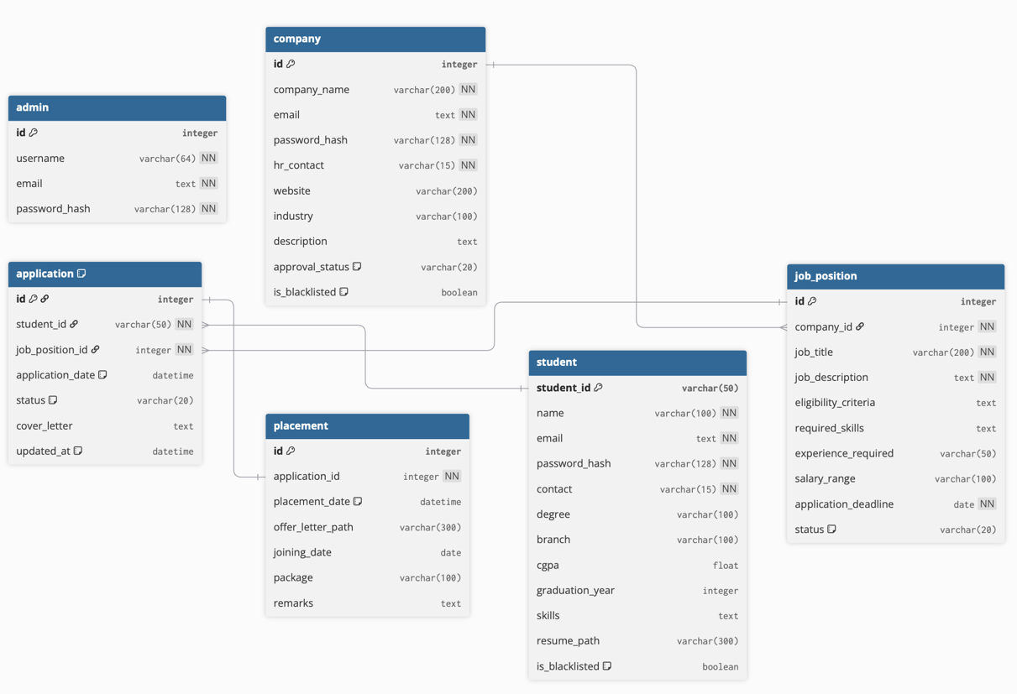
- API Resource Endpoints
Endpoint | Method | Description
/api/companies | GET | Fetches a list of companies
/api/students | GET | Fetches a list of students
/api/jobs | GET | Fetches a list of available jobs
/api/jobs | POST | Creates a new job listing
/api/applications | GET | Fetches a list of applications
/api/jobs/<job_id>/apply | POST | Submits a job application for a specific job ID
/api/applications/<app_id>/status | PATCH | Updates the status of a specific job application ID

YAML API Definition File:
Included separately in the submission ZIP as api.yaml .
- Architecture and Features
Architecture Overview:
- app.py – Main Flask application entry point, containing controllers and routing logic
- models.py – Database models and schema definitions using SQLAlchemy
- helpers.py – Utility functions, decorators, and validation logic
- /templates – Jinja2 HTML templates, organized into subdirectories by user role (`admin`, `company`, `student`)
- /static – CSS styling, JavaScript files, and static assets used across the platform

Implemented Features:
- Role-based user registration and login (Admin, Company, Student)
- Secure student profile management with resume document uploads
- Job creation, editing, and timeline management for recruiting companies
- Real-time job application submission and applicant status tracking (Applied, Shortlisted, Selected, etc.)
- Dedicated analytics and data visualization dashboards for companies and administrators
- Secure password hashing and robust user session handling
Additional Features:
- Export placement records and system data (e.g., CSV exports for admin reports)
- System moderation capabilities for admins (Company approval workflows, student/company blacklisting)
- Internal RESTful API endpoints to fetch resource data dynamically

- Video Presentation
Drive Link:

