import pandas
import numpy as np
import matplotlib.pyplot as plt
from sklearn.neighbors import KNeighborsClassifier
p1=[2,4]
p2=[4,2]
p3=[4,4]
p4=[4,6]
p5=[6,2]
p6=[6,4]
x=[p1,p2,p3,p4,p5,p6]
y=[0,0,1,0,1,0] # 0 for orange and 1 for blue
classifier=KNeighborsClassifier(n_neighbors=3,p=2, metric='minkowski')
classifier.fit(x,y)
x_pred=np.array([6,6])
y_pred=classifier.predict(x_pred.reshape(1,-1))
plt.scatter(p1[0],p1[1],c='orange',marker='s')
plt.scatter(p2[0],p2[1],c='orange',marker='s')
plt.scatter(p3[0],p3[1],c='blue',)
plt.scatter(p4[0],p4[1],c='orange',marker='s')
plt.scatter(p5[0],p5[1],c='blue')
plt.scatter(p6[0],p6[1],c='orange',marker='s')
if(y_pred==0):
color='orange'
marker='s'
else:
color='blue'
marker='.'
plt.scatter(x_pred[0],x_pred[1],c=color,marker=marker,s=400)
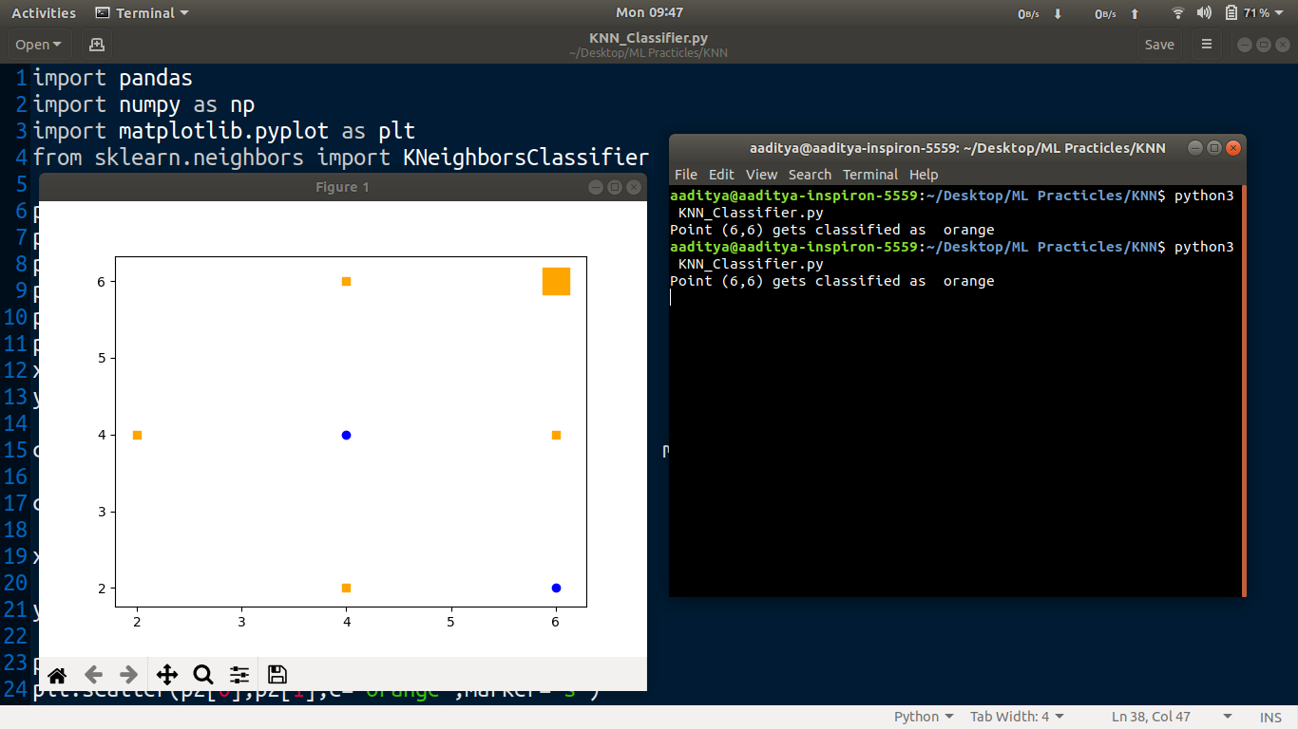
print("Point (6,6) gets classified as ",color)
plt.show()

OUTPUT: Point (6,6) gets classified as orange ie, Negative Sample

