from sklearn.preprocessing import LabelEncoder
from sklearn.tree import DecisionTreeClassifier
from sklearn.tree import export_graphviz
import pandas as pd
import numpy as np

dataset=pd.read_csv("assign2DataAll.csv")
x=dataset.iloc[0:15,:-1] #Reading all rows
y=dataset.iloc[:14,5] #Reading first 14 rows only 5th coloumn (from 0)

print("\nAll Data\n\n",x)

le=LabelEncoder()
lx=x.apply(le.fit_transform)

regressor=DecisionTreeClassifier()
regressor.fit(lx.iloc[:14,1:5],y) #Fitting only first 14 rows with label

x_test = lx[14:] #14 above till last for test (not 14)

print("\nTest Data\n\n",x_test)
x_test=sum(x_test.values.tolist(),[]) #for conversion of df to list

x_test =x_test[1:]
y_pred=regressor.predict([x_test])
print("\nFor test data:\n",x[14:])
print("Output: Prediction is ",y_pred)
export_graphviz(regressor, out_file ='tree.dot') #text graph

#sudo apt install graphviz
#dot -Tpng tree.dot -o tree.png

OUTPUT:
(base) ubuntu@OS-lab:~/Aaditya$ python3 Decision_Tree.py
All Data
id age income gender maritial status
0 1 <21 high male single
1 2 <21 high male married
2 3 21-35 high male single
3 4 >35 medium male single
4 5 >35 low female single
5 6 >35 low female married
6 7 21-35 low female married
7 8 <21 medium male single
8 9 <21 low female married
9 10 >35 medium female single
10 11 <21 medium female married
11 12 21-35 medium male married
12 13 21-35 high female single
13 14 >35 medium male married
14 15 <21 low female married

Test Data
id age income gender maritial status
14 14 1 1 0 0

For test data:
id age income gender maritial status
14 15 <21 low female married

Output: Prediction is ['yes']

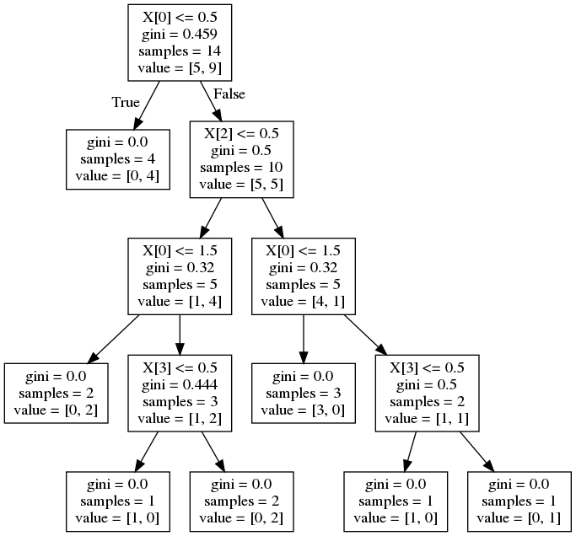 Final Decision Tree

