**Project Report On**

**“Project Centric Mail”**

**SUBMITTED TO SAVITRIBAI PHULE PUNE UNIVERSITY**

**BACHELOR OF ENGINEERING**

**(Computer Engineering)**

**By**

**1. Ayush Agarwal**

**2. Aaditya Deshpande**

**3.Shrikant Gadekar**

**4.Sunny Khandare**

**UNDER THE GUIDANCE OF**

**Bhagyashree Bhoyar**



**Department of Computer Engineering**

**Dr.D.Y.Patil Institute of Technology Pimpri, Pune-18**

**2018-2019**



**Dr.D.Y.Patil Institute of Technology Pimpri, Pune-18**

**Department of Computer Engineering**

**CERTIFICATE**

This is to certify that the project entitled

“**Project Centric Mail**”

Submitted By

Ayush V Agarwal examrollno

Aaditya Deshpande examrollno

Shrikant Gadekar examrollno

Sunny Khandare examrollno

is a bonafide work carried out by them under the supervision of **Guide Name**  and it is approved for the partial fulfillment of the requirement of SavitribaiPhule Pune University for the award of the Degree of Bachelor of Engineering(Computer Engineering )

.

Prof. Bhagyashree Bhoyar Dr. Pramod. D. Patil

Internal Guide H.O.D

Dept. of Computer Engg. Dept. of Computer Engg.

Dr.S. N. Mali

Principal

Dr. D. Y. Patil Institute of Technology, Pimpri, Pune

**Signature of Internal Examiner Signature of External Examiner**

**Content**

|  |  |  |
| --- | --- | --- |
| **Sr.No** | **Name** | **Page No** |
| **1** | **Introduction** |  |
| **2** | **Objective** |  |
| **3** | **Theory** |  |
| **4** | **Requirement Analysis** |  |
| **5** | **Design Planning** |  |
| **6** | **Implementation** |  |
| **7** | **System Requirement** |  |
| **8** | **Testing** |  |
| **9** | **Maintenance** |  |
| **10** | **Advantages & Disadvantages** |  |
| **11** | **Future Scope** |  |
| **12** | **Reference** |  |

**List of Figure**

|  |  |  |
| --- | --- | --- |
| **Sr.No** | **Name** | **Page No** |
|  |  |  |
|  |  |  |
|  |  |  |
|  |  |  |
|  |  |  |
|  |  |  |
|  |  |  |

**List of Table**

|  |  |  |
| --- | --- | --- |
| **Sr.No** | **Name** | **Page No** |
|  |  |  |
|  |  |  |
|  |  |  |
|  |  |  |
|  |  |  |
|  |  |  |
|  |  |  |

1. **Introduction**

“To realize the value of one second, ask the person who just missed a bus or train.”

This project, the Project Centric Mailbox (PCM) is based on a simple observation. In business, it is not easy to end up in his mailbox. Following this, the student engineers found a solution to improve the mailbox, with great attention to the visualization part.

**II.Objective**

In this project if someone works on five projects, they will have five clusters. In a concrete use case, a person arrives on the PCM. It allows the access to its mails, and these are imported on a database SQLite, encrypted and secured. Once connected, the person arrives on a home page, where they can see the different clusters, and go to the page that interests them. The mails of the various projects are no longer mixed, which facilitates the visibility of these. The second big change is using pattern matching (Machine Learning) for identification of spaming mails.

The third big feature is classification of mails on the basis of whether it is formal of informal. It helps the individual to identify the mails which belongs to its business,projects,etc .

1. **Theory**

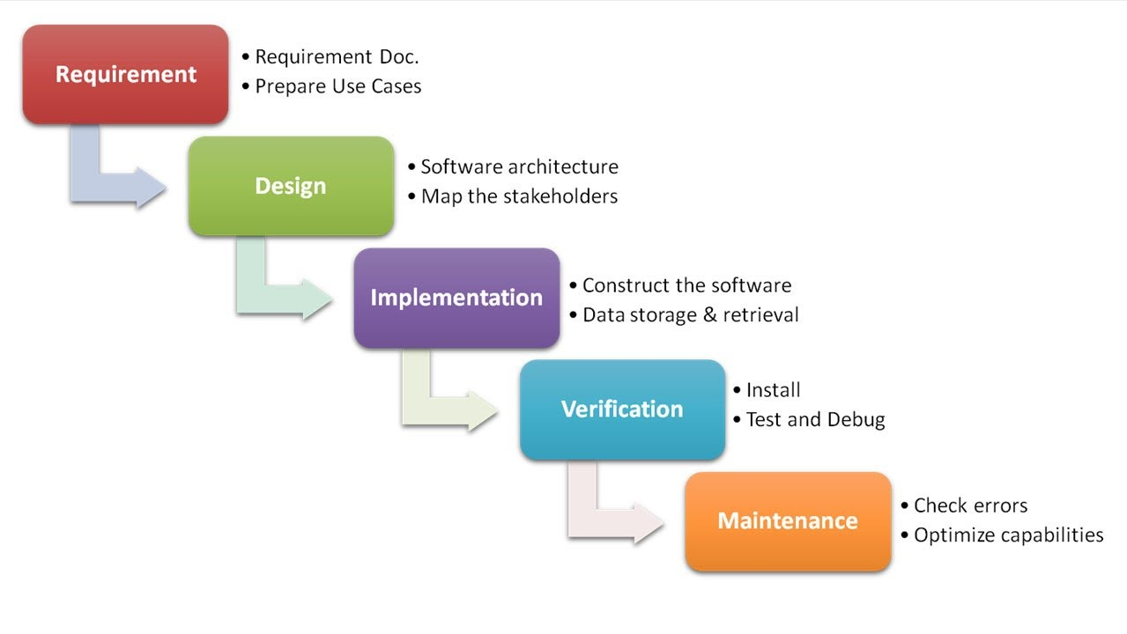

1. **Required Analysis**

**Login :**

User should be able to login to website with there username and password

**Logout:**

Logged in users should be able to log out of the site

**Authentication:**

Authentication with the users gmail accout should be done in order to gain reading access to the maintained

**Spaming :**

This page should show all the spaming mail received by the user

**Project clustering:**

Clustering(grouping) should be done on the basis of project and users should be shown mails according to the project

1. **Design Planning**
2. **Implementation**
3. **System Requirement**

**Software requirements:**

* Front end: HTML,Bootstrap
* Back end: Python,SQL
* Frame work: Django
* DBMS: SQLite

**Hardware requirements:**

* Processor: Intel core 7th generation
* Hard disk: minimum 200mb
* RAM: 512MB
* GPU: 2GB

1. **Testing**
2. **Maintenance**

* Browser needs to be updated to support HTML5
* Python3 and its libraries to be updated regular basis
* Django to be updated to get advance security features

1. **Advantages & Disadvantages**

**Advantages:**

* proper grouping of mails according to project
* Easy the mange company,bussiness related mails
* Spaming mails are indentified

**Disadvantages:**

* In one itteration only 100 mails can be process ,Cost will increase to process more mail .

1. **Future Scope**

For future development, many tools could be integrated into a new version. One can imagine the calendar / planning incorporated in the project view, project management tools, a system of sentiment studies (which feels bad in the company for example), etc.

1. **Conclusion**

**XII. Reference**

* [www.esilv.fr](http://www.esilv.fr/)
* [www.youtube.com](http://www.youtube.com/)
* [www.analyticsvidhya.com](http://www.analyticsvidhya.com/)
* <https://docs.djangoproject.com/en/2.1/>