**LOK SABHA ELECTIONS 2024**

**Introduction**

This report presents a detailed analysis of the recently concluded Lok Sabha Elections 2024. Utilizing the latest data, we explore key metrics such as total votes, seats won, and leading votes by each party. Our insights aim to provide a comprehensive understanding of the election outcomes, highlighting the performance of major political parties and offering a comparative view of their electoral success. Through visualizations and data-driven insights, this report sheds light on the electoral dynamics and voter preferences that shaped the 2024 Lok Sabha elections.

**Analysis and Key Insights**

**1) Total Seats Won**: An analysis of the total seats won by each party reveals

the dominant political forces in this election.

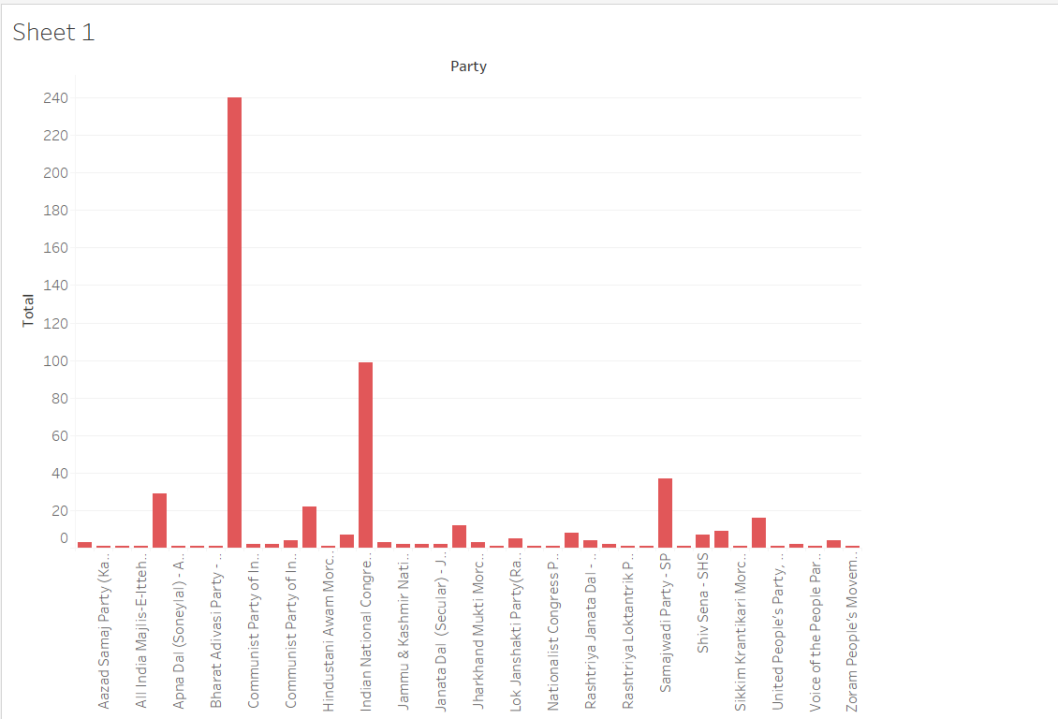

**2) Winning Party:** Identifying the party with the highest number of seats

won highlights the leading political entity in this election.

Bharatiya Janata Party - BJP

**3) Comparison of Total Votes vs. Won Votes by Party:**

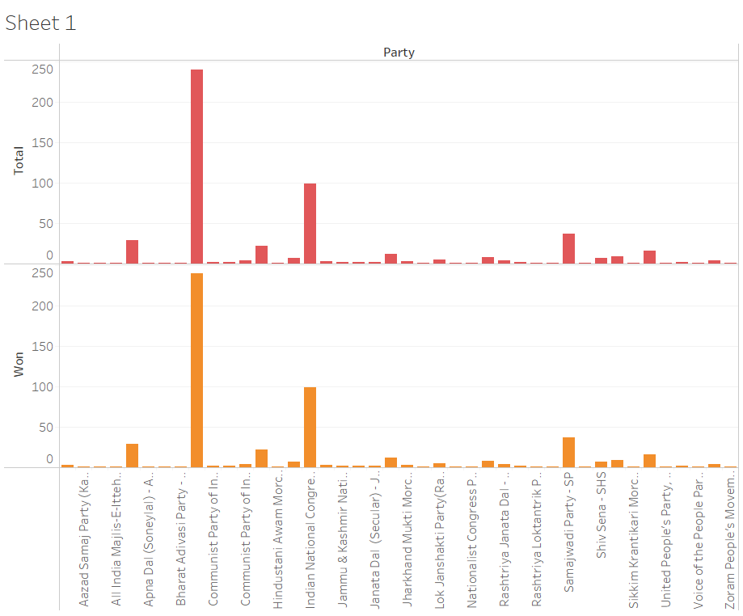

**4) Total Number of Parties Participated:** The total count of participating

parties highlighting the breadth of political engagement.

42

**5) Total Seats Leading:** Examining the total seats leading offers a snapshot of

the competitive constituencies and emerging trends.

0

**6) Winning Party Percentage of Total Seats:** Calculating the winning party's

percentage of total seats illustrates their relative dominance.

44.1988950

**7) Top 5 Parties by Seats Won:** A focused look at the top 5 parties based on the

number of seats won showcases the major players.

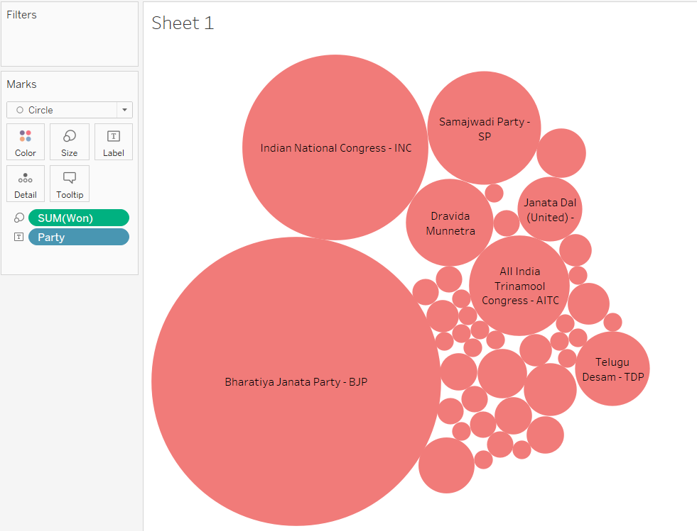

1) Bharatiya Janata Party - BJP

2) Indian National Congress - INC

3) Samajwadi Party - SP

4) All India Trinamool Congress - AITC

5) Dravida Munnetra Kazhagam - DMK

**8) Party with Most Leading Seats:** The party with the most seats currently

leading underscores potential shifts in political power.

Bharatiya Janata Party - BJP

**9) Total Number of Seats :** An analysis of the total seats won by all parties in all

Constituencies.

543

**10) Overall Performance by Party:**

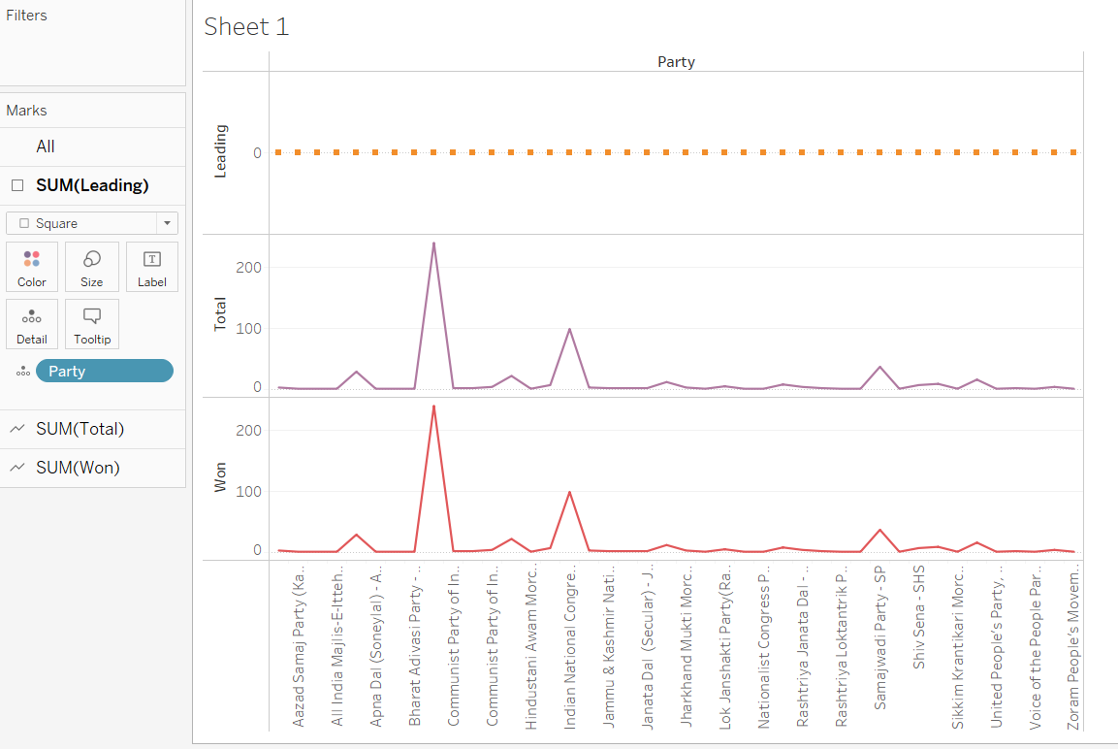

**11) Number of Parties with At Least One Seat Won:** This insight provides a

measure of the diversity of political representation.

42

**Tools and Libraries Used**

I) Python

II) ParseHub

III) Tableau

IV) Matplotlib

V) BeautifulSoup

VI) Requests

VII) JupyterHub

**CONCLUSION**

The analysis of the 2024 Lok Sabha election results provides a comprehensive overview of the electoral outcomes, revealing significant trends and patterns. Key insights indicate the dominance of certain political parties and voter turnout. The data highlights the total votes, seats won, and leading trends of major parties, offering a detailed look at their performance. This information is crucial for understanding the political landscape and voter behavior in India, providing valuable insights for future elections.